Math, Actually

Volume 3 - From Differential Equations to Abstract Algebra
A Volume in the Math, Actually Series

Lothar J. Musiol

Copyright © 2026 Lothar J. Musiol
All rights reserved. No part of this publication may be reproduced, distributed, or transmitted in any form or by any means, including photocopying, recording, or other electronic or mechanical methods, without the prior written permission of the author, except in the case of brief quotations embodied in critical reviews and certain other non-commercial uses permitted by copyright law.
First edition, 2026.
The mathematics in this book has been checked with care. No book of this size is entirely free of error, and the author would rather hear about a mistake than have it quietly inherited by the next reader. The useful report names the volume, the chapter, and the section.
Math, Actually series

Table of Contents
Also in This Series 7
About This Volume 8
How to Use This Book 9
What this book is, and what it is not 9
How each section is built 9
The worked examples are the exercises 10
The questions at the end of each chapter 10
When a chapter genuinely interests you, read beyond the book 10
How This Book Is Organized 11
Where the Foundations Are 12
This Volume’s Chapters 13
Chapter 26: Differential and Integro-Differential Equations 13
Section 26.1: Ordinary Differential Equations Revisited 17
Section 26.2: Systems, Stability, and Lyapunov Functions 23
Section 26.3: Boundary-Value Problems and Sturm–Liouville Theory 27
Section 26.4: Green’s Functions for ODEs 32
Section 26.5: What Integro-Differential Equations Are 36
Section 26.6: Volterra Integro-Differential Equations 41
Section 26.7: Fredholm Integro-Differential Equations and Eigenvalue Problems 45
Section 26.8: Delay Equations and Equations with Memory 49
Section 26.9: Looking Ahead: From Integro-Differential Equations to PDEs and Functional Analysis 53
Check Your Understanding — Chapter 26 56
Problems — Chapter 26 58
Chapter 27: Partial Differential Equations 59
Section 27.1: What a Partial Differential Equation Actually Is 61
Section 27.2: First-Order Equations and the Method of Characteristics 67
Section 27.3: Classification of Second-Order Equations 73
Section 27.4: The Wave Equation 78
Section 27.5: The Heat Equation 83
Section 27.6: Laplace’s Equation and Harmonic Functions 88
Section 27.7: Separation of Variables and Eigenfunction Expansions 93
Section 27.8: Green’s Functions, Maximum Principles, and Energy Methods 97
Section 27.9: Looking Ahead: From Classical PDEs to Modern Theory and Applications 101
Check Your Understanding — Chapter 27 106
Problems — Chapter 27 108
Chapter 28: Calculus of Variations 109
Section 28.1: The Calculus of Variations: The Euler–Lagrange Equation 111
Section 28.2: First Integrals, Constraints, and Variable Endpoints 115
Section 28.3: The Second Variation and Sufficient Conditions 119
Section 28.4: Hamilton’s Principle and Classical Mechanics 123
Section 28.5: Classical Applications: Geodesics, Minimal Surfaces, Isoperimetry 127
Section 28.6: Looking Ahead: From Classical Variational Calculus to Optimal Control and Geometric Analysis 132
Check Your Understanding — Chapter 28 136
Problems — Chapter 28 137
Chapter 29: Numerical Methods 138
Section 29.1: What Numerical Methods Are 140
Section 29.2: Root-Finding and Nonlinear Equations 146
Section 29.3: Interpolation, Approximation, and Splines 152
Section 29.4: Numerical Differentiation and Integration 157
Section 29.5: Numerical Linear Algebra 162
Section 29.6: Numerical Methods for Ordinary Differential Equations 167
Section 29.7: Numerical Methods for Partial Differential Equations 171
Section 29.8: Consistency, Stability, and Convergence 177
Section 29.9: Looking Ahead: From Elementary Numerics to High-Performance and Adaptive Methods 181
Check Your Understanding — Chapter 29 186
Problems — Chapter 29 188
Chapter 30: Optimization: Theory and Algorithms 189
Section 30.1: Modeling and the Landscape of Optimization Problems 191
Section 30.2: Linear Programming 196
Section 30.3: Unconstrained Nonlinear Optimization 201
Section 30.4: Constrained Nonlinear Optimization 208
Section 30.5: Convexity and Convex Optimization Algorithms 217
Section 30.6: Duality in Practice 225
Section 30.7: Integer and Combinatorial Optimization 229
Section 30.8: Derivative-Free, Stochastic, and Large-Scale Methods 233
Section 30.9: Looking Ahead: From Algorithms to Advanced Optimization and Applications 239
Check Your Understanding — Chapter 30 243
Problems — Chapter 30 246
Chapter 31: Differential Geometry 247
Section 31.1: What Differential Geometry Is 249
Section 31.2: Curves in the Plane and in Space 253
Section 31.3: The Frenet–Serret Apparatus 258
Section 31.4: Surfaces and the First Fundamental Form 263
Section 31.5: The Second Fundamental Form and Curvature 268
Section 31.6: Geodesics 272
Section 31.7: The Gauss–Bonnet Theorem 276
Section 31.8: Intrinsic Geometry and the Theorema Egregium 283
Section 31.9: Looking Ahead: From Surfaces to Manifolds, Riemannian Geometry, and Relativity 287
Check Your Understanding — Chapter 31 291
Problems — Chapter 31 293
Chapter 32: Topology 294
Section 32.1: What Topology Is 296
Section 32.2: Metric Spaces and Continuity 300
Section 32.3: Topological Spaces and Continuous Maps 305
Section 32.4: Connectedness and Path-Connectedness 311
Section 32.5: Compactness 315
Section 32.6: Separation Axioms and Countability 319
Section 32.7: Homotopy and the Fundamental Group 324
Section 32.8: Covering Spaces and Classification of Surfaces 329
Section 32.9: Looking Ahead: From Basic Topology to Algebraic Topology and Manifolds 333
Check Your Understanding — Chapter 32 336
Problems — Chapter 32 338
Chapter 33: Integral Geometry (Advanced) 340
Section 33.1: From Classical Formulas to Modern Valuations 342
Section 33.2: Convex Bodies and Intrinsic Volumes 346
Section 33.3: Continuous Valuations and Hadwiger’s Theorem 350
Section 33.4: The Principal Kinematic Formula and Its Relatives 354
Section 33.5: Integral Geometry on Spaces of Higher Rank 358
Section 33.6: Applications: Stereology, Tomography, and Geometric Probability 363
Section 33.7: Curvature Measures and the Normal Cycle (Advanced) 368
Section 33.8: The Algebra of Valuations (Advanced) 373
Section 33.9: Looking Ahead: Valuations on Manifolds and Algebraic Integral Geometry 377
Check Your Understanding — Chapter 33 381
Problems — Chapter 33 383
Chapter 34: Tensors & Manifolds 384
Section 34.1: Multilinear Algebra and Tensors 386
Section 34.2: Tensor Fields and Transformation Laws 391
Section 34.3: Smooth Manifolds 395
Section 34.4: Tangent Vectors, Vector Fields, and Flows 400
Section 34.5: Differential Forms and Exterior Calculus 404
Section 34.6: Integration on Manifolds and Stokes’ Theorem 408
Section 34.7: Riemannian Metrics 412
Section 34.8: Connections, Covariant Derivatives, and Curvature 416
Section 34.9: Looking Ahead: From Manifolds to Riemannian Geometry, Gauge Theory, and Relativity 420
Check Your Understanding — Chapter 34 424
Problems — Chapter 34 426
Chapter 35: Functional Analysis 428
Section 35.1: What Functional Analysis Is 430
Section 35.2: Banach Spaces and Hilbert Spaces 434
Section 35.3: Linear Operators and Duality 439
Section 35.4: The Fundamental Theorems 444
Section 35.5: Weak Topologies and Reflexivity 448
Section 35.6: Compact Operators and the Fredholm Alternative 452
Section 35.7: Spectral Theory of Compact Self-Adjoint Operators 456
Section 35.8: Unbounded Operators and Sobolev Spaces 461
Section 35.9: Looking Ahead: From Functional Analysis to Operator Algebras, Distributions, and PDEs 467
Check Your Understanding — Chapter 35 472
Problems — Chapter 35 474
Chapter 36: Measure Theory 474
Section 36.1: What Measure Theory Is 477
Section 36.2: Algebras, σ-Algebras, and Measures 481
Section 36.3: Outer Measure and Lebesgue Measure 487
Section 36.4: Measurable Functions 492
Section 36.5: The Lebesgue Integral 496
Section 36.6: Convergence Theorems 503
Section 36.7: Product Measures and Fubini’s Theorem 509
Section 36.8: Lᵖ Spaces and the Radon–Nikodym Theorem 514
Section 36.9: Looking Ahead: From Measure to Algebra, and Back to Probability 522
Check Your Understanding — Chapter 36 523
Problems — Chapter 36 525
Chapter 37: Abstract Algebra 527
Section 37.1: What Abstract Algebra Is 529
Section 37.2: Groups and Homomorphisms 535
Section 37.3: Group Actions, Cosets, and Quotient Groups 540
Section 37.4: Rings, Ideals, and Quotient Rings 544
Section 37.5: Factorization in Integral Domains 549
Section 37.6: Modules over Rings 554
Section 37.7: Field Extensions 559
Section 37.8: Introduction to Galois Theory 563
Section 37.9: Looking Ahead: From Abstract Algebra to Algebraic Geometry, Number Theory, and Representation Theory 567
Check Your Understanding — Chapter 37 571
Problems — Chapter 37 573
Epilogue — Between Volumes 574
Answer Key 575
Solutions to the Problems 640
Chapter 26 640
Chapter 27 640
Chapter 28 640
Chapter 29 640
Chapter 30 640
Chapter 31 640
Chapter 32 640
Chapter 33 640
Chapter 34 640
Chapter 35 640
Chapter 36 640
Chapter 37 640
Answers to the Practice Sets 645
Symbol & Notation Glossary 674
Appendix — Further Reading 680
Volume 1 — Arithmetic to Calculus (Chapters 1–12) 680
Volume 2 — Multivariable to Foundations (Chapters 13–25) 680
Volume 3 — Equations to Abstract Algebra (Chapters 26–37) 680
Volume 4 — Category Theory to the Frontier (Chapters 38–50) 681
If you read only one 681
Subject Index 682
About the Author 688
Also by Lothar J. Musiol 689
A Note Before You Go 691

Also in This Series
Volume 1 — From Arithmetic to Calculus
Counting and number theory, algebra, functions and graphs, coordinates, Euclidean geometry, trigonometry, logarithms, systems of equations, vectors, limits, the derivative, and the integral. Chapters 1–12; it reads on its own through single-variable calculus.
Volume 2 — From Multivariable Calculus to Set Theory & Logic
Multivariable functions and calculus, vector calculus, series, Fourier and Laplace transforms, integral geometry, matrices, linear algebra, analytic geometry, complex analysis, counting, and set theory and logic. Chapters 13–25.
Volume 4 — From Category Theory to the Frontier
Category theory, information theory, wavelets, game theory, statistics and probability, computational geometry, control theory, dynamical systems and chaos, mathematical physics, advanced optimization and numerical methods, and mathematical modeling. Chapters 38–50.
Also by Lothar J. Musiol: Physics, Actually, the companion series on the physical world, and Quantum, Actually, on the quantum world. Every title is listed on the Also by Lothar J. Musiol page at the back of this volume.

About This Volume
This is Volume 3 of Math, Actually, one continuous fifty-chapter book about mathematics published in four volumes. Volume 1 (Chapters 1–12) runs from arithmetic to single-variable calculus and holds the full preface; Volume 2 (Chapters 13–25) extends calculus to many variables and adds transforms, linear algebra, complex analysis, and the foundations of mathematics. If this is your first volume, the short notes that follow explain how the book is organized and where its foundations are; references to earlier volumes are given as a topic name with its volume, for example “Limits (Volume 1)”.
This volume covers Chapters 26 through 37: differential, integro-differential, and partial differential equations; optimization and the calculus of variations; numerical methods; differential geometry, topology, and advanced integral geometry; tensors and manifolds; functional analysis; measure theory; and abstract algebra. Twelve chapters about the equations that describe change, and the increasingly abstract structures mathematicians built to solve, generalize, and finally justify them.
Volume 2 ended with set theory and logic, quietly underwriting everything before it. This volume opens with differential equations, which put the calculus of Volumes 1 and 2 to work on change itself, and it closes with abstract algebra. Volume 4 picks up where abstract algebra leaves off, with category theory, and continues to the research frontier.

How to Use This Book

What this book is, and what it is not
A word on what the series is trying to do, so that it can be judged for that rather than for something it never attempted. This is a map of mathematics, not a replacement for the mathematics it maps. Fifty chapters cannot do the work of fifty textbooks, and this book does not pretend otherwise.
What it offers instead is a single continuous walk through the whole book, so that afterwards no section in it is entirely unfamiliar. That is a different achievement from expertise, and a more useful one than it sounds. Mathematics punishes the reader who meets an idea cold and rewards the one who has met it before, however briefly. A reader who half-remembers what a tensor is will read a physics paper very differently from one who has never seen the word.

How each section is built
Every chapter and section uses the same parts, so you always know where you are and what to do next. Exercises are the backbone: you meet one every few pages, graded from easy to challenging, and every one has a full worked answer.
Before you begin. At the start of each chapter: what you will be able to do, which earlier sections you need (each is a link), and a realistic study time.
Worked examples. Blue boxes. Cover the solution and attempt the example first.
Try it now. A short check inside the section, marked by a gold bar. Do it before you read on; the answer is one click away.
Keep only this. A gold box at the end of each section: the one idea, the core formulas, the most common mistake, a minimal example, and three practice questions graded Easy, Medium and Challenge. Every practice question is answered in full, with its common mistake named, in Answers to the Practice Sets.
Before this section. A navy box at the start of the harder sections and chapters: what you need, with links, and why it matters now.
Connection boxes. Teal boxes titled You have seen this before, Same structure, new language, Why this abstraction exists, Why we need this now, and Where this returns. They tie the section to earlier and later chapters, in this volume and in the others.
Chapter recap. A navy box just before Check Your Understanding: the chapter on one screen.
Check Your Understanding and Problems. At the end of each chapter. Every item carries one of six tags: [Concept] and [Explain] ask what an idea means or why it holds; [Compute] asks for a calculation; [Model] applies one to a real situation with units; [Prove] asks for a complete argument; [Challenge] goes beyond the section. Every answer and every solution is worked in full.

The worked examples are the exercises
There are 1,585 worked examples in the series, 361 of them in this volume, and they are the most valuable thing in it — but only if you use them properly.
When you reach one, stop. Cover everything below the first line, take a pencil, and attempt it yourself before reading on. A worked example read passively teaches almost nothing. The same example, attempted first and then checked against the book, teaches a great deal, because the value lies wholly in comparing your reasoning against the book’s and noticing where the two diverged.
This is not a moral instruction. It is the closest thing to a free lunch that the study of mathematics offers, and it costs about two minutes per example. Read that way, the series contains 1,585 such exercises, 361 of them in this volume, the worked solution attached — which is rather more practice than most textbooks provide, and all of it already checked. The problems at the end of each chapter are worked in Solutions to the Problems.

The questions at the end of each chapter
Every chapter closes with a short set of Check Your Understanding questions, and full answers are collected in the Answer Key at the back of the volume.
Those questions are deliberately conceptual rather than mechanical. They tend to ask why something is true, or why a plausible-looking claim is false — why the Dirichlet function has no Riemann integral, why a contractible disk and a circle cannot be the same shape, and why a continuous initial-value problem can still have more than one solution. Answers to questions of that kind survive; answers to “differentiate the following” tend not to.

When a chapter genuinely interests you, read beyond the book
The Further Reading appendix names one or two real textbooks for each region of the series — chosen because they are the ones people actually finish rather than the ones that look most impressive unopened.
Working through one of them properly, slowly, with a pencil and a certain amount of suffering, is the only method anyone has ever found that reliably turns acquaintance into competence. No survey substitutes for it, and this one does not try to. The series’ job is to help you decide which book to pick up, and to make sure that when you open it, the vocabulary is already familiar.

How This Book Is Organized
The fifty chapters of Math, Actually run continuously across the four volumes, so Chapter 13 opens Volume 2 and Chapter 50 closes Volume 4. Each chapter is one broad territory of mathematics. Each section within a chapter is one idea, numbered by its chapter: Section 6.3 is the third section of Chapter 6. Each chapter ends with Check Your Understanding questions and a set of Problems; their answers are at the back of the volume.
Whenever a section uses an idea from somewhere else, it names that section by its topic. Inside this volume the name is a link: follow it and you land on the section, and the Back button of your reader brings you home again. An idea from another volume cannot be linked across files, so it is named with its volume instead — “Limits (Volume 1)” — and the Subject Index of that volume will find it.
Every section is built in the same order. It opens in plain language: what the idea is, why it matters, and what it feels like, usually with numbers you can check by hand. The definitions and formulas come next, once you have seen why they are needed. The worked examples follow and put the formulas to use.
One more convention, purely visual. Worked examples appear in shaded boxes rather than running paragraphs, so that your eye can find them again on a later skim. A blue box marks an example that works through actual numbers, or through the general case when numbers would not illuminate anything — either way, one clean argument from start to finish. A purple box marks the rarer case where you get both: the concrete instance and the general pattern beside it, on the theory that seeing the same idea twice, once with numbers and once without, is worth the extra half-page far more often than authors like to admit.

Where the Foundations Are
One structural confession, best made early. The book begins with counting, because that is where a human being begins. But the logical foundations of mathematics — the axioms of set theory, the rules of inference, the machinery that says what a proof is — are not in Chapter 1. They are in Chapter 25, at the end of Volume 2, which is an odd place to put a foundation.
This is deliberate, and it is not a compromise. Mathematics was not discovered in logical order. Counting is some tens of thousands of years old; the axioms that justify it were written down in the 1920s. Children learn arithmetic long before they learn what a set is, and the ones who go on to learn what a set is do not thereby discover that their arithmetic was wrong. The foundations were laid underneath a subject that was already well established and doing perfectly well.
So you do not need Chapter 25 to read the chapters before it. You will want to read it eventually, for the same reason anyone eventually looks at foundations: not because anything is falling down, but because you have started to wonder what is holding it all up. Readers who prefer their logic first are welcome to read Chapter 25 early. It assumes very little and says so.

This Volume’s Chapters
Every chapter in this volume, one line each, with what it assumes you already know. Follow a title to jump straight there.
Volume 3 — From Differential Equations to Abstract Algebra
Chapter 26 — Differential and Integro-Differential Equations
This chapter picks up where Chapter 18 (Volume 2) (the Laplace transform) left off, and it uses the eigenvalues and eigenvectors of Chapters 20 and 21 (Volume 2) for fundamental matrices and matrix exponentials from the very first section. The elementary first-order habits — separable equations, integrating factors, constant-coefficient equations solved by exponentials — are taken up as they are needed. Picard iteration is built in Ordinary Differential Equations Revisited, rather than brought up from an earlier chapter.
Chapter 27 — Partial Differential Equations
Chapter 27 leans directly in Chapter 26’s differential equations — the method of characteristics reduces a PDE straight down to the ODEs solved there — and otherwise assumes ordinary comfort with multivariable calculus (partial derivatives, integration by parts, the gradient), Fourier series (Section 27.7’s eigenfunction expansions are Fourier series wearing a different coordinate system), and enough linear algebra to read the sign of an eigenvalue off a coefficient matrix (Classification of Second-Order Equations).
Chapter 28 — Calculus of Variations
This chapter opens by picking up directly from Chapter 27’s differential-equations machinery (the chapter explicitly frames itself as the “cheekier question” following on from that PDE material), so comfort with ordinary and partial differential equations there is assumed rather than re-taught. Beyond that explicit hand-off, the whole chapter leans hard on multivariable calculus (gradients, partial derivatives, the chain rule, and the vanishing gradient at an extremum) from Multi-Variable Calculus (Volume 2), and on integration by parts, since these are used constantly and never re-derived from scratch. The finite-dimensional theory of optima now lives in Chapter 30.
Chapter 29 — Numerical Methods
Come to this chapter fresh from Chapter 28’s calculus of variations, whose Euler–Lagrange equations — beautifully characterized but rarely solvable in closed form — are the motivating example that opens this chapter, and make sure Taylor expansions from Chapter 16 (Volume 2), the Intermediate Value Theorem from Chapter 10 (Volume 1), and ordinary matrix algebra (systems of equations, eigenvalues) are comfortable, since Section 29.2’s root-finding and Section 29.5’s linear-algebra machinery both lean on them without re-deriving them from scratch.
Chapter 30 — Optimization: Theory and Algorithms
Chapter 30 develops the finite-dimensional theory of what “best” means (critical points, Lagrange multipliers and the KKT conditions, convexity) alongside the algorithms that find it; it builds in Chapter 28’s Euler–Lagrange conditions and in Chapter 29’s numerical-approximation mindset, and it calls explicitly on the Weierstrass extreme value theorem from Chapter 10 (Volume 1); readers should also be comfortable with multivariable calculus and basic linear algebra (gradients, Hessians, positive-definite matrices) since Newton’s method and the Lagrangian machinery assume that comfort without re-deriving it.
Chapter 31 — Differential Geometry
Chapter 31 assumes real fluency with multivariable and vector calculus (dot products, cross products, partial derivatives, line and surface integrals) and with the linear algebra of eigenvalues, since curvature is built directly from that toolkit; it also leans on the existence-and-uniqueness theory of ordinary differential equations to justify the Frenet–Serret and geodesic equations. The text explicitly treats Chapter 30’s optimization machinery (gradients, critical points, “finding the bottom”) as the springboard this chapter pushes off from and past, so being comfortable with Chapter 30 is a good immediate warm-up even though its content isn’t strictly reused.
Chapter 32 — Topology
Chapter 31’s differential geometry is the direct springboard here — its curvature, geodesics, and Gauss–Bonnet material are explicitly reprised from the topological side in this chapter’s closing section — so that chapter should already feel settled. Beyond it, this chapter assumes a reader comfortable with real-analysis ε–δ continuity (which it deliberately re-derives before discarding) and with elementary group theory (needed the moment loops and the fundamental group appear), both taken as given rather than retaught.
Chapter 33 — Integral Geometry (Advanced)
Chapter 33 builds directly in Chapter 19 (Volume 2), whose invariant measures on lines and planes, Cauchy–Crofton theorem, and elementary kinematic formulas are the concrete machinery this chapter abstracts, classifies, and turns into an algebra; readers should also come in comfortable with convex geometry, basic measure theory, and a little representation theory, since Hadwiger’s characterization theorem and the Alesker product lean on exactly that vocabulary throughout.
Chapter 34 — Tensors & Manifolds
This chapter leans directly in Chapter 31, where the first and second fundamental forms of curved surfaces were introduced — Riemannian Metrics explicitly identifies those as the induced Riemannian metric and shape operator, now redone without an ambient space. Beyond that explicit link, readers need ordinary comfort with linear algebra (dual spaces, bilinear forms, change of basis) and multivariable calculus, since Multilinear Algebra and Tensors builds multilinear algebra straight out of the former and Sections 34.3–34.6 lean on the latter for charts, derivatives, and integration.
Chapter 35 — Functional Analysis
Come in comfortable with linear algebra (bases, linear maps, eigenvalues) and real analysis (metric spaces, Cauchy sequences, completeness, compactness, continuity), since this chapter’s opening line is literally “take linear algebra and let the dimension run away to infinity.” Chapter 34 is the immediate predecessor the opening paragraphs build from directly — it kept every tangent space finite-dimensional, and this chapter exists to remove that crutch.
Chapter 36 — Measure Theory
Chapter 12 (Volume 1) should be comfortably behind you, since this chapter opens by dismantling the Riemann integral built there and replacing it wholesale. Chapter 35 is even more essential — measure theory exists specifically to pour the foundation under the Lᵖ spaces that chapter introduced without explanation — and a working feel for countability arguments and the axiom of choice from Chapter 25 (Volume 2) is assumed for constructions like the Vitali set.
Chapter 37 — Abstract Algebra
This chapter leans hard in Chapter 21 (Volume 2) (Linear Algebra) — modules are, by explicit design, vector spaces with the field weakened to a ring, and Section 37.6’s Jordan canonical form assumes bases, dimension, and eigenvalues are already second nature. It also expects comfort with complex numbers and the fundamental theorem of algebra, first met properly in Chapter 23 (Volume 2) (Complex Analysis), for the splitting fields and Galois groups of Sections 37.7–37.8, plus the ordinary number-theoretic habits (primes, gcd, the Euclidean algorithm) built up in Chapter 1 (Volume 1).

Math, Actually

Chapter 26

Differential and Integro-Differential Equations
Beyond the Elementary, and the Art of Equations That Remember the Past
We have just spent an entire chapter convincing ourselves that mathematics can be built, brick by suspiciously circular-looking brick, out of sets and the bare rules of logic — that even the number 2 is, if you squint hard enough and do not mind a certain amount of existential vertigo, a set containing a set containing nothing at all. It was bracing. It was also, if we are honest, the sort of chapter after which one wants to go and calculate something. Anything. Preferably something that moves.
So let us go back to differential equations, which the series has so far met in pieces. Chapter 12 (Volume 1) taught the antiderivative, which solves the equations with no unknown function on the right-hand side. Chapter 18 (Volume 2) handed us the Laplace transform, a device for converting calculus into algebra, which is either a beautiful piece of mathematical alchemy or an elaborate way of postponing the hard part, depending on how the marking goes that week.
This chapter pushes further in two directions at once. First, upward and outward: from single equations to systems, from initial-value problems to boundary-value problems, from ‘does a solution exist’ to ‘does the whole infinite family of solutions organize itself into something as orderly as a Fourier series’ (it does, and the organizing principle is called Sturm–Liouville theory, which we promise is less alarming than it sounds). Second, and more interestingly, into equations that do not just react to the present but consult the past — integro-differential equations, in which the unknown function sits simultaneously under a derivative and under an integral sign, so that the instantaneous rate of change depends on the entire accumulated history of the system.
A small confession, before we start: once memory is admitted, the state of a system stops being a finite list of numbers and becomes a function — an entire curve’s worth of information, carried forward at every instant. The phase space swells from ℝⁿ to something infinite-dimensional, and the theory begins to look uncannily like the dynamical systems of the future chapters. That transition, from finite bookkeeping to infinite bookkeeping, is where the subject stops being homework and starts being interesting. Let’s remember.
Before you begin — Chapter 26
By the end of this chapter you will be able to:
1. State when an initial-value problem has exactly one solution, and build it by Picard iteration.
2. Solve linear systems with fundamental matrices and the matrix exponential, and classify equilibria by eigenvalues.
3. Prove stability with a Lyapunov function, and finish the argument with LaSalle’s principle.
4. Solve boundary-value and Sturm–Liouville problems, and build Green’s functions.
5. Solve Volterra and Fredholm integro-differential equations with Laplace transforms and linear algebra.
6. Solve delay equations by the method of steps and read stability from the characteristic equation.
Prerequisites. Derivatives and integrals from Differential (Volume 1) and Integral (Volume 1); eigenvalues from Linear Algebra (Volume 2); the Laplace transform from Laplace Transform (Volume 2).
Estimated study time. About 12 hours, exercises included.

Section 26.1: Ordinary Differential Equations Revisited
In Which the Same Old Problem Turns Out to Have Sharper Teeth
You have seen this before
The derivative of Differential (Volume 1) and the eigenvectors of Linear Algebra (Volume 2) are the whole toolkit of this section: eigenvectors turn exp(tA) into a sum of ordinary exponentials.
A differential equation is a rule saying how something changes from its present state, and the hope is that the present settles the whole future: drop a ball from a known height at a known speed and its path is fixed. Usually that hope is justified, but not always. Take a quantity that starts at zero and grows at a rate equal to the cube root of its current value. It can sit at zero forever, and it can equally well start growing at once, and both obey the rule. Two futures from one present is bad news for anyone trying to predict anything. This section pins down the extra smoothness condition that rules such double futures out.
The existence story it is tempting to stop at is reassuringly generous: give the equation below a continuous, nicely-behaved f, and a solution exists near the starting point, and — because nothing yet has said otherwise — it is tempting to assume it is the only one.
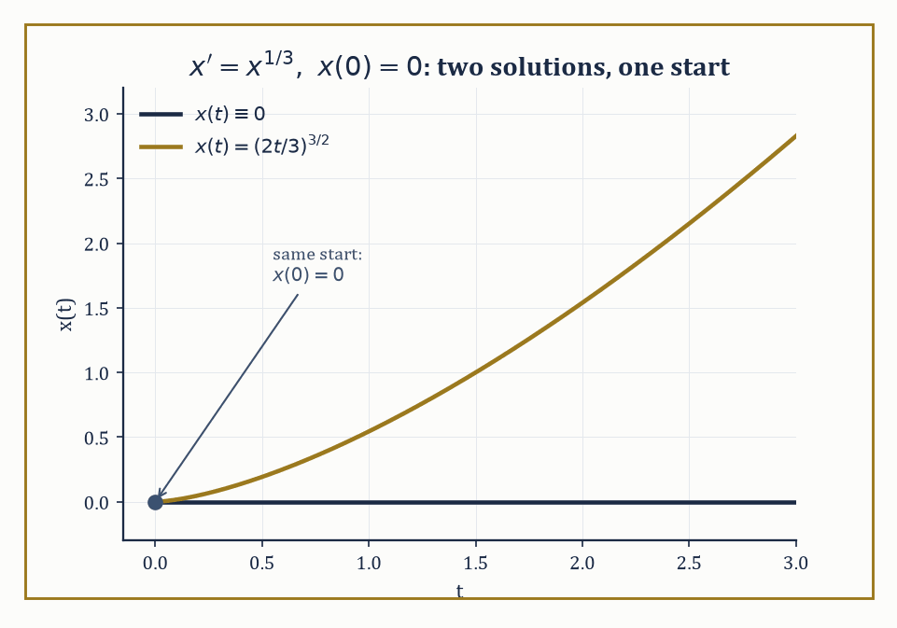
Figure 26.1 — Two different solutions of x′ = x^(1/3) leaving the same starting point — Lipschitz continuity is the guard rail that was missing.
x′ = f(t, x)
It is time to be more careful. The correct statement, the Picard–Lindelöf theorem, requires f to be Lipschitz in x: there must be a constant L such that the inequality below holds for all nearby x and y.
|f(t, x) − f(t, y)| ≤ L|x − y|
Under that hypothesis, a unique solution exists locally, produced by Picard iteration, which this section builds, now guaranteed to converge because the Lipschitz constant stops nearby approximations from drifting apart too fast. Drop the Lipschitz condition down to mere continuity of f, and Peano’s theorem still guarantees a solution exists — but no longer promises it is the only one. Continuity gets you a path through the woods; Lipschitz continuity gets you a path with guard rails.
Numeric example — a fork in the road. Consider the initial-value problem below.
x′(t) = x(t)^(1/3), x(0) = 0
One solution is the constant x(t) ≡ 0, since it satisfies the equation trivially.
0′ = 0 = 0^(1/3)
But try the following curve instead, for t ≥ 0.
x(t) = (2t/3)^(3/2)
Differentiating gives:
x′(t) = (3/2)·(2t/3)^(1/2)·(2/3) = (2t/3)^(1/2)
Meanwhile, raising x(t) itself to the power 1/3 gives the same expression.
x(t)^(1/3) = [(2t/3)^(3/2)]^(1/3) = (2t/3)^(1/2)
So this curve also satisfies the equation, and also starts at x(0) = 0. Two different solutions leave the same starting point. The culprit is that f(t, x) = x^(1/3) is not Lipschitz near x = 0: its x-derivative is (1/3)x^(−2/3), which blows up to infinity as x → 0, so nearby solutions are permitted to separate arbitrarily fast — and, as we have just seen, they take the opportunity.
Try it now — For y′ = y, y(0) = 1, compute the first two Picard iterates, starting from y₀(t) = 1. Answer →
For linear systems of the form below, where A(t) is an n×n matrix that may vary with t, the right generalization of ‘a basis of solutions’ is a fundamental matrix Φ(t).
x′(t) = A(t)x(t)
A fundamental matrix is an n×n matrix whose n columns are n linearly independent solution vectors, so that it satisfies the relation below.
Φ′(t) = A(t)Φ(t)
Its determinant W(t) = det Φ(t), the matrix analogue of the Wronskian, obeys the beautifully simple Abel–Liouville formula below.
W(t) = W(t₀)·exp(∫ₜ₀ᵗ tr A(s) ds)
The Wronskian’s whole evolution is governed only by the trace of A, never by the fine detail of the solutions themselves. In particular, if W(t₀) ≠ 0 at one point, it is nonzero everywhere the solution is defined — a fundamental matrix that starts out invertible stays invertible for good.
Numeric example — checking Abel’s formula. Let A = [0 1; −1 0] (constant). One checks by direct differentiation that the following matrix satisfies Φ′ = AΦ.
Φ(t) = [cos t sin t; −sin t cos t]
Differentiating gives:
Φ′(t) = [−sin t cos t; −cos t −sin t]
Meanwhile AΦ(t) has a first row that simplifies as follows.
[0·cos t + 1·(−sin t), 0·sin t + 1·cos t] = [−sin t, cos t]
And a second row that simplifies as follows.
[−1·cos t + 0·(−sin t), −1·sin t + 0·cos t] = [−cos t, −sin t]
An exact match. The Wronskian is therefore:
W(t) = cos²t + sin²t = 1
Abel’s formula predicts this without solving anything: the trace is tr A = 0 + 0 = 0, so
W(t) = W(0)·exp(∫₀ᵗ 0 ds) = 1·e⁰ = 1
The trace vanishing tells us, before we compute a single sine or cosine, that this fundamental matrix will never lose invertibility.
When A is constant, the fundamental matrix has a closed form: the matrix exponential eᴬᵗ, defined by the same power series as the ordinary exponential, but now with matrices.
eᴬᵗ = I + At + (At)²/2! + (At)³/3! + ⋯
When A is diagonalizable, A = PDP⁻¹ with D diagonal, this collapses to the formula below, where eᴰᵗ is the diagonal matrix of exp(λt) for each eigenvalue λ.
eᴬᵗ = P·eᴰᵗ·P⁻¹
This is an enormous shortcut, since it turns an infinite matrix series into ordinary scalar exponentials sandwiched between two fixed matrices.
Numeric example — building an exponential from eigenvectors. Let A = [1 1; 0 2]. Its eigenvalues, from the upper-triangular structure, are read straight off the diagonal.
λ₁ = 1, λ₂ = 2
For λ₁ = 1, the eigenvector equation (A − I)v = 0 gives the system below, so v₂ = 0 and we may take v = (1, 0).
[0 1; 0 1]v = 0
For λ₂ = 2, the eigenvector equation (A − 2I)v = 0 gives the system below, so v₁ = v₂, and we may take v = (1, 1).
[−1 1; 0 0]v = 0
Hence P = [1 1; 0 1] and, by inspection or by the 2×2 inverse formula, P⁻¹ = [1 −1; 0 1]. Then the matrix exponential is computed as follows.
eᴬᵗ = P·diag(eᵗ, e²ᵗ)·P⁻¹ = [1 1; 0 1]·[eᵗ 0; 0 e²ᵗ]·[1 −1; 0 1] = [1 1; 0 1]·[eᵗ −eᵗ; 0 e²ᵗ] = [eᵗ e²ᵗ − eᵗ; 0 e²ᵗ]
A sanity check: differentiating this matrix entrywise gives the matrix below.
d/dt eᴬᵗ = [eᵗ 2e²ᵗ − eᵗ; 0 2e²ᵗ]
And multiplying A by our answer gives, in the first row, the following.
[1·eᵗ + 1·0, 1·(e²ᵗ−eᵗ) + 1·e²ᵗ] = [eᵗ, 2e²ᵗ−eᵗ]
The derivative and A·eᴬᵗ agree exactly, as the defining property demands.
Floquet theory handles the case where A(t) is periodic, A(t + T) = A(t), rather than constant — the setting of, say, a pendulum whose length is mechanically pumped up and down once a second. The key object is the monodromy matrix, defined below, which tells you how the state has transformed after exactly one period.
M = Φ(T)Φ(0)⁻¹
Its eigenvalues, the Floquet multipliers, play the role that eigenvalues of eᴬᵀ play for constant systems: a multiplier of modulus less than 1 means that mode shrinks over one period, greater than 1 means it grows, and stability of the periodic system is decided by whether every multiplier lies strictly inside the unit circle.
Numeric example — stability by alternation. Consider a system that spends the first half of each period governed by A₁ = diag(1, −2) and the second half by A₂ = diag(−2, 1), so the full period is T = 2 (one unit of A₁, one of A₂). Because both matrices are diagonal, they commute with themselves trivially and the monodromy matrix is computed as follows.
M = exp(A₂)·exp(A₁) = diag(e⁻², e¹)·diag(e¹, e⁻²) = diag(e⁻²·e¹, e¹·e⁻²) = diag(e⁻¹, e⁻¹)
Both Floquet multipliers equal e⁻¹ ≈ 0.368, comfortably inside the unit circle — the periodic system is asymptotically stable. Notice the small paradox: A₁ alone has a growing direction (eigenvalue +1), and A₂ alone has a growing direction (eigenvalue +1) too — freeze the clock during either half-period and you would see one coordinate blowing up. But no coordinate gets to grow for a whole period; each direction spends half its time under the matrix that shrinks it, and the alternation nets out to overall decay. Averaging over time can rescue what a single snapshot would condemn.
The moral of this section, and the reason it earns its place before the harder material to come, is a shift in emphasis: from ‘write down the closed-form solution’ to ‘extract the structural fact you actually need — stability, boundedness, oscillation — directly from the equation, without ever solving it.’ Closed forms are lovely when they exist. They increasingly do not. Everything that follows is what mathematicians do instead.
Keep only this · Section 26.1: Ordinary Differential Equations Revisited
The idea. An initial-value problem with a Lipschitz right-hand side has exactly one solution. Linear systems are solved by a fundamental matrix, and for constant coefficients by the matrix exponential.
Core.
y′ = f(t, y), y(t₀) = y₀
Abel: det Φ(t) = det Φ(t₀)·exp(∫ tr A dt)
constant A: y(t) = exp(tA)y₀
Typical mistake. Assuming every initial-value problem has one solution. y′ = 3y^(2/3), y(0) = 0 is solved by y = 0 and by y = t³, because the right-hand side is not Lipschitz at 0.
Minimal example. y′ = ay: the solution y₀exp(at) is the 1 × 1 matrix exponential.
Practice. Easy to challenge; full worked answers, with the usual mistake, are in Answers to the Practice Sets at the back.
Easy — Solve y′ = −2y, y(0) = 5, and find y(1). Answer →
Medium — For y″ + 3y′ + 2y = 0, use Abel’s formula to find the Wronskian of two solutions, and check it with e⁻ᵗ and e⁻²ᵗ. Answer →
Challenge — Compute exp(tA) for A = [0 1; 0 0] and solve y′ = Ay, y(0) = (1, 2). Answer →

Section 26.2: Systems, Stability, and Lyapunov Functions
Energy, Judged Without Being Measured
For an autonomous system x′ = f(x), a point x* with f(x*) = 0 is an equilibrium — a place where, once you land there, you stay forever.
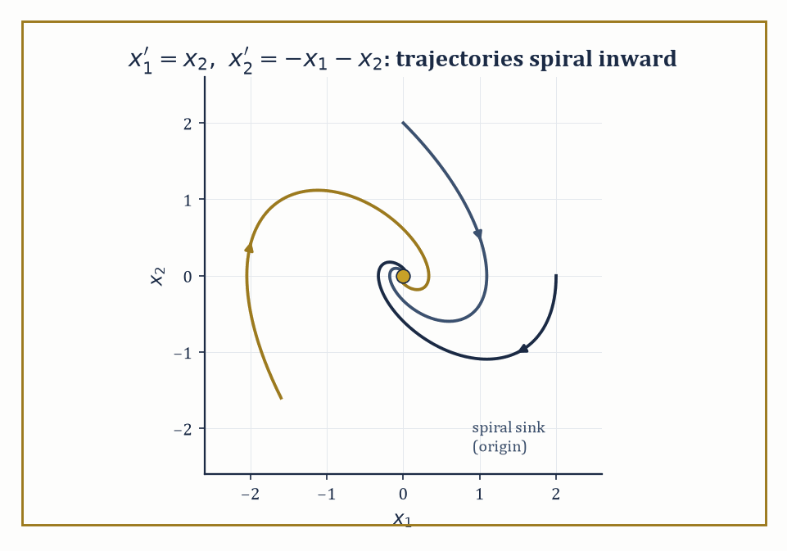
Figure 26.2 — Three trajectories of the damped spring system spiral into the origin — complex eigenvalues with negative real part, drawn rather than merely asserted.
It is stable if solutions that start near x* remain near x* for all future time — formally, for every ε > 0 there is a δ > 0 such that the condition below holds for all t ≥ 0.
|x(0) − x*| < δ ⟹ |x(t) − x*| < ε
It is asymptotically stable if, in addition, nearby solutions converge to x* as t → ∞; and unstable if neither holds — some nearby solutions wander off no matter how close you start.
The standard first move is linearization: replace f near x* by its Jacobian matrix Df(x*), obtaining a constant-coefficient linear system whose behavior we settled in Ordinary Differential Equations Revisited. If no eigenvalue of Df(x*) has zero real part — the hyperbolic case — the Hartman–Grobman theorem assures us the linearization’s stability verdict is also the true nonlinear verdict, at least locally.
Numeric example — a spiral sink by eigenvalues. Take the system below (a unit mass on a spring with unit damping), with equilibrium at the origin.
x₁′ = x₂, x₂′ = −x₁ − x₂
Since the system is already linear, its Jacobian everywhere is the constant matrix below.
A = [0 1; −1 −1]
The characteristic equation is det(A − λI) = 0, which works out as follows.
(−λ)(−1−λ) − (1)(−1) = λ + λ² + 1 = 0, i.e. λ² + λ + 1 = 0
The discriminant is 1 − 4 = −3, so the roots are:
λ = (−1 ± i√3)/2 ≈ −0.5 ± 0.866i
Both eigenvalues have real part −1/2, strictly negative and nonzero, so the origin is hyperbolic and asymptotically stable — trajectories spiral inward, tracing decaying loops rather than heading straight for the origin, because the eigenvalues are complex rather than real.
Try it now — Classify the origin for x′ = −x + y, y′ = −x − y. Answer →
Linearization is silent whenever an eigenvalue sits on the imaginary axis — the non-hyperbolic case — and this is where Lyapunov’s direct method earns its keep. Choose a scalar function V(x), positive definite near x* (meaning V(x*) = 0 and V(x) > 0 elsewhere nearby), and compute its rate of change along trajectories using the chain rule, but without ever solving the differential equation.
V̇(x) = ∇V(x)·f(x)
If V̇ ≤ 0 near x*, the equilibrium is stable — V acts as a generalized energy that never increases, trapping trajectories in shrinking level sets of V. If V̇ < 0 for all x ≠ x* nearby, the equilibrium is asymptotically stable. The method converts an analytic problem (solve the ODE) into an algebraic one (find a suitable V) — often far easier, and it works in the cases where linearization gives up.
Numeric example — succeeding where linearization is mute. Consider x′ = −x³, equilibrium at 0. Linearizing gives:
f′(x) = −3x², so f′(0) = 0
That’s a zero eigenvalue, the non-hyperbolic case, and Hartman–Grobman has nothing to say. Instead take V(x) = x²/2, which is positive definite (V(0) = 0, V(x) > 0 for x ≠ 0). Then:
V̇(x) = V′(x)·x′ = x·(−x³) = −x⁴
This is strictly negative for every x ≠ 0. Hence the origin is asymptotically stable — a fact linearization could not detect, but which one line of algebra with V confirms outright. Notice, incidentally, how slow that convergence is (x⁴ decay near zero rather than the exponential decay of a hyperbolic sink) — Lyapunov’s method certifies stability without being obliged to tell you the rate.
Sometimes the best V you can find only manages V̇ ≤ 0, not strictly negative — the pendulum’s energy is the standard example, since energy is conserved just where friction vanishes.
LaSalle’s invariance principle rescues the situation: trajectories still converge, not necessarily to x* itself, but to the largest invariant set contained inside {x : V̇(x) = 0}. If that set turns out to contain nothing but the equilibrium, asymptotic stability follows after all — just via a slightly longer argument.
Abstract example — the damped pendulum, rescued by LaSalle. Write the damped pendulum equation below as a first-order system.
θ″ + θ′ + sin θ = 0 ⟹ θ′ = ω, ω′ = −ω − sin θ
Take the mechanical energy V(θ, ω) = ω²/2 + (1 − cos θ), which is positive definite near (0, 0). Then:
V̇ = ω·ω′ + sin θ·θ′ = ω(−ω − sin θ) + sin θ·ω = −ω² − ω sin θ + ω sin θ = −ω²
This is only ≤ 0, not < 0 — it vanishes on the whole line ω = 0, not just at the origin, because a pendulum that has swung all the way to θ = π with zero velocity is instantaneously not losing energy either.
LaSalle asks: within the set {ω = 0}, which points can a trajectory stay at forever? If ω ≡ 0 along a trajectory then ω′ ≡ 0 too, and the equation ω′ = −ω − sin θ forces sin θ = 0, so θ = 0, π, 2π, … Restricting attention to a neighborhood of the origin, the only such point is θ = 0.
So the largest invariant subset of {V̇ = 0} near the origin is the equilibrium itself, and LaSalle upgrades ‘energy is non-increasing’ to ‘the pendulum, however gently it is losing energy at any given instant, is asymptotically stable at rest.’
Linearization, Lyapunov functions, and LaSalle’s principle together form the standard toolkit of nonlinear stability theory, and they underwrite the qualitative analysis of essentially every model in mechanics, population biology, chemical kinetics, and control engineering where an explicit solution formula is either unavailable or not the point.
Where this returns
Lyapunov functions and LaSalle’s principle come back as tools of design in Control Theory (Volume 4) and as tools of analysis in Dynamical Systems & Chaos (Volume 4), where the damped pendulum of this section reappears.
Keep only this · Section 26.2: Systems, Stability, and Lyapunov Functions
The idea. Linearization classifies a hyperbolic equilibrium by its eigenvalues. When it is silent, a Lyapunov function that decreases along trajectories proves stability, and LaSalle’s principle sharpens V̇ ≤ 0 to convergence.
Core.
asymptotically stable if every eigenvalue has Re λ < 0
V > 0 away from 0 and V̇ = ∇V · f ≤ 0 ⇒ stable
V̇ < 0 away from 0 ⇒ asymptotically stable
Typical mistake. Reading a zero eigenvalue as instability. x′ = −x³ linearizes to x′ = 0, yet the origin is asymptotically stable.
Minimal example. x′ = −x with V = x²: V̇ = −2x² < 0.
Practice. Easy to challenge; full worked answers, with the usual mistake, are in Answers to the Practice Sets at the back.
Easy — Find the eigenvalues of [−2 0; 0 −5] and classify the origin. Answer →
Medium — Show that V = x² + y² is a Lyapunov function for x′ = −x³, y′ = −y. Answer →
Challenge — For the damped pendulum θ′ = ω, ω′ = −sin θ − ω, compute V̇ for V = ½ω² + 1 − cos θ, and explain why LaSalle’s principle is needed. Answer →

Section 26.3: Boundary-Value Problems and Sturm–Liouville Theory
Conditions at Both Ends, and the Infinite Orthogonal Choir Between Them
An initial-value problem hands you all its conditions at one instant and asks you to march forward; a boundary-value problem (BVP) instead prescribes conditions at two or more separate points — commonly the two ends of an interval — and offers no ‘march forward from here’ starting gun at all.
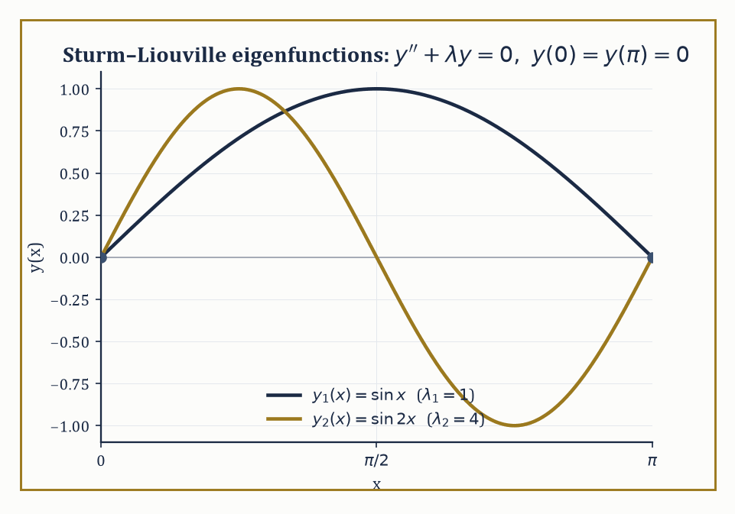
Figure 26.3 — The first two eigenfunctions sin x and sin 2x, pinned to zero at both ends and — as the worked example checks by hand — orthogonal on [0, π].
This changes the existence picture completely: a BVP can have no solution, exactly one solution, or infinitely many, depending on subtle interactions between the equation and the boundary conditions that an IVP never has to negotiate.
Numeric example — a straightforward boundary-value problem. Solve the boundary-value problem below.
x″(t) = −1, x(0) = 0, x(1) = 0
Integrating twice gives:
x(t) = −t²/2 + Ct + D
The condition x(0) = 0 gives D = 0 immediately. The condition x(1) = 0 gives −1/2 + C = 0, so C = 1/2. Hence:
x(t) = t/2 − t²/2 = t(1 − t)/2
Check: x′(t) = 1/2 − t, so x″(t) = −1, as required, and x(0) = 0, x(1) = 1·0/2 = 0. Unlike an IVP, both conditions had to be satisfied simultaneously by the two free constants — here it worked out to a unique solution, but a different right-hand side or different boundary values could easily have produced no solution at all, or (as the next paragraph shows) infinitely many.
Try it now — Solve y″ = 0 with y(0) = 1, y(1) = 3. Answer →
A Sturm–Liouville problem is a linear second-order boundary-value problem of the special self-adjoint form below, together with separated boundary conditions at each end, where p, q, w are given functions (w > 0 is a weight) and λ is an unknown parameter — an eigenvalue.
−(p(x)y′)′ + q(x)y = λw(x)y
Remarkably, under mild conditions on p, q, w, this equation has solutions only for a discrete increasing sequence of eigenvalues λ₁ < λ₂ < λ₃ < ⋯ → ∞, each with an essentially unique eigenfunction, and — the payoff — the eigenfunctions form an orthogonal basis of the space L²_w of square-integrable functions weighted by w. Any reasonable function can be expanded in this basis, as a periodic function is expanded in sines and cosines.
Numeric example — the simplest Sturm–Liouville problem, and orthogonality by hand. Take p = 1, q = 0, w = 1: the equation is below, with y(0) = 0, y(π) = 0.
y″ + λy = 0
Trying y = sin(√λ x) and enforcing y(π) = 0 forces √λ = n for a positive integer n, giving eigenvalues and eigenfunctions:
λₙ = n², yₙ(x) = sin(nx)
Let’s verify orthogonality directly for n = 1 and n = 2, using the product-to-sum identity sin A sin B = ½[cos(A−B) − cos(A+B)].
∫[0, π] sin(x) sin(2x) dx = ½∫[0, π] [cos(x) − cos(3x)] dx = ½[sin(x) − sin(3x)/3]₀^π = ½[(sin π − sin 3π/3) − (sin 0 − sin 0/3)] = ½[(0 − 0) − (0 − 0)] = 0
The two eigenfunctions are orthogonal on [0, π], as Sturm–Liouville theory promises for any two eigenfunctions belonging to different eigenvalues — no coincidence, a theorem.
Because the eigenfunctions form a basis, any function f on the interval can be written as an infinite sum, below, with the coefficients cₙ extracted by the same projection trick that produces ordinary Fourier coefficients — multiply by yₙ, integrate, and divide by the norm, using orthogonality to kill every other term in the sum.
f(x) = Σ cₙ yₙ(x)
This single machine both solves the homogeneous eigenvalue problem and, via variation of parameters term by term, solves the inhomogeneous problem −(py′)′ + qy = f for an arbitrary forcing f. The classical Fourier series, and the Legendre and Bessel expansions met in earlier chapters’ applied excursions, are Sturm–Liouville expansions for particular choices of p, q, w.
Numeric example — the first Fourier sine coefficient of a sawtooth. Expand f(x) = x on [0, π] in the basis yₙ(x) = sin(nx) from the previous example. The coefficient formula is:
bₙ = (2/π)∫[0, π] x sin(nx) dx
For n = 1, integrate by parts with u = x, dv = sin x dx, so du = dx, v = −cos x.
∫[0, π] x sin x dx = [−x cos x]₀^π + ∫[0, π] cos x dx = (−π cos π − 0) + [sin x]₀^π = (−π·(−1)) + (0 − 0) = π
So b₁ = (2/π)·π = 2, and the leading term of the sine-series for the sawtooth f(x) = x is 2 sin x — already a recognizable, if crude, approximation to a straight line using nothing but a single sine wave.
Beyond explicit expansion, Sturm–Liouville theory supplies purely qualitative tools: oscillation theorems (the n-th eigenfunction has exactly n − 1 interior zeros — you can count the wiggles without solving anything), and comparison theorems (a ‘stiffer’ equation has larger eigenvalues than a ‘softer’ one).
It also supplies the variational, or Rayleigh-quotient, characterization of the lowest eigenvalue, defined as a minimum over admissible trial functions y of the ratio below.
λ₁ = min[y] R[y], where R[y] = [∫ p(y′)² + qy² dx] / [∫ w y² dx]
Because this is a minimum over all admissible y, plugging in any single trial function — even a bad guess — produces a guaranteed upper bound on λ₁, with no solving required.
Numeric example — bounding an eigenvalue without solving the equation. For y″ + λy = 0 on [0, π] with y(0) = y(π) = 0 (p = 1, q = 0, w = 1), we already know the exact answer λ₁ = 1. Pretend we didn’t, and try the crude parabolic trial function below, which satisfies the boundary conditions precisely (it vanishes at both ends).
y = x(π − x) = πx − x²
Then y′ = π − 2x, so the numerator of the Rayleigh quotient works out as follows.
∫[0, π] (y′)² dx = ∫[0, π] (π − 2x)² dx = ∫[0, π] (π² − 4πx + 4x²) dx = π²·π − 4π·(π²/2) + 4·(π³/3) = π³ − 2π³ + (4/3)π³ = π³/3
And the denominator works out as follows.
∫[0, π] y² dx = ∫[0, π] (πx − x²)² dx = ∫[0, π] (π²x² − 2πx³ + x⁴) dx = π²·(π³/3) − 2π·(π⁴/4) + π⁵/5 = π⁵/3 − π⁵/2 + π⁵/5 = (10π⁵ − 15π⁵ + 6π⁵)/30 = π⁵/30
So the Rayleigh quotient is:
R[y] = (π³/3) / (π⁵/30) = 10/π² ≈ 10/9.8696 ≈ 1.0132
The true eigenvalue is λ₁ = 1, and our lazy parabola — chosen solely because it has the right boundary behavior, with no other cleverness — already bounds it from above by 1.0132. That’s the variational method’s whole appeal: even a bad guess is an honest, checkable bound.
This one-dimensional theory is the prototype for something much larger: the spectral theory of self-adjoint operators, which will reappear, considerably dressed up, when the unknown depends on several variables in the next chapter, and again — dressed up further still — in the functional-analytic framework that unifies differential and integral operators as instances of the same abstract object.
Where this returns
Sturm–Liouville expansions solve the heat and wave equations in Separation of Variables and Eigenfunction Expansions, and their general form is the spectral theorem of Spectral Theory of Compact Self-Adjoint Operators.
Keep only this · Section 26.3: Boundary-Value Problems and Sturm–Liouville Theory
The idea. Conditions at two ends can give no solution, one, or infinitely many. Sturm–Liouville problems have real eigenvalues and eigenfunctions that are orthogonal with weight w and expand general functions.
Core.
(p y′)′ + q y + λ w y = 0
∫ yₘ yₙ w dx = 0 (m ≠ n)
Rayleigh: λ₁ ≤ ∫(p u′² − q u²) dx / ∫ w u² dx
Typical mistake. Treating a boundary-value problem like an initial-value problem. y″ + y = 0, y(0) = 0, y(π) = 1 has no solution: every solution with y(0) = 0 is c sin x, which vanishes at π.
Minimal example. y″ + λy = 0 on [0, π], y(0) = y(π) = 0: λₙ = n², yₙ = sin nx.
Practice. Easy to challenge; full worked answers, with the usual mistake, are in Answers to the Practice Sets at the back.
Easy — Check that sin x and sin 2x are orthogonal on [0, π]. Answer →
Medium — Find the eigenvalues and eigenfunctions of y″ + λy = 0 on [0, L] with y(0) = y(L) = 0. Answer →
Challenge — Put u = x(1 − x) into the Rayleigh quotient for y″ + λy = 0 on [0, 1] with y(0) = y(1) = 0, and compare with λ₁ = π². Answer →

Section 26.4: Green’s Functions for ODEs
Delta Functions, Jump Conditions, and the Ghost of a Point Force
Given a linear differential operator L with a set of boundary conditions, the Green’s function G(x, ξ) is the response of the system, at position x, to an idealized unit point-source concentrated at position ξ — physically, it is what you’d measure at x if you poked the system with a sharp unit impulse at ξ and nowhere else.
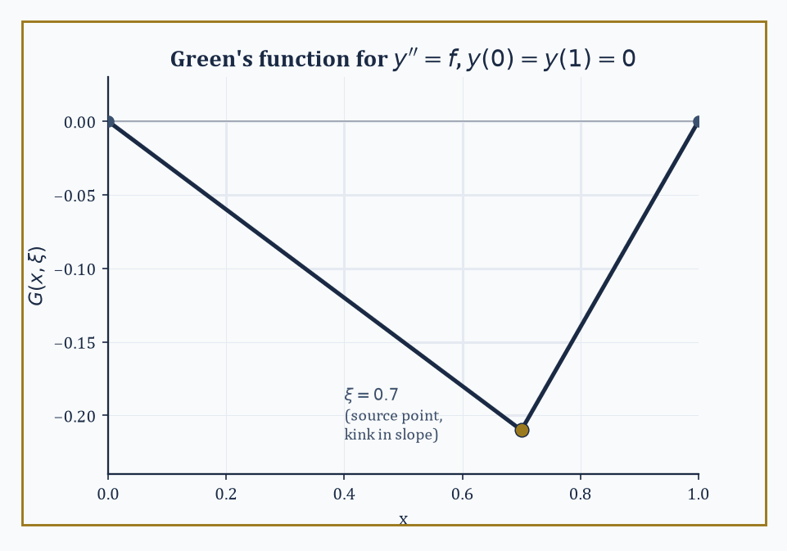
Figure 26.4 — The Green’s function for y″ = f on [0, 1]: continuous everywhere, but with a single polite kink in its slope at the source point ξ.
Once G is known, the solution to the full inhomogeneous problem Ly = f, with the same boundary conditions, is obtained by superposition — literally by integrating the point-response against the actual distributed source.
y(x) = ∫ G(x, ξ) f(ξ) dξ
This is the continuous analogue of solving Ax = b for a matrix A by first inverting A: G is, in a precise sense, the inverse of L.
Numeric example — constructing and testing a Green’s function. Solve Ly = y″ = f(x) on [0, 1] with y(0) = y(1) = 0.
Construction: on the left of the source point ξ, we need a homogeneous solution (y″ = 0, i.e. a straight line) satisfying the left boundary condition y(0) = 0 — take y = x, scaled by a constant depending on ξ. On the right of ξ, we need a homogeneous solution satisfying the right boundary condition y(1) = 0 — take y = x − 1, likewise rescaled.
Matching continuity of G at x = ξ and imposing the jump condition that a unit point-source in a second-order equation forces a unit jump in the first derivative there (since integrating y″ = δ(x − ξ) across the point gives exactly that), one finds:
G(x, ξ) = x(ξ − 1) for 0 ≤ x ≤ ξ, and G(x, ξ) = ξ(x − 1) for ξ ≤ x ≤ 1
Check the jump: for x < ξ, ∂G/∂x = ξ − 1; for x > ξ, ∂G/∂x = ξ; the jump at x = ξ is ξ − (ξ − 1) = 1, as required. Check continuity at x = ξ: both branches give ξ(ξ − 1). Check the boundary values: G(0, ξ) = 0, and G(1, ξ) = ξ(1 − 1) = 0.
Now test the whole machine against a case we can also solve directly: take f(x) = 1. Direct solution of y″ = 1, y(0) = y(1) = 0 gives:
y(x) = x²/2 + Cx, and y(1) = 0 forces C = −1/2, so y(x) = x²/2 − x/2 = x(x − 1)/2
Via the Green’s function instead:
y(x) = ∫₀ˣ ξ(x−1) dξ + ∫ₓ¹ x(ξ−1) dξ = (x−1)·(x²/2) + x·[(1/2 − 1) − (x²/2 − x)] = (x³/2 − x²/2) + (−x/2 − x³/2 + x²) = x²/2 − x/2 = x(x−1)/2
This precisely matches the direct solution. The Green’s function machinery, built once and for all without knowing f in advance, reproduces the answer for this particular f without further work.
Try it now — For y″ = f on [0, 1] with y(0) = y(1) = 0, G(x, ξ) = x(ξ − 1) for x ≤ ξ and ξ(x − 1) for x ≥ ξ. Evaluate G(0.5, 0.5). Answer →
The general recipe scales up in the obvious way: solve the homogeneous equation separately on each side of the source point ξ, impose all the boundary conditions on the appropriate side, glue the two pieces together with continuity in G itself and in all but its highest derivative, and finish with a single jump condition on the highest derivative — the size of the jump being fixed by the leading coefficient of the operator at ξ.
The same construction extends to operators of any order, and to systems of equations, with more derivatives required to be continuous and only the very last one permitted to jump. It is, in short, one polite kink allowed per Green’s function, and the bureaucracy of which derivative gets to misbehave is entirely determined in advance.
Abstract example — the pattern for a higher-order operator. For a general n-th order linear operator L = aₙ(x)·dⁿ/dxⁿ + ⋯ + a₀(x), the Green’s function G, G′, …, G⁽ⁿ⁻²⁾ must all be continuous across x = ξ, while the (n−1)-th derivative jumps by exactly 1/aₙ(ξ).
[G⁽ⁿ⁻¹⁾]_(ξ⁻)^(ξ⁺) = 1/aₙ(ξ)
The second-order example above is the case n = 2: no lower derivatives are required to be continuous besides G itself (that’s the n − 2 = 0 case, meaning only G is forced continuous), and the single jump falls on G′ = G⁽ⁿ⁻¹⁾, with a₂(ξ) = 1 giving a jump of exactly 1 — matching what we computed by hand.
A fourth-order beam equation (n = 4, governing the deflection of a loaded beam) would instead require G, G′, and G″ continuous, with the jump appearing three derivatives down, in G‴ — the same skeleton, just one level taller.
One structural feature is worth flagging before we move on: for a self-adjoint operator (the kind Sturm–Liouville theory specializes in), the Green’s function is symmetric.
G(x, ξ) = G(ξ, x)
The response measured at x to a poke at ξ is identical to the response measured at ξ to a poke at x, a mathematical statement of the physical principle of reciprocity (push here, measure there; the reading is the same as if you’d pushed there and measured here).
Numeric example — reciprocity, checked with actual numbers. Using the Green’s function constructed above, G(x, ξ) = x(ξ − 1) for x ≤ ξ and G(x, ξ) = ξ(x − 1) for x ≥ ξ, take the concrete pair x = 0.3, ξ = 0.7. Since 0.3 ≤ 0.7, we use the first branch.
G(0.3, 0.7) = 0.3·(0.7 − 1) = 0.3·(−0.3) = −0.09
Now evaluate G(0.7, 0.3) — swap the roles, so the first argument is 0.7 and the second is 0.3. Since 0.7 ≥ 0.3, we use the second branch with x = 0.7, ξ = 0.3.
G(0.7, 0.3) = 0.3·(0.7 − 1) = 0.3·(−0.3) = −0.09
The two values agree precisely, confirming G(0.3, 0.7) = G(0.7, 0.3) for this particular pair — and the same cancellation happens for any pair, since both branches reduce to the product (smaller argument)·(larger argument − 1) once you sort out which is which.
Green’s functions are the hinge on which this entire chapter turns: they convert a boundary-value problem, phrased purely in terms of derivatives, into an integral equation, phrased purely in terms of an integral kernel — precisely the bridge that lets Volterra Integro-Differential Equations and Fredholm Integro-Differential Equations and Eigenvalue Problems treat integro-differential equations as, in disguise, differential equations that have already had their Green’s function applied.
Keep only this · Section 26.4: Green’s Functions for ODEs
The idea. The Green’s function is the response to a unit point source. The solution for any forcing is the superposition y(x) = ∫ G(x, ξ) f(ξ) dξ, and self-adjoint problems have symmetric G.
Core.
L G(·, ξ) = δ(x − ξ), with the boundary conditions
y(x) = ∫ G(x, ξ) f(ξ) dξ
jump of ∂G/∂x at x = ξ: 1/a₂(ξ) for a₂y″ + ⋯
Typical mistake. Forgetting the boundary conditions. G must satisfy them in x for every ξ, or the superposition will not.
Minimal example. y″ = 1 on [0, 1], y(0) = y(1) = 0: ∫ G(x, ξ) dξ = x(x − 1)/2.
Practice. Easy to challenge; full worked answers, with the usual mistake, are in Answers to the Practice Sets at the back.
Easy — Using that G, find y(0.5) for y″ = 1. Answer →
Medium — Check reciprocity: compute G(0.2, 0.6) and G(0.6, 0.2). Answer →
Challenge — Find the Green’s function of y″ = f on [0, 1] with y(0) = 0 and y′(1) = 0. Answer →

Section 26.5: What Integro-Differential Equations Are
Equations That Keep a Diary
Most of the equations met so far have no memory: the rate at which a cup of tea cools depends only on how hot it is now. Many real systems are not like that. A loan balance depends on every payment ever made, a population on births many years back, a stretched polymer on its whole history of stretching. Equations for such systems put a rate of change and a running total over the past, an integral, side by side. These are integro-differential equations. They can look forbidding, but the past enters in a structured way, as a weighted sum of earlier values, and the same patient step-by-step approximations used for ordinary equations still close in on the answer.
An integro-differential equation (IDE) involves both derivatives and integrals of the unknown function in the same equation. A typical form is given below.
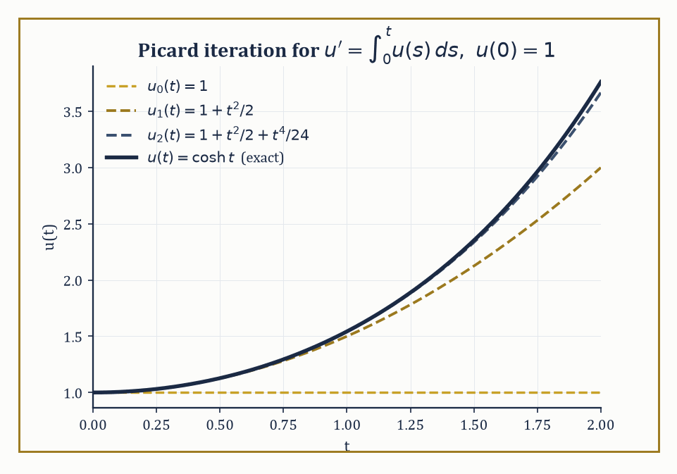
Figure 26.5 — Successive Picard iterates u₀, u₁, u₂ visibly closing in on the exact solution cosh t, one more term of its Taylor series at a time.
u′(t) = f(t, u(t)) + ∫₀ᵗ K(t, s, u(s)) ds
Begin with something your own legs already know. Go out for a run, and how fast you are slowing down has very little to do with how fast you are moving at this second. It has everything to do with how far you have already come. A runner twenty miles in and a runner three minutes in can be moving at precisely the same speed, side by side, and one of them is about to stop.
Hold that next to a cooling cup of tea. The tea loses heat at a rate settled entirely by how hot it is now. How it got hot is of no interest whatever — boiled kettle, microwave, left on a radiator all afternoon — and two cups at the same temperature have the same future, without exception. That is what made the first four sections of this chapter work. The present state was a complete summary of the past.
Your legs refuse to be summarized. Two runners at the same speed have different futures, so speed is not the whole story, and no amount of care in measuring it will make it so. The thing that distinguishes them is not in their current state at all. It is in everything that has already happened, and the tea had nothing of the kind.
So change the question. Not what is the rate of change, given the state right now, but what is the rate of change, given everything that has happened up to now?
That is harder than it sounds, and the difficulty is worth feeling. To answer it you must carry the entire past along with you. There is no single number standing in for the last twenty miles — no tiredness reading you could take that would let you throw the history away. You also cannot start the clock in the middle, because the middle means nothing without what came before it.
The repair looks like an admission of defeat. Alongside the rate of change, let the equation contain a running total of everything so far, and allow the rate to depend on that total. Here is the smallest interesting case, and the whole of it can be checked with a pencil. A quantity starts at 1, and at every instant its rate of growth equals the total it has accumulated since the start.
At the very beginning nothing has accumulated, so the growth rate is zero and the quantity sits at 1. But sitting at 1 accumulates, so the total creeps up, so the growth rate creeps up, so it climbs a little — and climbing makes it accumulate faster still. Follow that round a few times and the value at time 1 comes out as:
1, 3/2, 37/24, 1111/720, … = 1, 1.5, 1.541666…, 1.543055…
Each is the one before plus a smaller correction, and they are converging on 1.543080…
Notice what they never do. Not one of them is the answer. Every entry is a truncation, right by however many rounds you had the patience for and wrong after that, and the list would go on forever without ever landing. Yet the number it is walking toward is perfectly definite, and the section below names it: cosh 1.
That is an integro-differential equation — an equation in which the unknown appears both under a derivative and under an integral, so that the present rate answers to the accumulated past. The sign ∫₀ᵗ is a running total whose upper end is the word now.
The numeric example below solves this same problem exactly, reaching cosh t, and the figure shows these same partial sums closing in on it.
The rate of change at time t depends not only on the current state u(t), through f, but also on the entire trajectory of u from the start up to now, through the integral term. The kernel K encodes just how much each past moment s contributes to the present rate: it is the mathematical embodiment of memory. An ordinary differential equation is, in this light, the special (and rather amnesiac) case where K is identically zero — the present has no idea what the past got up to.
Nature, rather inconveniently for anyone who enjoyed the tidiness of an equation that sees only the present, is stuffed with genuine hereditary effects: a viscoelastic material’s stress depends on every strain it has ever experienced, not just its current one; a population’s birth rate depends on its whole past age structure, not just today’s headcount; a feedback controller with a sensor lag is, whether its designer intended it or not, solving a delay equation; and even classical electromagnetism, in certain formulations, has the field at a point depend on the source’s behavior at earlier retarded times.
Wherever the present depends on the accumulated past rather than merely on the instantaneous state, an ODE is the wrong tool and an IDE is the right one.
Numeric example — an equation that remembers everything. Consider the initial-value problem below: the instantaneous rate of change is governed entirely by the accumulated total of the function’s own past values.
u′(t) = ∫₀ᵗ u(s) ds, u(0) = 1
Set U(t) = ∫₀ᵗ u(s) ds, so the equation reads u′ = U, and differentiating the definition of U gives U′ = u. Differentiating the first relation again:
u″ = U′ = u
The integral has been traded for a second derivative, at the cost of needing a second condition: U(0) = ∫₀⁰ u(s) ds = 0, so u′(0) = U(0) = 0, alongside u(0) = 1. The equation u″ = u with u(0) = 1, u′(0) = 0 has solution:
u(t) = cosh t = (eᵗ + e⁻ᵗ)/2
Check directly against the original equation: u′(t) = sinh t, and
∫₀ᵗ u(s) ds = ∫₀ᵗ cosh s ds = [sinh s]₀ᵗ = sinh t
They agree. Notice how apt the example is: cosh t grows because it has been quietly integrating its own entire history since the beginning of time — an equation that, true to the memory theme of this chapter, never forgets a thing it has done.
Try it now — Differentiate u′(t) = ∫₀ᵗ u(s) ds, u(0) = 1, once. What ordinary equation do you get, and what is u? Answer →
Existence and uniqueness for IDEs adapt the Picard contraction argument from Ordinary Differential Equations Revisited, but applied to the integral formulation of the entire equation (derivative and all) rather than to the bare right-hand side.
A pleasant surprise awaits: because integration is a smoothing operation — it can only make a function better-behaved, never worse — the presence of the memory term very often improves the regularity of the solution rather than threatening it, in marked contrast to the intuition that ‘more terms means more trouble.’
Numeric example — Picard iteration building a Taylor series by hand. Return to u′(t) = ∫₀ᵗ u(s) ds, u(0) = 1, in its integral form below.
u(t) = 1 + ∫₀ᵗ ∫[0, t′] u(s) ds dt′
Start the Picard iteration from the crudest possible guess, u₀(t) = 1. Then:
u₁(t) = 1 + ∫₀ᵗ [∫[0, t′] 1 ds] dt′ = 1 + ∫₀ᵗ t′ dt′ = 1 + t²/2
Feed this back in:
u₂(t) = 1 + ∫₀ᵗ [∫[0, t′] (1 + s²/2) ds] dt′ = 1 + ∫₀ᵗ [t′ + t′³/6] dt′ = 1 + t²/2 + t⁴/24
Compare with the Taylor series of the exact solution found above.
cosh t = Σₙ t²ⁿ/(2n)! = 1 + t²/2! + t⁴/4! + ⋯ = 1 + t²/2 + t⁴/24 + ⋯
u₂ already matches every term up to t⁴ exactly (2! = 2, 4! = 24). The Picard iteration is not just converging in some abstract sense; it is visibly, term by term, constructing the Taylor series of cosh t from nothing but repeated integration.
One tool from Chapter 18 (Volume 2) survives this generalization almost unscathed: whenever the kernel is of convolution type, K(t, s, u(s)) = K(t − s)·u(s), depending only on the elapsed time t − s rather than on t and s separately, the Laplace transform turns the convolution integral into an ordinary product of transforms — and the whole IDE collapses back into an algebraic equation, as it did for plain linear ODEs.
This rests on the convolution theorem: the Laplace transform of a convolution is the product of the two individual transforms.
L{(K ∗ u)(t)} = L{∫₀ᵗ K(t−s)u(s) ds} = K̂(s)·û(s)
This turns the messiest-looking operation in this chapter into the most ordinary one in algebra.
Numeric example — the convolution theorem, checked both ways. Let K(t) = e⁻ᵗ and u(t) = 1 (the constant function). Directly:
(K ∗ u)(t) = ∫₀ᵗ e⁻⁽ᵗ⁻ˢ⁾·1 ds
Substitute w = t − s (so dw = −ds, and the limits flip from s: 0→t to w: t→0, which the sign flip turns back into w: 0→t).
∫₀ᵗ e⁻ʷ dw = [−e⁻ʷ]₀ᵗ = (−e⁻ᵗ) − (−1) = 1 − e⁻ᵗ
So (K*u)(t) = 1 − e⁻ᵗ. Now via transforms: K̂(s) = 1/(s+1) and û(s) = 1/s, so the theorem predicts the transform of the convolution is:
K̂(s)û(s) = 1/[s(s+1)]
Partial fractions give the decomposition below (check: common denominator gives [(s+1) − s]/[s(s+1)] = 1/[s(s+1)], correct).
1/[s(s+1)] = 1/s − 1/(s+1)
The inverse transform of 1/s is 1, and of 1/(s+1) is e⁻ᵗ, so the inverse transform of the product is 1 − e⁻ᵗ — matching the direct computation. This is the entire justification for treating a convolution integral as ‘just another algebraic factor’ once Laplace-transformed, and it is what makes Section 26.6’s resolvent calculations work.
Keep only this · Section 26.5: What Integro-Differential Equations Are
The idea. An integro-differential equation lets the rate of change depend on an integral of the function — over the past (Volterra) or over a whole interval (Fredholm). Convolution kernels and the Laplace transform are the main tools.
Core.
u′(t) = f(t, u) + ∫₀ᵗ K(t − s) u(s) ds
(K * u)(t) = ∫₀ᵗ K(t − s) u(s) ds
ℒ{K * u} = ℒ{K} · ℒ{u}
Typical mistake. Thinking the memory term is negligible because it vanishes at t = 0. It shapes u′ at every later time.
Minimal example. u′ = ∫₀ᵗ u ds, u(0) = 1: u = cosh t.
Practice. Easy to challenge; full worked answers, with the usual mistake, are in Answers to the Practice Sets at the back.
Easy — Compute the convolution of K(t) = 1 with u(t) = t. Answer →
Medium — Use the convolution theorem to compute e⁻ᵗ * 1, and check it directly. Answer →
Challenge — Compute three Picard iterates for u(t) = 1 + ∫₀ᵗ (t − s) u(s) ds, starting from u₀ = 1, and identify the limit. Answer →

Section 26.6: Volterra Integro-Differential Equations
Causality, or: Why the Future Is Not Allowed to Vote
Same structure, new language
The convolution theorem of Laplace Transform (Volume 2) is doing all the work: a Volterra equation with a convolution kernel is a linear equation that the transform turns into division.
Some systems cannot be described by their present state alone: what happens next depends on everything that has already happened. A fatigued spring, a creaking floorboard, a population still carrying last season’s losses — each is steering by its own history, and none can be captured by a derivative and a starting value. A Volterra equation is the repair. Its integral runs from a fixed starting point up to the variable t itself — ∫₀ᵗ, rather than over a fixed interval. That variable upper limit is what makes it causal, or hereditary: the value of the integral at time t depends only on the values of u at times s ≤ t, never on the future.
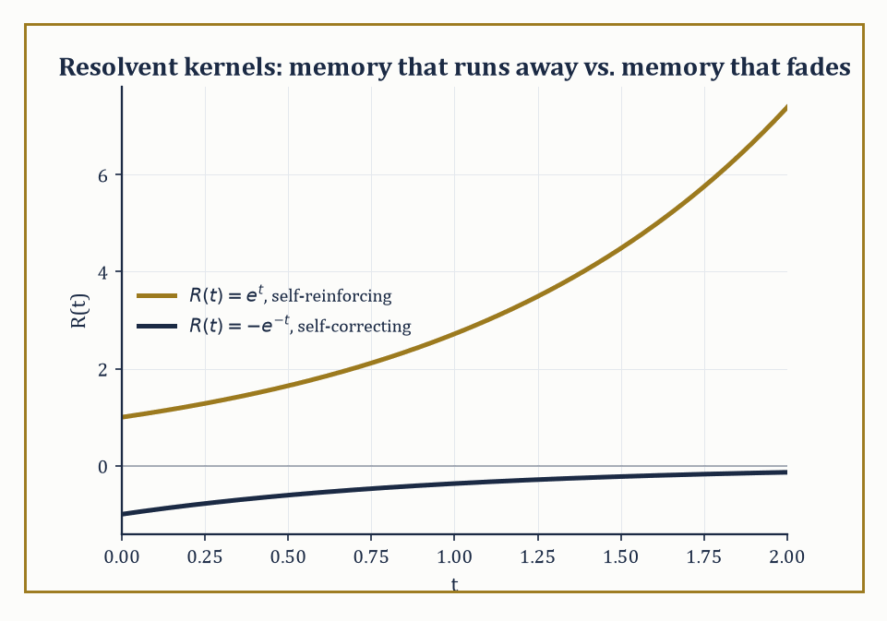
Figure 26.6 — Flip the sign of one kernel and the resolvent stops exploding and starts decaying — the algebraic fingerprint of self-reinforcing versus self-correcting memory.
Linear Volterra integro-differential equations can be recast as Volterra integral equations of the second kind by the same integration trick used in What Integro-Differential Equations Are.
u(t) = f(t) + ∫₀ᵗ K(t,s) u(s) ds
These can then be solved either by successive approximation, exactly as in Section 26.5’s Picard example, or — when the kernel is of convolution type — by the Laplace transform.
Numeric example — Laplace transform on a Volterra equation. Solve the equation below.
u′(t) = 1 + ∫₀ᵗ u(s) ds, u(0) = 0
Taking the Laplace transform of both sides (writing U(s) for the transform of u), and using that the transform of an integral from 0 to t divides by s:
sU(s) − u(0) = 1/s + U(s)/s
Since u(0) = 0, this is sU(s) − U(s)/s = 1/s. Multiplying through by s:
s²U(s) − U(s) = 1, so U(s) = 1/(s² − 1)
This is a standard transform pair: the inverse Laplace transform of 1/(s² − 1) is sinh t. So u(t) = sinh t.
Check directly: u(0) = sinh 0 = 0, correct. u′(t) = cosh t. And the right-hand side is:
1 + ∫₀ᵗ sinh s ds = 1 + [cosh s]₀ᵗ = 1 + (cosh t − 1) = cosh t
The two sides agree.
Try it now — Solve u′(t) = −∫₀ᵗ u(s) ds, u(0) = 1, with the Laplace transform. Answer →
Just as a constant-coefficient linear ODE has a fundamental matrix eᴬᵗ governing how any initial condition propagates, a linear Volterra equation has a resolvent kernel R(t, s), which satisfies its own integral equation (where ∗ denotes convolution) and plays the same organizing role.
R = K + K ∗ R
Once R is known, the solution for any forcing f is given by the variation-of-parameters-style formula below, valid for every choice of f without redoing the work.
u(t) = f(t) + ∫₀ᵗ R(t − s) f(s) ds
Numeric example — computing a resolvent kernel. For the equation below (constant kernel K ≡ 1), take Laplace transforms of the resolvent equation.
u(t) = f(t) + ∫₀ᵗ u(s) ds
The transform of the kernel is K̂(s) = 1/s, and the resolvent satisfies:
R̂(s) = K̂(s)/(1 − K̂(s)) = (1/s)/(1 − 1/s) = (1/s)/[(s−1)/s] = 1/(s − 1)
whose inverse transform is R(t) = eᵗ. Test it with f(t) = 1: the formula predicts:
u(t) = 1 + ∫₀ᵗ eᵗ⁻ˢ·1 ds = 1 + eᵗ∫₀ᵗ e⁻ˢ ds = 1 + eᵗ(1 − e⁻ᵗ) = 1 + eᵗ − 1 = eᵗ
Direct check: does u(t) = eᵗ satisfy u(t) = 1 + ∫₀ᵗ u(s) ds? The right-hand side is:
1 + ∫₀ᵗ eˢ ds = 1 + (eᵗ − 1) = eᵗ
It matches.
Whether the resolvent grows or decays over time is what determines whether the system’s memory is self-reinforcing (destabilizing) or self-correcting (stabilizing) — a distinction with no counterpart in ordinary differential equations, where there is no memory to reinforce or correct in the first place.
Numeric example — a self-correcting memory. Keep the same style of equation but flip the sign of the kernel.
u(t) = f(t) − ∫₀ᵗ u(s) ds
Now K̂(s) = −1/s, and:
R̂(s) = K̂(s)/(1 − K̂(s)) = (−1/s)/(1 + 1/s) = (−1/s)/[(s+1)/s] = −1/(s+1)
whose inverse transform is R(t) = −e⁻ᵗ. Where the previous example’s resolvent eᵗ exploded, this one decays to zero — the negative kernel means each past contribution is subtracted back off, a built-in corrective feedback rather than a runaway reinforcement, and the resolvent’s exponential decay is the algebraic fingerprint of that stability.
This machinery is not merely decorative: it is the standard language of viscoelasticity, where a material’s present stress depends on its entire strain history rather than on the current strain alone; of age-structured population models, where the birth rate today depends on an integral over the whole age distribution accumulated in the past; and of control systems with delayed feedback, where a controller’s present action is corrected by an integral of past tracking errors.
Three quite different disciplines, none of them willing to let the past go.
Worked example — viscoelastic stress relaxation. A simple linear viscoelastic model expresses stress as the integral below, where ε′(s) is the strain rate at past time s and E(t − s) is a relaxation modulus describing how much a strain increment from s time units ago still contributes to today’s stress.
σ(t) = ∫₀ᵗ E(t − s) ε′(s) ds
Take the common exponential relaxation modulus E(t − s) = E₀ exp(−(t−s)/τ) (a material that ‘forgets’ old strain on a timescale τ) under a constant strain rate ε′(s) = ε̇₀. Then:
σ(t) = E₀ε̇₀ ∫₀ᵗ exp(−(t−s)/τ) ds
Substituting w = t − s (so dw = −ds, and the limits flip from s: 0→t to w: t→0, which flips again on reversing the sign):
∫₀ᵗ exp(−(t−s)/τ) ds = ∫₀ᵗ exp(−w/τ) dw = τ(1 − exp(−t/τ))
So:
σ(t) = E₀ε̇₀τ(1 − exp(−t/τ))
As t → ∞, σ(t) → E₀ε̇₀τ, a finite steady-state stress, even though the strain itself is increasing without bound at constant rate ε̇₀ — the material’s fading memory (governed by τ) is just what keeps the stress from blowing up alongside the strain.
Keep only this · Section 26.6: Volterra Integro-Differential Equations
The idea. A Volterra equation integrates only over the past. Convolution kernels turn it into algebra under the Laplace transform, and the resolvent kernel solves it once for every forcing.
Core.
u(t) = f(t) + ∫₀ᵗ K(t − s) u(s) ds
U = F/(1 − K̂)
resolvent: R̂ = K̂/(1 − K̂), u = f + R * f
Typical mistake. Forgetting the initial value when transforming a derivative: ℒ{u′} = sU − u(0).
Minimal example. K ≡ 1, f ≡ 1: U = (1/s)/(1 − 1/s) = 1/(s − 1), so u = eᵗ.
Practice. Easy to challenge; full worked answers, with the usual mistake, are in Answers to the Practice Sets at the back.
Easy — Solve u(t) = t + ∫₀ᵗ u(s) ds. Answer →
Medium — Find the resolvent kernel for the constant kernel K(t) = 2. Answer →
Challenge — Solve u(t) = 1 − ∫₀ᵗ (t − s) u(s) ds, and say why the minus sign makes the solution oscillate. Answer →

Section 26.7: Fredholm Integro-Differential Equations and Eigenvalue Problems
No Causality Required: Every Point Consults Every Other Point at Once
A Fredholm equation, by contrast with a Volterra one, has fixed limits of integration — the entire interval, every time — and therefore no causal structure whatsoever: the kernel couples every point of the domain to every other point simultaneously, with no notion of ‘past’ or ‘future’ to keep them apart.
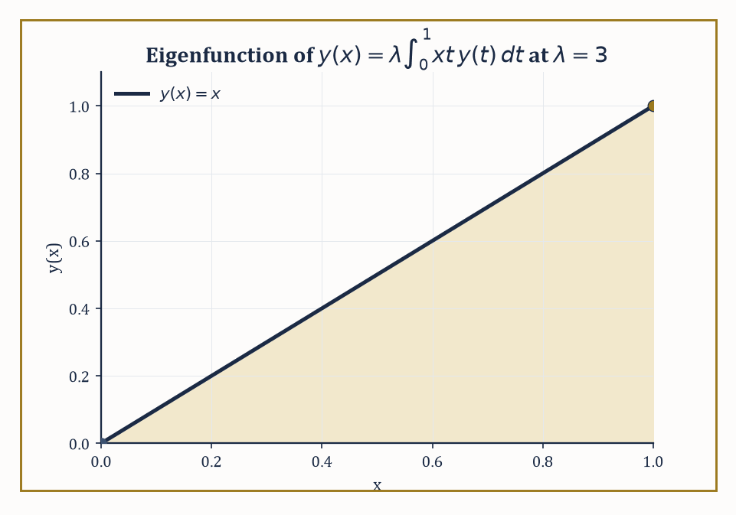
Figure 26.7 — The eigenfunction y(x) = x for the degenerate kernel K(x,t) = xt, found by hand and checked to satisfy the equation at λ = 3.
The Fredholm alternative governs solvability for a linear equation of the form below.
y − λ∫K(x,t)y(t)dt = f
Either the homogeneous version (f = 0) has only the trivial solution, in which case the inhomogeneous equation has a unique solution for every f, or the homogeneous version has nontrivial solutions, in which case the inhomogeneous equation is solvable only for those f that are orthogonal to every such solution — a dichotomy with no middle ground.
When the integral operator is compact (roughly: it smooths sharp features, as integration against a well-behaved kernel always does), its spectrum of eigenvalues is discrete, accumulating nowhere except possibly at zero — an infinite-dimensional operator behaving, spectrally, remarkably like a very large but ordinary matrix.
Numeric example — an eigenvalue by hand, degenerate kernel. Solve for eigenvalue λ and eigenfunction y in the equation below.
y(x) = λ∫₀¹ xt·y(t) dt
Because the kernel K(x, t) = xt factors as a function of x times a function of t (a ‘degenerate’ kernel), any solution must itself be of the form y(x) = cx for some constant c — the x dependence on the right-hand side is forced to be exactly x. Substitute y(t) = ct into the equation:
cx = λ∫₀¹ xt·(ct) dt = λcx∫₀¹ t² dt = λcx·(1/3)
Canceling x (valid for x ≠ 0) and c (assuming a nontrivial eigenfunction, c ≠ 0) leaves 1 = λ/3, so λ = 3. The eigenvalue is 3, with eigenfunction y(x) = x (up to an arbitrary overall scale, as always for eigenfunctions).
Check directly: with y(t) = t and λ = 3, the right-hand side is:
3∫₀¹ xt·t dt = 3x∫₀¹ t² dt = 3x·(1/3) = x = y(x)
It checks out precisely.
Try it now — Find λ for which y(x) = λ∫₀¹ x t y(t) dt has a nonzero solution. Answer →
Numeric example — the Fredholm alternative at resonance. Now perturb the previous eigenvalue problem into an inhomogeneous one, using λ = 3, the eigenvalue we just found.
y(x) − 3∫₀¹ xt·y(t) dt = g(x)
Try g(x) = x. Since the kernel is degenerate, any solution must have the form y(x) = x + 3x·c, where c = ∫₀¹ t·y(t) dt is a constant to be found self-consistently. Substituting:
c = ∫₀¹ t·(t + 3ct) dt = ∫₀¹ (t² + 3ct²) dt = (1 + 3c)·∫₀¹t²dt = (1+3c)/3 = 1/3 + c
This simplifies to c = 1/3 + c, i.e. 0 = 1/3 — a flat contradiction, so no solution exists for this g.
The Fredholm alternative explains why: at the eigenvalue λ = 3, the inhomogeneous equation is solvable only when g is orthogonal to the homogeneous eigenfunction y = x, meaning the condition below must hold.
∫₀¹ x·g(x) dx = 0
Here ∫₀¹ x·x dx = 1/3 ≠ 0, so the solvability condition fails, and our contradiction was the algebra dutifully reporting exactly that. This is the integral-equation cousin of mechanical resonance: forcing a system at its own natural frequency, with a forcing term that has a component along the resonant mode, produces no steady solution at all — only an amplitude that would need to grow without bound.
A Fredholm integro-differential eigenvalue problem combines a differential operator with a Fredholm integral operator in the same equation, with boundary conditions on y — for instance the equation below.
y″(x) = λ∫K(x,t)y(t)dt
Under the same compactness assumptions, the spectrum remains discrete, but an explicit formula for the eigenvalues is rarely available.
In practice one turns to numerical projection methods — collocation or Galerkin schemes — which represent the unknown eigenfunction approximately as a combination of a small, fixed set of basis functions, and in doing so reduce the entire infinite-dimensional eigenvalue problem to an ordinary matrix eigenvalue problem, solvable by the linear algebra of Chapters 20 and 21 (Volume 2).
Worked example — what the discretized problem looks like. Suppose a Galerkin projection of some Fredholm integro-differential operator onto just two basis functions produces the symmetric matrix below as its approximate representation (a stand-in for the far messier matrix a real discretization would produce, but structurally identical).
M = [2 1; 1 2]
Its trace is 4 and its determinant is 2·2 − 1·1 = 3, so the characteristic equation is:
λ² − 4λ + 3 = 0, factoring as (λ − 1)(λ − 3) = 0
The eigenvalues are 1 and 3.
For λ = 3:
(2−3)v₁ + v₂ = 0, i.e. v₂ = v₁, eigenvector (1, 1)
For λ = 1:
(2−1)v₁ + v₂ = 0, i.e. v₂ = −v₁, eigenvector (1, −1)
This two-line linear algebra computation is the kind of thing a Galerkin or collocation scheme reduces the original, genuinely infinite-dimensional eigenvalue problem to — swap ‘diagonalize a 2×2 matrix by hand’ for ‘diagonalize a 500×500 matrix on a computer in a fraction of a second,’ and you have the entire numerical strategy in miniature.
Such combined differential-and-integral eigenvalue problems arise in the theory of loaded strings (where an integral term represents an added mass distribution, rather than the string’s own uniform density), in certain formulations of neutron transport (where the integral represents scattering between all directions at once, not just neighboring ones), and in non-local continuum mechanics (where stress at a point depends on strain throughout a whole surrounding region, not merely at that point).
A useful rule of thumb, inherited directly from the Rayleigh-quotient monotonicity of Boundary-Value Problems and Sturm–Liouville Theory: adding a load — extra mass, or an extra non-local coupling — can only push the fundamental eigenvalue down, never up.
An unloaded string of length 1 satisfying y″ + λy = 0 with y(0) = y(1) = 0 has fundamental eigenvalue below (the n = 1 case of λₙ = (nπ)² on a unit interval).
λ₁ = π² ≈ 9.87
Loading it with any genuine Fredholm integral term is guaranteed, by that same variational principle, to produce a new fundamental eigenvalue strictly below 9.87 — the load makes the string want to vibrate more slowly, and the mathematics knew that before a single new number was computed.
Where this returns
The Fredholm alternative returns as a theorem about compact operators in Compact Operators and the Fredholm Alternative.
Keep only this · Section 26.7: Fredholm Integro-Differential Equations and Eigenvalue Problems
The idea. Fredholm equations integrate over a whole interval. A degenerate kernel reduces them to linear algebra, and the Fredholm alternative says when a solution exists: for every right side if λ is not an eigenvalue, otherwise only for right sides orthogonal to the adjoint eigenfunctions.
Core.
y(x) = f(x) + λ∫ₐᵇ K(x, t) y(t) dt
degenerate K = Σ aᵢ(x)bᵢ(t) ⇒ matrix problem
(I − λK)y = f solvable for all f ⇔ λ not an eigenvalue
Typical mistake. Reaching for the Laplace transform. An integral over a fixed interval is not a convolution.
Minimal example. K ≡ 1 on [0, 1]: y = λ∫₀¹ y dt forces y constant and λ = 1.
Practice. Easy to challenge; full worked answers, with the usual mistake, are in Answers to the Practice Sets at the back.
Easy — Solve y(x) = x + ∫₀¹ x t y(t) dt. Answer →
Medium — With λ = 3 in y(x) = f(x) + 3∫₀¹ x t y(t) dt, which f = a + bx allow a solution? Answer →
Challenge — Find the eigenvalues of K(x, t) = 1 + xt on [0, 1]. Answer →

Section 26.8: Delay Equations and Equations with Memory
The State of the System Is Not a Point, It Is a Recent Autobiography
When you adjust a shower, the water reaching your head reflects where you set the tap a couple of seconds ago, not where it is now, and that lag is why people swing from too cold to too hot and back. Systems like this are governed by delay equations, in which the rate of change depends on the state at an earlier time as well as on the present one. Blood-cell production, predator and prey populations and network traffic control all behave this way. The consequence is surprising: to predict the future you need not just the present value but the whole recent stretch of history, and the solution is built forward one delay-length at a time.
A delay differential equation (also called a functional differential equation of retarded type) has the form below, for a fixed delay τ > 0: the rate of change depends not only on the current state but explicitly on the state at one fixed moment in the past.
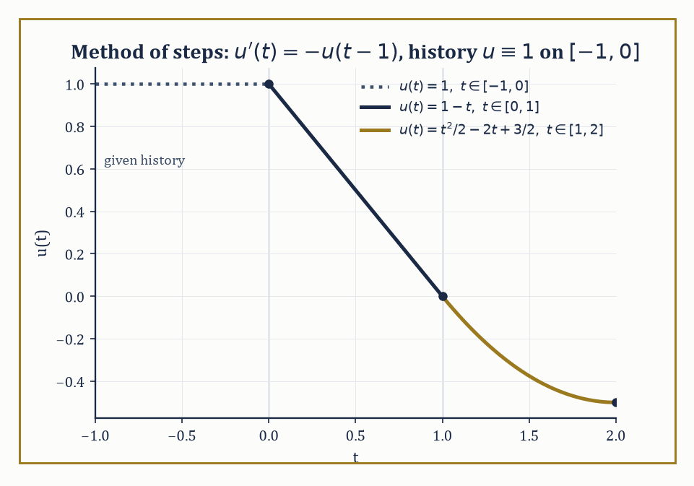
Figure 26.8 — The method of steps in action: each new piece of the solution is built entirely from the piece before it, one delay-window at a time.
u′(t) = f(t, u(t), u(t − τ))
This has a striking consequence for what ‘the state of the system’ even means: it is no longer the single number u(t), but the entire function segment on the trailing window [t − τ, t] — an element of the infinite-dimensional space of continuous functions on that window, rather than a point of ℝ.
Existence, uniqueness, and continuous dependence on the initial data hold under Lipschitz conditions on f, as in Ordinary Differential Equations Revisited, but the proof proceeds by the method of steps: solve the equation as an ordinary ODE on [0, τ] using the known history to fill in u(t − τ), then repeat on [τ, 2τ] using the solution just obtained, and so on indefinitely.
Numeric example — the method of steps. Solve u′(t) = −u(t − 1) with initial history u(t) = 1 for t ∈ [−1, 0].
On [0, 1]: here t − 1 ∈ [−1, 0], where the history says u(t−1) = 1, so the equation becomes the ordinary u′(t) = −1. Integrating from u(0) = 1 (the history’s endpoint value):
u(t) = 1 − t
In particular u(1) = 0.
On [1, 2]: now t − 1 ∈ [0, 1], where we just found u(t−1) = 1 − (t−1) = 2 − t, so the equation becomes u′(t) = −(2 − t) = t − 2. Integrating from u(1) = 0:
u(t) = 0 + ∫₁ᵗ (s − 2) ds = [s²/2 − 2s]₁ᵗ = (t²/2 − 2t) − (1/2 − 2) = t²/2 − 2t + 3/2
Check continuity at the join, t = 1: t²/2 − 2t + 3/2 = 1/2 − 2 + 3/2 = 0, matching u(1) = 0 from the first piece exactly. And u(2) = 4/2 − 4 + 3/2 = 2 − 4 + 1.5 = −0.5. Each interval’s solution is built wholly from the previous interval’s — a constructive, computable procedure, one delay-window at a time.
Try it now — For u′(t) = −u(t − 1) with history u = 1 on [−1, 0], find u on [0, 1]. Answer →
For the linear autonomous case below, trying the usual exponential ansatz u(t) = exp(λt) produces a characteristic equation.
u′(t) = a·u(t) + b·u(t − τ)
The ansatz produces the characteristic equation below.
λ − a − b exp(−λτ) = 0
But now this is transcendental rather than polynomial, and it has infinitely many roots in the complex plane, not the finite handful an ODE would give.
The long-term behavior is governed by the supremum of the real parts of all these roots (the ‘rightmost root’), and as the parameters a, b, τ vary continuously, individual roots can cross the imaginary axis — switching a stable equilibrium to an unstable one, or back, often repeatedly, producing bifurcation diagrams considerably richer than anything a finite-dimensional linear ODE could manage.
Numeric example — sitting on the edge of stability. Consider u′(t) = −(π/2)·u(t − 1), so a = 0, b = −π/2, τ = 1. The characteristic equation simplifies as follows.
λ − 0 − (−π/2)exp(−λ) = 0 ⟹ λ + (π/2)exp(−λ) = 0
Let’s check the purely imaginary value λ = iπ/2. We need:
exp(−iπ/2) = cos(−π/2) + i sin(−π/2) = 0 + i·(−1) = −i
So (π/2)exp(−iπ/2) = (π/2)(−i) = −iπ/2. Then:
λ + (π/2)exp(−λ) = iπ/2 + (−iπ/2) = 0
Exactly zero, confirming λ = iπ/2 is a root. This is the classical stability-boundary example of delay-equation theory: u′(t) = −a·u(t−1) is asymptotically stable for 0 < a < π/2 and unstable for a > π/2, with a = π/2 sitting on the boundary, sustaining an undying oscillation of angular frequency π/2 — that is, period 2π/(π/2) = 4 time units. A vanishingly small nudge to the coefficient a is the entire difference between a system that settles down and one that oscillates forever.
Two further generalizations enlarge the family without changing its essential character. Neutral equations let the derivative itself appear with a delay, as in the equation below — the rate of change now depends on how fast the system was changing in the past, not merely on where it was.
u′(t) = f(t, u(t), u(t−τ), u′(t−τ))
Distributed-delay equations replace the single fixed lag τ with a whole spread of lags, weighted by an integral kernel, as in the equation below — a more realistic model when the ‘memory’ of a system fades gradually rather than cutting off sharply at one instant.
u′(t) = ∫[−τ, 0] u(t + θ) dη(θ)
Both are, in the end, particular kernels within the general integro-differential framework laid out in What Integro-Differential Equations Are — the delay equation was an integro-differential equation wearing a disguise all along, its kernel a single spike (a Dirac delta) at lag τ rather than something spread out.
Numeric example — a distributed delay smoothing a jump. Take the uniform distributed-delay term below with τ = 1, acting on a step history: u(s) = 0 for s < 0, u(s) = 1 for s ≥ 0.
(1/τ)∫[t−τ, t] u(s) ds
For t ∈ [0, 1], the averaging window [t−1, t] straddles the jump at s = 0: the part of the window below 0 contributes nothing (u = 0 there), so:
(1/τ)∫₀ᵗ 1 ds = t
So the distributed-delay term rises linearly from 0 at t = 0 to 1 at t = 1.
For t ≥ 1, the entire window [t−1, t] lies at or past the jump, so the average is constant thereafter.
(1/τ)∫ₜ₋₁ᵗ 1 ds = 1
A single instantaneous jump in the underlying signal has been turned, by the act of averaging over a trailing window, into a smooth linear ramp exactly one delay-window wide — distributed memory is, quite literally, a smoothing device.
Keep only this · Section 26.8: Delay Equations and Equations with Memory
The idea. In a delay equation the rate depends on a past value, so the data is a whole history function. The method of steps solves it one interval at a time; the characteristic equation has infinitely many roots, and delay alone can destabilize.
Core.
u′(t) = a u(t) + b u(t − τ)
λ = a + b e^(−λτ)
data: u on [−τ, 0]
Typical mistake. Giving only u(0). The equation needs the whole history on [−τ, 0].
Minimal example. u′ = −u(t − 1), history 1: u = 1 − t on [0, 1].
Practice. Easy to challenge; full worked answers, with the usual mistake, are in Answers to the Practice Sets at the back.
Easy — Continue one more step and find u(2). Answer →
Medium — Check that λ = iπ/2 solves λ = −(π/2)e^(−λ), the characteristic equation of u′ = −(π/2)u(t − 1). Answer →
Challenge — For u′(t) = b u(t − 1) with b > 0, show that the characteristic equation has exactly one positive real root, and conclude. Answer →

Section 26.9: Looking Ahead: From Integro-Differential Equations to PDEs and Functional Analysis
Packing for the Next Chapter
We have now pushed the theory of differential equations from the existence theory of Ordinary Differential Equations Revisited through systems, stability, boundary-value problems, Green’s functions, and the principal classes of integro-differential and delay equations. Two threads run through everything in this chapter and both point directly at what comes next.
First, once the state of a system is a function rather than a finite list of numbers — as it becomes for a delay equation or a general integro-differential equation — we are already doing infinite-dimensional dynamics, whether we admit it or not. Second, Green’s functions and integral operators turned out to be differential operators wearing a different coat, unified by the same underlying spectral theory met first in Sturm–Liouville form.
Chapter 27 takes the next visible step: the unknown depends on several independent variables at once, and the operators become partial rather than ordinary — a heat equation or a wave equation is, in the right light, the kind of eigenvalue problem this chapter has been rehearsing, just with one more variable to keep track of.
Functional analysis, waiting a little later the series, supplies the fully abstract setting — Banach and Hilbert spaces of functions, with differential and integral operators alike treated as bounded or unbounded linear maps between them — in which existence, uniqueness, and spectral theory for both families are, at last, literally the same theorem.
Abstract example — two histories, one present value. Take the delay equation u′(t) = f(u(t), u(t−1)) and compare two candidate initial histories on [−1, 0], below.
φ₁(θ) = 1 for every θ ∈ [−1, 0]
φ₂(θ) = 1 + θ for θ ∈ [−1, 0]
φ₁ is a flat history; φ₂ is a history ramping up from φ₂(−1) = 0 to φ₂(0) = 1. Both histories agree at the single point that matters for an ordinary differential equation.
u(0) = φ₁(0) = φ₂(0) = 1
For an ODE, that single shared number would be the entire initial condition, and the two systems would evolve identically forever after. But for the delay equation, φ₁ and φ₂ are different points of the phase space C([−1,0], ℝ) — different whole segments — and as soon as t exceeds 0 and the term u(t−1) starts drawing on values from θ ∈ (−1, 0), the two trajectories can diverge, because they are consulting different pasts even though they share the same present.
This is the concrete, checkable sense in which ‘the state is not a point, it is a recent autobiography’: agreement on the last page of the diary says nothing about agreement on the pages before it.
Try it now — A simulation of N = 10,000 steps re-sums a memory integral over all earlier steps. Roughly how many terms is that? Answer →
There is also a genuinely practical challenge lurking behind all this elegance: simulating a memory term numerically, the naive way, means storing the entire history of the solution and re-summing over all of it at every single future time step — a cost that grows without bound as the simulation runs on.
The escape route, already visible in Section 26.5’s conversion of ∫₀ᵗ u(s) ds into an auxiliary variable U with its own ordinary differential equation, and in Section 26.6’s exponential resolvents, is to notice that kernels built from sums or products of exponentials satisfy their own tiny system of memoryless ODEs — a trick called Markovian embedding.
Replace the ever-growing memory integral with a handful of auxiliary variables that update cheaply at every step, and the past no longer needs to be stored at all — only summarized.
Numeric example — the price of forgetting how to forget. Suppose a simulation runs for N = 10,000 time steps, and at every step the naive approach must re-sum a memory integral over all previous steps.
N²/2 = 10,000²/2 = 100,000,000/2 = 5×10⁷ arithmetic operations
Now suppose the kernel happens to be a sum of exponential modes, and Markovian embedding replaces the memory integral with, say, 5 auxiliary variables, each updated by a cheap one-step rule independent of how far the simulation has already progressed.
5N = 5×10,000 = 50,000 = 5×10⁴ operations
The ratio is:
5×10⁷ / 5×10⁴ = 1,000
Three orders of magnitude cheaper, purely from recognizing that a decaying-exponential memory, however far back it appears to reach, is secretly satisfying its own local, memoryless differential equation the entire time.
The deeper lesson of this chapter, stripped of its machinery, is that a system’s dependence on its entire past is both physically utterly ordinary — friction has aftereffects, materials remember old strain, populations remember their age structure, almost nothing in the physical world is quite as forgetful as the idealized ODE pretends — and, once the right function spaces and integral operators are brought to bear, mathematically manageable rather than terrifying.
It is worth noticing, too, how much of this chapter’s vocabulary will change costume rather than disappear: the resolvent kernel of Volterra Integro-Differential Equations reappears in Chapter 27 as the fundamental solution, or heat kernel, of a partial differential equation — again a function of two points, again built to be integrated against a source to produce a solution, again governing just how sharply, or how gently, influence spreads from one point to another.
Differential and integro-differential equations together form the core language of continuous-time dynamical modeling, from the merely elementary right up to the frontier — and very little of the language will need to be relearned from scratch.
So: the future may depend on the whole of the past, and it turns out that is a perfectly respectable thing for a future to do, provided you are willing to work in the right space of functions and stop insisting that a system’s state be describable by a finite grocery list of numbers. Tenure committees, notoriously, remember only the last five years and forget everything inconvenient before that; our equations, to their credit, are considerably more honest about their memory than most of the institutions that employ the people who study them.
Chapter 27 now asks the unknown function to depend on more than one variable at once — space as well as time — and turns our ordinary derivatives into partial ones. Almost nothing here is wasted: the eigenvalue expansions of Boundary-Value Problems and Sturm–Liouville Theory return as separation of variables, the Green’s functions of Green’s Functions for ODEs return dressed as fundamental solutions of the heat and wave equations, and the qualitative instincts of Section 26.2’s stability theory return more or less unaltered, just with infinitely many directions to be stable or unstable in at once.
The series continues. We have learned that the future may remember the past — now let’s go and meet a function of two variables. It is about to get complicated in an entirely new direction, and we would not have it any other way.
Keep only this · Section 26.9: Looking Ahead: From Integro-Differential Equations to PDEs and Functional Analysis
The idea. In equations with memory the state is a whole function, not a number. That is the bridge to PDEs, whose unknowns depend on space as well as time, and to functional analysis, which treats functions as points.
Core.
state of a delay equation: u on [t − τ, t]
naive memory cost ≈ N²/2
Typical mistake. Thinking more numbers at time t would fix it. Two histories with the same present value give different futures; the state really is a function.
Minimal example. u′ = −u(t − 1): histories 1 and 1 + sin(πt) agree at t = 0 but give different u′ on (0, 1).
Practice. Easy to challenge; full worked answers, with the usual mistake, are in Answers to the Practice Sets at the back.
Easy — If N doubles, by what factor does the naive memory cost grow? Answer →
Medium — For the kernel e⁻ᵗ, show that I(t) = ∫₀ᵗ e^(−(t − s)) u(s) ds satisfies an ordinary equation, and say what that does to the cost. Answer →
Challenge — Turn u′ = −∫₀ᵗ e^(−(t − s)) u(s) ds, u(0) = 1 into a second-order ODE and solve it. Answer →
Chapter 26 recap · Differential and Integro-Differential Equations
• An initial-value problem with a Lipschitz right-hand side has exactly one solution, and Picard iteration builds it.
• Linear systems are solved by a fundamental matrix; for constant A the solution is exp(tA)y₀, and eigenvalues classify the equilibrium.
• Lyapunov functions prove stability without solving the equation; LaSalle’s principle upgrades V̇ ≤ 0 to convergence.
• Boundary-value problems can have no solution, one, or many. Sturm–Liouville eigenfunctions are orthogonal and expand general functions; Green’s functions solve every forcing at once.
• Integro-differential equations remember: Volterra integrals run over the past and yield to the Laplace transform; Fredholm integrals run over a fixed interval and lead to the Fredholm alternative.
• Delay equations need a whole history as data. The state is a function, which is the door to PDEs and functional analysis.

Check Your Understanding — Chapter 26
Answers are in the Answer Key at the back of the book — have a go before you look.
1. [Explain] The initial-value problem x′(t) = x(t)^(1/3), x(0) = 0 has more than one solution even though f(t,x) = x^(1/3) is continuous. Why doesn’t Peano’s theorem’s guarantee of existence also give uniqueness here?
See the answer →
2. [Explain] For x′ = −x³, linearization gives f′(0) = 0, a non-hyperbolic equilibrium the Hartman–Grobman theorem can’t classify. How does Lyapunov’s method establish asymptotic stability anyway, and what does it fail to reveal?
See the answer →
3. [Compute] Using the Green’s function G(x, ξ) = x(ξ − 1) for x ≤ ξ and G(x, ξ) = ξ(x − 1) for x ≥ ξ (built for y″ = f, y(0) = y(1) = 0), what solution does y(x) = ∫G(x,ξ)f(ξ)dξ give for f(x) = 1, and how do you check it?
See the answer →
4. [Concept] For the delay equation u′(t) = −a·u(t − 1), what is special about a = π/2, and what happens on either side of it?
See the answer →
5. [Compute] Solve x′ = Ax for A = [0 1; −2 −3], and classify the equilibrium at the origin.
See the answer →
6. [Compute] For −y″ = λy on [0, L] with y(0) = y(L) = 0, find all eigenvalues and eigenfunctions, and verify orthogonality for two distinct ones.
See the answer →
7. [Model] A harvested population obeys x′ = x(1 − x) − h with h ≥ 0. Find the equilibria, determine their stability, and identify the harvest rate at which the population collapses.
See the answer →
8. [Compute] Compute eᴬᵗ for A = [2 1; 0 2], and say why the answer is not simply diag(e²ᵗ, e²ᵗ).
See the answer →
9. [Explain] Explain why a non-hyperbolic equilibrium defeats linearization in general, not merely in the case x′ = −x³.
See the answer →
10. [Concept] Initial-value problems generically have exactly one solution locally. Boundary-value problems may have none, one, or infinitely many. What accounts for the difference?
See the answer →
11. [Explain] Lyapunov requires V̇ < 0 for asymptotic stability, but many natural energy functions give only V̇ ≤ 0. What does LaSalle add, and why is it enough?
See the answer →
12. [Prove] Prove the Abel–Liouville formula: if Φ is a fundamental matrix for x′ = A(t)x, then W(t) = det Φ(t) satisfies W′ = tr(A(t))·W.
See the answer →
13. [Prove] Prove that the initial-value problem x′ = f(t, x), x(t₀) = x₀ has at most one solution when f is Lipschitz in x.
See the answer →
14. [Prove] Prove that the Sturm–Liouville operator L[y] = −(py′)′ + qy is self-adjoint on the space of functions satisfying separated boundary conditions.
See the answer →
15. [Prove] Prove that eigenfunctions of a Sturm–Liouville problem belonging to distinct eigenvalues are orthogonal with respect to the weight w.
See the answer →
16. [Prove] Prove that the solution set of x′ = A(t)x on an interval I is a vector space of dimension exactly n.
See the answer →
17. [Prove] For a periodic system x′ = A(t)x with A(t + T) = A(t), prove that stability is determined by the eigenvalues of the monodromy matrix Φ(T).
See the answer →
18. [Prove] Prove that the Volterra integral equation u(t) = f(t) + ∫₀ᵗ K(t, s)u(s)ds has a unique continuous solution on [0, T] for every continuous f and bounded K, with no smallness assumption on K.
See the answer →
19. [Challenge] An ODE determines its future from a single point. A delay or integro-differential equation does not. What does that cost, structurally?
See the answer →
20. [Challenge] The resolvent of an integral equation is a geometric series in the kernel. Why should that be, and what is the analogy being exploited?
See the answer →
21. [Challenge] Hartman–Grobman says a hyperbolic equilibrium is topologically conjugate to its linearization. What is actually being bought, and what is being given up?
See the answer →
22. [Challenge] Fourier series turn out to be one instance of Sturm–Liouville theory rather than a special trick. What is it that really generalizes?
See the answer →
23. [Challenge] In what sense is a Green’s function an inverse, and why does the same object keep reappearing in subjects that seem unrelated?
See the answer →
24. [Challenge] A boundary-value problem can fail to have any solution at all. What is the deeper principle, and where else in the series does it appear?
See the answer →

Problems — Chapter 26
The questions above test whether the ideas landed. These ask you to use them. Solutions are in Solutions to the Problems at the back. Work them before you look.
1. [Compute] Solve x′ = −2x with x(0) = 3. What happens to x(t) as t grows, and what does that say about the equilibrium at 0?
2. [Compute] For x′ = x with x(0) = 1, compute the first two Picard iterates, starting from the constant function 1.
3. [Concept] The logistic equation x′ = x(1 − x) has equilibria at 0 and at 1. Classify each by the sign of the derivative of the right-hand side.
4. [Compute] The system x′ = x, y′ = −y has a single equilibrium at the origin. Classify it, and write the general solution.

Math, Actually

Chapter 27

Partial Differential Equations
Waves, Diffusion, Equilibrium, and the Art of Equations in Several Variables
The previous chapter left the unknown function in a comfortable, if occasionally chaotic, situation: it depended on one variable, usually called t, and its entire life story was a curve traced out over time. Differential and integro-differential equations, however wild their right-hand sides, were still fundamentally the story of a single point wandering through a state space. That was, in retrospect, a rather sheltered existence. We now remove the shelter.
From this chapter onward the unknown function u is allowed — indeed required — to depend on several independent variables at once: on x and y, or on x, y, z and t, or on however many coordinates the problem needs to describe a string, a drum, a slab of metal, or the electromagnetic field filling a section. An equation relating u to its partial derivatives with respect to these several variables is a partial differential equation, and the extra variables are not a cosmetic generalization.
They change everything: a single number (an initial condition) is no longer enough data to pin down a solution; one now needs data along entire curves or surfaces, the shape of the domain itself becomes part of the mathematics, and the same-looking differential expression can behave like three quite different animals — elliptic, parabolic, or hyperbolic — depending on the signs of a few coefficients.
This is traditionally the point in a mathematical education at which enthusiasm and confidence part ways for a while. The repertoire of equations one can solve by a formula shrinks alarmingly, replaced by a much larger repertoire of qualitative theorems — maximum principles, energy estimates, existence proofs by pure force of functional analysis — that tell you a great deal about a solution without ever writing it down. This is not a defect of the theory; it is the theory growing up. Ordinary differential equations are, with a few exceptions, the kind of problem one can hope to finish by hand. Partial differential equations are the kind of problem the whole of twentieth-century analysis was invented to survive.
We will keep to the classical core: first-order equations solved by the method of characteristics, the three great second-order archetypes (wave, heat, Laplace), separation of variables and eigenfunction expansions, and the maximum-principle and energy-method machinery that makes the entire subject rigorous rather than merely plausible. Nonlinear equations and the full modern apparatus of Sobolev spaces are visited only at the door, in the last section, as a preview of where the series goes next — although, as it happens, one of those maximum principles turns out to be secretly a minimization problem, which is as good an introduction as any to the chapter immediately above this one, where we finally ask what it means for a quantity to be as small (or as large) as it can possibly be. Let’s add independent variables.
Before you begin — Chapter 27
By the end of this chapter you will be able to:
1. Recognize a PDE’s order, linearity and type, and say what makes a problem well posed.
2. Solve first-order equations by characteristics, and predict when a shock forms.
3. Classify second-order equations by the discriminant or by eigenvalues.
4. Solve the wave equation by d’Alembert’s formula and the heat equation by the heat kernel.
5. Use harmonic functions, the mean-value property and the Poisson kernel.
6. Solve boundary-value problems by separation of variables, and prove uniqueness by maximum principles and energy.
Prerequisites. Ordinary differential equations and Sturm–Liouville problems from Differential and Integro-Differential Equations; partial derivatives from Multi-Variable Calculus (Volume 2); Fourier series from Fourier Transforms and FFT (Volume 2).
Estimated study time. About 12 hours, exercises included.

Section 27.1: What a Partial Differential Equation Actually Is
In which the unknown acquires several relatives to answer to
You have seen this before
Partial derivatives come from Multi-Variable Calculus (Volume 2), and the ordinary differential equations of Differential and Integro-Differential Equations are the one-variable case. The new feature is that the unknown depends on space and time together.
An ordinary differential equation asks a function of one variable to relate to its own derivatives — a curve, tracing out a life story in time. A partial differential equation asks more: it relates a function u of several independent variables to its partial derivatives with respect to each of them.
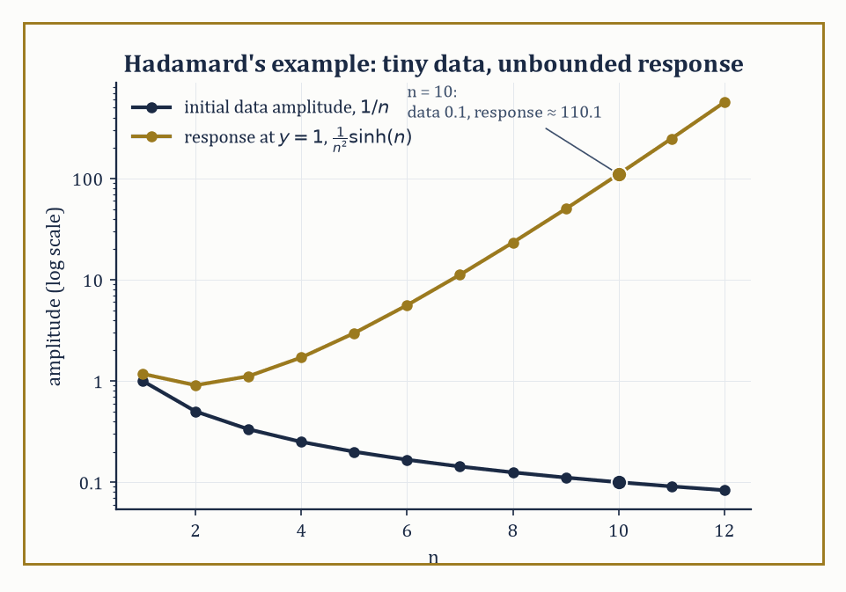
Figure 27.1 — As n grows, Hadamard’s initial data shrink to nothing while the corresponding solution explodes — ill-posedness made visible.
Begin with a section you have sat in. There is a radiator at one end and a window at the other, and it is January. Ask what the temperature of the section is, and you cannot answer with a number. By the radiator it is warm. By the window it is not. Move your chair and the answer changes, and if you sit still for an hour it changes again.
Everything in the previous chapter tracked a single number changing as time passed. A cooling cup of tea has one temperature at each moment, and its whole life story is a curve you could draw in one pencil stroke. That is what an ordinary differential equation describes, and it worked because there was only ever one number to describe.
The section defeats it. The temperature is not one number but a landscape of them, one for every spot, and that landscape is itself changing as the evening goes on. A single curve cannot hold it. You would need one curve for every spot in the room, and there are infinitely many spots.
So change the question. Not how does this number change as time passes, but how does an entire landscape of numbers change, when every point in it is watching its neighbors?
That last part is where the difficulty lives. You cannot follow one spot on its own and be finished. The air by the window cools because the air beside it is cooler, and that air cools because of the air beside it, back across the room to the radiator. No spot has a private fate. Choose any point and its future is already tangled with every other point, all of them settling their business in the same instant. There is no first domino.
The way round it sounds like an evasion. Stop following points at all. Write down only the local rule — how any one spot responds to the spots immediately around it — and then ask for the whole landscape that obeys that rule everywhere at once. You never solve for a point. You solve for the entire surface in a single act.
Before any notation, watch a rule checked by hand. The heat rule says a spot warms or cools in proportion to how far its neighbors differ from it. Here is a landscape somebody has proposed for a thin bar, where x runs along the bar and t is time:
u(x, t) = e⁻ᵗ sin x
At the start, when t is zero, the factor in front is 1 and the bar holds a single smooth hump: warm in the middle, cold at both ends. Let one unit of time pass. The factor becomes 0.368, and every reading is 0.368 of what it was. After another unit, 0.135. The hump never moves, never tilts, never changes shape. It sags, everywhere at once, by the same factor.
You can see why it must behave so. The middle of the hump is the spot most out of step with its neighbors, so it loses heat fastest — and it is also the tallest, so losing most is exactly what keeps the shape intact.
Notice what this does not do. Checking that a proposed landscape obeys the rule is arithmetic. Finding it in the first place is another matter, and nothing so far hints at how anybody arrived at that formula. Verifying a guess is not the same as having a method, and much of this chapter is about the difference.
That is a partial differential equation: a rule tying a landscape to its own rates of change in more than one direction at once. The curly ∂ you are about to meet is the ordinary d you already know, carrying a reminder that the other variables are held still while this one varies.
The numeric example below runs this same check, on the same bar and the same formula, with the arithmetic in full.
Instead of a single curve, the unknown is now a whole landscape — a temperature over a section, a displacement over a drumhead, a potential filling a volume — and the equation constrains how that landscape is allowed to look and how it is allowed to change.
The order of a PDE is, as for ODEs, the order of the highest derivative appearing; a solution is a function that satisfies the equation identically at every point of some domain.
Nothing here is conceptually new so far. What is new, and what will occupy the rest of this chapter, is that several variables turns out not to be a mild inconvenience but the whole story.
Numeric example — checking a candidate solution. Consider the following candidate, proposed as a solution of the heat equation (the simplest case, with diffusion constant k = 1):
u(x, t) = e⁻ᵗ sin x
The heat equation itself reads:
uₜ = uₓₓ
Differentiate the candidate:
uₜ = −e⁻ᵗ sin x
uₓ = e⁻ᵗ cos x
uₓₓ = −e⁻ᵗ sin x
These agree — uₜ = uₓₓ exactly, at every (x, t) — so u is indeed a solution. Notice the order of the equation: the highest derivative present is uₓₓ, a second derivative in x (the equation is only first order in t), so the heat equation has order 2.
This is the standard shape of a check: propose a candidate, differentiate it precisely as many times as the equation demands, and see whether the two sides agree identically, not just at one point.
Try it now — Check that u = e⁻ᵗ sin x solves uₜ = uₓₓ. Answer →
A PDE is linear if the unknown and all its derivatives occur to the first power and are not multiplied together — no u², no u·uₓ, no sin(u).
Constant-coefficient linear equations, such as the heat, wave, and Laplace equations, are by far the most tractable; allow the coefficients to vary, or allow the equation to become nonlinear, and explicit formulas mostly evaporate.
The single most useful consequence of linearity is the superposition principle: if u₁ and u₂ both solve a linear homogeneous PDE, so does any combination c₁u₁ + c₂u₂. This is what makes Fourier series solve the heat and wave equations later in this chapter — build the general solution by adding up simple ones.
Nonlinear equations grant no such courtesy, and the resulting loss of superposition is not a minor technical inconvenience; it is the mathematical origin of shocks, turbulence, and most of the phenomena that make fluid dynamics simultaneously fascinating and a Millennium Prize problem (a matter to which we will return, briefly and cautiously, at the end of this chapter).
Numeric example — superposition succeeds, then fails. Take Burgers’ equation, the simplest nonlinear transport equation:
uₜ + u uₓ = 0
Both u₁ = 1 (the constant function) and u₂ = x/t solve it: for u₁, every term is zero. For u₂, compute the pieces:
uₜ = −x/t², uₓ = 1/t
u·uₓ = (x/t)(1/t) = x/t²
uₜ + u uₓ = −x/t² + x/t² = 0
Good — both are bona fide solutions. Now test the sum:
w = u₁ + u₂ = 1 + x/t
Its derivatives are computed next (the constant contributes nothing to wₜ):
wₜ = −x/t², wₓ = 1/t
w·wₓ = (1 + x/t)(1/t) = 1/t + x/t²
wₜ + w·wₓ = −x/t² + 1/t + x/t² = 1/t
which is not zero. The sum of two solutions of a nonlinear equation is, in general, not a solution at all — superposition, the workhorse of the linear theory, simply fails.
The deepest question one can ask of a PDE, once it is written down, is whether it is well posed in Hadamard’s sense: a solution should exist, it should be unique, and — crucially — it should depend continuously on the given data (initial values, boundary values, coefficients).
That third condition is not pedantry. Data in any real problem come from measurement, and measurements carry error; if an arbitrarily small change in the data can produce an arbitrarily large change in the solution, the equation is useless as a model no matter how elegant it looks on paper.
Not every equation one can write down honestly deserves to be called a description of a physical process, and Hadamard supplied the standard cautionary tale using, of all things, Laplace’s equation — normally the best-behaved operator in the entire subject.
Numeric example — Hadamard’s ill-posed problem. Consider Laplace’s equation on the strip {(x, y) : y ≥ 0}:
u_xx + u_yy = 0
with Cauchy data prescribed at y = 0:
u(x, 0) = 0, u_y(x, 0) = (1/n) sin(nx)
for some large integer n. One checks directly that the following function is harmonic and matches the prescribed data exactly at y = 0:
uₙ(x, y) = (1/n²) sin(nx) sinh(ny)
Indeed u_xx = −sin(nx) sinh(ny) and u_yy = +sin(nx) sinh(ny), and they cancel.
As n → ∞, the initial data shrink to zero uniformly — the velocity data (1/n) sin(nx) has amplitude 1/n, vanishing.
Yet fix any y > 0, say y = 1, and take n = 10: the amplitude of the solution there is
(1/100) sinh(10) ≈ (1/100)(11013.2) ≈ 110.1
— over a thousand times larger than the initial data’s amplitude of 1/10 = 0.1, and this ratio grows without bound as n increases further, since sinh(n) grows exponentially.
Arbitrarily small data, arbitrarily large response: the Cauchy problem for Laplace’s equation is ill-posed, and the lesson generalizes — the type of a PDE (elliptic, parabolic, hyperbolic, the subject of the next section) determines which kind of data it is willing to accept at all.
Keep only this · Section 27.1: What a Partial Differential Equation Actually Is
The idea. A PDE relates partial derivatives of an unknown function of several variables. Order, linearity and type shape the theory, and a problem is well posed when a solution exists, is unique, and depends continuously on the data (Hadamard).
Core.
order = highest derivative present
linear: L(au + bv) = aLu + bLv ⇒ superposition
well posed: existence, uniqueness, stability
Typical mistake. Using superposition on a nonlinear equation. For Burgers’ equation uₜ + uuₓ = 0, the sum of two solutions is generally not a solution.
Minimal example. uₜ = uₓₓ: e⁻ᵗ sin x, e⁻⁴ᵗ sin 2x, and every sum of such terms.
Practice. Easy to challenge; full worked answers, with the usual mistake, are in Answers to the Practice Sets at the back.
Easy — Give the order of uₜ + uuₓ = uₓₓ and say whether it is linear. Answer →
Medium — u₁ = x/(1 + t) solves Burgers’ equation uₜ + uuₓ = 0. Does 2u₁? Answer →
Challenge — For Laplace’s equation on y ≥ 0 with u(x, 0) = 0 and u_y(x, 0) = sin(nx)/n, the solution is u = sin(nx) sinh(ny)/n². For n = 10, compare the size of the data with u(π/20, 1). Answer →

Section 27.2: First-Order Equations and the Method of Characteristics
Following information along the roads it travels
Picture an airport moving walkway that carries everything at 2 meters per second. Put a suitcase on it at the 1-meter mark. One second later the suitcase is at the 3-meter mark, two seconds later at the 5-meter mark. Nothing about the suitcase changes. Only its position does.
Now describe the whole walkway at once. Let u(x, t) be the height of whatever is sitting at position x at time t, and let f(x) be the starting picture, the heights at time 0. Because everything rides along unchanged, whatever is at position x now was at position x − 2t when the clock started:
t = 1, x = 3: it came from 3 − 2 = 1, the suitcase
t = 2, x = 5: it came from 5 − 4 = 1, the same suitcase
t = 2, x = 0: it came from 0 − 4 = −4
So u(x, t) = f(x − 2t). In the language of partial derivatives, ‘the height does not change as you ride along at speed 2’ is the equation uₜ + 2uₓ = 0. Solving it directly, as a statement about how u varies in two directions at once, looks hard. But each row of the table is really a statement about one path through space and time, the line x = x₀ + 2t that a single item follows, and along that path u does not change at all.
That suggests a strategy for a whole family of equations. A rule about how u changes along one path is an ordinary differential equation, which earlier chapters already know how to solve. So find the paths first, and then solve along each one. The paths are called characteristics.
The walkway is the easiest case, because every item moves at the same speed, and the first worked example below is exactly this one, with the starting picture f(x) = sin x. The interesting case comes when the speed depends on u itself, like traffic in which the faster cars start behind the slower ones. Then the paths can run into each other, and the section’s second example shows the solution breaking down at the moment they do.
A first-order quasilinear PDE has the form:
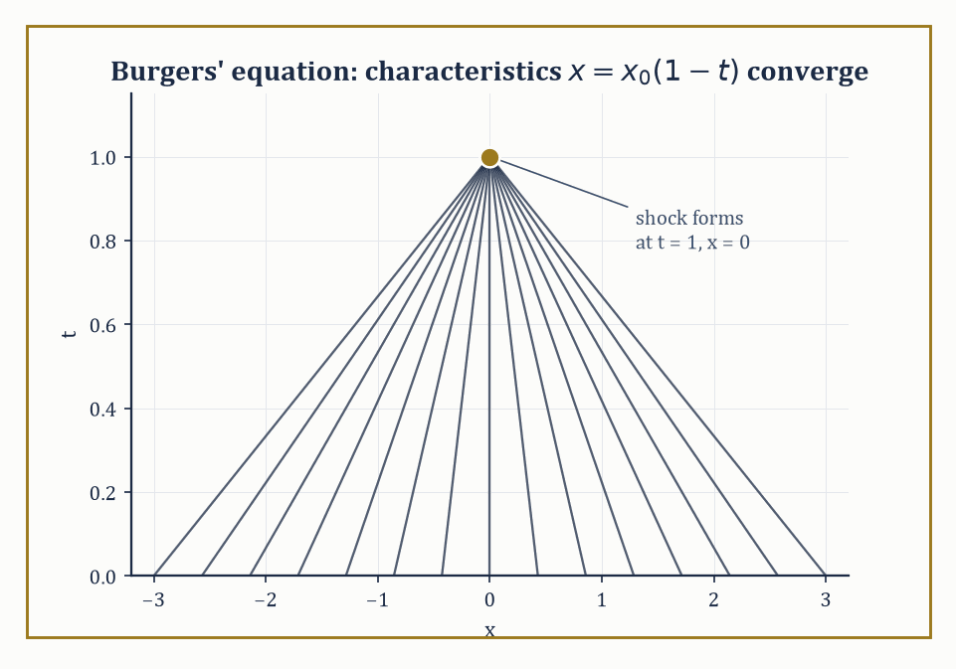
Figure 27.2 — Every characteristic of the collapsing profile u(x,0) = −x arrives at the same appointment: x = 0, t = 1.
a(x, y, u) u_x + b(x, y, u) u_y = c(x, y, u)
the unknown’s two first partial derivatives appear linearly, though the coefficients may depend on u itself.
The trick that unlocks such equations — the method of characteristics — is to notice that the left-hand side is a directional derivative: it is the rate of change of u along the direction (a, b) in the (x, y)-plane.
So instead of treating u_x and u_y separately, follow a curve (x(s), y(s)) whose tangent is precisely (a, b); along that curve the PDE collapses into an ordinary differential equation,
du/ds = c
Three coupled ODEs replace one PDE:
dx/ds = a, dy/ds = b, du/ds = c
This is the single most important idea in the whole first-order theory: a partial differential equation for information spread across a plane becomes an ordinary differential equation for information traveling along curves, called characteristics, and solving the PDE is reduced to solving these ODEs and then eliminating the parameter s.
Numeric example — linear transport. The homogeneous linear transport equation is the simplest case:
uₜ + c uₓ = 0
here a = c, b = 1 (treating t as the second variable), and the right-hand side is zero, so u is constant along each characteristic.
The characteristics themselves solve dx/dt = c, i.e.
x(t) = x₀ + ct
— straight lines of slope c in the (x, t)-plane — and:
u(x, t) = u(x₀, 0) = f(x₀) = f(x − ct)
Take c = 2 and initial data f(x) = sin x: the solution is
u(x, t) = sin(x − 2t)
a wave profile translating rigidly to the right at speed 2. Check it directly:
uₜ = −2 cos(x − 2t), uₓ = cos(x − 2t)
uₜ + 2uₓ = −2 cos(x − 2t) + 2 cos(x − 2t) = 0
as required. The entire solution is nothing more than ‘take the initial shape and slide it.’
Try it now — Solve uₜ + 3uₓ = 0 with u(x, 0) = x². Answer →
Once the coefficients depend on u itself — the quasilinear case proper — the characteristic curves are no longer parallel straight lines; each one carries its own value of u, and its own consequent slope, so different characteristics can converge.
Where they do, the classical (smooth, single-valued) solution breaks down: the same point (x, t) would be asked to carry two different values of u, which is nonsense for an honest function.
Physically this is the birth of a shock — a genuine discontinuity, such as the leading edge of a traffic jam or the front of a sonic boom — and the classical method of characteristics announces its own moment of failure by telling you exactly when and where it happens.
Numeric example — a smooth profile collapsing into a shock. Take inviscid Burgers’ equation with initial data u(x, 0) = −x:
uₜ + u uₓ = 0
Along a characteristic starting at (x₀, 0), u stays constant (du/ds = 0) at its initial value u₀ = −x₀, and the characteristic itself moves at that constant speed:
dx/dt = u = −x₀, so x(t) = x₀ + (−x₀)t = x₀(1 − t)
Solving for x₀ (valid while t ≠ 1) gives the solution:
x₀ = x/(1 − t)
u(x, t) = −x₀ = −x/(1 − t)
Checking:
uₜ = −x/(1 − t)², uₓ = −1/(1 − t)
u·uₓ = [−x/(1−t)]·[−1/(1−t)] = x/(1 − t)²
uₜ + u uₓ = −x/(1−t)² + x/(1−t)² = 0
— confirmed. But look at the characteristics:
x(t) = x₀(1 − t) = 0 at t = 1, for every single value of x₀
All the characteristics converge on the single point x = 0 simultaneously at t = 1: the solution’s slope uₓ = −1/(1−t) blows up as t → 1⁻, and beyond that moment no classical solution exists at all.
A perfectly smooth initial profile has focused itself into a shock in finite time, purely from the equation’s own nonlinearity — nobody had to hit it with anything.
The characteristic equations also handle the case where the right-hand side is not zero — an inhomogeneous quasilinear equation still reduces to the same three coupled ODEs,
dx/ds = a, dy/ds = b, du/ds = c
only now the last equation has to be integrated rather than dismissed as du/ds = 0. This is worth seeing worked through once in full, since it is the general pattern of which the pure transport equation above is only the simplest special case.
Numeric example — characteristics with a genuine source term. Solve the following equation, with data u(x, 0) = x prescribed along the line y = 0:
u_x + u_y = u
Here a = 1, b = 1, c = u, so the characteristic system is
dx/ds = 1, dy/ds = 1, du/ds = u
starting from (x₀, 0, x₀) at s = 0. The first two integrate to
x = x₀ + s, y = s
so s = y and x₀ = x − y. The third is a linear ODE in u alone, du/ds = u, whose solution is
u = x₀ eˢ = (x − y) eʸ
Check it directly:
uₓ = eʸ
u_y = −eʸ + (x − y)eʸ
(product rule on the two y-dependent factors), so:
u_x + u_y = eʸ + [−eʸ + (x−y)eʸ] = (x − y)eʸ = u
matching the right-hand side of the PDE. And on y = 0,
u = (x − 0)e⁰ = x
matching the prescribed data. A source term along the characteristic becomes an ODE to solve for how u itself grows or decays as it rides along — here it grows exponentially, at rate 1 per unit of the parameter s, which is the elapsed distance along the characteristic since it left the data curve.
This geometric idea — that a PDE governs how information propagates along preferred curves at a finite, computable speed — does not stay confined to first-order scalar equations.
It reappears, considerably dressed up, as the theory of characteristic surfaces for hyperbolic systems and second-order hyperbolic equations (the wave equation of The Wave Equation is the flagship example), and it is the precise mathematical reason that hyperbolic problems have a finite domain of dependence: a disturbance at one point cannot be felt everywhere instantly, only within the cone swept out by the characteristics through that point.
Elliptic and parabolic equations, we will see, have no such speed limit at all — a fact that will look eccentric the first time you meet it and entirely natural the second.
Keep only this · Section 27.2: First-Order Equations and the Method of Characteristics
The idea. A first-order PDE is an ODE along characteristic curves: the data is carried along them. In a nonlinear equation the characteristics can cross, and a shock forms.
Core.
uₜ + c uₓ = 0 ⇒ u = f(x − ct)
Burgers: u is constant on x = x₀ + f(x₀)t
first crossing: t* = −1/min f′ (when f′ < 0 somewhere)
Typical mistake. Moving the whole profile at one speed in a nonlinear equation. In Burgers’ equation each point moves at its own speed u.
Minimal example. uₜ + uₓ = 0, u(x, 0) = sin x: u = sin(x − t).
Practice. Easy to challenge; full worked answers, with the usual mistake, are in Answers to the Practice Sets at the back.
Easy — Evaluate the solution of uₜ + 2uₓ = 0, u(x, 0) = exp(−x²), at x = 5, t = 2. Answer →
Medium — Solve Burgers’ equation with u(x, 0) = −x and find when the solution blows up. Answer →
Challenge — For Burgers’ equation with u(x, 0) = 1/(1 + x²), find the breaking time. Answer →

Section 27.3: Classification of Second-Order Equations
Elliptic, parabolic, hyperbolic — or, conic sections get their revenge
Sound waves, heat spreading along a metal bar and a soap film stretched on a wire frame are all described by second-order partial differential equations, yet they behave in completely different ways. Waves travel at a finite speed and keep their sharp edges; heat spreads everywhere at once and smooths every edge away; the soap film is settled all at once by its boundary, with no time involved at all. Remarkably, which of these three personalities an equation has can be read off its coefficients by the same test that tells a circle, a parabola and a hyperbola apart. The three names, elliptic, parabolic and hyperbolic, are borrowed straight from the conic sections.
Here are three curves you have met before:
x² + y² = 1, a circle (the roundest ellipse)
x² − y² = 1, a hyperbola
x² − y = 0, a parabola
Their shapes could hardly be more different, yet one number sorts them. Write the squared-and-product part of each equation as Ax² + Bxy + Cy² and work out B² − 4AC. For the circle, A = 1, B = 0 and C = 1, so the number is −4. For the hyperbola, C = −1 and the number is +4. The parabola has no y² term at all, so C = 0 and the number is exactly 0. Negative means a closed curve, positive means a curve that runs off to infinity along two directions, and zero is the borderline between them.
Now take three famous equations involving second derivatives. Laplace’s equation, u_xx + u_yy = 0, describes a steady state: a soap film, or a plate whose temperature has stopped changing. The wave equation, u_tt − c²u_xx = 0, describes vibration. The heat equation, u_t − k u_xx = 0, describes diffusion. They behave so differently that you might expect three separate theories.
Here is the surprise. Copy each equation’s second-derivative coefficients into A, B and C, exactly as for the curves, and the same number sorts them. Laplace gives −4, like the circle. The wave equation gives 4c², positive, like the hyperbola. The heat equation has no second derivative in t, just as the parabola has no y², and gives 0.
That is why the three types carry the names of the conics: elliptic, hyperbolic and parabolic. This section makes the comparison precise, shows that switching to new coordinates cannot change the sign, and then explains why it matters: the type decides what data a problem needs before it has exactly one answer.
A general second-order linear PDE in two variables can be written:
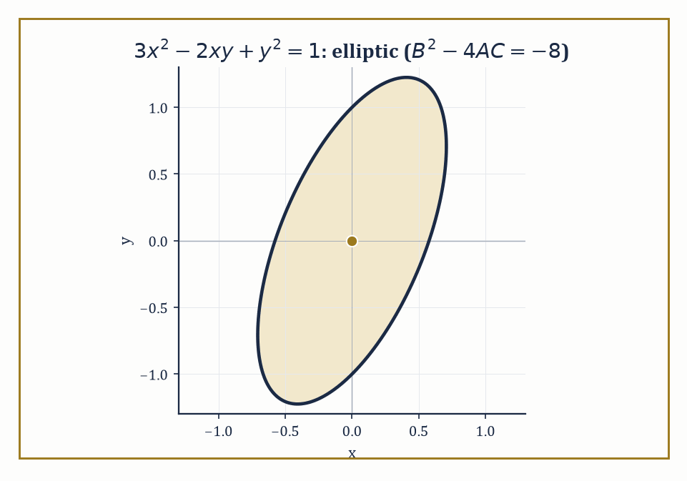
Figure 27.3 — The principal symbol 3x² − 2xy + y² = 1 draws an honest ellipse — the geometric fingerprint of an elliptic operator.
A u_xx + B u_xy + C u_yy + (lower-order terms) = 0
where A, B, C may depend on x and y. Its principal part — the terms with the highest (second) derivatives — is what governs the equation’s essential character, and that character is decided by a single number, the discriminant B² − 4AC, evaluated pointwise.
This is the same expression that classifies a conic section:
Ax² + Bxy + Cy² = const
as an ellipse, a parabola, or a hyperbola, and the naming is not a coincidence but a direct borrowing: the equation is called elliptic where B² − 4AC < 0, parabolic where it equals 0, and hyperbolic where it is positive.
Crucially, this sign is a genuine property of the equation, not an artifact of the coordinates chosen to write it down — a smooth invertible change of variables multiplies the discriminant by the square of the transformation’s Jacobian determinant, which is positive, so the sign survives unchanged.
Numeric example — classifying the three prototypes. Classify three familiar equations by their discriminant. First:
3u_xx − 2u_xy + u_yy = 0
Here A = 3, B = −2, C = 1, so:
B² − 4AC = 4 − 12 = −8 < 0
— elliptic. Second, the wave equation (treating x and t as the two variables, with no mixed uₓₜ term):
uₜₜ − c²uₓₓ = 0
Here A = −c², B = 0, C = 1, so:
B² − 4AC = 0 − 4(−c²)(1) = 4c² > 0
for any nonzero wave speed c — hyperbolic. Third, the heat equation, which has no uₜₜ term at all and no mixed term:
uₜ − k uₓₓ = 0
so A = −k, B = 0, C = 0, giving:
B² − 4AC = 0 − 4(−k)(0) = 0
exactly — parabolic, the boundary case between the other two, which is a rather satisfying way to discover that diffusion sits on the fence between equilibrium and vibration.
Try it now — Classify uₓₓ + 4uₓᵧ + 3uᵧᵧ = 0, using A uₓₓ + B uₓᵧ + C uᵧᵧ. Answer →
The type of the equation is not an idle label; it dictates which data make the problem well posed at all, foreshadowing everything that follows in this chapter.
Elliptic equations describe equilibrium states with no distinguished direction of propagation, so they are paired with boundary data prescribed all around a closed region (the Dirichlet or Neumann problem).
Hyperbolic equations propagate information at finite speed along characteristics, so they are paired with initial data — a snapshot and a velocity — on an open-ended domain.
Parabolic equations, true to their fence-sitting discriminant, need both: initial data at one moment and boundary data for all later time, because they diffuse forward but have no direction to diffuse backward into.
Prescribe the wrong kind of data for the wrong type — Cauchy data for an elliptic equation, say — and Hadamard’s catastrophe from What a Partial Differential Equation Actually Is is what results.
Abstract example — the conic-section shadow. The kinship with conic sections is not merely etymological; it is the same algebra wearing a different hat. The equation 3u_xx − 2u_xy + u_yy = 0 above has principal symbol matching the quadratic form:
3x² − 2xy + y² = 1
and this curve is, by the identical discriminant calculation (−8 < 0), an ellipse — a closed, bounded curve with no real asymptotic directions.
That absence of real asymptotic directions is the geometric shadow of the analytic fact that elliptic operators have no real characteristic curves at all: there is no direction along which information can leak out of the domain, which is why elliptic problems are equilibrium problems, sealed and self-consistent once boundary values are fixed, rather than problems that evolve.
Hyperbolic operators, by contrast, correspond to actual hyperbolas, which do have real asymptotes — and those asymptotic directions are precisely the characteristic directions along which Section 27.2’s information travels.
In more independent variables, or for a system of several coupled equations, the discriminant itself is replaced by something equivalent but grander: the eigenvalues of the matrix of coefficients attached to the principal part.
Elliptic still means all the eigenvalues share the same sign — no direction is special, exactly as in the plane.
Hyperbolic still means the signs split, one against the rest — a distinguished time-like direction emerges, along which information propagates, surrounded by the rest behaving as space does.
The three classical types remain, even in this generality, the organizing principle of the whole elementary theory; they stop being read off a single number and start being read off a spectrum.
Numeric example — classification by eigenvalues in higher dimensions. The three-dimensional Laplacian is:
u_xx + u_yy + u_zz = 0
It has principal-part coefficient matrix equal to the 3×3 identity matrix: eigenvalues 1, 1, 1, all strictly positive, all the same sign — elliptic, in exact agreement with the two-variable discriminant test and regardless of how many spatial dimensions are added.
The 3+1-dimensional wave equation is:
u_tt − c²(u_xx + u_yy + u_zz) = 0
It has coefficient matrix diag(1, −c², −c², −c²) (one eigenvalue for the t-direction, three for the spatial directions): eigenvalues 1, −c², −c², −c² — one positive, three negative, a signature of exactly one sign flipped against the rest.
This is the pattern that defines hyperbolic in the general sense, and it is no accident that physicists call this same signature pattern, dressed up as spacetime geometry, Lorentzian: the wave equation’s hyperbolicity and relativity’s distinction between time and space are, at the level of this one matrix of eigenvalues, the identical piece of linear algebra.
Keep only this · Section 27.3: Classification of Second-Order Equations
The idea. For A uₓₓ + B uₓᵧ + C uᵧᵧ + lower-order terms, the sign of B² − 4AC decides the type — hyperbolic (waves), parabolic (diffusion), elliptic (equilibrium) — and the type decides which data make a well-posed problem.
Core.
B² − 4AC > 0 hyperbolic, = 0 parabolic, < 0 elliptic
more variables: signs of the eigenvalues of the coefficient matrix
Typical mistake. Assuming one type everywhere. With variable coefficients the type can change: y uₓₓ + uᵧᵧ = 0 is elliptic for y > 0 and hyperbolic for y < 0.
Minimal example. uₜ = uₓₓ: A = 1, B = C = 0, discriminant 0, parabolic.
Practice. Easy to challenge; full worked answers, with the usual mistake, are in Answers to the Practice Sets at the back.
Easy — Classify uₓₓ − 9uᵧᵧ = 0. Answer →
Medium — Where is uₓₓ + x uᵧᵧ = 0 elliptic? Answer →
Challenge — Classify uₓₓ + uᵧᵧ + u_zz + 2uₓᵧ = 0 by the eigenvalues of its coefficient matrix. Answer →

Section 27.4: The Wave Equation
d’Alembert solves everything twice, once going each way
Pluck a guitar string and listen. The note rings for seconds. Flick one end of a long rope tied to a post and a hump runs along it, reaches the post, and comes back. Neither of those is what the heat rule of What a Partial Differential Equation Actually Is would do. Heat flattens a bump where it stands and never lets it travel; a hot spot on a bar does not set off down the bar as a hot spot.
You can see the difference in two numbers. Section 27.1’s first example, u = e⁻ᵗ sin x, is a bar cooling under the heat rule. This section’s second example, u = sin x · cos 2t, is a string swinging. Read both at the middle point, x = π/2, as time passes:
t = 0: heat 1, string 1
t = π/4 ≈ 0.785: heat 0.456, string 0
t = π/2 ≈ 1.571: heat 0.208, string −1
t = π ≈ 3.142: heat 0.043, string 1
The heat column falls toward zero and never reaches it, and it never comes back. The string column does not settle on anything at all. It swings through zero to −1 and returns to exactly where it started, and it will do so for ever.
So the question is not ‘how does a bump spread out’ but ‘what local rule makes a bump keep moving instead of melting away’?
The heat rule ties the rate of change of each point to how much it differs from its neighbors. A point that sits above its neighbors moves down, a point below them moves up, and the moment the bump is gone everything stops. A rule like that can only ever smooth. Nothing in it can carry a point past level and out the other side.
The fix is Newton’s. A string is a row of beads joined by tension, and tension pulls each bead toward the straight line through its neighbors, harder where the string is more bent. Force does not set a bead’s velocity, it sets its acceleration. Let the neighbors set the acceleration instead of the rate, and a bead pulled down to level arrives there still moving, overshoots, and has to be pulled back. That one change is the difference between the two columns of the table.
Written down, the rule is uₜₜ = c² uₓₓ. The left side, uₜₜ, is acceleration. The right side, uₓₓ, measures how bent the string is at that point: zero on a straight stretch, large at a sharp kink. The constant c² sets how hard tension pulls for a given bend, and c turns out to be the speed at which humps travel. Check it on the string above: for u = sin x · cos 2t, uₜₜ = −4 sin x · cos 2t and uₓₓ = −sin x · cos 2t, so the rule holds with c = 2.
The one-dimensional wave equation
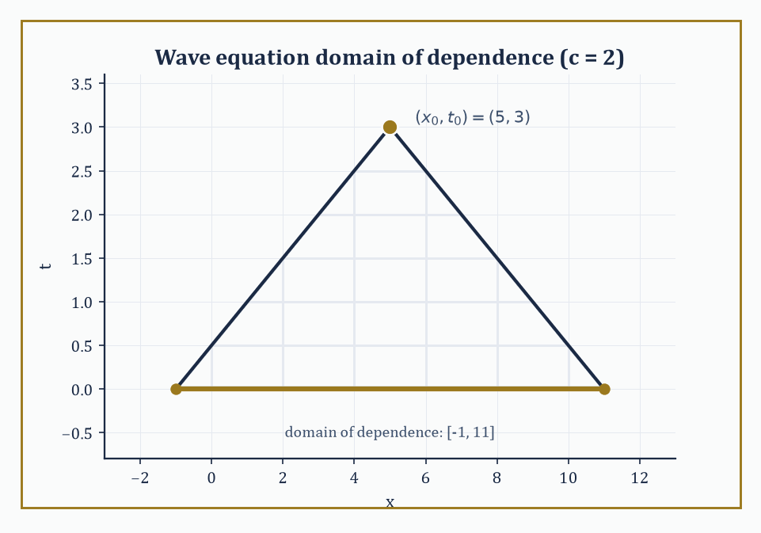
Figure 27.4 — The backward light cone from (5, 3) touches the initial line at exactly [−1, 11] — everything outside is none of its business.
uₜₜ = c² uₓₓ
governs a vibrating string, and its general solution has an unreasonably clean closed form: d’Alembert’s formula.
Because the equation factors — writing it as
(∂_t − c∂_x)(∂_t + c∂_x)u = 0
— the general solution is a superposition of a right-traveling wave and a left-traveling wave,
u(x, t) = φ(x − ct) + ψ(x + ct)
each moving rigidly at speed c without changing shape, in either direction.
Given initial displacement u(x, 0) = f(x) and initial velocity uₜ(x, 0) = g(x), the two profiles φ and ψ are pinned down completely, and the result collapses into the single formula:
u(x, t) = ½[f(x + ct) + f(x − ct)] + (1/2c) ∫ from x−ct to x+ct of g(s) ds
On the infinite line this determines the solution everywhere and for all time from the initial data alone — no boundary conditions needed, because there is no boundary.
Numeric example — d’Alembert in action, twice. Take c = 1, initial displacement f(x) = x², and initial velocity g(x) = 1 (the whole string starts moving upward uniformly). D’Alembert’s formula gives:
u(x, t) = ½[(x+t)² + (x−t)²] + ½∫ from x−t to x+t of 1 ds = ½[2x² + 2t²] + ½(2t) = x² + t² + t
Verify the PDE:
uₜₜ = 2, uₓₓ = 2, c² = 1, so uₜₜ = c²uₓₓ holds precisely
Verify the data:
u(x, 0) = x² = f(x); uₜ(x, t) = 2t + 1, so uₜ(x, 0) = 1 = g(x)
As a second instance, take instead c = 2, f(x) = sin x, g(x) = 0 (no initial velocity, a plucked string released from rest). Then:
u(x, t) = ½[sin(x+2t) + sin(x−2t)]
and the sum-to-product identity
sin A + sin B = 2 sin((A+B)/2) cos((A−B)/2)
collapses this to:
u(x, t) = sin x · cos 2t
— the initial shape stays put in x but oscillates in place with angular frequency 2, a standing wave built from two traveling ones.
Try it now — With c = 1, f(x) = x² and g = 0, use d’Alembert’s formula to find u(1, 2). Answer →
D’Alembert’s formula also reads off, at a glance, one of the wave equation’s signature features: finite propagation speed.
The value u(x₀, t₀) depends only on the initial data inside the interval [x₀ − ct₀, x₀ + ct₀] — the domain of dependence — because that is the only stretch of the initial line the two characteristic lines through (x₀, t₀) can reach.
Turn it around and a given point x₁ on the initial line can only influence the solution inside the expanding wedge |x − x₁| ≤ ct — its domain of influence. No signal, however the initial data are chosen, can travel faster than c.
This is the qualitative fingerprint of every hyperbolic equation, and it is why light, whose electric and magnetic fields obey wave equations of this kind, travels at a definite speed c rather than arriving everywhere at once.
Numeric example — domains of dependence and influence. With wave speed c = 2, the value of the solution at the spacetime point (x₀, t₀) = (5, 3) depends only on initial data on the interval:
[5 − 2·3, 5 + 2·3] = [−1, 11]
Data given outside that interval — say, a bump in f(x) centered at x = 20 — has, mathematically, zero effect on u(5, 3); no amount of waiting changes that, since t₀ is already fixed at 3.
If instead we ask what that same bump at x = 20 can influence by time t = 3, the answer is the interval:
[20 − 6, 20 + 6] = [14, 26]
— the point x₀ = 5 is nowhere near it, consistent with the domain-of-dependence calculation above. The two notions, dependence and influence, are simply the same cone viewed from its two ends.
Energy is conserved for the free wave equation — the quantity
E(t) = ½∫(uₜ² + c²uₓ²) dx
summing kinetic and elastic potential energy, is constant in time, and this single fact (provable by differentiating E and integrating by parts) supplies uniqueness for the wave equation with none of d’Alembert’s explicit formula required — an energy method, the first of several such arguments that will recur throughout this chapter.
In more than one space dimension the story acquires an extra, almost whimsical twist: Huygens’ principle.
In three dimensions (and in every odd dimension from three upward), a localized disturbance produces a sharp signal — an observer feels nothing, then feels the full disturbance, then feels nothing again, cleanly. In two (and any even) dimension, the signal never fully passes — it leaves a decaying wake behind it forever. One dimension is its own exception: a released bump does pass cleanly, but an initial push leaves the string displaced for good, which is the integral of g in d’Alembert’s formula at work.
This is why a firework you hear cleanly click and then stop, but a stone dropped in a pond leaves ripples lingering long after the splash: sound lives in three dimensions, but the surface of a pond is stuck in two.
Abstract example — a sharp bang against a lingering ripple. Fix wave speed c = 1 and imagine an idealized instantaneous disturbance released at the origin at time t = 0.
An observer at distance r = 10 from the origin, in three-dimensional space, feels absolutely nothing until t = 10, then experiences the disturbance, and then — this is the sharp part — feels nothing again for all t > 10: the trailing edge of the signal is as crisp as the leading edge, because the fundamental solution of the three-dimensional wave equation is supported exactly on the sphere:
|x| = ct
a set of measure zero at each instant.
Repeat the experiment with the two-dimensional wave equation (the honest model for ripples on a pond surface): the same observer still feels nothing before t = 10, begins to feel the disturbance at t = 10, but the response then decays only like:
1/√(t² − r²)
as t → ∞ rather than switching off — the disturbance rings on forever, ever more faintly.
The difference between these two outcomes is Huygens’ principle, and it holds in odd dimensions from three upward and fails in every even dimension, for reasons buried in the fine structure of Bessel functions that we will only glimpse, in Separation of Variables and Eigenfunction Expansions, and never fully chase down.
Keep only this · Section 27.4: The Wave Equation
The idea. uₜₜ = c²uₓₓ sends profiles at speed c in both directions. D’Alembert’s formula solves the problem on a line; information travels at finite speed, and energy is conserved.
Core.
u = ½[f(x − ct) + f(x + ct)] + (1/2c)∫ g(s) ds over [x − ct, x + ct]
domain of dependence of (x₀, t₀): [x₀ − ct₀, x₀ + ct₀]
E = ½∫(uₜ² + c²uₓ²) dx is constant
Typical mistake. Expecting the wave equation to smooth rough data. A kink in f travels along x ± ct and never rounds off.
Minimal example. f = 0, g = 1, c = 1: u = t.
Practice. Easy to challenge; full worked answers, with the usual mistake, are in Answers to the Practice Sets at the back.
Easy — With c = 2, which initial values determine u(5, 3)? Answer →
Medium — With c = 1, f = 0 and g(x) = cos x, find u(x, t). Answer →
Challenge — Show that the energy of u = sin x cos(ct) on [0, π] is constant. Answer →

Section 27.5: The Heat Equation
Where yesterday’s sharp corners become today’s smooth curves
Let a single drop of ink fall into a glass of still water. At first it is a small dark spot. A minute later it is a larger, paler cloud; later still, a faint tint through half the glass. The ink never disappears and never gathers itself back up. It only spreads, and the spreading slows down as it goes.
What a Partial Differential Equation Actually Is wrote down the local rule behind that, and this section solves it. Here is the answer first, as numbers. Release one unit of heat at a single point of a long bar, with diffusivity k = 1, and read the temperature directly above the release point:
t = 0.25: peak 0.5642, spread (standard deviation) 0.707
t = 1: peak 0.2821, spread 1.414
t = 4: peak 0.1410, spread 2.828
Each time t is multiplied by four, the peak halves and the spread doubles, so the area under the curve, the total heat, stays exactly 1. The peak never reaches zero, and neither does the temperature anywhere else: at every point of the bar it is already a little above zero, however far away and however soon. That last fact is surprising, and the section comes back to it.
The curve with those properties is a Gaussian, the bell curve, and in this setting it is called the heat kernel. The 0.2821 at t = 1 reappears in the first example below.
The heat equation
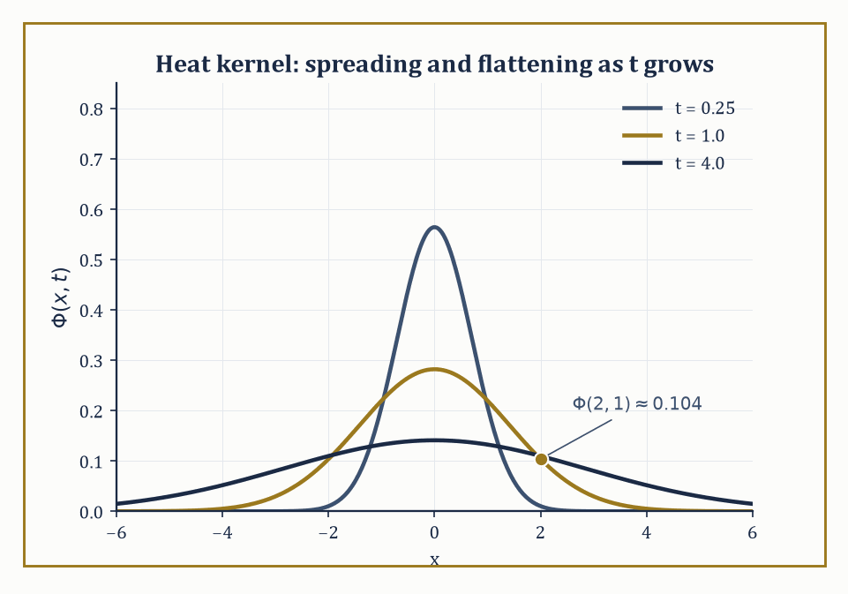
Figure 27.5 — The heat kernel at t = 0.25, 1, and 4 — same total area under each curve, ever more thinly spread.
uₜ = k uₓₓ
(with k > 0 the diffusivity) models the diffusion of temperature, of chemical concentration, or — rather more alarmingly for anyone who has just met it — of probability itself, since it is also the equation governing Brownian motion.
On the whole real line, the initial-value problem u(x, 0) = u₀(x) is solved by convolving the initial data against the heat kernel (or fundamental solution):
Φ(x, t) = (4πkt)^(−1/2) exp(−x²/4kt)
u(x, t) = ∫ over all y of Φ(x − y, t) u₀(y) dy
This formula is worth pausing over, because it encodes the equation’s entire personality.
Φ(·, t) is itself a Gaussian bump that starts (as t → 0⁺) infinitely tall and infinitely thin — a mathematical idealization of a point source of heat — and spreads out, flattening as t grows, while always integrating to exactly 1: heat is neither created nor destroyed, merely redistributed.
Numeric example — evaluating the fundamental solution. With diffusivity k = 1, evaluate the fundamental solution at x = 2, t = 1:
Φ(2, 1) = (4π·1)^(−1/2) exp(−4/4) = (4π)^(−1/2) e⁻¹
Numerically, 4π ≈ 12.566, so (4π)^(−1/2) ≈ 0.2821, and e⁻¹ ≈ 0.3679, giving:
Φ(2, 1) ≈ 0.2821 × 0.3679 ≈ 0.1038
This number is the temperature, at distance 2 from a unit point source of heat released at the origin at time 0, exactly one time unit later — compare it to the peak temperature directly above the source at the same instant:
Φ(0, 1) = (4π)^(−1/2) ≈ 0.2821
and the ratio
0.1038/0.2821 ≈ 0.368 = e⁻¹
shows the Gaussian’s characteristic exponential fall-off with distance.
Try it now — Evaluate the heat kernel Φ(x, t) = (4πkt)^(−1/2) exp(−x²/(4kt)) at x = 0, t = 1, k = 1. Answer →
An immediate and rather startling consequence of the convolution formula is that the solution becomes analytic (infinitely differentiable and locally given by a convergent power series) the instant t > 0, no matter how rough — even discontinuous — the initial data u₀ were. The heat equation is the great smoother of the PDE world.
The price for this generosity is infinite propagation speed: strictly, Φ(x, t) > 0 for every x and every t > 0, however large |x| and however small t, so heating a point at the origin is felt, in principle, everywhere else in the universe instantaneously (if only by an absurdly, undetectably tiny amount).
This is physically dubious — nothing should travel faster than light — but it is a faithful feature of the idealized model, and a useful warning that every PDE is a simplification with a domain of validity.
Numeric example — a Gaussian evolving into a wider, flatter Gaussian. Gaussian initial data evolve into Gaussian solutions, by the reproducing property of Gaussians under convolution — a fact worth checking explicitly rather than taking on faith.
Let k = 1 and u₀(x) = exp(−x²) (matching Φ’s form with an effective starting time a = 1/4, since exp(−x²/(4·(1/4))) = exp(−x²)). The general Gaussian-evolves-to-Gaussian formula gives:
u(x, t) = (1 + 4t)^(−1/2) exp(−x²/(1 + 4t))
At t = 0 this reads:
(1)^(−1/2)exp(−x²) = exp(−x²) = u₀(x)
correct. At t = 2:
u(x, 2) = 9^(−1/2) exp(−x²/9) = (1/3) exp(−x²/9)
— the bump has widened (the denominator inside the exponential grew from 1 to 9) and its peak height has dropped from 1 to 1/3, as diffusion should behave: same total heat, spread more thinly.
To confirm the PDE directly, set s = 1 + 4t and u = s^(−1/2)exp(−x²/s); differentiating gives:
uₓ = −2x s^(−3/2) exp(−x²/s)
uₓₓ = exp(−x²/s)[−2s^(−3/2) + 4x²s^(−5/2)]
while:
uₜ = (ds/dt)(du/ds) = 4·exp(−x²/s)[−½s^(−3/2) + x²s^(−5/2)] = exp(−x²/s)[−2s^(−3/2) + 4x²s^(−5/2)]
— identical to uₓₓ, term for term.
On a bounded interval, separation of variables (the subject of Separation of Variables and Eigenfunction Expansions in full generality) produces solutions as sums of exponentially decaying sine or cosine terms, each mode
exp(−λₙt) sin(nπx/L)
decaying at its own rate λₙ — the higher-frequency wiggles die out fastest, which is the smoothing phenomenon from the previous example rewritten in Fourier language.
Two further facts anchor the theory rigorously. The maximum principle states that a solution of the heat equation on a bounded space-time region attains both its maximum and its minimum on the parabolic boundary — the initial time slice together with the lateral spatial boundary — and, unless the solution is constant, nowhere else, which is the statement that heat cannot spontaneously well up from nowhere in the middle of a rod.
And energy methods, multiplying the equation by u and integrating by parts, show that the quantity ∫u² dx is non-increasing in time, giving uniqueness and quantitative decay estimates without ever solving the equation explicitly.
Numeric example — the maximum principle watching temperature decay. Solve uₜ = uₓₓ on the interval [0, π] with Dirichlet boundary conditions u(0, t) = u(π, t) = 0 and initial data u(x, 0) = sin x.
This is already an eigenfunction of the spatial operator (−d²/dx² with these boundary conditions has eigenfunctions sin(nx), eigenvalue n²), so no expansion is even needed: the exact solution matches Section 27.1’s very first example:
u(x, t) = e⁻ᵗ sin x
At t = 0, the maximum over the whole closed bar is 1, attained at x = π/2 — squarely on the initial-time part of the parabolic boundary, as the maximum principle demands.
At t = 1, the profile has shrunk uniformly to e⁻¹ sin x, whose maximum is e⁻¹ ≈ 0.368, less than 1; at t = 5, it has shrunk further to a maximum of e⁻⁵ ≈ 0.0067 — the temperature is, for all practical purposes, back to the (zero) boundary value everywhere, the decay-to-equilibrium behavior the energy method predicts in general, here made completely explicit.
Where this returns
The heat kernel is also the density of Brownian motion, and diffusion returns in that form in Probability Theory (Advanced) (Volume 4). The explicit heat scheme is analyzed in Numerical Methods for Partial Differential Equations.
Keep only this · Section 27.5: The Heat Equation
The idea. uₜ = kuₓₓ smooths and spreads. On the line the solution is the initial data convolved with the heat kernel; on an interval each Fourier mode decays like exp(−kn²t); the maximum principle says the maximum is attained at the start or on the boundary.
Core.
Φ(x, t) = (4πkt)^(−1/2) exp(−x²/(4kt))
u(·, t) = Φ(·, t) * u₀
sin(nx) decays like exp(−kn²t)
Typical mistake. Expecting finite speed. The heat kernel is positive everywhere for t > 0, so a local disturbance is felt everywhere at once, if faintly.
Minimal example. uₜ = uₓₓ, u(x, 0) = sin x on [0, π]: u = e⁻ᵗ sin x.
Practice. Easy to challenge; full worked answers, with the usual mistake, are in Answers to the Practice Sets at the back.
Easy — With k = 1, when has the mode sin 3x decayed to e⁻⁹ of its starting size? Answer →
Medium — With k = 1 and u₀ = exp(−x²), the solution is u = (1 + 4t)^(−1/2) exp(−x²/(1 + 4t)). Find u(0, 2). Answer →
Challenge — u(x, 0) = sin x + 0.5 sin 3x on [0, π] with zero boundary values and k = 1. Write u and find when the second mode is 1% of the first. Answer →

Section 27.6: Laplace’s Equation and Harmonic Functions
The mathematics of things that have settled down
Bend a loop of wire, dip it in soapy water and lift it out. The film that forms has settled: it is not moving, and, as long as the wire is only gently bent, every small patch of it sits at the average height of the film around it, because any patch higher than its surroundings would be pulled down by the tension around it, and any lower patch pulled up. A metal plate whose edges are held at fixed temperatures settles in the same way. Long after it was switched on, the temperature at each point is the average of the temperatures around it.
You can test the averaging rule with four numbers. Take the surface u = x² − y² from this section’s figure and stand at the origin, where u = 0. Step one unit east, north, west and south: u is 1, −1, 1 and −1, and the average of those four is 0, exactly the value at the center. Move to the point (1, 1), where u = 1 − 1 = 0 again, and do the same: east (2, 1) gives 3, north (1, 2) gives −3, west (0, 1) gives −1, south (1, 0) gives 1. The average is 0 once more.
A surface whose value at every point equals its average around every circle drawn about that point is called harmonic; the four-point check is the quick version of that test. The equation that says so, one point at a time, is Laplace’s equation, and it is the heat equation of The Heat Equation with the time derivative set to zero: the state the heat equation settles into once it has finished smoothing.
Laplace’s equation:
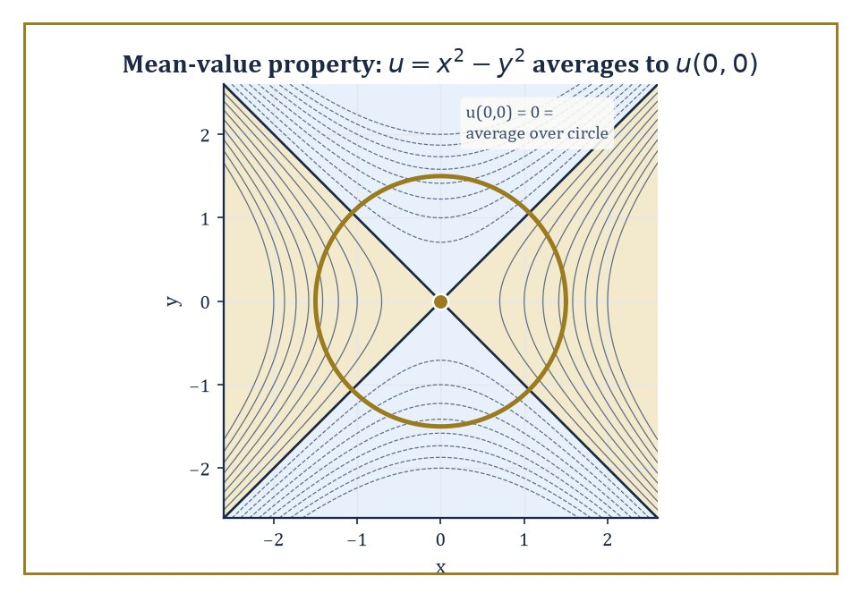
Figure 27.6 — The saddle u = x² − y² refuses to disagree with its own neighborhood: its average over any circle centered at the origin is u(0,0).
Δu = u_xx + u_yy (plus u_zz, in three dimensions) = 0
describes states of equilibrium: steady temperatures, electrostatic potentials in a charge-free region, or the velocity potential of an incompressible, irrotational fluid flow.
Solutions are called harmonic functions, and they are, by a wide margin, the best-behaved functions in the whole of analysis. Three facts anchor everything else in this section.
First, the mean-value property: the value of a harmonic function at any point equals its average over any circle (or sphere) centered at that point and lying inside the domain — a harmonic function literally cannot disagree with its own neighborhood on average.
Second, the maximum principle: a non-constant harmonic function on a bounded domain attains its maximum and minimum only on the boundary, never in the interior — an immediate corollary of the mean-value property, since an interior maximum would force the function to be constant nearby.
Third, the regularity theorem: harmonic functions are automatically real-analytic (locally a convergent power series) wherever they are merely twice differentiable — an astonishing amount of smoothness extracted from a single linear equation with no smoothing terms visibly built in.
Numeric example — checking harmonicity directly. Check that the following function is harmonic:
u(x, y) = x³ − 3xy²
(it is, in fact, the real part of z³ where z = x + iy, and the real and imaginary parts of any holomorphic function are automatically harmonic — a fact we will not prove here but is well worth remembering as a source of endless free examples). Differentiate:
uₓ = 3x² − 3y², so uₓₓ = 6x
u_y = −6xy, so u_yy = −6x
Then:
Δu = u_xx + u_yy = 6x + (−6x) = 0
for every (x, y) — harmonic everywhere, with no exceptions and no boundary needed to check it.
Try it now — Is u = x² − y² harmonic? Answer →
The mean-value property is not only a curiosity; it is directly checkable and directly useful, so it is worth verifying by honest computation rather than by appeal to holomorphic functions.
Numeric example — the mean-value property by direct integration. Take the harmonic function
u(x, y) = x² − y²
(harmonic since u_xx = 2, u_yy = −2, sum zero) and average it over the circle of radius r centered at the origin. In polar coordinates x = r cos θ, y = r sin θ, so:
u = r²(cos²θ − sin²θ) = r² cos 2θ
The average over the full circle is:
(1/2π)∫ from 0 to 2π of r² cos 2θ dθ = r² · (1/2π) · 0 = 0
since cos 2θ integrates to zero over a full period. And indeed
u(0, 0) = 0² − 0² = 0
exactly matches — the mean-value property confirmed by direct integration, for every radius r simultaneously, not just in the limit.
The Dirichlet problem seeks a harmonic function inside a domain matching prescribed values on the boundary; the Neumann problem instead prescribes the outward normal derivative there (physically: fixed temperature versus fixed heat flux).
On the unit disk, the Dirichlet problem has an explicit solution — the Poisson integral formula — built from the Poisson kernel:
Pᵣ(θ − φ) = (1 − r²)/(1 − 2r cos(θ − φ) + r²)
which reproduces boundary data as r → 1 and smooths it into a harmonic function for r < 1.
On domains without such convenient symmetry one falls back on conformal mapping (bend the domain into a disk, solve there, bend back), Perron’s method (build the solution as the supremum of all subharmonic functions staying below the boundary data), or variational methods, which — appropriately — are the subject waiting in the next chapter.
Numeric example — the Poisson kernel and a solved Dirichlet problem. Two quick illustrations of the Poisson machinery. First, the kernel value itself: with r = 0.5 and θ − φ = −π/2 (so cos(θ−φ) = 0):
P_0.5(−π/2) = (1 − 0.25)/(1 − 0 + 0.25) = 0.75/1.25 = 0.6
— a concrete number measuring how strongly the boundary value at angle φ influences the interior point at radius 0.5, angle θ.
Second, the whole Dirichlet problem in one easy case: if the boundary data are u(1, θ) = cos θ, the Poisson integral evaluates to:
u(r, θ) = r cos θ
which, converted back to Cartesian coordinates, is:
u(x, y) = x
Check it: Δx = 0 trivially (it’s linear), and on the unit circle x = cos θ matches the prescribed boundary data — the harmonic extension of cos θ into the disk is nothing more exotic than the coordinate function x itself.
Green’s identities — integration by parts applied twice to the Laplacian — relate volume (or area) integrals involving harmonic functions to boundary integrals, and they are the ultimate source of representation formulas like the Poisson integral and the mean-value property alike: both can be derived as special cases of Green’s second identity applied with a suitably chosen comparison function.
In this sense the mean-value property verified numerically above is not an isolated party trick but the shadow, on the very simplest possible domain (a disk with the source point at its center), of a much more general boundary-integral machine that will resurface, in more powerful clothing, as the Green’s function of Green’s Functions, Maximum Principles, and Energy Methods.
Keep only this · Section 27.6: Laplace’s Equation and Harmonic Functions
The idea. Harmonic functions (Δu = 0) are averages of themselves: the value at a center equals the mean over any circle around it. That gives the maximum principle, and the Poisson kernel solves the Dirichlet problem on a disk.
Core.
Δu = uₓₓ + uᵧᵧ = 0
u(center) = mean of u over any circle
Poisson kernel: (1/2π)(1 − r²)/(1 − 2r cos θ + r²)
Typical mistake. Assuming symmetry means harmonic. x² + y² is perfectly symmetric and Δ(x² + y²) = 4.
Minimal example. u = x on the unit disk: the mean of cos θ over the circle is 0 = u(0, 0).
Practice. Easy to challenge; full worked answers, with the usual mistake, are in Answers to the Practice Sets at the back.
Easy — Check that u = eˣ cos y is harmonic. Answer →
Medium — A harmonic function on the unit disk has boundary values 3 + cos θ + 2 sin 2θ. Find u(0, 0). Answer →
Challenge — Solve the Dirichlet problem on the unit disk with boundary values cos 2θ, and evaluate the solution at (0.5, 0). Answer →

Section 27.7: Separation of Variables and Eigenfunction Expansions
Divide the problem, then add the pieces back up
Same structure, new language
The eigenfunctions here are those of Boundary-Value Problems and Sturm–Liouville Theory, and the expansions are the Fourier series of Fourier Transforms and FFT (Volume 2). Separation of variables is the step that hands a PDE to that machinery.
Pluck a guitar string and it vibrates in a blend of simple patterns: the whole string swinging as one arch, the two halves swinging in opposition, then three parts, and so on, each pattern with its own pitch. Separation of variables turns that observation into a method. Guess that the solution is a shape in space multiplied by a rhythm in time, find the possible shapes and rhythms separately, and then add up enough of them to match how the string started. For a string first pulled into a smooth arch, just two such sine patterns already reproduce the starting shape to within 0.6 per cent at its highest point.
Separation of variables is the great workhorse of explicit PDE-solving on domains with enough symmetry to support it. The method guesses that a solution factors,
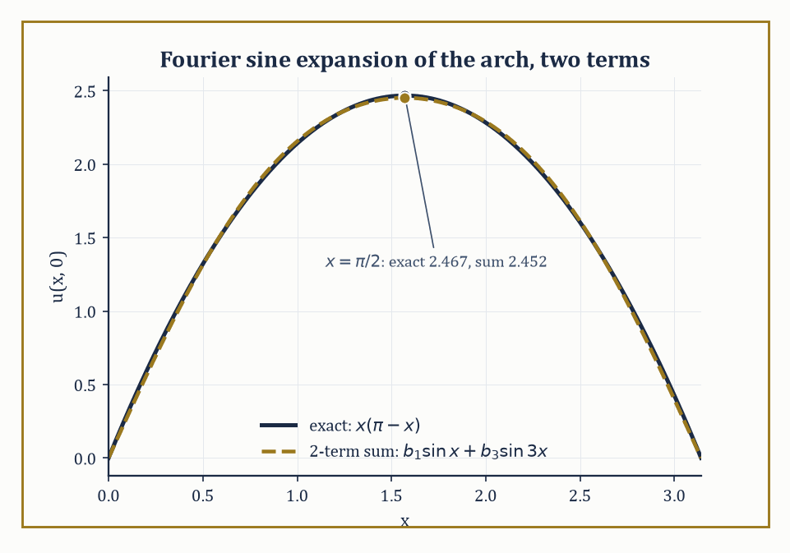
Figure 27.7 — Just two terms of the sine expansion already trace the arch x(π − x) to within 0.6% at its peak.
u(x, t) = X(x)T(t)
substitutes into the PDE, and — if the equation and the geometry cooperate — finds that the two sides of the resulting equation depend on different variables and so must both equal the same constant, traditionally written −λ.
This single step converts one PDE into two ODEs: a temporal one involving λ, and a spatial one,
X″ + λX = 0
(say), that together with the boundary conditions becomes a Sturm–Liouville eigenvalue problem.
Only special values of λ — the eigenvalues — admit nonzero solutions X (the eigenfunctions), and Sturm–Liouville theory guarantees these eigenfunctions form a complete orthogonal basis for the relevant space of functions on the domain.
The full solution of the original PDE is then an infinite sum — an eigenfunction expansion — of these building blocks, each carrying its own time-dependence, with coefficients fixed by matching the initial or boundary data via the orthogonality of the basis (the machinery of Fourier series, generalized).
Numeric example — expanding a non-eigenfunction initial profile. Solve uₜ = uₓₓ on [0, π] with Dirichlet conditions u(0,t)=u(π,t)=0 and a non-eigenfunction initial profile — a smooth arch, zero at both ends, unlike Section 27.5’s convenient sin x:
u(x, 0) = x(π − x)
The eigenfunctions here are sin(nx) with eigenvalue n² (n = 1, 2, 3, …), so we need the Fourier sine coefficients:
bₙ = (2/π)∫ from 0 to π of x(π−x) sin(nx) dx
A standard integration-by-parts computation (twice, on the x² term) gives:
∫ from 0 to π of x(π−x) sin(nx) dx = 2(1 − (−1)ⁿ)/n³
which vanishes for even n and equals 4/n³ for odd n; hence:
bₙ = 8/(πn³) for odd n, and 0 for even n
Numerically,
b₁ = 8/π ≈ 2.5465, b₃ = 8/(27π) ≈ 0.0943
— already two orders of magnitude smaller, showing how fast this particular expansion converges. The full solution is:
u(x, t) = the sum over odd n of (8/(πn³)) exp(−n²t) sin(nx)
Check the initial profile at x = π/2, where the exact value is:
(π/2)(π/2) = π²/4 ≈ 2.4674
the two-term truncation gives:
b₁ sin(π/2) + b₃ sin(3π/2) = 2.5465(1) + 0.0943(−1) ≈ 2.4522
already within 0.6% of the exact arch height using only two terms — and the n = 3 mode decays, in time, nine times faster in the exponent than the n = 1 mode (e⁻⁹ᵗ against e⁻ᵗ), so the arch not only matches almost immediately but also smooths toward a pure sine shape almost immediately after.
Try it now — Which separated solution of uₜ = uₓₓ on [0, π] with zero boundary values starts as sin 2x? Answer →
The specific special functions that appear as eigenfunctions depend entirely on the coordinate system forced on you by the domain’s geometry. Rectangular domains, as above, produce ordinary sines and cosines.
Problems with circular or cylindrical symmetry (a vibrating drum, heat flow in a cylindrical rod) produce Bessel functions in the radial variable. Problems with spherical symmetry (heat flow in a ball, the hydrogen atom’s angular structure, gravitational or electrostatic potentials) produce Legendre functions and, combined with the angular sines and cosines, spherical harmonics.
In every case the underlying logic is identical — separate, reduce to a Sturm–Liouville problem, find the eigenbasis, expand — even though the resulting functions look, at first encounter, like wholly different species.
The same technique also handles non-homogeneous equations (a forcing term present): expand the forcing term itself in the same eigenbasis and solve, mode by mode, for the coefficients of the response, since the eigenbasis diagonalizes the linear operator completely.
Abstract example — the fundamental note of a circular drum. Consider a circular drum of radius a, governed by the two-dimensional wave equation in polar coordinates.
Separation of variables in r and θ leads, for the radially symmetric modes, to Bessel’s equation of order zero, whose solutions regular at the center are J₀(kr) for a parameter k; the clamped-edge boundary condition u(a, t) = 0 forces J₀(ka) = 0, so k must be chosen so that ka is a zero of J₀.
The first positive zero of J₀ is the well-tabulated constant:
j₀,₁ ≈ 2.4048
(a distant relative, purely by coincidence, of the sinh-based blow-up constants in Section 27.1’s Hadamard example — both are where certain classical functions happen to vanish or explode).
For a drum of radius a = 1 with wave speed c = 1, the fundamental angular frequency is therefore:
ω = c·j₀,₁/a ≈ 2.4048 rad/s
giving an ordinary frequency:
f = ω/(2π) ≈ 0.3827 Hz
— the lowest note the drum can produce, computed from nothing but the first zero of a Bessel function, the same logic that gave the note exp(−n²t) sin(nx) its overtone structure on a rectangular string, wearing the costume appropriate to a round drum instead.
Separation of variables remains, after everything modern analysis has added to the subject, the single most important explicit method for solving the classical linear equations on domains with enough symmetry to support it — squares, disks, balls, cylinders, and their kin.
It is not universal (an irregularly shaped domain, in general, offers no separable coordinate system at all), but where it applies it turns an infinite-dimensional problem into a countable family of one-dimensional ones, and that reduction is, in a very real sense, the origin of the entire theory of Fourier and eigenfunction expansions that pervades the rest of analysis.
Keep only this · Section 27.7: Separation of Variables and Eigenfunction Expansions
The idea. Try u = X(x)T(t). The PDE splits into an eigenvalue problem in x and an ODE in t; the boundary conditions pick the eigenfunctions, and the initial data is expanded in them.
Core.
u = Σ bₙ exp(−n²t) sin(nx)
bₙ = (2/π)∫₀^π f(x) sin(nx) dx
wave: u = Σ (aₙ cos nct + bₙ sin nct) sin nx
Typical mistake. Separating with nonzero boundary values. First subtract a steady state so the boundary conditions become zero.
Minimal example. f = sin x + sin 3x: u = e⁻ᵗ sin x + e⁻⁹ᵗ sin 3x.
Practice. Easy to challenge; full worked answers, with the usual mistake, are in Answers to the Practice Sets at the back.
Easy — Find b₁ for f(x) = 1 on [0, π]. Answer →
Medium — With f(x) = 1, write the first two nonzero terms of the solution of uₜ = uₓₓ. Answer →
Challenge — Solve uₜ = uₓₓ on [0, π] with u(0, t) = 0, u(π, t) = π and u(x, 0) = 0. Answer →

Section 27.8: Green’s Functions, Maximum Principles, and Energy Methods
How to know a great deal about a solution you will never write down
Press on a taut trampoline with one finger and the surface dips around that point. Press with a whole hand, or scatter sand across it, and the shape you get is simply the sum of single-finger dips, one for every point where weight is applied. That single-finger response is the Green’s function, and once you know it, any load can be handled by adding up responses. For a string held fixed at both ends, the response to a push three tenths of the way along is a tent, rising in a straight line to that point and falling in a straight line beyond it. The section adds two more ways to study a solution never written down.
The Green’s function of a linear differential operator L, subject to given boundary conditions, is the integral kernel G(x, ξ) such that the solution of Lu = f is recovered as:
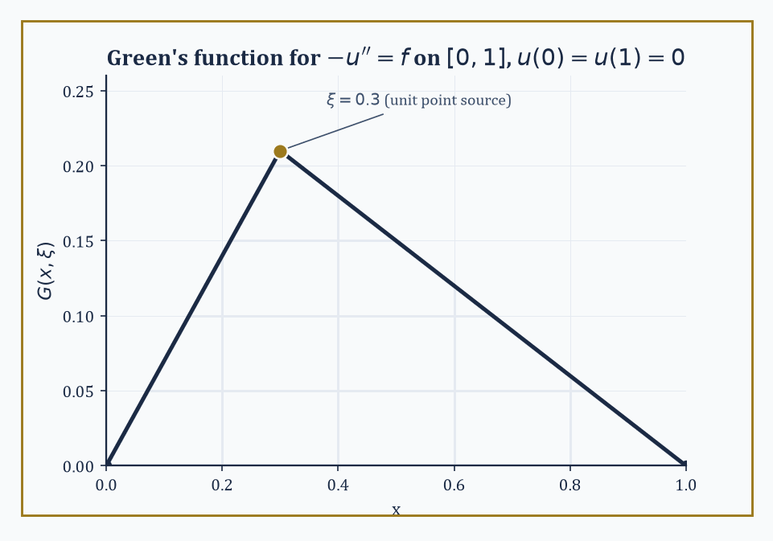
Figure 27.8 — The Green’s function for −u″ = f on [0,1] is a tent pitched at the source point ξ = 0.3 — the response to a single unit push.
u(x) = ∫G(x, ξ)f(ξ) dξ
Conceptually, G(x, ξ) is the response at x to a unit point source concentrated at ξ — build the solution for an arbitrary forcing f by superposing (integrating over) point-source responses, which works because L is linear.
Constructing G explicitly for the Laplacian on simple domains (a disk, a half-space, a ball) is classical, typically via the method of images; for more general operators or domains one appeals instead to abstract existence theory or numerical approximation, but the interpretive idea — a solution is a weighted average of point-source responses — survives unchanged.
Numeric example — building and using a Green’s function. Construct the Green’s function for −u″ = f on [0, 1] with Dirichlet conditions u(0) = u(1) = 0 — the ODE case, simplest possible setting, but the logic transfers directly to the Laplacian.
The response to a unit point source at ξ is a function linear on each side of ξ, continuous at ξ, vanishing at the two endpoints, with a unit jump in slope at ξ (from integrating −u″ = a point source once):
G(x, ξ) = x(1 − ξ) for x ≤ ξ, and ξ(1 − x) for x ≥ ξ
Use it to solve −u″ = 1 (uniform unit forcing, ξ ranging over all of [0,1]):
u(x) = ∫ from 0 to x of ξ(1−x) dξ + ∫ from x to 1 of x(1−ξ) dξ
The first integral is (1−x)·x²/2; the second, after expanding, is x/2 − x² + x³/2. Adding:
(x²/2 − x³/2) + (x/2 − x² + x³/2) = x/2 − x²/2 = x(1−x)/2
Check directly:
u = (x − x²)/2 gives u″ = −1, so −u″ = 1 = f
just as required, and u(0) = u(1) = 0 — the Green’s function reproduces the standard textbook answer for this equation without ever solving the ODE by hand.
Try it now — On the disk of radius 2, where does u = x² − y² take its largest and smallest values? Answer →
Maximum principles, met already for the heat equation and for harmonic functions, generalize to a wide class of elliptic and parabolic operators, and they give something ODEs rarely offer for free: pointwise control of a solution purely from control of its boundary and initial data, without solving the equation at all.
This is the direct route to uniqueness theorems (two solutions with the same data must agree, since their difference is a solution with zero data and hence, by the maximum principle, identically zero) and to comparison theorems (if one problem’s data dominate another’s everywhere on the boundary, its solution dominates the other’s everywhere inside too).
Numeric example — the maximum principle bounding an interior value. Take the harmonic function u(x, y) = x² − y² on the disk of radius 2 centered at the origin. On the boundary, x² + y² = 4, so y² = 4 − x², giving:
u = x² − (4 − x²) = 2x² − 4
since x² ranges over [0, 4] on this circle, the boundary values of u range over [−4, 4] (the minimum −4 at (0, ±2), the maximum 4 at (±2, 0)).
The maximum principle guarantees every interior value also lies in [−4, 4] — check the interior point (1, 1) (inside the disk since 1² + 1² = 2 < 4):
u(1,1) = 1 − 1 = 0
comfortably inside [−4, 4], as promised, and indeed inside every interior point one might try.
Energy methods take a different but complementary route: multiply the equation by the solution itself (or by a suitable test function), integrate over the domain, and integrate by parts to trade derivative-heavy terms for boundary terms plus a manifestly signed quantity — typically ∫|∇u|² or similar, which is never negative.
The resulting a priori estimate bounds the size of the solution (or of the difference of two candidate solutions) solely in terms of the data, again without needing an explicit formula, and this technique is considerably more robust than maximum principles: it survives the transition to weak solutions, to systems of equations, and to many nonlinear problems where no maximum principle is available at all.
Abstract example — uniqueness for Poisson’s equation by the energy method. Prove uniqueness for the Dirichlet problem Δu = f on a bounded domain Ω, u = g on the boundary of Ω, by the energy method, as a template for the technique.
Suppose u₁ and u₂ both solve it; let w = u₁ − u₂. Then:
Δw = 0 in Ω, w = 0 on the boundary
Multiply Δw = 0 by w and integrate over Ω:
the integral over Ω of w·Δw equals 0
Integrate by parts (Green’s first identity) on the left:
the integral over Ω of w·Δw equals the boundary integral of w times the outward normal derivative of w, minus the integral over Ω of |∇w|²
The boundary integral vanishes because w = 0 on all of the boundary, leaving:
minus the integral of |∇w|² equal to 0, so the integral of |∇w|² over Ω is 0
Since |∇w|² ≥ 0 pointwise and its integral is zero, |∇w| is identically zero throughout Ω — w is constant. And since w = 0 on the boundary, that constant is 0.
Hence u₁ ≡ u₂: uniqueness, extracted entirely from one multiplication, one integration by parts, and the simple fact that a nonnegative quantity integrating to zero must vanish everywhere — no explicit solution formula was needed, or in fact available, for a general domain Ω.
Keep only this · Section 27.8: Green’s Functions, Maximum Principles, and Energy Methods
The idea. Green’s functions give solutions as integrals against a point-source response. The maximum principle bounds harmonic functions by their boundary values, and energy integrals prove uniqueness.
Core.
−u″ = f on [0, 1]: G = x(1 − ξ) for x ≤ ξ, ξ(1 − x) for x ≥ ξ
harmonic u: max over the closed region = max on the boundary
∫|∇w|² = 0 ⇒ w constant
Typical mistake. Applying the maximum principle to Δu = f with f ≠ 0. It holds for harmonic (or subharmonic) functions, not for every solution of Poisson’s equation.
Minimal example. −u″ = 1 with u(0) = u(1) = 0: u = x(1 − x)/2.
Practice. Easy to challenge; full worked answers, with the usual mistake, are in Answers to the Practice Sets at the back.
Easy — Using G above, compute u(1/2) for −u″ = 1. Answer →
Medium — A harmonic function on the unit disk has boundary values 1 + 2 cos θ. Bound u on the disk and find u(0, 0). Answer →
Challenge — Prove by the energy method that −u″ = f on [0, 1] with u(0) = u(1) = 0 has at most one solution. Answer →

Section 27.9: Looking Ahead: From Classical PDEs to Modern Theory and Applications
Everything above was the warm-up
We have now acquired the classical core of the subject: the method of characteristics for first-order equations, the elliptic/parabolic/hyperbolic classification, the three prototype equations solved essentially by hand, separation of variables and eigenfunction expansions for domains with symmetry, and Green’s functions, maximum principles, and energy methods as the analytic tools that make everything rigorous rather than merely suggestive.
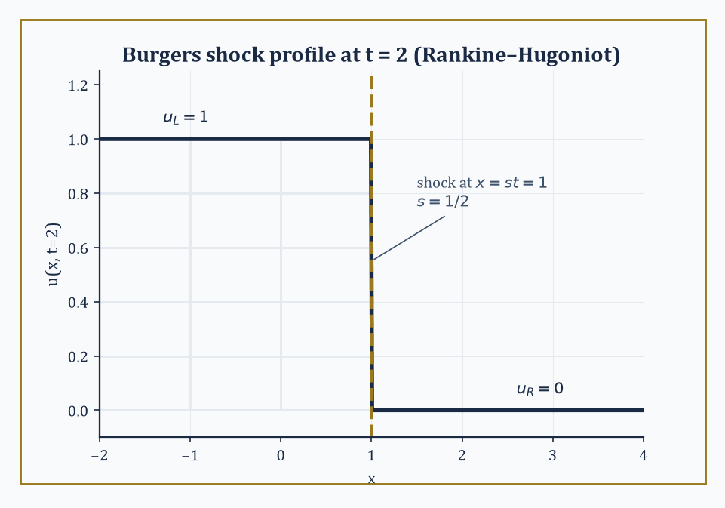
Figure 27.9 — Rankine–Hugoniot names the price of admission: the jump from u = 1 to u = 0 must travel at exactly speed ½.
This is, roughly, where the subject stood at the start of the twentieth century — a formidable achievement, and also, by the standards of what came after, still comparatively tame.
The modern theory begins by admitting that classical (smooth, everywhere-differentiable) solutions are a luxury not every sensible problem can afford.
Sobolev spaces — spaces of functions whose derivatives, in a suitably generalized sense, are only square-integrable rather than continuous — permit weak solutions: functions that satisfy the equation only after being tested against smooth functions and integrated by parts, the maneuver used twice already in Green’s Functions, Maximum Principles, and Energy Methods.
This is not a retreat from rigor but an expansion of it, since existence theorems become available for equations whose classical solutions may not exist at all — the discontinuous shocks encountered in First-Order Equations and the Method of Characteristics, for instance, are perfectly respectable weak solutions even though no classical derivative of them exists at the discontinuity.
Numeric example — the speed of a shock, via Rankine-Hugoniot. A weak (shock) solution of Burgers’ equation:
uₜ + (u²/2)ₓ = 0
with the discontinuous Riemann initial data u(x, 0) = 1 for x < 0 and u(x, 0) = 0 for x > 0 propagates as a single jump moving at a speed s fixed by the Rankine–Hugoniot condition:
s = [f(u_L) − f(u_R)]/[u_L − u_R]
where f(u) = u²/2 is the flux. Here u_L = 1, u_R = 0, so:
s = (1²/2 − 0²/2)/(1 − 0) = (1/2)/1 = 1/2
the jump travels rigidly to the right at speed ½, with u = 1 to its left and u = 0 to its right for all time.
Unlike Section 27.2’s smooth arch collapsing into a shock at t = 1, this discontinuity is present in the data from the very start — and the Rankine–Hugoniot formula is precisely what tells you, once a shock has formed by either route, how fast it subsequently travels.
Try it now — A Burgers shock has u_L = 2 on the left and u_R = 0 on the right. How fast does it move? Answer →
Fully nonlinear equations — reaction-diffusion systems, nonlinear wave equations, and above all the Navier–Stokes equations of fluid flow — abandon superposition altogether and require an entirely different toolkit: fixed-point arguments (find a solution as the fixed point of a suitable map, rather than by formula), compactness methods (extract a convergent solution from a sequence of approximations), and, in the hardest cases, geometric measure theory.
Whether solutions of the three-dimensional Navier–Stokes equations always stay smooth, or can develop singularities in finite time from smooth data, is one of the seven Clay Millennium Prize problems — unresolved, as of this writing, and worth one million dollars to whoever settles it, which ought to put the difficulty of everything in this chapter into some perspective.
Numeric example — how large a Reynolds number gets. The nonlinearity’s grip on a fluid flow is measured by the Reynolds number:
Re = UL/ν
comparing inertial effects (the troublesome u·∇u term) to viscous ones (the friendly, linear Δu term). For water (kinematic viscosity ν ≈ 1.0 × 10⁻⁶ m²/s) flowing at U = 1 m/s past an obstacle of size L = 1 m:
Re = (1)(1)/(1.0×10⁻⁶) = 1,000,000
comfortably past the threshold (of the order of a few thousand, depending on geometry) at which flows abandon smooth, orderly streamlines for turbulence.
It is this regime — large Re, nonlinearity dominant, viscosity a negligible correction rather than a stabilizing force — where the Millennium Prize question lives; at small Re the linear, viscosity-dominated theory is comparatively well understood.
Where no formula, weak or otherwise, is to be had, numerical methods take over: finite differences replace derivatives with difference quotients on a discrete grid, finite elements approximate the solution by piecewise polynomials tailored to complicated geometries, and spectral methods approximate it by truncated eigenfunction expansions — Section 27.7’s technique, industrialized.
All three convert a PDE into a large, structured system of algebraic equations solvable on a computer, and all three carry their own analysis: does the discrete approximation converge to the true solution as the grid is refined, and how fast?
Numeric example — one step of a finite-difference scheme, right at the edge of stability. The simplest finite-difference scheme for the heat equation uₜ = uₓₓ (diffusivity 1) replaces derivatives by differences on a grid with spacing Δx and time step Δt, giving the explicit update:
uᵢⁿ⁺¹ = uᵢⁿ + r(uᵢ₊₁ⁿ − 2uᵢⁿ + uᵢ₋₁ⁿ)
where r = Δt/Δx² is the scheme’s single governing parameter. Take Δx = 0.25 (so Δx² = 0.0625) and Δt = 0.03125, giving:
r = 0.03125/0.0625 = 0.5
— the classical stability limit for this scheme (von Neumann analysis shows it is stable only for r ≤ ½). Start from a spike:
uᵢ₋₁ = 0, uᵢ = 1, uᵢ₊₁ = 0, all neighbors further out also 0
One step gives:
uᵢⁿᵉʷ = 1 + 0.5(0 − 2 + 0) = 1 − 1 = 0
uᵢ₋₁ⁿᵉʷ = 0 + 0.5(1 − 0 + 0) = 0.5, and symmetrically uᵢ₊₁ⁿᵉʷ = 0.5
the spike has, in a single time step, collapsed to zero at its own location and jumped its neighbors up to 0.5 each — total heat conserved (still summing near 1, spread over more points, as diffusion should), but sitting right at the edge of instability, r = 0.5 is a cautionary illustration of why numerical analysts lose sleep over stability conditions that a naive implementation could violate by an innocent-looking choice of grid spacing.
We set out, at the top of this chapter, to let the unknown function depend on more than one variable, and everything since has been the working-out of the consequences: characteristics carrying information along curves, a threefold classification borrowed wholesale from conic sections, three prototype equations whose behavior — vibration, diffusion, equilibrium — covers most of continuum physics between them, separation of variables turning symmetry into explicit series, and Green’s functions, maximum principles, and energy methods standing guard over the whole enterprise’s rigor.
It should be said plainly, in case the steeper learning curve of this chapter has been discouraging: partial differential equations are where mathematics stops being a bag of solvable tricks and becomes a genuine theory of infinite-dimensional dynamical systems, and that transition is exactly why the tools multiplied the way they did. Nobody enjoys learning to prove existence without ever seeing the solution; everybody is, eventually, grateful for a theorem that survives contact with an equation too unruly for any formula to hold it.
The next chapter turns, at last, to a question this one kept nearly asking outright — the Dirichlet problem’s harmonic functions, recall, are the minimizers of the Dirichlet energy ∫|∇u|² among functions with the given boundary values, a fact we touched but did not chase. Optimization and the calculus of variations pick up there: what does it mean for a quantity to be as small, or as large, as it can possibly be, and what equation must its minimizer satisfy? We have learned to let the unknown depend on several variables. Next, we ask it to be the very best version of itself.
Where this returns
Weak solutions need spaces of functions with weak derivatives, built in Unbounded Operators and Sobolev Spaces; the stability condition Δt/Δx² ≤ 1/2 is proved in Consistency, Stability, and Convergence.
Keep only this · Section 27.9: Looking Ahead: From Classical PDEs to Modern Theory and Applications
The idea. Classical solutions run out. Shocks need weak solutions and entropy conditions, fluids need nonlinear analysis, and computers need stable discretizations.
Core.
Burgers shock speed: s = (u_L + u_R)/2
Reynolds number: Re = UL/ν
explicit heat scheme stable when Δt/Δx² ≤ 1/2
Typical mistake. Treating a discontinuous weak solution as a defect. For conservation laws it is the physically correct answer.
Minimal example. u_L = 1, u_R = 0: shock speed 1/2.
Practice. Easy to challenge; full worked answers, with the usual mistake, are in Answers to the Practice Sets at the back.
Easy — Find the Reynolds number for U = 1 m/s, L = 0.1 m and ν = 10⁻⁶ m²/s (water). Answer →
Medium — With Δx = 0.1, what is the largest stable time step for the explicit heat scheme? Answer →
Challenge — Take one explicit step uⱼ ← uⱼ + r(uⱼ₊₁ − 2uⱼ + uⱼ₋₁) from the values 0, 1, 0, with r = 1/2 and with r = 1. What happens to the middle value? Answer →
Chapter 27 recap · Partial Differential Equations
• A PDE relates partial derivatives of a function of several variables; a problem is well posed when a solution exists, is unique, and depends continuously on the data.
• First-order equations are ODEs along characteristics; when nonlinear characteristics cross, a shock forms.
• The sign of B² − 4AC sorts second-order equations into hyperbolic, parabolic and elliptic, and the type decides which data are appropriate.
• Waves travel at finite speed and keep their shape (d’Alembert); heat spreads instantly and smooths (the heat kernel); harmonic functions are averages of themselves.
• Separation of variables turns a linear problem on a simple domain into Sturm–Liouville eigenfunction expansions.
• Green’s functions build solutions, maximum principles bound them, and energy integrals prove uniqueness.

Check Your Understanding — Chapter 27
Answers are in the Answer Key at the back of the book — have a go before you look.
1. [Explain] Hadamard’s example takes u_n(x,y) = (1/n²) sin(nx) sinh(ny), solving Laplace’s equation on y ≥ 0 with data u(x,0)=0, u_y(x,0)=(1/n)sin(nx). Why does this show the Cauchy problem for Laplace’s equation is ill-posed?
See the answer →
2. [Explain] For inviscid Burgers’ equation uₜ + u uₓ = 0 with initial data u(x,0) = −x, when and why does the classical solution break down?
See the answer →
3. [Compute] With wave speed c = 2, what interval of initial data determines the wave equation’s solution at the spacetime point (x0, t0) = (5, 3)?
See the answer →
4. [Explain] Solving uₜ = uₓₓ on [0,π] with the non-eigenfunction initial profile u(x,0) = x(π−x), why does keeping just the first two terms of the sine expansion already approximate the exact arch height at x=π/2 to within 0.6%, and why does the shape smooth toward pure sin(x) so quickly in time?
See the answer →
5. [Compute] Solve the transport equation uₜ + c·uₓ = 0 with u(x, 0) = exp(−x²), and describe the solution in words.
See the answer →
6. [Compute] Solve uₜ = k·uₓₓ on 0 < x < L with u(0, t) = u(L, t) = 0 and u(x, 0) = sin(3πx/L). Then state the decay rate for a general initial conditions n-th mode.
See the answer →
7. [Compute] Use dAlemberts formula to solve uₜₜ = c²uₓₓ on the line with u(x, 0) = 0 and uₜ(x, 0) = g(x), where g = 1 on [−1, 1] and 0 elsewhere. Describe the solution at large t.
See the answer →
8. [Compute] For Burgers equation uₜ + u·uₓ = 0 with u(x, 0) = −x, find where and when the solution first breaks down.
See the answer →
9. [Explain] Why does the heat equation smooth its data instantly while the wave equation does not?
See the answer →
10. [Explain] What does it mean for a problem to be well posed, and why is backward heat flow the standard counterexample?
See the answer →
11. [Explain] The classification into elliptic, parabolic and hyperbolic comes from the discriminant B² − 4AC. Why should an algebraic sign govern the qualitative behavior of a PDE?
See the answer →
12. [Prove] Prove the maximum principle for the Laplace equation: a harmonic function on a bounded domain attains its maximum on the boundary.
See the answer →
13. [Prove] Prove uniqueness for the Dirichlet problem Δu = f in Ω, u = g on ∂Ω, using an energy argument rather than the maximum principle.
See the answer →
14. [Prove] Prove that the heat kernel Φ(x, t) = (4πkt)^(−1/2)·exp(−x²/4kt) has total integral 1 for every t > 0, and explain what conservation law this expresses.
See the answer →
15. [Prove] Prove that separation of variables produces all solutions of the heat equation on a bounded interval with homogeneous Dirichlet data, not merely some.
See the answer →
16. [Prove] Prove the Rankine–Hugoniot condition: a shock in uₜ + f(u)ₓ = 0 travels at speed s = [f(u)]/[u], the ratio of the jumps in flux and in the conserved quantity.
See the answer →
17. [Prove] Prove that the wave equation conserves the energy E(t) = ½∫(uₜ² + c²uₓ²)dx for solutions decaying at infinity.
See the answer →
18. [Challenge] The heat equation propagates information at infinite speed, which is physically absurd. Why is it still the right model?
See the answer →
19. [Challenge] Elliptic equations have no characteristics. What does that cost, and what does it buy?
See the answer →
20. [Challenge] Weak solutions abandon differentiability, yet they are not a retreat. What is actually gained by the move?
See the answer →
21. [Challenge] Separation of variables works beautifully on a rectangle and on a disk, and not at all on a domain shaped like a boot. What is the real requirement?
See the answer →
22. [Challenge] Green’s functions, fundamental solutions, impulse responses and propagators are four names appearing in four subjects. In what sense are they one object?
See the answer →
23. [Challenge] A conservation law and a PDE look like the same statement. Which is the more fundamental, and how do you tell?
See the answer →
24. [Challenge] The Laplacian appears in heat flow, in electrostatics, in probability and in image processing. Why does one operator turn up in so many unrelated places?
See the answer →

Problems — Chapter 27
The questions above test whether the ideas landed. These ask you to use them. Solutions are in Solutions to the Problems at the back. Work them before you look.
1. [Compute] Let u(x,t) = e⁻⁴ᵗ sin(2x). Show that it satisfies the heat equation uₜ = uₓₓ, and the boundary conditions u(0,t) = u(π,t) = 0.
2. [Concept] Classify Laplace’s equation u_xx + u_yy = 0, the wave equation u_tt − c² u_xx = 0, and the heat equation u_t − u_xx = 0 as elliptic, hyperbolic, or parabolic, and say what about the equation decides it.
3. [Compute] Separate variables in uₜ = uₓₓ by writing u = X(x)T(t). What relation ties X′′/X to T′/T?
4. [Explain] A solution of the heat equation on a finite rod, with the ends held at 0, is a sum of terms exp(−n² t) sin(nx). Which term is still visible latest, and why?

Math, Actually

Chapter 28

Calculus of Variations
Functionals, Extremals, and the Art of Finding the Best Path or the Best Function
The previous chapter left us standing before the great cathedral of partial differential equations, watching heat diffuse, waves propagate, and potentials settle into equilibrium — all of it description. Given a system and its rules, the PDE told us what happens next. It is, in its way, a profoundly passive kind of mathematics: the universe does something, and we write down the equation that reports it faithfully, like a rather diligent court stenographer. This chapter asks a cheekier question. Not what does happen, but what ought to happen — of all the paths a particle could take, all the shapes a soap film could assume, all the curves joining two points, which one does nature pick, and why does it always seem to be the frugal one?
That question has a finite-dimensional version and an infinite-dimensional one. The finite-dimensional version — given a function of finitely many real variables, find the point where it is smallest — gets its theory and its algorithms together in Chapter 30. (Minimization and maximization are the same sport played facing opposite directions; we shall mostly talk about minimizing, partly by convention and partly because pessimism is more mathematically productive.) This chapter takes the grander version: given a functional — a rule that eats an entire curve or function and spits out a single number, such as its length, its energy, or the time it takes light to traverse it — find the function that minimizes it. Note the word functional, one syllable longer than function for the very good reason that it is a function of functions, a promotion in abstraction that the calculus of variations earns by never once making it feel painful.
The remarkable fact, which this chapter exists to demonstrate rather than merely assert, is that the grander problem obeys the same logic as the finite one: at an extremum, the first-order rate of change vanishes. In finite dimensions this is the vanishing gradient, familiar from Multi-Variable Calculus (Volume 2). In the infinite-dimensional setting it becomes the Euler–Lagrange equation, and once you have seen the derivation you will never again be able to look at ∇f = 0 without hearing its infinite-dimensional cousin humming in the background.
We shall meet Lagrange multipliers in their infinite-dimensional disguise, the second variation (the functional version of the second-derivative test), Hamilton’s principle (in which all of classical mechanics turns out to be a single sentence about laziness), and the classical trio of geodesics, minimal surfaces, and the isoperimetric problem, which between them explain why soap bubbles are round and why the shortest way to type this sentence would have been to write less of it.
One administrative note before we begin: tenure committees notwithstanding, optimization is the only branch of mathematics that is, quite literally, about doing your best. Let’s minimize.
Before you begin — Chapter 28
By the end of this chapter you will be able to:
1. Derive the Euler–Lagrange equation from the first variation, and use the Beltrami identity.
2. Handle integral constraints with a multiplier and free endpoints with natural boundary conditions.
3. Test a candidate with the Legendre and Jacobi conditions.
4. Derive equations of motion from Hamilton’s principle and read conservation laws from symmetries.
5. Solve the classical problems: geodesics, minimal surfaces of revolution, the isoperimetric inequality.
6. Say when a minimizer exists, and recognize optimal control as the next step.
Prerequisites. Integration by parts from Integral (Volume 1); the vanishing gradient at an extremum from Multi-Variable Calculus (Volume 2); second-order ODEs from Differential and Integro-Differential Equations.
Estimated study time. About 9 hours, exercises included.

Section 28.1: The Calculus of Variations: The Euler–Lagrange Equation
Where the Gradient Learns to Integrate by Parts
You have seen this before
At an interior extremum of a function of several variables the gradient vanishes — Multi-Variable Calculus (Volume 2). The Euler–Lagrange equation is the same statement for a function of infinitely many variables. The finite-dimensional theory, with its algorithms, is in Unconstrained Nonlinear Optimization.
Ordinary calculus finds the number that makes a quantity smallest. The calculus of variations finds the whole curve that does. Which path between two points is shortest? Which shape of hanging chain has the lowest center of gravity? Which curve, spun around an axis, makes the soap film of least area? Each question has a single number to minimize, a length, an energy or an area, but the unknown is an entire function. The trick is to wiggle a candidate curve slightly and demand that, to first order, nothing improves, just as a derivative is zero at a minimum. That demand produces a differential equation, and for the soap film its solution is the hyperbolic cosine, the catenary.
Now for the promotion in abstraction flagged in the opening pages. A functional J[y] takes an entire function y(x) (defined on [a,b], with fixed endpoint values y(a) and y(b)) and returns a single real number, typically via an integral
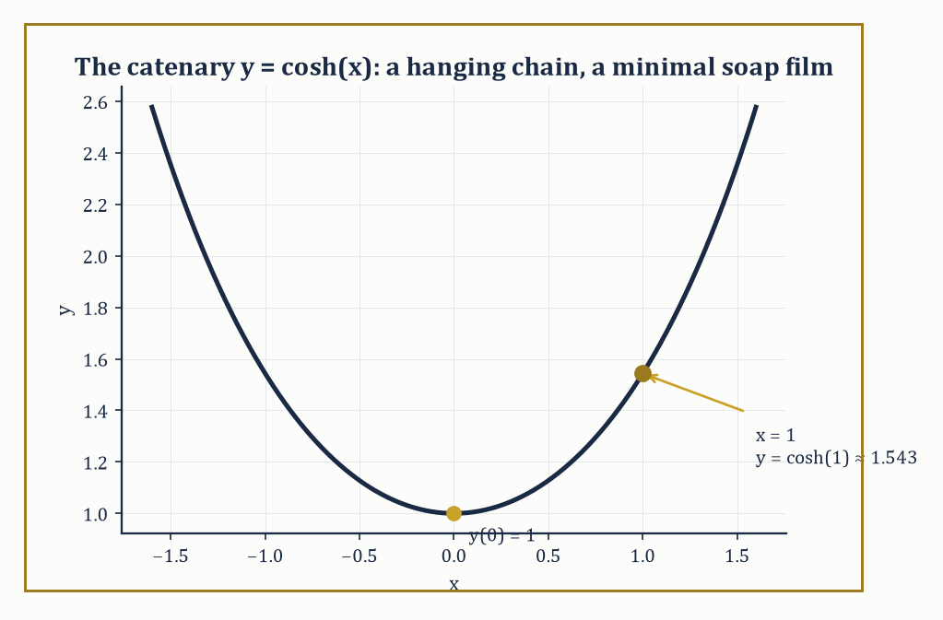
Figure 28.1 — y = cosh(x): the curve the Beltrami identity hands back the moment you ask a soap film to mind its own curvature.
J[y] = ∫ₐᵇ L(x, y, y′) dx
Where L — the Lagrangian, or integrand — is some prescribed function of position x, the curve’s height y, and its slope y′. The calculus of variations asks: among all admissible curves y, which one makes J[y] as small (or large) as possible?
The strategy mimics ordinary calculus with startling fidelity. Consider a one-parameter family of nearby curves y(x) + εη(x), where η is an arbitrary smooth ‘variation’ vanishing at both endpoints (η(a) = η(b) = 0, so every curve in the family still passes through the same fixed endpoints) and ε is a small real parameter. If y is a genuine extremal of J, then the ordinary function of one variable ε ↦ J[y + εη] must have a critical point at ε = 0, for every choice of η — because if some η made J improve by nudging ε away from 0, y could not have been extremal in the first place.
Differentiating under the integral sign and setting the derivative to zero at ε = 0 gives
∫ₐᵇ [∂L/∂y · η + ∂L/∂y′ · η′] dx = 0
Integrating the second term by parts (using η(a) = η(b) = 0 to kill the boundary contribution) converts η′ into η, leaving
∫ₐᵇ [∂L/∂y − d/dx(∂L/∂y′)] η dx = 0 for every admissible η
The fundamental lemma of the calculus of variations then says: if a continuous function multiplied against every such η integrates to zero, that function must itself be identically zero (for if it were nonzero anywhere, a cleverly bump-shaped η concentrated there would make the integral nonzero too, a contradiction). The conclusion is the Euler–Lagrange equation:
d/dx(∂L/∂y′) = ∂L/∂y
The infinite-dimensional counterpart of ∇f = 0, obtained by the same logic of ‘no admissible perturbation may improve things’, merely with integration by parts standing in for the chain rule.
Numeric example — the shortest path is a straight line. Minimize the arc-length functional J[y] = ∫₀¹ √(1 + y′²) dx among curves with y(0) = 0, y(1) = 1 (so L(x, y, y′) = √(1 + y′²), which happens not to depend on y at all). Then ∂L/∂y = 0, and the Euler–Lagrange equation collapses to d/dx(∂L/∂y′) = 0, meaning ∂L/∂y′ is constant along the extremal. Computing:
∂L/∂y′ = y′/√(1 + y′²)
Since the function t ↦ t/√(1+t²) is strictly increasing (its derivative is 1/(1+t²)^(3/2), always positive), the only way for y′/√(1+y′²) to stay constant is for y′ itself to be constant, say y′ = m. Integrating, y = mx + c. The boundary condition y(0) = 0 gives c = 0; the condition y(1) = 1 gives m = 1. So
y = x
The straight line joining (0,0) to (1,1), as three thousand years of geometry led us to expect, now derived from first principles by an integration by parts.
Try it now — For L = y′², write the Euler–Lagrange equation and its solutions. Answer →
Solving the Euler–Lagrange equation directly is a second-order ordinary differential equation in general, but three special structural cases let us shortcut to a first-order equation instead — a first integral, one power of differentiation cheaper. If L does not depend explicitly on y (only on x and y′), the equation reduces immediately to ∂L/∂y′ = const, just as in the straight-line example above.
If L does not depend explicitly on x, the relevant first integral is the Beltrami identity:
L − y′·(∂L/∂y′) = const
It is derived by noting that dL/dx = ∂L/∂y·y′ + ∂L/∂y′·y″ along any curve (chain rule), while the Euler–Lagrange equation lets us replace ∂L/∂y with d/dx(∂L/∂y′); a short rearrangement then shows d/dx[L − y′·∂L/∂y′] = 0 identically — the bracketed quantity, sometimes called the Hamiltonian of the problem, is conserved along extremals whenever the Lagrangian carries no explicit x-dependence, which is the variational shadow of energy conservation we will meet again properly in Hamilton’s Principle and Classical Mechanics.
Abstract example — the Beltrami identity derives the catenary. Consider L(y, y′) = y·√(1 + y′²) — the functional this generates, ∫L dx, computes (up to a factor of 2π) the surface area of the surface of revolution obtained by spinning the curve y(x) around the x-axis; minimizing it is the classical soap-film problem for two coaxial rings. Since L has no explicit x-dependence, the Beltrami identity applies directly:
L − y′·(∂L/∂y′) = C
First, ∂L/∂y′ = y·y′/√(1+y′²). Substituting:
y√(1+y′²) − y′·[y·y′/√(1+y′²)] = C
Putting both terms over the common denominator √(1+y′²):
y[(1+y′²) − y′²] / √(1+y′²) = C
And the bracket collapses to exactly 1, leaving
y/√(1+y′²) = C
Squaring and rearranging:
1 + y′² = y²/C², so y′² = (y² − C²)/C², i.e. y′ = (1/C)√(y² − C²)
This separates as dy/√(y² − C²) = dx/C, and the standard integral ∫dy/√(y²−C²) = cosh⁻¹(y/C) gives
cosh⁻¹(y/C) = (x − x₀)/C, or y = C·cosh((x − x₀)/C)
The catenary curve, the exact shape a hanging chain assumes under gravity, and (rotated about its axis) the exact shape of the minimal soap film spanning two coaxial rings. One equation, one identity, and an entire family of hanging chains and soap films falls out the other end.
Keep only this · Section 28.1: The Calculus of Variations: The Euler–Lagrange Equation
The idea. A functional assigns a number to a whole function. At an extremum the first variation vanishes in every admissible direction η, and integration by parts turns that into the Euler–Lagrange equation.
Core.
J[y] = ∫ₐᵇ L(x, y, y′) dx
d/dx(∂L/∂y′) − ∂L/∂y = 0
no x in L (Beltrami): y′ ∂L/∂y′ − L = constant
Typical mistake. Forgetting why the boundary term disappears. With fixed endpoints η(a) = η(b) = 0; with a free endpoint the term survives and becomes a boundary condition.
Minimal example. L = √(1 + y′²): the extremals are straight lines.
Practice. Easy to challenge; full worked answers, with the usual mistake, are in Answers to the Practice Sets at the back.
Easy — Write the Euler–Lagrange equation for L = y′² + y². Answer →
Medium — Find the extremal of J = ∫₀¹ (y′² + 2y) dx with y(0) = y(1) = 0. Answer →
Challenge — Apply the Beltrami identity to L = y√(1 + y′²) and check that y = cosh x is an extremal. Answer →

Section 28.2: First Integrals, Constraints, and Variable Endpoints
The Same Trick, With More Furniture
Just as finite-dimensional optimization gained a constrained version via Lagrange multipliers, the calculus of variations admits constraints on the admissible curves, and the resolution is structurally identical, with one wrinkle: the multiplier can itself become a function of x.
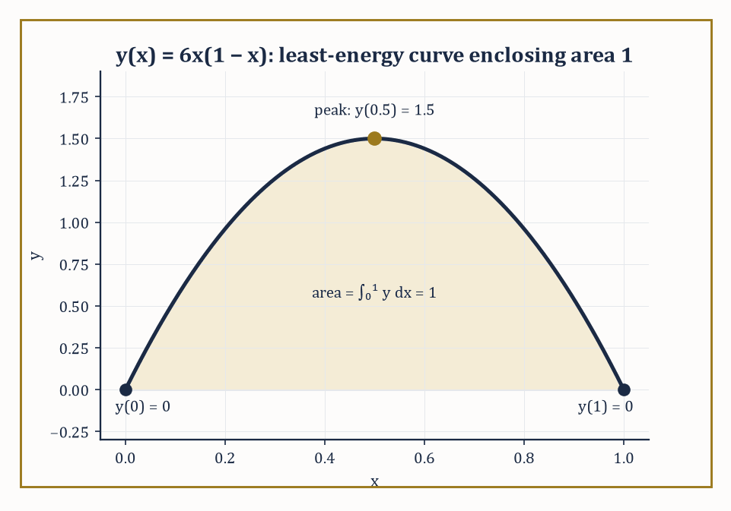
Figure 28.2 — The parabola y = 6x(1 − x): the unique least-bending curve through (0,0) and (1,0) whose enclosed area is pinned at exactly 1.
Two flavors arise in practice. A pointwise (holonomic) constraint, say φ(x, y₁, y₂) = 0 relating several dependent variables at every single x, needs a multiplier λ(x) that is free to vary along the curve, since the constraint is really infinitely many constraints, one per point. An integral (isoperimetric-type) constraint, of the form ∫ₐᵇ G(x,y,y′) dx = k for some fixed number k, is a single global condition — just one number to satisfy — and so needs only a single constant multiplier λ, as in Constrained Nonlinear Optimization.
In either case the recipe is the same: form the augmented Lagrangian L* = L − λ·G (or L − λ(x)·φ, for the pointwise case) and apply the ordinary Euler–Lagrange equation to L*, treating λ as fixed during the variation and solving for it afterwards using the constraint itself.
Numeric example — minimum energy with a fixed total. Minimize J[y] = ∫₀¹ (y′)² dx subject to y(0) = y(1) = 0 and the isoperimetric constraint ∫₀¹ y dx = 1 (the curve must enclose a fixed area of 1 above the x-axis, while minimizing its total ‘wiggling energy’). Form L* = (y′)² − λy, with λ a constant multiplier (this is an integral constraint, so a single λ suffices). The Euler–Lagrange equation for L* is d/dx(∂L*/∂y′) = ∂L*/∂y, i.e.
d/dx(2y′) = −λ, so 2y″ = −λ, giving y″ = −λ/2
A constant — meaning y is a parabola. Integrating twice: y′ = −(λ/2)x + b, and y = −(λ/4)x² + bx + c. The condition y(0) = 0 gives c = 0. The condition y(1) = 0 gives −λ/4 + b = 0, so b = λ/4. Hence
y = (λ/4)(x − x²) = (λ/4)·x(1−x)
Now impose the constraint:
∫₀¹ y dx = (λ/4)∫₀¹ x(1−x) dx = (λ/4)·[x²/2 − x³/3]₀¹ = (λ/4)·(1/2 − 1/3) = (λ/4)·(1/6) = λ/24
Setting this equal to 1 gives λ = 24, and so
y(x) = 6x(1 − x)
A downward parabola peaking at y(0.5) = 6·0.25 = 1.5. Checking the constraint directly: ∫₀¹ 6x(1−x) dx = 6·(1/6) = 1 ✓. This shape — not a semicircle, not a triangle, but this particular parabola — is the unique curve of least ‘bending energy’ that starts and ends at zero while enclosing area exactly 1.
Try it now — For J = ∫₀¹ y′² dx with y(0) = 0 and y(1) free, what condition replaces the missing endpoint value, and what is the extremal? Answer →
So far every extremal problem has fixed both endpoint values in advance. Relax that, and let one endpoint — say y(b) — be free to take any value, and a subtlety appears: the derivation of the Euler–Lagrange equation used η(b) = 0 to discard a boundary term during integration by parts, but if y(b) is unconstrained, η(b) need not vanish, and that boundary term must instead be forced to zero on its own.
The result is a natural boundary condition: ∂L/∂y′ evaluated at x = b must equal zero (this is one instance of the more general transversality condition, which governs the geometry of how an extremal is allowed to meet a moving or free endpoint). It is called ‘natural’ because the calculus of variations imposes it automatically, with no extra input from the modeler — the curve chooses the best possible endpoint value entirely on its own.
Numeric example — a free right endpoint. Minimize J[y] = ∫₀¹ (y′)² dx with y(0) = 0 fixed but y(1) left free. The Euler–Lagrange equation (with ∂L/∂y = 0, since L = (y′)² has no y-dependence) gives d/dx(2y′) = 0, so y″ = 0 and y = mx + c. The fixed condition y(0) = 0 gives c = 0, so y = mx. The natural boundary condition at the free end demands
∂L/∂y′|ₓ₌₁ = 0, i.e. 2y′(1) = 2m = 0, so m = 0
The extremal is therefore y ≡ 0, the flat zero function, with J[y] = ∫₀¹ 0 dx = 0. This is precisely right: freed from any obligation at x = 1, the cheapest possible curve refuses to move at all, achieving the absolute floor of zero energy that (y′)² can ever attain — no cleverness required, just permission to be lazy.
Abstract example — corner conditions and Snell’s law. Some variational problems have extremals with a kink — a point where y′ jumps discontinuously, as when a light ray crosses the interface between two media of different refractive indices, or a mechanical path meets an obstacle. The Weierstrass–Erdmann corner conditions govern such kinks: across any corner, both ∂L/∂y′ and L − y′·∂L/∂y′ must remain continuous, even though y′ itself is allowed to jump.
Apply this to Fermat’s principle — light travels the path of least time — with a Lagrangian L = n(y)·√(1+y′²), where n is the (piecewise constant) refractive index, jumping from n₁ above an interface to n₂ below it. Continuity of ∂L/∂y′ = n·y′/√(1+y′²) across the interface, combined with the geometric fact that y′ = tan(angle from the interface normal) — more exactly, y′/√(1+y′²) = sin(angle of incidence θ, measured from the normal) — turns the continuity condition directly into
n₁ sin θ₁ = n₂ sin θ₂
Snell’s law of refraction, recovered not from optics but from a single continuity requirement on a corner in an extremal curve. The bending of a pencil in a glass of water is, from this vantage point, the Weierstrass–Erdmann conditions doing their job in plain sight.
Same structure, new language
The multiplier λ here does what the Lagrange multiplier does for points in Constrained Nonlinear Optimization: the constraint is enforced by paying a price for violating it.
Keep only this · Section 28.2: First Integrals, Constraints, and Variable Endpoints
The idea. Missing variables give first integrals. An integral constraint ∫G dx = c adds a multiplier (extremize ∫(L − λG) dx), and a free endpoint adds the natural boundary condition ∂L/∂y′ = 0 there.
Core.
no y in L: ∂L/∂y′ = constant
constraint ∫G dx = c: extremize ∫(L − λG) dx
free end: ∂L/∂y′ = 0 there
Typical mistake. Solving the multiplier equation and stopping. λ is fixed by the constraint ∫G dx = c, not by the boundary conditions.
Minimal example. Minimize ∫₀¹ y′² dx with y(0) = y(1) = 0 and ∫₀¹ y dx = 1: y = 6x(1 − x).
Practice. Easy to challenge; full worked answers, with the usual mistake, are in Answers to the Practice Sets at the back.
Easy — Compute J = ∫₀¹ y′² dx for y = 6x(1 − x). Answer →
Medium — Minimize ∫₀¹ (y′² − 2y) dx with y(0) = 0 and y(1) free. Answer →
Challenge — Light crosses the interface x = 0 from a medium with speed v₁ = 1 into one with v₂ = 0.75, at θ₁ = 30° from the normal. Use the corner condition to find θ₂. Answer →

Section 28.3: The Second Variation and Sufficient Conditions
Necessary Was Never Going to Be Enough
The Euler–Lagrange equation is a first-order-variation condition: it says the derivative of J[y + εη] with respect to ε vanishes at ε = 0, which — exactly as with ∇f = 0 in finite dimensions — is necessary for an extremum but cannot by itself distinguish a minimum from a maximum or a saddle. For that we need the second variation, the functional analogue of the Hessian, obtained by differentiating J[y + εη] twice with respect to ε and evaluating at ε = 0.
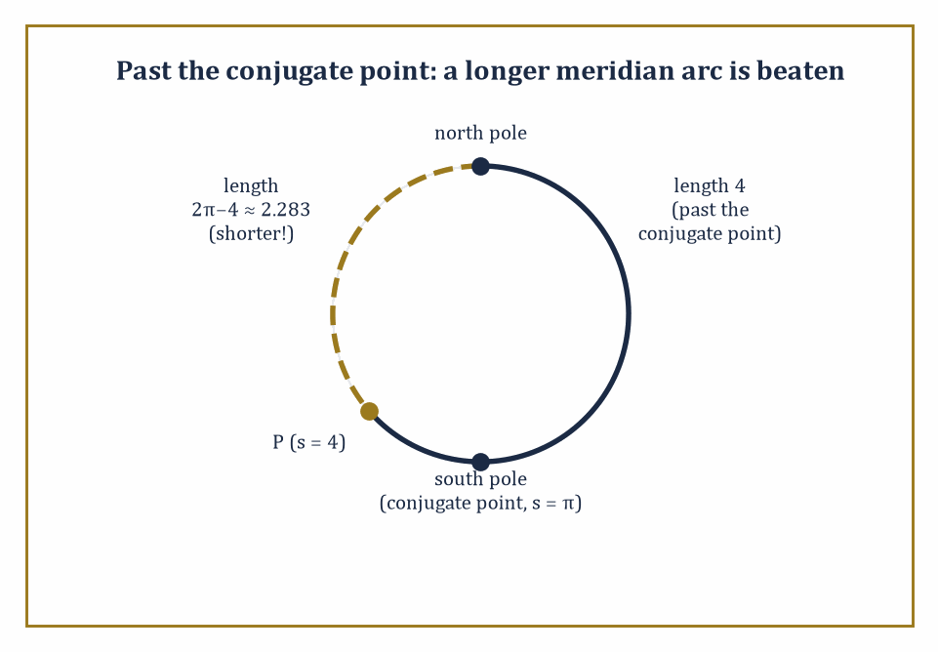
Figure 28.3 — The length-4 meridian arc has already sailed past its conjugate point at the south pole — the dashed route the short way round is shorter still.
Three conditions, working together, certify a genuine local minimum. The Legendre condition asks that ∂²L/∂y′² ≥ 0 along the extremal (strengthened to strict inequality, it is the direct analogue of a positive-definite Hessian, ruling out the curve being a saddle with respect to nearby perturbations in slope).
The Jacobi condition asks that the interval [a,b] contain no conjugate point — a technical but geometrically vivid notion covered in the next paragraph, ruling out a more subtle failure where the extremal is fine locally but a nearby extremal, starting at the same point, manages to cross back and beat it globally.
The Weierstrass condition is the strongest of the three, controlling behavior under ‘strong’ variations (nearby curves whose slopes may differ a great deal, not just infinitesimally) and is needed to certify a strong minimum rather than merely a weak one.
Abstract example — checking the Legendre and Jacobi conditions for a straight line. Take L(y, y′) = (y′)² once more, the functional minimized by straight lines (The Calculus of Variations). The Legendre condition:
∂²L/∂y′² = 2
Which is strictly positive for every value of y′ whatsoever — the strengthened Legendre condition holds everywhere, with plenty of room to spare.
For the Jacobi condition, the relevant second-order ‘Jacobi equation’ governing how nearby extremals spread apart is, for this particular quadratic L, η″ = 0 (the second variation here is precisely ∫(η′)² dx, and its own Euler–Lagrange equation is η″ = 0) — whose solutions are straight lines in η, of the form η(x) = px + q. Such a solution vanishing at x = a (as any admissible variation must) is η(x) = p(x − a), which vanishes again only at x = a itself, never at any later point.
There is therefore no conjugate point anywhere on (a, b], for any finite b: the Jacobi condition holds vacuously and completely. Both sufficient conditions confirmed, straight-line extremals of arc length are genuine (indeed strong) local minima, not mere critical curves posing as one — reassuring, since a universe in which the shortest path were only a saddle point would be an uncomfortable one to live in.
Try it now — Check the Legendre condition for L = y′². Answer →
A conjugate point marks where the second variation stops being positive: it is a point along the extremal where a distinct nearby extremal, launched from the same starting point, manages to cross back and meet the original curve again. Past that crossing, the original extremal can typically be beaten by a competitor that follows the second extremal partway and switches — so a conjugate point is the boundary past which an otherwise-valid critical curve stops being minimizing at all. The textbook illustration is geodesics on a sphere.
Numeric example — conjugate points on the unit sphere. On the unit sphere (radius 1, so its great circles — the geodesics — have total circumference 2π), consider the meridian geodesic starting at the north pole and running south, parametrized by arc length s. Every meridian through the north pole reconverges at the south pole, at arc length s = π (exactly half the great-circle circumference); the south pole is therefore the conjugate point of the north pole along any meridian, and in fact along every geodesic emanating from the pole simultaneously — a famously crowded conjugate point.
Take a specific meridian arc of length s = 4 (note 4 > π ≈ 3.14159, so this arc has already passed its conjugate point). Is it still the shortest path to its endpoint? Going the other way around the same great circle instead covers a length of
2π − 4 ≈ 6.28319 − 4 = 2.28319
Which is shorter than 4. So the length-4 arc, despite satisfying the Euler–Lagrange equation (it is a perfectly genuine geodesic) and despite the Legendre condition holding trivially (as it does for arc length generally), is not the minimizing path between its endpoints — precisely because it has run past its conjugate point at s = π, and the Jacobi condition has failed. This is the precise, quantitative reason a geodesic on a sphere ‘gives up’ being shortest once it passes the antipode: not a vague geometric intuition, but a conjugate point sitting at a computable arc length.
The Weierstrass condition is what remains to be checked once Legendre and Jacobi have both passed. It compares the Lagrangian’s value along the candidate extremal against its value for a competitor curve with a wildly different slope p at the very same point (x, y) — not an infinitesimally nearby slope, as the second variation alone examines, but any slope whatsoever, however extreme. Define the excess function
E(x, y, y′, p) = L(x, y, p) − L(x, y, y′) − (p − y′)·∂L/∂y′(x, y, y′)
The Weierstrass condition demands E ≥ 0 for every admissible p, at every point of the extremal. Passing Legendre and Jacobi certifies that no nearby wiggle can improve the curve; passing Weierstrass as well certifies that no competitor curve can improve it either, however sharply that competitor’s direction departs from the original — the difference between a merely locally best route and a globally best one among all curves with comparable slopes, sharp corners included.
Abstract example — the excess function for arc length. For L(y, y′) = √(1+y′²) (arc length once more), compute the excess function directly. ∂L/∂y′ = y′/√(1+y′²), so
E(y′, p) = √(1+p²) − √(1+y′²) − (p−y′)·y′/√(1+y′²)
Multiply through by √(1+y′²) and simplify (a short but entirely mechanical algebraic exercise): the expression reduces to
E = [√(1+p²)·√(1+y′²) − 1 − p·y′] / √(1+y′²)
And the numerator is the two-dimensional Cauchy–Schwarz-style quantity √(1+p²)√(1+y′²) − (1 + py′), which is nonnegative for all real p and y′ by the Cauchy–Schwarz inequality applied to the vectors (1,p) and (1,y′) — with equality only when p = y′.
So E ≥ 0 always, confirming what geometry already told us: a straight line beats every competing curve through the same points, not only every curve with a similar slope, which is why ‘the shortest distance between two points is a straight line’ is a strong global fact and not merely a locally defensible opinion.
Keep only this · Section 28.3: The Second Variation and Sufficient Conditions
The idea. A vanishing first variation finds candidates; the second variation decides. Legendre’s condition L_(y′y′) ≥ 0 is necessary for a minimum; the strict version plus the absence of conjugate points (Jacobi) is sufficient for a weak minimum.
Core.
δ²J = ½∫(Pη′² + Qη²) dx, P = L_(y′y′), Q = L_yy − (d/dx)L_(yy′)
Legendre: P ≥ 0 along the extremal
Jacobi: no conjugate point in (a, b]
Typical mistake. Treating Legendre’s condition as sufficient. A great-circle arc longer than π on the unit sphere satisfies it and is still not the shortest path: it contains a conjugate point.
Minimal example. L = y′²: P = 2, Q = 0, no conjugate points, so straight lines minimize.
Practice. Easy to challenge; full worked answers, with the usual mistake, are in Answers to the Practice Sets at the back.
Easy — Compute L_(y′y′) for L = √(1 + y′²). Answer →
Medium — On the unit sphere, geodesics from the north pole meet again at the south pole. Which meridian arcs from the north pole are minimizing? Answer →
Challenge — For L = y′² − y² on [0, b] with y(0) = y(b) = 0, find the Jacobi equation and the first conjugate point. For which b is y = 0 a minimum? Answer →

Section 28.4: Hamilton’s Principle and Classical Mechanics
The Universe, It Turns Out, Is Lazy
Throw a ball and it follows a parabola, but the ball does not work out its forces step by step. There is another way to describe its path: of all the routes it could take between where it starts and where it lands, in the time it takes, the real one makes a certain total, the action, stationary. The action adds up, moment by moment, the energy of motion minus the energy of position. From this single principle all of Newton’s mechanics follows, and it extends cleanly to planets, pendulums and light. For a mass on a spring, the principle returns a steady oscillation, with energy passing back and forth between spring and motion while the total stays fixed.
Hamilton’s principle is the single most quietly astonishing sentence in classical physics: among all the paths a mechanical system could conceivably take between a fixed initial and final configuration, the one it takes is a stationary point of the action,
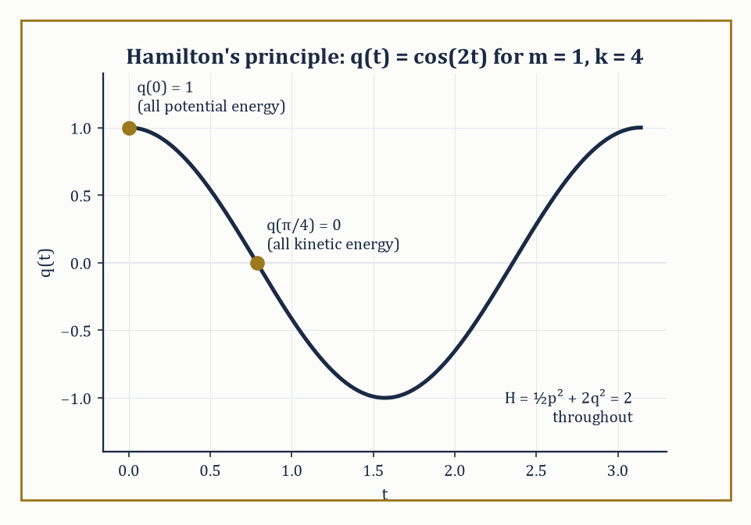
Figure 28.4 — q(t) = cos(2t): the mass swaps potential energy for kinetic and back again, while H = ½p² + 2q² stands guard at 2 the entire time.
S = ∫L dt
Where the Lagrangian L = T − V is kinetic energy minus potential energy. Not the path of least energy, note, nor the fastest, nor the shortest — the one that makes the action stationary, an altogether more abstract quantity balancing how much kinetic energy is ‘spent’ against how much potential energy is ‘owed’ along the way.
Apply the Euler–Lagrange machinery of The Calculus of Variations to this L, with the generalized coordinate q(t) playing the role of y(x) and time t playing the role of x, and out comes
d/dt(∂L/∂q̇) = ∂L/∂q
Which, for an ordinary particle with L = ½mq̇² − V(q), reads
d/dt(mq̇) = −V′(q), i.e. mq̈ = −V′(q)
That is Newton’s second law, force equals mass times acceleration, with force identified as −V′(q), the negative gradient of the potential. Newtonian mechanics and Hamilton’s variational principle are not two different theories that happen to agree; they are the same theory, and the calculus of variations is a more economical way of stating it — a single scalar functional, minimized, in place of a vector differential equation posited by fiat.
Numeric example — the harmonic oscillator from Hamilton’s principle. Take a unit mass on a spring, m = 1, spring constant k = 4, so L = ½q̇² − 2q² (using T = ½mq̇² = ½q̇² and V = ½kq² = 2q²). The Euler–Lagrange equation: d/dt(∂L/∂q̇) = ∂L/∂q gives
d/dt(q̇) = −4q, i.e. q̈ = −4q
Simple harmonic motion with angular frequency ω = √(k/m) = √4 = 2. With initial conditions q(0) = 1, q̇(0) = 0, the solution is q(t) = cos(2t): check q̇(t) = −2sin(2t), so q̇(0) = 0 ✓, and q̈(t) = −4cos(2t) = −4q(t) ✓ for all t. Hamilton’s principle, applied to this specific L, has reproduced the equation of a mass bobbing on a spring exactly, with no reference to forces or Newton’s laws anywhere in the derivation — only a statement about which path makes ∫L dt stationary.
Try it now — For L = ½q̇² − 2q², write the equation of motion. Answer →
Passing to the Hamiltonian formulation trades the single second-order Euler–Lagrange equation for a pair of first-order equations on phase space (position and momentum treated as independent coordinates), via the momentum p = ∂L/∂q̇ and the Hamiltonian H = pq̇ − L (a Legendre transform, in fact the very same construction that produced the Beltrami identity in The Calculus of Variations — no coincidence, since the Beltrami identity is precisely energy conservation in disguise).
Noether’s theorem then supplies the deepest structural fact of the whole subject: every continuous symmetry of L corresponds to a conserved quantity along the extremal. Invariance of L under translations in time (L does not depend explicitly on t) yields conservation of the Hamiltonian, i.e. of energy — this is the Beltrami identity applied to a Lagrangian in time rather than in x. Invariance of L under translations in space yields conservation of momentum. Symmetry, in other words, is not merely an aesthetic nicety physicists enjoy pointing out; it is mathematically equivalent to a conservation law, term for term.
Numeric example — energy conservation via the Hamiltonian. Continue the oscillator above (m=1, k=4). The momentum is p = ∂L/∂q̇ = q̇, and the Hamiltonian is
H = pq̇ − L = p² − (½p² − 2q²) = ½p² + 2q²
Kinetic plus potential energy, as it should be. At t = 0: q = 1, q̇ = 0, so p = 0, giving H = ½(0)² + 2(1)² = 2. At t = π/4 (a quarter of the period, since the period is 2π/ω = π): q(π/4) = cos(π/2) = 0, and q̇(π/4) = −2sin(π/2) = −2, so p = −2, giving
H = ½(−2)² + 2(0)² = ½(4) + 0 = 2
The Hamiltonian is exactly 2 at both instants, confirming energy conservation numerically — the oscillator has, at t = π/4, converted all of its potential energy into kinetic energy (dropping through equilibrium at maximum speed) while the total remains fixed at 2, as Noether’s theorem, applied to L’s indifference to what time it happens to be, guarantees it must.
Abstract example — translation symmetry conserves total momentum. Consider two particles with L = ½m₁ẋ₁² + ½m₂ẋ₂² − V(x₁ − x₂), where the potential depends only on the separation x₁ − x₂, not on the particles’ absolute positions — L is invariant under simultaneously shifting both x₁ and x₂ by the same constant, a spatial translation symmetry.
The Euler–Lagrange equation for x₁: d/dt(m₁ẋ₁) = ∂L/∂x₁ = −V′(x₁−x₂). For x₂: d/dt(m₂ẋ₂) = ∂L/∂x₂ = +V′(x₁−x₂) (the chain rule contributes a sign flip, since x₂ appears as −x₂ inside V). Adding the two equations:
d/dt(m₁ẋ₁ + m₂ẋ₂) = −V′(x₁−x₂) + V′(x₁−x₂) = 0
The total momentum m₁ẋ₁ + m₂ẋ₂ is therefore constant in time — Newton’s third law (equal and opposite internal forces, visible here as the two V′ terms canceling) emerging as a direct corollary of Noether’s theorem applied to the translation symmetry of the Lagrangian, rather than being assumed as a separate law of physics.
Where this returns
Lagrangians, Hamiltonians and Noether’s theorem are the starting point of Mathematical Physics (Volume 4).
Keep only this · Section 28.4: Hamilton’s Principle and Classical Mechanics
The idea. Hamilton’s principle: the true motion makes the action S = ∫(T − V) dt stationary. The Euler–Lagrange equation is Newton’s law; H = pq̇ − L is conserved when L has no explicit t; each symmetry gives a conservation law (Noether).
Core.
S = ∫ L dt, L = T − V
d/dt(∂L/∂q̇) = ∂L/∂q
p = ∂L/∂q̇, H = pq̇ − L
Typical mistake. Calling it a principle of least action. The action is stationary; over long time intervals the true path need not minimize it.
Minimal example. Free particle, L = ½mẋ²: ẍ = 0.
Practice. Easy to challenge; full worked answers, with the usual mistake, are in Answers to the Practice Sets at the back.
Easy — For L = ½mẋ² − mgx, find the equation of motion. Answer →
Medium — For L = ½q̇² − 2q², write H and check that it is constant along q = sin 2t. Answer →
Challenge — For L = ½m(ṙ² + r²θ̇²) − V(r), find the conserved quantity that comes from rotational symmetry. Answer →

Section 28.5: Classical Applications: Geodesics, Minimal Surfaces, Isoperimetry
Straight Lines, Soap Films, and the Vindication of the Circle
Stretch a rubber band between two pins on a melon and let go. It pulls itself taut and stops somewhere definite — not along the straight line between the pins, because that line runs through the fruit, and the band is not allowed to leave the surface. What it finds instead is a geodesic: the surface’s own best attempt at a straight line, given that a genuine shortcut through the surrounding space is forbidden. Formally it is an extremal of the arc-length functional restricted to curves lying on the surface, and its governing equation says the geodesic curvature — the curving of the path as measured within the surface itself, ignoring any curving forced merely by the surface’s own bending in space — vanishes identically.
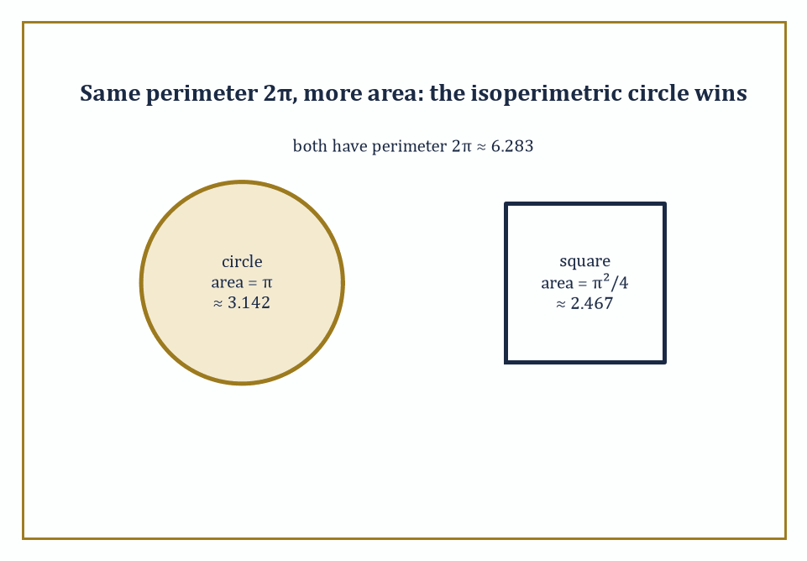
Figure 28.5 — Same fencing, more pasture: a circle and a square sharing perimeter 2π, with the circle enclosing roughly 27% more area — the isoperimetric inequality in a single picture.
On a flat plane this reduces to y″ = 0, straight lines, as derived in The Calculus of Variations; on a curved surface it becomes a nontrivial second-order ODE. One of the cleanest cases is a developable surface — one that can be unrolled flat without stretching, like a cylinder or a cone — where geodesics are straight lines in the unrolled picture, mapped back onto the curved surface.
Numeric example — geodesic distance on a cylinder. Take a cylinder of radius r = 1, and two points on it: one at angular coordinate θ = 0, height z = 0, the other at θ = π/2, height z = 1. Unroll the cylinder into a flat strip: the angular coordinate becomes an ordinary horizontal distance, rθ, and the height stays as it is. The two points become, in the unrolled plane,
(0, 0) and (r·π/2, 1) = (π/2, 1) ≈ (1.5708, 1)
The geodesic on the cylinder is exactly the straight line joining these points in the unrolled picture (since unrolling is a local isometry — it preserves lengths — a straight line in the flat picture is a length-minimizing curve on the actual cylinder, tracing out a helical arc once rolled back up). Its length is
√((π/2)² + 1²) = √(2.4674 + 1) = √3.4674 ≈ 1.8621
This is shorter than either traveling straight up (length 1, but not reaching the right θ) or straight around (length π/2 ≈ 1.5708, but not reaching the right z) — the helix is the genuine compromise, and its length of ≈1.8621 is provably the shortest possible route between the two points along the cylinder’s surface.
Try it now — On a cylinder of radius 1, find the geodesic distance from (θ, z) = (0, 0) to (π/2, 1). Answer →
A minimal surface is the higher-dimensional sibling of a geodesic: an extremal of the area functional, among surfaces spanning some fixed boundary curve (a wire frame, in the soap-film picture). The Euler–Lagrange equation for the area functional turns out to say that the mean curvature — the average of the two principal curvatures at each point — vanishes identically, which is the physical balance condition for a soap film with equal air pressure on both sides (surface tension pulls the film taut everywhere in a way that, absent a curvature imbalance, has nowhere left to push it).
The catenoid derived symbolically in The Calculus of Variations — the surface swept out by revolving a catenary y = C·cosh(x/C) about the x-axis — is the minimal surface spanning two coaxial circular rings, and it is famously not the only story: beyond a certain critical ratio of the rings’ separation to their radius, no smooth catenoid can span them at all, and the physical soap film instead collapses discontinuously into two flat disks, one across each ring (the so-called Goldschmidt solution) — a reminder that existence of a smooth extremal is never to be taken for granted, however elegant the Euler–Lagrange equation looks on paper.
Numeric example — checking that the catenoid is genuinely minimal. For a surface of revolution generated by rotating y(x) about the x-axis, the vanishing-mean-curvature condition works out to the ODE
y·y″ = 1 + y′²
A fact worth taking on trust here rather than re-deriving (it is a short exercise in the surface-area first and second fundamental forms, and not the variational machinery this chapter is otherwise built from). Take the catenary y = cosh(x) (the C = 1 case from The Calculus of Variations) and check the condition at x = 1. First, y = cosh(1) ≈ 1.54308, y′ = sinh(1) ≈ 1.17520, and y″ = cosh(1) ≈ 1.54308 (since the catenary’s second derivative is again cosh, unlike almost everything else in calculus). Left-hand side:
y·y″ = cosh(1)² ≈ 2.38110
Right-hand side:
1 + y′² = 1 + sinh(1)² ≈ 1 + 1.38110 = 2.38110
The two sides agree — unsurprisingly, since cosh²t − sinh²t = 1 is an identity for every t, so the check holds not just at x = 1 but at every point along the curve. The catenoid generated by this curve is therefore a bona fide zero-mean-curvature surface, precisely as the Beltrami-identity derivation back in The Calculus of Variations promised, and what a soap film — which can only ever balance surface tension against itself, never against a curvature it cannot feel — is physically obliged to become.
The isoperimetric problem asks: among all closed curves of a fixed perimeter P, which one encloses the greatest area? The answer — proved rigorously via the calculus of variations, though known to intuition since antiquity — is the circle, and the same principle extends to enclosing maximal volume for fixed surface area in three dimensions (which is why soap bubbles, free to choose their own shape and answerable only to surface tension, are spheres).
Numeric example — the circle beats the square. Take perimeter P = 2π ≈ 6.2832. A circle with this circumference has radius r = P/(2π) = 1, enclosing area πr² = π ≈ 3.1416. A square with the same perimeter has side length P/4 = 2π/4 = π/2 ≈ 1.5708, enclosing area (π/2)² = π²/4 ≈ 2.4674.
The circle’s area, ≈3.1416, comfortably exceeds the square’s ≈2.4674 — for the identical budget of boundary length, the circle does more with it, as the isoperimetric inequality guarantees it must for any competing shape whatsoever, not merely the square chosen here for concreteness.
Abstract example — the brachistochrone and the cycloid. The brachistochrone problem — posed by Johann Bernoulli in 1696 — asks for the curve down which a bead, sliding frictionlessly under gravity from rest, falls from one fixed point to another (not directly below it) in the least time. With y measured downward from the start and x horizontal, the time functional is
J[y] ∝ ∫√((1+y′²)/y) dx
Using energy conservation to write speed as √(2gy). This L has no explicit x-dependence, so the Beltrami identity of The Calculus of Variations applies just as it did for the catenary: L − y′·∂L/∂y′ = C works out (via the same algebra pattern as before, with √y in place of y in the earlier computation) to
1/(√y·√(1+y′²)) = C, i.e. y(1+y′²) = 2r for a constant 2r = 1/C²
This first-order equation is solved by the standard substitution y′ = cot(θ/2), which converts it into the parametric pair
x(θ) = r(θ − sin θ), y(θ) = r(1 − cos θ)
A cycloid, the curve traced by a point on the rim of a circle of radius r rolling along a line. That the fastest way down is not the straight line, nor any circular arc, but this specific rolling-wheel curve, is the sort of counterintuitive answer the calculus of variations excels at producing and then, immediately afterward, rendering completely inevitable in hindsight.
Keep only this · Section 28.5: Classical Applications: Geodesics, Minimal Surfaces, Isoperimetry
The idea. Geodesics extremize length, minimal surfaces extremize area (zero mean curvature), and the isoperimetric problem maximizes area for a fixed perimeter: the circle wins, 4πA ≤ P².
Core.
4πA ≤ P², equality only for the circle
minimal surface of revolution: y = c cosh(x/c)
brachistochrone: a cycloid
Typical mistake. Thinking a minimal surface must have zero Gaussian curvature. It has zero mean curvature; the catenoid has negative Gaussian curvature.
Minimal example. P = 2π: the circle encloses π, the square π²/4 ≈ 2.47.
Practice. Easy to challenge; full worked answers, with the usual mistake, are in Answers to the Practice Sets at the back.
Easy — Check the isoperimetric inequality for the unit square. Answer →
Medium — On a cylinder of radius 2, find the geodesic distance from (θ, z) = (0, 0) to (π, 3). Answer →
Challenge — Show that y = c cosh(x/c) satisfies yy″ = 1 + y′², the equation for minimal surfaces of revolution. Answer →

Section 28.6: Looking Ahead: From Classical Variational Calculus to Optimal Control and Geometric Analysis
The View From the End of This Chapter
We have now assembled the full classical toolkit: the Euler–Lagrange equation and its first integrals, second-variation sufficiency conditions, Hamilton’s principle, and the great trio of geodesics, minimal surfaces, and isoperimetry. Each of these tools opens directly onto a modern research program, and it is worth a moment naming where they lead, if only so that the map of the series stays legible from here.
Optimal control theory extends the calculus of variations to problems where the ‘curve’ being chosen is constrained to obey a differential equation of its own (a state ẋ = f(x,u) driven by a control u that the modeler gets to choose), and asks for the control minimizing some cost. Pontryagin’s maximum principle is the direct descendant of the Euler–Lagrange equation for this richer setting, introducing a costate variable that plays the role of the multiplier function λ(x) from First Integrals, Constraints, and Variable Endpoints, now evolving in time according to its own differential equation.
Numeric example — Pontryagin’s maximum principle recovers an old friend. Minimize ∫₀¹ u(t)² dt subject to the state equation ẋ = u, with x(0) = 0 and x(1) = 1 fixed, over all control functions u(t) (this is the same problem as minimizing kinetic-type energy to move a particle from 0 to 1 in unit time). Form the control Hamiltonian H(x,u,p) = u² + p·u, with costate p. Pontryagin’s condition requires u to minimize H pointwise:
∂H/∂u = 2u + p = 0, so u = −p/2
The costate equation is ṗ = −∂H/∂x = 0 (H has no explicit x-dependence here), so p is constant, say p = p₀, forcing u to be constant too: u ≡ −p₀/2 =: u₀. The state then evolves as x(t) = u₀t (using x(0)=0), and the terminal condition x(1) = 1 forces u₀ = 1. So the optimal control is the constant u(t) ≡ 1, giving x(t) = t and total cost ∫₀¹1² dt = 1.
Compare this to the ordinary calculus-of-variations formulation of the identical problem back in The Calculus of Variations and First Integrals, Constraints, and Variable Endpoints — minimize ∫₀¹(y′)² dx with y(0)=0, y(1)=1 — whose Euler–Lagrange solution was y = x with the same cost of 1. Two formalisms, one dressed in costates and control Hamiltonians, the other in multipliers and integrands, arriving at the identical answer by what is, underneath the notation, the identical argument.
Try it now — Minimize ∫₀¹ u² dt subject to ẋ = u, x(0) = 0, x(1) = 1. What is the optimal u? Answer →
Geometric analysis takes the variational machinery of this chapter and applies it to maps between curved spaces rather than curves in flat ones — harmonic maps (extremals of an energy functional generalizing both geodesics and minimal surfaces at once), and curvature functionals whose extremals include the Einstein metrics of general relativity and the Ricci flow used, famously, in the resolution of the Poincaré conjecture.
Abstract example — harmonic maps recover two old friends as special cases. The harmonic map energy for φ: (M, g) → (N, h) is
E[φ] = ½∫[M] |dφ|² dvol
A direct generalization of the kinetic-energy functional from Hamilton’s Principle and Classical Mechanics. Take the domain M to be simply an interval [a, b] (a one-dimensional, flat manifold): then |dφ|² is |φ′(t)|², and
E[φ] = ½∫ₐᵇ |φ′(t)|² dt
The free-particle Lagrangian from Hamilton’s Principle and Classical Mechanics with V ≡ 0, whose Euler–Lagrange equation forces φ to travel at constant speed along a length-minimizing curve in the target N. In other words, a harmonic map out of an interval is a geodesic in the target manifold: the ‘straight line’ concept of The Calculus of Variations is the M = [a,b] case of harmonic maps and nothing more exotic.
Now take M to be a two-dimensional surface instead, and restrict attention to conformal maps φ (ones preserving angles, though not necessarily lengths). For conformal φ, a standard identity gives
E[φ] ≥ Area(φ(M))
With equality exactly when φ is also harmonic — so among conformal parametrizations of a given image surface, the energy-minimizing (harmonic) one is precisely the area-minimizing one, and minimal surfaces fall out as the M = (2-dimensional surface) case. Geodesics and minimal surfaces, which Classical Applications introduced as two separate classical stories, are thus literally the same equation, harmonic map theory, read at two different dimensions of domain.
Direct methods in the calculus of variations sidestep the Euler–Lagrange equation altogether where it cannot be solved explicitly, instead proving a minimizer exists abstractly — via weak lower semicontinuity of the functional and compactness of minimizing sequences in a Sobolev space — and only afterward, if ever, extracting an equation the minimizer must satisfy.
The strategy, in outline: take a minimizing sequence of curves yₙ (one that drives J[yₙ] down toward the infimum value), extract a subsequence converging in a suitably weak sense to some limit y (this is the compactness step, and it is why Sobolev spaces — which control a function together with a weak derivative, but only in an averaged, integral sense rather than pointwise — are the natural home for the argument), and finally argue that J itself cannot jump upward in the limit (lower semicontinuity), so J[y] ≤ liminf J[yₙ] = the infimum, forcing y to attain it. Not one derivative of L is differentiated in this entire argument; existence is bought with compactness and inequalities rather than with calculus.
Abstract example — why a minimizing sequence can fail to converge to a minimizer. Consider J[y] = ∫₋₁¹ (y′)² + y²(y²−1)² dx over curves with y(−1) = −1, y(1) = 1 (a toy double-well problem — the integrand is small only where y is close to a straight interpolation and near the wells y = ±1). A minimizing sequence can, in principle, oscillate faster and faster between values near −1 and +1 across a thin transition layer, driving the well-term y²(y²−1)² arbitrarily close to zero almost everywhere while paying an ever-shrinking cost in (y′)² by making each transition steeper but rarer — the sequence’s energy can approach an infimum without any single member of the sequence, nor any reasonable limit of the sequence, actually attaining that infimum cleanly.
This is the phenomenon the direct method’s compactness step is built to rule out or correctly diagnose: without a genuine bound controlling oscillation (an equicontinuity or Sobolev bound on the yₙ, not merely a bound on J[yₙ]), a minimizing sequence can fail to converge to anything achieving the infimum at all, and existence of a minimizer becomes a real theorem to be proved, not a formality to be waved through.
And numerical methods, the very next chapter of this series, discretize the functional itself (replacing the continuum of admissible curves by a finite-dimensional family, and the integral by a finite sum) and hand the resulting finite-dimensional optimization problem back to the machinery of Unconstrained Nonlinear Optimization — which is a pleasing closure: the infinite-dimensional theory, computationally, dissolves right back into the finite-dimensional theory it was built to generalize.
The deeper lesson of this chapter, stripped of its equations, is this: an astonishing number of the shapes, paths, and configurations we observe in the world are not arbitrary. They are the configurations that minimize or maximize some quantity — length, time, energy, area — and the mathematical expression of that fact is a variational principle. Optics obeys Fermat’s principle; mechanics obeys Hamilton’s principle; soap films minimize area; hanging chains minimize potential energy subject to their own length. Optimization and the calculus of variations are, in the end, the mathematics of the word best — and it is a small but genuine comfort, on the many days when finding the best of anything feels impossible, that at least somewhere in the universe, physics is doing it automatically, without complaint, and without ever once applying for a grant.
We arrived at this chapter already knowing how systems evolve; we leave it knowing why they evolve the way they do — because some quantity, somewhere, is being made as small (or as large) as the constraints allow, and the Euler–Lagrange equation is the bookkeeping that makes this precise. It is a rare thing in mathematics for a single idea — the first variation vanishes — to organize such an enormous span of material, from the placement of a single constrained point in ℝⁿ to the trajectory of a planet to the shape of a bubble, but there it is: vanish, and you have found what is best, subject to whatever the world has insisted you put up with.
What we have not done — and could not do, within one chapter — is compute any of this at scale. Every worked example above was small enough to solve by hand, precisely because it needed to be checkable by hand; the moment a functional loses its convenient structure, or a constraint set gains a hundred more dimensions, closed-form answers evaporate and we are left needing an algorithm rather than an identity. That is where the next chapter begins: Numerical Methods takes the gradient descent and Newton’s method sketched briefly in Unconstrained Nonlinear Optimization, and the discretized functionals gestured at in Looking Ahead: From Classical Variational Calculus to Optimal Control and Geometric Analysis, and builds the machinery that turns ‘in principle solvable’ into ‘solved, on a computer, this afternoon.’
The series continues. We have learned to ask what is best; next, we learn how to go and find it when nobody is kind enough to hand us a closed form.
Where this returns
Pontryagin’s principle is developed in Control Theory (Volume 4). The direct method needs weak compactness, built in Weak Topologies and Reflexivity and Unbounded Operators and Sobolev Spaces.
Keep only this · Section 28.6: Looking Ahead: From Classical Variational Calculus to Optimal Control and Geometric Analysis
The idea. Optimal control adds a controlled state equation (Pontryagin’s maximum principle); geometric analysis studies harmonic maps and minimal surfaces in general spaces; the direct method proves existence by compactness and lower semicontinuity — and fails without them.
Core.
control: minimize ∫ L(x, u) dt subject to ẋ = f(x, u)
direct method: minimizing sequence + compactness + lower semicontinuity
Typical mistake. Assuming the infimum is attained. J[y] = ∫₋₁¹ x²y′² dx with y(±1) = ±1 has infimum 0 and no minimizer.
Minimal example. ẋ = u with cost ∫u² dt: the optimal u is constant.
Practice. Easy to challenge; full worked answers, with the usual mistake, are in Answers to the Practice Sets at the back.
Easy — With ẋ = u, x(0) = 0, x(2) = 1, minimize ∫₀² u² dt. Answer →
Medium — Compare the cost of u = 2t with that of u = 1 for ẋ = u, x(0) = 0, x(1) = 1. Answer →
Challenge — For J[y] = ∫₋₁¹ x²y′² dx with y(±1) = ±1, show that yₙ = arctan(nx)/arctan(n) has J → 0, and explain why no minimizer exists. Answer →
Chapter 28 recap · Calculus of Variations
• A functional assigns a number to a whole function; at an extremum the first variation vanishes, and integration by parts gives the Euler–Lagrange equation.
• Missing variables give first integrals (Beltrami); constraints add multipliers; free endpoints add natural boundary conditions.
• Legendre’s condition and the absence of conjugate points (Jacobi) separate minima from mere stationary points.
• Hamilton’s principle turns mechanics into one variational statement; symmetries give conservation laws.
• Geodesics, minimal surfaces and the isoperimetric inequality are the classical successes; existence of minimizers needs compactness, which can fail.

Check Your Understanding — Chapter 28
Answers are in the Answer Key at the back of the book — have a go before you look.
1. [Compute] Use the Euler–Lagrange equation to show that the shortest path between two fixed points in the plane is a straight line.
See the answer →
2. [Concept] According to Noether’s theorem as applied in this chapter, what does it mean physically that a Lagrangian has no explicit dependence on time, and what is conserved as a result?
See the answer →
3. [Compute] Find the extremal of J[y] = ∫₀¹ (y′² + y²)dx with y(0) = 0, y(1) = 1.
See the answer →
4. [Compute] Show that the shortest path between two points in the plane is a straight line, by applying Euler–Lagrange to the arc-length functional.
See the answer →
5. [Concept] The calculus of variations is often described as calculus with points replaced by functions. Where does that analogy hold, and where does it break?
See the answer →
6. [Prove] Derive the Euler–Lagrange equation for J[y] = ∫ₐᵇ L(x, y, y′)dx with fixed endpoints.
See the answer →
7. [Prove] Prove that if L does not depend explicitly on x, then the Beltrami quantity H = y′L_(y′) − L is constant along extremals.
See the answer →
8. [Prove] Prove the isoperimetric inequality 4πA ≤ P² for a simple closed plane curve, using the Fourier method.
See the answer →
9. [Prove] Prove that the second variation being non-negative is necessary for a minimum, and explain why it is not sufficient.
See the answer →
10. [Prove] Prove that among all plane curves of given length joining two points, the extremal of the area functional satisfies a constraint equation with a constant multiplier.
See the answer →
11. [Challenge] Hamilton’s principle says nature extremizes an action. Is that a physical law or a reformulation?
See the answer →
12. [Challenge] Optimization problems in infinite dimensions can fail to have solutions even when the infimum is finite. What has gone wrong?
See the answer →
13. [Challenge] The brachistochrone is a cycloid, and the cycloid is also the tautochrone. Is that a coincidence?
See the answer →
14. [Challenge] Minimal surfaces have zero mean curvature, not zero Gaussian curvature. Why is it the mean that matters?
See the answer →
15. [Challenge] Every conservation law in physics corresponds to a symmetry. What is the mechanism, and why did it take until 1918 to notice?
See the answer →
16. [Challenge] Chapter 28 characterizes optimal functions; most of Chapter 30 is about computing optima. Why is characterizing an optimum a genuinely different task from computing one?
See the answer →

Problems — Chapter 28
The questions above test whether the ideas landed. These ask you to use them. Solutions are in Solutions to the Problems at the back. Work them before you look.
1. [Compute] Among functions y(x), which ones minimize the integral of (y′)²? Use the Euler–Lagrange equation.

Math, Actually

Chapter 29

Numerical Methods
Approximation, Discretization, and the Art of Computing What Cannot Be Solved Exactly
You have just come down from the calculus of variations, where we spent an entire chapter arguing, with great formality, about which curve — among the uncountably many candidates on offer — minimizes some functional. The Euler–Lagrange equation duly arrived, stamped its authority on the problem, and handed us a differential equation that characterized the optimal curve perfectly. And then, in the overwhelming majority of cases that anyone cares about, that equation turned out to have no closed-form solution whatsoever. We proved existence. We proved a beautiful necessary condition. We did not, in general, get to write the answer down. This is rather like being told the exact address of buried treasure in a language nobody living can read.
Numerical methods are where the series stops apologizing for this and starts doing something useful about it instead. The premise of this chapter is disarmingly simple: if you cannot solve a problem precisely, replace it with a nearby problem you can solve — finitely, mechanically, on a machine that only knows how to add, subtract, multiply, divide, and (crucially) forget most of its digits after about sixteen of them — and then prove, rigorously, that the replacement’s answer is close to the real one. That last clause is the whole discipline in miniature. Anyone can approximate; the mathematics is in knowing, in advance and with a number attached, how wrong you’re allowed to be.
So this chapter sits at an unusually honest chapter of the series: it is the one where exact mathematics is required to shake hands with a machine that cannot do exact mathematics at all, and the two of them are asked to get along. We will meet the two great sources of error that haunt every numerical result — the error of replacing the infinite with the finite (truncation), and the error of the machine’s own arithmetic being slightly, unavoidably, wrong (rounding) — and we will watch, in numbers, how they trade off against each other. We will find roots we cannot factor, fit curves through data that refuses to sit still, integrate functions with no elementary antiderivative, solve linear systems too large to look at, and march differential equations forward in time one careful step at a time.
One chapter from now the series returns to optimization proper — this time without the infinite-dimensional scaffolding of variational calculus, and with the discrete, unglamorous, extremely useful machinery of gradients, constraints, and algorithms that actually terminate. Consider this chapter the toolkit that makes that one possible, and indeed makes most of applied mathematics possible: nearly every equation you have solved symbolically since Chapter 1 (Volume 1) was, secretly, a lucky exception. Let’s discretize.
Before you begin — Chapter 29
By the end of this chapter you will be able to:
1. Separate truncation error from rounding error and read big-O costs.
2. Find roots by bisection and Newton’s method, and say when Newton fails.
3. Interpolate, fit by least squares, and avoid Runge’s phenomenon.
4. Differentiate and integrate numerically, and sharpen results by Richardson extrapolation.
5. Solve linear systems by LU factorization, and judge results by the condition number.
6. Integrate ODEs and PDEs numerically, and check stability by von Neumann analysis and the CFL condition.
Prerequisites. Taylor polynomials from Series (Volume 2); matrices from Matrices (Volume 2); the ODEs and PDEs of Differential and Integro-Differential Equations and Partial Differential Equations.
Estimated study time. About 11 hours, exercises included.

Section 29.1: What Numerical Methods Are
In which the infinite is replaced by the finite, and nobody is fooled about it
Numerical analysis is the study of algorithms for solving continuous mathematical problems approximately, together with rigorous accounting for how far the approximation is from the truth. The three concerns that govern every method in this chapter are accuracy (how small is the error?), efficiency (how much arithmetic does it cost to get that error?), and stability (does the algorithm silently amplify small errors — in the input data, or in the machine’s own rounding — into large ones in the output?).
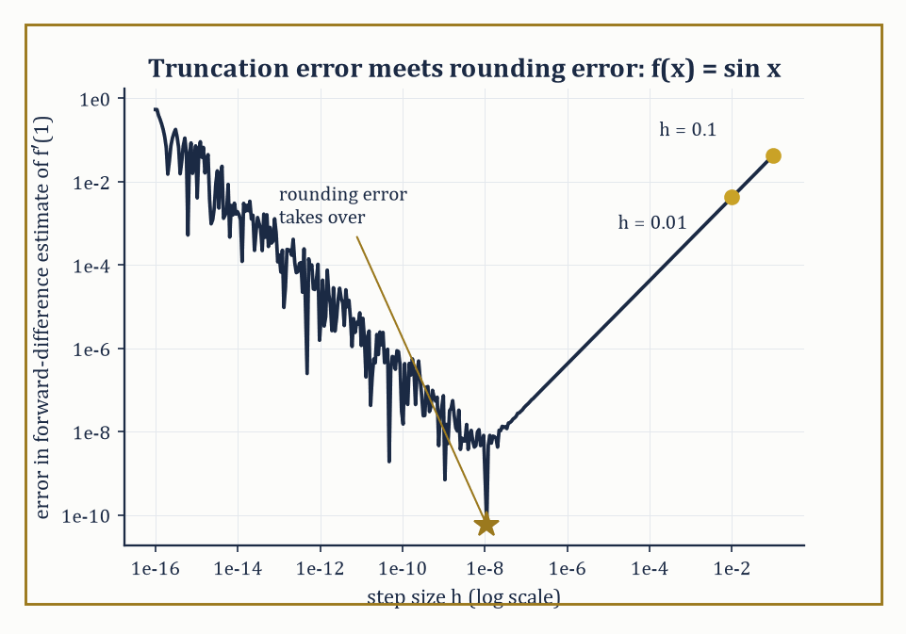
Figure 29.1 — The forward-difference error for f′(1) = cos(1), plotted against step size: truncation error falling on the left, rounding error rising on the right, and the U’s floor sitting right where the worked example warned it would.
Begin with the dial on a car dashboard. A speedometer claims to tell you how fast you are going at this instant, and it cannot possibly do that. Speed is distance divided by time, and at an instant no distance has been covered and no time has passed. What the instrument actually does is watch the wheels over a very short stretch, divide, and present the answer as though it were instantaneous. Nobody is deceived and nobody minds.
That is the whole trade. Something you cannot compute is swapped for something you can, the swap introduces an error, and the error is small enough not to matter. Every numerical method ever written does this and nothing else.
The obvious thought is to shrink the stretch. Watch the wheels over a shorter distance and the answer sits closer to the truth, so watch them over a shorter one still, and keep going. In the mathematics this works beautifully. Take the slope of a curve at a point by measuring across a small step h, using the curve y = sin x at x = 1, where the true slope is 0.5403023. Shrink the step and watch:
h = 0.1 gives 0.4974 · h = 0.01 gives 0.5361 · h = 0.001 gives 0.5399
Those are wrong by 0.043, then 0.0042, then 0.00042. Each tenfold cut in the step cuts the error tenfold, which is as orderly as anyone could ask. Carry on to a step of a millionth of a millionth and the error should fall to around four parts in ten thousand billion.
It does not. At that step the answer is wrong by about four parts in a hundred thousand — a hundred million times worse than the prediction. The method has not been shrinking toward the truth at all. It has been shrinking toward the truth and then walking back away from it, and somewhere in between there was a best step size that nobody chose on purpose.
The reason is worth feeling. The calculation subtracts two numbers that are nearly equal, and a machine holds only about sixteen digits of each. Make the step small enough and those two numbers agree in the first twelve digits, so the subtraction throws all twelve away and builds its answer from the handful of digits that were least reliable to begin with. Halving the step halves the honest part while leaving the noise where it was.
So change the question. Not how do I compute the exact answer, but how close can I get, and what is it that stops me getting closer?
Two things stop you, and they pull in opposite directions. Chopping the problem into finite pieces leaves an error that shrinks as the pieces get smaller. Storing numbers in finitely many digits leaves an error that grows as the pieces get smaller. No step size kills both. Past a certain point, trying harder makes the answer worse — which is not a failure of care, and no amount of diligence removes it.
The response looks like a retreat and is not one. Stop chasing the exact answer. Produce an approximation, and alongside it a rigorous account of how wrong it can be. The accounting is the discipline; the approximating is the easy half.
Notice what the numbers above never do. Not one of them is the slope at the point. Every one is the slope across a real stretch of curve, and the list would run forever without landing — the same thing the chapter on differentiation said about h — except that here h is never permitted to reach zero, because the machine would have nothing left to divide.
That is what numerical methods are: an infinite object replaced by a finite one, together with honest arithmetic about the size of the lie. The figure and numeric example below take this same curve at this same point, and show both errors at once.
It is worth dwelling on why this discipline exists at all. Most equations that arise from physics, engineering, biology, or finance have no closed-form solution: no finite combination of the functions you learned in Chapters 1 through 20 will express the answer exactly.
Even the equations that do have closed forms are sometimes numerically treacherous to evaluate — the quadratic formula, of all things, can lose most of its accuracy to catastrophic cancellation if you are not careful about which root you compute first. And for a general polynomial of degree five or higher, Galois theory (Chapter 37, later in this very volume) proved that no formula built from radicals exists at all, for reasons that have nothing to do with anyone’s cleverness and everything to do with the structure of the symmetric group.
Numerical methods do not mourn this; they route around it.
Every numerical method works by the same trick: it replaces an infinite-dimensional object — a function, an integral, the exact solution of a differential equation — with a finite-dimensional proxy that a computer can hold in memory: a table of numbers, a weighted sum, a grid of values at finitely many points. This substitution introduces truncation error (sometimes called discretization error): the gap between the true infinite-dimensional answer and the best the finite-dimensional proxy could possibly achieve.
Separately, because the computer represents real numbers with only finitely many binary digits (typically about sixteen decimal digits of precision, the so-called machine epsilon, roughly 10⁻¹⁶), every arithmetic operation the machine performs introduces a further sliver of rounding error. A good numerical method is one where these two errors are both under control and, ideally, roughly balanced — driving the truncation error down further than the arithmetic can resolve is polishing a mirror in a dark room.
Numeric example — watching truncation error shrink, forward difference. Take f(x) = sin(x) and try to approximate f′(1) = cos(1) = 0.5403023 using nothing but function values, via the forward-difference formula
f′(x) ≈ (f(x+h) − f(x)) / h
which you get by truncating the Taylor series
f(x+h) = f(x) + h f′(x) + (h²/2) f″(x) + …
after the linear term. With h = 0.1:
sin(1.1) = 0.8912074, sin(1) = 0.8414710
so the difference quotient is
(0.8912074 − 0.8414710)/0.1 = 0.4973638
The true value is 0.5403023, so the error is 0.0429385. Now halve the step to h = 0.01:
sin(1.01) = 0.8468318
(0.8468318 − 0.8414710)/0.01 = 0.5360858
giving an error of 0.0042165 — almost exactly one-tenth of the previous error, for a step ten times smaller. That is truncation error behaving precisely as the discarded Taylor term predicts: the leading error term is
−(h/2)f″(x) = (h/2) sin(1)
which evaluates to 0.0420735 at h = 0.1 and 0.0042074 at h = 0.01, matching our computed errors closely.
If you kept shrinking h past about 10⁻⁸, though, the story would reverse: sin(1+h) and sin(1) become so close together that subtracting them on a machine with sixteen digits of precision loses most of the significant digits to cancellation, and rounding error — not truncation error — starts to dominate and the total error starts climbing again.
Every numerical differentiation formula has this U-shaped error curve; the art is stopping at the bottom of the U.
Try it now — Approximate the derivative of sin at x = 1 by the forward difference with h = 0.1. How far off is it from cos 1 ≈ 0.5403? Answer →
The efficiency axis is usually measured, as elsewhere in the series, in the big-O language of algorithmic complexity: how does the cost of the method grow as the problem size n grows? This is not idle bookkeeping — the growth rate decides which methods are merely slow and which are outright impossible on real hardware, and it is the reason Numerical Linear Algebra will spend real effort distinguishing an O(n³) linear solve from an O(n) iterative one.
Numeric example — why the exponent in big-O matters more than the constant. Gaussian elimination on a dense n×n system costs roughly n³/3 arithmetic operations (Numerical Linear Algebra derives this properly). At n = 100, that’s about
100³/3 ≈ 333,333 operations
— instant on any modern machine. Scale the problem up tenfold, to n = 1000 — not an unusual size for a discretized PDE — and the cost becomes
1000³/3 ≈ 333,333,333 operations
a thousandfold increase in cost for only a tenfold increase in problem size, because the cost scales with the cube of n, and 10³ = 1000. Scale up once more to n = 10,000, typical of a modest three-dimensional grid, and the cost reaches roughly
3.3 × 10¹¹ operations
— a further thousandfold jump. This cubic wall, entirely mechanical and utterly indifferent to how cleverly the code is written, is precisely why Numerical Linear Algebra devotes so much space to iterative methods, whose cost per step scales far more gently with n, as the only realistic option once problems reach this size.
Numerical analysis therefore lives at the intersection of three subjects the series has already built separately: analysis (which supplies the Taylor expansions and inequalities that bound truncation error), linear algebra (which supplies the machinery for the large systems that discretization inevitably produces), and computer science (which supplies the actual floating-point arithmetic, the big-O cost accounting, and its own, wholly honest, imperfections).
It is simultaneously a branch of pure mathematics — approximation theory and stability theory are theorems, proved the way theorems are always proved — and the working engine room of scientific computing. The chapters ahead build this vocabulary one problem at a time: finding roots, fitting curves, differentiating and integrating numerically, solving huge linear systems, and marching differential equations forward through time and space.
Keep only this · Section 29.1: What Numerical Methods Are
The idea. Numerical methods replace exact operations by finite ones. The error has a truncation part, from the approximation, and a rounding part, from floating point; cost grows with problem size at a rate measured by big-O.
Core.
forward difference error: O(h)
total error ≈ Ch + ε/h, smallest near h ≈ √(ε/C)
dense Gaussian elimination ≈ n³/3 operations
Typical mistake. Shrinking h forever. In double precision, below about h = 10⁻⁸ the forward difference gets worse, because rounding error grows like ε/h.
Minimal example. Halve h in the forward difference and the error roughly halves.
Practice. Easy to challenge; full worked answers, with the usual mistake, are in Answers to the Practice Sets at the back.
Easy — Gaussian elimination costs about n³/3. How much longer does n = 2000 take than n = 1000? Answer →
Medium — Repeat the forward difference for sin at 1 with h = 0.05 and compare the error with the one for h = 0.1. Answer →
Challenge — With ε ≈ 10⁻¹⁶ and C ≈ 1, estimate the best h for the forward difference and the error it gives. Answer →

Section 29.2: Root-Finding and Nonlinear Equations
Bisection is slow and honest; Newton is fast and occasionally reckless
You have seen this before
Newton’s method is the linear approximation of Differential (Volume 1), used repeatedly: replace f by its tangent line and solve that instead.
You have played this game. Someone thinks of a number between one and a hundred, you say fifty, and they tell you higher or lower. Seven guesses later you have it, and you were never required to be clever — only to know which half the answer was hiding in. Root-finding is that game played against an equation that refuses to be rearranged. The oldest and most robust method, bisection, is the halving strategy itself: given an interval [a, b] on which a continuous function f changes sign, the Intermediate Value Theorem (Chapter 10 (Volume 1), and it has been quietly doing this job ever since) guarantees a root somewhere inside.
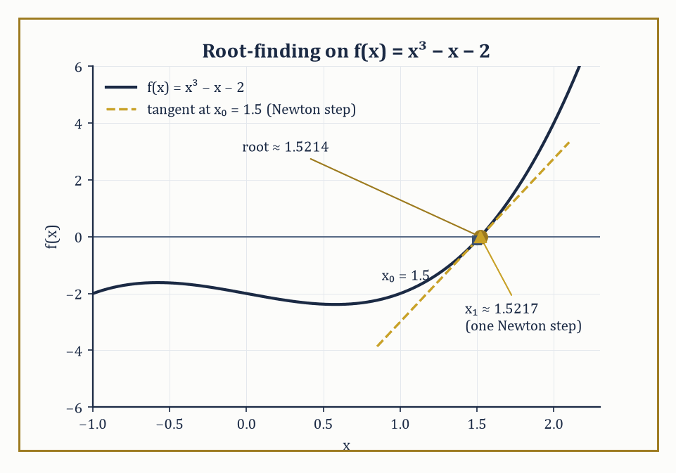
Figure 29.2 — f(x) = x³ − x − 2 and its root near 1.5214, with the Newton tangent from x₀ = 1.5 landing within 0.0003 of the answer in a single step.
Evaluate f at the midpoint; whichever half still brackets the sign change becomes the new interval; repeat.
The interval halves every iteration, so the error is cut in half at every step — a textbook case of linear convergence, meaning the error after n steps is proportional to (1/2)ⁿ.
It is slow, but it essentially cannot fail, provided you started with a genuine bracket.
Numeric example — bisection on x³ − x − 2. Let f(x) = x³ − x − 2.
f(1) = 1 − 1 − 2 = −2
f(2) = 8 − 2 − 2 = 4
So a root lies in [1, 2].
Midpoint 1.5:
f(1.5) = 3.375 − 1.5 − 2 = −0.125
Still negative, so the root is in [1.5, 2].
Midpoint 1.75:
f(1.75) = 5.359375 − 1.75 − 2 = 1.609375
Positive, so the root is in [1.5, 1.75].
Midpoint 1.625:
f(1.625) = 4.291016 − 1.625 − 2 = 0.666016
Positive, root in [1.5, 1.625].
Midpoint 1.5625:
f(1.5625) = 3.814697 − 1.5625 − 2 = 0.252197
Positive, root in [1.5, 1.5625].
Midpoint 1.53125:
1.53125³ = 3.590363
f(1.53125) = 3.590363 − 1.53125 − 2 = 0.059113
Still positive, so the root is in [1.5, 1.53125].
Five steps have squeezed the bracket from width 1 down to width 0.03125 — exactly (1/2)⁵ — and the true root, 1.5213797, sits obligingly inside. Reliable, but you can see already that reaching machine precision this way would take about fifty iterations.
Try it now — Take one bisection step for f(x) = x³ − x − 2 on [1, 2]. Answer →
Newton’s method trades that reliability for speed by using derivative information: given a current guess xₙ, approximate f near xₙ by its tangent line and jump to where the tangent crosses zero.
xₙ₊₁ = xₙ − f(xₙ)/f′(xₙ)
When it works, it works spectacularly — the error roughly squares at every step, so-called quadratic convergence, meaning the number of correct digits roughly doubles each iteration.
The catch, and it is a real one, is the phrase ‘when it works’: Newton’s method has no memory of where the root actually is, and a poorly chosen starting guess, a nearby inflection point, or a flat derivative can send it wandering arbitrarily far away.
Numeric example — Newton on the same cubic — watch the digits double. With f(x) = x³ − x − 2, f′(x) = 3x² − 1.
Start at x₀ = 1.5:
f(1.5) = −0.125
f′(1.5) = 3(2.25) − 1 = 5.75
x₁ = 1.5 − (−0.125/5.75) = 1.5 + 0.021739 = 1.521739
Compare to bisection, which after five steps had only pinned the root to within 0.03 — Newton got within 0.0003 in a single step.
Iterate again:
x₁² = 2.315690
x₁³ = 3.523876
f(x₁) = 3.523876 − 1.521739 − 2 = 0.002137
f′(x₁) = 3(2.315690) − 1 = 5.947070
x₂ = 1.521739 − 0.002137/5.947070 = 1.521739 − 0.000359 = 1.521380
The true root is 1.5213797 — x₂ is correct to six decimal places after just two iterations from a mediocre starting guess.
That is quadratic convergence made visible: the error went from about 0.02 (at x₀) to about 0.0004 (at x₁) to about 0.00000003 (at x₂), each error roughly the square of the one before.
Newton’s method generalizes to systems of n nonlinear equations in n unknowns by replacing the single derivative f′ with the Jacobian matrix J, the n×n matrix of all first partial derivatives, and solving the following linear system at every step for the update Δ:
J(xₙ)·Δ = −F(xₙ)
Then set:
xₙ₊₁ = xₙ + Δ
This costs an O(n³) linear solve at every iteration (Numerical Linear Algebra explains why), which for large systems is expensive enough that quasi-Newton methods — which update a cheap approximation to the Jacobian rather than recomputing and refactoring it from scratch every time — are often preferred in practice.
Numeric example — Newton’s method on a 2×2 system. Find the intersection, in the first quadrant, of the circle x² + y² = 4 and the line x − y = 1 — that is, solve:
F(x, y) = (x² + y² − 4, x − y − 1) = (0, 0)
This particular system has a closed form, by design, so we can check our work: substituting x = y + 1 gives the quadratic
2y² + 2y − 3 = 0
y = (−1 + √7)/2 = 0.8228757, x = 1.8228757
The Jacobian is:
J = [2x 2y; 1 −1]
Start at (x₀, y₀) = (2, 1):
F(2,1) = (1, 0)
J(2,1) = [4 2; 1 −1], determinant −6
Solving JΔ = −F gives:
Δx = Δy = −1/6
(x₁, y₁) = (1.833333, 0.833333)
Already within 0.01 of the true answer after one step.
A second iteration:
F(1.833333, 0.833333) = (3.361111 + 0.694444 − 4, 0) = (0.055556, 0)
J = [3.666667 1.666667; 1 −1], determinant −5.333333
Solving gives:
Δx = Δy = −0.010417
(x₂, y₂) = (1.822917, 0.822917)
Against the exact answer (1.8228757, 0.8228757) the error is about 0.00004 in each coordinate — down from about 0.010 after the first step, the error again roughly squaring, as quadratic convergence promises.
For polynomials specifically, one elegant trick converts root-finding entirely into an eigenvalue problem: the companion matrix of a monic polynomial
p(x) = xⁿ − cₙ₋₁xⁿ⁻¹ − ⋯ − c₁x − c₀
is the n×n matrix with 1s on the subdiagonal and the coefficients cᵢ down the final column, and its characteristic polynomial is p(x) — so the roots of p are the eigenvalues of this matrix, and can be found by the eigenvalue algorithms of Numerical Linear Algebra (this is, in fact, how MATLAB’s roots function works under the hood).
Specialized algorithms — Jenkins–Traub, Aberth’s method — are faster for polynomials of very high degree, but the companion-matrix trick is a beautiful illustration of one numerical problem being silently converted into another.
Abstract example — the companion matrix of x³ − x − 2. For p(x) = x³ − x − 2, write it as x³ − 0·x² − 1·x − 2, so c₂ = 0, c₁ = 1, c₀ = 2.
C = [0 0 2; 1 0 1; 0 1 0]
Expanding det(xI − C) along the first row recovers x³ − 0x² − x − 2, confirming the construction.
We already found one eigenvalue by Newton’s method above: the real root 1.5213797.
The other two eigenvalues are complex, and Vieta’s formulas pin them down without any further iteration: the three roots sum to 0 (the coefficient of x² is zero) and multiply to 2 (minus the constant term), so the remaining pair sums to −1.5213797 and multiplies to:
2/1.5213797 = 1.3145962
They are therefore the roots of:
t² + 1.5213797t + 1.3145962 = 0
t = (−1.5213797 ± i√2.9437886... )/2
That is, approximately −0.7606899 ± 0.8578735i.
This is just what an eigenvalue algorithm applied to the companion matrix would report, and it is a useful reminder that a real cubic with one real root always hides a complex-conjugate pair, quietly, in the other two eigenvalues.
Two cautionary notes complete the picture.
First, conditioning: the roots of a polynomial can be exquisitely sensitive to tiny changes in its coefficients — Wilkinson’s famous example, the degree-twenty polynomial with roots 1 through 20, has some roots that move by several units, and even leave the real line wholly to become complex-conjugate pairs, when a single coefficient is perturbed by an amount of order 10⁻⁷. Multiple or tightly clustered roots are the worst-conditioned of all.
Second, globalization: Newton’s method’s quadratic convergence is only a local guarantee, so practical solvers wrap it in a line search (shrink the step if it doesn’t improve things) or a trust region (only trust the linear model within a ball of adaptively chosen radius) to widen the basin of initial guesses from which the method converges.
Numeric example — Newton gone astray. Return to f(x) = x³ − x − 2 but start Newton’s method from x₀ = 0, well away from the root near 1.52.
f(0) = −2
f′(0) = −1
x₁ = 0 − (−2/−1) = 0 − 2 = −2
Overshooting wildly to the other side of the real line.
f(−2) = −8 + 2 − 2 = −8
f′(−2) = 12 − 1 = 11
x₂ = −2 − (−8/11) = −2 + 0.727273 = −1.272727
f(−1.272727) = −2.061455 + 1.272727 − 2 = −2.788728
f′(−1.272727) = 3(1.619835) − 1 = 3.859505
x₃ = −1.272727 − (−2.788728/3.859505) = −1.272727 + 0.722461 = −0.550266
Three iterations in, and instead of approaching 1.5214 we are bouncing around the negative axis, nowhere near converging.
This is the pathology that line search and trust-region methods exist to prevent — bare, unprotected Newton is a brilliant local tool and a reckless global one.
Keep only this · Section 29.2: Root-Finding and Nonlinear Equations
The idea. Bisection always converges, halving the bracket each step. Newton’s method converges quadratically near a simple root but can wander from a poor start. Systems use the Jacobian, and polynomial roots are the eigenvalues of the companion matrix.
Core.
bisection: error ≤ (b − a)/2ⁿ
Newton: xₙ₊₁ = xₙ − f(xₙ)/f′(xₙ)
systems: J(xₙ)Δ = −F(xₙ)
Typical mistake. Starting Newton anywhere. For x³ − x − 2 from x₀ = 0 the first step jumps to −2, away from the root near 1.52.
Minimal example. x² − 2 from x₀ = 1: Newton gives 1.5, 1.41667, 1.41422.
Practice. Easy to challenge; full worked answers, with the usual mistake, are in Answers to the Practice Sets at the back.
Easy — How many bisection steps reduce a bracket of length 1 below 10⁻⁶? Answer →
Medium — Take one Newton step for x³ − x − 2 from x₀ = 1.5. Answer →
Challenge — Near a simple root r, Newton’s errors satisfy eₙ₊₁ ≈ (f″(r)/(2f′(r)))eₙ². Use it to predict e₁ for x² − 2 from x₀ = 1.5, and compare with the actual error. Answer →

Section 29.3: Interpolation, Approximation, and Splines
Threading a curve through the data without letting it misbehave at the edges
Given n + 1 data points with distinct x-coordinates, there is exactly one polynomial of degree at most n that passes through all of them — this is the interpolation theorem, and it is worth pausing on why it is true: n + 1 unknown coefficients, n + 1 linear conditions (pass through each point), and the resulting linear system’s matrix (the Vandermonde matrix) is invertible precisely because the x-coordinates are distinct.
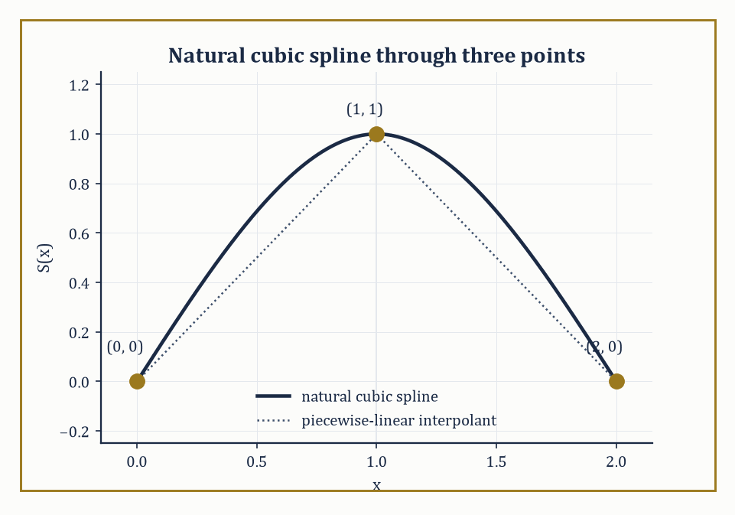
Figure 29.3 — The natural cubic spline through (0,0), (1,1), (2,0), rising and falling with no kink at the knot — compared against the plain connect-the-dots path it improves on.
The Lagrange form writes this polynomial directly as a weighted sum of data values without ever solving a linear system explicitly:
P(x) = Σᵢ yᵢ Lᵢ(x)
Here Lᵢ(x) is the unique degree-n polynomial that equals 1 at xᵢ and 0 at every other node, built by construction as a product of factors (x − xⱼ)/(xᵢ − xⱼ).
Numeric example — Lagrange interpolation through three points. Interpolate the points (0, 1), (1, 2), (3, 10) with a quadratic. The Lagrange basis polynomials are as follows.
L₀(x) = (x−1)(x−3)/((0−1)(0−3)) = (x−1)(x−3)/3
L₁(x) = x(x−3)/((1)(1−3)) = x(x−3)/(−2)
L₂(x) = x(x−1)/((3)(3−1)) = x(x−1)/6
The interpolant is P(x) = 1·L₀(x) + 2·L₁(x) + 10·L₂(x). Expanding each term over a common denominator of 6, L₀ contributes (2x² − 8x + 6)/6, 2L₁ contributes (−6x² + 18x)/6, and 10L₂ contributes (10x² − 10x)/6.
(2 − 6 + 10)x² + (−8 + 18 − 10)x + 6 = 6x² + 0x + 6
P(x) = (6x² + 6)/6 = x² + 1
Check: P(0) = 1 ✓, P(1) = 2 ✓, P(3) = 10 ✓ — and indeed those three data points were secretly sampled from f(x) = x² + 1, so the unique quadratic interpolant has exactly and exhaustively reconstructed the function that generated the data, as the interpolation theorem promised it would for any three points of a quadratic.
Try it now — Interpolate (0, 1), (1, 2), (3, 10) by a quadratic and evaluate it at x = 2. Answer →
The error formula for polynomial interpolation is equally instructive: if f is n + 1 times differentiable, the interpolation error at any point x is given below, for some ξ in the interval.
f(x) − P(x) = f⁽ⁿ⁺¹⁾(ξ)/(n+1)! · ∏ᵢ(x − xᵢ)
The product term — the nodal polynomial — depends only on where you placed your nodes, not on f. This is where Runge’s phenomenon lurks: for equally spaced nodes on an interval, the nodal polynomial’s peaks near the endpoints grow so large, so fast, as the degree increases that for functions with a sharp enough peak (the classic villain is f(x) = 1/(1 + 25x²) on [−1, 1]), the interpolation error near the endpoints grows without bound as more equally spaced nodes are added — more data makes the fit worse.
Chebyshev nodes cluster near the endpoints where equally spaced nodes are weakest, shrinking the nodal polynomial’s peak there and taming the divergence. They are defined, for k = 1, …, n, by:
xₖ = cos((2k−1)π/(2n))
Numeric example — five Chebyshev nodes. For n = 5 nodes on [−1, 1], the formula xₖ = cos((2k−1)π/10) gives the following values.
x₁ = cos(π/10) = cos 18° = 0.9510565
x₂ = cos(3π/10) = cos 54° = 0.5877853
x₃ = cos(5π/10) = cos 90° = 0
x₄ = cos(7π/10) = cos 126° = −0.5877853
x₅ = cos(9π/10) = cos 162° = −0.9510565
Compare five equally spaced nodes on the same interval: −1, −0.5, 0, 0.5, 1.
The Chebyshev nodes visibly bunch up near ±1 — the gap from the boundary x=1 to the nearest node is a mere 0.049, while the gap between the two nodes flanking the center (x₂ to x₃) is 0.588, more than ten times as wide — and thin out near the middle accordingly, the opposite spacing of the equally spaced set, and what is needed to suppress the endpoint blow-up that ruins high-degree interpolation on a uniform grid.
When there are more data points than you want polynomial coefficients — or when the data is noisy and passing through every point would be actively undesirable — least-squares approximation finds the polynomial (or, more generally, the member of whatever basis you choose) that minimizes the sum of squared residuals given below.
Σᵢ(yᵢ − P(xᵢ))²
Setting the gradient of this sum to zero produces the normal equations, a small linear system in the unknown coefficients.
Numeric example — least-squares line through four points. Fit y = a + bx to (1,2), (2,3), (3,5), (4,6).
n = 4, Σx = 10, Σy = 16, Σx² = 1+4+9+16 = 30, Σxy = 2+6+15+24 = 47
The normal equations for simple linear regression give the slope and intercept.
b = (nΣxy − ΣxΣy)/(nΣx² − (Σx)²) = (4·47 − 10·16)/(4·30 − 100) = (188 − 160)/(120 − 100) = 28/20 = 1.4
a = (Σy − bΣx)/n = (16 − 14)/4 = 0.5
The fitted line is y = 0.5 + 1.4x. Its predictions are 1.9, 3.3, 4.7, 6.1 against actual values 2, 3, 5, 6, giving residuals +0.1, −0.3, +0.3, −0.1 — which sum to exactly zero, as they always must for a least-squares fit with an intercept term, a handy self-check.
Splines take a different tack: rather than one global polynomial, use a different low-degree polynomial on each subinterval between data points, and require enough of the derivatives to match at the joints (the ‘knots’) that the whole curve looks smooth to the eye.
Cubic splines — piecewise cubics matching value, first, and second derivative at every interior knot — are the workhorse of computer-aided design because they combine local flexibility (wiggling one data point only disturbs the curve nearby) with global smoothness (no visible kinks), unlike a single high-degree interpolating polynomial, which Runge’s phenomenon shows can wiggle catastrophically everywhere in response to one troublesome data point.
Numeric example — a natural cubic spline through three points. Interpolate (0,0), (1,1), (2,0) with a natural cubic spline (second derivative zero at both endpoints). With equal spacing h = 1 and second-derivative unknowns M₀, M₁, M₂, the interior smoothness condition for uniform spacing reads:
Mᵢ₋₁ + 4Mᵢ + Mᵢ₊₁ = (6/h²)(yᵢ₋₁ − 2yᵢ + yᵢ₊₁)
Naturalness forces M₀ = M₂ = 0, leaving:
4M₁ = 6(0 − 2 + 0) = −12, so M₁ = −3
Standard cubic-spline formulas then give, on [0,1] and on [1,2] respectively:
S₀(x) = −0.5x³ + 1.5x
S₁(x) = −0.5(2−x)³ + 1.5(2−x)
Check the joins:
S₀(0) = 0 ✓, S₀(1) = −0.5+1.5 = 1 ✓, S₁(1) = −0.5+1.5 = 1 ✓, S₁(2) = 0 ✓
First derivatives:
S₀′(x) = −1.5x²+1.5 gives S₀′(1) = 0; S₁′(x) = 1.5(2−x)²−1.5 gives S₁′(1) = 0
They agree, so the curve has no kink at x = 1.
Second derivatives:
S₀″(x) = −3x gives S₀″(0) = 0 (natural, as required) and S₀″(1) = −3 = M₁ ✓; S₁″(1) = −3 = M₁ ✓ and S₁″(2) = 0 (natural) ✓
Every condition checks out by hand, and the spline rises smoothly to its peak at x = 1 and falls away again, with no trace of the overshoot a degree-2 global interpolant would already be capable of avoiding here, but which a higher-degree global fit through many such points would not.
Approximation theory asks a sharper question than ‘how well does this particular method do?’ — it asks how well any method built from a given class of approximants (degree-n polynomials, say) could possibly do, for a given class of functions.
The Weierstrass approximation theorem (any continuous function on a closed interval can be approximated arbitrarily well by polynomials) has a wonderfully constructive proof due to Bernstein, using the Bernstein polynomials defined below.
Bₙ(f; x) = Σₖ f(k/n) C(n,k) xᵏ(1−x)ⁿ⁻ᵏ
The rate at which Bₙ(f) converges to f, along with the matching rate given by Jackson’s theorem for the best possible polynomial approximation, quantifies exactly how much accuracy a given approximation budget can buy.
Abstract example — Bernstein polynomials converging to x². For f(x) = x², the Bernstein polynomial has the closed form given below (a standard identity, easily checked for n = 2).
Bₙ(x²; x) = x² + x(1−x)/n
With f(0)=0, f(0.5)=0.25, f(1)=1, the check for n = 2 proceeds as follows.
B₂(x) = 0.25·2x(1−x) + x² = 0.5x(1−x) + x² = 0.5x + 0.5x²
x² + x(1−x)/2 = x² + 0.5x − 0.5x² = 0.5x² + 0.5x
The two match precisely. At x = 0.5, B₂(0.25; 0.5)... rather, the evaluation is:
B₂(x²; 0.5) = 0.5(0.25)+0.5(0.5) = 0.125+0.25 = 0.375
That is against the true value 0.25 — an error of 0.125. Bump n to 10:
B₁₀(x²; 0.5) = 0.25 + 0.5(0.5)/10 = 0.25 + 0.025 = 0.275
That gives an error of 0.025 — a fivefold reduction for a fivefold increase in n, consistent with the general O(1/n) convergence rate that both the Bernstein construction and Jackson’s theorem predict for this class of function. It is not a fast rate, by the standards of later chapters, but it is a completely explicit and constructive one — you can write down, in closed form, the very polynomial that does the approximating.
Keep only this · Section 29.3: Interpolation, Approximation, and Splines
The idea. Interpolation passes a polynomial through data. High-degree interpolation on equally spaced nodes can oscillate wildly (Runge’s phenomenon); Chebyshev nodes fix that, least squares fits noisy data, and splines join low-degree pieces smoothly.
Core.
f(x) − p(x) = f⁽ⁿ⁺¹⁾(ξ)/(n + 1)! · ∏(x − xᵢ)
Chebyshev nodes: xₖ = cos((2k − 1)π/(2n))
least squares: AᵀAc = Aᵀy
Typical mistake. Raising the degree to improve the fit on equally spaced nodes. For 1/(1 + 25x²) the error at the ends grows with the degree.
Minimal example. Two points, degree one: the secant line.
Practice. Easy to challenge; full worked answers, with the usual mistake, are in Answers to the Practice Sets at the back.
Easy — Find the two Chebyshev nodes on [−1, 1]. Answer →
Medium — Fit y = a + bx by least squares to (0, 0), (1, 1), (2, 3). Answer →
Challenge — Bound the error of linear interpolation of sin x on [0, π/2] at the midpoint, and compare with the actual error. Answer →

Section 29.4: Numerical Differentiation and Integration
Differentiation punishes noise; integration, mercifully, forgives it
Finite-difference formulas approximate derivatives from sampled function values, and their order of accuracy — how fast the error shrinks as the step h shrinks — is read directly off the Taylor expansion term that the formula fails to cancel.
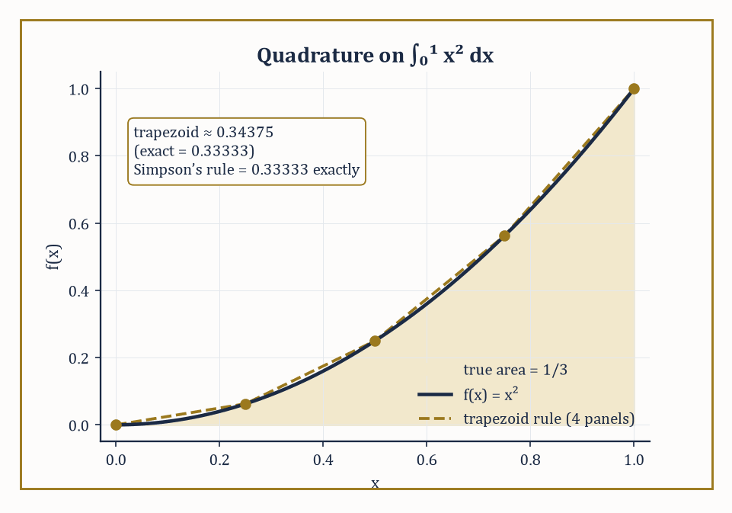
Figure 29.4 — ∫₀¹ x² dx: the trapezoid rule’s straight segments overshoot the curve’s true area, while Simpson’s parabola-fitting gets the exact answer, 1/3, from the same five points.
The forward-difference formula met in What Numerical Methods Are is first order, O(h); the central-difference formula cancels the next Taylor term for free by symmetry and is second order, O(h²):
(f(x+h) − f(x−h))/(2h)
Halving h quarters the error rather than merely halving it.
Numeric example — central difference beats forward difference. Return to f(x) = sin(x), f′(1) = cos(1) = 0.5403023, with h = 0.1.
sin(1.1) = 0.8912074, sin(0.9) = 0.7833269
central difference = (0.8912074 − 0.7833269)/0.2 = 0.5394023
This gives an error of just 0.0009000 — about 48 times smaller than the forward-difference error of 0.0429385 computed in What Numerical Methods Are at the very same step size. Theory explains why exactly: the central-difference leading error term is
(h²/6)f‴(ξ) ≈ (0.01/6)cos(1) = 0.0009005
which matches the observed error to five decimal places. Halve the step to h = 0.05:
sin(1.05) = 0.8674233, sin(0.95) = 0.8134156
central difference = (0.8674233 − 0.8134156)/0.1 = 0.5400772, error 0.0002251
And 0.0002251/0.0009000 ≈ 0.25, the quartering that O(h²) accuracy predicts.
Try it now — Approximate the derivative of sin at 1 by the central difference with h = 0.1. Answer →
Richardson extrapolation squeezes yet more accuracy out of a known order of convergence for free, by combining two estimates at different step sizes to cancel the leading error term algebraically. If a method is O(h²), then the following combination cancels the h² term and leaves an O(h⁴) result:
Dₑₓₜᵣₐₚ = (4·D(h/2) − D(h)) / 3
No new function evaluations beyond the ones you already had are required.
Numeric example — Richardson extrapolation on the central difference. Using the two central-difference values just computed, D(0.1) = 0.5394023 and D(0.05) = 0.5400772:
Dₑₓₜᵣₐₚ = (4·0.5400772 − 0.5394023)/3 = (2.1603088 − 0.5394023)/3 = 1.6209065/3 = 0.5403022
The true value is cos(1) = 0.5403023 — the extrapolated estimate is correct to six decimal places, an error of about 10⁻⁷, roughly two thousand times smaller than the better of the two central-difference estimates that went into it. This is the general phenomenon: extrapolation converts an O(h²) method into an O(h⁴) one using arithmetic alone, no extra sampling of the function required.
Numerical integration, or quadrature, replaces the integral of f(x) by a weighted sum:
∫f(x)dx ≈ Σwᵢf(xᵢ)
The Newton–Cotes family uses equally spaced nodes: the trapezoid rule fits a straight line between consecutive points, while Simpson’s rule fits a parabola through each group of three, and is exact for any cubic — not only any quadratic — because the error term happens to involve a fourth derivative that vanishes identically for cubics, a small piece of good luck baked into the formula’s derivation.
Numeric example — trapezoid vs Simpson on ∫₀¹ x² dx. The exact value is 1/3 = 0.333333. Using five equally spaced nodes (h = 0.25): x = 0, 0.25, 0.5, 0.75, 1 with f-values 0, 0.0625, 0.25, 0.5625, 1.
Trapezoid: (h/2)[f₀ + 2f₁ + 2f₂ + 2f₃ + f₄] = 0.125[0 + 0.125 + 0.5 + 1.125 + 1] = 0.125 × 2.75 = 0.34375
This gives an error of 0.01042.
Simpson’s rule: (h/3)[f₀ + 4f₁ + 2f₂ + 4f₃ + f₄] = (0.25/3)[0 + 0.25 + 0.5 + 2.25 + 1] = 0.083333 × 4 = 0.333333
This is exactly right, to all the digits shown, because x² is a quadratic and Simpson’s rule is exact through cubics. Four equally spaced points bought trapezoid an error of about 3%; the same four points, weighted differently, bought Simpson an exact answer.
Gaussian quadrature abandons equally spaced nodes altogether and instead chooses both the node positions and the weights to maximize the degree of polynomial that the rule integrates precisely — an n-point Gaussian rule is exact for polynomials up to degree 2n − 1, roughly twice what an n-point Newton–Cotes rule achieves for the same number of function evaluations.
The two-point Gauss–Legendre rule on [−1, 1] uses nodes ±1/√3 with weight 1 each, and is exact through degree 3.
Numeric example — two-point Gaussian quadrature. Test on ∫₋₁¹ x² dx (exact value 2/3 = 0.666667). The nodes are ±1/√3 = ±0.5773503, and (1/√3)² = 1/3 exactly, so f(±0.5773503) = 0.333333 at both nodes.
1×0.333333 + 1×0.333333 = 0.666667
This is exact, as promised, since x² has degree 2 ≤ 3. Now push past the rule’s guaranteed exactness with ∫₋₁¹ x⁴ dx (exact value 2/5 = 0.4): f(±0.5773503) = (1/3)² = 0.111111 at both nodes, giving the rule’s estimate 0.222222 — a substantial error of 0.177778, because degree 4 exceeds the two-point rule’s degree-of-precision ceiling of 3.
The lesson sits right there in the two computations: a Gaussian rule is exact, not approximately good, up to its guaranteed degree, and then its accuracy falls off a cliff one degree higher — which is why quadrature rules are always chosen (or composited into smaller pieces) with the smoothness and polynomial-likeness of the integrand in mind.
The Euler–Maclaurin formula explains a delightful special case: it expresses the exact difference between the trapezoidal-rule sum and the true integral as a series of correction terms involving the derivatives of f at the endpoints and the Bernoulli numbers, met here for the first time. The first few are 1, −1/2, 1/6, 0, −1/30, and every odd one after the second is 0. They are the coefficients of these correction terms; in this section they control quadrature error.
When f is smooth and periodic and you integrate over exactly one full period, every derivative of f matches at the two endpoints, every correction term in the series cancels, and the humble trapezoid rule — normally only second-order accurate — converges spectrally fast: faster than any power of h.
Numeric example — the trapezoid rule’s secret superpower on periodic integrands. Compute ∫[0, 2π] sin²(x) dx using the trapezoid rule with just four subintervals, h = π/2. Nodes at 0, π/2, π, 3π/2, 2π give f-values 0, 1, 0, 1, 0 (since sin²(π/2) = 1 and sin² of 0, π, 2π are all 0). The periodic trapezoid sum (endpoints coincide and get combined) is h × (f₁ + f₂ + f₃) with the shared endpoint counted once:
T = h × [0.5·f₀ + f₁ + f₂ + f₃ + 0.5·f₄] = 1.570796 × [0 + 1 + 0 + 1 + 0] = 1.570796 × 2 = 3.141593
The exact value is
∫[0, 2π] sin²(x)dx = π = 3.14159265
since sin² averages to 1/2 over a full period. With only four points, the trapezoid rule has recovered π correct to six decimal places — a result that would ordinarily need dozens of points to achieve for a non-periodic integrand of comparable smoothness. This is the Euler–Maclaurin cancellation in action: nothing clever was done except that the domain of integration was exactly one full period of a smooth periodic function.
Keep only this · Section 29.4: Numerical Differentiation and Integration
The idea. Symmetric formulas cancel error terms: central differences are O(h²) and Simpson’s rule O(h⁴). Richardson extrapolation combines two step sizes to cancel the leading error, and Gaussian quadrature places its nodes to integrate high-degree polynomials exactly.
Core.
central difference: (f(x + h) − f(x − h))/2h, error O(h²)
Richardson for an O(h²) method: (4D(h/2) − D(h))/3
Simpson: (h/3)(f₀ + 4f₁ + 2f₂ + ⋯ + 4fₙ₋₁ + fₙ)
Typical mistake. Using Richardson’s factor 4 for a first-order method. For a method of order p the factor is 2ᵖ.
Minimal example. Two-point Gauss on ∫₋₁¹ x² dx: 1/3 + 1/3 = 2/3, exact.
Practice. Easy to challenge; full worked answers, with the usual mistake, are in Answers to the Practice Sets at the back.
Easy — Apply the trapezoid rule with one panel to ∫₀¹ x² dx. Answer →
Medium — Combine D(0.1) = 0.5394023 and D(0.05) = 0.5400772 by Richardson extrapolation. Answer →
Challenge — Apply Simpson’s rule with h = 0.5 to ∫₀¹ x³ dx, and explain why the answer is exact. Answer →

Section 29.5: Numerical Linear Algebra
Solving Ax = b, and finding out afterwards how much you should trust the answer
You have seen this before
LU factorization is Gaussian elimination from Matrices (Volume 2), with the multipliers kept; the power method uses the eigenvalues of Linear Algebra (Volume 2).
Gaussian elimination with partial pivoting is still, after two centuries, the default way to solve a linear system Ax = b: it factors a row-permuted version of A into a product of a lower-triangular matrix L (with 1s on the diagonal, recording the elimination multipliers) and an upper-triangular matrix U (the result of the elimination itself).
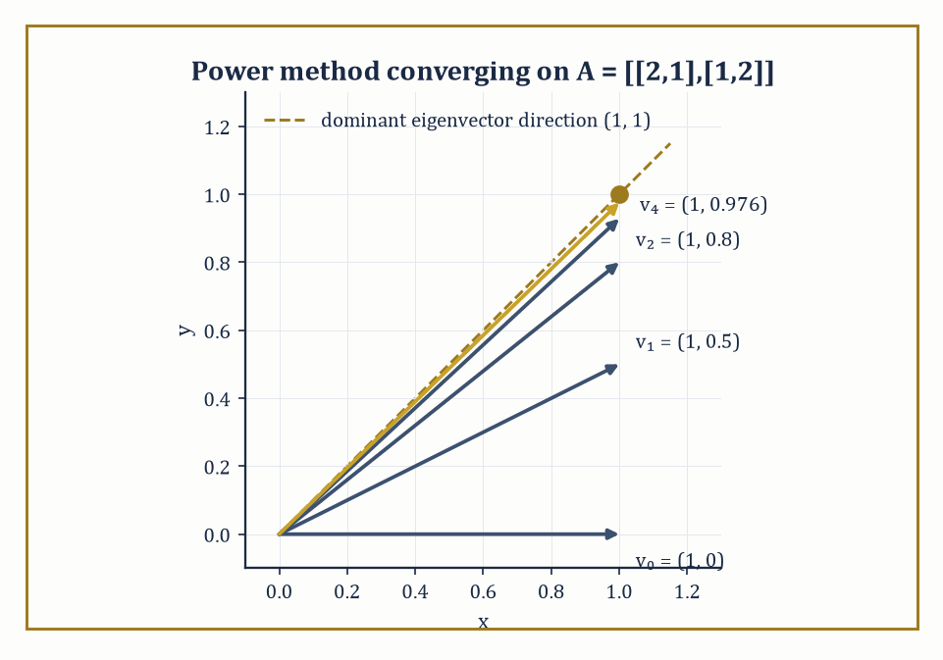
Figure 29.5 — The power method’s iterates v₀ through v₄, started at (1,0) and repeatedly multiplied by A = [2 1; 1 2], swinging steadily into line with the dominant eigenvector direction (1,1).
PA = LU
This factorization costs O(n³) arithmetic operations for an n×n system. Once you have L and U, solving Ax = b is cheap: forward-substitute to solve Ly = Pb, then back-substitute to solve Ux = y, each an O(n²) operation.
Numeric example — LU decomposition and a full solve. Let A = [2 1 1; 4 3 3; 8 7 9]. Eliminate column 1:
Row2 − 2·Row1 gives [0,1,1]
Row3 − 4·Row1 gives [0,3,5]
Eliminate column 2:
Row3 − 3·Row2 gives [0,0,2]
So, recording the multipliers used and noting that no row swaps were needed here (since every pivot encountered — 2, then 1, then 2 — was already the largest available, so P = I):
U = [2 1 1; 0 1 1; 0 0 2]
L = [1 0 0; 2 1 0; 4 3 1]
Check that LU reproduces A — for instance, row 3 of LU:
4·[2,1,1] + 3·[0,1,1] + 1·[0,0,2] = [8,4,4]+[0,3,3]+[0,0,2] = [8,7,9]
This matches A precisely, as do the other two rows. Now solve Ax = b for b = (4, 10, 20). Forward substitution on Ly = b gives:
y₁ = 4
2(4) + y₂ = 10 ⟹ y₂ = 2
4(4) + 3(2) + y₃ = 20 ⟹ 16 + 6 + y₃ = 20 ⟹ y₃ = −2
Back substitution on Ux = y gives:
2x₃ = −2 ⟹ x₃ = −1
x₂ + x₃ = 2 ⟹ x₂ = 3
2x₁ + x₂ + x₃ = 4 ⟹ 2x₁ = 4 − 3 + 1 = 2 ⟹ x₁ = 1
So x = (1, 3, −1). Checking directly against A:
row 1: 2(1)+1(3)+1(−1)=4 ✓
row 2: 4(1)+3(3)+3(−1)=10 ✓
row 3: 8(1)+7(3)+9(−1)=20 ✓
Try it now — Factor A = [2 1; 4 3] as LU. Answer →
Not every system is so cooperative. The condition number of A measures how much a relative perturbation in the input (A or b) can be amplified into a relative perturbation in the solution x — a well-conditioned matrix (condition number near 1) is forgiving; an ill-conditioned one (condition number in the thousands or millions) can turn a rounding error smaller than you could ever see into a solution that is qualitatively wrong.
Numeric example — an ill-conditioned 2×2 system amplifying a tiny perturbation. Let A = [1 1; 1 1.0001] and b = (2,2). Solving exactly, from row 1, x₁+x₂=2; subtracting row 1 from row 2 gives:
0.0001x₂ = 0, so x₂ = 0 and x₁ = 2
The solution is (2, 0). Now perturb b by the tiniest amount, to b′ = (2, 2.0001) — a change of just 0.0001 in one entry. Solving again, x₁ + x₂ = 2, and subtracting gives:
0.0001x₂ = 0.0001, so x₂ = 1 and x₁ = 1
The solution is now (1, 1). A change of only 0.0001 in the input produced a change of over 1.4 (in Euclidean norm) in the output — an amplification factor above ten thousand. This is what a large condition number promises: here det(A) = 0.0001 is tiny relative to the entries of A, which is the hallmark of near-singularity, and the ∞-norm condition number works out to roughly 40,000, consistent with the enormous amplification just witnessed by hand.
For systems too large to factor directly — arising, typically, from discretizing a PDE over a fine grid — iterative methods build a sequence of increasingly accurate approximate solutions instead. The simplest, Jacobi iteration, updates every unknown simultaneously using only the previous iterate’s other components; Gauss–Seidel uses updated values as soon as they’re available within the same sweep and typically converges faster.
The conjugate gradient method (for symmetric positive-definite systems) and GMRES (for general systems) are far more sophisticated, choosing each new approximation to minimize the error, or the residual, over an expanding search space, and are the only realistic option once n reaches the millions.
Numeric example — Jacobi iteration converging to a known answer. Solve 5x + y = 11 and x + 5y = 7, whose exact solution is x = 2, y = 1 (check: 5(2)+1=11 ✓, 2+5(1)=7 ✓). Jacobi iteration rearranges each equation to isolate its own variable:
xᵏ⁺¹ = (11 − yᵏ)/5, yᵏ⁺¹ = (7 − xᵏ)/5
Starting from (x₀,y₀) = (0,0):
iteration 1: (x₁,y₁) = (2.2, 1.4)
iteration 2: x₂ = (11−1.4)/5 = 1.92, y₂ = (7−2.2)/5 = 0.96
iteration 3: x₃ = (11−0.96)/5 = 2.008, y₃ = (7−1.92)/5 = 1.016
iteration 4: x₄ = (11−1.016)/5 = 1.9968, y₄ = (7−2.008)/5 = 0.9984
The iterates are visibly converging on (2, 1), oscillating in from either side as the diagonal dominance of this system (each row’s diagonal entry, 5, exceeds the off-diagonal entry, 1, in magnitude) guarantees they must — no matrix factorization was needed at any point, only cheap arithmetic repeated a handful of times.
Eigenvalue algorithms round out the toolkit: the power method repeatedly multiplies a vector by A and renormalizes, and converges to the eigenvector of the largest-magnitude eigenvalue, since that eigenvalue’s contribution dominates every other after enough multiplications.
The QR algorithm, Lanczos, and Arnoldi are more industrial-strength methods for computing the full spectrum, or large chunks of it, of matrices too large to diagonalize directly.
Numeric example — the power method finding a dominant eigenvalue. Let A = [2 1; 1 2], with eigenvalues found from:
λ² − 4λ + 3 = 0 (trace 4, determinant 3), so λ = 1 or 3
The dominant eigenvalue 3 belongs to the eigenvector direction (1,1). Start the power method at v₀ = (1,0).
v₁ = Av₀ = (2,1); normalize by the largest entry, 2, to get (1, 0.5)
v₂ = A(1,0.5) = (2.5, 2); normalize by 2.5 to get (1, 0.8)
v₃ = A(1,0.8) = (2.8, 2.6); normalize by 2.8 to get (1, 0.928571)
v₄ = A(1,0.928571) = (2.928571, 2.857143); normalize by 2.928571 to get (1, 0.975610)
Two things are converging simultaneously: the direction (1, 0.5), (1, 0.8), (1, 0.928571), (1, 0.975610), … is visibly homing in on (1,1), the dominant eigenvector; and the normalizing factors 2, 2.5, 2.8, 2.928571, … are visibly homing in on 3, the dominant eigenvalue — the pair the algebra predicted, extracted using nothing but repeated matrix-vector multiplication.
Underlying all of this is the notion of backward stability: a numerically stable algorithm for solving Ax = b is one whose computed answer x̂ is the exact solution of a slightly perturbed problem
(A + δA)x̂ = b, with δA tiny
This holds even though x̂ itself might be far from the true x, if the problem was ill-conditioned to begin with. LU decomposition with partial pivoting and QR decomposition are both backward stable in this sense. It is a subtle but essential distinction: a stable algorithm cannot manufacture ill-conditioning that wasn’t already present in the problem, but it also cannot cure ill-conditioning that was.
Numeric example — backward stability rescuing an alarming-looking answer. Return to the ill-conditioned system A = [1 1; 1 1.0001], b = (2,2), true solution x = (2,0), condition number ≈40,000. Suppose a rounding-prone solver hands back x̂ = (2.0002, −0.0002) instead — visibly wrong, off by 0.0002 in each coordinate. Is the algorithm to blame? Check the first equation:
x̂₁ + x̂₂ = 2.0002 − 0.0002 = 2.0000
This matches b₁ exactly, so that row of A needs no adjustment at all. Check the second: does x̂ satisfy x₁ + 1.0001x₂ = 2? Plugging in gives:
2.0002 + 1.0001×(−0.0002) = 2.0002 − 0.00020002 = 1.99999998
This is short of 2 by just 0.00000002. So x̂ is not the exact solution of the original system — but nudge the coefficient of x₁ in that row from 1 up to 1.00000001 (a change of one part in 10⁸) and it becomes one:
(1.00000001)(2.0002) + 1.0001×(−0.0002) = 2.00020002 − 0.00020002 = 2.0000
So x̂ is the exact solution of (A + δA)x = b for a δA with a single nonzero entry of size 10⁻⁸ — utterly tiny, and b was never touched. The forward error (0.0002 per coordinate) is roughly 14,000 times the backward error (10⁻⁸) that fully explains it, comfortably inside the bound set by the condition number (≈40,000) computed earlier. The algorithm did nothing wrong; it simply solved, precisely, a problem so close to the one asked that no reasonable person could tell them apart — the ill-conditioning did the rest.
Keep only this · Section 29.5: Numerical Linear Algebra
The idea. Gaussian elimination is LU factorization, and pivoting keeps it stable. The condition number measures how much the problem itself amplifies errors; iterative methods such as Jacobi and the power method trade exactness for cheap steps.
Core.
PA = LU
relative error in x ≲ κ(A) × relative error in the data
power method: xₖ₊₁ = Axₖ/‖Axₖ‖
Typical mistake. Blaming the algorithm for an ill-conditioned problem. A backward-stable solver can still return a large error when κ(A) is large.
Minimal example. A = [1 1; 1 1.0001]: κ(A) ≈ 40,000.
Practice. Easy to challenge; full worked answers, with the usual mistake, are in Answers to the Practice Sets at the back.
Easy — Solve [2 1; 4 3]x = (3, 7) with that LU. Answer →
Medium — Take one Jacobi step for 5x + y = 11, x + 5y = 7 from (0, 0). Answer →
Challenge — Apply two steps of the power method to A = [2 1; 1 2] from (1, 0), and estimate the dominant eigenvalue by the Rayleigh quotient. Answer →

Section 29.6: Numerical Methods for Ordinary Differential Equations
Marching a solution forward one careful step at a time — and knowing when the steps must be very careful indeed
Most differential equations met in practice have no solution formula, so we compute the solution instead, one small step at a time: use the current rate of change to estimate where things will be a moment later, move there, and repeat. The danger is that small errors pile up. Take something that grows at a rate equal to its own size, starting from 1. Stepping forward a tenth at a time with the simplest rule gives 1.1, then 1.21, then 1.331, while the true value after those three steps is about 1.350. Cleverer rules sample the rate several times per step and do dramatically better; this section shows how, and when even they need special care.
An initial-value problem y′ = f(x,y), y(x₀) = y₀ is advanced through time by one-step methods, which compute yₙ₊₁ purely from yₙ, or multistep methods, which also draw on several previous values. The simplest one-step method, forward Euler, just follows the tangent line.
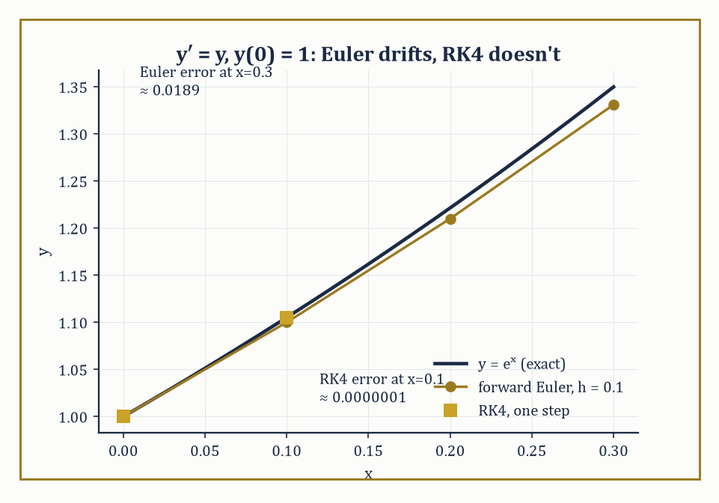
Figure 29.6 — y′ = y, y(0) = 1: forward Euler’s step points visibly drift below the true curve eˣ, while a single RK4 step lands on it to six decimal places.
yₙ₊₁ = yₙ + h·f(xₙ,yₙ)
It is first-order accurate — the local error at each step is O(h²), which accumulates to a global error of O(h) — and it is the natural first thing to try, and the natural first thing to be disappointed by.
Numeric example — Euler’s method drifting away from eˣ. Solve y′ = y, y(0) = 1 (exact solution y = eˣ) with step h = 0.1. Since f(x,y) = y, Euler’s update is yₙ₊₁ = 1.1·yₙ. Three steps produce the following values.
y₁ = 1.1, y₂ = 1.21, y₃ = 1.331
The exact values are exp(0.1) = 1.105171, exp(0.2) = 1.221403, exp(0.3) = 1.349859.
Errors: 0.005171, 0.011403, 0.018859
These errors grow roughly in proportion to the number of steps taken, the signature of a global error that is O(h): a fixed step size buys a fixed, non-shrinking rate of error accumulation per unit of time integrated.
Try it now — Take one Euler step for y′ = y, y(0) = 1, with h = 0.1. Answer →
The classical fourth-order Runge–Kutta method (RK4) buys dramatically more accuracy for the same step size, at the cost of four function evaluations per step instead of one: it samples the slope at the start of the interval, twice more at estimated midpoints, and once at an estimated endpoint, then combines all four slope estimates in a weighted average designed so that the resulting step matches the Taylor expansion of the true solution through the fourth-order term.
Numeric example — one step of RK4 on the same problem. Same problem, y′ = y, y(0) = 1, h = 0.1. The four slope estimates are computed in turn.
k₁ = f(x₀,y₀) = 1
k₂ = f(x₀+h/2, y₀+ (h/2)k₁) = 1 + 0.05(1) = 1.05
k₃ = f(x₀+h/2, y₀+(h/2)k₂) = 1 + 0.05(1.05) = 1.0525
k₄ = f(x₀+h, y₀+h·k₃) = 1 + 0.1(1.0525) = 1.10525
The RK4 update combines all four.
y₁ = y₀ + (h/6)(k₁ + 2k₂ + 2k₃ + k₄) = 1 + (0.1/6)(1 + 2.1 + 2.105 + 1.10525) = 1 + 0.0166667 × 6.31025 = 1 + 0.1051708 = 1.1051708
The exact value is exp(0.1) = 1.1051709 — correct to six decimal places from a single step, where Euler’s method at the same step size was wrong in the third decimal place. Four function evaluations bought roughly ten thousand times the accuracy of one.
Some equations resist explicit methods entirely, no matter how small a step you take, if you insist on ordinary efficiency — these are stiff equations, typically ones whose Jacobian has eigenvalues with large negative real parts, meaning some part of the true solution decays extremely fast even while the overall solution you care about is smooth and slow. Explicit methods like Euler and RK4 have a bounded region of stability in the step size, and for a stiff problem that bound can force absurdly tiny steps — not for accuracy’s sake, but merely to avoid the numerical solution exploding.
Numeric example — an explicit method blowing up on a stiff equation. Solve y′ = −50y, y(0) = 1 (exact solution y = e⁻⁵⁰ˣ, decaying smoothly to zero) with forward Euler at h = 0.1. The update is yₙ₊₁ = yₙ + 0.1(−50yₙ) = yₙ(1 − 5) = −4yₙ.
y₁ = −4, y₂ = 16, y₃ = −64
The numerical solution oscillates in sign and grows explosively, even though the true solution is monotonically decaying toward zero and is already smaller than 10⁻⁶ by x = 0.3. The culprit is the stability condition for Euler’s method applied to y′=λy, which requires |1+hλ| ≤ 1.
λ = −50, h = 0.1 ⟹ |1 − 5| = 4
That value is far outside the stable range. Shrinking to h = 0.01 gives |1 − 0.5| = 0.5, safely stable, and the method then tracks the true exponential decay correctly — but only because the step size was dictated wholly by the fast, uninteresting transient, not by the accuracy you wanted.
Numeric example — an implicit method handling the same equation gracefully. Apply backward Euler instead: yₙ₊₁ = yₙ + h·f(xₙ₊₁,yₙ₊₁) = yₙ − 50h·yₙ₊₁, which rearranges to yₙ₊₁ = yₙ/(1+50h). With the same h = 0.1, the iterates decay smoothly.
y₁ = 1/6 = 0.166667, y₂ = 0.166667/6 = 0.027778, y₃ = 0.027778/6 = 0.004630
There is no oscillation and no blow-up, despite using the very same ‘too-large’ step size that destroyed the explicit method. Backward Euler’s stability condition, |1/(1+hλ)| ≤ 1, holds for every h > 0 whenever λ has negative real part — it is unconditionally stable (A-stable, in the jargon) for decaying problems, which is just why implicit methods, despite requiring a (typically nonlinear, typically Newton-solved) equation at every step rather than a simple formula, are the standard tool for stiff systems.
Practical solvers rarely fix h in advance and then trust to luck; instead they estimate the local error at each step — often by running two methods of different order simultaneously (an embedded pair, sharing most of their function evaluations to keep the extra cost low) and comparing — and shrink or grow the step to keep that estimated error within a user-specified tolerance, a little like a driver constantly adjusting their speed to the bendiness of the road rather than picking one speed for the whole journey.
Boundary-value problems, where conditions are imposed at both ends of the interval rather than all at the start, are handled either by shooting (guess the missing initial condition, integrate forward, and adjust the guess with a root-finder from Root-Finding and Nonlinear Equations until the far-end condition is met — trial, error, and a great deal of politely renamed trial and error) or by discretizing the entire interval at once into a finite-difference or collocation system and solving it as one large algebraic system with the tools of Numerical Linear Algebra.
Numeric example — adaptive step-size control in action. Suppose RK4 (local truncation error scaling as Ch⁵, since it is a fourth-order method) is integrating some initial-value problem with step h = 0.2, and an embedded-pair comparison estimates the local error at that step to be 3.2×10⁻⁵ — but the user asked for a per-step tolerance of 1×10⁻⁶, more than thirty times stricter. Since the error scales as h⁵, halving the step multiplies it by (1/2)⁵ = 1/32.
3.2×10⁻⁵ ÷ 32 = 1.0×10⁻⁶
So a single halving, from h = 0.2 to h = 0.1, lands precisely on the requested tolerance. The standard step-size formula confirms it without any guessing.
h_new = h × (tol/est)^(1/(p+1)) = 0.2 × (10⁻⁶/3.2×10⁻⁵)^(1/5) = 0.2 × (1/32)^(1/5) = 0.2 × (2⁻⁵)^(1/5) = 0.2 × 2⁻¹ = 0.1
This is exactly the arithmetic every adaptive ODE solver performs at every single step, usually with far less obliging numbers and without pausing to admire how neatly they came out.
Keep only this · Section 29.6: Numerical Methods for Ordinary Differential Equations
The idea. Euler’s method is first order and RK4 fourth order. Stiff equations force explicit methods to tiny steps for stability, while implicit methods stay stable; embedded pairs choose the step size automatically.
Core.
Euler: yₙ₊₁ = yₙ + h f(xₙ, yₙ)
forward Euler on y′ = λy is stable iff |1 + hλ| ≤ 1
backward Euler on y′ = λy: yₙ₊₁ = yₙ/(1 − hλ)
Typical mistake. Choosing h for accuracy alone. On y′ = −50y, forward Euler with h = 0.1 multiplies by −4 each step and explodes.
Minimal example. y′ = −y with h = 0.1: Euler multiplies by 0.9 each step.
Practice. Easy to challenge; full worked answers, with the usual mistake, are in Answers to the Practice Sets at the back.
Easy — Take three Euler steps for y′ = y, y(0) = 1, h = 0.1. Answer →
Medium — What is the largest stable step for forward Euler on y′ = −50y? Answer →
Challenge — RK4 has local error proportional to h⁵. A step with h = 0.2 has estimated error 10⁻⁵ and the tolerance is 10⁻⁷. What step should be tried next? Answer →

Section 29.7: Numerical Methods for Partial Differential Equations
Explicit schemes are cheap and skittish; implicit schemes are expensive and imperturbable
To simulate heat spreading through a metal rod, a computer chops the rod into short pieces and time into short ticks, and at every tick it updates each piece from its neighbors: a piece hotter than the average of its two neighbors cools, one that is colder warms. It is a simple recipe and it works, but only if the tick is short enough compared with the size of the pieces. Take too long a tick and the method overcorrects; a hot spot can produce a temperature colder than anything present at the start, and the errors then grow without limit. This section explains that trade-off and the more expensive methods that avoid it entirely.
Partial differential equations involve derivatives in more than one variable, so discretization now means laying down a grid in space and time (or space and space) and replacing every partial derivative with a difference quotient over that grid.
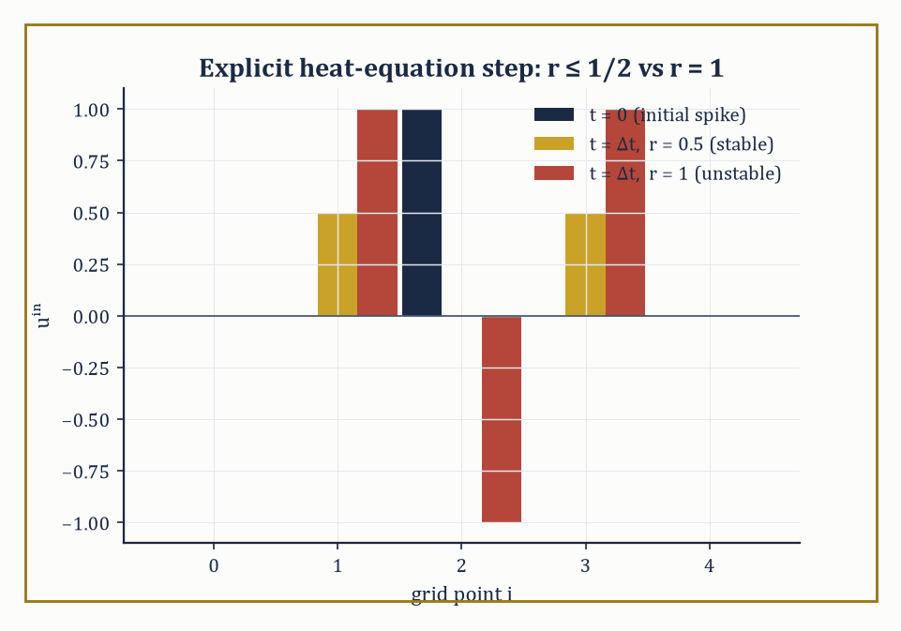
Figure 29.7 — One explicit step on the five-point temperature spike: r = 0.5 diffuses it smoothly and symmetrically, while r = 1 produces a negative temperature — nonsense that only the mesh ratio can be blamed for.
The simplest scheme for the heat equation
uₜ = uₓₓ
is explicit in time, obtained by combining a forward difference in time with a central difference in space:
uᵢⁿ⁺¹ = uᵢⁿ + r(uᵢ₊₁ⁿ − 2uᵢⁿ + uᵢ₋₁ⁿ), where r = Δt/Δx² is the mesh ratio
It is cheap — each new grid value is computed directly from old ones, with no linear system to solve — but it is only stable, in the sense that small errors don’t get amplified without bound, when the mesh ratio satisfies
r ≤ 1/2
Numeric example — explicit heat equation, stable vs unstable mesh ratio. Take grid values u = [0, 0, 1, 0, 0] at five points with the two ends held fixed at 0 (a temperature spike at the center).
With r = 0.5 (right at the edge of stability):
u₁ⁿ⁺¹ = 0 + 0.5(1−0+0) = 0.5, u₂ⁿ⁺¹ = 1 + 0.5(0−2+0) = 0, u₃ⁿ⁺¹ = 0 + 0.5(0−0+1) = 0.5
This gives [0, 0.5, 0, 0.5, 0] — the spike has diffused outward smoothly and symmetrically, as heat should behave.
Now try r = 1, twice the stability limit:
u₁ⁿ⁺¹ = 0+1(1−0+0)=1, u₂ⁿ⁺¹=1+1(0−2+0)=−1, u₃ⁿ⁺¹=0+1(0−0+1)=1
This gives [0, 1, −1, 1, 0] — a negative temperature has already appeared, which is nonsense for a diffusion process, and the pattern is alternating in sign, the classic fingerprint of an unstable sawtooth mode.
One more step at r=1 from here gives:
u₁=1+1(−1−2+0)=−2, u₂=−1+1(1+2+1)=3, u₃=1+1(0−2−1)=−2
So [0,−2,3,−2,0] — the magnitude has grown from a peak of 1 to a peak of 3 in two steps and is still climbing. The scheme is diverging in real time, purely because r exceeded 1/2, with nothing else about the problem having changed.
Try it now — Take one explicit heat step with r = 1/2 on u = (0, 0, 1, 0, 0), ends fixed at 0. Answer →
Implicit schemes evaluate the spatial difference at the new time level instead of the old one, which means every unknown at time n+1 is coupled to its neighbors and a linear system (typically tridiagonal, hence cheap to solve despite being implicit) must be solved at every time step.
But in exchange, the scheme becomes unconditionally stable, with no restriction on r whatsoever.
Numeric example — the implicit scheme tames the same r = 1. Using the same spike data and the same r = 1, the backward-time scheme gives, for the three interior unknowns u₁, u₂, u₃ (with fixed zero boundaries), the tridiagonal system:
3u₁ − u₂ = 0, −u₁ + 3u₂ − u₃ = 1, −u₂ + 3u₃ = 0
The first and third equations give u₂ = 3u₁ and u₃ = u₁; substituting into the middle equation:
−u₁ + 9u₁ − u₁ = 7u₁ = 1
So u₁ = 1/7 = 0.142857, u₂ = 3/7 = 0.428571, u₃ = 1/7 = 0.142857.
Compare directly with the explicit scheme’s catastrophic [0, 1, −1, 1, 0] at the very same r = 1: the implicit result [0, 0.142857, 0.428571, 0.142857, 0] is smooth, symmetric, entirely positive, and behaves the way diffusing heat should — the only thing that changed between the two computations is which time level the spatial difference was evaluated at.
The von Neumann analysis that predicts these thresholds is developed properly in Consistency, Stability, and Convergence; the underlying restriction, that information cannot be allowed to propagate across the grid faster in the numerical scheme than it does in the true physics, generalizes to hyperbolic problems as the Courant–Friedrichs–Lewy (CFL) condition.
Finite-element methods take a wholly different route: rather than discretizing the differential equation pointwise on a grid, they discretize its weak (integrated, or variational) form using functions that are piecewise polynomial on a mesh of elements, which handles irregular geometries far more gracefully than a rectangular grid and produces sparse, symmetric, positive-definite linear systems for the elliptic problems (like steady-state heat flow) where the underlying equation comes from minimizing an energy.
Abstract example — a one-element-family finite-element solve. Solve the boundary-value problem
−u″ = 1 on [0,1] with u(0)=u(1)=0
by the weak (Galerkin) formulation, using piecewise-linear ‘hat’ basis functions on a mesh with a single interior node at x=0.5 (so two elements, each of width h=0.5).
For the interior hat function φ, the stiffness entry is
Kᵢᵢ = ∫φ′² dx = 2/h
(each half of the hat has slope ±1/h over length h, contributing 1/h each), and the load entry is
bᵢ = ∫φ·1 dx = h
(the area of a triangle of base 2h and height 1).
The one-unknown Galerkin system is
(2/h)U₁ = h, so U₁ = h²/2
With h = 0.5, U₁ = 0.125.
The exact solution of the same boundary-value problem is
u(x) = x(1−x)/2 (check: u″ = −1 ✓, u(0)=u(1)=0 ✓)
so u(0.5) = 0.5×0.5/2 = 0.125 — the finite-element solution is exact at the node, not merely close, a pleasant instance of the nodal superconvergence that linear finite elements enjoy for this simple class of problem.
Spectral methods go further still, representing the solution globally by a truncated series in a well-chosen basis (Fourier modes for periodic problems, Chebyshev polynomials otherwise) rather than piecewise polynomials at all.
For a smooth periodic function, the Fourier coefficients decay faster than any power of 1/n — an infinite-order (spectral) rate of decay — whereas a function with even a single jump discontinuity has coefficients that decay only like O(1/n).
Spectral methods exploit this: on simple domains, for smooth solutions, they can reach machine precision with a handful of basis functions where a finite-difference or finite-element method would need thousands of grid points to match.
The price is a total lack of the geometric flexibility that made finite elements attractive in the first place — you get either simple geometry or dramatic speed, and choosing among finite differences, finite elements, and spectral methods is really a choice about which of geometry, regularity, and conservation properties matters most for the problem in front of you.
Numeric example — algebraic decay versus spectral decay, side by side. Take the classic sawtooth
f(x) = x on (−π, π)
extended periodically — a function with a jump discontinuity at the wrap-around point. Its Fourier sine coefficients are
bₙ = 2(−1)ⁿ⁺¹/n
so
|b₁₀| = 2/10 = 0.2 and |b₂₀| = 2/20 = 0.1
doubling n only halves the coefficient, the textbook signature of O(1/n) decay demanded by the discontinuity.
Now take the Poisson kernel f(θ) with Fourier coefficients
cₙ = rⁿ for some fixed 0 < r < 1
— a perfectly smooth (indeed real-analytic), periodic function with no discontinuity anywhere. With r = 0.5:
c₁₀ = 0.5¹⁰ = 1/1024 ≈ 0.000977, and c₂₀ = 0.5²⁰ = 1/1,048,576 ≈ 0.00000095
Doubling n from 10 to 20 has divided the coefficient not by 2 but by 1024 = 2¹⁰ — geometric decay, annihilating the sawtooth’s already-modest rate by three orders of magnitude at n = 20 alone.
This is the whole spectral-methods pitch in two columns of arithmetic: smoothness is not a nicety, it is worth whole powers of ten in every additional basis function you bother to add, which is exactly why a spectral solver can reach machine precision on a smooth problem with a dozen terms, while the sawtooth’s cousin PDEs — the ones with shocks, kinks, or other rude discontinuities — are the cases spectral methods handle worst.
Keep only this · Section 29.7: Numerical Methods for Partial Differential Equations
The idea. Finite differences replace derivatives by difference quotients on a grid. Explicit schemes are cheap but conditionally stable; implicit schemes solve a linear system each step and are stable for any step. Finite elements use weak forms, and spectral methods converge fast for smooth solutions.
Core.
explicit heat: uⱼⁿ⁺¹ = uⱼⁿ + r(uⱼ₊₁ⁿ − 2uⱼⁿ + uⱼ₋₁ⁿ), r = Δt/Δx²
stable when r ≤ 1/2
implicit: a tridiagonal system each step
Typical mistake. Refining Δx while keeping Δt fixed. r = Δt/Δx² grows like 1/Δx², and the explicit scheme goes unstable.
Minimal example. r = 1/2 replaces each interior value by the average of its neighbors.
Practice. Easy to challenge; full worked answers, with the usual mistake, are in Answers to the Practice Sets at the back.
Easy — With Δx = 0.05, what is the largest stable Δt for the explicit scheme? Answer →
Medium — Repeat the Try it now step with r = 1. Answer →
Challenge — The implicit scheme with r = 1 solves (1 + 2r)uⱼ − r(uⱼ₋₁ + uⱼ₊₁) = old uⱼ. Solve it for three interior points from (0, 1, 0). Answer →

Section 29.8: Consistency, Stability, and Convergence
Lax’s theorem: be truthful locally, be calm globally, and convergence follows for free
Lax’s equivalence theorem is the organizing principle behind everything in Numerical Methods for Ordinary Differential Equations and Numerical Methods for Partial Differential Equations, and it says something almost suspiciously clean: for a consistent finite-difference scheme approximating a well-posed linear problem, stability is necessary and sufficient for convergence. Unpack the three words.
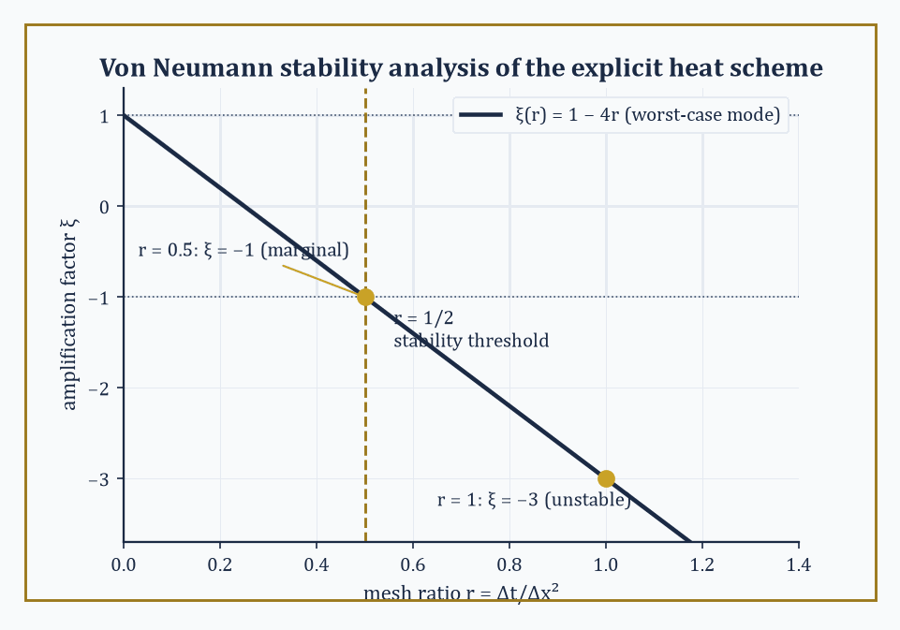
Figure 29.8 — The worst-case amplification factor ξ(r) = 1 − 4r for the explicit heat scheme, crossing out of the stable band |ξ| ≤ 1 at the r = 1/2 threshold used, unproved, back in Numerical Methods for Partial Differential Equations.
Consistency means the scheme’s local truncation error — the residual left over when you substitute the true solution into the discrete formula — tends to zero as the grid is refined; this is checked mechanically by Taylor expansion, as in What Numerical Methods Are.
Stability means errors already present (from rounding, or from an earlier approximate step) are not amplified without bound as the computation proceeds.
Convergence, the thing you actually want, means the numerical solution tends to the true solution as the grid is refined. Lax’s theorem says you only ever need to check the first two, which are each comparatively easy, to get the third, which on its own would be much harder to verify directly.
Stability itself is most often checked by von Neumann analysis: substitute a single Fourier mode into the difference scheme and solve for the amplification factor ξ as a function of the wavenumber k.
uⱼⁿ = ξⁿe^(ikjΔx)
The scheme is stable exactly when |ξ| ≤ 1 for every k that the grid can represent.
Worked example — von Neumann analysis derives the r ≤ 1/2 threshold from Numerical Methods for Partial Differential Equations. For the explicit heat-equation scheme
uᵢⁿ⁺¹ = uᵢⁿ + r(uᵢ₊₁ⁿ − 2uᵢⁿ + uᵢ₋₁ⁿ)
substituting the Fourier mode gives
ξ = 1 + r(exp(ikΔx) − 2 + exp(−ikΔx)) = 1 − 2r(1 − cos(kΔx)) = 1 − 4r·sin²(kΔx/2)
Stability requires −1 ≤ ξ ≤ 1 for every k; since sin² ranges up to 1, the tightest case is ξ = 1 − 4r, and requiring this to stay ≥ −1 gives
4r ≤ 2, i.e. r ≤ 1/2
the threshold used, without derivation, back in Numerical Methods for Partial Differential Equations. Plug in the two mesh ratios tested there directly: at r = 0.5, the worst-case mode has
ξ = 1 − 4(0.5)(1) = −1
magnitude exactly 1 — marginal stability, matching the smoothly (if boundary-case) well-behaved numerical result we saw. At r = 1, the worst-case mode has
ξ = 1 − 4(1)(1) = −3
magnitude 3 — meaning that particular Fourier mode, the alternating +1,−1,+1,−1,… sawtooth, triples in amplitude every time step. And that is precisely the mode that appeared in Section 29.7’s r=1 example: the sequence [0,1,−1,1,0] then [0,−2,3,−2,0] is a sawtooth pattern growing by very close to a factor of 3 per step, the abstract Fourier prediction and the concrete hand-computed blow-up agreeing to the digit.
Try it now — Find the amplification factor of forward Euler on y′ = −50y with h = 0.1. Is it stable? Answer →
For ordinary differential equations, the direct analogue of Lax’s theorem (due to Dahlquist) plays out identically: apply a one-step method to the linear test equation y′ = λy, and the method is stable exactly when its amplification factor stays within the unit disk.
Applied to forward Euler, the amplification factor is 1 + hλ, giving the stability condition met already in Numerical Methods for Ordinary Differential Equations.
|1 + hλ| ≤ 1
Numeric example — Dahlquist’s version, tied back to Section 29.6’s stiff blow-up. For y′ = −50y with forward Euler at h = 0.1, the amplification factor is
1 + (0.1)(−50) = 1 − 5 = −4
magnitude 4, well outside the stable range |ξ|≤1 — and indeed the computed sequence 1, −4, 16, −64 grows by a factor of exactly 4 in magnitude at every step, matching |ξ|=4 precisely. At h = 0.01, the amplification factor is
1 − 0.5 = 0.5
inside the unit disk, and the sequence 1, 0.5, 0.25, 0.125, … decays geometrically by just that factor, tracking the true exponential decay. Consistency was never in question for forward Euler (its local truncation error is O(h²) regardless of λ); it was purely the stability condition, violated at h=0.1 and satisfied at h=0.01, that decided whether the method converged to the truth or diverged from it — Lax’s principle, and Dahlquist’s, in miniature.
Nonlinear problems refuse to sit still for Fourier analysis, since superposition of modes no longer applies once the equation itself is nonlinear, so convergence proofs there lean on different structural properties instead: monotonicity (the scheme doesn’t create new local maxima or minima that weren’t in the initial data), the total-variation-diminishing (TVD) property (the total up-and-down wiggle of the solution never increases), and entropy conditions (borrowed conceptually from thermodynamics, they rule out numerical solutions that satisfy the discrete equations but correspond to unphysical shocks the true equation would never produce).
A simple, tangible descendant of the CFL condition mentioned in Numerical Methods for Partial Differential Equations governs even the simplest nonlinear-adjacent case, linear advection
uₜ + a·uₓ = 0
with upwind differencing: the scheme is monotone, and hence well-behaved, exactly when the Courant number does not exceed 1.
aΔt/Δx ≤ 1
Numeric example — the CFL condition for advection. With wave speed a = 2 and grid spacing Δx = 0.1: choosing Δt = 0.04 gives a Courant number of
2(0.04)/0.1 = 0.8 ≤ 1
safely inside the stable, monotone regime, while choosing Δt = 0.06 gives
2(0.06)/0.1 = 1.2 > 1
which for the upwind scheme produces spurious oscillation and eventual blow-up, for the same structural reason — information trying to move across the grid faster than the numerical stencil can transmit it — that drove the r ≤ 1/2 threshold for diffusion and the |1+hλ|≤1 threshold for stiff ODEs. Three different equations, three different-looking stability conditions, and underneath them all, the same one idea: the numerical domain of dependence must contain the true one.
Keep only this · Section 29.8: Consistency, Stability, and Convergence
The idea. Lax equivalence: for a consistent linear scheme, stability is equivalent to convergence. Von Neumann analysis checks stability one Fourier mode at a time, and the CFL condition says the numerical domain of dependence must contain the true one.
Core.
consistent + stable ⇔ convergent (Lax)
heat scheme: ξ = 1 − 4r sin²(kΔx/2)
CFL: |a|Δt/Δx ≤ 1
Typical mistake. Checking consistency only. A consistent scheme still diverges if it is unstable.
Minimal example. a = 1 and Δx = 0.1: the CFL condition needs Δt ≤ 0.1.
Practice. Easy to challenge; full worked answers, with the usual mistake, are in Answers to the Practice Sets at the back.
Easy — Find the Courant number for a = 2, Δx = 0.1, Δt = 0.04. Answer →
Medium — Find the worst-case amplification factor of the heat scheme with r = 0.6. Answer →
Challenge — Show that |1 − 4r sin²(θ/2)| ≤ 1 for all θ exactly when r ≤ 1/2. Answer →

Section 29.9: Looking Ahead: From Elementary Numerics to High-Performance and Adaptive Methods
The vocabulary is complete; the machine room, mercifully, keeps expanding
We have now acquired the basic vocabulary of numerical methods: root-finding, interpolation and approximation, quadrature, numerical linear algebra, time-stepping for ordinary differential equations, discretization of partial differential equations, and — tying the whole enterprise together — the triad of consistency, stability, and convergence.
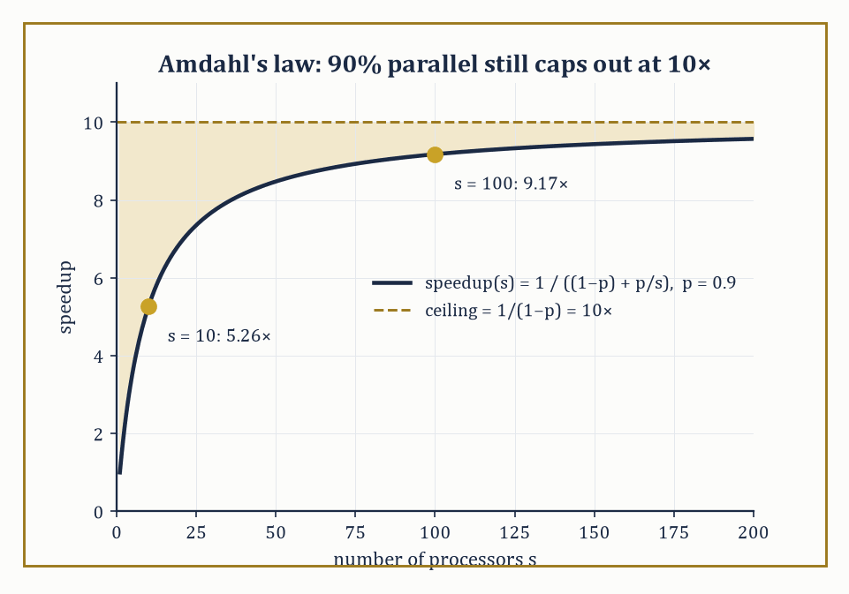
Figure 29.9 — Amdahl’s law at p = 0.9: speedup climbs fast at first, then flattens toward a hard ceiling of 10×, no matter how many processors you throw at the stubborn 10% that refuses to parallelize.
Every method we have met has followed the same shape: replace an infinite-dimensional problem with a finite one, bound the truncation error by Taylor expansion or approximation theory, keep the arithmetic stable, and let the two errors — truncation and rounding — settle into a trade-off you understand and can control.
These tools are the foundation of scientific computing, and the frontier from here is mostly about spending the same computational budget more cleverly.
Adaptive mesh refinement concentrates grid points, or elements, precisely where the solution is rough — steep gradients, shocks, singularities — rather than distributing them uniformly across regions where the solution is already smooth and cheap to represent.
Numeric example — where adaptivity would have paid off. Recall the explicit heat-equation spike from Numerical Methods for Partial Differential Equations: a temperature of 1 at the center grid point, 0 everywhere else.
The solution’s curvature — and hence the local truncation error of any fixed-grid scheme — is enormous right at the spike and essentially zero a few points away.
A uniform grid fine enough to resolve the spike accurately wastes nearly all of its resolution on the flat, featureless regions either side.
An adaptively refined grid would place many points near x=2 (the spike) and only a handful near the boundaries, achieving comparable accuracy to the uniform grid’s finest resolution using a fraction of the total grid points — the same principle that let Chebyshev nodes in Interpolation, Approximation, and Splines outperform equally spaced ones, applied dynamically and locally rather than fixed in advance.
Try it now — A simulation is 90% parallelizable. What is the largest possible speedup? Answer →
Parallel algorithms and high-performance implementations exploit modern many-core and distributed architectures, which changes which algorithms are ‘fast’ in practice — an algorithm with more total arithmetic but better parallel structure can outrun a leaner sequential one.
But parallelism has its own conservation law, Amdahl’s law: if a fraction p of a computation can be parallelized and the rest, fraction (1−p), is stubbornly sequential, then running on s processors gives a speedup of:
Speedup = 1/((1−p) + p/s)
This speedup never exceeds the ceiling
Speedup ≤ 1/(1−p)
no matter how large s grows.
Numeric example — Amdahl’s law and the ceiling on speedup. Suppose a simulation is 90% parallelizable (p = 0.9, so 1−p = 0.1).
On s = 10 processors, the speedup is:
1/(0.1 + 0.9/10) = 1/(0.1 + 0.09) = 1/0.19 = 5.26×
That’s respectable, but nowhere near the naive tenfold hope.
Throw ten times more hardware at it, s = 100: the speedup becomes:
1/(0.1 + 0.009) = 1/0.109 = 9.17×
A tenfold increase in processors bought less than a twofold increase in speedup.
Push s to infinity and the speedup still only approaches:
1/0.1 = 10×
forever capped by that stubborn 10% sequential remainder.
This is why real high-performance numerical codes obsess over minimizing the sequential fraction of an algorithm — the communication step, the boundary synchronization, the single-threaded setup — far more than over adding raw processor count, and it is a sobering, quantitative answer to the naive assumption that more cores means proportionally more speed.
Uncertainty quantification propagates uncertainty in a model’s inputs through to uncertainty in its outputs, often using Monte Carlo sampling, whose error famously shrinks as O(1/√N) regardless of how many input dimensions the problem has.
That’s a blessing for high-dimensional problems where grid-based quadrature is hopeless, and a curse for everyone’s patience, since quadrupling the sample size only halves the error, as the next example shows.
Numeric example — the diminishing returns of Monte Carlo sampling. If N = 100 samples of some quantity give a standard error of:
σ/√100 = σ/10
Reaching ten times less error, σ/100, requires not ten times but one hundred times as many samples,
N = 10,000
since the error scales with 1/√N.
Going one further order of magnitude down, to σ/1000, requires:
N = 1,000,000
This √N law is why Monte Carlo methods are prized in high dimensions (where the curse of dimensionality makes grid-based quadrature’s cost explode exponentially in the number of variables, while Monte Carlo’s O(1/√N) rate doesn’t care about dimension at all) and exactly why nobody uses Monte Carlo to compute a one-dimensional integral to ten digits — Gaussian quadrature, from Numerical Differentiation and Integration, will get there with a handful of points and no randomness required.
Model-order reduction and, increasingly, machine-learning surrogates aim to replace an expensive high-fidelity simulation with a cheap approximate one, trained or constructed once and then queried many times — useful when a numerical model must be evaluated thousands of times inside a larger optimization loop or a real-time control system.
Verification and validation close the loop responsibly: verification asks whether the code correctly solves the equations it claims to solve (a question numerical analysis is well-equipped to answer, with the tools of this chapter), while validation asks the separate, harder question of whether those equations describe the physical reality you set out to model in the first place — a question no amount of numerical analysis, however rigorous, can answer on its own.
The deeper lesson of this chapter, if it has one beyond its formulas, is that computation is not a substitute for analysis but a continuation of it by other means: every reliable numerical result, from a bisected root to a spectrally converged PDE solve, ultimately rests on a theorem about consistency, stability, or approximation, proved with the same rigor as anything else in this series.
The machine does the arithmetic; the mathematics is what tells you to trust it.
Numerical methods turn mathematical models into quantitative predictions, and that, when you step back from the individual formulas, is the entire point of the exercise: a differential equation nobody can solve by hand becomes a bridge’s stress tolerance, a weather forecast, a dose calculation. We began this chapter by admitting that the calculus of variations had left us holding a beautifully characterized equation with no closed-form answer; we end it having built an entire apparatus for extracting trustworthy numbers from that kind of equation anyway, with the error bars to prove it.
If there is a single thread running through every section here, it is that approximation, done honestly, is not a lesser cousin of exact mathematics — it is exact mathematics, applied to a slightly different, and more useful, question. Not ‘what is the answer?’ but ‘how close can I get, how do I know how close I got, and how do I stop the machine’s own arithmetic from lying to me along the way, unannounced?’ Every convergence rate, every stability threshold, every condition number in this chapter was a theorem before it was a rule of thumb.
In the next chapter, the series turns to optimization in its own right — no longer variational calculus’s infinite-dimensional search over curves, but the finite, computational, extremely practical business of finding the best point, subject to constraints, using the kind of iterative machinery root-finding and Newton’s method have already previewed here. Bring the condition numbers; you will need them again almost immediately.
We have learned to replace the infinite with the finite and still trust the answer. The series continues.
Where this returns
Adaptive, parallel and randomized methods continue in Numerical Methods (Advanced) (Volume 4). Gradient methods for minimization are the subject of Unconstrained Nonlinear Optimization.
Keep only this · Section 29.9: Looking Ahead: From Elementary Numerics to High-Performance and Adaptive Methods
The idea. Modern numerics adapts the mesh to the solution, runs in parallel within Amdahl’s limit, and samples when the dimension is high: Monte Carlo error falls like 1/√N in any dimension.
Core.
Amdahl: speedup = 1/((1 − p) + p/N)
Monte Carlo standard error ∝ 1/√N
Typical mistake. Expecting linear speedup. With p = 0.9, even infinitely many processors give at most 10×.
Minimal example. p = 0.5: at most 2×.
Practice. Easy to challenge; full worked answers, with the usual mistake, are in Answers to the Practice Sets at the back.
Easy — Find the speedup for p = 0.9 on N = 10 processors. Answer →
Medium — Monte Carlo with N = 100 samples has standard error 0.1. How many samples give 0.01? Answer →
Challenge — Compare a grid of 10 points per axis in dimension 10 with 10⁴ Monte Carlo samples. Answer →
Chapter 29 recap · Numerical Methods
• Every numerical result carries truncation error (from the method) and rounding error (from floating point); their sum decides the best step size.
• Bisection is slow and safe; Newton is fast near a simple root and unreliable far from one.
• Interpolate on Chebyshev nodes, fit noisy data by least squares, join smooth pieces with splines.
• Symmetric formulas, Richardson extrapolation and Gaussian quadrature buy accuracy cheaply.
• LU factorization solves linear systems; the condition number says how much the problem amplifies errors.
• For time-stepping, consistency plus stability gives convergence; stiff problems need implicit methods, and explicit schemes need r ≤ 1/2 or the CFL condition.

Check Your Understanding — Chapter 29
Answers are in the Answer Key at the back of the book — have a go before you look.
1. [Explain] Newton’s method converges dramatically faster than bisection, but bisection is the more ‘reliable’ method. Why is each of those statements true?
See the answer →
2. [Explain] What is Runge’s phenomenon, and why does switching to Chebyshev nodes fix it?
See the answer →
3. [Compute] Solving Ax=b for A=[1 1; 1 1.0001] and b=(2,2) gives x=(2,0). If b is perturbed by just 0.0001, to (2, 2.0001), the solution jumps to (1,1). What does this reveal, and what number quantifies it?
See the answer →
4. [Explain] Solving y′ = −50y, y(0)=1 with forward Euler at h=0.1 gives the wildly oscillating sequence 1, −4, 16, −64, even though the true solution decays smoothly to zero. Why does forward Euler fail here, and why does backward Euler handle the very same step size gracefully?
See the answer →
5. [Compute] Apply two steps of Newton’s method to f(x) = x² − 2 from x₀ = 1, and count the correct digits at each step.
See the answer →
6. [Compute] Estimate ∫₀¹ exp(−x²)dx using the trapezoidal rule with four subintervals, and bound the error.
See the answer →
7. [Compute] A matrix has singular values 100 and 0.01. Find its condition number in the 2-norm and say how many significant digits you expect to lose solving a system with it in double precision.
See the answer →
8. [Compute] For y′ = −10y with y(0) = 1, find the largest step size for which forward Euler is stable, and compute two steps at h = 0.25 to show what happens beyond it.
See the answer →
9. [Explain] Why does interpolating at more equally spaced points make a polynomial fit worse rather than better?
See the answer →
10. [Explain] Distinguish truncation error from rounding error, and explain why refining a finite difference eventually makes the answer worse.
See the answer →
11. [Explain] The Lax equivalence theorem says consistency plus stability equals convergence. Why is consistency alone not enough?
See the answer →
12. [Prove] Prove that Newton’s method converges quadratically near a simple root.
See the answer →
13. [Prove] Prove that Gaussian quadrature with n nodes integrates polynomials of degree up to 2n − 1 exactly.
See the answer →
14. [Prove] Prove that the trapezoidal rule has error O(h²) on a smooth function.
See the answer →
15. [Prove] Prove that a strictly diagonally dominant matrix is invertible, and that Jacobi iteration converges for it.
See the answer →
16. [Prove] Prove that the composite Simpson’s rule is exact for cubics, despite being derived from a quadratic interpolant.
See the answer →
17. [Prove] Prove that for a symmetric positive definite matrix, the conjugate gradient method terminates in at most n steps in exact arithmetic.
See the answer →
18. [Challenge] Numerical analysis is sometimes dismissed as approximation rather than real mathematics. What does the subject actually prove?
See the answer →
19. [Challenge] Why does an algorithm’s cost matter mathematically, rather than merely practically?
See the answer →
20. [Challenge] Floating-point arithmetic is not associative. What breaks, and what has to be rebuilt?
See the answer →
21. [Challenge] Adaptive methods spend effort where the solution is difficult. Why is that more than an engineering convenience?
See the answer →
22. [Challenge] Why can a numerical scheme be perfectly accurate on smooth solutions and badly wrong once a shock forms?
See the answer →
23. [Challenge] Monte Carlo converges at the deplorable rate of 1/√N, independent of dimension. Why is it nevertheless the method of choice in high dimensions?
See the answer →
24. [Challenge] What is the difference between a method that converges and a method you can trust?
See the answer →

Problems — Chapter 29
The questions above test whether the ideas landed. These ask you to use them. Solutions are in Solutions to the Problems at the back. Work them before you look.
1. [Compute] Start Newton’s method for x² − 2 = 0 at x₀ = 1. Compute x₁.
2. [Compute] The bisection method looks for a root of x² − 2 on [1, 2]. Compute the midpoint, the sign of the function there, and the interval you keep.
3. [Compute] Estimate ∫ from 0 to 1 of x² dx by the trapezoidal rule with two panels. Compare with the exact value 1/3.
4. [Concept] A quadrature rule of higher order needs higher derivatives of the integrand in its error term. What, in one sentence, do the Bernoulli numbers do in that error term?

Math, Actually

Chapter 30

Optimization: Theory and Algorithms
Algorithms, Duality, and the Art of Finding Better Answers Efficiently
Chapter 29 taught us how to compute what cannot be computed precisely — how to bound an error, trust an approximation, and stop pretending that closed-form solutions are the normal case rather than the charming exception. Chapter 28 told us what ‘best’ means for a whole function: the Euler–Lagrange conditions that certify a minimum in principle without troubling themselves over how you might locate one. This chapter first does the same for functions of finitely many variables — critical points, Lagrange multipliers, convexity — and then closes the gap both chapters leave open: knowing what you are looking for, and knowing that a solution exists in principle, is not remotely the same as having a plan of action that will find it, in finite time, without your standing over its shoulder.
This chapter fills that gap. It is organized, deliberately, not by application but by structure — because in optimization, structure is destiny. A linear objective over a polyhedron gets the simplex method and a perfect duality theory (Linear Programming). Convexity, wherever it turns up, gets algorithms that need only find a stationary point to have found the global answer (Convexity and Convex Optimization Algorithms). Smooth unconstrained problems get gradients, Hessians, and the whole spectrum from gradient descent to Newton’s method (Unconstrained Nonlinear Optimization); putting the constraints back in gets penalties, barriers, and the Lagrangian (Constrained Nonlinear Optimization). Discrete variables get branch-and-bound and a hard limit imposed by computational complexity itself (Integer and Combinatorial Optimization); missing derivatives and enormous datasets get their own dedicated toolkit (Derivative-Free, Stochastic, and Large-Scale Methods). Recognizing which of these worlds a given problem belongs to is, as we shall keep insisting, most of the battle.
A small confession, before we begin: optimization algorithms have an unfortunate tendency to be taught, and used, as black boxes — feed in an objective, receive an answer, ask no further questions. They earn your trust, rather than merely your obedience, only once you understand the geometry they are actually following (descent directions, level sets, the shape of a feasible region) and the certificates they can produce along the way (a duality gap that has shrunk to zero, a KKT residual that has vanished, a proof of infeasibility that cannot be argued with). That understanding, and not merely the ability to call a solver, is this chapter’s actual goal.
If the calculus of variations taught us what ‘best’ means, optimization algorithms teach us how to compute it. Let’s solve.
Where this chapter starts
From Calculus of Variations: an optimum is where the first variation vanishes, and constraints bring multipliers. This chapter asks the same questions for a point x in ℝⁿ: ∇f = 0 replaces the Euler–Lagrange equation, and ∇f = λ∇g replaces the multiplier rule.
From Numerical Methods: errors, conditioning and convergence rates. Here they decide which optimization algorithm to trust.
New in this chapter: the finite-dimensional theory itself — critical points and Hessians in Unconstrained Nonlinear Optimization, Lagrange multipliers and KKT in Constrained Nonlinear Optimization, convexity in Convexity and Convex Optimization Algorithms — next to the algorithms that compute optima.
Before you begin — Chapter 30
By the end of this chapter you will be able to:
1. Turn a verbal problem into an optimization model, and recognize infeasible and unbounded ones.
2. Solve small linear programs, write their duals, and read dual values as prices.
3. Find and classify critical points, and minimize by gradient descent, Newton and quasi-Newton methods.
4. Use Lagrange multipliers and the KKT conditions, and know when a constraint qualification is needed.
5. Recognize convex problems and use projected and proximal gradient steps.
6. Bound and solve integer programs by branch-and-bound, and use stochastic and derivative-free methods.
Prerequisites. Gradients and Hessians from Multi-Variable Calculus (Volume 2); eigenvalues from Linear Algebra (Volume 2); the extreme value theorem from Limits (Volume 1); Newton’s method from Root-Finding and Nonlinear Equations.
Estimated study time. About 12 hours, exercises included.

Section 30.1: Modeling and the Landscape of Optimization Problems
In Which We Learn That the Hardest Part Is Admitting What You Want
An optimization problem, stripped to its underwear, consists of three ingredients: a decision vector x — the things you are allowed to choose, living in ℝⁿ for some dimension n; an objective function f(x) — the single number you are trying to make as small (or, by the trivial trick of negating it, as large) as possible; and a feasible set S ⊆ ℝⁿ — the subset of choices you are permitted to make, usually carved out by equality constraints gᵢ(x) = 0 and inequality constraints hⱼ(x) ≤ 0.
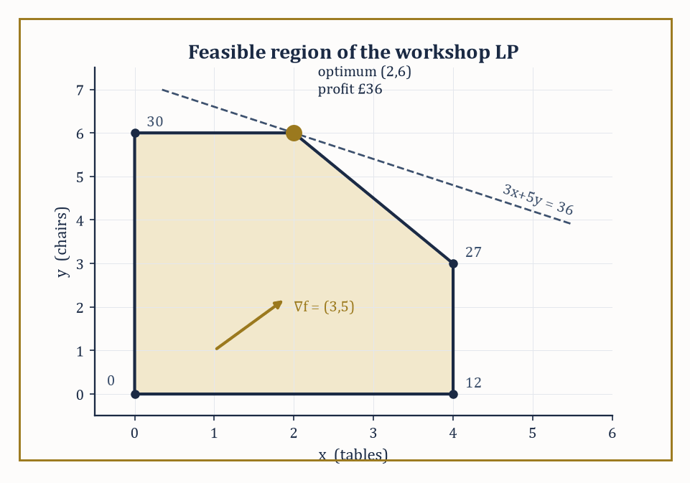
Figure 30.1 — The workshop’s feasible pentagon, with the objective’s gradient and its level line through the optimum at (2,6) — the vertex the whole chapter keeps returning to.
The problem is then simply:
find x* ∈ S minimizing f(x) over all x ∈ S
Everything else in this chapter — every algorithm, every convergence proof, every duality certificate — is commentary on how to find, or verify, such an x*. The genuinely difficult part, and the part no textbook can do for you, is choosing f, S, and the meaning of x in the first place.
A model is a translation from ‘what I really want’ into ‘what an algorithm can chew on’, and translations lose things.
The art of modeling is choosing a translation that loses as little as possible while remaining tractable — a compromise every applied mathematician learns to live with, rather the way one learns to live with a leaking roof in a listed building: not ideal, but the alternative of knocking the entire thing down is worse.
Numeric example — setting up and solving a small factory model. A workshop makes tables and chairs. Each table needs 1 hour on the cutting machine (capacity 4 hours/day); each chair needs 2 hours on the finishing machine (capacity 12 hours/day, so at most 6 chairs’ worth); both share a shaping machine, needing 3 hours per table and 2 hours per chair out of 18 hours/day. A table earns £3 profit, a chair £5.
With x = tables and y = chairs, the model is:
maximize 3x + 5y subject to x ≤ 4, 2y ≤ 12, 3x + 2y ≤ 18, x ≥ 0, y ≥ 0
This is a linear objective over a polyhedral feasible set — a linear program. The feasible region is a pentagon with corners (0,0), (4,0), (4,3), (2,6), (0,6).
Check the corner (4,3), which sits on the shaping-machine boundary:
3(4) + 2(3) = 18
Evaluating the objective at each corner — a fact justified properly in Linear Programming, but usable on faith already — gives 0, 12, 27, 36, 30 respectively.
The best corner is (2,6): make 2 tables and 6 chairs, for a daily profit of £36.
The optimum sits at a vertex, not in the interior; this is not a coincidence, and it is the single most important geometric fact about linear programming.
Try it now — The workshop maximizes 3x + 5y subject to x ≤ 4, 2y ≤ 12, 3x + 2y ≤ 18, x, y ≥ 0. Evaluate the objective at the vertices (4, 3) and (2, 6). Answer →
Problems are classified by the shape of f and S, and the classification is not academic pedantry — it is the single most consequential decision you will make, because it determines which algorithms are even available to you.
A linear program (linear f, polyhedral S) can be solved to global optimality in polynomial time for problems with millions of variables.
A convex program (convex f, convex S) still guarantees that any local minimum is global, so the algorithms of Unconstrained Nonlinear Optimization and Convexity and Convex Optimization Algorithms apply with confidence.
A smooth nonconvex program offers only local guarantees. A nonsmooth program breaks the derivative-based machinery outright and calls for the subgradient and proximal ideas of Convexity and Convex Optimization Algorithms.
An integer program restricts some or all of x to the integers, turning a continuous search into a combinatorial one — and, as Integer and Combinatorial Optimization will make uncomfortably clear, this single restriction is usually what separates ‘solvable before lunch’ from ‘solvable, in the worst case, some considerable time after the heat death of the universe.’
Recognizing which box a problem falls into, before writing a single line of solver code, is the decisive step; everything downstream is technique.
Numeric example — the same workshop, three disguises. Perturb the workshop three ways to see the classification boundaries in action.
(i) If profit is still 3x + 5y, the problem is linear — solvable just as above.
(ii) Suppose the shaping machine wears out faster the more it is used, so the effective cost is:
3x + 2y + 0.1(3x+2y)²
This quadratic term keeps the problem convex, since it is a linear function plus a convex quadratic (its Hessian is positive semidefinite), so local methods remain globally trustworthy even though the neat vertex argument of Linear Programming no longer applies unmodified.
(iii) Suppose chairs must be built as whole objects — true of actual chairs, and blithely ignored in (i) — so y must be a nonnegative integer.
The feasible set is now a finite lattice of points inside the same pentagon rather than the entire pentagon, and although the optimum still happens to be (2,6), since that vertex was already integral, proving no better integer point exists in general requires Section 30.7’s branch-and-bound machinery, not the vertex argument alone.
Before running any algorithm, a modeler should ask two boring but essential questions: does a minimizer exist, and if the algorithm reports ‘unbounded’ or ‘infeasible’, what does that mean?
Existence is guaranteed, by the Weierstrass extreme value theorem (met properly in Chapter 10 (Volume 1), and used constantly ever since), whenever f is continuous and S is nonempty, closed, and bounded — compact, in the jargon.
Drop compactness and existence can fail: the infimum is approached but never attained, rather like a don’s retirement, perpetually one more paper away.
In practice, when a solver reports the problem is unbounded (the objective can be driven to −∞ while staying feasible) or infeasible (S is empty), this is overwhelmingly a modeling error rather than a mathematical curiosity — a missing constraint, a flipped sign, an upper bound the real world imposes but you forgot to write down.
Treat these diagnostics as the solver’s polite way of telling you that you have not yet said what you meant.
Numeric example — unbounded and infeasible siblings. Delete both x ≤ 4 and 2y ≤ 12 from the workshop model, keeping only x,y ≥ 0 and 3x+2y ≤ 18.
This alone does not create unboundedness: with x = 0, the shaping constraint still caps y at 9, so the feasible region is merely a larger triangle, and the objective 3x+5y tops out along its edge at:
5(9) = 45
— bounded, just less tightly.
Genuine unboundedness needs the shaping constraint gone too: delete 3x+2y ≤ 18 as well, leaving only x,y ≥ 0.
Now y can grow without limit while x stays at 0, and profit tops out at:
5y → ∞
The solver correctly reports ‘unbounded’ — not a paradox, just a missing capacity constraint, and a reminder that dropping one binding constraint is not always enough to break a model; sometimes you must drop the one doing the work.
For infeasibility, restore the original constraints but add a contractual obligation to deliver at least 5 tables per day, x ≥ 5, alongside the original x ≤ 4.
No x can simultaneously satisfy x ≥ 5 and x ≤ 4, so:
S = ∅
and the solver reports ‘infeasible’ — the honest answer to a promise that cannot be kept.
Keep only this · Section 30.1: Modeling and the Landscape of Optimization Problems
The idea. Modeling means choosing variables, an objective and constraints. The form of the model — linear or not, convex or not, continuous or integer — decides which algorithms apply and what they guarantee. A model can also be infeasible or unbounded.
Core.
minimize f(x) subject to gᵢ(x) ≤ 0, hⱼ(x) = 0
LP: f, g and h all linear
empty feasible set: infeasible; f → −∞ on it: unbounded
Typical mistake. Treating a modeling choice as harmless. Requiring whole numbers of tables turns the LP into an integer program, a different and harder problem.
Minimal example. Maximize x subject to x ≤ 3: optimum 3, on the boundary.
Practice. Easy to challenge; full worked answers, with the usual mistake, are in Answers to the Practice Sets at the back.
Easy — Check that (2, 6) satisfies the workshop constraints, and say which are binding. Answer →
Medium — Is the problem maximize x + y subject to x − y ≤ 1, x, y ≥ 0 bounded? Answer →
Challenge — Show that x + y ≤ 1 and x + y ≥ 2 have no common solution, and give a certificate. Answer →

Section 30.2: Linear Programming
Walking the Edges of a Very Well-Behaved Polyhedron
A workshop makes two products from limited supplies of labor, material and machine time, and wants the greatest profit. The profit is a simple sum, so much per item of each product, and each limit is a simple inequality. Problems of exactly this kind are linear programs, and they are the best-understood optimization problems there are. Drawn on paper, the allowed production plans form a region with straight edges, here a pentagon, and the best plan always sits at one of its corners. The simplex method exploits that by walking from corner to better corner along the edges; in this section’s example it reaches the best corner after visiting just four of the five.
Linear programming — minimize (or maximize) a linear objective cᵀx over a polyhedron — is the best-understood optimization problem in existence, and deservedly so: it is the one case where ‘solve it’ means something completely unambiguous. The polyhedron is defined by:
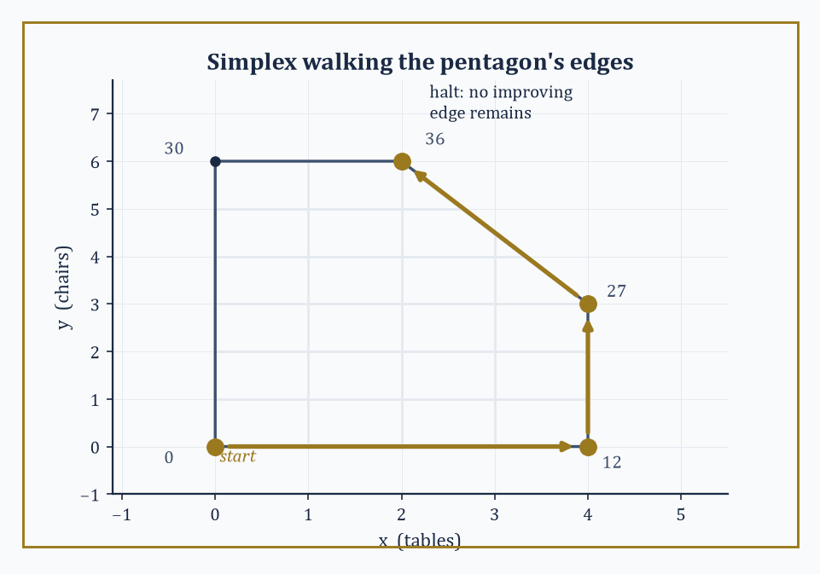
Figure 30.2 — Simplex takes three improving edges — (0,0) to (4,0) to (4,3) to (2,6) — then halts, having visited only four of the pentagon’s five vertices.
{x : Ax ≤ b, x ≥ 0}
The simplex method, devised by George Dantzig in 1947 and still, remarkably, competitive today, exploits the fact glimpsed in Modeling and the Landscape of Optimization Problems that an optimal solution, if one exists, can always be found at a vertex of the polyhedron. It starts at some vertex, looks along each edge leaving that vertex, and if any edge improves the objective, walks along it to the next vertex; when no improving edge remains, it stops, and — this is the theorem that makes the whole enterprise trustworthy — that vertex is guaranteed globally optimal, not only locally so.
Interior-point methods take the opposite aesthetic: rather than crawling along the boundary, they cut through the interior of the polyhedron along a smooth curve called the central path, parameterized by a barrier weight driven to zero, arriving at the optimal vertex (or face) in the limit.
Simplex tends to win on small-to-medium problems and gives a clean combinatorial picture; interior-point methods tend to win on very large, sparse problems, where their polynomial worst-case complexity is not just a theoretical nicety but a practical guarantee.
Numeric example — simplex walking the workshop’s pentagon. Return to the workshop of Modeling and the Landscape of Optimization Problems: maximize 3x+5y over the pentagon with vertices (0,0), (4,0), (4,3), (2,6), (0,6), objective values 0, 12, 27, 36, 30.
A simplex run might start at the origin (0,0), value 0.
The edge toward (4,0) increases the objective (to 12), so simplex takes it.
From (4,0), the edge toward (4,3) increases it further (to 27), so simplex takes that too.
From (4,3), the edge toward (2,6) increases the objective again (to 36) — note x actually decreases along this edge, a reminder that simplex follows edges of the polyhedron, not the steepest local direction in the (x,y) plane.
From (2,6), both remaining edges — toward (4,3) and toward (0,6) — decrease the objective (to 27, or to 30), so simplex halts.
Three pivots, visiting four of the five vertices, and the halting vertex (2,6) is certified optimal purely because no neighboring edge improves things further — no need to check the fifth vertex (0,0) at all.
Try it now — The workshop’s dual is: minimize 4u₁ + 12u₂ + 18u₃ subject to u₁ + 3u₃ ≥ 3, 2u₂ + 2u₃ ≥ 5, u ≥ 0. Check that (0, 1.5, 1) is feasible and compute its value. Answer →
Every linear program has a shadow twin, its dual, built from the same data.
If the primal is:
max cᵀx subject to Ax ≤ b, x ≥ 0
the dual is:
min bᵀu subject to Aᵀu ≥ c, u ≥ 0
— the roles of constraints and variables swap, and minimization replaces maximization.
Weak duality is easy: any feasible u gives an upper bound bᵀu on the primal optimum, for any feasible x.
Strong duality is the deeper fact, true for linear programs whenever either side is feasible and bounded: the two optimal values coincide exactly, with no gap.
At a joint optimum, complementary slackness pins down the relationship precisely: for each constraint, either it holds with equality (is ‘tight’ or ‘binding’) or its corresponding dual variable is zero — never both slack at once.
The dual variables have a wonderful economic interpretation as shadow prices: uⱼ* measures how much the optimal objective would improve per unit of extra capacity in constraint j — exactly the sensitivity analysis a manager wants, obtained for free once the dual is solved.
Numeric example — the workshop’s dual, solved by complementary slackness. The dual of the workshop LP is:
minimize 4u₁ + 12u₂ + 18u₃ subject to u₁ + 3u₃ ≥ 3, 2u₂ + 2u₃ ≥ 5, u₁,u₂,u₃ ≥ 0
(one dual variable per primal constraint: cutting, finishing, shaping). The primal optimum is (x,y) = (2,6). Complementary slackness cuts both ways.
First: since x=2 is strictly less than its bound 4, the cutting constraint is slack, so its dual price is worthless:
u₁ = 0
Second, the other direction of the same principle: since x=2 and y=6 are themselves both strictly positive, their corresponding dual constraints must hold with equality (a primal variable that is used forces its dual constraint to bind):
u₁ + 3u₃ = 3, 2u₂ + 2u₃ = 5
(As a consistency check, y=6 and 3x+2y=18 do indeed hit their bounds exactly, so u₂ and u₃ are free to be nonzero — nothing there rules out the values about to be found.) With u₁=0:
3u₃ = 3 ⟹ u₃ = 1
Then:
2u₂ + 2 = 5 ⟹ u₂ = 1.5
Dual objective:
4(0) + 12(1.5) + 18(1) = 0 + 18 + 18 = 36
— the primal optimum of £36, confirming strong duality.
Reading the shadow prices: an extra hour of finishing capacity (u₂=1.5) is worth £1.50/day, an extra hour of shaping capacity (u₃=1) is worth £1/day, and extra cutting capacity (u₁=0) is worth nothing at all, since the workshop was not using all four available hours of it anyway.
Linear programming’s importance far outstrips its apparent simplicity: it is the computational backbone of operations research (scheduling, blending, staffing, logistics), the relaxation at the heart of most integer and mixed-integer solvers (Integer and Combinatorial Optimization leans on this relaxation constantly), and a subroutine inside many nonlinear methods (Section 30.4’s SQP solves a sequence of related quadratic — and sometimes linear — programs).
Two structured special cases deserve a mention of their own: network flow problems (route quantity through a graph of nodes and capacitated edges to minimize cost or maximize throughput) and transportation problems (ship goods from several supply points to several demand points at minimum cost) both reduce, on paper, to plain LPs.
But their constraint matrices are so specially structured (‘totally unimodular’, in the jargon) that purpose-built combinatorial algorithms, such as the network simplex method, solve them enormously faster than a general-purpose LP solver would, and, as a pleasant bonus, guarantee integer solutions automatically whenever the supplies and demands are integers, with no need for Section 30.7’s machinery at all.
Numeric example — a transportation problem, integral for free. Two warehouses supply two shops. Warehouse 1 holds 5 units, warehouse 2 holds 7 (12 in total); shop A needs 4, shop B needs 8 (12 in total, so the problem balances precisely).
Shipping costs per unit are £2 (warehouse 1 to A), £3 (warehouse 1 to B), £5 (warehouse 2 to A), £1 (warehouse 2 to B). Minimize total cost subject to each warehouse shipping out its supply and each shop receiving its demand — an LP with no integrality constraint imposed anywhere.
Writing x₁₁,x₁₂,x₂₁,x₂₂ for the four shipped quantities, the four equality constraints leave only one free parameter t = x₂₁ (the redundancy is typical of balanced transportation problems):
x₁₁ = 4−t, x₁₂ = 1+t, x₂₂ = 7−t, with t ∈ [0,4]
to keep everything nonnegative. Total cost works out to:
2(4−t) + 3(1+t) + 5t + 1(7−t) = 18 + 5t
minimized by taking t as small as possible, t=0.
That gives x₁₁=4, x₁₂=1, x₂₁=0, x₂₂=7, total cost £18 — and every shipped quantity is already a whole number, with no branch-and-bound in sight, the automatic-integrality bonus the totally-unimodular structure promises whenever supplies and demands are themselves integers.
Keep only this · Section 30.2: Linear Programming
The idea. A linear program’s optimum, if there is one, is at a vertex; the simplex method walks from vertex to better vertex. Every LP has a dual with the same optimal value (strong duality), and complementary slackness links the two solutions.
Core.
max cᵀx s.t. Ax ≤ b, x ≥ 0 ↔ min bᵀu s.t. Aᵀu ≥ c, u ≥ 0
weak duality: cᵀx ≤ bᵀu
complementary slackness: uᵢ(b − Ax)ᵢ = 0
Typical mistake. Looking for an interior optimum. A linear objective on a polytope is optimal at a vertex (and possibly along a whole edge or face).
Minimal example. Maximize x + y on the unit square: the vertex (1, 1).
Practice. Easy to challenge; full worked answers, with the usual mistake, are in Answers to the Practice Sets at the back.
Easy — Evaluate the workshop objective at the vertices (0, 6) and (4, 0). Answer →
Medium — In the workshop’s dual solution, what does u₂ = 1.5 mean? Answer →
Challenge — Solve maximize 2x + 3y subject to x + y ≤ 4, x + 3y ≤ 6, x, y ≥ 0 by checking vertices, and confirm with the dual. Answer →

Section 30.3: Unconstrained Nonlinear Optimization
Downhill, but Cleverly
Finding the lowest point of a landscape in thick fog is the everyday picture of optimization. The obvious strategy is to feel which way the ground slopes most steeply, take a step downhill and repeat. This is gradient descent, and it underlies the training of almost every machine-learning system in use today. It has one weakness. In a long, narrow valley the steepest direction points mostly across the valley rather than along it, so you zigzag from wall to wall and progress slowly. A bowl ten times steeper in one direction than the other is enough to show it. Newton’s method, which also uses the curvature of the ground, reaches the bottom of such a bowl in a single step.
Before the algorithms, the theory they rest on: what a minimum is, how the gradient and the Hessian detect one, and when a minimum must exist at all. Chapter 28 asked the same questions for whole functions; here the unknown is a point of ℝⁿ.
Let f: ℝⁿ → ℝ be a smooth function — think of it as a landscape, with f(x) the altitude at position x. We say f has a local minimum at a point x* if f(x*) ≤ f(x) for every x in some small neighborhood of x*; it is nature’s way of saying ‘you have found the bottom of a valley, even if you cannot yet see whether it is the deepest valley on the map.’
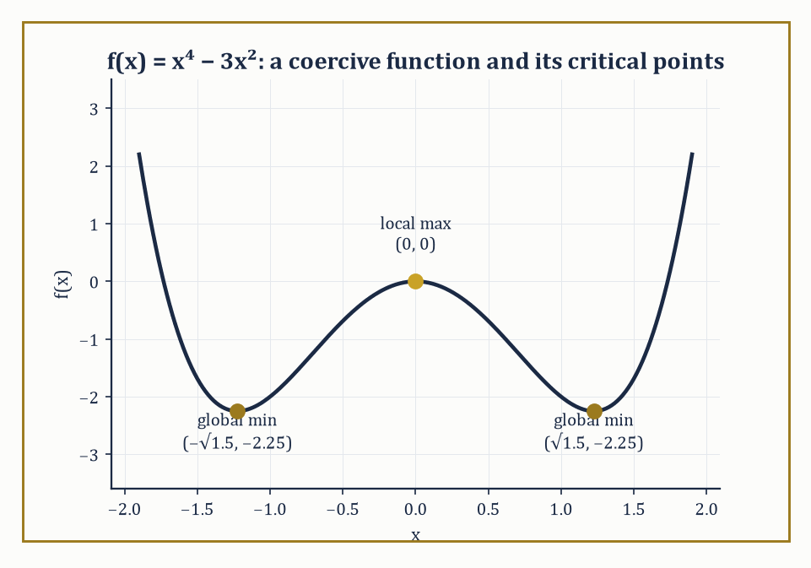
Figure 30.3 — f(x) = x⁴ − 3x² is coercive: a middling local maximum at the origin flanked by two equally deep global minima, as the second-derivative test predicts.
The first-order necessary condition is that the gradient vanishes there, because if the gradient were nonzero it would point uphill, and its negative would point downhill, meaning x* could not possibly be a local floor — you could always take a small step in the downhill direction and do better.
∇f(x*) = 0
A point where the gradient vanishes is called a critical point (or, if you enjoy sounding portentous at dinner parties, a stationary point). Not every critical point is a minimum; it might be a maximum, or — the interesting case — a saddle, where the landscape rises in some directions and falls in others, rather like most compromises.
To tell these apart we look at the Hessian matrix H(x*), the n×n matrix of second partial derivatives. If H(x*) is positive definite (all its eigenvalues strictly positive), the critical point is a genuine local minimum; if it is negative definite, a local maximum; if it has eigenvalues of both signs, a saddle. This is exactly the second-derivative test from one-variable calculus, wearing a matrix for a hat.
Numeric example — locating and classifying a critical point. Let f(x, y) = x² + 2y² − 4x − 4y. First, the gradient:
∂f/∂x = 2x − 4, ∂f/∂y = 4y − 4
Setting both to zero gives x = 2, y = 1, so the sole critical point is (2, 1). The Hessian is constant here (f is quadratic):
H = [2 0; 0 4]
A diagonal matrix, so its eigenvalues are its diagonal entries, 2 and 4, both strictly positive. Hence H is positive definite and (2, 1) is a local minimum; because f is a convex quadratic (more on convexity in Convexity and Convex Optimization Algorithms) it is in fact the global minimum. Its value:
f(2, 1) = 4 + 2 − 8 − 4 = −6
So the deepest point of this particular bowl sits at height −6, and there is nowhere on the entire infinite plane that does better.
Try it now — Find and classify the critical point of f(x, y) = x² + y² − 2x. Answer →
The existence of a global minimum is a separate question from locating one, and it is worth being honest about the gap: a function can have plenty of critical points and still fail to attain a minimum anywhere (f(x) = eˣ has no critical point at all and no minimum; f(x) = 1/(1+x²) has a maximum but only an infimum of 0, never attained).
Two standard guarantees rescue us. First, if the domain is compact (closed and bounded) and f is continuous, the Extreme Value Theorem guarantees a global minimum exists somewhere on it — compactness is doing all the work, by ruling out the function sneaking off to −∞ or to an unreachable boundary.
Second, on an unbounded domain like all of ℝⁿ, coercivity does the job instead: f is coercive if f(x) → +∞ as ‖x‖ → ∞, meaning the landscape eventually rises in every direction you might run off to escape it. A continuous coercive function on ℝⁿ attains a global minimum, because far enough out the function is provably worse than its value at the origin, so the search can be confined to a large-but-bounded ball, at which point compactness takes back over.
Numeric example — coercivity guarantees a global minimum. Let f(x) = x⁴ − 3x² on ℝ. As x → ±∞, the x⁴ term dominates the −3x² term, so f(x) → +∞ in both directions: f is coercive, and a global minimum must exist somewhere finite. Differentiating:
f′(x) = 4x³ − 6x = 2x(2x² − 3)
This vanishes at x = 0 and at x = ±√1.5 ≈ ±1.2247. The second derivative is f″(x) = 12x² − 6. At x = 0, f″ = −6 < 0, a local maximum (value f(0) = 0). At x = ±√1.5, f″ = 12(1.5) − 6 = 12 > 0, a local minimum, and by the symmetry of the function both give the same value:
f(√1.5) = (1.5)² − 3(1.5) = 2.25 − 4.5 = −2.25
Since coercivity rules out anything worse lurking off at infinity, −2.25 (attained at both x = +√1.5 and x = −√1.5) is the global minimum — a rare case of a function unable to decide between two equally good answers, which is its business, not ours.
Once the objective stops being linear, vertices lose their magic and we must search the interior. The oldest idea is gradient descent: from a point xₖ, move a small step in the direction of steepest decrease, −∇f(xₖ), since the gradient always points toward locally increasing f.
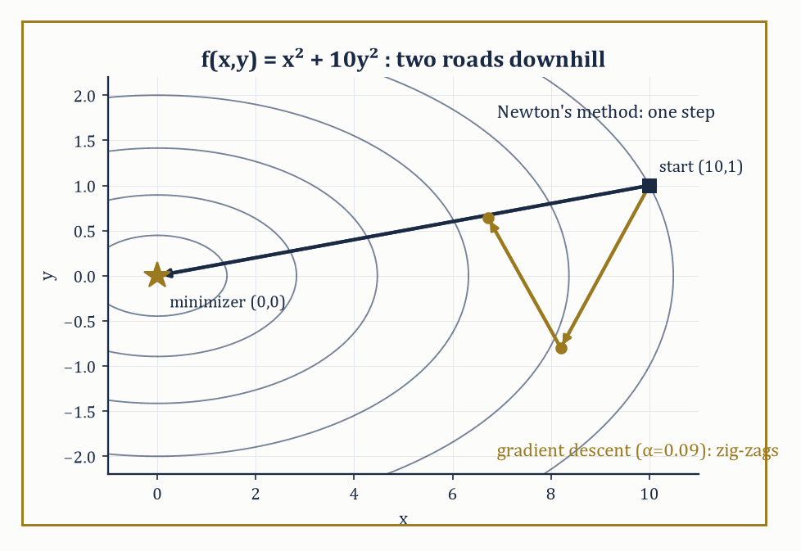
Figure 30.4 — On the elongated bowl x²+10y², gradient descent zig-zags across the narrow valley while Newton’s method walks straight to the minimizer in a single step.
xₖ₊₁ = xₖ − α∇f(xₖ)
Where α > 0 is the step size (or learning rate, if you have wandered in from machine learning, where this entire chapter is running, unadvertised, underneath everything). Too large a step size and you overshoot the valley and oscillate or diverge; too small and you converge with the urgency of continental drift.
Iterated, this converges under mild conditions, but can crawl agonizingly slowly along narrow curved valleys — a problem momentum methods address by carrying forward a fraction of the previous step, much as a ball rolling downhill accumulates velocity rather than forgetting it at every instant, and Nesterov’s accelerated variant improves further by evaluating the gradient at a look-ahead point rather than the current one, squeezing out a provably faster worst-case rate.
Numeric example — three steps of gradient descent. Minimize f(x) = x² by gradient descent, starting at x₀ = 1 with step size α = 0.3. The derivative is f′(x) = 2x, so the update is:
xₖ₊₁ = xₖ − 0.3·(2xₖ) = xₖ(1 − 0.6) = 0.4xₖ
Starting from x₀ = 1:
x₁ = 0.4·1 = 0.4, x₂ = 0.4·0.4 = 0.16, x₃ = 0.4·0.16 = 0.064
Each step multiplies the distance to the true minimum (at x = 0) by exactly 0.4, so the iterates decay geometrically to zero — convergence, but at a rate entirely dictated by the step size: choose α = 0.5 instead and the update becomes xₖ₊₁ = 0·xₖ, landing on the exact minimum in a single step (a lucky accident of this particular quadratic); choose α = 1.1 and the multiplier 1 − 2.2 = −1.2 has magnitude greater than 1, and the iterates diverge, marching off to infinity with great confidence and no destination.
Newton’s method takes a fundamentally different view: it builds a local quadratic model of f using the Hessian (the matrix of second derivatives) and jumps straight to that model’s minimizer,
xₖ₊₁ = xₖ − H(xₖ)⁻¹∇f(xₖ)
Near a well-behaved minimizer this converges quadratically — the number of correct digits roughly doubles each iteration, a rate gradient descent can only dream of — at the cost of computing and inverting an n×n Hessian, which is where quasi-Newton methods (BFGS, and its memory-frugal cousin L-BFGS) earn their keep, building up an approximation to the Hessian purely from gradients already computed, with no second derivatives required at all.
Trust-region methods hedge against a Newton step that has wandered outside the region where the quadratic model can be trusted, by explicitly bounding the step length and shrinking or growing that bound based on how well the model’s prediction matched reality.
Numeric example — Newton versus gradient descent on an ill-conditioned bowl. Let f(x,y) = x² + 10y², an elongated quadratic bowl whose Hessian, [2 0; 0 20], has eigenvalues 2 and 20 — a condition number of 10, mild by real-world standards but plenty to illustrate the point. Start at (x₀,y₀) = (10,1).
Gradient descent, step size α = 0.09 (close to the largest stable value, 2/20 = 0.1, for the steep y-direction): the gradient at the starting point is
∇f(10,1) = (20,20)
x₁ = (10,1) − 0.09(20,20) = (8.2, −0.8)
Then, at the new point, the gradient is
∇f(8.2,−0.8) = (16.4, −16)
x₂ = (8.2,−0.8) − 0.09(16.4,−16) = (6.724, 0.64)
Notice y flips sign twice in two steps (1 → −0.8 → 0.64) while x creeps down only slowly (10 → 8.2 → 6.724): this zig-zag, forced by one step size having to respect the steep y-direction while the shallow x-direction limps along, is the signature of ill-conditioning, and it worsens as the condition number grows.
Newton’s method, by contrast, uses the inverse Hessian H⁻¹ = [0.5 0; 0 0.05]; at the same starting gradient ∇f(10,1) = (20,20), the Newton step is
H⁻¹∇f = (0.5·20, 0.05·20) = (10,1)
x₁ = (10,1) − (10,1) = (0,0)
That is the exact minimizer, reached in a single step. This is not a fluke of easy numbers: for any quadratic function, Newton’s method reaches the exact minimum in one step, because the local quadratic model it builds is the function.
A method that converges beautifully once it is near a minimizer is of limited use if it diverges before getting there, so both families are wrapped in a globalization strategy.
Line search picks a direction (steepest descent, Newton, quasi-Newton) and then searches along that ray for a step length satisfying sufficient-decrease conditions (the Wolfe or Armijo conditions, in the trade), guaranteeing the objective drops enough to make provable progress. Trust-region methods, as noted above, instead bound the step and adjust the bound adaptively.
Both convert a method with only local convergence guarantees into one with global convergence — meaning convergence to a stationary point from any reasonable starting point, not (confusingly, but this is standard usage) convergence to the global minimum, which nonconvex problems cannot generally promise regardless of the starting point.
The rate near the solution — linear, superlinear, or quadratic, in decreasing order of how painful they are to sit through — and worst-case complexity bounds (how many iterations before the gradient norm is guaranteed below some tolerance ε, in the worst case over a whole class of problems) are the theoretical face of exactly the practical experience above: conditioning, again, decides how many of those iterations you actually need.
Numeric example — quasi-Newton curvature from gradient differences alone. Quasi-Newton methods build their Hessian approximation from the secant condition: if you know the gradient at two points, their difference tells you the average curvature between them, with no second derivative required. Take f(x) = x⁴, so f′(x) = 4x³, and, for comparison, the true second derivative f″(x) = 12x².
Evaluate the gradient at x₀=2 and x₁=1.5:
f′(2) = 4(8) = 32
f′(1.5) = 4(3.375) = 13.5
The secant estimate of curvature is
(f′(x₁)−f′(x₀))/(x₁−x₀) = (13.5−32)/(1.5−2) = (−18.5)/(−0.5) = 37
Compare with the true curvature at the midpoint x=1.75:
f″(1.75) = 12(1.75²) = 12(3.0625) = 36.75
The secant estimate (37) is within about 1% of the true value (36.75) — BFGS builds this kind of estimate, in n dimensions, updating it after every step, and it is remarkable how faithfully a method that never touches a second derivative tracks one anyway.
The practical choice among these methods is a triangle of trade-offs: dimension (Newton’s O(n³) linear solve per iteration is fine for n=50 and unthinkable for n=10⁸, where L-BFGS’s O(n) memory footprint or plain gradient descent is the only option), cost of derivatives (if a gradient is cheap but a Hessian is expensive or simply unavailable analytically, quasi-Newton is the natural compromise), and desired accuracy (a machine-learning training run tolerating a few percent error can happily use noisy first-order methods, while a spacecraft trajectory computation demanding ten correct digits will pay gladly for Newton’s quadratic convergence).
There is no universally best method here, only a best method for the problem in front of you — a fact optimization shares with most of applied mathematics, and with restaurant recommendations.
You have seen this before
Newton’s method for minimization is Newton’s method for root-finding from Root-Finding and Nonlinear Equations, applied to the equation ∇f = 0.
Keep only this · Section 30.3: Unconstrained Nonlinear Optimization
The idea. At an interior minimum ∇f = 0 and the Hessian is positive semidefinite; a positive definite Hessian makes a critical point a strict local minimum. Compactness or coercivity guarantees that a global minimum exists. Gradient descent walks downhill; Newton’s method uses curvature and converges quadratically; quasi-Newton methods learn curvature from gradients.
Core.
∇f(x) = 0 and H(x) positive definite ⇒ strict local minimum
gradient descent: xₖ₊₁ = xₖ − α∇f(xₖ)
Newton: xₖ₊₁ = xₖ − H(xₖ)⁻¹∇f(xₖ)
Typical mistake. Calling every critical point a minimum. f(x, y) = x² − y² has ∇f = 0 at the origin, which is a saddle.
Minimal example. f(x) = x² with α = 0.3: gradient descent multiplies x by 0.4 each step.
Practice. Easy to challenge; full worked answers, with the usual mistake, are in Answers to the Practice Sets at the back.
Easy — Classify the critical point of f(x, y) = x² − 4xy + y². Answer →
Medium — Take one gradient step on f(x, y) = x² + 10y² from (1, 1) with α = 0.05. Answer →
Challenge — For f = x² + 10y², the gradients at (1, 1) and (0.9, 0) are (2, 20) and (1.8, 0). Check the secant condition Hs = y, and compute the curvature sᵀy/sᵀs a quasi-Newton method learns along the step. Answer →

Section 30.4: Constrained Nonlinear Optimization
Downhill, Without Falling Off the Map
A straight road runs past a well at the origin, along the line x + y = 1. Which point of the road is closest to the well? Without the road the question is empty: the closest point to the well is the well itself, (0, 0), and the downhill methods of Unconstrained Nonlinear Optimization would walk straight to it. But (0, 0) is not on the road. Walking downhill takes you off the map.
So measure along the road instead. The squared distance from the well is f = x² + y², and the points of the road have y = 1 − x:
(0, 1): f = 1
(0.25, 0.75): f = 0.625
(0.5, 0.5): f = 0.5
(0.75, 0.25): f = 0.625
(1, 0): f = 1
The best point is (0.5, 0.5). Look at what is special about it. The gradient of f, ⟨2x, 2y⟩, points the way f increases fastest. At (0, 1) it is ⟨0, 2⟩, and moving along the road in the direction ⟨1, −1⟩ changes f at the rate 2x − 2y = −2: there is still something to gain by sliding along. At (0.5, 0.5) the gradient is ⟨1, 1⟩, which points straight across the road, and the rate along the road is 2(0.5) − 2(0.5) = 0. Nothing more can be gained without leaving the road.
That is the condition for a constrained minimum: the gradient of f has no part along the constraint, so it lines up with the constraint’s own gradient, here ⟨1, 1⟩. Written as ∇f = λ∇g, it is the method of Lagrange multipliers. The theory comes first — one constraint, several constraints, then inequalities and the KKT conditions — and then the algorithms, which start with two cruder ideas: fine the walker for leaving the road, or build a wall along it.
Suppose you must minimize f(x) subject to an equality constraint g(x) = 0 — the point x is confined to some surface (a curve, in two dimensions) rather than the whole plane.
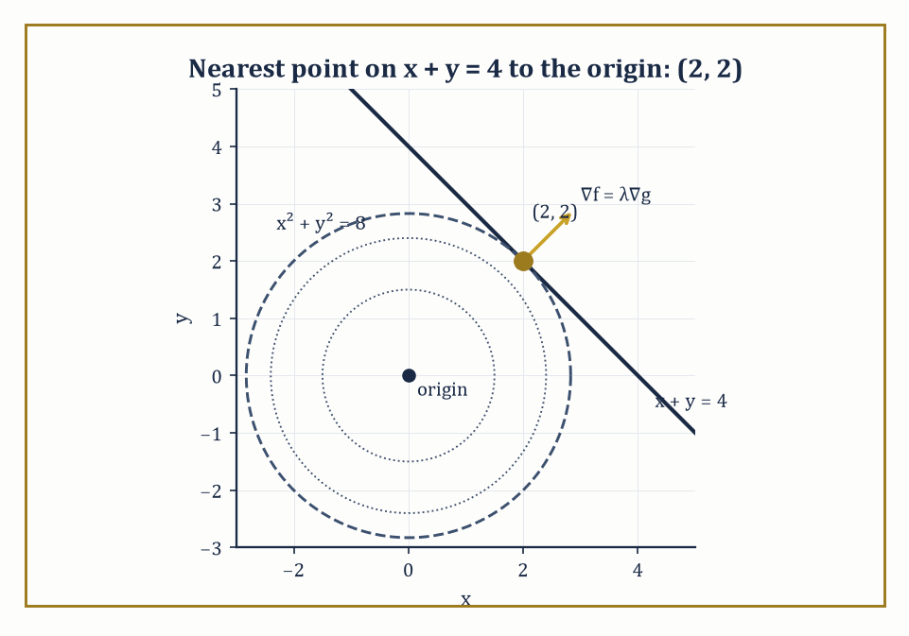
Figure 30.5 — At the constrained optimum (2, 2), the level circle x² + y² = 8 sits tangent to the line x + y = 4 — the geometric meaning of ∇f = λ∇g.
The method of Lagrange multipliers observes that at a constrained extremum, the gradient of f need not vanish, but it must be perpendicular to the constraint surface — equivalently, it must be parallel to ∇g, the gradient of the constraint, since ∇g is itself always perpendicular to the level surface g = 0. Parallel vectors differ only by a scalar multiple, so we demand
∇f = λ∇g
For some scalar λ, the Lagrange multiplier, alongside the constraint g(x) = 0 itself. Geometrically: if ∇f had any component along the constraint surface, you could slide along the surface in that direction and improve f, so at a true constrained extremum no such improving direction can exist — the two gradients must be aligned. With multiple constraints g₁ = g₂ = ⋯ = 0, the condition generalizes to ∇f lying in the span of ∇g₁, …, ∇gₖ, one multiplier per constraint.
Numeric example — nearest point on a line. Minimize f(x, y) = x² + y² subject to g(x, y) = x + y − 4 = 0 (this is the question: what point on the line x + y = 4 is closest to the origin, since x² + y² is the squared distance from the origin). Set up ∇f = λ∇g:
(2x, 2y) = λ(1, 1)
Giving 2x = λ and 2y = λ, so x = y. Substituting into the constraint: x + x = 4, so x = y = 2. The nearest point is (2, 2), at squared distance
f(2, 2) = 4 + 4 = 8
I.e. actual distance √8 = 2√2 ≈ 2.828. A quick sanity check: the line x + y = 4 has direction vector (1, −1), and the segment from the origin to (2, 2) has direction (1, 1) — perpendicular to the line, just as it should be for the shortest connecting segment.
Try it now — Minimize x² + y² subject to x + y = 2 with a Lagrange multiplier. Answer →
Multiple constraints work the same way, with one multiplier apiece and the resulting gradient condition asking for ∇f to be a genuine linear combination of all the constraint gradients — not parallel to any single one, but reachable by mixing them in the right proportions.
Numeric example — two constraints, two multipliers. Minimize f(x, y, z) = x² + y² + z² subject to g₁: x + y + z = 1 and g₂: x − y = 0. From g₂, y = x; substituting into g₁, z = 1 − 2x. So f becomes a function of x alone:
f(x) = x² + x² + (1 − 2x)² = 2x² + 1 − 4x + 4x² = 6x² − 4x + 1
Differentiating and setting to zero: 12x − 4 = 0, so x = 1/3, giving y = 1/3 and z = 1 − 2/3 = 1/3 — the constrained minimizer is (1/3, 1/3, 1/3), with f = 3·(1/9) = 1/3. Now check the Lagrange condition directly: ∇f = (2/3, 2/3, 2/3), ∇g₁ = (1, 1, 1), ∇g₂ = (1, −1, 0). We need
λ(1,1,1) + μ(1,−1,0) = (2/3, 2/3, 2/3)
The third component gives λ = 2/3 immediately; the first component then gives 2/3 + μ = 2/3, so μ = 0 — and the second component, λ − μ = 2/3 − 0 = 2/3, checks out. The two constraint gradients here happened to require no contribution from μ at all, which is a coincidence of this particular problem, not a general rule.
Inequality constraints g(x) ≥ 0 are trickier, because the constraint might or might not be ‘active’ at the solution — the optimum might sit comfortably in the interior of the feasible region (in which case the constraint is irrelevant there, as in the unconstrained problem) or be pinned against the boundary.
The Karush–Kuhn–Tucker (KKT) conditions handle both cases in one stroke: stationarity ∇f = λ∇g, primal feasibility g(x) ≥ 0, dual feasibility λ ≥ 0, and complementary slackness
λ·g(x) = 0
That last condition is the clever bit: it forces either λ = 0 (the constraint is inactive, contributing nothing) or g(x) = 0 (the constraint is active, pressed right up against its boundary) — never both nonzero at once, since a multiplier is only ‘needed’ when its constraint is actually doing something. Under mild technical conditions on the constraints (constraint qualifications, ensuring the gradients behave well enough for multipliers to exist at all), the KKT conditions are necessary for optimality, and for convex problems — the subject of the next section — they are sufficient too.
Numeric example — an active inequality constraint. Minimize f(x) = x² subject to x ≥ 1. Write the constraint as g(x) = x − 1 ≥ 0. Unconstrained, the minimum of x² sits at x = 0, which is infeasible (0 is not ≥ 1), so the constraint must be active: x = 1. Check KKT: stationarity requires f′(x) = λg′(x), i.e.
2x = λ·1, so λ = 2x
At the candidate x = 1, λ = 2, which is indeed ≥ 0 as dual feasibility demands. Complementary slackness: λ·(x − 1) = 2·0 = 0, satisfied automatically since the constraint is active. All four KKT conditions hold, so x = 1 is confirmed optimal, with minimum value f(1) = 1 — as is obvious in hindsight, since x² is increasing for x > 0 and the constraint will not let you go any lower than x = 1.
Constraints complicate the descent picture: the steepest way downhill may lead straight out of the feasible set.
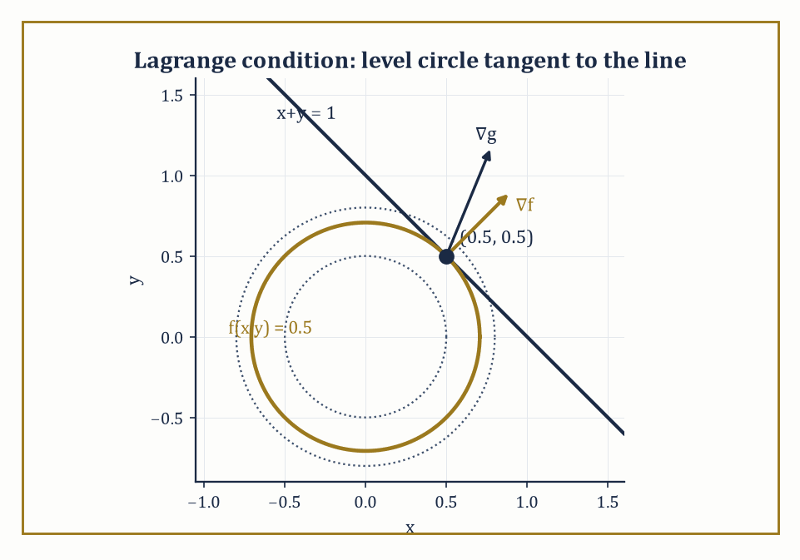
Figure 30.6 — At the constrained minimum (0.5,0.5), the level circle of f just touches the line x+y=1 — tangency is what ∇f = λ∇g looks like.
Penalty methods respond with fines — replace the constrained problem with an unconstrained one:
minimize f(x) + ρ·(constraint violation)²
Increase the penalty weight ρ until violating the constraint becomes so expensive that the unconstrained minimizer is dragged, in the limit, onto the feasible boundary.
Barrier methods take the opposite tack, adding a term that blows up to +∞ as x approaches the boundary of the feasible region from the inside — enforcing feasibility not by punishment but by making the boundary infinitely unattractive, which is also, not coincidentally, the interior-point idea already met in Linear Programming, generalized from polyhedra to arbitrary convex (and even some nonconvex) constraint sets.
Sequential quadratic programming (SQP) is more surgical still: at each iterate it builds a quadratic model of the Lagrangian and a linear model of the constraints, solves the resulting quadratic program for a step, and repeats — effectively running Newton’s method on the system of optimality conditions (the KKT conditions, met properly below) rather than on the objective alone.
Numeric example — penalty and barrier methods homing in from opposite sides. Minimize f(x) = x² subject to x ≥ 1.
The true solution is x* = 1, since x² is increasing for x>0, so the smallest feasible x wins.
f(x*) = 1
Watch the two unconstrained conversions find it.
Penalty: consider the penalized objective, where the constraint is violated (x<1):
φᵨ(x) = x² + ρ(1−x)²
Setting dφᵨ/dx = 0:
dφᵨ/dx = 2x − 2ρ(1−x) = 0
x(2+2ρ) = 2ρ
xᵨ = ρ/(1+ρ)
At ρ=1: x=0.5 (violates by 0.5)
At ρ=9: x=0.9 (violates by 0.1)
At ρ=99: x=0.99 (violates by 0.01)
The penalized minimizer creeps toward 1 as ρ→∞, always staying slightly infeasible.
Barrier: minimize ψ_μ(x) = x − μ ln(x−1) for x>1 (minimizing x itself keeps the arithmetic clean, so the constraint alone prevents the unconstrained-side minimum of −∞):
ψ_μ(x) = x − μ ln(x−1)
Setting dψ_μ/dx = 0:
dψ_μ/dx = 1 − μ/(x−1) = 0
x_μ = 1+μ
At μ=0.1: x=1.1
At μ=0.01: x=1.01
This always stays strictly feasible, approaching 1 from the other side.
Both sequences converge to the true constrained optimum x*=1; they approach it from opposite directions, which is the geometric distinction between penalty and barrier methods.
An active-set method takes the view that, at the solution, some inequality constraints will be tight (‘active’, in the jargon) and others irrelevantly slack; if you could only guess correctly which is which, the problem would reduce to an equality-constrained one, solvable directly via the method of Lagrange multipliers.
The Lagrangian turns constrained stationarity into unconstrained stationarity of L over both x and the multipliers λ:
L(x,λ) = f(x) − Σλᵢgᵢ(x)
Stationarity in x, ∇ₓL = 0, recovers the constraint gradients balancing the objective gradient.
Stationarity in the multipliers, ∂L/∂λᵢ = 0, recovers the constraint gᵢ(x)=0 itself.
Active-set methods iteratively guess the active set, solve the resulting equality-constrained subproblem, check whether any inactive constraint has been violated or any multiplier has the wrong sign, and update the guess accordingly.
Because progress must be measured on two fronts at once — is the objective decreasing, and is infeasibility shrinking — merit functions combine both into a single scalar to search over (typically f(x) plus a penalty on violation).
Filter methods instead maintain a small Pareto-style list of previously acceptable (objective, violation) pairs and reject any new point dominated by one already on the list, which is rather more forgiving of an occasional uphill objective step made in service of a much-improved feasibility.
Numeric example — solving an equality-constrained problem via the Lagrangian. Minimize f(x,y) = x² + y² subject to the equality constraint x + y = 1.
Form the Lagrangian:
L(x,y,λ) = x² + y² − λ(x+y−1)
Stationarity requires:
∂L/∂x = 2x − λ = 0
∂L/∂y = 2y − λ = 0
giving:
x = y = λ/2
i.e. x = y.
Feasibility requires x+y=1, which combined with x=y gives:
x = y = 0.5
λ = 2x = 1
This is the point on the line x+y=1 closest to the origin, as one would hope for minimizing squared distance subject to a linear constraint.
Geometrically, the gradient of f at (0.5,0.5), namely (1,1), is indeed parallel to the constraint’s gradient (1,1), confirming that the circle f=const and the line x+y=1 are tangent at the solution, which is what the Lagrange condition ∇f = λ∇g encodes.
All of this rests on a technical but consequential assumption: that the active constraints’ gradients, at the candidate solution, are linearly independent (or satisfy some weaker but related condition) — a constraint qualification, without which the Lagrange-multiplier machinery can simply fail to certify a genuine minimum, or fail to produce a valid multiplier at all.
Second-order sufficient conditions then distinguish an actual local minimum from a mere stationary saddle: roughly, the Hessian of the Lagrangian must be positive definite on the subspace tangent to the active constraints, ruling out any feasible direction of decrease to second order.
Practical algorithms further need the active set itself to stabilize — to stop flipping constraints in and out — as they converge, since a method that cannot decide which constraints are binding cannot settle into the fast local convergence rate its unconstrained cousin enjoys.
Abstract example — a constraint qualification quietly failing. Consider minimizing f(x₁,x₂) = −x₁ subject to x₂ − (1−x₁)³ ≤ 0 and −x₂ ≤ 0 — a standard cautionary tale from the numerical-optimization literature.
The two constraints force:
0 ≤ x₂ ≤ (1−x₁)³
which is only satisfiable when 1−x₁ ≥ 0, i.e. x₁ ≤ 1 — so the feasible region is a cusp-shaped sliver pinched to a single point at (1,0), lying entirely in x₁ ≤ 1.
Minimizing −x₁ means pushing x₁ as large as possible, and x₁ ≤ 1 throughout the sliver, so (1,0) is in fact the solution — the cusp itself, where the constraint reduces to the single point x₁=1, x₂=0.
But look at the active constraint gradients there. The first is:
∇g₁ = (3(1−x₁)², 1)
which, evaluated at x₁=1, gives:
∇g₁ = (0,1)
while the second is:
∇g₂ = (0,−1)
These two vectors are parallel — one is the negative of the other — so they are linearly dependent, and the standard constraint qualification (LICQ) fails at the point where we need it to hold.
Indeed, no valid multipliers exist here at all: stationarity would require:
∇f + λ₁∇g₁ + λ₂∇g₂ = (−1,0) + λ₁(0,1) + λ₂(0,−1) = (0,0)
and since both constraint gradients are purely vertical, no choice of λ₁,λ₂ ≥ 0 can ever cancel that leading −1.
So (1,0) is a genuine, bona fide minimizer for which the Lagrange-multiplier certificate fails to exist — exactly the failure a constraint qualification is meant to rule out, and exactly why serious software checks for this kind of degeneracy rather than trusting blindly that a stationary point of the Lagrangian is the same thing as a solution.
Keep only this · Section 30.4: Constrained Nonlinear Optimization
The idea. At a constrained minimum ∇f is a combination of the active constraint gradients — Lagrange’s condition, and for inequalities the KKT conditions — provided a constraint qualification holds. Penalty methods approach the solution from outside, barrier methods from inside, and SQP and interior-point methods solve the KKT system directly.
Core.
equality: ∇f = λ∇g
KKT for g(x) ≥ 0: ∇f = λ∇g, λ ≥ 0, λ·g(x) = 0
quadratic penalty: f + (μ/2)(violation)²
Typical mistake. Trusting multipliers without a constraint qualification. In the cusp example the minimizer (1, 0) has no valid multipliers at all.
Minimal example. Minimize x² subject to x ≥ 1: x = 1, λ = 2.
Practice. Easy to challenge; full worked answers, with the usual mistake, are in Answers to the Practice Sets at the back.
Easy — Minimize x + y subject to x² + y² = 2. Answer →
Medium — For minimize x² subject to x = 1, minimize the penalty function x² + (μ/2)(x − 1)². Find x(μ) and its limit. Answer →
Challenge — Minimize x² + y² subject to x + 2y ≥ 2 with the KKT conditions. Answer →

Section 30.5: Convexity and Convex Optimization Algorithms
Where Local Really Does Mean Global
Searching a landscape for its lowest point is hopeless in general: you can never be sure that no deeper valley lies over the next ridge, and walking all of them is the only honest method. Convexity removes the ridges. In a convex landscape any bottom you reach is the bottom, so a local search settles a global question — which is why the practical divide in optimization runs between convex problems and the rest, and not, as most people first assume, between linear and nonlinear ones. A function f is convex when the line segment joining any two points on its graph never dips below the graph itself — formally,
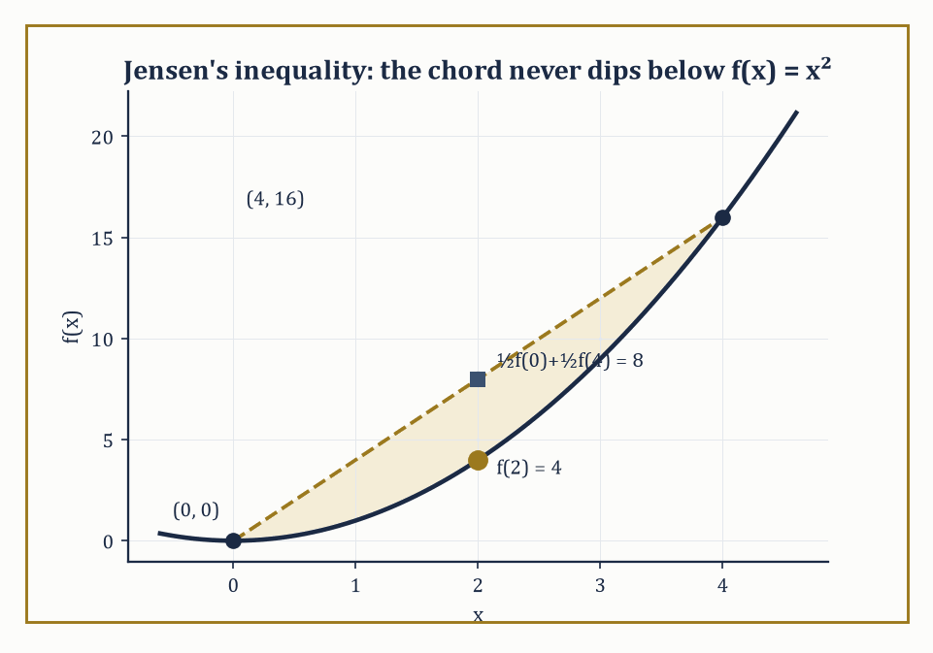
Figure 30.7 — Jensen’s inequality made visible: the chord from (0, 0) to (4, 16) never dips below the graph of f(x) = x², with a comfortable gap of 4 to spare at the midpoint.
f(θx + (1−θ)y) ≤ θf(x) + (1−θ)f(y) for all x, y and all θ ∈ [0,1]
A statement known as Jensen’s inequality. Geometrically this says the epigraph of f (the region on or above the graph) is a convex set: pick any two points inside it, and the straight segment between them stays inside too.
For twice-differentiable functions there is a mercifully computational test: f is convex if and only if its Hessian is positive semidefinite everywhere (all eigenvalues ≥ 0), and strictly convex if the Hessian is positive definite everywhere (a slightly stronger condition that, among other things, rules out flat stretches).
Convexity is the single most consequential property in optimization, for a simple and slightly miraculous reason: for a convex function, every local minimum is automatically a global minimum, and the set of all minimizers is itself convex. There is no possibility of getting trapped in a merely-locally-good valley while a better one lurks elsewhere — convex landscapes have exactly one basin, however oddly shaped.
Numeric example — checking Jensen’s inequality. Let f(x) = x², and take x = 0, y = 4, θ = 0.5 (the midpoint). Left-hand side:
f(0.5·0 + 0.5·4) = f(2) = 4
Right-hand side:
0.5·f(0) + 0.5·f(4) = 0.5·0 + 0.5·16 = 8
Indeed 4 ≤ 8, confirming convexity at this pair of points (and the gap of 4 between the two sides is itself informative — it measures how much curvature f has between 0 and 4). The Hessian test agrees instantly: f″(x) = 2 > 0 for every x, so f is strictly convex everywhere, and its unique global minimum, x = 0, needs no further searching once convexity is established — a local check at any critical point is automatically a global certificate.
Try it now — Is f(x) = eˣ + x² convex? Answer →
It is worth seeing what goes wrong without convexity, if only to appreciate what convexity is buying us. A non-convex function can perfectly well have a local minimum that is not global, or worse, no global minimum at all despite having plenty of local ones — the optimization landscape equivalent of confidently climbing down into the wrong valley and declaring victory.
Numeric example — a local minimum that is not global. Let f(x) = x³ − 3x. Then f′(x) = 3x² − 3 = 0 gives x = ±1, and f″(x) = 6x. At x = 1, f″ = 6 > 0, a local minimum with value f(1) = 1 − 3 = −2. At x = −1, f″ = −6 < 0, a local maximum with value f(−1) = −1 + 3 = 2.
But as x → −∞, the x³ term dominates and f(x) → −∞: the function has no global minimum at all — it plunges without limit far to the left, quite unbothered by the tidy local minimum sitting at x = 1. This is precisely the pathology convexity forbids: f here is not convex (its second derivative 6x is negative for x < 0), and the consequence is the kind of local-versus-global confusion that a convex function is structurally incapable of producing.
Convex problems also come equipped with a duality theory of startling usefulness. Every convex minimization problem (the primal) has an associated dual problem, a maximization over a different set of variables (the multipliers, now promoted to first-class citizens), and weak duality guarantees the dual’s value never exceeds the primal’s — the dual is always a certified lower bound, obtainable without solving the primal at all.
Under a constraint qualification (Slater’s condition being the usual one: some point strictly satisfies all inequality constraints), strong duality holds and the two values coincide exactly, so solving either problem solves both. This is the engine behind interior-point methods and much of modern large-scale optimization: certify optimality by exhibiting a dual solution matching the primal, rather than trusting a first-order condition alone.
Numeric example — a linear program and its dual. Primal: minimize 3x₁ + 2x₂ subject to x₁ + x₂ ≥ 4, x₁ ≥ 0, x₂ ≥ 0. Since x₂ is cheaper per unit than x₁ (coefficient 2 versus 3), the optimal strategy uses only x₂: set x₁ = 0, and the constraint forces x₂ ≥ 4, minimized at x₂ = 4, giving primal cost 3(0) + 2(4) = 8. (Formally: on the boundary x₁ + x₂ = 4, cost is 3x₁ + 2(4 − x₁) = x₁ + 8, minimized at x₁ = 0.)
The dual problem is: maximize 4y subject to y ≤ 3, y ≤ 2, y ≥ 0 (one dual variable y for the single primal constraint, with dual constraints built from each column of the primal). The binding restriction is y ≤ 2, so the dual optimum is y = 2, giving dual value 4·2 = 8.
Primal value 8 equals dual value 8 — strong duality holds exactly, and either number alone would have certified the other as optimal without further work.
Strict convexity is worth separating from plain convexity, because it buys something extra: uniqueness. Ordinary convexity guarantees the set of minimizers is convex — possibly a single point, but possibly an entire flat plateau of equally good answers, as happens whenever the function has a genuinely flat stretch at its lowest level. Strict convexity (Hessian positive definite, not merely semidefinite, everywhere) rules out flat stretches entirely, and with them any possibility of a tie: the minimizer, when it exists, is the only one there is.
Numeric example — a tie for convex, no tie for strictly convex. Compare f(x, y) = x² (convex but not strict, since it ignores y wholly — the Hessian is [2 0; 0 0], positive semidefinite but not definite) against g(x, y) = x² + y² (strictly convex, Hessian [2 0; 0 2], positive definite). Both attain minimum value 0.
But f attains it along the entire line x = 0 — every point (0, y) for any y whatsoever gives f = 0, an infinite plateau of tied minimizers — while g attains it at the single point (0, 0) only, since x² + y² = 0 forces both x = 0 and y = 0 simultaneously. The extra strictness in g’s curvature (curving in the y-direction, which f simply lacked) is exactly what collapses an entire line of ties down to one answer.
For algorithms, this means a method need only promise convergence to a stationary point to have effectively solved a convex problem outright.
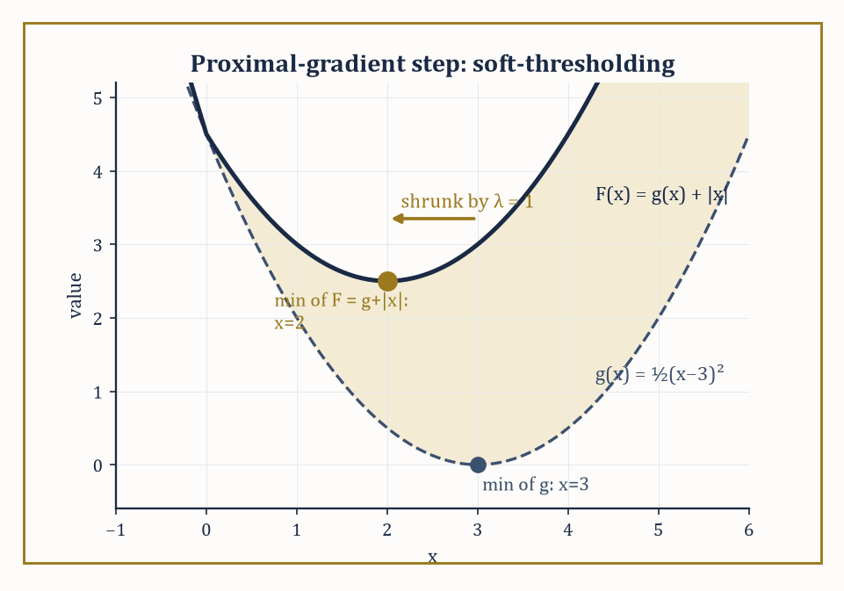
Figure 30.8 — Adding the ℓ₁ penalty |x| to g(x) drags the minimizer from x=3 to x=2 — soft-thresholding made visible.
Projected gradient descent handles simple constraints by alternating an ordinary gradient step with a projection back onto the feasible set (find the nearest feasible point, in Euclidean distance, to the unconstrained step) — cheap whenever that projection is cheap, as it is for a box or a ball, and expensive or worse otherwise.
Proximal gradient generalizes this to composite objectives
f(x) = g(x) + h(x)
where g is smooth and h is convex but possibly nonsmooth (an absolute value, an indicator of a constraint set, a sparsity-inducing norm): take a gradient step on the smooth part g, then apply the proximal operator of h,
proxₕ(v) = argmin[z] [h(z) + ½‖z−v‖²]
which reduces to plain projection when h is the indicator of a set, and to elegant closed forms, as the next example shows, for many popular choices of h.
Accelerated proximal methods (FISTA and relatives) apply Nesterov’s momentum trick to this composite setting, improving the convergence rate from O(1/k) to O(1/k²) in the number of iterations k — a free lunch, algorithmically speaking, purchased only by remembering the previous iterate.
Numeric example — one proximal-gradient step solves a sparse problem precisely. Minimize F(x) = g(x) + h(x) where g(x) = ½(x−3)², a smooth quadratic, and h(x) = |x|, the nonsmooth ℓ₁ penalty that promotes sparsity — a single variable here for arithmetic’s sake, but the same mechanism scales to LASSO regression in thousands of dimensions.
The proximal operator of λ|·| is soft-thresholding:
prox_(λ|·|)(v) = sign(v)·max(|v|−λ, 0)
Take a proximal-gradient step from x₀=0 with step size t=1: first the gradient step on g alone,
z = x₀ − t∇g(x₀) = 0 − 1·(0−3) = 3
then the proximal step with λ=t=1:
prox(3) = sign(3)·max(3−1,0) = 2
One iteration lands at x₁=2. Because g is quadratic with curvature matching the chosen step size, this single step is in fact exact: checking the subdifferential of F at x=2 directly,
(2−3) + 1·sign(2) = −1+1 = 0 ∈ ∂F(2)
confirming x=2 is the true minimizer — the ℓ₁ penalty has shrunk the unconstrained optimum (x=3) toward zero by λ=1, the ‘soft-thresholding’ behavior that makes sparse solutions so common in ℓ₁-penalized problems.
For linear, quadratic, and semidefinite programming, interior-point methods (Section 30.2’s central path, generalized) are polynomial-time in the worst case and, for problems up to a few thousand variables, blisteringly efficient in practice, typically converging in a number of iterations that barely depends on problem size at all — a handful of dozens, whether n is 50 or 5,000.
Their Achilles’ heel is the linear system solved at each iteration, which costs roughly O(n³) and eventually becomes the bottleneck; first-order methods (gradient, proximal, accelerated variants) trade this cubic per-iteration cost for a much cheaper O(n) or O(n log n) iteration, at the price of needing many more iterations to reach the same accuracy — the right trade when n is enormous and a few correct digits will do, which describes most of modern machine learning.
Numeric example — how the iteration budgets compare. A typical interior-point solver needs roughly O(√n · log(1/ε)) iterations to reach accuracy ε; a typical first-order method needs roughly O(1/ε) (or O(1/√ε) with acceleration) iterations, with no explicit dependence on n at all. Suppose n=10,000 and ε=10⁻⁶.
Interior-point:
√10,000 · log₁₀(10⁶) ≈ 100 · 6 = 600 iterations
each costing O(n³) ≈ 10¹² operations for the linear solve — expensive per step.
Accelerated first-order: 1/√ε = 1,000 iterations, each costing only O(n) ≈ 10⁴ operations.
Interior-point needs far fewer iterations but each is vastly more expensive; first-order needs more iterations but each is nearly free. Totting up:
first-order costs roughly 10⁴ × 10³ = 10⁷ operations against interior-point’s roughly 10¹² × 600 ≈ 6×10¹⁴
which is why first-order methods dominate large-scale machine learning while interior-point solvers still rule moderate-sized, high-accuracy engineering problems.
Beyond raw dimension, convex problems often carry exploitable structure: separability (the objective splits into a sum of pieces each touching only a few variables), sparsity or group sparsity (most of the optimal x, or blocks of it, are expected to be exactly zero), or low rank (the optimal matrix variable is expected to have far fewer independent directions than its size suggests).
Splitting methods, of which the alternating direction method of multipliers (ADMM) is the most celebrated, are built precisely to exploit this: they solve a problem of the form
minimize f(x)+g(z) subject to a linear coupling constraint Ax+Bz=c
by alternately minimizing over x (with z fixed), minimizing over z (with x fixed), and updating a multiplier that enforces the coupling — turning one hard joint problem into a sequence of easy separate ones, each often solvable in closed form.
Abstract example — one ADMM cycle splitting a joint problem in two. Minimize x² + z² subject to the coupling constraint x + z = 4 — trivial to solve directly (by symmetry and Lagrange multipliers, x=z=2), but instructive to watch ADMM find its way there by alternating.
The augmented Lagrangian (penalty weight ρ=1) is
L(x,z,y) = x² + z² + y(x+z−4) + ½(x+z−4)²
Start at z₀=0, y₀=0. x-update: minimize x² + ½(x+0−4)² over x; setting 2x + (x−4) = 0 gives
3x=4, x₁=4/3
z-update: minimize z² + ½(4/3+z−4)² = z² + ½(z−8/3)² over z; setting 2z + (z−8/3) = 0 gives
3z=8/3, z₁=8/9
Multiplier update:
y₁ = y₀ + ρ(x₁+z₁−4) = 4/3+8/9−4 = 12/9+8/9−36/9 = −16/9
After a single cycle, x₁≈1.33 and z₁≈0.89 have both moved substantially off their starting value of 0, toward the true answer of 2 each; the residual −16/9 measures the remaining coupling violation, and further cycles shrink it toward zero, each cycle costing nothing more than two independent one-variable minimizations plus a trivial update — the entire point of splitting being that neither subproblem ever has to look at the other’s variable directly, only at its current value.
Keep only this · Section 30.5: Convexity and Convex Optimization Algorithms
The idea. For a convex function on a convex set every local minimum is global, and strict convexity makes the minimizer unique. Convex problems come with a usable duality theory, and their algorithms — projected and proximal gradient, interior-point methods, ADMM — come with guarantees.
Core.
f(tx + (1 − t)y) ≤ t f(x) + (1 − t) f(y)
smooth f: convex ⇔ Hessian positive semidefinite everywhere
prox of t|x| at v: sign(v)·max(|v| − t, 0)
Typical mistake. Testing convexity at one pair of points. One chord above the graph proves nothing; convexity is a statement about every pair.
Minimal example. f(x) = x²: the chord from 0 to 4 lies above the graph, with gap 4 at x = 2.
Practice. Easy to challenge; full worked answers, with the usual mistake, are in Answers to the Practice Sets at the back.
Easy — Project the point (2, −1) onto the box [0, 1]². Answer →
Medium — Compute the proximal operator of |x| (t = 1) at v = 3 and at v = 0.4. Answer →
Challenge — Show that f(x) = x³ is not convex on ℝ but is convex on [0, ∞). Answer →

Section 30.6: Duality in Practice
How to Prove You’ve Won Without Playing Every Move
Suppose a planner claims that a delivery schedule costing 120 pounds is the cheapest possible. How could you check without trying every other schedule? Duality supplies the answer. Alongside every minimization problem sits a second problem, the dual, whose values are guaranteed never to exceed the best value of the first. If someone also hands you a dual value of 120, the matter is settled, because no schedule can beat a figure that a lower bound already matches. In good cases, including every linear program and every convex problem meeting a mild condition, the two problems meet exactly, and the dual’s solution also tells you what each constraint is worth: the price of loosening it.
The Lagrangian, met in Constrained Nonlinear Optimization as a device for locating stationary points, has a second life as a certificate-generating machine. Define the dual function as follows (inequality constraints gᵢ(x)≤0, multipliers λᵢ≥0, for concreteness):
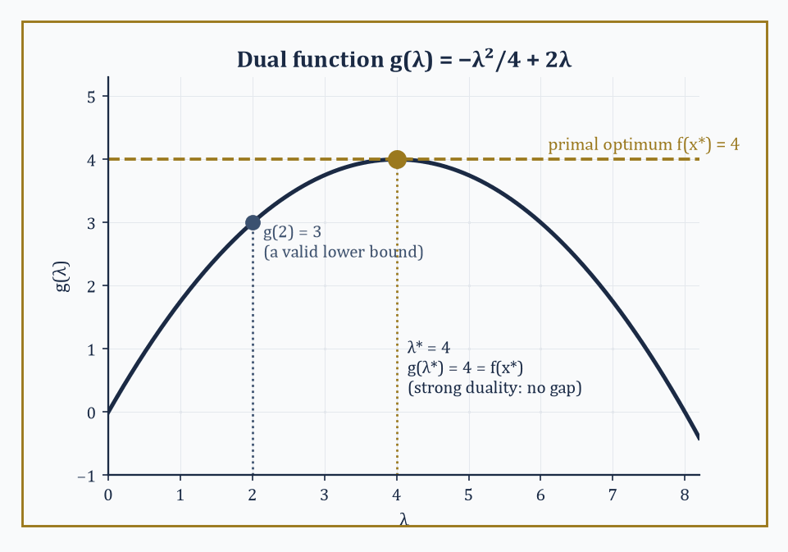
Figure 30.9 — The dual function g(λ) is always concave; here its peak at λ*=4 meets the primal optimum, closing the duality gap to zero.
g(λ) = minₓ L(x,λ) = minₓ [f(x) − Σλᵢgᵢ(x)]
Weak duality is almost embarrassingly easy to prove and holds always, convex or not: for any feasible x and any λ≥0,
g(λ) ≤ f(x)
because at a feasible x the subtracted terms −λᵢgᵢ(x) are all ≥0. So g(λ) is a lower bound on the true minimum for every choice of λ≥0 — and maximizing g over λ (the dual problem) hunts for the best such bound.
Strong duality — the dual’s best bound equals the primal’s true minimum, with zero gap — holds for convex problems under a mild regularity condition (Slater’s condition: some point strictly satisfies all inequality constraints).
When it holds, solving the dual is just as good as solving the primal, and often computationally cheaper or more naturally decomposable; and when a candidate (x,λ) satisfies stationarity and complementary slackness, that pair is a certificate of optimality checkable in a fraction of the time it took to find it.
It is worth dwelling on why this works at all: g(λ) is a minimum of a family of functions of x, and a pointwise minimum of a family of (affine-in-λ) functions is always concave in λ, whatever the convexity or otherwise of the original f — so the dual problem, maximize g(λ) over λ≥0, is always a concave maximization, hence itself a convex-flavored (and typically easier) problem, even when the primal is not convex at all.
Duality, in other words, is not merely a bookkeeping trick; it manufactures a well-behaved problem out of a possibly ill-behaved one, at the cost of only ever giving you a bound rather than an answer, unless strong duality happens to close the gap.
Numeric example — weak and strong duality for a one-variable convex program. Minimize f(x) = x² subject to x ≥ 2 (rewritten as 2−x ≤ 0). The Lagrangian is as follows.
L(x,λ) = x² − λ(x−2) = x² − λx + 2λ
The dual function is g(λ) = minₓ [x² − λx + 2λ]; setting the x-derivative to zero, 2x−λ=0, gives x=λ/2, and substituting back:
g(λ) = (λ/2)² − λ(λ/2) + 2λ = λ²/4 − λ²/2 + 2λ = −λ²/4 + 2λ
Check weak duality first at an arbitrary λ=2:
g(2) = −4/4+4 = 3
Indeed 3 is a valid lower bound: the true minimum, at x*=2, is f(2)=4, and 3 ≤ 4 as weak duality promises.
Now maximize g over λ≥0: dg/dλ = −λ/2+2=0 gives λ*=4, and
g(4) = −16/4+8 = 4
— exactly matching the primal optimum. Strong duality holds (the problem is convex, and x=3 strictly satisfies x>2, so Slater’s condition is met), and λ*=4 together with x*=2 is a complete, checkable certificate: no cleverer feasible x could possibly beat f=4, because the dual has just proved a matching lower bound.
Try it now — For minimize x² subject to x ≥ 2, with L = x² + λ(2 − x), find the dual function g(λ) and its maximum. Answer →
In linear and conic programming the dual is, happily, an explicit optimization problem in the same class as the primal (a linear program’s dual is another linear program, as Linear Programming showed; a semidefinite program’s dual is another semidefinite program), so ‘solve the dual’ is a genuine, practical alternative rather than an abstract existence statement.
In combinatorial optimization, where integrality typically destroys strong duality (a gap persists between the best achievable bound and the true integer optimum — the integrality gap), weak duality survives regardless and becomes the engine of every branch-and-bound method: solve a relaxation (drop the integrality requirement, or drop some hard constraints) to get a bound, and use that bound to prove — without ever examining most of the exponentially many candidate solutions — that huge swathes of the search space cannot possibly contain anything better than the best integer solution found so far.
Numeric example — an LP-relaxation bound for a small knapsack problem. A thief has a sack of capacity 50 and three items: A (value 60, weight 10), B (value 100, weight 20), C (value 120, weight 30) — each either taken whole or left behind (a 0/1 knapsack). Relax the 0/1 requirement to 0≤(fraction taken)≤1 — a linear program, dropping the combinatorial structure entirely.
The greedy LP-optimal fills by value-per-weight ratio: A (6/unit), then B (5/unit), then C (4/unit). Take A fully (weight 10, value 60, 40 remaining); take B fully (weight 20, value 100, 20 remaining); take 20/30 of C, computed as follows:
120×2/3 = 80
LP-relaxation value:
60+100+80 = 240
— an upper bound on any 0/1 solution, since the 0/1 feasible set sits inside the fractional one. Compare against the true integer optimum: checking combinations under weight 50, B+C (weight 50, value 220) beats A+B (weight 30, value 160) and A+C (weight 40, value 180); A+B+C exceeds capacity. True optimum: 220.
The LP bound (240) does not equal the true optimum (220) — an integrality gap of 20 — but it proves, instantly and without checking a single explicit combination, that nothing scores above 240, the kind of certificate branch-and-bound uses to prune a search tree, as Integer and Combinatorial Optimization now demonstrates on this very example.
This is the real payoff of duality, and it is worth stating plainly: an algorithm that merely returns ‘here is my best answer’ asks you to trust it; an algorithm that returns a primal solution together with a matching, or provably close, dual bound asks for no trust at all, because the gap between the two is itself a certificate you can check by hand, in time far shorter than it took to solve the problem.
This is what separates optimization as engineering from optimization as an act of faith — and it is why a well-written solver reports not just ‘optimal value: 36’ but also the dual variables that prove it, the way a well-written proof does not only assert a theorem but exhibits the construction that makes it undeniable.
Where this returns
The minimax theorem for zero-sum games, met in Game Theory & Decision Mathematics (Volume 4), can also be proved from LP duality: the two players’ optimal mixed strategies solve a dual pair of linear programs.
Keep only this · Section 30.6: Duality in Practice
The idea. Every problem has a dual whose value bounds it (weak duality); under convexity plus a condition such as Slater’s, the bound is tight (strong duality). Dual solutions are prices, LP relaxations bound integer problems, and the gap measures how far a candidate is from optimal.
Core.
g(λ) = min over x of L(x, λ)
weak duality: g(λ) ≤ f(x) for feasible x and λ ≥ 0
convex + Slater: max g = min f
Typical mistake. Expecting a zero gap for integer or non-convex problems. The knapsack’s LP bound 240 exceeds its integer optimum 220.
Minimal example. Minimize x subject to x ≥ 1: g(1) = 1 = the optimum.
Practice. Easy to challenge; full worked answers, with the usual mistake, are in Answers to the Practice Sets at the back.
Easy — Evaluate g(λ) = 2λ − λ²/4 at λ = 2, and compare with the primal optimum. Answer →
Medium — Knapsack, capacity 50: A (value 60, weight 10), B (100, 20), C (120, 30). Solve the LP relaxation. Answer →
Challenge — Find the best integer solution to that knapsack and the duality gap. Answer →

Section 30.7: Integer and Combinatorial Optimization
Where the Continuous World’s Tricks Mostly Stop Working
Integer linear programs (ILPs) require some or all decision variables to be integers — a single word, ‘integer’, that converts a problem solvable in polynomial time into one that is, in the worst case, NP-hard, meaning informally (a proper technical treatment awaits many chapters hence) that no algorithm known to humanity solves every instance in time bounded by a polynomial in the input size, and most complexity theorists suspect none exists.
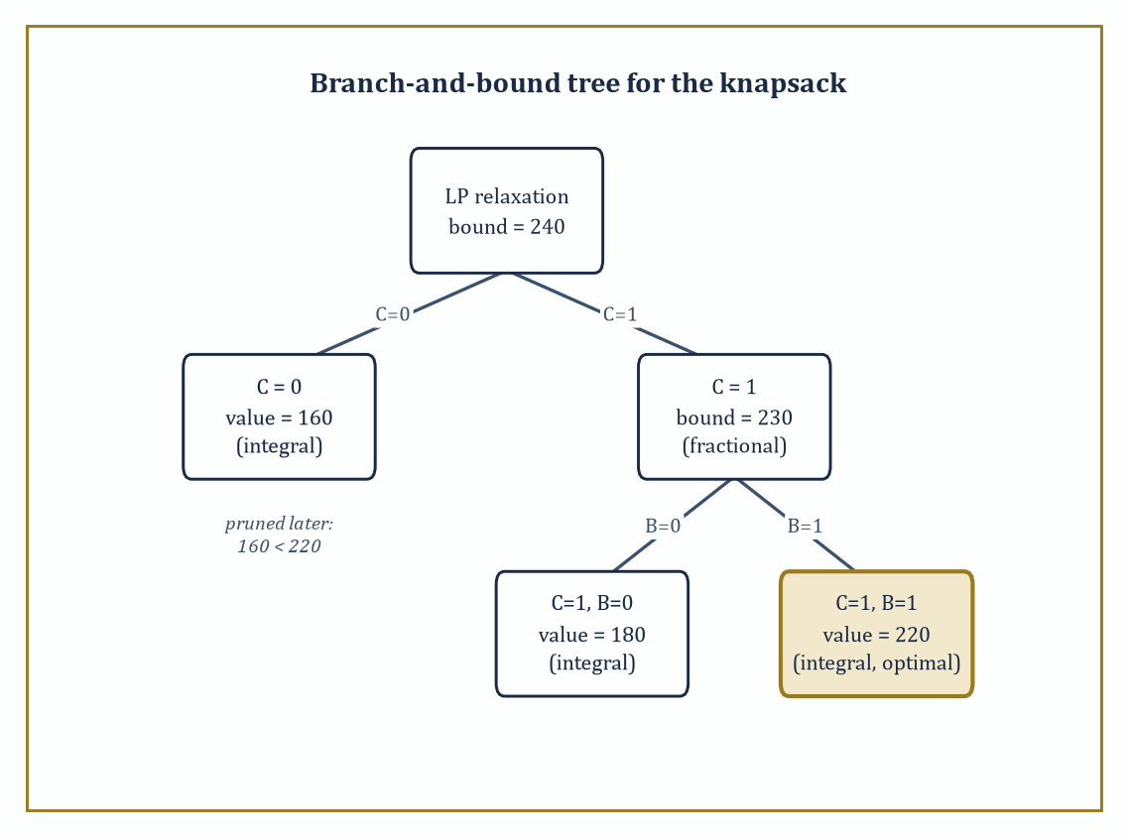
Figure 30.10 — Four subproblems, not eight combinations: the knapsack’s branch-and-bound tree, each bound doing the pruning the exhaustive search never needed.
Branch-and-bound is the standard weapon: solve the LP relaxation (Section 30.6’s trick — drop integrality, solve the continuous problem); if the relaxed solution happens to be integral already, you are done. If not, pick a variable with a fractional value, say xⱼ=2.4, and branch into two subproblems:
xⱼ ≤ 2
xⱼ ≥ 3
Each of the two subproblems is then solved recursively in the same way.
Bound each subproblem by its own LP relaxation value, and prune — discard without further branching — any subproblem whose bound is no better than the best integer solution found so far; the entire efficiency of the method rests on how quickly bounds allow whole branches to be pruned unexamined.
Branch-and-cut supplements this with cutting planes: additional valid inequalities, satisfied by every integer point but violated by the current fractional relaxed solution, added on the fly to tighten the relaxation and shrink the gap before branching at all.
The strength of the relaxation matters enormously in practice: a badly chosen formulation of the same underlying problem can leave the LP relaxation bound miles from the true integer optimum (a large integrality gap, forcing branch-and-bound to explore a vast tree before it can prune anything), while a cleverer formulation — often found by adding valid inequalities that are individually obvious but collectively tightening — can shrink that gap dramatically, sometimes closing it entirely, before a single branch is taken.
Good heuristics that find strong feasible incumbents early play a complementary role, since a good incumbent value is precisely what allows the bounding step to prune aggressively.
Numeric example — branch-and-bound solving the Duality in Practice knapsack. Recall the knapsack — A(60,10), B(100,20), C(120,30), capacity 50 — with LP-relaxation bound 240 (fractional at C=2/3). Branch on the fractional item C.
Branch C=0: remaining items A,B fit wholly (weight 30 ≤ 50) — already integral.
value = 60 + 100 = 160
This is a feasible incumbent.
Branch C=1 (weight 30, value 120, capacity remaining 20): relax A,B by ratio — A fully (weight 10, value 60, 10 remaining), then B at 10/20=0.5 (value 50).
bound = 120 + 60 + 50 = 230
Since 230 > 160, this branch is not yet pruned, and since it is still fractional, it must be branched again.
Sub-branch C=1,B=0: capacity 20 available, take A fully — integral.
value = 120 + 60 = 180
This is a new incumbent (it beats 160).
Sub-branch C=1,B=1: capacity is exhausted, so A is excluded — integral.
weight = 30 + 20 = 50
value = 120 + 100 = 220
This is a new incumbent (it beats 180).
All branches are now integral and exhausted, so the search tree is complete and the certified optimum is 220 — matching the exhaustive answer of Duality in Practice, but reached here by examining only four subproblems rather than every one of the 2³=8 possible 0/1 combinations.
Each pruning decision was backed by an LP bound proving the discarded branch could not possibly contain anything better.
Try it now — How many distinct tours does an undirected traveling salesman problem on 5 cities have? Answer →
Some combinatorial problems, despite looking superficially like generic integer programs, possess enough hidden structure to admit fast, purpose-built polynomial-time algorithms that never touch branch-and-bound at all: shortest path (Dijkstra’s algorithm, and its relatives for negative weights), maximum matching in a graph, and network flow (Section 30.2’s special case, solvable by augmenting-path or push-relabel methods) are the classical success stories, each exploiting a specific combinatorial property — no negative cycles; bipartite or general graph structure; the max-flow-min-cut duality — that a generic ILP solver would never discover on its own.
Other problems — the traveling salesman problem (TSP), set cover, and most of their relatives — are provably NP-hard, with no such shortcut known, and for these, approximation algorithms trade exactness for a provable performance guarantee: an algorithm that runs in polynomial time and is guaranteed to return a solution within some fixed factor (a constant multiple, or 1+ε for any desired ε) of the true optimum, without ever needing to find that optimum exactly.
Numeric example — how fast the exact TSP search space explodes. The traveling salesman problem on n cities has the following number of distinct tours (fixing a starting city removes redundant rotations, and dividing by 2 removes each tour’s mirror image):
number of tours = (n−1)!/2
For n=10, this works out to a number checkable by a patient computer in well under a second:
9!/2 = 362,880/2 = 181,440
For n=20, however, the number explodes:
19!/2 = 121,645,100,408,832,000/2 = 60,822,550,204,416,000 ≈ 6.08×10¹⁶
At a billion tours checked per second, that works out to roughly 6.08×10⁷ seconds, the better part of two years, spent on nothing but a single ten-city upgrade.
Adding a mere ten cities has not made the problem ten times harder, or even a hundred times harder, but roughly 335 billion times harder — the practical face of NP-hardness, and the kind of growth that separates ‘solve it and go home’ from ‘settle for an approximation algorithm, and be grateful one exists.’
The boundary between what is polynomially solvable (shortest path, matching, flow, linear programming itself) and what is NP-hard (TSP, general integer programming, set cover) is not a minor technical footnote — it is arguably the central organizing question of theoretical computer science, formalized as the P versus NP problem, one of the seven Clay Millennium Prize problems and, at time of writing, entirely unresolved despite the collective effort of several generations of extremely clever, occasionally sleep-deprived people.
For the working optimizer, the practical lesson is more modest but no less important: recognizing which side of this boundary your problem sits on tells you, before you write a line of code, whether to reach for an exact polynomial algorithm, brace for exponential worst-case behavior tamed only by good bounds and heuristics, or settle deliberately for a provably near-optimal approximation.
It also explains why so much of algorithm design, in practice, is not about inventing cleverer search strategies but about finding the right relaxation or the right structural reformulation that moves a problem, or at least a useful approximation of it, from the hard side of the boundary to the tractable one.
Keep only this · Section 30.7: Integer and Combinatorial Optimization
The idea. Integer variables destroy convexity. Branch-and-bound splits on a fractional variable and prunes every branch whose bound cannot beat the best solution found; cutting planes tighten the relaxation. Many combinatorial problems are NP-hard, so heuristics matter.
Core.
branch: xᵢ ≤ ⌊xᵢ⌋ or xᵢ ≥ ⌈xᵢ⌉
prune (maximization) when bound ≤ incumbent
TSP: (n − 1)!/2 tours
Typical mistake. Rounding the LP solution. Rounding can be infeasible or far from optimal; the knapsack LP takes 2/3 of item C.
Minimal example. Knapsack LP: C is fractional, so branch on C = 0 and C = 1.
Practice. Easy to challenge; full worked answers, with the usual mistake, are in Answers to the Practice Sets at the back.
Easy — How many tours for 10 cities? Answer →
Medium — In the knapsack, find the LP bounds of the branches C = 0 and C = 1. Answer →
Challenge — Finish branch-and-bound on the knapsack. Answer →

Section 30.8: Derivative-Free, Stochastic, and Large-Scale Methods
When You Can’t (Or Shouldn’t) Compute the Gradient
Sometimes the thing you want to optimize is not a formula at all. It might be a crash simulation that takes an hour per run, a wind-tunnel test, or a chemical process you can only measure; there is no derivative to compute, and every evaluation is expensive. At other times there is a formula, but it is a sum over a billion data points, and computing its exact slope at every step would take forever. This section gathers the methods built for these situations: comparing a few trial points and moving the worst one, estimating slopes from the readings themselves, and following a cheap, noisy slope estimate computed from a small random sample of the data.
Suppose the function you want to minimize is a sealed box. You type in a number x, wait, and a number comes out. You cannot differentiate the formula inside, because you never see it. Here are three readings:
x = 0: 9
x = 1: 4
x = 2: 1
Even without a formula, the readings say something. From 0 to 1 the output fell by 5, so near x = 0.5 the slope is about −5. From 1 to 2 it fell by 3, so near x = 1.5 the slope is about −3. Going right is downhill, and the slope is flattening out. That is a gradient estimated from function values alone. For this box, which happens to contain (x − 3)², the estimates are exactly right: the true slopes at 0.5 and 1.5 are −5 and −3.
The catch is the cost. With n inputs instead of one, each estimate of the gradient needs at least n + 1 readings, and if a reading is a day-long experiment or an hour of simulation, that is ruinous. Derivative-free methods are cleverer ways of spending readings. The Nelder–Mead method below never estimates a slope at all: it keeps a triangle of readings and moves away from the worst corner.
This section also meets the opposite problem. A gradient may be perfectly computable but enormous, a sum over a million training examples. Then the cure is to estimate it from a handful of terms, accept the noise, and let it average out over many steps. Both halves of the section ask the same question: how much accuracy in each step can you give up in exchange for steps you can afford?
Every method met so far has assumed access to a gradient, computed cheaply and exactly.
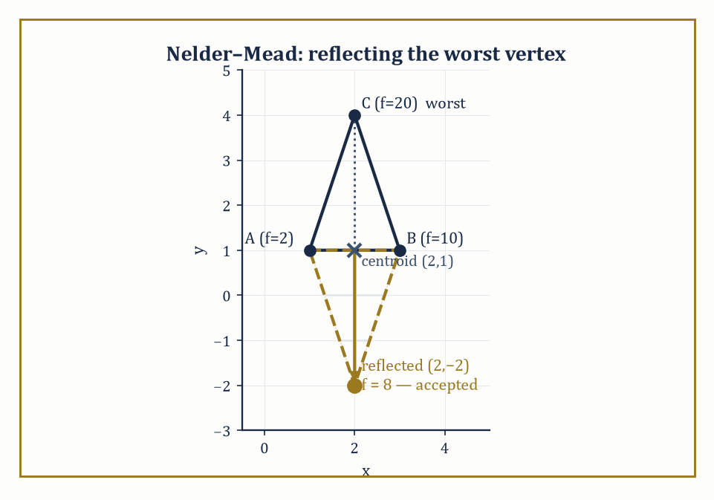
Figure 30.11 — Nelder–Mead reflects the worst vertex C through the centroid of A and B, landing at f=8 and replacing C outright — no derivative in sight.
That assumption fails constantly in practice: the objective might come from a black-box simulation, a physical experiment, or someone else’s undocumented legacy code, with no derivative in sight. Derivative-free methods manage with function values alone.
The Nelder–Mead simplex method maintains n+1 points forming a simplex (a triangle in 2D, a tetrahedron in 3D) and, at each step, reflects the worst point through the centroid of the remaining points, accepting the reflection if it improves things and falling back to more conservative moves (contraction, shrinkage) if it does not — a purely geometric, gradient-free hill-descending dance.
Pattern search methods poll a fixed set of directions around the current point and move to the first (or best) improving one found. Model-based trust-region methods build a local quadratic (or simpler) surrogate from a modest number of function evaluations and minimize that surrogate instead, refitting as they go.
Bayesian optimization goes further, building a full probabilistic surrogate (typically a Gaussian process) that models both a best guess and an uncertainty estimate at every unvisited point, then chooses the next expensive evaluation to balance exploiting the current best region against exploring where uncertainty is high — the method of choice for expensive black-box evaluations (a physical experiment costing a day per run, a hyperparameter search costing a GPU-week per run) in low dimension, where a Gaussian process remains tractable.
Numeric example — one Nelder–Mead reflection step. Minimize f(x,y) = x²+y² using a Nelder–Mead simplex with current vertices A=(1,1) [f=2], B=(3,1) [f=10], C=(2,4) [f=20]. C is worst.
Compute the centroid of the remaining two vertices:
centroid = ((1+3)/2, (1+1)/2) = (2,1)
Reflect C through the centroid with the standard coefficient 1:
x_reflect = centroid + (centroid − C) = (2,1) + ((2,1)−(2,4)) = (2,1) + (0,−3) = (2,−2)
Evaluate:
f(2,−2) = 4+4 = 8
Since 8 beats the worst vertex it replaces (20) — indeed beats the second-worst, B, at 10 as well — the reflection is accepted outright (a plain ‘reflection’ move, as opposed to the more aggressive ‘expansion’ that would be tried next had 8 also beaten the best vertex A’s 2). The new simplex is A=(1,1)[2], B=(3,1)[10], and the reflected point (2,−2)[8], and the whole process repeats — no derivative was consulted at any point, only three function evaluations.
Try it now — For f(w) = (1/6)Σ(w − aᵢ)² with a = {1, 3, 5}, take one full-gradient step from w = 0 with step size 1. Answer →
At the opposite extreme from expensive black boxes sit problems with cheap but astronomically numerous gradient contributions — the defining situation of machine learning, where the objective is a sum (or average) over millions of training examples, and computing the exact gradient means touching every single one.
Stochastic gradient descent (SGD) sidesteps this by estimating the gradient from a single randomly chosen example (or a small mini-batch) at each step: cheap, noisy, and — remarkably — still guaranteed to converge, provided its step sizes shrink suitably over time, not because any individual step is trustworthy, but because the noise averages out over many steps, giving convergence in expectation (the expected distance to the optimum shrinks) or with high probability, rather than the deterministic, monotonic decrease of full-batch gradient descent.
Variance-reduction techniques (SVRG, SAGA, and relatives) periodically anchor the noisy estimate to a full-gradient computation to cut the variance without paying the full cost every step; adaptive step-size methods (AdaGrad, Adam, and their descendants) rescale each coordinate’s step by its own historical gradient magnitude, which helps enormously when different parameters naturally want very different step sizes; mini-batching trades off the cheapness of single-example noise against the smoother estimates of larger batches, and is essentially always used in practice as the compromise.
Numeric example — one full-batch step versus two stochastic steps. Minimize f(w) = (1/2n)Σᵢ(w−aᵢ)² over the three data points a = {1,3,5}, n=3.
This is minimized at the sample mean:
w* = (1+3+5)/3 = 3
Full-batch gradient at w₀=0:
∇f(0) = (1/3)[(0−1)+(0−3)+(0−5)] = (1/3)(−9) = −3
A full-batch step with learning rate 1:
w₁ = 0 − 1·(−3) = 3
— the exact minimizer, in one step (an artifact of f being a simple quadratic average, as in Section 30.3’s Newton example). Now the stochastic version, using one randomly drawn sample per step: suppose the first draw is a=1:
stochastic gradient estimate = (w₀−1) = −1
(only this one term, not the average). Step:
w₁ = 0−1·(−1) = 1
— an under-shoot, because sample 1 alone pulls toward 1, not the true mean 3. Suppose the second draw is a=5:
stochastic gradient = (w₁−5) = (1−5) = −4
Step:
w₂ = 1 − 1·(−4) = 5
— an over-shoot past the true mean. The path 0→1→5 bounces noisily around the true optimum 3 rather than marching straight to it. With a fixed step size of 1 it never settles down: each step jumps exactly onto whichever data point was drawn, so its average position is 3 but it keeps bouncing between 1, 3 and 5. Shrinking the step size over time is what turns that correct average into genuine convergence.
When a problem’s data or variables do not fit on one machine, or when updating all variables simultaneously is wasteful, further tricks apply.
Coordinate descent updates one variable (or one block of variables) at a time, holding all others fixed, cycling through the coordinates repeatedly — trivially parallelizable across variables when they interact weakly, and often exact after a single pass when the problem happens to be separable.
Distributed and parallel algorithms (of which the ADMM of Convexity and Convex Optimization Algorithms is a natural fit, since its subproblems already decouple) spread both data and computation across many machines, communicating only the small quantities (gradients, dual variables) needed to keep everyone synchronized rather than the raw data itself.
Sketching techniques compress a large problem (a huge matrix, an enormous dataset) into a much smaller random projection that provably preserves the quantities the optimization needs, trading a controlled, quantifiable amount of accuracy for a dramatic reduction in the size of the problem actually solved — skimming a very long document on the strength of a mathematical guarantee that the gist survives, rather than on faith alone.
Numeric example — coordinate descent solving a separable problem in one cycle. Minimize f(x,y) = (x−1)² + (y−2)², starting from (0,0) — deliberately separable, to see coordinate descent’s best-case behavior.
Step 1: fix y=0, minimize over x alone:
d/dx (x−1)² = 2(x−1) = 0 ⟹ x=1
New point: (1,0).
Step 2: fix x=1, minimize over y alone:
d/dy (y−2)² = 2(y−2) = 0 ⟹ y=2
New point: (1,2) — the exact global minimum, reached after a single full cycle through the two coordinates. This is the best case, guaranteed whenever the objective is separable (no cross-terms coupling x and y); a non-separable objective, such as (x−1)² + (y−2)² + xy, would instead need many cycles, each nudging both coordinates a little closer, since fixing one variable now genuinely changes the optimal value of the other.
Keep only this · Section 30.8: Derivative-Free, Stochastic, and Large-Scale Methods
The idea. When derivatives are missing, Nelder–Mead and other direct searches compare function values. When data are huge, stochastic gradient descent uses cheap noisy gradients. Coordinate descent and decomposition exploit structure in very large problems.
Core.
SGD: w ← w − α∇fᵢ(w), i random
Nelder–Mead reflection: R = 2·(centroid of the others) − worst
coordinate descent: minimize in one variable at a time
Typical mistake. Expecting SGD with a constant step to converge exactly. The noise keeps it bouncing near the minimizer unless the step shrinks.
Minimal example. f = (x − 1)² + (y − 2)²: coordinate descent from (0, 0) reaches (1, 2) in one cycle.
Practice. Easy to challenge; full worked answers, with the usual mistake, are in Answers to the Practice Sets at the back.
Easy — SGD with α = 0.5 on fᵢ(w) = ½(w − aᵢ)², from w = 0, using a₁ = 1. Answer →
Medium — Continue with a₂ = 5 and α = 0.5. Answer →
Challenge — Take one cycle of coordinate descent on f = x² + xy + y² from (1, 1). Answer →

Section 30.9: Looking Ahead: From Algorithms to Advanced Optimization and Applications
We Have Learned to Compute the Best
We have now acquired the algorithmic core of optimization: linear programming and its duality (Linear Programming), unconstrained smooth methods from gradient descent to Newton (Unconstrained Nonlinear Optimization), constrained methods built on penalties, barriers, and the Lagrangian (Constrained Nonlinear Optimization), the specialized machinery convexity unlocks (Convexity and Convex Optimization Algorithms), duality as a certificate-producing habit of mind rather than a mere theoretical nicety (Duality in Practice), the combinatorial world of integer programming and its complexity boundary (Integer and Combinatorial Optimization), and the derivative-free and stochastic methods that scale to expensive or enormous problems (Derivative-Free, Stochastic, and Large-Scale Methods).

Figure 30.12 — An equal blend of two uncorrelated assets carries less risk than either asset alone — diversification, computed rather than merely asserted.
Between them, these cover the overwhelming majority of optimization problems anyone solves for a living. Notice, in retrospect, how much of the chapter has been one idea wearing different hats: exploit whatever structure the problem hands you — linearity, convexity, separability, sparsity, cheap-but-noisy gradients — and let that structure choose the algorithm, rather than reaching by habit for the one method you happen to know best.
A hammer is a fine tool, but a linear program is not a nail, and neither, for that matter, is a semidefinite one.
These tools support applications across the whole of science and engineering, and it is worth naming a few explicitly, if only to watch the same handful of algorithmic ideas recur under different costumes.
Portfolio optimization (choose asset weights to balance expected return against risk) is a quadratic program, solved by the interior-point or first-order methods of Convexity and Convex Optimization Algorithms.
Structural design (choose a beam’s cross-section, or a truss’s topology, to minimize weight subject to stress and deflection limits) is a constrained nonlinear program, often nonconvex, leaning on Section 30.4’s SQP or interior-point machinery.
Machine learning training is large-scale, usually nonconvex, unconstrained (or lightly constrained) optimization, overwhelmingly solved by the stochastic gradient methods of Derivative-Free, Stochastic, and Large-Scale Methods.
Control (choose a sequence of actions to steer a system toward a target while respecting physical limits) frequently reduces to solving a fresh, small quadratic program at every time step — model predictive control is, quite literally, Linear Programming and Convexity and Convex Optimization Algorithms’s machinery run in a tight loop, thousands of times a second, on hardware small enough to sit inside a car.
Logistics (route vehicles, schedule staff, plan supply chains) is typically integer or mixed-integer programming, Section 30.7’s domain, at industrial scale.
And statistics — maximum likelihood estimation, regularized regression, the LASSO of Section 30.5’s proximal-gradient example — is optimization wearing yet another hat.
A later chapter, Chapter 48 (Volume 4), picks up the advanced and unfinished business this one has had to leave aside: nonconvex landscape analysis (why, empirically, large neural networks train at all, despite Section 30.3’s guarantees covering only local behavior), stochastic programming (optimizing under genuine uncertainty about future data, not just noisy gradients), robust optimization (guarding against the worst case within an uncertainty set rather than merely the expected case), multi-objective optimization (there is no single ‘best’ when two goals conflict, only a frontier of trade-offs), and the still-developing interface between optimization theory and the empirical successes of machine learning.
In practice almost none of this is coded up from scratch: modeling languages and solvers (CVX, JuMP, Gurobi, IPOPT, and their many relatives) turn the algorithms of this chapter into everyday working tools, letting a user write down a model in something close to mathematical notation and leave the choice of algorithm to decades of accumulated engineering.
Numeric example — a two-asset portfolio, minimizing risk for a target return. Two assets: expected returns 8% and 12%, standard deviations 20% and 30% (variances 0.04 and 0.09), assumed uncorrelated for simplicity (covariance 0). Choose weights w₁ and w₂, constrained to sum to one, to achieve a target expected return of 10% at minimum variance:
w₁+w₂=1
The return constraint sets the weighted average return to the 10% target:
8w₁+12w₂=10
Substituting w₁=1−w₂ and solving:
8(1−w₂)+12w₂=10 ⟹ 8+4w₂=10 ⟹ w₂=0.5
So w₁=0.5 too — an equal split.
Portfolio variance, with no covariance term since correlation is zero, works out to:
w₁²(0.04)+w₂²(0.09) = 0.25(0.04)+0.25(0.09) = 0.01+0.0225 = 0.0325
This gives a portfolio standard deviation of √0.0325 ≈ 18.03% — notably less than either asset’s own standard deviation (20% and 30%), the entire point of diversification made numerically explicit: combining two imperfectly related risks can reduce total risk below what either asset offers alone, and finding how much to combine is, mechanically, nothing more than the quadratic programming of Convexity and Convex Optimization Algorithms.
Try it now — Two uncorrelated assets have variances 0.04 and 0.09. What is the variance of a 50/50 portfolio? Answer →
The deeper lesson, if this chapter has one, is that a well-modeled optimization problem, paired with an algorithm that exploits its structure, converts a design or decision question — what should I build, buy, route, or believe — into a computation whose result can be trusted, checked, and in the best cases certified beyond reasonable doubt.
That is no small thing to have built, and it is worth remembering how recent most of it is: the simplex method is younger than the transistor, interior-point methods for linear programming are younger than the personal computer, and stochastic gradient descent — a technique now training models with hundreds of billions of parameters — was, for most of its history, a mathematical curiosity used to fit rather modest statistical models.
An entire computational discipline, still visibly under construction.
Optimization is the computational engine of decision-making under constraints — which, on reflection, describes rather a lot of what a life consists of.
So ends our tour of finding the best answer efficiently — vertex by vertex, gradient step by gradient step, branch by pruned branch, always accompanied, where we could manage it, by a certificate proving we were right rather than merely lucky.
Chapter 31 climbs into differential geometry, and the change of scenery is more relevant to everything we have just done than it might first appear. Every gradient we followed this chapter lived its whole life in flat Euclidean space, where ‘downhill’ needs no further justification. On a curved manifold, that convenience evaporates: ‘downhill’ first needs a metric before it means anything at all, and the natural generalization of gradient descent — as any student of modern statistics or robotics eventually discovers, usually the hard way — has to account for a curvature the naive Euclidean version was blithely ignoring all along. The series continues, and the ground, it turns out, was never quite as flat as we assumed.
Where this returns
The advanced theory continues in Optimization (Advanced) (Volume 4), and optimal control in Control Theory (Volume 4).
Keep only this · Section 30.9: Looking Ahead: From Algorithms to Advanced Optimization and Applications
The idea. Optimization reaches into finance, machine learning, control and design. The advanced topics — semidefinite and robust optimization, optimal transport, non-convex landscapes — build on the theory of this chapter.
Core.
uncorrelated portfolio variance: w²σ₁² + (1 − w)²σ₂²
minimum variance: w = σ₂²/(σ₁² + σ₂²)
Typical mistake. Putting everything in the safer asset to minimize risk. Mixing uncorrelated assets gives a variance below either one.
Minimal example. Two identical uncorrelated assets: a 50/50 mix halves the variance.
Practice. Easy to challenge; full worked answers, with the usual mistake, are in Answers to the Practice Sets at the back.
Easy — With expected returns 8% and 12%, what does the 50/50 portfolio return? Answer →
Medium — Find the minimum-variance weight for σ₁² = 0.04, σ₂² = 0.09, and its variance. Answer →
Challenge — For a target return of 10%, which portfolio has the least variance? Answer →
Chapter 30 recap · Optimization: Theory and Algorithms
• Model first: variables, objective, constraints. Linear, convex, smooth or integer — the form decides the method and the guarantee.
• Linear programs are solved at vertices; duality gives prices and certificates of optimality.
• Unconstrained: ∇f = 0 with a positive definite Hessian; gradient descent is cheap and slow on ill-conditioned problems, Newton fast and expensive.
• Constrained: Lagrange multipliers and the KKT conditions, valid under a constraint qualification; penalties, barriers and interior points compute them.
• Convexity makes local minima global; duality bounds every problem, tightly in the convex case.
• Integer problems need branch-and-bound; huge or derivative-free problems need stochastic and direct-search methods.

Check Your Understanding — Chapter 30
Answers are in the Answer Key at the back of the book — have a go before you look.
1. [Concept] In the workshop model of Modeling and the Landscape of Optimization Problems, what does it mean when a solver reports a linear program is ‘infeasible’ or ‘unbounded’, and should you treat this as a deep mathematical event?
See the answer →
2. [Explain] In the workshop’s dual solution (u1=0, u2=1.5, u3=1), what does u2=1.5 mean economically, and why is u1 exactly zero?
See the answer →
3. [Explain] In Section 30.4’s cusp example, minimizing −x1 subject to x2≤(1−x1)³ and x2≥0, the true minimizer is (1,0), yet no Lagrange multipliers exist there. Why?
See the answer →
4. [Compute] Using Nelder-Mead on f(x,y)=x²+y² with vertices A=(1,1) [f=2], B=(3,1) [f=10], C=(2,4) [f=20], compute the reflected point replacing the worst vertex C and its function value.
See the answer →
5. [Compute] Minimize f(x, y) = x² + 10y² by gradient descent. Find the condition number, the optimal fixed step size, and the resulting convergence factor per iteration.
See the answer →
6. [Compute] Solve the linear program: maximize 3x + 2y subject to x + y ≤ 4, x + 3y ≤ 6, x, y ≥ 0. Enumerate the vertices and identify the optimum.
See the answer →
7. [Compute] Minimize x² + y² subject to x + y ≥ 2 using the KKT conditions, and verify complementary slackness.
See the answer →
8. [Compute] Show that Newton’s method minimizes a convex quadratic in a single step from any starting point, and say what this implies about its behavior on general functions.
See the answer →
9. [Explain] Why does the condition number govern the convergence rate of gradient descent but not that of Newton’s method?
See the answer →
10. [Explain] In high-dimensional non-convex optimization the main obstacle is usually saddle points rather than local minima. Why should dimension change which one dominates?
See the answer →
11. [Concept] The simplex method has exponential worst-case complexity yet is excellent in practice. What resolves the apparent contradiction?
See the answer →
12. [Prove] Prove that gradient descent with step 1/L converges linearly on an L-smooth, μ-strongly convex function.
See the answer →
13. [Prove] Prove weak duality: for any feasible primal point and any non-negative multiplier vector, the dual objective never exceeds the primal objective.
See the answer →
14. [Prove] Prove that for a differentiable convex function, f(y) ≥ f(x) + ∇f(x)ᵀ(y − x) for all x, y — the tangent plane lies below the graph.
See the answer →
15. [Prove] Prove that the set of optimal solutions of a convex minimization problem is itself convex.
See the answer →
16. [Prove] Prove Jensen’s inequality for a convex function and a finite set of weights.
See the answer →
17. [Prove] Prove that a strictly convex function has at most one minimizer.
See the answer →
18. [Prove] Prove that if strong duality holds, then any primal–dual pair with zero duality gap is optimal, and that complementary slackness follows.
See the answer →
19. [Challenge] The textbook dividing line is linear versus nonlinear, but practitioners draw it at convex versus non-convex. Who is right?
See the answer →
20. [Challenge] Stochastic gradient descent uses a noisy estimate of the gradient and works better than the exact method on large problems. How can less accurate information be an advantage?
See the answer →
21. [Challenge] The no-free-lunch theorem is often quoted to mean no optimizer is better than another. Is that what it says?
See the answer →
22. [Challenge] Interior-point methods approach the optimum from inside the feasible region while simplex walks along its boundary. Why does the interior turn out to be the better place to travel?
See the answer →
23. [Challenge] A solution that is optimal for the model may be a poor choice in reality. What is the mathematical content of that complaint?
See the answer →
24. [Challenge] Dimension is catastrophic for numerical integration but often manageable in optimization. Why do the two react so differently?
See the answer →
25. [Compute] For f(x, y) = x² + 2y² − 4x − 4y, find the critical point and determine whether it is a minimum, maximum, or saddle.
See the answer →
26. [Explain] Why does convexity guarantee that any local minimum of f is automatically a global minimum?
See the answer →
27. [Model] Find the rectangle of largest area with perimeter 40, first by calculus and then by the AM–GM inequality, and say what the second method shows that the first does not.
See the answer →
28. [Compute] Minimize f(x, y) = x² + y² subject to x + 2y = 5 using Lagrange multipliers, and interpret λ.
See the answer →
29. [Explain] Why does ∇f = 0 characterize interior optima but say nothing at a boundary, and what replaces it there?
See the answer →
30. [Concept] Convexity is described as the property that makes optimization tractable. What exactly does it deliver?
See the answer →
31. [Prove] Prove that a local minimum of a convex function on a convex set is global.
See the answer →
32. [Challenge] Duality assigns to every optimization problem a second one whose value bounds the first. Why should such a partner exist at all?
See the answer →

Problems — Chapter 30
The questions above test whether the ideas landed. These ask you to use them. Solutions are in Solutions to the Problems at the back. Work them before you look.
1. [Compute] Gradient descent on f(x) = x², starting at x = 1, with step length 1/10. Compute the next point.
2. [Concept] On a convex function whose gradient is Lipschitz, what does a sufficiently small constant step length guarantee, and what does it not guarantee in one step?
3. [Compute] f(x,y) = x² + 4y². Compute the gradient at (1, 1) and one gradient step of length 1/8.
4. [Explain] Newton’s method for minimization uses the Hessian. For f(x) = x², what is the Hessian, and why does one Newton step from any start land on the minimum?
5. [Compute] Find and classify the critical points of f(x) = x² − 4x + 1.
6. [Compute] Minimize x² + y² subject to x + y = 1.
7. [Concept] A constraint g(x,y) = 0 and an objective f. In one sentence, what does a Lagrange multiplier enforce at the minimum?

Math, Actually

Chapter 31

Differential Geometry
Curves, Surfaces, Curvature, and the Art of Geometry by Calculus
Chapter Thirty comes down, at last, to a single ruthless instruction: find the bottom. Convex functions, Lagrange multipliers, gradient descent trudging downhill like a man late for a meeting he doesn’t want to attend — all of it in service of one question, where is the minimum? It is a fine question, and we answered it with some rigor. But notice what it never asked. It never asked what shape the hill was. It assumed the landscape and hunted for its lowest point; it did not once ask whether the landscape itself was curved, and if so, by how much, and whether a beetle living on it could work that out without ever being allowed to climb out and look.
That is the question this chapter exists to answer. Differential geometry takes the calculus we have spent thirty chapters building — derivatives, integrals, vectors, the whole apparatus — and points it not at functions of a real variable but at curves and surfaces themselves, treating shape as something you can differentiate. Euclidean geometry, two millennia ago, studied rigid figures with a ruler and a compass, the sort of thing you could draw and then admire.
Analytic geometry, several chapters back in this series’ foundations, described the same figures with coordinates and equations, so that a circle became x² + y² = r² and a parabola became something you could plug numbers into. Differential geometry does something rather more ambitious: it asks how curves and surfaces bend, and it insists on measuring that bending with the exact same machinery — tangent vectors, derivatives, integrals — that has carried us this far up the series.
The single most startling discovery in the entire subject, and the one this chapter is organized around, is that a great deal of geometry is intrinsic — measurable from inside, without ever needing to know how, or whether, the surface sits inside some larger space. A sufficiently clever and sufficiently patient insect, confined forever to the surface of a sphere, can determine that it is not living on a flat plane purely by taking measurements along the surface itself, never once being permitted to fly up and look down from outside. That fact is not a curiosity. It is the seed from which Riemannian geometry, and eventually Einstein’s picture of gravity as curved spacetime, will grow. We will spend this chapter building the classical machinery — curves, the Frenet–Serret frame, the first and second fundamental forms, geodesics, and the extraordinary Gauss–Bonnet theorem — that makes that insect’s discovery precise.
A small professional confession before we start: differential geometry is the subject in which computation and insight are most uncomfortably intertwined. The formulas look baroque on first encounter — a jungle of E’s, F’s, G’s and Christoffel symbols with more indices than a bureaucrat’s filing system — until the moment you see what they are actually measuring, at which point they become, all at once, obvious. We will try to reach that moment as often as possible, and to show our working every single time we get there. The next chapter concerns Topology, which will ask what survives when you throw all these lovingly computed curvatures away and keep only the shape’s coarsest, most stubborn features; today we are still interested in the fine print. Let’s compute some curvature.
Before you begin — Chapter 31
By the end of this chapter you will be able to:
1. Parametrize curves by arc length and compute curvature and torsion.
2. Use the Frenet–Serret frame to describe how a space curve turns and twists.
3. Compute the first fundamental form of a surface and use it for lengths, angles and areas.
4. Compute Gaussian and mean curvature from the second fundamental form.
5. Recognize geodesics and apply the Gauss–Bonnet theorem.
6. Explain why Gaussian curvature is intrinsic (Theorema Egregium).
Prerequisites. Vectors, dot and cross products from Vectors & Vector Algebra (Volume 1); partial derivatives and surface integrals from Multi-Variable Calculus (Volume 2) and Vector Calculus (Volume 2); eigenvalues from Linear Algebra (Volume 2).
Estimated study time. About 10 hours, exercises included.

Section 31.1: What Differential Geometry Is
In which we discover that geometry can be done without ever standing outside it
You have seen this before
Tangent vectors are derivatives from Differential (Volume 1), and the dot and cross products of Vectors & Vector Algebra (Volume 1) measure lengths, angles and normals. This chapter combines the two.
Differential geometry, stated plainly, is the study of geometric objects using the tools of differential and integral calculus. In its classical guise — the one this chapter mostly inhabits — the geometric objects are curves and surfaces sitting inside ordinary three-dimensional Euclidean space ℝ³, the space you and your coffee mug occupy.
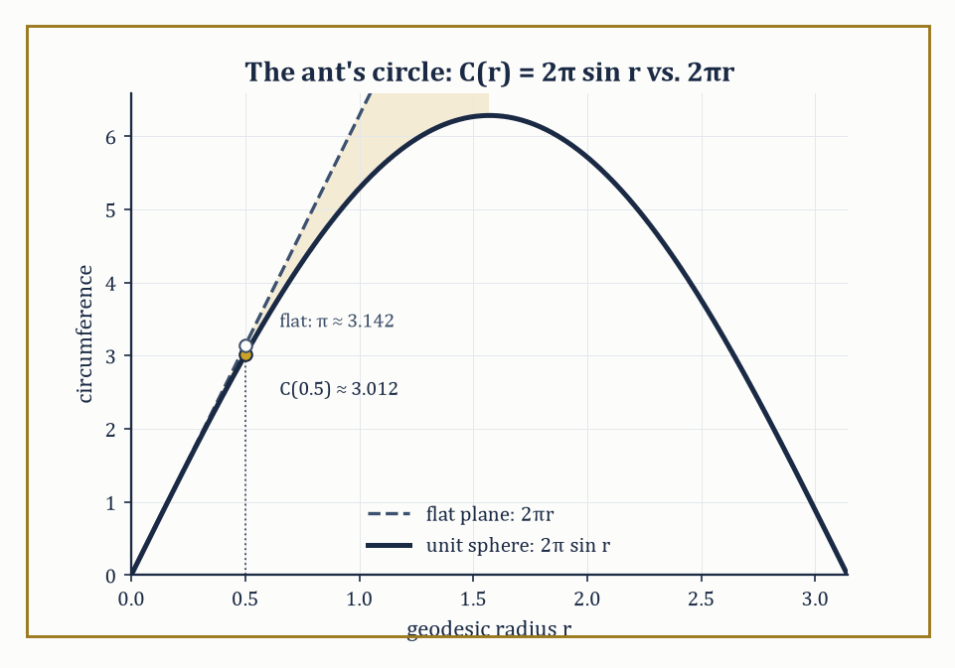
Figure 31.1 — The ant’s rope traces C(r) = 2π sin r on the sphere, falling short of the flat-plane prediction 2πr — a shortfall measured entirely from within.
In its modern guise, which later chapters will unveil, the objects are manifolds: spaces that locally resemble ℝⁿ but need not sit inside any larger space at all, equipped with extra structure such as a Riemannian metric, a connection, or a symplectic form.
Do not worry yet about what those words mean; this chapter builds the classical case so thoroughly that the modern generalization, when it arrives, will feel less like a leap and more like a shrug.
The subject is organized around one relentless question, asked in several disguises throughout the chapter: which properties of a curved shape can be detected by measurement alone, and which require you to step outside and look?
A property is called intrinsic if an inhabitant confined to the surface — measuring distances, angles, and areas using only paths that stay on the surface — can determine it. A property is extrinsic if it depends on how the surface happens to be sitting inside the ambient space.
The central and rather startling discovery of this chapter, due mostly to Gauss, is that curvature — the very thing you would swear requires standing outside a shape to see it bend — is, properly defined, intrinsic. We will prove this in Intrinsic Geometry and the Theorema Egregium, under the magnificent name Gauss gave his own theorem: Theorema Egregium, Latin for ‘remarkable theorem’, which is either admirable restraint or immodesty so complete it wraps around into humility; historians disagree.
Here is the flagship illustration, in numbers, before we have defined a single piece of formal machinery. Imagine an ant standing on the surface of a sphere of radius 1 (any convenient unit — call it a very large beach ball).
The ant walks outward along the surface, in every direction simultaneously, to a fixed geodesic distance r from its starting point — think of it as tracing out a circle by walking a rope of length r taut along the surface and pivoting. On a flat plane, that procedure produces a circle of circumference exactly 2πr, as everyone learns in school. On the sphere it does not, and the size of the shortfall is a direct, measurable signature of curvature.
Numeric example — The ant’s shortfall. Take r = 0.5 (half the sphere’s radius) on the unit sphere. The circumference traced out by the ant’s rope is given by the following formula, which we will derive properly once the first fundamental form is in hand (Surfaces and the First Fundamental Form) — for now simply evaluate it.
C(r) = 2π sin(r)
Since sin(0.5 radians) ≈ 0.47943, we get:
C(0.5) = 2π × 0.47943 ≈ 3.0123
Compare this to the flat-plane prediction:
2π × 0.5 = π ≈ 3.1416
The ant’s measured circumference falls short by about 0.129 — roughly four per cent — and that shortfall is entirely computable from measurements the ant made without ever leaving the surface. No flight required, no view from outside, just a very patient ant with a rope and a talent for arithmetic. That the shortfall is a reliable, repeatable, computable quantity — and that it grows as the sphere gets more tightly curved — is the entire content of Gaussian curvature stated informally, and unpacking it properly is most of what this chapter does.
Try it now — On the unit sphere, a circle of geodesic radius r = 0.5 has circumference 2π sin r. Compare it with the flat value 2πr. Answer →
Not every curvature-flavored quantity is intrinsic, and telling the two kinds apart early will save considerable confusion later. Consider the equator of that same unit sphere, traced as a curve in three-dimensional space.
As a space curve it bends rather sharply — its curvature, in the sense The Frenet–Serret Apparatus will define precisely, is 1, the tightest a curve of that particular radius can manage. But as a curve confined to the surface of the sphere, the equator is perfectly straight in the only sense available to an inhabitant: it is a geodesic, and its geodesic curvature — the part of its bending that the surface itself can detect — is exactly 0.
The difference between these two numbers is the entire distinction between extrinsic bending (how the curve looks from outside, embedded in space) and intrinsic bending (how much the curve deviates from straightness according to measurements taken along the surface). We will make both notions rigorous in The Frenet–Serret Apparatus and Geodesics; for now, file away the fact that a curve can be dramatically curved in space while being quite straight according to anyone actually standing on it.
Abstract example — The flight to Vancouver. A commercial airliner flying from London to Vancouver along the shortest available route does not fly in a straight line on the map — it curves alarmingly northward, arcing up over Greenland, which looks to a passenger glancing at the in-flight map like a wild detour.
To the pilot’s instruments, however, the aircraft is flying as straight as physically possible: it is following a geodesic of the Earth’s surface, a great-circle route, analogous to the equator above. The ‘curve’ visible on a flat map is an artifact of extrinsic curvature — the sphere’s shape as seen from outside, distorted further by the map projection — while the geodesic curvature experienced by the flight is zero throughout.
This is not a metaphor; it is the literal reason transatlantic and transpacific flight paths look bent on a Mercator projection while being, in the geometry that matters to the aircraft, dead straight.
Differential geometry is therefore best understood as a direct continuation of the multivariable calculus developed many chapters ago, redirected at geometric objects rather than at scalar-valued functions, and it is simultaneously the foundation on which modern geometry, geometric analysis, and — several chapters hence — general relativity are built. Everything from here on is an attempt to make the ant’s discovery, and the pilot’s straight-but-curved flight path, completely precise.
Keep only this · Section 31.1: What Differential Geometry Is
The idea. Differential geometry measures shape with calculus: curvature of curves, the metric and curvature of surfaces, geodesics as straightest paths. Some quantities depend on how a surface sits in space; others are intrinsic and can be measured by an inhabitant.
Core.
unit sphere: circle of geodesic radius r has circumference 2π sin r
intrinsic = computable from lengths measured on the surface
Typical mistake. Taking a straight line on a flat map as the shortest route on the globe. The shortest routes are great circles.
Minimal example. Flat plane: circumference exactly 2πr, curvature zero.
Practice. Easy to challenge; full worked answers, with the usual mistake, are in Answers to the Practice Sets at the back.
Easy — Find the circumference of the circle of geodesic radius π/2 on the unit sphere, and the flat value. Answer →
Medium — For small r, 2π sin r ≈ 2π(r − r³/6). Estimate the shortfall at r = 0.1. Answer →
Challenge — On a sphere of radius R the circumference is 2πR sin(r/R). Show that 2πr − C ≈ πr³/(3R²), and explain how that lets an inhabitant measure the curvature 1/R². Answer →

Section 31.2: Curves in the Plane and in Space
Where speed becomes irrelevant and shape becomes everything
Everything in this chapter begins with the humble parametric curve: a smooth map r(t) from an interval of real numbers into the plane ℝ² or into space ℝ³, thought of as tracing out a path as the parameter t increases, the way a satellite’s position traces a path as time passes.
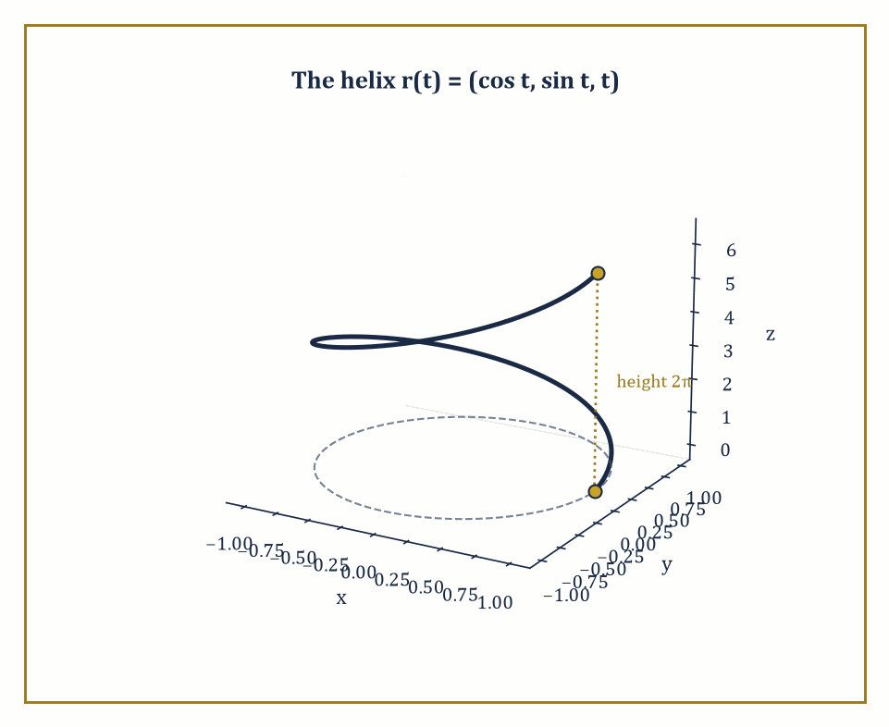
Figure 31.2 — One full turn of the helix r(t) = (cos t, sin t, t), climbing a height of 2π while circling the unit circle below.
We insist the curve be regular, meaning its velocity r′(t) never vanishes — the tracing object never stops dead. This is not pedantry: a curve with a vanishing derivative can develop a sharp corner or a cusp at that instant (think of the path traced by a point on the rim of a rolling wheel, which momentarily stops and reverses at the point of contact with the ground), and the smooth theory of curvature we are about to build requires there to be no such stopping points.
The parameter t itself, however, is largely bookkeeping — an artifact of how you happened to describe the curve, not a property of the curve’s shape. Two different people could trace an identical circle at wildly different speeds, one crawling and one sprinting, and produce the same geometric object.
To strip away this arbitrary choice, we reparametrize by arc length: we replace t by the distance s already traveled along the curve, defined by
s(t) = ∫[t₀, t] |r′(u)| du
and rewrite the curve as a function of s instead. The payoff is that the reparametrized curve automatically has unit speed,
|dr/ds| = 1
everywhere — because by construction you have traveled exactly one unit of curve-distance for every unit increase in s.
This unit-speed form is the standard costume the curve wears for the rest of the theory: once a curve is parametrized by arc length, its unit tangent vector T = dr/ds is a unit vector, and its rate of change dT/ds measures curvature directly, with no leftover speed factors cluttering the formula.
Numeric example — Arc length of a helix. Consider the circular helix
r(t) = (cos t, sin t, t), t ∈ [0, 2π]
a point spiraling once around the unit circle while climbing steadily upward, tracing out one full turn of a spring. Its velocity is
r′(t) = (−sin t, cos t, 1)
and its speed is
|r′(t)| = √(sin²t + cos²t + 1) = √(1 + 1) = √2
a constant — this particular helix happens to move at the same speed throughout, which is convenient but not typical. The arc length of one full turn is therefore
s = ∫[0, 2π] √2 dt = 2π√2 ≈ 8.886
Note that this is longer than the 2π ≈ 6.283 you would get from just going around the underlying unit circle in the plane — entirely sensible, since the helix has to climb a height of 2π on top of going around, and √2 > 1 is precisely the factor by which the climbing lengthens the path. To reparametrize by arc length we would write
s = t√2, i.e. t = s/√2
and substitute; we shall spare the reader the resulting expression and note that it exists and behaves exactly as promised.
Try it now — Find the arc length of the helix r(t) = (cos t, sin t, t) for 0 ≤ t ≤ 2π. Answer →
Once a plane curve is unit-speed, its curvature is defined as the signed rate at which its unit tangent vector turns:
κ(s) = dφ/ds
where φ is the angle the tangent makes with a fixed direction, or equivalently the scalar κ such that
dT/ds = κN
for the unit normal N obtained by rotating T through a right angle.
For a curve given in an arbitrary, not necessarily unit-speed, parametrization (x(t), y(t)), the same quantity is computed by the formula
κ = (x′y″ − y′x″) / (x′² + y′²)^(3/2)
which looks less inevitable than it is: it is the arc-length formula run through the chain rule to strip out the speed dependence, so that curvature — a geometric quantity — comes out the same regardless of how fast you happened to be tracing the curve.
Numeric example — Circle and parabola. For a circle of radius R traced as
r(t) = (R cos t, R sin t)
we have
x′ = −R sin t, y′ = R cos t, x″ = −R cos t, y″ = −R sin t
Then:
x′y″ − y′x″ = (−R sin t)(−R sin t) − (R cos t)(−R cos t) = R²sin²t + R²cos²t = R²
(x′² + y′²)^(3/2) = (R²)^(3/2) = R³
So:
κ = R²/R³ = 1/R
exactly — a tight little circle of radius 1 has curvature 1, while a lazy circle of radius 100 has curvature 0.01, confirming the intuitive fact that curvature is the reciprocal of the radius of the best-fitting circle, and that gentler bends have smaller curvature.
As a second data point, the parabola y = x² at the origin, written as (t, t²), has
x′ = 1, y′ = 2t, x″ = 0, y″ = 2
at t = 0 this gives
κ = (1·2 − 0·0)/(1 + 0)^(3/2) = 2
The parabola at its vertex bends as sharply as a circle of radius 1/2 — which is, incidentally, the osculating circle that best fits y = x² at the origin, a fact you are welcome to verify by drawing it.
For plane curves, curvature alone determines the shape completely: the fundamental theorem of plane curves states that a prescribed continuous curvature function κ(s) determines the curve uniquely up to a rigid motion of the plane — there is, up to sliding and turning the picture, exactly one curve with that curvature history.
Closed plane curves carry a further intrinsic accountant, the rotation index — the total number of full turns the tangent vector makes as you traverse the curve once.
Two classical results bound how curvature can behave: Fenchel’s theorem says the total absolute curvature of any closed space curve is at least 2π (you cannot close a loop without turning through at least one full revolution somewhere), and the four-vertex theorem guarantees that any simple closed plane curve has at least four points where curvature is locally extreme (an ellipse, for instance, has exactly four such vertices, at the ends of its two axes).
Abstract example — Two circles, one shape. Take two circles of radius 3, one centered at the origin and traced starting at (3,0) going counterclockwise, the other centered at (7,7) and traced starting at (7,10) going counterclockwise. These look like different curves — different starting points, different locations in the plane — but both have the exact same constant curvature function:
κ(s) = 1/3 for all s
The fundamental theorem of plane curves guarantees, correctly, that they are the same curve up to rigid motion: slide the second circle’s center to the origin and it lands on the first, with matching starting point after an appropriate rotation of the parametrization.
This is the theorem’s entire content in miniature — curvature is shape, stripped of position and orientation — and it is why no amount of relabeling coordinates can turn a circle into an ellipse: their curvature functions, constant versus periodically varying, are genuinely different.
Space curves have one more trick available to them that plane curves do not: they can leave the plane. A plane curve’s shape is captured entirely by κ(s), but a curve wandering through three dimensions can twist out of any given plane, and curvature alone cannot detect this — a helix and a circle can have related curvature behavior while looking nothing alike, because the helix is climbing out of the plane the circle stays confined to.
Capturing that extra freedom requires a second scalar invariant, torsion, which measures the rate at which the curve departs from planarity. Torsion, together with curvature, will turn out to determine a space curve completely, in exact analogy with the plane case — but building torsion properly requires the full apparatus of the next section, the Frenet–Serret frame, so we leave it dangling here deliberately, as a promissory note.
Keep only this · Section 31.2: Curves in the Plane and in Space
The idea. A regular curve can be reparametrized by arc length. Curvature κ = |T′(s)| measures turning per unit length and does not depend on the parametrization; a circle of radius R has κ = 1/R.
Core.
s(t) = ∫ |r′(u)| du
κ = |r′ × r″|/|r′|³
circle of radius R: κ = 1/R
Typical mistake. Taking |r″| as the curvature when the curve is not parametrized by arc length.
Minimal example. A straight line: κ = 0.
Practice. Easy to challenge; full worked answers, with the usual mistake, are in Answers to the Practice Sets at the back.
Easy — Find the curvature of the circle (3 cos t, 3 sin t). Answer →
Medium — Find the curvature of the parabola y = x² at the origin. Answer →
Challenge — Find the curvature of the helix (cos t, sin t, t). Answer →

Section 31.3: The Frenet–Serret Apparatus
Three mutually perpendicular vectors, doing all the work
At every point of a regular space curve with nonvanishing curvature, we can erect a moving orthonormal frame — three mutually perpendicular unit vectors, rigidly attached to the curve, that travel along with it like a tiny cockpit bolted to the curve’s leading edge.
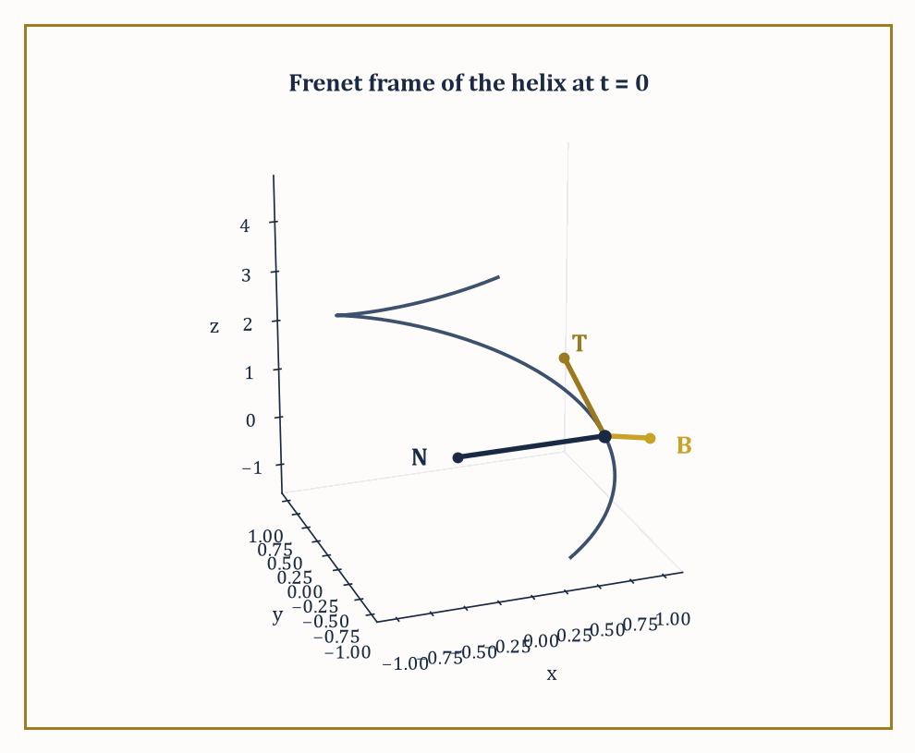
Figure 31.3 — The Frenet frame {T, N, B} of the helix at t = 0, computed in the worked example alongside it.
The first is the unit tangent, already familiar from the previous section, pointing in the direction of travel:
T = dr/ds
The second is the principal normal, pointing in the direction the tangent is turning — the direction, informally, that centripetal acceleration would point if you were riding the curve like a vehicle:
N = (dT/ds)/|dT/ds|
The third is the binormal, perpendicular to both, completing a right-handed frame the way the x, y, and z axes complete each other:
B = T × N
This trio {T, N, B} is called the Frenet frame, and it is the prototype for one of the most powerful ideas in the whole subject: attach a frame to a geometric object and track how the frame itself rotates as you move.
The rate at which this frame rotates is captured by two scalars, curvature κ and torsion τ, through the Frenet–Serret equations:
dT/ds = κN
dN/ds = −κT + τB
dB/ds = −τN
Read them as a statement about spin: the tangent tips toward the normal at rate κ (that is the definition of curvature restated); the normal tips back toward −T at the same rate κ, but also tips toward the binormal at rate τ; and the binormal tips toward −N at rate τ.
Torsion, precisely, is the rate at which the osculating plane — the plane momentarily containing T and N, the plane the curve is instantaneously flattest against — twists about the tangent direction. A curve confined permanently to a single plane never twists that osculating plane at all, so a plane curve has torsion identically zero — torsion is, quite literally, the measurement of how much a space curve refuses to lie flat.
Numeric example — The Frenet frame of a helix. Return to the helix r(t) = (cos t, sin t, t) from Curves in the Plane and in Space. Since it is not parametrized by arc length, we use the general formulas:
κ = |r′ × r″| / |r′|³
τ = ((r′ × r″) · r‴) / |r′ × r″|²
Compute the derivatives:
r′ = (−sin t, cos t, 1), r″ = (−cos t, −sin t, 0), r‴ = (sin t, −cos t, 0)
The cross product r′ × r″ works out to (sin t, −cos t, 1) — check the k-component alone as a sanity test:
(−sin t)(−sin t) − (cos t)(−cos t) = sin²t + cos²t = 1
which matches. Its magnitude is:
|r′ × r″| = √(sin²t + cos²t + 1) = √2
and we already know |r′| = √2, so |r′|³ = 2√2. That gives:
κ = √2 / (2√2) = 1/2
a constant — this helix bends just as sharply everywhere along its length, a pleasant symmetry consequence of the parametrization’s own regularity.
For torsion:
(r′ × r″) · r‴ = (sin t, −cos t, 1) · (sin t, −cos t, 0) = sin²t + cos²t + 0 = 1
and |r′ × r″|² = 2, giving:
τ = 1/2
This particular helix, remarkably, has curvature and torsion equal — it bends and twists at matched rates, everywhere, forever.
At t = 0 we can assemble the actual frame. The point is r(0) = (1, 0, 0). The unit tangent is:
T = r′(0)/|r′(0)| = (0, 1, 1)/√2
The binormal is B = (r′ × r″)/|r′ × r″| evaluated at t = 0, which is:
B = (0, −1, 1)/√2
The principal normal follows from N = B × T (to keep the frame right-handed): computing the cross product of (0,−1,1) and (0,1,1) gives (−1−1, 0−0, 0+0) = (−2, 0, 0), and dividing out the two leftover factors of √2 (which multiply to 2) gives:
N = (−1, 0, 0)
exactly — a clean unit vector pointing straight from the point (1,0,0) toward the z-axis, exactly the direction you would expect the curve to be curving toward, since the helix is wrapping around that axis.
As a check, T × N should reproduce B:
(0,1,1)/√2 × (−1,0,0) = (0,−1,1)/√2
which is indeed B. The bookkeeping closes perfectly, which is always a relief in a subject with this many indices.
Try it now — Find the unit tangent of the helix (cos t, sin t, t) at t = 0. Answer →
These two scalar functions turn out to be the entire story: the fundamental theorem of space curves states that any two continuous functions κ(s) > 0 and τ(s), prescribed in advance, determine a space curve uniquely up to a rigid motion of ℝ³. This is the three-dimensional upgrade of the fundamental theorem of plane curves from the previous section, and it says something rather remarkable — that all the infinite variety of possible space curves is secretly indexed by nothing more than two functions of a single real variable.
Existence and uniqueness both follow from standard theorems about ordinary differential equations, applied to the Frenet–Serret system itself: given κ and τ as data, the Frenet equations become a linear system of ODEs for T, N, B, which has a unique solution once initial values are fixed, and integrating T then recovers the curve r(s) itself.
Abstract example — The general helix. Consider the general circular helix
r(t) = (a cos t, a sin t, bt), a > 0
of which our worked example above was the special case a = b = 1. A short computation, entirely parallel to the one above, gives constant curvature and torsion:
κ = a/(a² + b²), τ = b/(a² + b²)
Plugging in a = b = 1 recovers κ = τ = 1/2 as computed. Because these are constant, the fundamental theorem tells us something strong: any space curve whatsoever with constant positive curvature and constant torsion must be a circular helix of this form (or, in the degenerate case τ = 0, a circle) — there is no other shape available to it.
This is the payoff of the fundamental theorem in practice: two numbers, held constant, pin down the geometry completely, without needing to solve a single differential equation by hand.
The Frenet frame is the first instance, but by no means the last, of a moving frame — an orthonormal basis attached to a geometric object and differentiated to reveal its bending. The same idea, generalized, reappears attached to surfaces (the Darboux frame, quietly at work in Geodesics) and to submanifolds of every dimension in later, more abstract chapters.
Once you have seen curvature packaged as ‘the rotation rate of an attached frame’, the generalization to higher-dimensional curved objects becomes a matter of bookkeeping rather than a conceptual leap — which is, not coincidentally, the sales pitch differential geometry has been making since Frenet and Serret worked this out for curves in the 1850s.
Keep only this · Section 31.3: The Frenet–Serret Apparatus
The idea. Along a space curve the frame T, N, B turns according to the Frenet–Serret equations. Curvature κ and torsion τ determine the curve up to a rigid motion.
Core.
T′ = κN, N′ = −κT + τB, B′ = −τN (derivatives in s)
τ = (r′ × r″)·r‴/|r′ × r″|²
Typical mistake. Expecting torsion in a plane curve. A plane curve has τ = 0; torsion measures leaving the osculating plane.
Minimal example. Circle of radius R: κ = 1/R, τ = 0.
Practice. Easy to challenge; full worked answers, with the usual mistake, are in Answers to the Practice Sets at the back.
Easy — Find the binormal of the circle (cos t, sin t, 0). Answer →
Medium — Find the torsion of the helix (cos t, sin t, t). Answer →
Challenge — The helix (a cos t, a sin t, bt) has κ = a/(a² + b²) and τ = b/(a² + b²). Check this for a = b = 1, and find a and b with κ = τ = 1. Answer →

Section 31.4: Surfaces and the First Fundamental Form
Measuring a surface without ever admitting it lives in space
Lay a sheet of paper on a table and you can name any spot on it with two numbers: so far across, so far up. Crumple the sheet, drape it over a bowl, and the two numbers still work — every spot on the sheet keeps the address it had before, even though the sheet now lives in three dimensions and curves as it goes. That is the whole idea of a surface: a flat sheet of addresses, bent into space. A regular surface is the two-dimensional generalization of a regular curve — a smooth map r(u, v) from a region of the (u, v)-plane into ℝ³, whose two partial derivatives rᵤ and rᵥ are linearly independent at every point, so that they span an honest two-dimensional plane rather than collapsing onto a line.
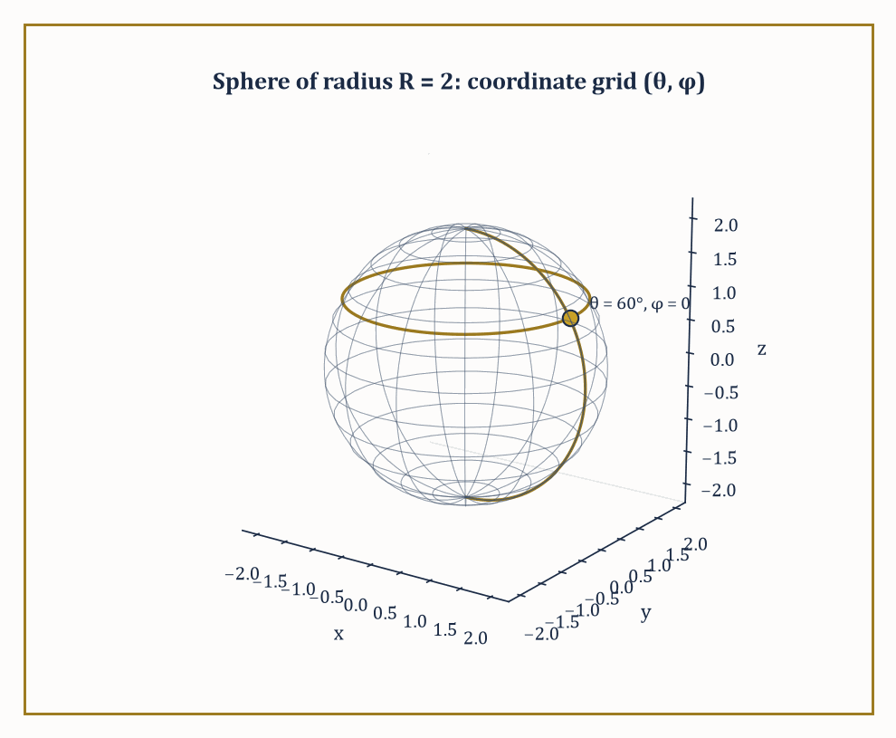
Figure 31.4 — The (θ, φ) coordinate grid on a sphere of radius 2, with the meridian and latitude circle through the worked point θ = 60°, φ = 0.
That spanned plane, translated to sit at the point r(u,v) itself, is the tangent plane at that point: the best flat approximation to the surface there, exactly as a tangent line is the best flat approximation to a curve. Think of a sheet of paper laid flat against a globe at a single point of contact — the paper models the tangent plane, and it touches the sphere at exactly one point while approximating its curving surface arbitrarily well in the immediate vicinity of that contact.
The first fundamental form is the tool that lets us measure lengths, angles, and areas on the surface using only the parameters (u, v), without ever referring back to the ambient space ℝ³ the surface happens to sit inside. It is the ordinary Euclidean dot product, restricted to vectors lying in the tangent plane, and expressed in coordinates by three functions:
E = rᵤ · rᵤ, F = rᵤ · rᵥ, G = rᵥ · rᵥ
Given these, the length-squared of an infinitesimal displacement (du, dv) on the surface is:
ds² = E du² + 2F du dv + G dv²
a direct two-dimensional analogue of Pythagoras, complicated only by the fact that the (u, v) grid need not be a nice rectangular grid of unit squares once it is bent onto the curved surface.
Numeric example — The first fundamental form of a sphere. Parametrize a sphere of radius R by
r(θ, φ) = (R sinθ cosφ, R sinθ sinφ, R cosθ)
the usual spherical coordinates with θ the angle down from the north pole and φ the angle around the equator. Differentiating:
r_θ = (R cosθ cosφ, R cosθ sinφ, −R sinθ), rᵩ = (−R sinθ sinφ, R sinθ cosφ, 0)
A short computation, expanding each dot product and using sin² + cos² = 1 twice, gives:
E = r_θ·r_θ = R², F = r_θ·rᵩ = 0, G = rᵩ·rᵩ = R² sin²θ
Take a concrete case: R = 2 and θ = 60° = π/3, so sinθ = √3/2 and sin²θ = 3/4. Then:
E = 4, F = 0, G = 4 × 3/4 = 3
The first fundamental form at that point is therefore:
ds² = 4 dθ² + 3 dφ²
A small step of dθ = 0.1 and dφ = 0.1 (in radians) has length:
ds = √(4 × 0.01 + 3 × 0.01) = √0.07 ≈ 0.2646
computed entirely from E and G, with no need ever to plug the displacement back into the three-dimensional formula for r. Notice also that G shrinks as θ approaches 0 or π, the poles, which is the first fundamental form correctly reporting that circles of latitude shrink to points at the poles — a fact that resurfaces, with consequences, the moment we integrate area below.
Try it now — Find E, F and G for the plane r(u, v) = (u, v, 0). Answer →
Because arc length, area, and angle are all built from the dot product and hence wholly computable from E, F, G alone, any quantity expressible purely in terms of the first fundamental form is intrinsic in the precise sense of What Differential Geometry Is — it can be measured by an inhabitant of the surface who has access only to the (u,v) coordinates and the functions E, F, G, never to the ambient embedding r itself.
The area of a region is one such quantity: the area element is
dA = √(EG − F²) du dv
and integrating it over a parameter region gives the total surface area.
Numeric example — The area of a sphere, derived intrinsically. Continuing with the sphere of radius R, the area element is:
dA = √(R² · R²sin²θ − 0) dθ dφ = R² sinθ dθ dφ
Integrating over the whole sphere, θ from 0 to π and φ from 0 to 2π, gives:
Area = ∫[0, 2π] ∫[0, π] R² sinθ dθ dφ = R² × 2π × [−cosθ]₀^π = R² × 2π × 2 = 4πR²
the familiar schoolroom formula for the surface area of a sphere, now derived altogether from an intrinsic recipe rather than remembered from a textbook. For our R = 2 example, this gives:
4π(4) = 16π ≈ 50.27
square units — you may check this against any reference for the surface area of a sphere of radius 2 and find perfect agreement.
Two surfaces, or two regions of surface, are called isometric if there is a correspondence between their points that preserves the first fundamental form — equivalently, that preserves all lengths of curves drawn on the surfaces.
This is a strictly weaker condition than being congruent by a rigid motion of the ambient space: a surface can be bent, without stretching or tearing, into a wildly different-looking shape in ℝ³ while remaining isometric to its original self throughout the bending, precisely because bending without stretching does not change any of E, F, or G. This distinction — intrinsic sameness without extrinsic sameness — is the doorway into everything the rest of this chapter does with curvature.
Abstract example — Rolling paper into a cylinder. Take a flat rectangular sheet of paper and roll it into a cylinder without stretching or creasing it. Parametrize the resulting cylinder as
r(u, v) = (cos u, sin u, v)
Then rᵤ = (−sin u, cos u, 0) and rᵥ = (0, 0, 1), giving:
E = rᵤ·rᵤ = sin²u + cos²u = 1, F = rᵤ·rᵥ = 0, G = rᵥ·rᵥ = 1
So the first fundamental form of the cylinder is:
ds² = du² + dv²
the flat, ordinary Pythagorean metric of the original flat sheet of paper, coordinate for coordinate.
The cylinder, despite being visibly and undeniably curved when viewed from outside in ℝ³, is intrinsically indistinguishable from a flat plane: any measurement an inhabitant could make of distances and angles on the cylinder comes out identical to what it would have been on the original unrolled sheet.
This is not a trick of choosing convenient coordinates — it is the precise, provable statement that rolling paper into a tube is an isometry, and it is the reason a flat sheet of paper can be rolled into a cylinder without ever tearing, while a flat sheet cannot be wrapped around a sphere without wrinkling or cutting somewhere, a fact every mapmaker and every giftwrapper has discovered the hard way, and which Intrinsic Geometry and the Theorema Egregium will explain completely.
Keep only this · Section 31.4: Surfaces and the First Fundamental Form
The idea. The first fundamental form E du² + 2F du dv + G dv² records lengths and angles on a surface, and areas are ∫√(EG − F²) du dv. Surfaces with the same form, like a flat sheet and a cylinder, are locally isometric.
Core.
E = r_u·r_u, F = r_u·r_v, G = r_v·r_v
length: ∫ √(Eu′² + 2Fu′v′ + Gv′²) dt
area element: √(EG − F²) du dv
Typical mistake. Calling a cylinder intrinsically curved. Its first fundamental form is the plane’s.
Minimal example. Cylinder (cos u, sin u, v): E = 1, F = 0, G = 1.
Practice. Easy to challenge; full worked answers, with the usual mistake, are in Answers to the Practice Sets at the back.
Easy — For the sphere of radius R, E = R², F = 0, G = R² sin²θ. Write the area element. Answer →
Medium — Integrate that element to get the area of the sphere. Answer →
Challenge — Find the length of the latitude circle θ = π/3 on the sphere of radius 2. Answer →

Section 31.5: The Second Fundamental Form and Curvature
Where the surface finally admits it isn’t flat
The first fundamental form measures distances and angles within the tangent plane, but it says nothing about how the surface curves away from that tangent plane as you move off the point of tangency — and it cannot say anything about that, because a flat sheet of paper and a sphere can share identical first fundamental forms locally, as the previous section’s cylinder example showed, while looking utterly different in space.
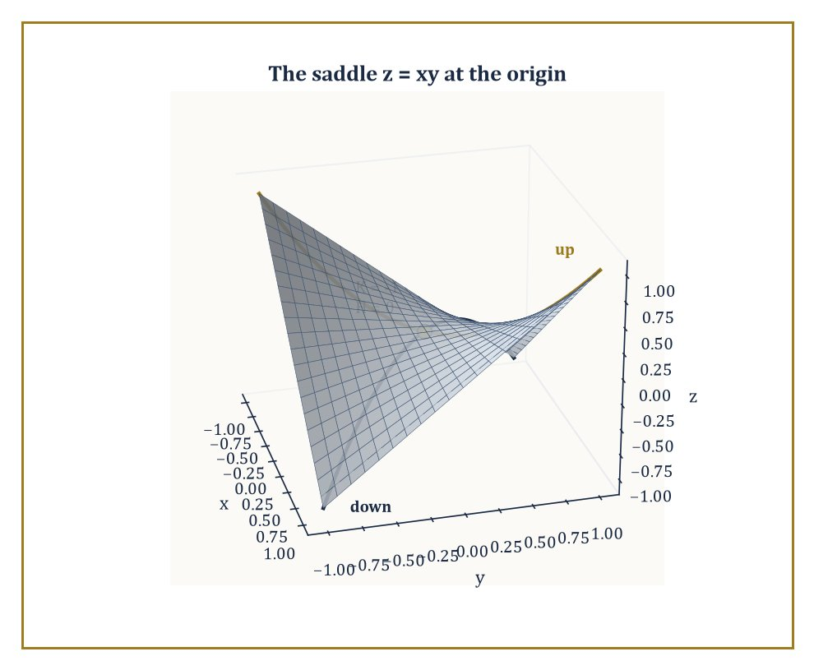
Figure 31.5 — The saddle z = xy at the origin: K = −1, H = 0 — curving upward along one principal direction and downward along the other.
To capture the surface’s actual bending, we need a second object entirely: the second fundamental form, which measures the rate at which the surface pulls away from its own tangent plane. It is built from the unit normal vector:
n = (rᵤ × rᵥ)/|rᵤ × rᵥ|
the vector sticking straight out of the surface at each point — via the coefficients:
e = rᵤᵤ · n, f = rᵤᵥ · n, g = rᵥᵥ · n
the normal components of the surface’s second derivatives, the part of the surface’s acceleration that the tangent plane cannot see.
From e, f, g together with E, F, G, two numbers of central importance are extracted. The principal curvatures κ₁ and κ₂ are the eigenvalues of the shape operator, the linear map on the tangent plane built by combining the two fundamental forms, and they measure the maximum and minimum rates of bending of the surface at that point, taken over all possible directions.
Their product is the Gaussian curvature, computable directly by the formula:
K = κ₁κ₂ = (eg − f²)/(EG − F²)
their average is the mean curvature:
H = (κ₁+κ₂)/2 = (eG − 2fF + gE)/(2(EG − F²))
Points where κ₁ = κ₂, the surface bending equally in every direction like a sphere, are called umbilic points; the classification of a point as elliptic (K > 0, bowl-shaped, bending the same way in all directions), hyperbolic (K < 0, saddle-shaped, bending opposite ways in different directions), or parabolic (K = 0, flat in at least one direction) is read off directly from the sign of K.
Numeric example — Curvature of a sphere. Return to the sphere of radius R from Surfaces and the First Fundamental Form, at θ = π/3, R = 2 (giving E = 4, F = 0, G = 3). Differentiating the normal appropriately (a computation we spare in full but whose outcome is standard) gives, using the outward normal convention:
e = −R, f = 0, g = −R sin²θ
so with R = 2 and sin²θ = 3/4:
e = −2, f = 0, g = −2 × 3/4 = −1.5
Then Gaussian curvature:
K = (eg − f²)/(EG − F²) = ((−2)(−1.5) − 0)/((4)(3) − 0) = 3/12 = 0.25
matching, reassuringly, the general formula K = 1/R² = 1/4 for a sphere of radius 2, independent of which point θ, φ you evaluate it at, as intrinsic curvature should be. Mean curvature works out to:
H = (eG − 2fF + gE)/(2(EG−F²)) = ((−2)(3) − 0 + (−1.5)(4))/(2 × 12) = (−6 − 6)/24 = −0.5
matching the general formula H = −1/R. Because K and H agree with the general sphere formulas at this arbitrarily chosen point, and because the sphere formulas themselves do not depend on θ or φ at all, every point of a sphere is umbilic — it bends identically in every direction, which is, after all, more or less the definition of a sphere.
Try it now — Find the Gaussian curvature of a sphere of radius 2. Answer →
Numeric example — Curvature of a saddle. Now the opposite case. Consider the saddle surface z = xy, parametrized as
r(x, y) = (x, y, xy)
at the origin. Here r_x = (1, 0, y) and r_y = (0, 1, x), which at the origin give r_x = (1,0,0) and r_y = (0,1,0), so:
E = 1, F = 0, G = 1
the tangent plane at the origin is the flat xy-plane, unsurprisingly. The unit normal at the origin, from r_x × r_y = (0,0,1) there, is n = (0,0,1). The second derivatives are r_xx = (0,0,0), r_yy = (0,0,0), and r_xy = (0,0,1) (differentiate r_x = (1,0,y) with respect to y). So:
e = r_xx·n = 0, g = r_yy·n = 0, f = r_xy·n = (0,0,1)·(0,0,1) = 1
Then:
K = (eg − f²)/(EG − F²) = (0 − 1)/(1 − 0) = −1
a clean, negative Gaussian curvature, confirming that the origin of z = xy is a genuine saddle point, curving upward in one direction and downward in the perpendicular direction, just as the surface’s picture suggests. Mean curvature here is:
H = (eG − 2fF + gE)/(2(EG−F²)) = (0 − 0 + 0)/2 = 0
the two principal curvatures at this point are equal and opposite, so their average vanishes even though neither is individually zero, the local signature of a minimal surface point.
Surfaces with H = 0 everywhere, not just at one point, are called minimal surfaces — the mathematical formalization of a soap film stretched across a wire loop, which physically minimizes surface area subject to its boundary, and which mean curvature zero characterizes exactly (a fact whose proof belongs to the calculus of variations rather than this chapter, but which explains the name).
Surfaces of constant mean curvature more generally include spheres, where H is the nonzero constant −1/R computed above, and cylinders, and arise physically as the shapes of soap bubbles and fluid interfaces under uniform pressure.
Of the two curvatures, Gaussian curvature K is by a wide margin the more important for the rest of this chapter: it is the one that turns out, per the Theorema Egregium of Intrinsic Geometry and the Theorema Egregium, to be intrinsic, while mean curvature H depends on how the surface is embedded and can be changed by bending alone — flattening a cylinder partway, for instance, changes H without changing K, since the cylinder stays isometric to the flat plane throughout.
Keep only this · Section 31.5: The Second Fundamental Form and Curvature
The idea. The second fundamental form measures how a surface bends away from its tangent plane. The principal curvatures k₁ and k₂ give K = k₁k₂ and H = (k₁ + k₂)/2, and K = (LN − M²)/(EG − F²).
Core.
K = (LN − M²)/(EG − F²)
H = (k₁ + k₂)/2
graph z = f(x, y): K = (f_xx f_yy − f_xy²)/(1 + f_x² + f_y²)²
Typical mistake. Calling a saddle flat because its mean curvature is zero. z = xy has H = 0 at the origin but K = −1 there.
Minimal example. Cylinder of radius 1: k₁ = 1, k₂ = 0, K = 0.
Practice. Easy to challenge; full worked answers, with the usual mistake, are in Answers to the Practice Sets at the back.
Easy — Find K for z = x² + y² at the origin. Answer →
Medium — Find the principal curvatures and H for z = x² + y² at the origin. Answer →
Challenge — Find K for z = xy at the point (1, 1, 1). Answer →

Section 31.6: Geodesics
As straight as the surface will allow
Look at the route map in the back of an airline magazine. The flights from London to New York do not run straight across the page. They arch north, up over Greenland, as though the pilot were taking the scenic way round. They are not. That arc is the shortest path there is, and it only looks like a detour because the map is flat and the Earth is not. On a globe, with a piece of string pulled tight between the two cities, the string lies along exactly that arc. A geodesic is what the string finds: a surface’s best available substitute for a straight line — the straightest curve the surface permits, given that the surface may not allow anything straight to exist on it at all.
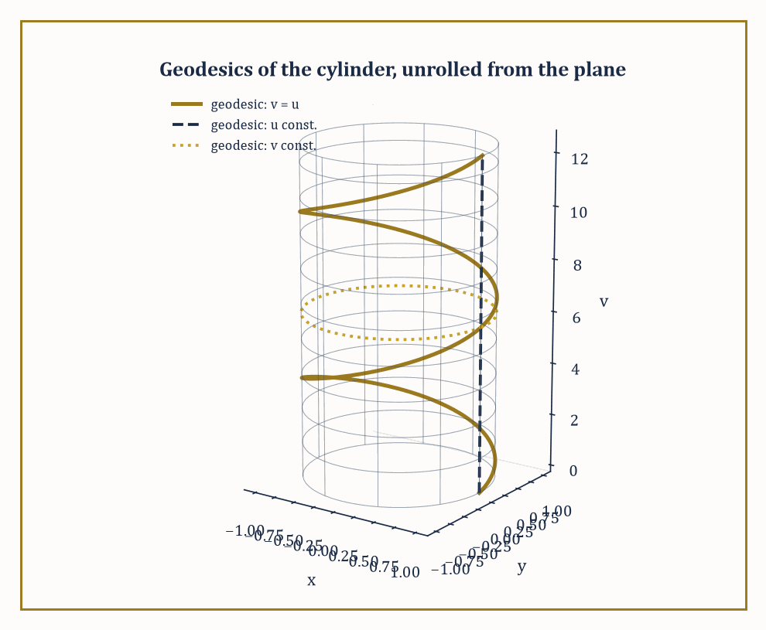
Figure 31.6 — The geodesics of a cylinder are the images of straight lines under unrolling: helices, vertical lines, and circles.
Precisely: a curve on a surface is a geodesic if its acceleration, as a curve in the ambient space ℝ³, has no component tangent to the surface at all — every bit of its bending is forced on it by the surface curving away beneath it, and none of it is the curve choosing, of its own accord, to turn left or right within the surface.
Equivalently, its geodesic curvature κ_g — the tangential part of its curvature, the part an inhabitant of the surface could actually feel as sideways turning — vanishes identically. A straight line drawn on a flat plane is trivially a geodesic, its acceleration being zero altogether; the interest begins once the surface itself is curved.
Geodesics have a variational characterization that justifies calling them ‘straightest’: among all curves connecting two nearby points on the surface, the geodesic is a critical point of the arc-length functional — locally, it is the shortest path between the points, or at least a locally shortest one; globally, other geodesics may beat it, as we shall see.
Written out in the surface’s own coordinates, a curve (u(t), v(t)) is a geodesic exactly when it satisfies a pair of second-order ordinary differential equations involving the Christoffel symbols — correction terms, built entirely from E, F, G and their derivatives, that account for how the coordinate grid itself twists as you move across the surface. Because these are ordinary differential equations of the standard existence-and-uniqueness type, prescribing a starting point and a starting direction determines a unique geodesic, as prescribing a position and velocity determines a unique straight-line trajectory in flat space.
Numeric example — The equator is a geodesic. On the unit sphere, take the equator
r(t) = (cos t, sin t, 0)
Its velocity is r′(t) = (−sin t, cos t, 0) and its acceleration is:
r″(t) = (−cos t, −sin t, 0) = −r(t)
Since the sphere is centered at the origin, the outward unit normal at the point r(t) is n(t) = r(t) itself, as it already has length 1. So the acceleration:
r″(t) = −r(t) = −n(t)
points directly along the normal direction, with no tangential component whatsoever. By the definition above, this means geodesic curvature κ_g = 0 along the entire equator: it is a geodesic.
The same argument, run with any great circle in place of the equator (any circle on the sphere whose center coincides with the sphere’s center), gives the same conclusion — great circles are precisely the geodesics of the sphere, which is why international flight routes hug great circles rather than lines of constant latitude, except, notably, the equator itself, which is both.
Try it now — Is the equator of the unit sphere a geodesic? Check its acceleration. Answer →
On a complete surface — one where geodesics can be extended indefinitely without running off an edge — any two sufficiently close points are joined by a geodesic that is the shortest path between them, not merely a critical point of length. This local minimizing property can fail globally: travel far enough along a geodesic and you may pass a conjugate point, beyond which the geodesic, while still a geodesic, is no longer the shortest route to nearby points on it.
The sphere gives the cleanest possible illustration: every geodesic leaving the north pole, regardless of initial direction, reconverges at the south pole — the north and south poles are conjugate points of each other along any of the meridian geodesics connecting them, and any geodesic extended even slightly past the south pole is demonstrably no longer minimizing, since you could instead go the short way round.
Geodesics interact beautifully with the isometries of Surfaces and the First Fundamental Form, because the geodesic equations depend only on the Christoffel symbols, which depend only on E, F, G — purely intrinsic data. An isometry, by definition, preserves E, F, G exactly, and therefore must carry geodesics to geodesics.
This gives a shortcut for finding geodesics on the cylinder without solving any differential equation at all: since the cylinder is isometric to the flat plane (Surfaces and the First Fundamental Form), and straight lines are trivially the geodesics of the flat plane, the images of straight lines under the unrolling map must be the geodesics of the cylinder.
Abstract example — Unrolling the cylinder’s geodesics. Unroll the flat (u, v)-plane onto the cylinder
r(u, v) = (cos u, sin u, v)
the inverse of the rolling-up operation from Section 31.4’s isometry example. A straight line in the plane at 45° to the v-axis, say v = u, becomes, under this map, the curve:
(cos u, sin u, u)
which is the unit circular helix analyzed at length in The Frenet–Serret Apparatus, where we computed its constant curvature κ = 1/2 and constant torsion τ = 1/2 as a curve in space. Because straight lines are geodesics of the flat plane, and the unrolling map is an isometry, this helix must be a geodesic of the cylinder — a fact that would be considerably more tedious to verify directly from the geodesic differential equations.
Steeper or shallower lines in the (u,v)-plane produce more tightly or loosely wound helices; a vertical line (u constant) produces a straight vertical line on the cylinder, and a horizontal line (v constant) produces a circle round the cylinder — all geodesics, all inherited for free from the trivial geodesics of the plane they were unrolled from.
Geodesics are, in the end, the intrinsic replacement for straight lines promised at the start of this section, and they are the natural carriers of a surface’s intrinsic geometry: the lengths of geodesic triangles, the angles at which geodesics cross, and the way nearby geodesics converge or diverge all encode the surface’s curvature without any reference to the ambient embedding. That encoding is made completely explicit in the next section, by the single most quotable theorem in the whole of classical differential geometry.
Keep only this · Section 31.6: Geodesics
The idea. A geodesic is a curve with no acceleration along the surface: its acceleration is normal. Geodesics locally minimize length, satisfy second-order ODEs built from the metric, and on a surface that unrolls flat they unroll to straight lines.
Core.
geodesic: constant speed, r″ normal to the surface
geodesic equations: ẍᵏ + Γᵏᵢⱼ ẋⁱ ẋʲ = 0
Typical mistake. Calling every circle on a sphere a geodesic. Only great circles are; a circle of latitude away from the equator turns within the surface.
Minimal example. In the plane, geodesics are straight lines.
Practice. Easy to challenge; full worked answers, with the usual mistake, are in Answers to the Practice Sets at the back.
Easy — Is a meridian of the sphere a geodesic? Answer →
Medium — Which curves on the cylinder (cos u, sin u, v) are geodesics? Answer →
Challenge — Show that the circle of latitude at height z = 1/2 on the unit sphere is not a geodesic. Answer →

Section 31.7: The Gauss–Bonnet Theorem
Where local bending finally has to answer to global shape
Every theorem so far has been resolutely local: curvature at a point, geodesics through a point, fundamental forms defined pointwise. The Gauss–Bonnet theorem is the first global statement in this chapter, and it is one of the most astonishing results in all of mathematics, for how little fanfare it makes: it asserts that the total amount of curvature spread across an entire closed surface is not free to be anything at all — it is locked, rigidly, to the surface’s topology.
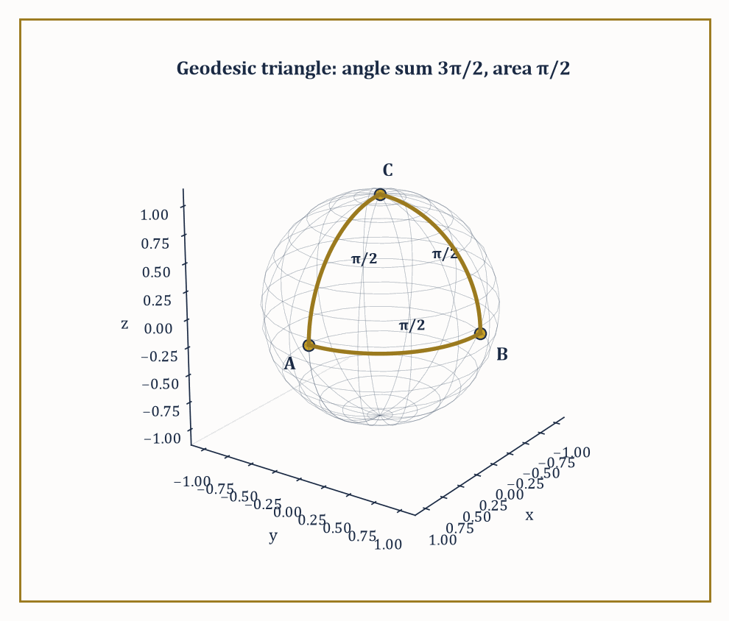
Figure 31.7 — A right-angled octant triangle on the unit sphere: three π/2 angles summing to 3π/2, exceeding π by the enclosed area.
Begin by walking round a section. Start at one corner facing along a wall, walk to the next corner, turn to follow the next wall, and carry on until you are back where you began, facing the way you set off.
Add up the turns you made. In a rectangular room you turned four times, a quarter circle each time, and the total is one full circle. Try it in a section shaped like an L and you will turn six times, some of them the other way, and the total is one full circle. Try it in a circular room, turning continuously as you go, and the total is one full circle. The shape of the section is irrelevant. Walk any closed route on a flat floor and come back facing the way you started, and the turning adds to exactly one circle. You have never thought about this, and you have relied on it every time you have walked anywhere.
Now take the same walk on the Earth, and make it large enough that the Earth has a chance to interfere.
Start at the North Pole. Walk straight south until you reach the equator. You have not turned once — you have gone straight the whole way, as straight as the surface permits. At the equator, turn a quarter circle to your left and walk straight along the equator until you have covered a quarter of the way round the world. Turn a quarter circle to your left again, and walk straight north. That road brings you back to the North Pole. Turn a quarter circle to your left one last time, and you are facing the way you originally set off.
Count the turns. Three of them, a quarter circle each, three quarters of a circle in total. Not one circle. Three quarters.
Yet nothing went wrong. You walked straight every time you walked, you came back to where you started, and you finished facing your original direction — every condition from the flat case is satisfied. The turning is a quarter circle short, and there is nowhere to put the blame. No step of the journey was unusual. No corner was mismeasured. Check any single moment of the walk and it will look exactly like walking on a flat floor.
So change the question. Not how much did you turn, but how much turning did the ground do on your behalf?
That is an uncomfortable question because the answer is not anywhere. It is not at the poles, not at the corners, not on the equator. The missing quarter circle was not lost at a place; it accumulated across the whole region your walk enclosed, a little at every point, in amounts too small to notice as you passed over them. Local measurements cannot find it, because locally there is nothing to find.
The resolution looks too convenient to be true. Add up the bending of the surface across the entire region you walked around, and the total comes to precisely the turning you did not have to do. The ground keeps accounts, and the books balance.
Check it by hand on the walk above. The triangle you traced has three corners, each a quarter circle, which on a flat floor would have to add up to half a circle and instead add up to three quarters. The excess is a quarter circle — in radians, π/2.
Now measure the patch of the globe you walked around. It runs from the North Pole down to the equator and a quarter of the way round, which is one eighth of the sphere. The whole surface of a sphere of radius 1 has area 4π, so your patch has area 4π divided by 8:
excess turning = π/2 · area enclosed = 4π ⁄ 8 = π/2
The same number twice, and no adjustment was made to force it. On a sphere of radius 1 the angle you did not have to turn is equal to the area you walked around.
Push the idea to the whole sphere and something stranger appears. A sphere of radius R bends less sharply than a small one — the bending at each point measures 1/R², so doubling the radius quarters it. But the surface area is 4πR², which doubling the radius quadruples. Multiply the two together and the R disappears entirely:
(1 ⁄ R²) × 4πR² = 4π
A marble and a planet have the same total bending. The quantity is blind to size, and it is blind to shape as well: dent the sphere, stretch it into an egg, cover it in bumps, and provided you do not tear it or glue it, the total stays 4π. Push the bending down in one place and it appears somewhere else, always in the same amount.
Notice what that total is not telling you. It says nothing about how big the surface is, nothing about how sharply it curves anywhere in particular, and nothing you could use to tell a marble from a planet. Every geometric fact has been canceled out. What survives is a single number that counts something the geometry cannot touch — and for a sphere that number is 2, the same 2 that appears when you count the corners, edges and faces of any box, pyramid or football and combine them.
That is the Gauss–Bonnet theorem: the total bending of a closed surface, added up point by point, is fixed in advance by its shape in the crudest possible sense — how many holes it has — and cannot be altered by any amount of local reshaping. The symbol χ below is that count, and the numeric example that follows works the sphere of radius R in full, arriving at the same 4π for every R whatsoever.
Precisely, for a closed orientable surface:
∫∫ K dA = 2π χ
where χ is the Euler characteristic, a purely topological integer (2 for a sphere, 0 for a torus, and so on down through the more elaborately handled surfaces that Chapter 32 will formalize properly).
More generally, for a region R on a surface with boundary, the local form reads:
∫∫[R] K dA + ∮[∂R] κ_g ds = 2π χ(R)
balancing the curvature trapped inside the region against the geodesic curvature of its boundary and the region’s topology.
Numeric example — Total curvature of a sphere, any size. Take a sphere of radius R, with constant Gaussian curvature K = 1/R² (The Second Fundamental Form and Curvature) and total surface area 4πR² (Surfaces and the First Fundamental Form). The total curvature is:
∫∫ K dA = (1/R²)(4πR²) = 4π
for every value of R whatsoever — a large sphere has proportionally less curvature per unit area but proportionally more area, and the two effects cancel exactly.
Since a sphere has Euler characteristic χ = 2, a fact Chapter 32 will justify properly but which you may already recall from Euler’s formula for polyhedra, Gauss–Bonnet predicts:
2πχ = 2π(2) = 4π
an exact match, and one that holds regardless of the sphere’s radius, which is the entire point: the theorem relates a topological invariant, which cannot change under bending or scaling, to a curvature integral that individually can change enormously (a beach ball and a marble have very different K) but whose total, integrated, cannot.
Try it now — Find the total curvature of a sphere of radius 3. Answer →
Applied to a single geodesic triangle — a triangle whose three sides are geodesics — the local Gauss–Bonnet formula collapses into a beautifully quotable statement about angles: if the triangle’s interior angles are α, β, γ, then:
(α + β + γ) − π = ∫∫ K dA
over the triangle’s interior, the boundary term vanishing because geodesics have κ_g = 0 by definition. On a flat surface this recovers the schoolroom fact that a triangle’s angles sum to π; on a positively curved surface the angles sum to more than π, and on a negatively curved surface, less.
Numeric example — A right-angled octant triangle. On the unit sphere (R = 1, K ≡ 1), take the geodesic triangle with vertices at (1,0,0), (0,1,0), and (0,0,1) — one on the equator at longitude 0, one on the equator at longitude 90°, and one at the north pole. Each side is a quarter of a great circle, and each of the three interior angles, where the sides meet, is π/2, a right angle — you can see this directly, since the two equatorial sides meet the meridian sides at right angles by symmetry. The angle sum is therefore:
3 × π/2 = 3π/2
exceeding π by precisely π/2. Independently, this triangle is exactly one octant of the sphere, so its area is one-eighth of the total area:
4π(1)² = 4π, area = π/2
Since K = 1 on the unit sphere, ∫∫ K dA over the triangle equals its area, π/2, matching the angle excess exactly, as Gauss–Bonnet demands. The sphere’s positive curvature has visibly fattened the triangle’s angles beyond the flat total of π, and the theorem tells you by exactly how much: the enclosed curvature, no more, no less.
The theorem’s consequences reach well beyond pleasant angle-counting. Because ∫∫ K dA = 2πχ and χ(sphere) = 2 ≠ 0, Gaussian curvature cannot be identically zero anywhere on a sphere-topology surface — there must be points of strictly positive curvature somewhere, which in particular proves that no flat (K ≡ 0) metric can ever be put on a sphere, however cleverly you try to bend or deform it; the theorem forbids it outright, by a topological argument that requires no calculation of any specific metric.
This single fact is the rigorous version of every mapmaker’s ancient complaint: you cannot flatten the Earth’s surface onto a sheet of paper without distortion, because a genuinely undistorted, isometric, hence curvature-preserving flattening would require the Earth to be intrinsically flat, and Gauss–Bonnet forbids that categorically.
Abstract example — The torus’s curvature budget. Now consider a torus (a doughnut surface), which has Euler characteristic χ = 0, so Gauss–Bonnet demands:
∫∫ K dA = 0
exactly. Unlike the sphere, the torus’s curvature is not constant: parametrizing the tube by an angle θ around its circular cross-section, the standard torus of tube radius r and central radius R₀ has Gaussian curvature:
K = cosθ / (r(R₀ + r cosθ))
which is positive on the outer part of the tube, θ near 0, the part bulging away from the central hole, shaped locally like a sphere, and negative on the inner part, θ near π, the part curving in toward the hole, shaped locally like a saddle, passing through zero at the very top and bottom of the tube (θ = ±π/2), where the surface is momentarily flat in one direction.
The positive contribution from the outer region and the negative contribution from the inner region cancel in the integral precisely, forced to do so by Gauss–Bonnet, however the torus’s specific proportions, the ratio of r to R₀, are chosen. No mere geometric coincidence: it is topology, in the shape of χ = 0, insisting on the outcome before a single integral is computed.
Gauss–Bonnet is the prototype for an entire genre of theorem that recurs throughout the later chapters of this series: a local, differential, calculus-flavored quantity, curvature, is shown to integrate to a global, discrete, algebraic quantity, the Euler characteristic, that depends only on the coarse topological type of the space, utterly indifferent to how that space happens to be curved or embedded. It is, in a very real sense, this chapter’s handshake with the next one.
Where this returns
The Euler characteristic is the topological invariant of Covering Spaces and Classification of Surfaces, and the angle excess reappears as holonomy in Connections, Covariant Derivatives, and Curvature.
Keep only this · Section 31.7: The Gauss–Bonnet Theorem
The idea. Gauss–Bonnet: for a closed surface ∫K dA = 2πχ, and for a geodesic triangle the angle sum minus π equals ∫K dA. Total curvature is a topological invariant.
Core.
closed surface: ∫K dA = 2πχ
geodesic triangle: α + β + γ − π = ∫K dA
χ(sphere) = 2, χ(torus) = 0
Typical mistake. Expecting a bigger sphere to have more total curvature. K falls like 1/R² while the area grows like R².
Minimal example. Octant triangle on the unit sphere: three right angles, excess π/2, area π/2.
Practice. Easy to challenge; full worked answers, with the usual mistake, are in Answers to the Practice Sets at the back.
Easy — Find the total curvature of a torus. Answer →
Medium — A geodesic triangle on the unit sphere has angles 90°, 60° and 60°. Find its area. Answer →
Challenge — Find the total curvature of a closed orientable surface of genus 2, and say what it forces. Answer →

Section 31.8: Intrinsic Geometry and the Theorema Egregium
Gauss’s remarkable theorem, and why he had every right to name it that
We have been promising, since What Differential Geometry Is, a precise version of the claim that Gaussian curvature is intrinsic — measurable from within the surface, unaffected by how the surface happens to sit in space. Gauss’s Theorema Egregium delivers that: it proves that K, defined in The Second Fundamental Form and Curvature as (eg − f²)/(EG − F²) using the extrinsic second fundamental form, can in fact be rewritten entirely in terms of E, F, G and their derivatives alone, with no reference to e, f, or g whatsoever.
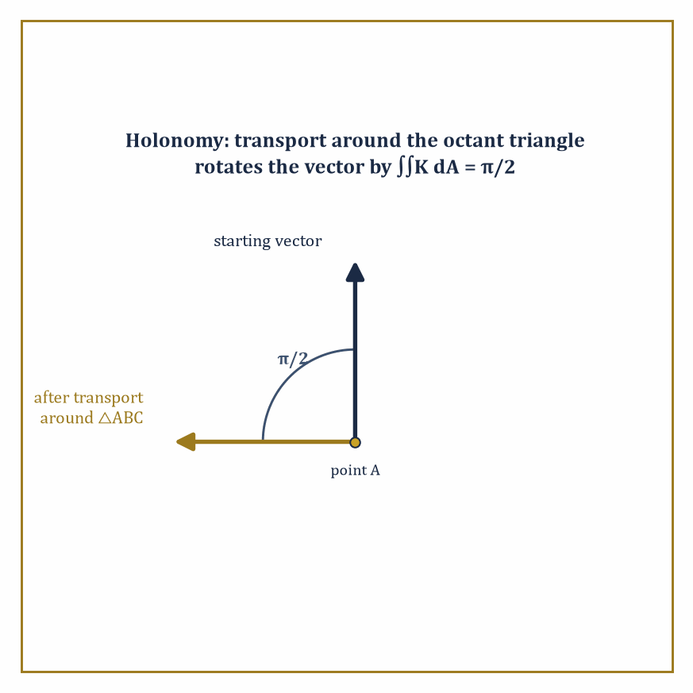
Figure 31.8 — Carried around the octant triangle of The Gauss–Bonnet Theorem, a vector returns rotated by π/2 — holonomy made visible, and equal to the enclosed curvature.
The proof is a nontrivial computation — a compatibility condition, called the Gauss equation, relating the two fundamental forms, from which the e, f, g dependence can be algebraically eliminated — but the conclusion is what matters here: bend a surface without stretching or tearing it, an operation that by definition preserves E, F, G exactly, and its Gaussian curvature at every point is unchanged, even though the surface may look, from outside, dramatically different.
This resolves, with total rigor, the paradox lurking in the cylinder example of Surfaces and the First Fundamental Form. The cylinder is visibly curved when viewed sitting in ℝ³ — you can see it bending away from any tangent plane — and indeed its second fundamental form is not zero.
Numeric example — The cylinder’s honest confession. For the cylinder r(u,v) = (cos u, sin u, v), we found E = 1, F = 0, G = 1 in Surfaces and the First Fundamental Form. Continuing the computation: the unit normal is n = (cos u, sin u, 0), pointing straight outward from the cylinder’s axis, and rᵤᵤ = (−cos u, −sin u, 0), giving:
e = rᵤᵤ · n = −cos²u − sin²u = −1
decidedly nonzero, confirming that the cylinder really is extrinsically curved, bending away from its tangent plane at a definite, measurable rate. Meanwhile rᵥᵥ = (0,0,0) gives g = 0, and rᵤᵥ = (0,0,0) gives f = 0. Plugging into the Gaussian curvature formula:
K = (eg − f²)/(EG − F²) = ((−1)(0) − 0)/((1)(1) − 0) = 0
Despite e = −1 being emphatically nonzero — the cylinder is bending in space — the Gaussian curvature comes out precisely zero, matching the flat plane it is isometric to.
This is the Theorema Egregium made completely concrete: extrinsic bending (e ≠ 0) and intrinsic curvature (K) are different quantities, and a surface can have plenty of the first while having none of the second.
Try it now — The cylinder has E = 1, F = 0, G = 1. What does the Theorema Egregium say about its Gaussian curvature? Answer →
The machinery that makes this rewriting possible — expressing K purely from E, F, G — runs through the Christoffel symbols mentioned already in Geodesics, which are themselves built entirely from E, F, G and their partial derivatives by an explicit, if visually intimidating, formula, and through the Riemann curvature tensor, the higher-dimensional generalization of curvature that later, more abstract chapters will need in full force but which, for a two-dimensional surface, collapses down to essentially nothing more than the single number K.
This collapse is a special gift of dimension two: in three or more dimensions the Riemann tensor carries vastly more independent information than a single scalar, which is why general relativity, a four-dimensional theory, needs a tensor with twenty independent components rather than one lonely number, but that reckoning belongs to a much later chapter.
Perhaps the most physically vivid manifestation of intrinsic curvature is parallel transport: carrying a vector along a curve on the surface while keeping it, at every instant, as ‘unchanging’ as the surface will permit — no tangential turning is applied to it beyond what following the curve itself requires.
Carry a vector all the way around a closed loop back to its starting point, and in flat space it returns just as it left. On a curved surface it generally does not: it returns rotated, by an angle called the holonomy of the loop, and that rotation angle is the total Gaussian curvature enclosed by the loop — exactly the ∫∫ K dA that Gauss–Bonnet already taught us to compute.
Abstract example — Parallel transport around the octant triangle. Take the same geodesic triangle from The Gauss–Bonnet Theorem — vertices at (1,0,0), (0,1,0), (0,0,1) on the unit sphere, enclosing a total curvature of π/2. Stand at (1,0,0) holding an arrow tangent to the sphere, pointing, say, due north along the meridian toward (0,0,1).
Parallel-transport that arrow along the first geodesic side to (0,0,1), then along the second side to (0,1,0), then along the third side back to (1,0,0), at every stage keeping the arrow as unrotated relative to the direction of travel as the surface allows. When the arrow returns to its starting point, it has been rotated by π/2 — a quarter turn — relative to its original direction, matching the enclosed curvature computed in The Gauss–Bonnet Theorem.
This is not a coincidence dressed up as a theorem; it is the same theorem, viewed through a different, more tactile lens: Gauss–Bonnet’s curvature integral and the holonomy of parallel transport are two descriptions of the identical underlying fact about how the surface bends.
The intrinsic/extrinsic distinction, sharpened here into the Theorema Egregium, is the conceptual center of gravity of the entire subject, and the reason abstract Riemannian manifolds — spaces with a notion of distance and curvature but no ambient embedding to fall back on at all — are even possible to define.
If curvature required an outside view to make sense, an un-embedded abstract space could never be said to be curved; because it does not, curvature becomes a self-contained property a space can have, embedding or no embedding, which is the freedom the rest of this series’ geometric chapters will spend so lavishly.
Keep only this · Section 31.8: Intrinsic Geometry and the Theorema Egregium
The idea. Gauss’s Theorema Egregium: K can be computed from the first fundamental form alone, so it is intrinsic and unchanged by bending without stretching. Parallel transport around a loop rotates vectors by the enclosed total curvature.
Core.
F = 0: K = −(1/(2√(EG)))[(E_v/√(EG))_v + (G_u/√(EG))_u]
rotation after transport around a loop = ∫K dA (mod 2π)
Typical mistake. Hoping for a flat map of the Earth that keeps all distances. K = 1 on the unit sphere and 0 on the plane, so no isometry exists, even on a small patch.
Minimal example. A pizza slice bent along one direction keeps K = 0, so it cannot also bend the other way: it stays stiff.
Practice. Easy to challenge; full worked answers, with the usual mistake, are in Answers to the Practice Sets at the back.
Easy — By how much does a vector rotate when parallel-transported around the octant triangle on the unit sphere? Answer →
Medium — Use the formula with E = 1, F = 0, G = sin²u (the unit sphere, u = θ). Answer →
Challenge — Find K for the metric E = 1, F = 0, G = cosh²u. Answer →

Section 31.9: Looking Ahead: From Surfaces to Manifolds, Riemannian Geometry, and Relativity
The view from the top of the classical theory
We have, over eight sections, assembled the complete classical theory of curves and surfaces sitting inside three-dimensional Euclidean space: arc length and the Frenet–Serret frame for curves; the first fundamental form for measuring within a surface; the second fundamental form and its curvatures for measuring how the surface bends; geodesics as the intrinsic replacement for straight lines; the Gauss–Bonnet theorem tying local curvature to global topology; and the Theorema Egregium establishing, with full rigor, that Gaussian curvature is intrinsic all along.
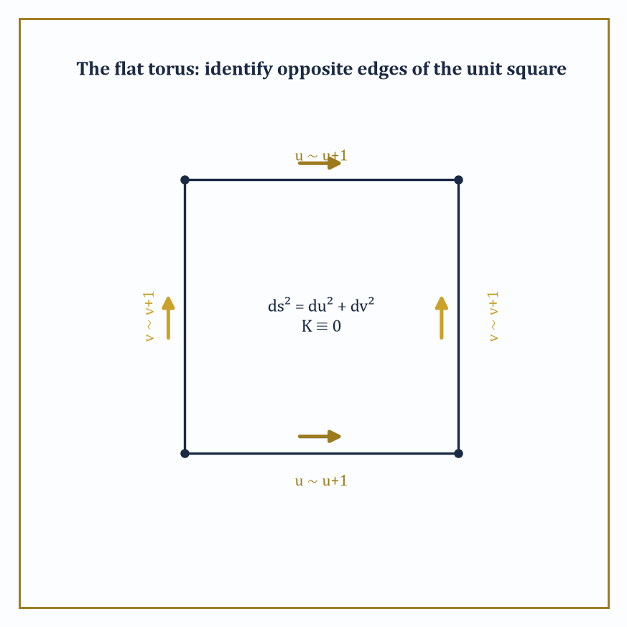
Figure 31.9 — The flat torus: glue opposite edges of a unit square and the flat metric ds² = du² + dv² survives intact, with K ≡ 0 everywhere.
That is a formidable amount of machinery, and it was all built using nothing more exotic than the vector calculus and linear algebra earlier chapters already supplied.
The modern theory generalizes every piece of it, and the generalization is best understood as simply removing the crutch of the ambient space. A manifold abstracts the local structure of a surface — something that looks like ordinary flat space up close, in small enough patches — to any number of dimensions, and crucially without requiring that manifold to sit inside some larger Euclidean space at all; it can exist, defined by how its local patches are glued together.
A Riemannian metric generalizes the first fundamental form, supplying a notion of length and angle at every point of such a manifold, purely intrinsically. The Levi-Civita connection generalizes the Christoffel symbols, telling you how to parallel-transport vectors and hence what ‘straight’, or geodesic, means, again with no outside space to lean on. Sectional curvature generalizes Gaussian curvature, measuring how two-dimensional slices through the manifold bend.
Abstract example — Two toruses, one topology. Compare two versions of the torus. The embedded doughnut of The Gauss–Bonnet Theorem, sitting in ℝ³, has Gaussian curvature that varies continuously from positive on the outer rim to negative on the inner rim, yet integrates to zero as Gauss–Bonnet demands, since χ = 0.
Now consider the flat torus, defined abstractly with no embedding at all: take the flat (u,v)-plane with the ordinary metric
ds² = du² + dv²
and identify u with u+1 and v with v+1 — glue the left edge of a unit square to the right edge, and the top to the bottom, exactly as classic video games wrap the screen. This is a perfectly legitimate manifold, carrying a perfectly legitimate Riemannian metric,
E = G = 1, F = 0
everywhere, by construction, with Gaussian curvature K ≡ 0 identically, since it is locally indistinguishable from the flat plane at every point. Gauss–Bonnet still applies, and still gives the correct answer:
∫∫ K dA = 0 = 2π(0) = 2πχ
trivially satisfied because every term is already zero.
The doughnut and the flat torus share the exact same topology, χ = 0, and hence the exact same total curvature, 0, but wildly different local geometry — one bulges and pinches through positive and negative curvature, the other is quite flat everywhere. Topology, it turns out, constrains the total; it has almost nothing to say about the local details, the gap the next chapter is built to explore properly, and precisely the freedom this chapter’s local machinery was built to exploit.
Try it now — A flat torus is a square with opposite sides glued. What is its total curvature? Answer →
The single most consequential application of all this machinery lies several chapters later in the series, in general relativity, which identifies physical spacetime itself with a four-dimensional Lorentzian manifold — a close cousin of a Riemannian manifold, differing only in a sign convention that keeps time from behaving exactly like space — whose curvature is determined, via Einstein’s field equations, by the distribution of matter and energy within it.
Gravity, in that picture, stops being a force reaching out across space and becomes instead a direct consequence of spacetime’s intrinsic curvature — massive objects do not pull on each other so much as they bend the geometry that everything else must then travel as straight as possible, that is, as a geodesic, through. It is, in the most literal sense available, the ant on the sphere from What Differential Geometry Is, promoted to four dimensions and handed the entire universe to measure.
The deeper lesson of this chapter, stated once more before we leave it, is that geometry can be done entirely from within — by measurements available to a patient, sufficiently clever inhabitant who never gets to step outside and look — and that the resulting intrinsic geometry is rich enough to describe both the classical curved surfaces of the nineteenth century and the curved spacetime of the twentieth.
Differential geometry is, in the end, the mathematics of curved space, done honestly, from the inside. The next chapter turns away from measuring how curved a space is and asks the coarser, stranger question of what survives when curvature itself is thrown away wholly — when a coffee mug and a doughnut become, for every purpose that matters, the same object. We have learned, here, to measure bending with derivatives; up in Topology, we learn what is true regardless of any bending at all.
And so this chapter closes just where the last theorem of Intrinsic Geometry and the Theorema Egregium pointed: at the boundary between geometry, which measures how much a space bends, and topology, which cares only about the shape’s most stubborn, unshakable features. The Gauss–Bonnet theorem was the whole chapter’s quiet thesis smuggled into a single equation — ∫∫ K dA = 2πχ — a local, calculus-flavored, altogether bendable quantity on the left, and a rigid, discrete, unbendable integer on the right, held together by nothing more than a proof.
Chapter 32 picks up that integer and runs with it. Topology will cheerfully throw away every curvature we have spent nine sections so carefully computing — a sphere squashed into a cube, a mug reshaped into a doughnut, all quantities of interest here rendered meaningless there — and ask instead what remains constant through any amount of stretching, squashing, and bending short of tearing. It is, in a sense, the discipline that begins where our patience for measuring precise numbers runs out, and asks the coarser but in some ways harder question of shape stripped down to its bones.
A closing word of reassurance for what lies ahead, since differential geometry has a reputation, not entirely undeserved, for burying good ideas under bad notation: every formula in this chapter — the Frenet–Serret equations, the two fundamental forms, Gauss–Bonnet itself — turned out, without exception, to be a precise restatement of something you could picture. That habit does not stop here. It has been, for one chapter, dressed up in Christoffel symbols and asked to compute exactly.
The series continues. We have learned to measure the bending of space with derivatives; next, we learn what survives when we stop measuring it altogether.
Where this returns
Manifolds, metrics and the curvature tensor are built in Tensors & Manifolds; spacetime curvature returns in Mathematical Physics (Volume 4).
Keep only this · Section 31.9: Looking Ahead: From Surfaces to Manifolds, Riemannian Geometry, and Relativity
The idea. Manifolds generalize surfaces to any dimension without a surrounding space. A Riemannian metric supplies lengths, curvature becomes a tensor, and general relativity reads gravity as the curvature of spacetime.
Core.
n-manifold: locally like ℝⁿ
Riemannian metric: gᵢⱼ dxⁱ dxʲ
Typical mistake. Thinking curvature needs a surrounding space. Gauss showed it does not, and Riemann built geometry on that.
Minimal example. Flat torus: K = 0 everywhere, χ = 0.
Practice. Easy to challenge; full worked answers, with the usual mistake, are in Answers to the Practice Sets at the back.
Easy — A closed surface has K = 0 everywhere. What is its Euler characteristic? Answer →
Medium — Can a closed orientable surface with K > 0 everywhere be a torus? Answer →
Challenge — The Riemann tensor in dimension n has n²(n² − 1)/12 independent components. Compute this for n = 2, 3 and 4, and say what n = 2 means. Answer →
Chapter 31 recap · Differential Geometry
• Curvature κ measures how fast a curve turns per unit length; torsion τ how fast it leaves its plane. Together they fix the curve up to rigid motion.
• The first fundamental form E, F, G measures lengths, angles and areas on a surface.
• The second fundamental form measures bending in space; K = k₁k₂ and H = (k₁ + k₂)/2.
• Geodesics have acceleration normal to the surface; they are the locally shortest paths.
• Gauss–Bonnet: ∫K dA = 2πχ for a closed surface, and the angle excess of a geodesic triangle is its total curvature.
• Theorema Egregium: K depends on E, F, G alone, so it is intrinsic; that is the step from surfaces to manifolds.

Check Your Understanding — Chapter 31
Answers are in the Answer Key at the back of the book — have a go before you look.
1. [Explain] An ant on a unit sphere walks a taut rope of length r in every direction to trace a circle, measuring its circumference as C(r) = 2π sin r rather than the flat-plane value 2πr. Why does this shortfall matter for the claim that curvature is intrinsic?
See the answer →
2. [Explain] Rolling a flat sheet of paper into a cylinder r(u,v) = (cos u, sin u, v) gives first fundamental form E=1, F=0, G=1, identical to the flat sheet’s own ds² = du² + dv². What does this tell an inhabitant of the cylinder, and why can paper wrap a cylinder but not a sphere without wrinkling?
See the answer →
3. [Compute] Compute the Gaussian curvature K of the saddle surface z = xy at the origin, and explain what its sign tells you.
See the answer →
4. [Concept] A geodesic triangle on the unit sphere with vertices (1,0,0), (0,1,0), (0,0,1) has three right angles summing to 3π/2 and encloses an area of π/2 (one octant of the sphere). Show this is consistent with the Gauss–Bonnet theorem.
See the answer →
5. [Compute] For the helix r(t) = (a cos t, a sin t, bt), compute the curvature and the torsion, and say what each measures.
See the answer →
6. [Compute] Find the curvature of the parabola y = x² at the origin and at x = 1, and explain the difference.
See the answer →
7. [Compute] Compute the first fundamental form of the sphere of radius R in spherical coordinates, and use it to find the length of a circle of constant latitude.
See the answer →
8. [Compute] Find the principal, Gaussian and mean curvatures of a cylinder of radius R, and comment on the result.
See the answer →
9. [Concept] Gaussian curvature is intrinsic and mean curvature is not. What does that distinction actually mean, and how would an inhabitant of the surface tell?
See the answer →
10. [Concept] Geodesics are often called the straight lines of a surface, yet a geodesic need not be the shortest path. Reconcile this.
See the answer →
11. [Explain] Why can no map of the Earth preserve both areas and angles, and what is the theorem behind the cartographer’s complaint?
See the answer →
12. [Prove] Derive the Frenet–Serret formulas for a unit-speed curve.
See the answer →
13. [Prove] Prove that geodesics satisfy the geodesic equation, by taking the first variation of arc length.
See the answer →
14. [Prove] Prove that the shape operator is self-adjoint, and deduce that principal curvatures are real with orthogonal principal directions.
See the answer →
15. [Prove] Prove the Theorema Egregium: Gaussian curvature depends only on the first fundamental form.
See the answer →
16. [Prove] Prove that a surface with K ≡ 0 is locally isometric to the plane.
See the answer →
17. [Prove] Prove the Gauss–Bonnet theorem for a geodesic triangle: the angle excess equals the integral of Gaussian curvature over the enclosed region.
See the answer →
18. [Challenge] Curvature requires a second derivative. Why can no first-order quantity capture it?
See the answer →
19. [Challenge] Gauss–Bonnet equates an integral of a locally defined quantity with a topological invariant. Why is that surprising, and what does it foreshadow?
See the answer →
20. [Challenge] Why does general relativity need intrinsic geometry rather than a surface sitting in a higher-dimensional space?
See the answer →
21. [Challenge] The Gauss map sends each point of a surface to its unit normal on the sphere. Why is this the right object to differentiate?
See the answer →
22. [Challenge] Curves have curvature and torsion; surfaces have two principal curvatures. What decides how many invariants an object gets?
See the answer →
23. [Challenge] A soap film minimizes area and has zero mean curvature, while a soap bubble has constant mean curvature instead. What changed?
See the answer →
24. [Challenge] Chapter 31 studies surfaces that bend; Chapter 32 discards bending entirely. What is gained by throwing away the metric?
See the answer →

Problems — Chapter 31
The questions above test whether the ideas landed. These ask you to use them. Solutions are in Solutions to the Problems at the back. Work them before you look.
1. [Compute] The curve y = x². Compute its curvature at x = 0.
2. [Compute] A circle of radius 3. What is its curvature, and what length of curve corresponds to an angle of π/3?
3. [Concept] A curve on a surface has geodesic curvature and normal curvature. Which of the two does a geodesic kill, and what is left?
4. [Compute] The unit sphere. Gaussian curvature is 1 everywhere. What is the total curvature over the whole sphere, and which theorem turns that integral into a topological integer?

Math, Actually

Chapter 32

Topology
Continuity, Connectedness, and the Art of Geometry Without Distance
The previous chapter spent its many sections teaching us to measure a bent sheet with real precision — Gaussian curvature computed to the decimal place, geodesics tracked as if we owned a very small and very diligent surveyor, the Theorema Egregium proving that some of what we measured was secretly independent of how we bent the sheet in the first place. Now we do something that will feel, for the first few sections at least, faintly indecent: we put the ruler down. Not lose it, in the manner of most rulers in most houses — put it down on purpose, to see what is left standing once the ability to measure length or angle is taken away wholly.
What is left, it turns out, is a great deal. Nearness survives, in a suitably laundered form. Continuity survives. So does the qualitative fact that a coffee cup and a doughnut are, deep down, the same shape, however differently they behave at breakfast, and the equally qualitative fact that neither of them is a sphere. Topology is the discipline built altogether out of what remains after distance has been confiscated, and the standing joke about the field — that its definitions look almost empty and its theorems turn out to be surprisingly strong — is not really a joke at all. The emptiness is the whole method: throw away everything except the purely qualitative skeleton of a space, and what is left over is precisely what a continuous deformation cannot destroy.
This chapter climbs from the comfortable ground of metric spaces, where continuity still has an ε and a δ to hide behind, up through the more austere world of general topological spaces defined by open sets alone, through the two great structural properties — connectedness and compactness — and the separation axioms that keep a space civilized, and finally into algebraic topology proper: homotopy, the fundamental group, covering spaces, and the complete classification of closed surfaces, one of the few genuinely finished answers topology has ever produced to the question of what shapes there are.
Let’s forget distances.
Before you begin — Chapter 32
By the end of this chapter you will be able to:
1. Say what a homeomorphism is and use invariants to tell spaces apart.
2. Work with metric spaces, ε–δ continuity, completeness and contractions.
3. Work with open sets, closures, subspaces and quotients in general topological spaces.
4. Prove connectedness and compactness results and use them (intermediate and extreme values).
5. Use separation and countability axioms, and Urysohn functions.
6. Compute fundamental groups and covering spaces, and classify closed surfaces.
Prerequisites. ε–δ limits and continuity from Limits (Volume 1); sets and functions from Set Theory & Logic (Volume 2); the idea of a group from Groups and Homomorphisms helps in the last sections but is introduced there as needed.
Estimated study time. About 11 hours, exercises included.

Section 32.1: What Topology Is
In Which We Confiscate the Ruler
Topology is the study of those properties of a space that survive continuous deformation — stretching, bending, squashing, twisting — but never tearing and never gluing. It is sometimes called rubber-sheet geometry, a name that undersells it slightly, since rubber sheets are things you can actually buy, and topology has no interest in what a space is made of, only in how its points hang together.
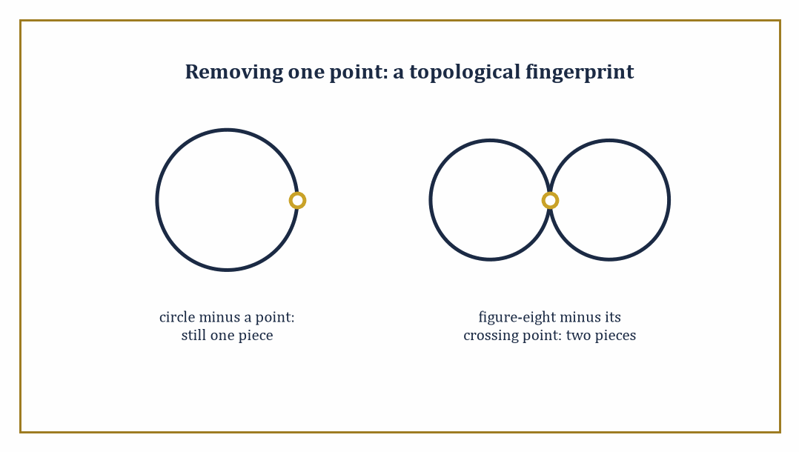
Figure 32.1 — Delete one point from a circle and it stays entire; delete the crossing point from a figure-eight and it falls into two pieces — a topologist’s fingerprint, no ruler required.
Two spaces count as the same — technically, homeomorphic — if one can be continuously deformed into the other, with a continuous deformation running in reverse to undo it. Distance is not invited to this discussion. Neither is angle.
What survives is something thinner and, as it turns out, considerably more robust: the pattern of which points are near which other points.
Abstract example — the mug and the doughnut. The standard illustration, repeated in every topology course since roughly the dawn of time, is the coffee mug and the doughnut (properly, the torus). Both objects have exactly one hole clean through them — the doughnut’s is obvious, the mug’s is the handle.
Watch a deformation: soften the mug like warm wax; let the bowl of the mug sag and flatten into a thick disk while the handle stays put; keep flattening until the disk becomes a fat ring with a hole exactly where the handle already met it. What remains, up to some cosmetic squashing, is a torus.
At no stage did we tear the wax or press two previously separate points together — we only bent and squashed, and squashing is free in topology.
A solid ball, by contrast, has no hole to preserve; no amount of squashing turns a doughnut into a ball without either tearing the ring open or gluing its ends into a single point, both forbidden moves.
Hence the old joke that a topologist cannot tell her coffee cup from her doughnut — though she can, immediately, tell either one from the ball-shaped paperweight on her desk, which is why the discipline is not, despite appearances, a complete abdication of rigor.
Try it now — Removing one point leaves a circle connected but splits a line. Why does that show S¹ and ℝ are not homeomorphic? Answer →
The subject splits, historically and pedagogically, into two branches this chapter will visit in turn. Point-set topology (also called general topology) builds the basic vocabulary: open sets, continuity, connectedness, compactness — the grammar in which every later sentence of the subject will be written.
Algebraic topology takes the braver step of attaching algebraic objects — groups, rings, vector spaces — to a space, in such a way that continuous maps between spaces become algebraic homomorphisms between their invariants.
The point of this seemingly baroque maneuver is entirely practical: algebra is far easier to compute with than raw point-set data, and two spaces with non-isomorphic invariants cannot possibly be homeomorphic, however hard they might be to tell apart by eye.
Abstract example — telling a circle from a disk. Consider the circle S¹ and the closed disk D² (the circle together with everything it encloses). Staring at them, one might wonder whether some devious continuous bending could turn one into the other — both are bounded, both are connected, both look round.
Algebraic topology settles the question outright. The disk is contractible: it can be continuously shrunk to its center point, so its fundamental group (built properly in Homotopy and the Fundamental Group) is trivial, containing only the identity element.
The circle is not contractible — a loop winding once around the hole in the middle cannot be shrunk to a point without leaving the circle — and its fundamental group turns out to be the infinite cyclic group ℤ, one copy of the integers for each possible winding number.
Trivial group versus infinite group: the two cannot be isomorphic, so S¹ and D² cannot be homeomorphic.
Notice what happened — a question about bending and stretching was answered using nothing but group theory. That transfer of labor, geometry’s hard questions handed over to algebra’s comparatively tractable ones, is the entire strategic point of algebraic topology, and we shall lean on it for the rest of the chapter.
Abstract example — a point-set argument, no algebra required. Not every distinction needs algebra. Consider the circle S¹ and the figure-eight (two circles joined at a single crossing point).
Remove the crossing point from the figure-eight: what remains is two disjoint open arcs, a disconnected space — removing one point split it in two.
Now remove any point from the circle instead: what remains is a single connected arc, however oddly bent, since a circle with one point deleted is still all one piece.
A homeomorphism must send a point whose removal disconnects the space to a point whose removal disconnects the space, since counting how many pieces are left behind after deleting a point is itself a topological invariant, no algebra needed.
The figure-eight has such a point and the circle does not, so the two spaces cannot be homeomorphic — connectedness alone, patiently applied, already settles a question one might instinctively have reached for the fundamental group to answer, and Connectedness and Path-Connectedness will make this trick precise.
Topology, then, supplies the load-bearing vocabulary underneath most of modern geometry, analysis, and dynamical systems — whenever someone asks whether two structures are essentially the same shape, or whether a space has a hole, or whether a system’s trajectories can be continuously deformed into one another, they are asking a topological question, whether or not they use the word.
We will spend the rest of this chapter building that vocabulary from the ground up: first through the familiar comfort of metric spaces, then through the more austere abstraction of general topological spaces, and finally into the algebraic machinery that lets us count holes for a living.
Keep only this · Section 32.1: What Topology Is
The idea. Topology studies the properties that survive continuous deformation — homeomorphisms — such as connectedness, compactness and holes. Invariants, numerical or algebraic, tell spaces apart.
Core.
homeomorphism: continuous bijection with continuous inverse
invariant: takes the same value on homeomorphic spaces
Typical mistake. Proving two spaces different by failing to find a homeomorphism. You need an invariant that takes different values.
Minimal example. Mug and torus: one hole each, homeomorphic.
Practice. Easy to challenge; full worked answers, with the usual mistake, are in Answers to the Practice Sets at the back.
Easy — How many pieces are left when the crossing point is removed from a figure-eight? And from a circle minus any point? Answer →
Medium — Are [0, 1] and (0, 1) homeomorphic? Answer →
Challenge — Show that the letter T is not homeomorphic to [0, 1]. Answer →

Section 32.2: Metric Spaces and Continuity
Where Distance Still Behaves Itself, For Now
You have seen this before
The ε–δ definition of continuity is the one from Limits (Volume 1). The only change is that |x − y| becomes d(x, y).
You already know what distance means, and you already know more than one kind. From your house to the shop is one number as the crow flies, a bigger one on foot, and bigger again by bus on a Sunday. All three are honest answers. What makes each of them a distance is not any formula but three promises every one of them keeps. Nothing is ever a negative distance away, and the only place at zero distance from you is where you are standing. The trip there is as long as the trip back. And going via somewhere else is never shorter than going direct. A metric space is a set carrying a rule that keeps those three promises: a distance function d: X × X → ℝ satisfying positivity, symmetry, and the triangle inequality.
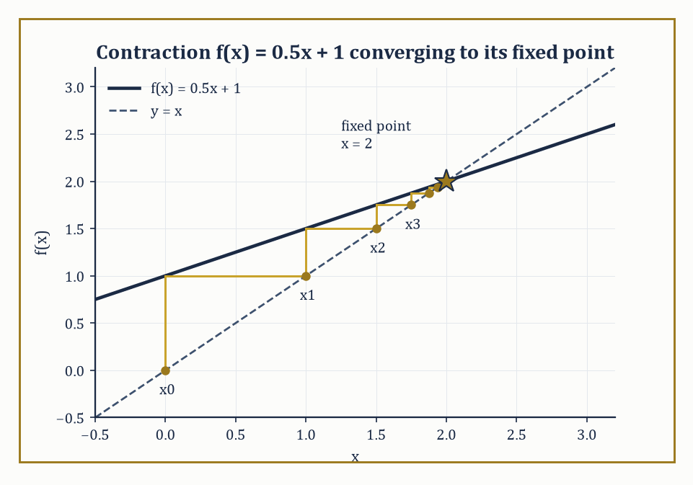
Figure 32.2 — The contraction f(x) = 0.5x + 1, iterated from x0 = 0, staircases its way straight into the fixed point x = 2 — as promised by a constant L = 0.5 comfortably under 1.
d(x,y) ≥ 0, with equality when x = y
d(x,y) = d(y,x)
d(x,z) ≤ d(x,y) + d(y,z)
The triangle inequality is the formal statement that a detour is never shorter than the direct route. From d alone we build open balls, and declare a set U open if every point of U sits inside some open ball entirely contained in U.
B(x,r) = {y ∈ X : d(x,y) < r}
This collection of open sets is the topology generated by the metric — the first, and friendliest, example of the more general structure met properly in Topological Spaces and Continuous Maps.
Numeric example — checking the axioms. Take the Euclidean plane ℝ² with distance
d(p,q) = √((p₁−q₁)² + (p₂−q₂)²)
and three points p = (0,0), r = (3,0), q = (3,4). Then:
d(p,r) = √(3²+0²) = 3
d(r,q) = √(0²+4²) = 4
d(p,q) = √(3²+4²) = √25 = 5
A 3-4-5 right triangle, chosen to keep the square roots honest. Symmetry is immediate: swapping the arguments swaps nothing in the formula. Positivity holds since all three points are distinct, giving strictly positive distances.
And the triangle inequality reads:
5 ≤ 3 + 4 = 7
Comfortably true, with equality reserved for the degenerate case where the middle point lies on the straight segment, which r here does not.
Try it now — For f(x) = x² at x₀ = 2 with ε = 0.1, does δ = 0.02 work? Answer →
A function f: X → Y between metric spaces is continuous at a point x if points near x are sent to points near f(x): for every ε > 0 there exists δ > 0 such that
d(x,x′) < δ implies d(f(x),f(x′)) < ε
This is the familiar ε–δ definition from analysis, and it turns out to be equivalent to the topological statement that the pre-image of every open set is open — continuity, reframed, is the demand that closeness pull back correctly through f. The equivalence is worth sitting with: analysis phrases continuity in terms of numbers getting small; topology phrases the same fact in terms of open sets pulling back, with no numbers in sight. Discarding the numbers is just what will let the idea extend to spaces where no distance function exists at all.
Numeric example — an ε–δ check. Let f(x) = x² on ℝ, and check continuity at x₀ = 2 with tolerance ε = 0.1. We need |x − 2| < δ to force |x² − 4| < 0.1. Factor:
|x² − 4| = |x − 2|·|x + 2|
Restrict to δ ≤ 1, so x lies in (1,3) and |x+2| < 5. Choosing:
δ = min(1, 0.1/5) = 0.02
then gives, whenever |x − 2| < 0.02:
|x² − 4| = |x−2|·|x+2| < 0.02 × 5 = 0.1
The bound required. So δ = 0.02 works for ε = 0.1 at x₀ = 2 — a small, honest computation standing in for the general fact that every polynomial is continuous everywhere.
The concept covers far more than Euclidean space. Function spaces carry metrics too: the uniform metric measures the worst-case vertical gap between two functions,
d(f,g) = supₓ |f(x) − g(x)|
while the integral metric measures the total area between their graphs,
d(f,g) = ∫|f(x) − g(x)| dx
two different notions of nearby function, generating two different topologies on the same set of functions. At the other extreme sits the discrete metric, which declares every point isolated from every other.
d(x,y) = 0 if x = y and 1 otherwise
Numeric example — the discrete metric. On X = {a, b, c} with the discrete metric, the open ball
B(a, 0.5) = {y ∈ X : d(a,y) < 0.5}
contains only a itself, since
d(a,b) = d(a,c) = 1 ≥ 0.5
The same holds for every point, so every singleton {a}, {b}, {c} is open, and since arbitrary unions of open sets are open, every subset of X is open. The discrete metric therefore generates the discrete topology, in which nothing is ever close to anything else except itself — a useful, if slightly antisocial, toy example to keep in reserve whenever a general claim about topological spaces needs testing against an extreme case.
A metric space is complete if every Cauchy sequence (one whose terms eventually cluster arbitrarily close together) converges to a point of the space. ℝ is complete; ℚ is not, since a sequence of rationals can Cauchy-converge toward √2 without ever reaching a rational limit. Every incomplete metric space can be completed by formally adjoining the missing limit points — this is how ℝ is built from ℚ in the first place.
Completeness matters because it powers the contraction mapping theorem (the Banach fixed-point theorem): if f: X → X on a complete metric space satisfies
d(f(x),f(y)) ≤ L·d(x,y) for some fixed L < 1
then f has exactly one fixed point, and iterating f from any starting point converges to it. This single theorem underwrites the existence and uniqueness theory for ordinary differential equations and generates the self-similar fractals met several chapters ago — a piece of pure metric-space topology doing heavy lifting, unannounced, elsewhere in the series.
Numeric example — a contraction in action. Let f(x) = 0.5x + 1 on ℝ (complete, certainly). For any x, y:
|f(x) − f(y)| = |0.5x − 0.5y| = 0.5|x − y|
so f is a contraction with L = 0.5 < 1. Its fixed point solves:
x = 0.5x + 1, so 0.5x = 1, so x = 2
Iterate from x₀ = 0:
x₁ = f(0) = 1
x₂ = f(1) = 1.5
x₃ = f(1.5) = 1.75
x₄ = f(1.75) = 1.875
x₅ = f(1.875) = 1.9375
The errors 2 − xₙ run 2, 1, 0.5, 0.25, 0.125, 0.0625 — halving at each step, precisely as the contraction constant L = 0.5 predicts, converging inexorably to the true fixed point x = 2 regardless of where the iteration started.
Keep only this · Section 32.2: Metric Spaces and Continuity
The idea. A metric space has a distance that is positive, symmetric and obeys the triangle inequality. Open balls define open sets and ε–δ continuity; in a complete space every Cauchy sequence converges, and a contraction has exactly one fixed point (Banach).
Core.
d(x, y) = 0 ⇔ x = y; d(x, y) = d(y, x); d(x, z) ≤ d(x, y) + d(y, z)
contraction: d(f(x), f(y)) ≤ q·d(x, y), q < 1
Banach: one fixed point x, and fⁿ(x₀) → x
Typical mistake. Using Banach’s theorem on an incomplete space. f(x) = x/2 is a contraction of (0, 1] with no fixed point in it.
Minimal example. Discrete metric: every ball of radius 1/2 is a single point.
Practice. Easy to challenge; full worked answers, with the usual mistake, are in Answers to the Practice Sets at the back.
Easy — Find the taxicab distance between (0, 0) and (3, 4). Answer →
Medium — Find the fixed point of f(x) = 0.5x + 1 and three iterates from 0. Answer →
Challenge — Show that d(x, y) = |x − y|/(1 + |x − y|) is a metric on ℝ. Answer →

Section 32.3: Topological Spaces and Continuous Maps
Open Sets, All the Way Down
Why this abstraction exists
Continuity, connectedness and compactness can all be stated with open sets alone; distances were never essential. Dropping them lets one theory cover function spaces, quotients and spaces with no natural metric at all.
The previous section bought nearness with a ruler. This one takes the ruler away and keeps the nearness. That sounds like a conjuring trick, and an underground map is the proof that it is not: such a map carries no distances at all, and you have never once needed them. A topological space is what remains. It is a set X together with a chosen collection τ of subsets, called open sets, obeying three rules: the empty set and X are both open; any union of open sets is open; and the overlap of finitely many open sets is open. Notice what has been thrown away — there is no distance anywhere in that list, only a bookkeeping rule for which subsets count as open.
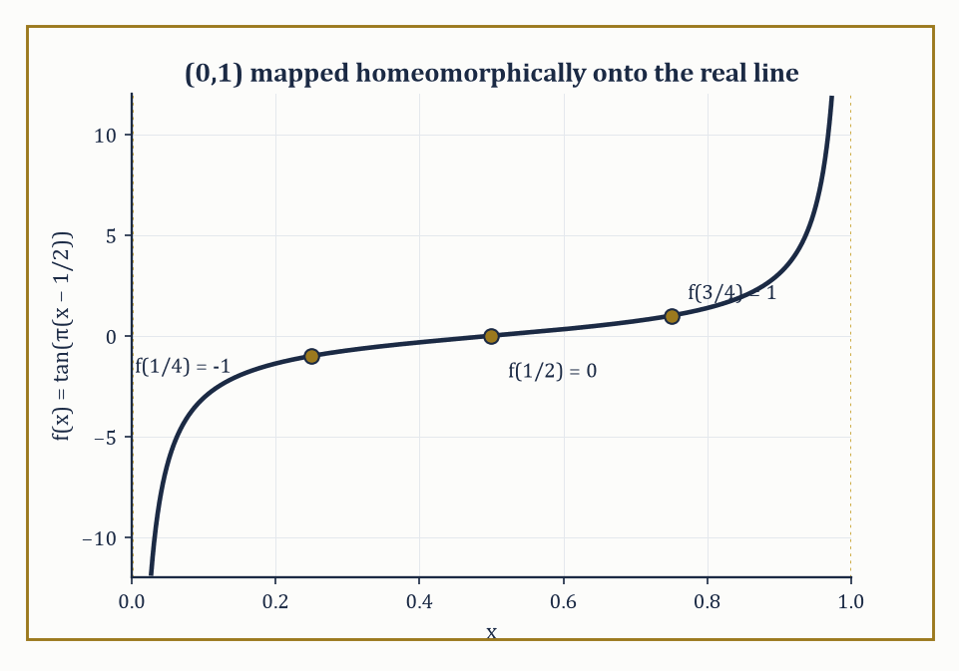
Figure 32.3 — f(x) = tan(π(x − 1/2)) bends the bounded interval (0,1) into the whole real line — proof that boundedness was only ever a fact about the ruler, not about the space.
Begin with a map you have already used. The underground map on the wall of any station is, as a picture of the city, a pack of lies. The distances are wrong. The angles are wrong. The river bends in a way no river has ever bent. You have stood in front of one, found your route in ten seconds, and never once complained.
Now try to make it answer a different question. How far is it from one station to the next, in miles? The map will not say. It threw that away when it was drawn, and it threw away direction with it.
Yet the map still answers everything you actually asked. Which stations connect. What lies on the way. Where you must change. Something survived the loss of distance, and whatever it is, it was the part you were using all along.
So change the question. Not how far apart two things are, but what it takes to say two things are near each other when there is no ruler in the room.
Here is the difficulty, and it is worth sitting with. Every notion of nearness you own runs through a number. Near means the distance is small. Take the ruler away and there is nothing left to be small, and the definition collapses. You cannot even say a point lies inside a region without, somewhere underneath, measuring something.
The way round it sounds like a refusal to answer. Stop trying to work out which points are near each other. Declare it instead. Hand down a list of which pieces of the set count as neighborhoods, and let that list be the whole story.
The list cannot be arbitrary, and you can find out what it must obey with three points and a pencil. Take the set of three things a, b and c, and try declaring this list of neighborhoods:
nothing at all, {a}, {a, b}, the whole set
Test it. Put any two of them together and the result is on the list again — {a} together with {a, b} gives {a, b}, which is there. Overlap any two and the result is on the list again — the overlap of {a, b} with the whole set is {a, b}. Nothing you can do to the members takes you outside it. The list is closed for business.
Now spoil it. Swap {a, b} for {b} and try again. Put {a} together with {b} and you get {a, b}, which is no longer on the list. One swap, and the list leaks. That is the whole constraint: whatever you declare, combining neighborhoods must never carry you off the list.
Notice what the list never does: it never tells you why those pieces are the neighborhoods. Nothing forces the choice. A different list on the same three points gives a different notion of nearness, and both are legitimate — which is the price of throwing away the ruler, and the reason the subject is more spacious than geometry.
That list is a topology, the set carrying it is a topological space, and the pieces on the list are its open sets. The word is the one you already met at school: an open interval is the one without its endpoints, the one where every point has room to move a little in either direction. Here that idea is promoted from a fact you check to a rule you declare.
The abstract example below does this properly, on the same three points, and finds the same list.
A closed set is the complement of an open set. The interior of a set A is the largest open set contained in A; its closure is the smallest closed set containing A; and its boundary is the closure minus the interior — the skin of A, belonging to neither its open interior nor its open exterior.
Abstract example — a topology on three points. Let X = {a, b, c} and declare
τ = { ∅, {a}, {a,b}, X }
Check the axioms directly: ∅ and X are present, as required. Unions:
{a} ∪ {a,b} = {a,b} ∈ τ
{a} ∪ X = X ∈ τ
every union formable from the listed sets is already on the list. Intersections:
{a} ∩ {a,b} = {a} ∈ τ
{a,b} ∩ X = {a,b} ∈ τ
All three axioms hold, so τ is a genuine topology on X — despite no distance function ever being mentioned, and despite this particular topology being deliberately lopsided (notice {c} is not open, nor is {b} on its own). The closed sets are the complements of the open ones: the complement of ∅ is X, the complement of {a} is {b,c}, the complement of {a,b} is {c}, and the complement of X is ∅. So {c} is closed but not open, {b,c} is closed but not open, and X and ∅ are, as always, both open and closed simultaneously.
Try it now — Is {∅, {a}, {a, b}, X} a topology on X = {a, b, c}? Answer →
Numeric example — interior, closure, boundary. Consider A = [0,1) inside ℝ with its standard topology. The interior of A is the largest open set contained in A: every point of (0,1) has a small open interval around it that stays entirely inside A, but 0 does not — any open interval around 0, however small, pokes out into the negative numbers, so 0 fails to be an interior point. Hence
interior(A) = (0,1)
The closure of A is the smallest closed set containing A. A itself is not closed: its complement is (−∞,0) ∪ [1,∞), and this complement is not open, since 1 has no open interval around it that avoids A wholly (any such interval dips back below 1, into A). The smallest closed set containing A must therefore also contain the limit point 1, giving
closure(A) = [0,1]
The boundary is closure minus interior:
[0,1] minus (0,1) = {0,1}
the two edge points of the half-open interval, one of which (0) happens to belong to A and one of which (1) does not, a useful reminder that boundary points need not belong to the set whose boundary they form.
A function f: X → Y between topological spaces is continuous if the pre-image f⁻¹(V) of every open set V ⊆ Y is open in X — no numbers, no ε, no δ, just open sets pulling back to open sets.
A homeomorphism is a continuous bijection whose inverse is also continuous; homeomorphic spaces are, topologically, indistinguishable, and homeomorphisms play exactly the role isomorphisms play elsewhere in mathematics. A topological invariant is any property preserved by homeomorphisms — connectedness, compactness, and the fundamental group, still to come, are the working invariants of this chapter, and proving two spaces are not homeomorphic is almost always done by finding an invariant on which they disagree.
Abstract example — continuity between finite spaces. Equip Y = {1, 2} with the Sierpiński topology
σ = { ∅, {1}, Y }
the smallest topology on two points that is not discrete. Take X = {a,b,c} with the topology τ from the earlier example, and define f: X → Y by f(a) = 1, f(b) = 1, f(c) = 2. To check continuity, test every open set of Y:
f⁻¹(∅) = ∅ (open in X)
f⁻¹({1}) = {a,b} (open in X, since {a,b} ∈ τ)
f⁻¹(Y) = X (open in X)
All three pre-images are open, so f is continuous — verified entirely by set membership, without a single distance computed, the promise of the topological definition.
Worked example — a bounded interval is homeomorphic to the whole line. Consider the open interval (0,1) and the whole real line ℝ, which look different in size — one is bounded, the other is not — yet are homeomorphic. The map
f(x) = tan(π(x − 1/2))
sends (0,1) bijectively onto ℝ, is continuous throughout the open interval (tangent only misbehaves at odd multiples of π/2, never reached on this domain), and has a continuous inverse. Check three values:
f(1/2) = tan(0) = 0
f(3/4) = tan(π/4) = 1
f(1/4) = tan(−π/4) = −1
As x sweeps from just above 0 to just below 1, f(x) sweeps out the entire real line — boundedness, in other words, is not a topological invariant in its own right, only a property of a particular metric someone happened to put on the space.
Three standard constructions build new topological spaces from old ones. The subspace topology on A ⊆ X takes as open sets all intersections of A with open sets of X. The product topology on X × Y takes as a basis all products U × V of open sets from each factor. The quotient topology, given an equivalence relation ~ on X, declares a subset of X/~ open exactly when its pre-image under the quotient map is open in X — the topology that makes gluing points together a continuous operation, at the cost of being the trickiest of the three to picture.
Worked example — building a circle by gluing an interval’s ends. Take X = [0,1] and glue the two endpoints together, declaring 0 ~ 1. The quotient map q: [0,1] → [0,1]/~ can be pictured concretely as
q(t) = (cos 2πt, sin 2πt) ∈ ℝ²
landing on the unit circle S¹. Check values:
q(0) = (1,0)
q(1) = (cos 2π, sin 2π) = (1,0)
the two endpoints, as promised, land on the same point. Meanwhile
q(1/4) = (cos(π/2), sin(π/2)) = (0,1)
q(1/2) = (cos π, sin π) = (−1,0)
q(3/4) = (0,−1)
four evenly spaced points going once around. The quotient topology confirms what the picture already suggests: [0,1]/(0~1) is homeomorphic to the circle S¹, and this take-an-interval-and-glue-the-ends construction is the standard way to build a circle out of a straight piece of string, topologically speaking.
The range of topologies in active use is wide. Euclidean space carries its familiar metric topology; a discrete space declares every subset open; the Zariski topology of algebraic geometry declares a set closed exactly when it is the zero set of some collection of polynomials (on the real line, this reduces to the cofinite topology, whose open sets are complements of finite sets); and the weak topologies of functional analysis are built to be just barely fine enough to make a chosen family of functions continuous, no finer.
Numeric example — axioms in the cofinite topology. On ℝ with the cofinite topology, declare a set open exactly when its complement is finite (plus the empty set). Take two open sets U = ℝ minus {1,2} and V = ℝ minus {3,4,5}. Their intersection U ∩ V is ℝ minus {1,2,3,4,5} — complement of size 5, still finite, so U ∩ V is open, confirming the finite-intersection axiom on this concrete pair.
For unions: an arbitrary union of cofinite open sets has a complement equal to the intersection of the corresponding finite complements, which is contained in any single one of them and hence finite — so the union is again open, and the arbitrary-union axiom survives contact with an infinite family, not just the pair tested by hand.
Keep only this · Section 32.3: Topological Spaces and Continuous Maps
The idea. A topology is a collection of open sets closed under arbitrary unions and finite intersections. Continuity means preimages of open sets are open; interior, closure, boundary, subspaces, products and quotients are all built from open sets.
Core.
∅, X open; unions and finite intersections of open sets are open
f continuous ⇔ f⁻¹(open) is open
∂A = closure of A minus interior of A
Typical mistake. Allowing infinite intersections. The intersection of the open intervals (−1/n, 1/n) is {0}, which is not open in ℝ.
Minimal example. Sierpiński space {1, 2} with open sets ∅, {1}, {1, 2}.
Practice. Easy to challenge; full worked answers, with the usual mistake, are in Answers to the Practice Sets at the back.
Easy — Find the interior, closure and boundary of [0, 1) in ℝ. Answer →
Medium — Is {∅, {a}, {b}, X} a topology on X = {a, b, c}? Answer →
Challenge — Give an explicit homeomorphism from (0, 1) onto ℝ. Answer →

Section 32.4: Connectedness and Path-Connectedness
On Being in One Piece
Drop a plate and you can see at a glance whether it is still one thing or several. Nobody had to teach you the difference between a plate and a plate in pieces. The awkward part is saying what you saw without pointing at it. You cannot appeal to the gap between the pieces, because a set can be in two pieces with no gap you could ever measure. So the test gets turned inside out. A shape is in one piece when there is no way to split it into two separate open chunks that share nothing and between them use up everything. A topological space X is connected if it cannot be written as the union of two disjoint, nonempty open sets — the same sentence again, in the language the rest of the chapter speaks.
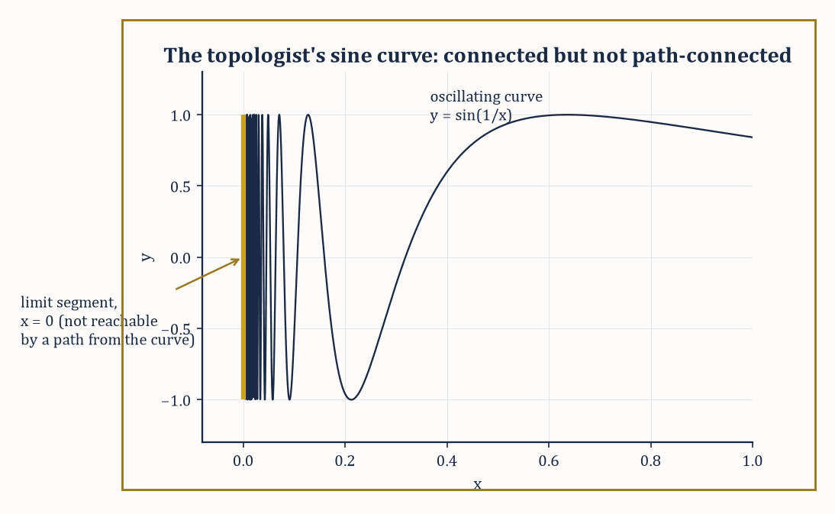
Figure 32.4 — The topologist’s sine curve: the oscillating graph and the vertical segment it accumulates onto form one connected set that no path can cross.
Continuous images of connected spaces are connected: if f: X → Y is continuous and X is connected, then f(X) cannot be disconnected either, since a splitting of f(X) into two disjoint nonempty open pieces would pull back to a splitting of X.
The classical intermediate value theorem is the special case where X is a closed interval [a,b] (connected, since intervals in ℝ are the connected subsets) and f is continuous and real-valued: the image f([a,b]) is connected, hence an interval, hence contains every value between f(a) and f(b).
Numeric example — a disconnection and an intermediate value. First, a disconnection: ℝ minus {0} splits as the union of two disjoint nonempty open sets whose union is the whole punctured line.
ℝ \ {0} = (−∞,0) ∪ (0,∞)
So ℝ minus {0} is disconnected, matching the picture of two separate half-lines with a gap punched in the middle. Now the intermediate value theorem itself: let f(x) = x² − 2 on the connected interval [1,2].
f(1) = 1 − 2 = −1
f(2) = 4 − 2 = 2
Since f is continuous and [1,2] is connected, f([1,2]) is an interval containing both −1 and 2, hence containing 0 — so somewhere in (1,2) there is a root of x² − 2 = 0, namely
x = √2 ≈ 1.41421
Connectedness of the interval is doing all the real work here; the familiar fact that a continuous function cannot skip a value is nothing but the connectedness of [1,2] transported through f.
Try it now — Write a path from (0, 0) to (3, 4) in ℝ². Answer →
The connected components of a space are its maximal connected subsets — every point lies in exactly one component, components are always closed, and the space is connected when it has a single component.
Numeric example — counting the pieces. Let
X = [0,1] ∪ [2,3] ⊂ ℝ
with the subspace topology. Each of [0,1] and [2,3] is connected (both are intervals), and they cannot be joined into a larger connected subset of X, since any subset straddling both would itself split along the gap between 1 and 2 — for instance
U = X ∩ (−1, 1.5) = [0,1]
V = X ∩ (1.5, 4) = [2,3]
are disjoint, nonempty, and open in X, with union all of X. So X has exactly two connected components, [0,1] and [2,3], matching the picture of two separate solid bars with a visible gap between them.
Path-connectedness demands more: X is path-connected if any two points x, y ∈ X can be joined by a continuous path γ: [0,1] → X with γ(0) = x and γ(1) = y.
Every path-connected space is connected (the image of the connected interval [0,1] under a continuous map is connected, and it links x to y), but the converse can fail.
In Euclidean space specifically, open connected sets are always path-connected — one can always thread a polygonal path between any two points of an open connected region — so the two notions coincide for the friendly open regions differential geometry has been living in for the last several chapters. The divergence shows up only once the space is allowed to be less well-behaved, and local connectedness (every point has arbitrarily small connected neighborhoods) and local path-connectedness are the technical conditions that keep the two notions tied together.
Numeric example — a straight-line path. To connect two points of ℝ² explicitly, take x = (0,0) and y = (3,4).
γ(t) = (1−t)x + t·y = (3t, 4t), t ∈ [0,1]
This is a continuous path with γ(0) = (0,0) and γ(1) = (3,4), threading through every point in between:
γ(0.5) = (1.5, 2)
the midpoint of the segment. Since ℝ² is open, connected, and convex, this straight-line trick works for any pair of points at all, confirming directly that ℝ² is path-connected — and hence, since path-connected always implies connected, also confirming that ℝ² is connected, without needing to hunt for a hypothetical disconnection and rule it out by hand.
Abstract example — the topologist’s sine curve. The standard example of connected-but-not-path-connected is the topologist’s sine curve: let S be the graph
{(x, sin(1/x)) : 0 < x ≤ 1}
together with the extra segment
{(0,y) : −1 ≤ y ≤ 1}
on the vertical axis. As x approaches 0 from the right, 1/x blows up and sin(1/x) oscillates through every value in [−1,1] infinitely often, so the curve’s closure necessarily includes the whole vertical segment — which is precisely why S is connected: it cannot be split into two disjoint open pieces, since every neighborhood of a point on the vertical segment meets the oscillating curve.
But S is not path-connected: no continuous path can start on the vertical segment and reach the oscillating part, because any such path would need infinitely many oscillations in a finite time interval near x = 0, which continuity forbids. It is the standard cautionary tale told to anyone tempted to assume connected automatically means path-connected, and it earns its keep in every topology course for that reason.
Keep only this · Section 32.4: Connectedness and Path-Connectedness
The idea. A space is connected if it is not the union of two disjoint nonempty open sets, and path-connected if any two points are joined by a path. Path-connected implies connected, and continuous images of connected spaces are connected — the source of the intermediate value theorem.
Core.
connected: no split into two disjoint nonempty open sets
path-connected ⇒ connected
X connected, f continuous ⇒ f(X) connected
Typical mistake. Assuming the converse. The topologist’s sine curve is connected but not path-connected.
Minimal example. ℝ minus {0} = (−∞, 0) ∪ (0, ∞): disconnected.
Practice. Easy to challenge; full worked answers, with the usual mistake, are in Answers to the Practice Sets at the back.
Easy — How many components does {x ∈ ℝ : x² ≠ 1} have? Answer →
Medium — Use connectedness to show x³ + x − 1 has a root in [0, 1]. Answer →
Challenge — Show that the invertible 2 × 2 real matrices form a disconnected space. Answer →

Section 32.5: Compactness
A Kind of Finiteness, Politely Disguised
Suppose you must light a long corridor, and you may use as many lamps as you like, each throwing a pool of light of whatever size you choose. If the corridor has a far wall, a handful of lamps will do, however you started. If it runs on forever, no finite number of lamps will ever finish the job. That difference is the one this section is about, and it survives in places where words like length and far wall have stopped meaning anything. A space X is compact if every open cover of X — every collection of open sets whose union is the whole of X — contains a finite subcover, a handful of them that still covers everything. Finitely many lamps, always, no matter how the lamps were chosen.
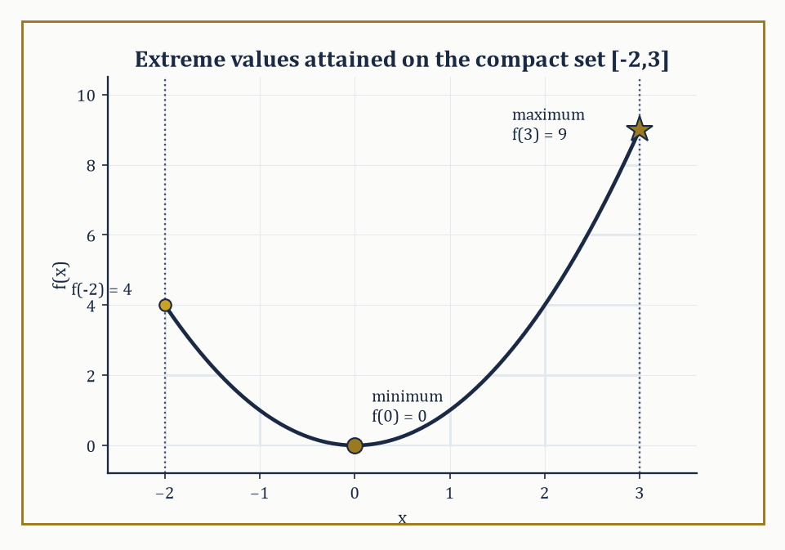
Figure 32.5 — f(x) = x² on the compact interval [−2,3]: the extreme value theorem’s minimum and maximum are not just approached but actually attained, at x = 0 and x = 3.
The definition looks almost too weak to be useful the first time one meets it, since it says nothing about size or boundedness directly; its power only becomes visible once one starts using it.
The intuition worth holding onto is that compactness is the topological stand-in for finiteness: many arguments that work effortlessly on a finite set (a finite set of numbers always has a largest element; a function on a finite set is automatically bounded) turn out, almost unchanged, to work on any compact set as well, however infinite it may be as a set of points. The finite-subcover clause is the mechanism that smuggles a finite argument into an infinite setting, which is why compactness hypotheses show up so relentlessly throughout analysis.
Numeric example — two spaces that fail to be compact, and why. Cover the open interval (0,1) by the sets Uₙ = (1/n, 1) for n = 2, 3, 4, …. Every point of (0,1) lies in some Uₙ (a point x has 1/n < x once n exceeds 1/x), so this is a genuine open cover.
But no finite sub-collection Uₙ₁, …, Uₙₖ covers (0,1): taking N as the largest index among the finitely many chosen, the union of the chosen sets is still just (1/N, 1), which misses every point in (0, 1/N] — for instance the point 1/(2N) is left uncovered.
Since any proposed finite subcover always leaves a point out, no finite subcover exists, and (0,1) is not compact; the failure traces to (0,1) not being closed (it is missing its boundary point 0).
A second, complementary failure: cover the whole line ℝ by Vₙ = (−n, n) for n = 1, 2, 3, …, a genuine open cover since every real number lies in some Vₙ.
Any finite sub-collection has a largest index N, and its union is just (−N, N), which misses N + 1 and every point beyond it — so ℝ is not compact either, this time because it is unbounded rather than because it is missing a boundary point.
Heine–Borel needs both closed and bounded, and these two examples show neither condition alone is enough to spare.
Try it now — Find the largest and smallest values of x² on [−2, 3]. Answer →
In Euclidean space, the Heine–Borel theorem gives a complete and computable answer: a subset of ℝⁿ is compact exactly when it is both closed and bounded.
Continuous images of compact spaces are compact, and a continuous real-valued function on a compact space is automatically bounded and attains both a maximum and a minimum — the extreme value theorem, another classical result from single-variable calculus revealed as a special case of a purely topological fact.
Numeric example — extreme values on a compact set. Let f(x) = x² on the compact set [−2,3] (closed and bounded, hence compact by Heine–Borel).
The minimum occurs at x = 0, since x² ≥ 0 everywhere with equality only at the origin, which lies in the domain.
f(0) = 0
The maximum occurs at whichever endpoint is farther from 0.
f(−2) = 4
f(3) = 9
So the maximum is 9, attained at x = 3. Both extrema are attained, as compactness guarantees — contrast this with f(x) = x² on the non-compact open interval (−2,3), where the supremum is still 9 but is never reached, since x = 3 is excluded from the domain.
Sequential compactness — every sequence has a convergent subsequence — coincides with compactness for metric spaces (this equivalence is the content of the Bolzano–Weierstrass theorem in its topological dress), though the two notions can diverge in more exotic, non-metrizable topological spaces.
Tychonoff’s theorem states that an arbitrary product of compact spaces, even an infinite product, is again compact; the proof requires the axiom of choice, and the result is one of the hardest-working single theorems in analysis and logic, silently underwriting compactness arguments in infinite-dimensional settings where Heine–Borel gives no direct help.
Numeric example — a subsequence that behaves. On the compact interval [−1,1], take the sequence xₙ = (−1)ⁿ, i.e. −1, 1, −1, 1, …. The full sequence does not converge (it oscillates forever), but it has convergent subsequences.
The even-indexed terms x₂, x₄, x₆, … are all 1, converging trivially to 1, and the odd-indexed terms are all −1, converging to −1.
Sequential compactness of [−1,1] only promises some convergent subsequence exists, not that the whole sequence converges — and indeed here there are two, landing on the two different limit points 1 and −1, both comfortably inside the compact set.
Abstract example — an infinite product that stays compact. For a genuinely infinite-dimensional instance, consider the countably infinite product {0,1} × {0,1} × {0,1} × ⋯, each factor the two-point discrete space (certainly compact, being finite).
A point of this product is an infinite sequence of coin-flips, (b₁,b₂,b₃,…) with each bᵢ ∈ {0,1}.
Tychonoff’s theorem guarantees this infinite product is compact in the product topology — by no means obvious from staring at it, since the space has uncountably many points and no finite subcover is remotely visible by inspection.
This particular compact space, incidentally, is homeomorphic to the Cantor set, connecting an abstract existence theorem back to one of the strangest concrete objects in all of analysis.
Keep only this · Section 32.5: Compactness
The idea. A space is compact if every open cover has a finite subcover. In ℝⁿ that means closed and bounded (Heine–Borel); in a metric space, that every sequence has a convergent subsequence. Continuous real functions on compact spaces attain their extremes, and products of compact spaces are compact (Tychonoff).
Core.
compact: every open cover has a finite subcover
ℝⁿ: compact ⇔ closed and bounded
X compact, f: X → ℝ continuous ⇒ f attains max and min
Typical mistake. Thinking bounded is enough. (0, 1) is bounded, and the cover by the intervals (1/n, 1) has no finite subcover.
Minimal example. On [−1, 1], xₙ = (−1)ⁿ has the convergent subsequence 1, 1, 1, …
Practice. Easy to challenge; full worked answers, with the usual mistake, are in Answers to the Practice Sets at the back.
Easy — Which are compact: [0, 1], [0, ∞), {1/n : n ≥ 1} ∪ {0}? Answer →
Medium — Does 1/x attain a maximum on (0, 1]? Why is this no contradiction? Answer →
Challenge — Prove that a closed subset F of a compact space X is compact. Answer →

Section 32.6: Separation Axioms and Countability
How Civilized Is Your Space?
Separation axioms measure how generously a topology allows points and closed sets to be pried apart using open sets.
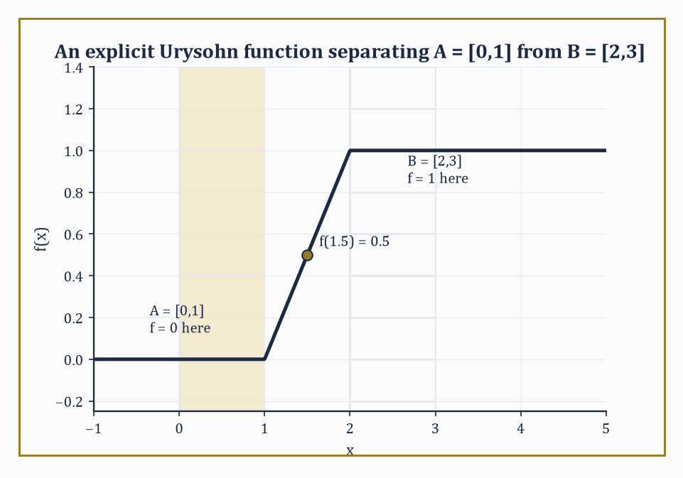
Figure 32.6 — An explicit Urysohn function ramping linearly from 0 on A = [0,1] to 1 on B = [2,3] — the closed sets kept apart, the numbers kept honest.
The hierarchy runs, roughly, T₀ (distinct points have at least one open set containing one but not the other), T₁ (each single point is a closed set), T₂ or Hausdorff (any two distinct points have disjoint open neighborhoods), regular and T₃ (a point and a closed set not containing it can be separated by disjoint open sets), and normal and T₄ (any two disjoint closed sets can be separated by disjoint open sets).
Hausdorff is the working assumption of almost all of analysis: in a Hausdorff space, compact subsets are automatically closed, and limits of sequences, when they exist, are unique — without the Hausdorff property, a sequence can legitimately converge to two different points at once, the kind of pathology one wants to rule out before doing calculus.
Abstract example — T₀ without T₁. Recall the Sierpiński space Y = {1,2} with topology { ∅, {1}, Y }.
It is T₀: the open set {1} contains 1 but not 2, enough to distinguish them.
But it fails T₁: T₁ requires every singleton to be closed, and {1} is closed only if its complement {2} is open — but {2} is not among the three sets in the topology, so {1} is not closed, and Y fails T₁.
It therefore also fails Hausdorff, since Hausdorff would require disjoint open neighborhoods separating 1 from 2, and the only open set containing 2 at all is Y itself, which also contains 1.
Try it now — In Sierpiński space {1, 2} with open sets ∅, {1}, {1, 2}, is there an open set containing 2 but not 1? Answer →
Abstract example — T₁ without Hausdorff. For a subtler example, return to the cofinite topology on an infinite set, say ℝ (open sets: complements of finite sets, plus ∅).
This space is T₁: every singleton {x} is closed, since its complement is ℝ minus {x}, cofinite and hence open.
But it is not Hausdorff: take any two distinct points x ≠ y and any open sets U ∋ x, V ∋ y.
Each has finite complement, so U ∩ V has complement equal to the union of two finite sets — still finite — meaning U ∩ V is cofinite, and in particular nonempty (an infinite set minus a finite set is never empty).
So U and V can never be made disjoint, however cleverly chosen, and the cofinite topology on an infinite set satisfies T₁ without satisfying Hausdorff — the standard example showing the separation hierarchy really does have distinct rungs.
Countability axioms measure the size of the topology’s bookkeeping rather than its separating power.
A space is first-countable if every point has a countable neighborhood basis; second-countable if the whole topology has a countable basis; and separable if it contains a countable dense subset.
Second-countable spaces are automatically separable and Lindelöf (every open cover has a countable subcover), and manifolds are conventionally required to be second-countable precisely so that they admit countable atlases and partitions of unity — the technical infrastructure differential geometry, in the previous chapter, quietly relied on throughout.
Numeric example — ℝ is second-countable and separable. ℝ with its usual topology is second-countable: the collection of open intervals (p,q) with p, q rational forms a countable basis, since there are only countably many pairs of rationals, and every open subset of ℝ is a union of such intervals.
ℝ is also separable, witnessed directly by ℚ itself: every real number is a limit of rationals — for instance:
1.4, 1.41, 1.414, 1.4142, … converges to √2
— so ℚ, a countable set, is dense in ℝ.
These are the same underlying fact wearing two different hats — a countable basis of intervals and a countable dense set of points — and the equivalence between them is just what second-countability buys you.
Urysohn’s lemma is the payoff for working in a normal space: given two disjoint closed sets A and B, there exists a continuous function
f: X → [0,1], with f ≡ 0 on A and f ≡ 1 on B
The Tietze extension theorem strengthens this further, allowing any continuous real-valued function defined on a closed subset to be extended continuously to the entire space.
Together they are the bridge from the purely qualitative world of open and closed sets back into the world of honest, computable, real-valued functions — the world analysis wants to work in.
Numeric example — an explicit Urysohn function. On ℝ (normal, being metric), take the disjoint closed sets:
A = [0,1], B = [2,3]
An explicit Urysohn function is given piecewise, ramping linearly from 0 to 1 across the gap between the two closed sets:
f(x) = 0 for x ≤ 1
f(x) = x − 1 for 1 ≤ x ≤ 2
f(x) = 1 for x ≥ 2
Check continuity at the joins. At x = 1, the left piece gives f(1) = 0 and the middle piece gives:
f(1) = 1 − 1 = 0
matching. At x = 2, the middle piece gives:
f(2) = 2 − 1 = 1
and the right piece gives f(2) = 1, matching again. And at the midpoint of the gap:
f(1.5) = 1.5 − 1 = 0.5
halfway between the two target values, as the linear ramp promises.
This one function, built by hand in thirty seconds, is already an instance of Urysohn’s lemma in action — the general theorem guarantees such a function exists even when the two closed sets are too gnarled to write a formula down by inspection.
Keep only this · Section 32.6: Separation Axioms and Countability
The idea. Separation axioms say how well open sets separate points and closed sets: T₀, T₁, Hausdorff (T₂), regular, normal. Countability axioms limit size: a second-countable space has a countable basis. Metric spaces are normal, and Urysohn’s lemma builds continuous functions that separate closed sets.
Core.
Hausdorff: distinct points have disjoint neighborhoods
normal: disjoint closed sets have disjoint neighborhoods
Urysohn: continuous f with f = 0 on A and f = 1 on B
Typical mistake. Assuming limits are unique in every space. In the cofinite topology on ℝ the sequence 1, 2, 3, … converges to every point.
Minimal example. ℝ: intervals with rational endpoints form a countable basis.
Practice. Easy to challenge; full worked answers, with the usual mistake, are in Answers to the Practice Sets at the back.
Easy — Is ℝ with the discrete metric second-countable? Answer →
Medium — Write a Urysohn function on ℝ for A = (−∞, 0] and B = [1, ∞). Answer →
Challenge — Show that the cofinite topology on ℝ is T₁ but not Hausdorff. Answer →

Section 32.7: Homotopy and the Fundamental Group
Counting Holes for a Living
A rubber band on a table can be slid into any other loop on the table. Put it round a post and it cannot be removed without cutting it or lifting it over the top. That difference is exactly what topology measures with loops. Two loops count as the same if one can be deformed into the other without breaking, and the different kinds of loop that remain, together with the rule for following one loop after another, form the fundamental group of a space. A flat disk has only one kind of loop. A doughnut’s surface has loops that go round the hole, loops that go through it, and combinations, so the group detects its holes.
Two continuous maps f, g: X → Y are homotopic if there is a continuous family of maps H: X × [0,1] → Y, a homotopy, interpolating between them, so that at the endpoints of the time parameter it agrees with f and g:
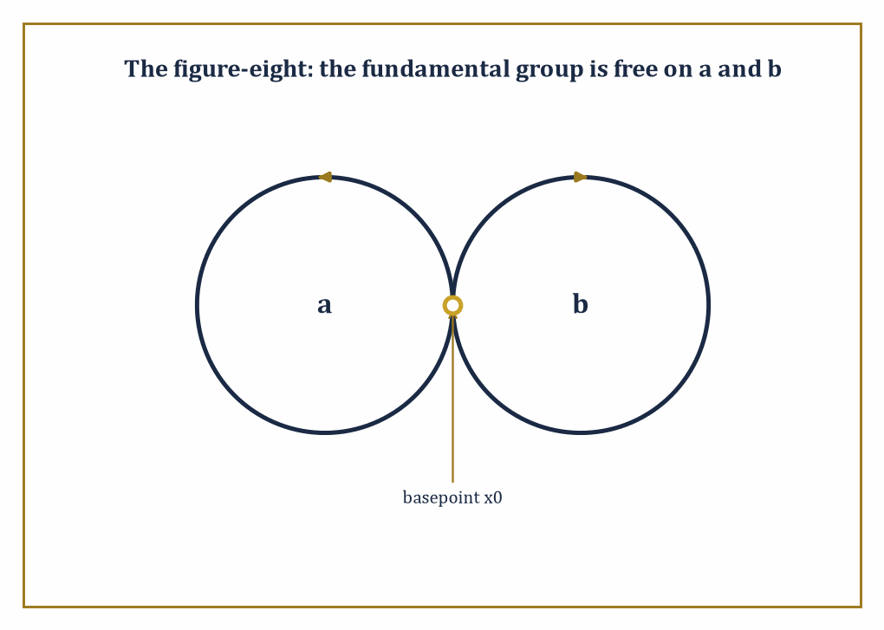
Figure 32.7 — The figure-eight’s two lobes, a and b, generate its fundamental group freely — with no filled-in square behind them to let one loop slide past the other and force them to commute.
H(x,0) = f(x), H(x,1) = g(x) for every x
Think of the parameter t ∈ [0,1] as time, and H(·,t) as a film showing f smoothly morphing into g.
Homotopy is an equivalence relation and is compatible with composition, so it descends to a sensible notion of sameness up to continuous deformation for maps, not just for spaces.
A space X is contractible if the identity map on X is homotopic to a constant map — informally, if X can be continuously shrunk down to a single point without leaving X.
Numeric example — sliding one point to another, and shrinking a plane. In ℝ² (or any convex subset of it), any two continuous maps f, g: X → ℝ² are homotopic via the straight-line homotopy, sliding each image point along the segment from f(x) to g(x):
H(x,t) = (1−t)f(x) + t·g(x)
Take X a single point, f the constant map to (2,3), and g the constant map to (0,0). Then:
H(t) = (1−t)(2,3) + t(0,0) = (2(1−t), 3(1−t))
At t = 0, H = (2,3); at t = 0.5, H = (1, 1.5); at t = 1, H = (0,0)
That is a straight, continuous slide from one point to the other.
The same recipe applied to the identity map on all of ℝ², homotoped to the constant map at the origin, shows ℝ² itself is contractible:
H(x,t) = (1−t)x
Every point slides straight in to the origin as t runs from 0 to 1, and at t = 1 the whole plane has collapsed onto a single point.
Try it now — Write a homotopy from the loop (cos t, sin t) to the constant loop (0, 0) in ℝ². Answer →
Fix a basepoint x₀ ∈ X. The fundamental group π₁(X,x₀) is the set of homotopy classes of loops based at x₀ — continuous maps γ: [0,1] → X satisfying:
γ(0) = γ(1) = x₀
Two loops count as homotopic if one can be continuously deformed into the other while keeping the basepoint fixed throughout.
The group operation is concatenation — run one loop, then the other, at double speed to fit into the same time interval — and this satisfies the group axioms up to homotopy, with the constant loop at x₀ as identity and a loop run backwards as its inverse.
π₁ is a topological invariant: homeomorphic spaces have isomorphic fundamental groups, based at corresponding points, for path-connected spaces where the basepoint choice does not matter.
Numeric example — concatenating two loops. Concatenation is defined piecewise: for loops γ, δ based at x₀,
(γ ∗ δ)(t) = γ(2t) for t ∈ [0, 1/2], and δ(2t − 1) for t ∈ [1/2, 1]
That is, run γ in the first half of the time available, δ in the second half, each compressed to fit. Now concatenate the winding-number-1 loop
γ₁(t) = (cos 2πt, sin 2πt)
with itself, and check continuity at the join, t = 1/2:
γ₁(2t) at t = 1/2 gives γ₁(1) = (1,0), matching γ₁(0) = (1,0)
So the join is continuous. Over the first half the loop winds around once; over the second half it winds around once more; the concatenation has total winding number
1 + 1 = 2
matching γ₂ from the example below and confirming that the group operation on π₁(S¹) really does correspond to addition of integers under the winding-number isomorphism.
Numeric example — winding number two on the circle. For the circle S¹, the fundamental group π₁(S¹) is the infinite cyclic group ℤ, and the isomorphism has a concrete description: it sends a loop to its winding number, the signed number of times the loop travels around the circle. Take the loop
γₙ(t) = (cos 2πnt, sin 2πnt), for an integer n
This loop starts and ends at (1,0) and winds around exactly n times. For n = 2, trace it step by step:
t = 0: γ₂(0) = (1,0)
t = 1/4: 2π·2·(1/4) = π, cos π = −1, sin π = 0, so γ₂(1/4) = (−1,0)
t = 1/2: 2π·2·(1/2) = 2π, so γ₂(1/2) = (1,0)
t = 3/4: 2π·2·(3/4) = 3π, so γ₂(3/4) = (−1,0)
t = 1: 2π·2·1 = 4π, so γ₂(1) = (1,0)
That’s two full laps — winding number 2, corresponding to the element 2 ∈ ℤ. No two loops with different winding numbers are homotopic, since a loop cannot be unwound without cutting it as it crosses the hole — which is why π₁(S¹) is infinite rather than trivial or finite.
The torus has fundamental group ℤ × ℤ, generated by two independent loops — one going around the long way through the hole, one going the short way around the tube — that commute with each other, since the two loops can slide past one another on the surface.
The figure-eight, two circles joined at a single point, has fundamental group free on two generators, one loop per lobe, and crucially these do not commute: going around the left lobe then the right is not homotopic to right-then-left, since there is no section on a figure-eight for one loop to slide past the other the way there was on the torus.
Abstract example — why the torus’s two loops commute. Picture the torus as a square with opposite sides identified: the bottom edge glued to the top edge produces the loop b (the long way through the hole), the left edge glued to the right edge produces the loop a (the short way around the tube).
Tracing a then b runs along the bottom edge and then up the right edge of the square; tracing b then a runs up the left edge and then along the top edge.
Because the whole square is filled in — it is a solid 2-cell, not just its boundary — one path can be slid continuously across that filled interior onto the other, so the loop a, then b, then a backwards, then b backwards, is homotopic to the constant loop at the corner:
aba⁻¹b⁻¹ ≃ constant loop at the corner
and a and b commute as ℤ × ℤ requires. The figure-eight has no such filled square lurking behind its two loops, which is why its two generators are free to disagree about order rather than being forced to agree.
The Seifert–van Kampen theorem lets one compute the fundamental group of a space built by gluing two open pieces U, V together along a path-connected overlap, in terms of π₁(U), π₁(V), and π₁(U ∩ V):
π₁(U ∪ V) ≈ π₁(U) ∗ π₁(V), with relations imposed by however loops in the overlap map into each piece
Abstract example — van Kampen on the figure-eight. Apply the theorem directly to the figure-eight: let U be a small neighborhood of the left circle, deformation-retracting onto it, and V a small neighborhood of the right circle, likewise deformation-retracting, so that:
π₁(U) ≅ ℤ, π₁(V) ≅ ℤ
The two neighborhoods overlap only in a small contractible patch around the shared basepoint, where π₁(U ∩ V) is trivial. With no relations imposed by the trivial overlap group, Seifert–van Kampen gives:
π₁(figure-eight) = ℤ ∗ ℤ
exactly the free group on two generators asserted above — the general gluing theorem reproducing, from a formula, the answer stated by direct inspection two paragraphs earlier, which is reassuring in the way two independent routes to the same destination always are.
Same structure, new language
π₁ is a group in the sense of Groups and Homomorphisms, and a continuous map induces a homomorphism of fundamental groups. Turning spaces into groups and maps into homomorphisms is an early example of a functor, the subject of Category Theory (Volume 4).
Keep only this · Section 32.7: Homotopy and the Fundamental Group
The idea. Two maps are homotopic if one deforms continuously into the other. Loops up to homotopy form the fundamental group π₁: π₁(S¹) = ℤ by winding number, π₁(torus) = ℤ², and van Kampen’s theorem computes π₁ of glued spaces — the figure-eight gives the free group on two generators.
Core.
π₁(S¹) ≅ ℤ (winding number)
π₁(torus) ≅ ℤ × ℤ
π₁(figure-eight) ≅ free group on a, b
Typical mistake. Assuming π₁ is commutative. In the figure-eight, ab and ba are different loops.
Minimal example. Every convex subset of ℝⁿ has trivial π₁.
Practice. Easy to challenge; full worked answers, with the usual mistake, are in Answers to the Practice Sets at the back.
Easy — Find the winding number of t ↦ (cos 3t, sin 3t), 0 ≤ t ≤ 2π. Answer →
Medium — γ winds twice around the circle and δ winds −1 times. What is the winding number of γ followed by δ? Answer →
Challenge — Explain why the two basic loops a and b of the torus commute. Answer →

Section 32.8: Covering Spaces and Classification of Surfaces
The Complete List, No Exceptions
Walk once round a spiral staircase and you arrive above where you began, not back at it. Seen from directly overhead, though, you have gone round a circle and returned to the start. The staircase and the circle sit over one another: every point of the circle has a whole column of stairs above it, and a short stretch of circle lifts to a short flight you could walk without noticing the spiral at all. The staircase has unwound something the circle keeps hidden — the fact that going round and coming back are different acts. A covering space of a base space X is a space X̃ with a map p: X̃ → X that is a local homeomorphism with discrete fibers: the staircase, the overhead view, and the column of steps above each point.
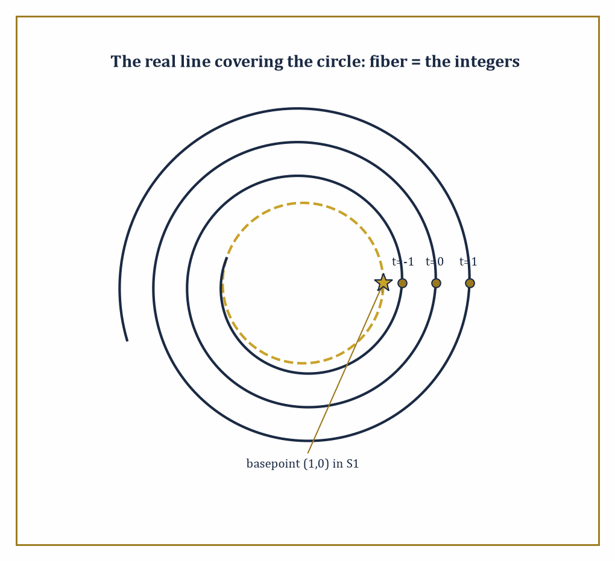
Figure 32.8 — The real line spirals endlessly above the circle’s basepoint (1,0); each integer t marks one more sheet of the cover, and the entire tower unwinds the one loop the circle cannot shrink away.
Concretely, every point of X has an open neighborhood U such that p⁻¹(U) splits into disjoint open copies of U, each mapped homeomorphically onto U by p — the classic image is a spiral staircase or parking-garage ramp lying above a circle on the ground, wrapping around it repeatedly.
The word local is doing serious work in that definition: p need not be a homeomorphism globally — indeed the whole point of the construction is usually that it is not, since it is the many-to-one wrapping that lets a simply connected space like the staircase sit above a space with a genuine hole, like the circle at its base.
Numeric example — the line covering the circle. The standard example is p: ℝ → S¹, wrapping the real line around the circle infinitely many times, given by the map below.
p(t) = (cos 2πt, sin 2πt)
Take the base point (1,0) ∈ S¹; its fiber, p⁻¹((1,0)), is the set of all t satisfying the two conditions below.
cos 2πt = 1 and sin 2πt = 0
These conditions hold exactly when t is an integer, so the fiber is a discrete copy of the integers sitting inside ℝ:
p⁻¹((1,0)) = {…,−2,−1,0,1,2,…} = ℤ
Near (1,0), a small arc of the circle lifts to infinitely many disjoint small intervals on ℝ, one around each integer, and p restricted to any one of them is a homeomorphism onto the arc — the local-homeomorphism-with-discrete-fibers picture the definition demands.
Try it now — For p(t) = (cos 2πt, sin 2πt), which t map to (1, 0)? Answer →
The fundamental group of the base acts on the fiber above the basepoint, and this action turns out to encode the entire classification: covering spaces of X (with X reasonably well-behaved) correspond to subgroups of π₁(X), up to a natural notion of equivalence.
The trivial subgroup corresponds to the universal cover — the most unwound covering space, itself only connected, from which every other covering space can be built as a further quotient.
Abstract example — the double cover of the circle. For S¹, the subgroup 2ℤ ⊂ ℤ = π₁(S¹) — the even integers, index 2 in the full group — corresponds to the double cover q: S¹ → S¹, given below.
q(z) = z², or equivalently q(θ) = 2θ on angles
A loop winding once around the base circle (winding number 1) does not lift to a closed loop at all: it lifts to an open path that travels only halfway around the covering circle, ending at the point diametrically opposite where it started.
Only loops whose winding number is a multiple of 2 lift to closed loops upstairs, matching the subgroup 2ℤ.
The universal cover of S¹, corresponding to the trivial subgroup {0} ⊂ ℤ, is the ℝ → S¹ covering from the previous example. ℝ is simply connected, so there is nowhere further to unwind, and every other cover of the circle sits between ℝ and S¹ in this hierarchy of subgroups.
Closed surfaces — compact, connected, boundaryless two-dimensional manifolds — are completely classified up to homeomorphism by two pieces of data: orientability, and genus, the number of handles.
The orientable ones form the sequence: the sphere (genus 0, no handles), the torus (genus 1, one handle), the double torus (genus 2, two handles glued in a connected sum), and so on.
The non-orientable ones are built from connected sums of projective planes: the projective plane itself, the Klein bottle (the connected sum of two projective planes), and further sums beyond that.
Every closed surface, however wildly it is presented, is homeomorphic to exactly one entry on this list — one of the genuinely complete classification theorems in all of topology, and the historical template every later, harder classification problem in topology has tried, usually without success, to imitate.
Numeric example — reading off genus from the Euler characteristic. The Euler characteristic — vertices minus edges plus faces, for any polyhedral decomposition of the surface — is a complete invariant distinguishing genus, given by the formula below.
χ = V − E + F
For an orientable surface of genus g, it relates to the genus by the formula below.
χ = 2 − 2g
Take a cube: it has 8 vertices, 12 edges, and 6 faces, giving the Euler characteristic below.
χ = 8 − 12 + 6 = 2
Solving for the genus gives the result below, correctly identifying the cube’s surface as topologically a sphere — which indeed it is, since rounding off the corners deforms it straight into one.
2 = 2 − 2g, so g = 0
For the double torus, genus g = 2 by construction, so the Euler characteristic works out as shown below.
χ = 2 − 2(2) = 2 − 4 = −2
This negative Euler characteristic reflects that each additional handle punches the count down by 2, offering a clean numeric fingerprint for a shape that would otherwise take some effort to describe in words.
This same Euler characteristic reappears, unexpectedly from the topological side, as the topological half of the Gauss–Bonnet theorem from the previous chapter: the integral of Gaussian curvature K over the surface equals 2πχ.
The left-hand side is a purely geometric, distance-dependent quantity; the right-hand side is a purely topological invariant that does not care how the surface is bent or measured, only how many handles it has.
That a curvature integral, which visibly depends on the metric, always collapses to a multiple of a topological invariant that does not depend on the metric at all, is as good a one-line summary as any of why geometry and topology insist on talking to each other.
It also settles, in one stroke, a question that might otherwise seem to require checking every possible metric one at a time: no matter how a torus is bent, stretched, or dented, the total curvature spread across it always integrates to the value below (since χ(torus) = 0).
2π·0 = 0
This is because bending the surface can move curvature around from one region to another but can never change the topological total it is required to sum to.
Keep only this · Section 32.8: Covering Spaces and Classification of Surfaces
The idea. A covering map looks locally like a stack of copies of the base. Paths lift uniquely, which computes π₁(S¹), and subgroups of π₁ correspond to covering spaces. Closed surfaces are classified by orientability and Euler characteristic.
Core.
ℝ → S¹, t ↦ (cos 2πt, sin 2πt)
χ = V − E + F
closed orientable surface of genus g: χ = 2 − 2g
Typical mistake. Classifying by χ alone. The torus and the Klein bottle both have χ = 0; orientability separates them.
Minimal example. Double cover S¹ → S¹, z ↦ z².
Practice. Easy to challenge; full worked answers, with the usual mistake, are in Answers to the Practice Sets at the back.
Easy — Find χ for the surface of a cube. Answer →
Medium — A closed orientable surface has χ = −4. What is its genus? Answer →
Challenge — Lift the loop that winds twice around S¹ to ℝ, starting at 0, and then to the double cover z ↦ z². Answer →

Section 32.9: Looking Ahead: From Basic Topology to Algebraic Topology and Manifolds
Onward, Upward, Still No Ruler
We have, in the space of eight sections, built the working core of point-set topology and taken the first real steps into algebraic topology: topological spaces and continuous maps, connectedness and compactness as the two basic global invariants, the separation and countability axioms that keep spaces well-behaved enough for analysis, homotopy and the fundamental group as our first algebraic invariant, and covering spaces and the classification of closed surfaces as the reward for all the machinery — a complete, checkable answer to the question of what shapes a closed surface can actually be.
It is worth pausing on how much of that list needed no numbers at all. Connectedness, compactness, and the fundamental group were each defined without ever writing down a distance, and yet each one was strong enough to prove genuine, sharp, previously-unobvious facts — that a circle is not a disk, that a bounded interval is secretly the same shape as the whole real line, that a doughnut and a two-holed pretzel are different no matter how one is squashed toward the other.
The emptiness promised on this chapter’s opening page turned out, true to form, to be exactly the source of the strength.
These tools open directly onto the rest of the subject. Higher homotopy groups πₙ(X) for n ≥ 2 generalize the fundamental group to loops of higher dimension (a map from the n-sphere rather than the circle); homology and cohomology theories offer computationally friendlier invariants that, unlike the higher homotopy groups, are almost always tractable to calculate, at some cost in discriminating power.
Manifold topology narrows attention to spaces that look locally like Euclidean space, and becomes the shared setting of differential topology and geometric topology, where the classification triumph of Covering Spaces and Classification of Surfaces is attempted, with much greater difficulty and several dimensions higher, for 3-manifolds and 4-manifolds — a project that consumed a fair fraction of twentieth-century mathematics and is nowhere near as finished as the surface case might lead one to hope.
Abstract example — a fundamental group that misses something. Consider S², the ordinary sphere. Its fundamental group π₁(S²) is trivial — any loop on a sphere can be slid off to one side and shrunk to a point, since the sphere has no hole for a loop to catch on.
But its second homotopy group π₂(S²) is ℤ, detected by the identity map from S² to itself, which cannot be continuously deformed to a constant map (a fact provable rigorously via degree theory).
More strikingly still, π₃(S²) is also infinite cyclic — the celebrated Hopf fibration, an honestly surprising fact that no amount of staring at loops alone could have revealed.
The fundamental group, powerful as it is, is blind to structure that only shows up one or two dimensions higher, which is the gap the higher homotopy groups and homology theories exist to close.
Try it now — What is π₁(S²), and is S² contractible? Answer →
Abstract example — what homology forgets, on purpose. Homology’s tractability comes largely from a theorem of Hurewicz relating it back to the fundamental group: for a path-connected space, the first homology group H₁(X) is the abelianization of π₁(X) — the same group with a new relation forced on it, that every pair of elements commutes.
Recall from earlier in this section that π₁(figure-eight) is the free group on two generators a and b, where a and b do not commute: the element aba⁻¹b⁻¹ (go around the left lobe, then the right, then backward around the left, then backward around the right) is not the identity in the free group, since nothing forces the loops to slide past each other.
Pass to the abelianization, however, and aba⁻¹b⁻¹ becomes, once commuting is allowed to reorder the letters:
ab a⁻¹ b⁻¹ = (aa⁻¹)(bb⁻¹) = e
So:
H₁(figure-eight) = ℤ × ℤ
That is strictly smaller information than π₁(figure-eight) itself. Homology, in other words, is the fundamental group with all the non-commuting detail sanded off: easier to compute, because there is provably less of it to compute.
Further out still, characteristic classes and cobordism theory extract algebraic invariants from manifolds equipped with extra structure — a vector bundle, an orientation — and these feed directly into index theorems, results equating an analytic quantity (counting solutions to a differential equation) with a topological one (an integral of characteristic classes), and into the gauge theory used in mathematical physics, where the topology of a space of fields constrains the physics living on it.
The flagship result of manifold topology in dimension three is the Poincaré conjecture: every simply connected closed 3-manifold is homeomorphic to the 3-sphere S³, a claim that sounds like nothing more than a three-dimensional cousin of the surface classification in Covering Spaces and Classification of Surfaces, and which resisted proof for very nearly a century until Grigori Perelman settled it in 2003 — fittingly enough, using Ricci flow, a tool borrowed from the previous chapter’s subject rather than from topology’s own toolkit.
Its four-dimensional analogue remains open to this day, a reminder that the tidy, finished classification of surfaces was a nineteenth-century gift that later dimensions have been under no obligation to repeat.
The throughline connecting all of it back to this chapter’s opening page is simple to state and endlessly productive in practice: continuity alone, with no distance in sight, is already a powerful organizing principle, and the qualitative shape of a space can be captured by algebraic invariants that are both computable and discriminating.
We arrived at the top of this chapter having built, from nothing but open sets and continuity, a working vocabulary for shape itself: connectedness for being in one piece, compactness for a kind of topological finiteness, separation axioms for civility, and a fundamental group sharp enough to prove, by pure algebra, that a circle is not a disk and a sphere is not a torus. Along the way we recovered the classification of closed surfaces — genus and orientability, the complete list, no exceptions — one of the great satisfying finished theorems of the subject, in a field not otherwise overflowing with finished theorems.
The next chapter puts a surprising amount of the ruler back. Integral geometry asks what happens when one integrates, not over a space of points, but over a space of lines, planes, or other geometric objects sweeping through it — Crofton’s formula, the kinematic measure, and their descendants recover geometric quantities like length and area by averaging over how often a random line happens to cross a curve. It is, in a sense, geometry and topology meeting each other halfway: the measuring apparatus returns, but organized by the kind of global, qualitative thinking this chapter has spent its length cultivating.
We have learned, at any rate, to recognize shape without measuring distance. Not a bad trick for a subject whose opening definitions look, on first meeting, almost too thin to hold any weight at all. The series continues.
Keep only this · Section 32.9: Looking Ahead: From Basic Topology to Algebraic Topology and Manifolds
The idea. The fundamental group misses higher-dimensional holes; homology and the higher homotopy groups detect them. Manifolds — spaces locally like ℝⁿ — are where topology meets calculus.
Core.
H₁ = abelianization of π₁ (path-connected spaces)
π₂(S²) ≅ ℤ
Typical mistake. Concluding a space is contractible because π₁ is trivial. S² is the standard counterexample.
Minimal example. S²: π₁ trivial, H₂ ≅ ℤ.
Practice. Easy to challenge; full worked answers, with the usual mistake, are in Answers to the Practice Sets at the back.
Easy — Abelianize the free group on a and b. Answer →
Medium — Find H₁ of the torus. Answer →
Challenge — Find H₁ of the closed orientable surface of genus 2. Answer →
Chapter 32 recap · Topology
• Topology studies what survives continuous deformation; invariants tell spaces apart.
• Metric spaces bring ε–δ continuity, completeness and Banach’s fixed point theorem; topological spaces keep only the open sets.
• Connected spaces map to connected images (intermediate values); compact spaces give finite subcovers and attained extremes.
• Separation axioms decide how well points and closed sets can be pulled apart; metric spaces are normal.
• The fundamental group counts loops up to deformation: π₁(S¹) = ℤ, π₁(torus) = ℤ²; covering spaces compute it.
• Closed surfaces are classified by orientability and Euler characteristic; higher invariants need homology.

Check Your Understanding — Chapter 32
Answers are in the Answer Key at the back of the book — have a go before you look.
1. [Explain] The disk D² is contractible with trivial fundamental group, while the circle S¹ has fundamental group ℤ. Why does this already prove S¹ and D² are not homeomorphic, without any picture of bending or stretching?
See the answer →
2. [Explain] Using the open cover Uₙ = (1/n, 1) for n = 2, 3, 4, …, explain why the open interval (0,1) fails to be compact.
See the answer →
3. [Explain] Give an example of a space that is connected but not path-connected, and explain briefly why it fails to be path-connected.
See the answer →
4. [Compute] A closed orientable surface has Euler characteristic χ = −2. What is its genus, and which surface is it?
See the answer →
5. [Compute] Show that (0, 1) and ℝ are homeomorphic, then show that [0, 1] is homeomorphic to neither. What single property separates them?
See the answer →
6. [Compute] Which of these subsets of ℝ are compact: [0, 1], (0, 1), {1/n : n ∈ ℕ}, and {0} ∪ {1/n : n ∈ ℕ}? Justify each by Heine–Borel.
See the answer →
7. [Compute] Find the interior, closure and boundary of ℚ ∩ [0, 1] as a subset of ℝ, and say what this reveals.
See the answer →
8. [Compute] Compute the Euler characteristic of the sphere and of the torus from triangulations, and state the genus formula.
See the answer →
9. [Concept] Compactness is often described as the next best thing to being finite. In what sense is that accurate?
See the answer →
10. [Explain] Why is continuity defined by preimages of open sets rather than by ε and δ, when the two agree on metric spaces?
See the answer →
11. [Explain] What goes wrong without the Hausdorff condition, and why is it assumed almost everywhere?
See the answer →
12. [Prove] Prove that the continuous image of a compact space is compact.
See the answer →
13. [Prove] Prove that the continuous image of a connected space is connected.
See the answer →
14. [Prove] Prove that a compact subset of a Hausdorff space is closed.
See the answer →
15. [Prove] Prove that [0, 1] is connected.
See the answer →
16. [Prove] Prove that a continuous bijection from a compact space to a Hausdorff space is a homeomorphism.
See the answer →
17. [Prove] Prove that the fundamental group of the circle is isomorphic to ℤ.
See the answer →
18. [Prove] Prove that the product of two connected spaces is connected.
See the answer →
19. [Challenge] The fundamental group can be non-abelian. What is it detecting that a mere hole count cannot?
See the answer →
20. [Challenge] Surfaces are completely classified, yet three-manifolds resisted for a century. Why should one extra dimension matter so much?
See the answer →
21. [Challenge] Brouwer’s fixed point theorem is a statement about continuous maps of a disk. Why is it really a theorem about holes?
See the answer →
22. [Challenge] You cannot comb a hairy ball flat, but you can comb a hairy torus. What distinguishes them?
See the answer →
23. [Challenge] Persistent homology applies topology to noisy data. How can a discipline that ignores distance say anything about measurements?
See the answer →
24. [Challenge] Chapter 31 measured curvature; this chapter discards it. What is the general principle about discarding structure?
See the answer →

Problems — Chapter 32
The questions above test whether the ideas landed. These ask you to use them. Solutions are in Solutions to the Problems at the back. Work them before you look.
1. [Explain] Remove one point from the real line, and remove one point from the plane. Which of the two remains path-connected, and why?
2. [Compute] A tetrahedron has 4 vertices, 6 edges, and 4 faces. Compute its Euler characteristic. Which surface does that match?
3. [Explain] The circle has fundamental group ℤ. The torus is a product of two circles. What is the fundamental group of the torus, and why is it not ℤ?
4. [Compute] A closed orientable surface has Euler characteristic −4. What is its genus?

Math, Actually

Chapter 33

Integral Geometry (Advanced)
Valuations, Kinematic Formulas, and the Art of Measuring Geometry with Groups
You have just spent an entire chapter being assured that shape, in the end, does not matter. A teacup and a doughnut are, to a topologist squinting through sufficiently smudged spectacles, the same object, and questions like ‘how long is it’ or ‘how much does it hold’ were treated as vulgar distractions from the real business of counting holes. It was liberating, in the way that being told your possessions don’t matter is liberating right up until the bailiffs arrive with a tape measure. Here in the thirty-third chapter we reverse the polarity entirely.
Shape matters again. Size matters again, and rather badly. We are going to spend a great deal of effort insisting that certain numbers attached to a solid lump of space — its volume, its surface area, something engagingly called its ‘mean width’, and one stubborn old acquaintance, the Euler characteristic, last seen counting holes in topology — are not merely well defined, but are, in a precise sense that this chapter exists to make precise, the only numbers of their kind that could possibly exist.
Long ago, back in Chapter 19 (Volume 2), we built the classical apparatus of integral geometry: invariant measures on the space of lines and planes, the Cauchy–Crofton theorem relating the length of a curve to how often random lines cross it, and the first, elementary kinematic formulas — averages, taken as one convex body is jiggled and rotated past another, that come out to tidy closed forms. That chapter’s tools were concrete: pick a line at random, count intersections, integrate. This chapter’s tools are the same tools with the safety catches removed. Instead of asking ‘what happens when I average over lines’, we ask ‘what is the complete space of quantities that COULD be averaged, and what algebraic structure does it carry’. The answer turns out to be startlingly small and startlingly rigid, and once you know it, every kinematic formula you will ever need writes itself.
The central actors are continuous valuations on convex bodies — functionals that behave like area or volume in the one respect that matters (they add up correctly when you glue pieces together) without necessarily being area or volume. Hadwiger’s characterization theorem will tell us, astonishingly, that there are only finitely many independent invariant valuations in each dimension: the intrinsic volumes, full stop, nothing else need apply.
Chern’s principal kinematic formula will tell us how these interact when one body is swept past another by the full group of rigid motions. And curvature measures will localize all of this, spreading the intrinsic volumes out over the boundary of a body the way a smeared-out density spreads mass over a solid. The whole enterprise leans on the classical material of Chapter 19 (Volume 2) and on the language of convex geometry and differential forms, so if either has gone a little soft in the memory, a glance backward will not go amiss. Nothing here requires more than that.
A small confession, before we begin: advanced integral geometry has a well-earned reputation for being a very long list of very structured formulas, the kind of subject that looks, from the outside, like a phone directory with theorems in it. It stops looking that way the moment you notice that every entry in the list is a consequence of one principle — the uniqueness of invariant valuations, married to the algebraic structure of the kinematic product — so that the geometry is, quite literally, encoded in the representation theory of the motion group. Classical integral geometry taught us to average geometric quantities over lines and planes. The modern theory teaches us to let the entire group of rigid motions act, all at once, and to read the geometry off as an algebraic identity. Let’s let the group measure.
Optional advanced excursion
This chapter is an excursion beyond the main line of the volume. Nothing in Chapters 34–37 depends on it; skip it on a first reading and come back when you want the modern theory behind Integral Geometry (Volume 2).
Sections 33.1–33.6 carry the main story: valuations, intrinsic volumes, Hadwiger’s theorem, the kinematic formulas and their applications. The two deepest topics are collected at the end in clearly labelled advanced sections: Curvature Measures and the Normal Cycle (Advanced) and The Algebra of Valuations (Advanced). The rest of the chapter mentions them only in passing.
Before you begin — Chapter 33
By the end of this chapter you will be able to:
1. Check the valuation law and use inclusion–exclusion on convex bodies.
2. Compute intrinsic volumes from Steiner’s formula and perimeters from Cauchy’s formula.
3. Use Hadwiger’s theorem to pin down an invariant valuation from a few values.
4. Evaluate the principal kinematic formula in the line and the plane.
5. Apply Crofton-type formulas, stereology and geometric probability.
6. (Advanced) Localize intrinsic volumes as curvature measures and read the algebra of valuations.
Prerequisites. Integral Geometry (Volume 2) — invariant measures on lines, Cauchy–Crofton; the Euler characteristic from The Gauss–Bonnet Theorem; compactness from Compactness.
Estimated study time. About 9 hours for Sections 33.1–33.6, plus 3 hours for the advanced sections.

Section 33.1: From Classical Formulas to Modern Valuations
In which we stop computing averages and start classifying them
You have seen this before
The invariant measures on lines and the Cauchy–Crofton formula come from Integral Geometry (Volume 2). This chapter asks which functionals behave like those measures, and finds there are very few.
The classical Crofton and kinematic formulas of Chapter 19 (Volume 2) all share a family resemblance: on the left-hand side sits some geometric quantity of an intersection — a length, an area, a count — and on the right sits an integral over a group of motions. Modern integral geometry performs a small act of intellectual jujitsu: instead of treating each left-hand side as a bespoke computation, it asks what kind of object a ‘geometric quantity of a convex body’ could be in general, gives that object a name — a valuation — and then classifies all of them at once.
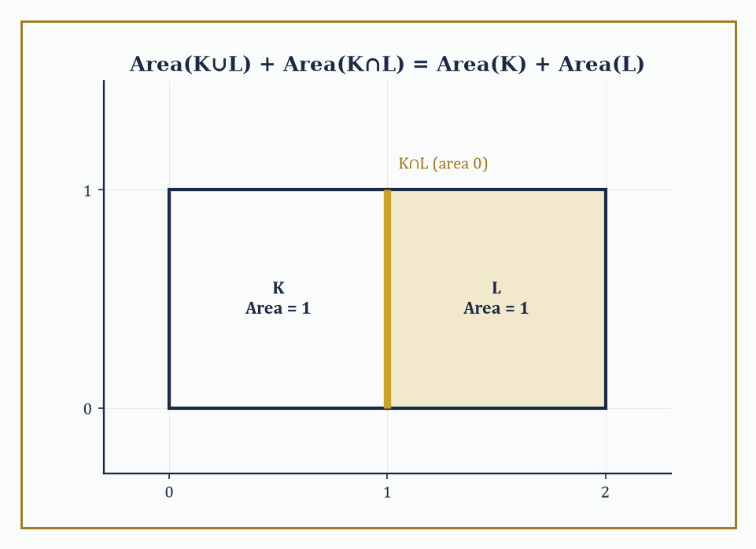
Figure 33.1 — Two unit squares sharing an edge: the union and intersection contribute 2 and 0 respectively, so both sides of the valuation law come to 2.
A valuation is a function μ assigned to convex bodies (or, more generously, to polyhedra, or to the still larger class of sets of positive reach that we will meet in Curvature Measures and the Normal Cycle (Advanced)) satisfying one structural law: whenever K and L are convex bodies whose union K∪L also happens to be convex, the following holds.
μ(K∪L) + μ(K∩L) = μ(K) + μ(L)
This is the inclusion–exclusion law that area and volume already obey; a valuation is anything that obeys it, whether or not it started life as a measure. Unlike an honest measure, a valuation is not required to be non-negative — the Euler characteristic itself is a valuation that returns 1 for a point and, on more elaborate constructible sets, can happily return negative values — nor is it required to satisfy the stronger countable-additivity axiom that measure theory insists on. What it must do is behave correctly under the one operation convex geometry performs on convex sets: gluing two of them together along a shared convex boundary.
Numeric example — checking the valuation law on two rectangles. Let K = [0,1]×[0,1] and L = [1,2]×[0,1], two unit squares sharing the edge x = 1. Their union K∪L = [0,2]×[0,1] is itself a rectangle, hence convex, so the valuation law applies directly.
The areas of K and L are:
Area(K) = 1, Area(L) = 1
The intersection K∩L is the segment {1}×[0,1] — a line, with two-dimensional area 0, while the union has area:
Area(K∩L) = 0, Area(K∪L) = 2×1 = 2
Check the law:
Area(K∪L) + Area(K∩L) = 2 + 0 = 2
Area(K) + Area(L) = 1 + 1 = 2
They agree. Note what the example demonstrates in passing: a valuation need not distinguish a fat two-dimensional overlap from a knife-edge one-dimensional overlap — both simply contribute whatever their own area happens to be, here zero. That is the whole content of the axiom, and it is exactly strong enough to force everything that follows.
Try it now — Check the valuation law for area with K = [0, 1]², L = [1, 2] × [0, 1]. Answer →
The two-body law is not restricted to pairs — applied repeatedly, it extends to any finite union of convex sets, at the cost of a longer inclusion–exclusion sum, precisely as ordinary measure theory would lead one to expect.
This is precisely the mechanism by which a valuation, originally defined only on single convex bodies, extends to the entire ring of polyconvex sets (finite unions of convex bodies): an n-fold union is decomposed by inclusion–exclusion into intersections of subsets, each individually convex or empty, and the valuation’s value on the union is assembled from its values on all of them, with alternating signs, the way a careful accountant avoids double-counting overlapping claims.
Numeric example — inclusion–exclusion for three overlapping intervals. Let A = [0,4], B = [2,6], C = [4,8] on the real line, all of length 4. The three-set inclusion–exclusion law states:
|A∪B∪C| = |A|+|B|+|C| − |A∩B| − |A∩C| − |B∩C| + |A∩B∩C|
Compute each piece:
A∩B = [2,4], length 2
B∩C = [4,6], length 2
A∩C = [4,4] = {4}, a single point, length 0
A∩B∩C = {4} also, length 0
The right-hand side is therefore:
4+4+4 − 2−0−2 + 0 = 12 − 4 = 8
Directly:
A∪B∪C = [0,8], of length 8
matching exactly. The two-body valuation axiom, applied twice in succession (first to A and B, then to that union and C), reproduces this three-body formula automatically — nobody needed to invent a separate axiom for three sets, or for three hundred.
This is the natural continuation of a research program going back to Blaschke and Santaló, and completed in the convex setting across the twentieth century by Hadwiger, then Federer, then — bringing genuinely new algebraic structure — Alesker.
Blaschke and Santaló supplied the classical integral formulas of Chapter 19 (Volume 2); Hadwiger supplied the classification theorem explaining why those particular formulas, and no others, were ever going to arise; Federer supplied the geometric-measure-theoretic machinery (curvature measures, sets of positive reach) needed to push the theory past smooth convex bodies and into singular ones; and Alesker, working within living memory, supplied the algebra — the discovery that the space of valuations is not merely a list but a ring, with its own multiplication, which The Algebra of Valuations (Advanced) will meet in full.
The intrinsic volumes will turn out to be the complete answer to ‘what are the invariant valuations’, and the kinematic product will turn out to be the complete answer to ‘how do they combine’. Everything else in this chapter is detail, admittedly rather a lot of very beautiful detail.
Abstract example — why ‘union must be convex’ is the whole ballgame. Consider two disjoint unit disks K and L, sitting far apart in the plane. Their union is emphatically not convex — a straight line drawn between a point of K and a point of L leaves the union entirely, passing through the empty space in between. The valuation axiom, as stated, does not apply to this pair; it is silent.
And yet ordinary area obeys additivity for disjoint sets regardless, because the intersection is empty:
Area(K∪L) = Area(K) + Area(L), since Area(K∩L) = Area(∅) = 0
The moral is that the valuation axiom is deliberately weaker than full measure-theoretic additivity — it only ever commits itself when the union stays inside the convex world.
This is precisely what makes the theory tractable: to extend a valuation from convex bodies to arbitrary finite unions of convex bodies (the polyconvex sets of the previous paragraph), one must actually prove an extension theorem, rather than getting it for free. That extension theorem exists, and it is the quiet workhorse behind every ‘Euler characteristic of a union of convex pieces’ computation in the rest of this chapter.
Keep only this · Section 33.1: From Classical Formulas to Modern Valuations
The idea. A valuation is a functional on convex bodies that adds like area: μ(K ∪ L) + μ(K ∩ L) = μ(K) + μ(L) whenever K ∪ L is convex. Volume, surface area, mean width and the Euler characteristic are all valuations.
Core.
μ(K ∪ L) + μ(K ∩ L) = μ(K) + μ(L) (K ∪ L convex)
|A ∪ B ∪ C| = Σ|A| − Σ|A ∩ B| + |A ∩ B ∩ C|
Typical mistake. Applying the law when K ∪ L is not convex. Two disjoint disks do not form a convex body, so the law as stated says nothing about them.
Minimal example. Lengths on a line: [0, 2] and [1, 3] give 3 + 1 = 2 + 2.
Practice. Easy to challenge; full worked answers, with the usual mistake, are in Answers to the Practice Sets at the back.
Easy — A = [0, 4], B = [2, 6], C = [4, 8]. Use inclusion–exclusion to find the length of A ∪ B ∪ C. Answer →
Medium — Check the valuation law for perimeter on the same two squares, counting the shared segment’s perimeter as 2. Answer →
Challenge — Show that the Euler characteristic (1 on nonempty convex bodies, 0 on the empty set) is a valuation. Answer →

Section 33.2: Convex Bodies and Intrinsic Volumes
Steiner’s formula, or: what happens when you inflate a shape with a hosepipe
Take a convex body K in ℝⁿ and fatten it: form the parallel body K + εB, the set of all points within distance ε of K, where B is the unit ball and ε > 0. (In ℝ², think of pushing a disk of radius ε out along the entire boundary at once — the corners round off, the edges push out in parallel strips.) The volume of this fattened body turns out to be a polynomial in ε, the Steiner formula.
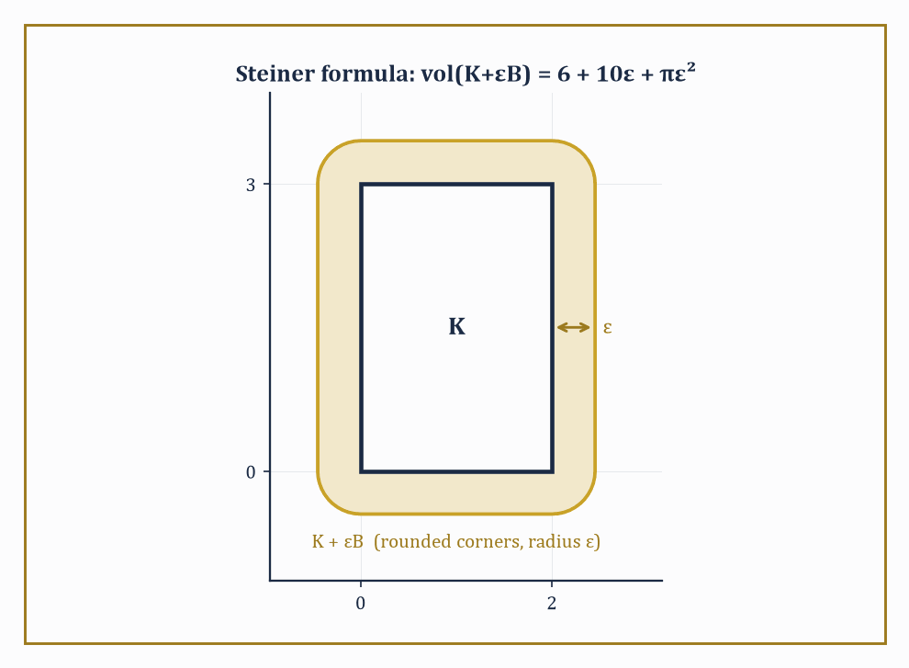
Figure 33.2 — The 2×3 rectangle fattened by ε: its rounded parallel body’s area, 6 + 10ε + πε², reads off the three intrinsic volumes at a glance.
vol(K + εB) = Σᵢ εⁿ⁻ⁱ κₙ₋ᵢ Vᵢ(K)
Here κⱼ denotes the volume of the unit ball in ℝʲ (so κ₀ = 1, κ₁ = 2, κ₂ = π, κ₃ = 4π/3, and so on), and the coefficients V₀(K), …, Vₙ(K) are the intrinsic volumes. They are called ‘intrinsic’ because, unlike the surface area or the volume of the fattened body, they depend only on K itself, not on the ambient dimension n it happens to be sitting inside — a square is a square whether you view it inside the plane or inside a thousand-dimensional space with 998 spare dimensions doing nothing in particular. Vₙ(K) is ordinary volume, Vₙ₋₁(K) is (half) the surface area, and V₀(K) is the Euler characteristic — which for any convex body, however oddly shaped, is 1.
Numeric example — Steiner’s formula for a 2×3 rectangle. Let K be the rectangle [0,2]×[0,3] in ℝ², so n = 2. Fattening K by ε means keeping the original 2×3 rectangle, adding four border strips (two of size 2×ε along the short sides, two of size 3×ε along the long sides) and rounding the four corners into quarter-circles of radius ε, which together assemble into one full circle of area πε². So directly:
vol(K+εB) = 6 + 2(2ε) + 2(3ε) + πε² = 6 + 10ε + πε²
Now match this against the Steiner formula in ℝ²:
vol(K+εB) = ε²κ₂V₀(K) + εκ₁V₁(K) + κ₀V₂(K) = πε²V₀(K) + 2εV₁(K) + V₂(K)
Comparing coefficients term by term:
V₀(K) = 1
matching the πε² term exactly — and indeed a rectangle, being convex, has Euler characteristic 1.
2V₁(K) = 10, so V₁(K) = 5
precisely half the perimeter, which is 2(2+3) = 10, as it should be.
V₂(K) = 6
the area. Three coefficients, extracted from one polynomial, and every one of them is an old friend wearing a new uniform.
Try it now — Use Steiner’s formula to write the area of K + εB for the 2 × 3 rectangle. Answer →
The same technique works one dimension up, and the reader with a healthy suspicion of things that ‘obviously generalize’ is encouraged to check it rather than take it on faith — which is what the next example does. In ℝ³ the relevant unit-ball volumes are κ₀ = 1, κ₁ = 2, κ₂ = π, κ₃ = 4π/3, and the Steiner formula now produces four intrinsic volumes, V₀ through V₃, rather than three.
Numeric example — Steiner’s formula for a ball in ℝ³. Let K be a ball of radius r in ℝ³. Its parallel body K + εB is a larger ball of radius r + ε, with volume (4/3)π(r+ε)³. Expand the cube:
(r+ε)³ = r³ + 3r²ε + 3rε² + ε³
so
vol(K+εB) = (4/3)πr³ + 4πr²ε + 4πrε² + (4/3)πε³
Now match against the general ℝ³ Steiner formula:
vol(K+εB) = ε³κ₃V₀ + ε²κ₂V₁ + εκ₁V₂ + κ₀V₃ = (4π/3)ε³V₀ + πε²V₁ + 2εV₂ + V₃
Comparing the constant (ε⁰) terms:
V₃ = (4/3)πr³
the volume, just as expected. Comparing the ε¹ terms:
2V₂ = 4πr², so V₂ = 2πr²
half the surface area 4πr², matching the general rule that Vₙ₋₁ is half the surface area. Comparing the ε² terms:
πV₁ = 4πr, so V₁ = 4r
Comparing the ε³ terms:
(4π/3)V₀ = 4π/3, so V₀ = 1
the Euler characteristic of a ball, as it must be.
V₀=1, V₁=4, V₂=2π≈6.283, V₃=4π/3≈4.189
At r = 1, this reads as four numbers, all pulled out of one cubic polynomial, generalizing the 2×3 rectangle example above by exactly one dimension and one extra term, with not a single new idea required.
The intrinsic volumes do not merely sit still waiting to be read off a Steiner expansion; they also satisfy their own integral-geometric identities, generalizing the Crofton and Cauchy formulas of Chapter 19 (Volume 2). The cleanest of these is the Cauchy projection formula: the perimeter (twice V₁) of a planar convex body equals the integral, over all directions θ from 0 to π, of the width of the body’s shadow in that direction. Intuitively, if you shine a very thin beam of light through K from every angle and add up the width of every shadow it casts, you recover the perimeter — a fact that feels almost too generous to be true, and yet is.
Numeric example — Cauchy’s formula on a unit square. Let K be the unit square with vertices (0,0), (1,0), (0,1), (1,1). Its width function — the length of its shadow when light shines from angle θ — is
w(θ) = |cos θ| + |sin θ|
Cauchy’s formula claims
perimeter(K) = ∫[0, π] w(θ) dθ
Split the integral. Since sin θ ≥ 0 throughout [0,π]:
∫[0, π] |sin θ| dθ = ∫[0, π] sin θ dθ = [−cos θ]₀^π = (−(−1)) − (−1) = 2
For cos θ, it is non-negative on [0, π/2] and non-positive on [π/2, π], so:
∫[0, π] |cos θ| dθ = ∫[0, π/2] cos θ dθ + ∫[π/2, π] (−cos θ) dθ = [sin θ]₀^(π/2) + [−sin θ]_(π/2)^π = 1 + 1 = 2
Adding the two pieces:
∫[0, π] w(θ) dθ = 2 + 2 = 4
which is the perimeter of the unit square. As a second check, for a disk of radius r the width is constant, w(θ) = 2r, and
∫[0, π] 2r dθ = 2πr
the familiar circumference. Two very different shapes, one formula, no exceptions.
Keep only this · Section 33.2: Convex Bodies and Intrinsic Volumes
The idea. Steiner’s formula: the volume of the parallel body K + εB is a polynomial in ε whose coefficients are the intrinsic volumes — Euler characteristic, mean width, surface area, volume, up to constants. Cauchy’s formula recovers the perimeter from the average width.
Core.
plane: A(K + εB) = A(K) + P(K)ε + πε²
plane: V₂ = area, V₁ = perimeter/2, V₀ = χ
Cauchy: P(K) = ∫₀^π w(θ) dθ
Typical mistake. Treating the corners as small squares. Fattening rounds them into quarter-disks, which together make one disk: the πε² term.
Minimal example. A segment of length 1 in the plane: A(K + εB) = 2ε + πε².
Practice. Easy to challenge; full worked answers, with the usual mistake, are in Answers to the Practice Sets at the back.
Easy — Find the area of the unit square fattened by ε = 0.5. Answer →
Medium — Expand the volume of a ball of radius r + ε in ℝ³ and read off the surface area. Answer →
Challenge — The unit square has width w(θ) = |cos θ| + |sin θ|. Use Cauchy’s formula to find its perimeter. Answer →

Section 33.3: Continuous Valuations and Hadwiger’s Theorem
The theorem that puts the whole subject out of a job, in the best possible way
Fix the valuation law from From Classical Formulas to Modern Valuations, add two further demands — invariance under rigid motions (rotate or translate K, and μ(K) does not change) and continuity with respect to the Hausdorff metric (wiggle K a little, and μ(K) wiggles only a little in response, ruling out valuations that jump discontinuously as a body deforms) — and Hadwiger’s characterization theorem delivers a result of almost suspicious tidiness: every such μ is a linear combination of the intrinsic volumes V₀, …, Vₙ, and nothing else.
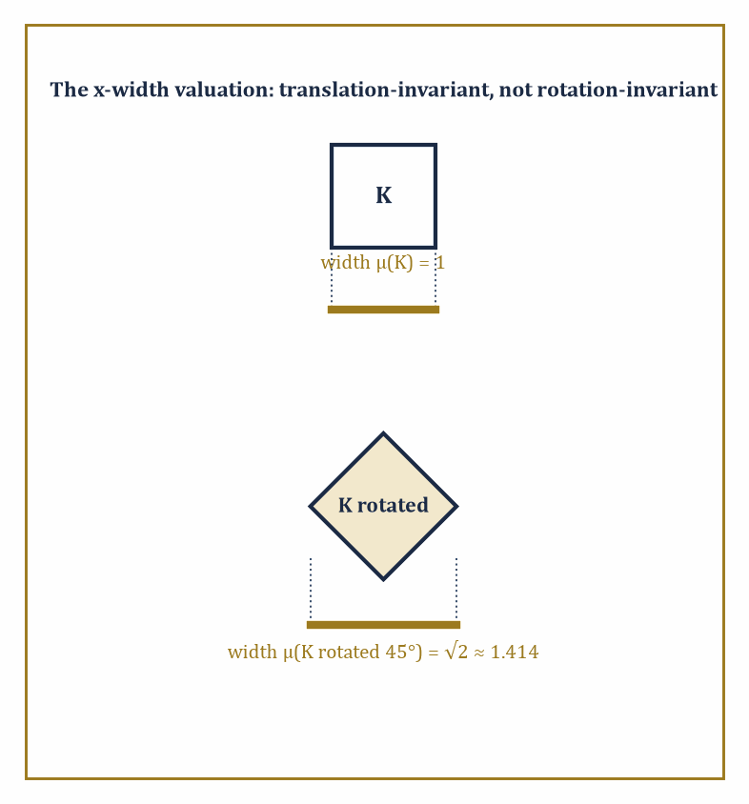
Figure 33.3 — A square’s x-shadow has width 1, but rotate it 45° and the shadow widens to √2 — the anisotropy Hadwiger’s theorem forbids once rotation-invariance is required.
There is no secret extra invariant valuation lurking undiscovered in some corner of convex geometry; the intrinsic volumes are the entire cast list.
The proof proceeds by induction on dimension, first showing that a valuation vanishing on every lower-dimensional convex body must be a multiple of ordinary volume, and then building the full classification chapter by chapter (an image this series cannot resist).
One practical consequence dominates everything that follows: to identify a mystery invariant valuation, you no longer need to understand it in general — you only need to evaluate it on balls, or any other single convenient family of test bodies, and Hadwiger’s theorem guarantees the coefficients you find there are the entire truth about it everywhere else.
Numeric example — pinning down a valuation from its values on disks. Suppose μ is known, by whatever means, to be a continuous rigid-motion-invariant valuation in the plane of the form
μ = 2V₀ + 3V₁ + V₂
— perhaps this combination fell out of some computation and we merely want its value on a specific body. Hadwiger’s theorem guarantees this is a legitimate and complete description; there is nothing further to check. Evaluate μ on a disk K of radius r = 3. Recall from Convex Bodies and Intrinsic Volumes that for a disk of radius r,
V₀ = 1, V₁ = πr, V₂ = πr²
where V₁ is half the circumference 2πr and V₂ is the area. At r = 3, these become:
V₀ = 1, V₁ = 3π, V₂ = 9π
μ(K) = 2(1) + 3(3π) + 1(9π) = 2 + 9π + 9π = 2 + 18π
That number, 2 + 18π ≈ 58.55, is now known with total confidence to be the value of μ on every disk of radius 3, on every rotated or translated copy of one, and — via the same linear formula with the intrinsic volumes of whatever body you like — on every convex body in the plane at all.
Try it now — An invariant valuation in the plane is μ = aV₀ + bV₁ + cV₂, and μ(point) = 1. Find a. Answer →
It is worth pausing to see an example of a perfectly plausible-looking functional that fails to be a valuation at all, if only to appreciate how little slack the definition leaves. Consider the functional
μ(K) = 1 if the origin lies in the interior of K, and μ(K) = 0 otherwise
— a natural enough thing to want to measure, and certainly rigid-motion invariant is not what is being claimed here (it flatly is not, since it privileges the origin), but let us test only the additivity law, holding the origin fixed as a landmark, to see whether it even survives that much scrutiny.
Abstract example — a functional that looks geometric but is not a valuation. Let K = [0,2]×[−1,1] and L = [−2,0]×[−1,1], two rectangles meeting along the segment {0}×[−1,1]. Their union K∪L = [−2,2]×[−1,1] is convex, so the valuation law is entitled to be tested.
The origin lies on the boundary of K (on its left edge, x=0), not in its interior, so μ(K) = 0; by the mirror-image argument, μ(L) = 0 as well. The intersection K∩L is the segment {0}×[−1,1], a set with empty interior in the plane, so it cannot contain the origin as an interior point either: μ(K∩L) = 0. But the union K∪L = [−2,2]×[−1,1] does contain the origin in its interior, so μ(K∪L) = 1.
Check the valuation law:
μ(K∪L) + μ(K∩L) = 1 + 0 = 1, while μ(K) + μ(L) = 0 + 0 = 0
These disagree — 1 ≠ 0 — so this ‘origin-detector’ fails the valuation axiom outright, on a quite ordinary pair of convex rectangles, well before invariance or continuity ever enter the discussion. Hadwiger’s theorem is not merely ruling out exotic pathologies; the definition of a valuation itself is already strict enough to exclude functionals that look, at a glance, entirely reasonable.
Hadwiger’s theorem was proved for scalar-valued valuations on convex bodies in Euclidean space, but the same rigidity persists as the hypotheses are relaxed one at a time.
Drop rotation-invariance and keep only translation-invariance, and the classification enlarges but stays governed by representation theory of the orthogonal group (this is the doorway through which Section 33.8’s algebra enters).
Allow the valuation to take values in tensors rather than in scalars, and one obtains the Lipschitz–Killing tensor valuations, central to modern shape statistics. Weaken continuity to a coarser topology, and yet another controlled enlargement results.
In every variant, the moral survives unscathed: an apparently vast space of ‘reasonable’ geometric functionals collapses, under invariance and continuity, to something finite-dimensional and completely listable.
Numeric example — a valuation that survives translation but not rotation. To see the classification widen once rotation-invariance is dropped, consider the width of K in a fixed direction, say the x-direction — the length of K’s shadow when projected onto the x-axis:
μ(K) = max{x : (x,y)∈K} − min{x : (x,y)∈K}
Check the valuation law on the two unit squares from Section 33.1’s very first example: K=[0,1]×[0,1] and L=[1,2]×[0,1], with union K∪L=[0,2]×[0,1] convex. Here μ(K)=1, μ(L)=1, μ(K∩L)=μ({1}×[0,1])=0 (a vertical segment has zero x-extent), and μ(K∪L)=2. Check:
μ(K∪L)+μ(K∩L)=2+0=2, and μ(K)+μ(L)=1+1=2
the law holds, so μ is a genuine valuation, and it is translation-invariant, since sliding K along either axis never changes the spread of its x-coordinates.
But μ is emphatically not rotation-invariant: rotate the unit square by 45° about its center, and its x-shadow becomes the square’s diagonal, of length √2 ≈ 1.414, not 1. Nor can μ be written as a combination of V₀, V₁, V₂ alone, since none of those three changes under rotation while μ visibly does.
This is exactly the kind of extra functional that becomes available the moment rotation-invariance is struck from the list of hypotheses, as the preceding paragraph promised, and why the translation-only classification needs more than three numbers to describe it.
Keep only this · Section 33.3: Continuous Valuations and Hadwiger’s Theorem
The idea. Hadwiger’s theorem: every continuous, rigid-motion-invariant valuation on convex bodies in ℝⁿ is a linear combination of the n + 1 intrinsic volumes. In the plane, three numbers determine such a functional.
Core.
μ = c₀V₀ + c₁V₁ + ⋯ + cₙVₙ
plane: μ = aχ + b·P/2 + c·A
Typical mistake. Calling every geometric-looking functional a valuation. The diameter fails the valuation law.
Minimal example. Area alone: a = b = 0, c = 1.
Practice. Easy to challenge; full worked answers, with the usual mistake, are in Answers to the Practice Sets at the back.
Easy — μ(point) = 1, μ(segment of length 1) = 2 and μ(unit square) = 5. Find a, b and c. Answer →
Medium — Evaluate that μ on the unit disk. Answer →
Challenge — Show that the diameter is not a valuation, using K = [0, 2] × [−1, 1] and L = [−2, 0] × [−1, 1]. Answer →

Section 33.4: The Principal Kinematic Formula and Its Relatives
Two shapes, one enormous group, and a very tidy answer
Here is the question the whole chapter has been building toward: take two convex bodies K and L, and let one of them, say gL, wander over every possible position and orientation as g ranges over the group of rigid motions. As g varies, K ∩ gL winds up empty most of the time (once gL has wandered far enough away) and some convex shape the rest of the time. What is the total ‘amount’ of overlap, averaged with the natural invariant measure on the motion group?
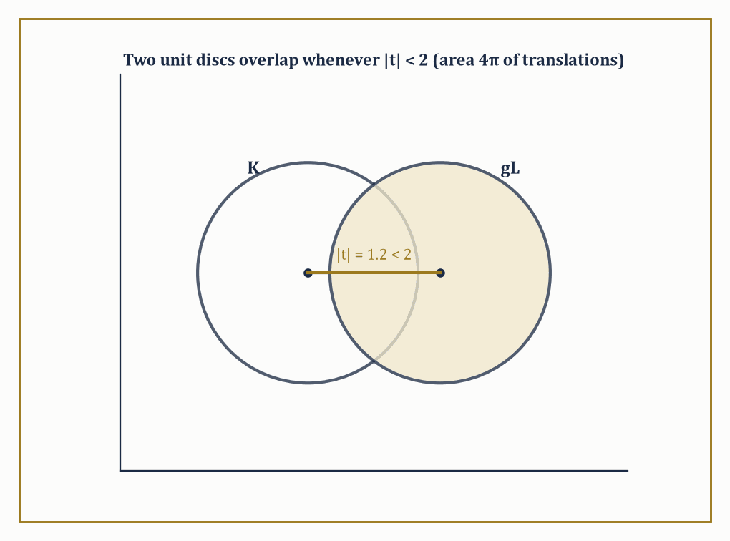
Figure 33.4 — Two unit disks centered a distance |t| = 1.2 apart: they overlap for every |t| < 2, the disk of translations whose area 4π drives Santaló’s formula.
The principal kinematic formula answers this for the crudest possible measure of overlap, the Euler characteristic (which is 1 whenever the two bodies meet, 0 whenever they do not, since an intersection of convex sets is itself convex or empty): the integral of χ(K ∩ gL) over the entire motion group comes out as an explicit, finite sum of products of intrinsic volumes of K and of L separately.
The formula is finite — despite the motion group itself being non-compact and infinite in extent — because χ(K∩gL) vanishes for all sufficiently distant or extreme placements of g, so the integrand has compact support even though the domain of integration does not.
Numeric example — the simplest possible case, two intervals on a line. Before tackling the plane, it pays to see the pattern in its barest form, one dimension down. Let K = [0,3] and L = [0,5] on the real line, where the ‘motion group’ is translation (there is no rotation to speak of in one dimension). Translate L by x to get L+x = [x, x+5]. The two intervals overlap exactly when x + 5 > 0 and x < 3, that is, for x ∈ (−5, 3), an interval of length 3 − (−5) = 8. So directly:
∫_ℝ χ(K ∩ (L+x)) dx = 8
Now compare this to the general pattern the kinematic formula predicts: in dimension n = 1, the intrinsic volumes are V₀ (Euler characteristic, equal to 1 for any nonempty compact interval) and V₁ (length), and the one-dimensional kinematic formula reads:
∫ χ(K∩(L+x)) dx = V₀(K)V₁(L) + V₁(K)V₀(L)
Plugging in: V₀(K)=1, V₁(K)=3, V₀(L)=1, V₁(L)=5, giving
1×5 + 3×1 = 8
The direct geometric computation and the abstract formula agree precisely, which is reassuring, since the whole of the rest of this section is this same idea with a rotation thrown in.
Try it now — On the line, K = [0, 3] and L = [0, 5]. For which translations t does K meet L + t, and what is the total length of that set? Answer →
In the plane, the classical form of the principal kinematic formula (due, in this generality, to Santaló) is:
∫ χ(K ∩ gL) dg = 2π(Area(K) + Area(L)) + Perimeter(K)·Perimeter(L)
where dg = dθ dx dy is the natural kinematic density (θ the rotation angle, (x,y) the translation), integrated over the full rigid-motion group of the plane. Notice the shape of the right-hand side: it is a sum of products of intrinsic volumes of K with intrinsic volumes of L, with the degrees always adding up to n = 2 (an area, degree 2, paired with V₀, degree 0; and V₁, degree 1, paired with V₁, degree 1). This ‘degrees add to n’ pattern is not a coincidence — it is a shadow of a genuine algebraic structure that The Algebra of Valuations (Advanced) will name properly.
Numeric example — two unit disks in the plane. Let K and L both be disks of radius 1. Then Area(K) = Area(L) = π and Perimeter(K) = Perimeter(L) = 2π. Santaló’s formula gives:
∫ χ(K∩gL) dg = 2π(π + π) + (2π)(2π) = 2π·2π + 4π² = 4π² + 4π² = 8π²
As a check, integrate out the rotation first: since disks look the same from every angle, χ(K∩gL) does not depend on θ at all, so integrating over θ ∈ [0,2π) multiplies by 2π, leaving:
2π · ∫[ℝ²] χ(K∩(L+t)) dt = 8π², i.e. ∫χ(K∩(L+t)) dt = 4π
But that remaining integral is the area of the set of translation vectors t for which two unit disks with centers a distance |t| apart overlap — which happens exactly when |t| < 2, a disk of radius 2, of area π·2² = 4π. The two computations, one via the abstract formula and one via elementary plane geometry, agree on the nose.
Higher kinematic formulas repeat the trick for the other intrinsic volumes and for curvature measures instead of χ, each time producing a sum of products with degrees adding to n, and each time with explicit combinatorial coefficients. This is more than a curiosity: the classical Crofton formula of Chapter 19 (Volume 2) (relating the perimeter of a body to how often random lines cross it) can itself be recovered as a limiting or degenerate case of the kinematic formula — take L to be a very thin sliver, or more let one of the bodies degenerate toward a line, and the principal kinematic formula collapses down into the Crofton formula, which was there all along, sitting inside the general theory as a special case rather than a separate result. Transfer principles and template methods exploit this systematically, letting one reduce an unfamiliar-looking integral-geometric computation to reading off a handful of already-tabulated coefficients.
Abstract example — Crofton’s formula as a shrunk-down kinematic formula. Take the plane formula
∫χ(K∩gL)dg = 2π(Area(K)+Area(L)) + Perimeter(K)Perimeter(L)
and let L shrink to a thin rectangle of width δ and some fixed length ℓ, aligned so it behaves, in the limit δ → 0, like a line segment sweeping across the plane. As δ → 0, Area(L) → 0 (a rectangle of vanishing width has vanishing area), so the 2π(Area(K)+Area(L)) term degenerates to 2π·Area(K) alone — a bounded quantity that measures how often a full line, rather than a segment, passes through K at all, which is not quite what Crofton’s formula is about.
The perimeter term, meanwhile, survives: Perimeter(L) stays bounded near 2ℓ even as δ → 0 (a thin rectangle still has two long sides of length ℓ each, contributing 2ℓ to the perimeter regardless of how thin it gets). It is precisely this surviving Perimeter(K)·Perimeter(L) term, isolated in the thin-body limit, that becomes (up to the standard normalizing constant) the Cauchy–Crofton relation between the perimeter of K and the measure of lines crossing it — the general kinematic formula for two fat bodies contains the classical formula for a body and a line as a genuine special case, obtained exactly this way.
Keep only this · Section 33.4: The Principal Kinematic Formula and Its Relatives
The idea. The principal kinematic formula averages χ(K ∩ gL) over all rigid motions g and gets a sum of products of intrinsic volumes whose degrees add to n. In the plane, with rotations of total measure 2π: ∫χ(K ∩ gL) dg = 2π(A_K + A_L) + P_K P_L.
Core.
line: ∫ χ(K ∩ (L + t)) dt = |K| + |L|
plane: ∫ χ(K ∩ gL) dg = 2π(A_K + A_L) + P_K P_L
in each product the degrees add to n
Typical mistake. Forgetting the rotations. In the plane each translation is paired with a full circle of rotations, which contributes the factor 2π.
Minimal example. Two unit disks: 2π(2π) + (2π)² = 8π².
Practice. Easy to challenge; full worked answers, with the usual mistake, are in Answers to the Practice Sets at the back.
Easy — For K = L = [0, 2] on the line, find the measure of translations for which they meet. Answer →
Medium — Find the kinematic measure for a unit disk and a unit square. Answer →
Challenge — A needle of length ℓ (area 0, perimeter 2ℓ) is placed at random on a convex K. Write the kinematic measure of the positions where they meet, and evaluate it for the unit disk and ℓ = 1. Answer →

Section 33.5: Integral Geometry on Spaces of Higher Rank
Lines were only ever the beginning
Everything so far has used the group of rigid motions of ℝⁿ acting on convex bodies, but the same program — find the invariant measure, prove a Crofton-type formula, prove a kinematic formula — makes sense wherever a group acts nicely on a homogeneous space of geometric objects.
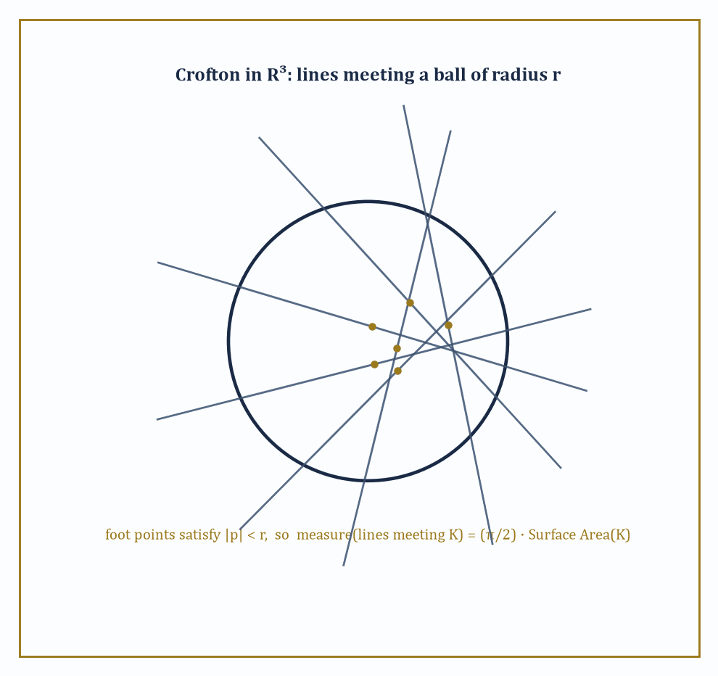
Figure 33.5 — A ball in R³ with several random lines crossing it, foot point marked on each: only lines whose foot lies within radius r contribute, giving measure (π/2)·Surface Area(K).
The affine Grassmannian of k-dimensional planes in ℝⁿ (lines when k=1, hyperplanes when k=n−1, and everything in between) carries its own invariant measure and its own Crofton formula, relating the measure of k-planes meeting a convex body to that body’s intrinsic volumes.
The case k=1 (lines) and k=n−1 (hyperplanes) are, technically, ‘rank-one’ cases — the corresponding Grassmannian of linear subspaces is, in a precise sense from Lie theory, as simple as such a space can be.
Higher-rank behavior, with several independent invariants rather than one, appears only once 1 < k < n−1, for instance 2-planes inside ℝ⁴ — which is where the phrase ‘higher rank’ in this section’s title starts to earn its keep.
Numeric example — lines meeting a ball in ℝ³. Even the rank-one case in three dimensions is worth doing carefully, since it is the direct three-dimensional generalization of Chapter 19 (Volume 2)’s Crofton formula and the launching point for everything higher-rank.
Parametrize a line in ℝ³ by a direction ω on the unit sphere S² and a foot point p — the point on the line closest to the origin — lying in the two-dimensional plane through the origin perpendicular to ω. The natural invariant measure is:
dμ = dp dω
Fix a ball of radius r centered at the origin. A line in direction ω meets the ball exactly when its foot point satisfies:
|p| ≤ r
This is a disk of area πr² in the perpendicular plane. Integrating over all ω ∈ S² (total surface area 4π):
∫[S²] πr² dω = 4π · πr² = 4π²r²
Since each physical line has been counted twice this way (direction ω and direction −ω describe the same line), halve the result: the measure of lines meeting the ball is
2π²r²
For r = 1 this is
2π²
Compare this to the ball’s surface area, 4πr²: the ratio is
(2π²r²)/(4πr²) = π/2
This is independent of r, so the formula reads, in general:
μ(lines meeting K) = (π/2)·Surface Area(K)
for any convex body K in ℝ³ — a genuine three-dimensional Crofton formula, with an explicit and dimensionally correct constant, derived here from nothing but a direct integration over the sphere.
Try it now — With lines in the plane measured by dp dθ (θ ∈ [0, π)), the measure of lines meeting a convex K is its perimeter. What is it for the unit disk? Answer →
The complementary rank-one case — hyperplanes rather than lines, k=n−1 rather than k=1 — is worth doing too, because it uses a different intrinsic volume, and the contrast between the two is the cleanest possible illustration of why intermediate ranks need more than one number at all.
Numeric example — planes meeting a ball in ℝ³. Parametrize a plane (hyperplane) in ℝ³ by its unit normal u ∈ S² and its signed distance t ∈ ℝ from the origin, so the plane is given by:
{x : x·u = t}
The natural invariant measure is:
dμ = dt du
A ball of radius r centered at the origin meets this plane exactly when
|t| ≤ r
an interval of length 2r for each fixed u. Integrating over u ∈ S² (area 4π):
∫[S²] 2r du = 2r · 4π = 8πr
Here too each plane has been counted twice — normal u at distance t and normal −u at distance −t describe the same plane {x : x·u = t} — so halve the result: the measure of planes meeting the ball is
4πr
The mean width of a ball of radius r is the constant 2r (its shadow has the same width, 2r, from every direction), so the ratio is:
(4πr)/(2r) = 2π
This is again independent of r, so in general:
μ(hyperplanes meeting K) = 2π·(mean width of K)
Lines are governed by surface area with constant π/2; hyperplanes are governed by mean width with constant 2π — two different intrinsic volumes for the two extreme ranks, which is the seed of the higher-rank story: an intermediate k, neither 1 nor n−1, cannot pick one intrinsic volume to be governed by, and needs a richer invariant instead.
Complex integral geometry replaces the orthogonal group by the unitary group, acting on complex projective space or on Grassmannians of complex subspaces, and produces its own intrinsic volumes and its own kinematic formulas — structurally identical in spirit to the real case, but with the combinatorics governed by the representation theory of U(n) rather than O(n).
Quaternionic analogues, with the symplectic group in place of the unitary group, complete the classical trio.
What unifies all three is not a shared formula but a shared method: identify the relevant compact group, find its invariant measure, and let representation theory hand you the kinematic formula’s structure constants — the same method, verbatim, that produces Section 33.8’s multiplication table.
Abstract example — two 2-planes in ℝ⁴, a genuinely higher-rank instance. Take two 2-dimensional linear subspaces of ℝ⁴ in general position. Since the dimensions add up precisely:
2 + 2 = 4 = dim ℝ⁴
generically the two planes meet only at the origin, so naïvely one might expect their relative position to be described by a single number, as it would be for two lines in the plane (where the only invariant is the angle between them). It is not.
The correct classical description, via principal angles, requires two numbers θ₁ and θ₂, measuring how the two planes twist against each other along two independent directions simultaneously — one plane cannot, in general, be rotated onto the other using a single angle of rotation, the way two lines through the origin always can be. These angles satisfy:
0 ≤ θ₁ ≤ θ₂ ≤ π/2
This is the concrete manifestation of ‘rank two’: the homogeneous space of pairs of 2-planes in ℝ⁴ needs two coordinates to describe its geometry, not one, and any Crofton-type or kinematic formula built on this Grassmannian must be a function of both θ₁ and θ₂ together, rather than of a single Crofton-style angle as in the rank-one theories earlier in the chapter.
The representation theory controlling the coefficients of such a formula is correspondingly richer — governed by the full rank-two structure of O(4) rather than by a single binomial coefficient — which is just why this section stops short of writing the formula out in full and instead points, with a straight face, at the literature.
Keep only this · Section 33.5: Integral Geometry on Spaces of Higher Rank
The idea. In higher dimensions one integrates over affine subspaces of every dimension — lines, planes, k-planes — and Crofton-type formulas recover each intrinsic volume. When the motion group has higher rank, as for pairs of 2-planes in ℝ⁴, relative position needs several angles, and representation theory organizes the formulas.
Core.
plane: measure of lines meeting K = P(K)
∫ length(K ∩ ℓ) dℓ = πA(K)
two generic 2-planes in ℝ⁴: two principal angles
Typical mistake. Using one angle for the relative position of two 2-planes in ℝ⁴. Generic pairs need two principal angles; that is what higher rank means.
Minimal example. Lines meeting a segment of length ℓ: measure 2ℓ.
Practice. Easy to challenge; full worked answers, with the usual mistake, are in Answers to the Practice Sets at the back.
Easy — Find the measure of lines meeting the unit square. Answer →
Medium — A random line meets the disk of radius 2. What is the probability that it also meets the concentric disk of radius 1? Answer →
Challenge — A random line meets the unit square. Find the expected length of the chord. Answer →

Section 33.6: Applications: Stereology, Tomography, and Geometric Probability
Where all this machinery finally earns its keep
Stereology is the practical discipline of estimating the three-dimensional shape of an object — a biological tissue sample, a mineral deposit, a porous material — from lower-dimensional data: planar sections, or even just a scattering of points and lines.
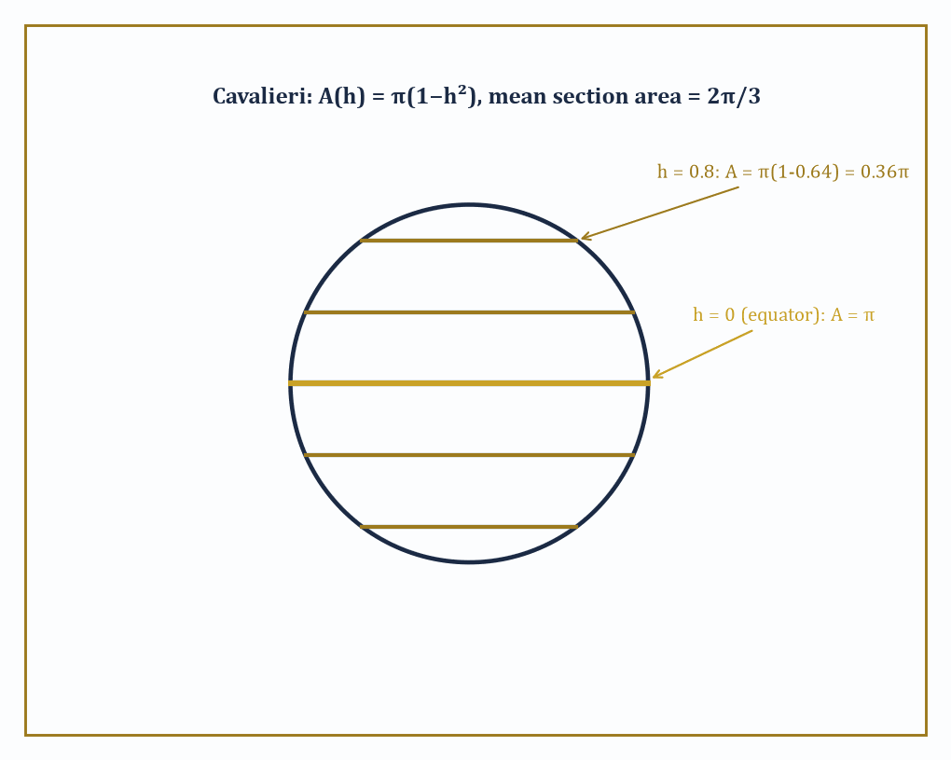
Figure 33.6 — Slicing the unit ball at several heights h: the cross-sectional area π(1−h²) shrinks away from the equator, and its average over all h recovers the volume by Cavalieri’s principle.
The kinematic formulas of this chapter are what make such estimation unbiased rather than merely hopeful: if you know how a section’s area behaves on average as the sectioning plane varies over all positions (with the correct invariant measure), you can invert that average to recover the volume of the original solid, without ever having to reconstruct its full three-dimensional shape.
This is Cavalieri’s principle, now recognizable as the simplest possible curvature-measure kinematic formula: the volume of a solid equals the integral, over parallel slicing planes, of the cross-sectional area.
Numeric example — mean section area of a ball, and Cavalieri’s check. Let K be a ball of radius r = 1, and slice it with a plane at signed height h ∈ [−1, 1] from the center.
The cross-section at height h is a disk of radius √(1−h²), with area:
A(h) = π(1−h²)
First, Cavalieri’s principle directly: integrating A(h) over the full range of heights should recover the volume of the ball.
∫₋₁¹ π(1−h²) dh = π[h − h³/3]₋₁¹ = π[(1 − 1/3) − (−1 + 1/3)] = π[(2/3) − (−2/3)] = π(4/3) = 4π/3
That is the volume of the unit ball, as it must be. Now compute the mean section area, averaging A(h) uniformly over h ∈ [−1,1]:
mean = (1/2)∫₋₁¹ π(1−h²) dh = (1/2)(4π/3) = 2π/3 ≈ 2.094
Compare this to the area of the equatorial great circle, π ≈ 3.1416: the mean section is noticeably smaller than the biggest possible slice, precisely because most randomly chosen heights land well away from the equator, on shrinking disks near the poles.
A stereologist averaging many random section areas from an unknown ball-shaped sample would, on this evidence, expect to see roughly 2π/3 times the squared radius as their average reading — and could recover the volume from that average by simply multiplying by the total height range, exactly as Cavalieri’s principle prescribes.
Try it now — Slice the unit ball by a plane at height h. What is the area of the section, and its average over h ∈ [−1, 1]? Answer →
Tomographic reconstruction pushes the same idea further: recover an entire function (a density, an image) from its integrals — its Radon transform — over lines or planes, rather than recovering a single number like volume.
The invertibility of the Radon transform, together with stability estimates controlling how noise in the measured projections propagates into errors in the reconstructed image, is itself a room’s worth of integral geometry on its own, and the medical CT scanner sitting in any large hospital is, underneath its casing, a machine for inverting a Radon transform in real time.
A toy, purely discrete version of the same idea — recovering an unknown grid of numbers from a handful of its row, column, and diagonal sums — captures the logical shape of the problem without any of the analytic machinery.
Numeric example — reconstructing a 2×2 grid from its projections. Suppose an unknown 2×2 grid of numbers, [a b; c d], is probed only through its ‘projections’: the row sums, the column sums, and the sum along the main diagonal. Measurement reveals:
a+b = 5, c+d = 3
a+c = 4, b+d = 4
a+d = 3
From the sum a+b=5, solve for b:
b = 5−a
From the sum a+c=4, solve for c:
c = 4−a
Substitute into c+d=3 to solve for d:
d = 3−c = 3−(4−a) = a−1
Check consistency against the fourth measurement, b+d=4:
(5−a)+(a−1) = 4
This holds for every a — so the row and column sums alone leave one degree of freedom undetermined, as four equations with only three independent constraints must. This is where the diagonal projection earns its place: substitute d = a−1 into a+d=3.
a + (a−1) = 3, so 2a = 4 and a = 2
Then compute the remaining unknowns:
b = 5−2 = 3, c = 4−2 = 2, d = 2−1 = 1
The reconstructed grid is [2 3; 2 1] — and indeed it checks out against every original measurement:
2+3=5, 2+1=3, 2+2=4, 3+1=4, 2+1=3
all consistent. Three families of projections (rows, columns, one diagonal) sufficed to pin down all four unknowns uniquely; a real Radon transform performs the same feat, continuously, with a whole circle’s worth of projection angles instead of three, and the same question — how many projections, from which angles, are enough to reconstruct the object without ambiguity — is exactly the subject of tomographic sampling theory.
Geometric probability closes the loop by turning kinematic formulas directly into probabilities: if a body is dropped uniformly at random within some large region, the kinematic formula’s overlap measure, divided by the size of that region, is the probability of a collision, intersection, or containment event.
This is Buffon’s needle all grown up, with lines replaced by arbitrary convex shapes and a single trigonometric integral replaced by the full apparatus of The Principal Kinematic Formula and Its Relatives and The Algebra of Valuations (Advanced).
Numeric example — the probability two unit disks overlap. From the worked example in The Principal Kinematic Formula and Its Relatives, two unit disks overlap exactly when their centers lie within distance 2 of each other, and the set of such relative positions is a disk of radius 2, with area:
π·2² = 4π
Suppose one disk’s center is fixed, and the second disk’s center is dropped uniformly at random somewhere inside a large 10×10 square window, of area A = 100 (with the fixed disk’s center comfortably away from the window’s edge, so boundary effects can be ignored).
The probability of the two disks overlapping is then approximately (favorable area)/(window area):
4π/100 ≈ 12.566/100 ≈ 0.1257
That is a little over 12.5 per cent. Halve the window’s side length to 5×5 (area 25) and the same favorable region of area 4π now occupies a much larger fraction:
4π/25 ≈ 50.3 per cent
This is a stark illustration of how geometric probability depends on nothing but the ratio of two areas, one of them a kinematic-formula overlap measure and the other the size of the sample space, with no calculus required once the kinematic formula itself has done the hard work.
Keep only this · Section 33.6: Applications: Stereology, Tomography, and Geometric Probability
The idea. Stereology estimates volumes and surface areas from random sections; tomography reconstructs a body from its projections (the Radon transform); geometric probability turns kinematic measures into probabilities.
Core.
Cavalieri: ∫ section area dh = volume
Radon transform: integrals over lines
P(meet) = measure of meeting positions / total measure
Typical mistake. Taking the central section as typical. Random planes cut off-center more often, so the mean section is smaller than the central one.
Minimal example. Unit ball: central section π, mean section 2π/3.
Practice. Easy to challenge; full worked answers, with the usual mistake, are in Answers to the Practice Sets at the back.
Easy — A cube of side 2 is cut by planes parallel to a face. What is each section’s area, and what does Cavalieri give? Answer →
Medium — A 2 × 2 grid [a b; c d] has row sums 3 and 7, column sums 4 and 6, and diagonal sum a + d = 5. Reconstruct it. Answer →
Challenge — The center of a unit disk is placed uniformly in a 10 × 10 square (ignore edge effects), and another unit disk sits at the center. Find the probability that they overlap. Answer →

Section 33.7: Curvature Measures and the Normal Cycle (Advanced)
Smearing the intrinsic volumes across the boundary, one corner at a time
The intrinsic volumes Vᵢ(K) are global numbers — one figure summarizing the whole body. Curvature measures ask a sharper, more local question: how much of Vᵢ(K) is ‘located’ near any given patch of the boundary of K? Formally, the i-th curvature measure Cᵢ(K, ·) is a measure supported on (or associated with) the boundary of K, whose total mass over the whole boundary recovers the intrinsic volume:
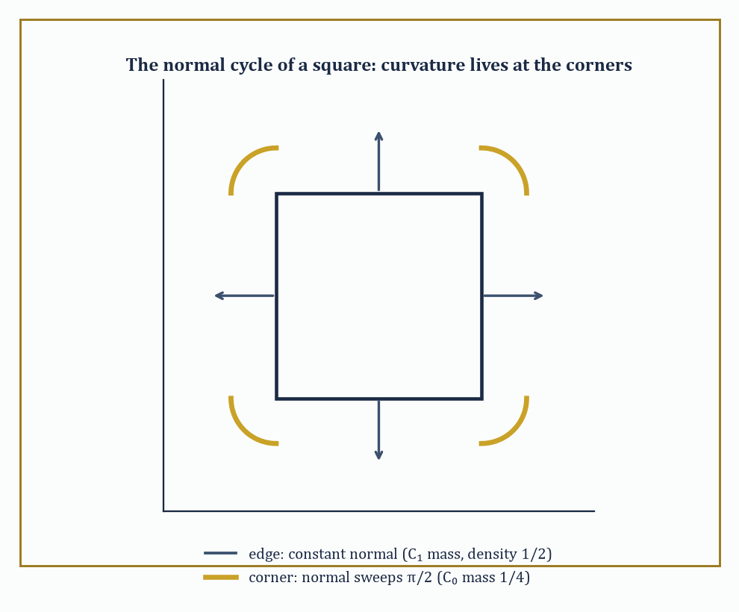
Figure 33.7 — The normal cycle of a square: C₁ spreads evenly along the flat edges while C₀ concentrates entirely in the four π/2 turns at the corners.
Cᵢ(K, ∂K) = Vᵢ(K)
For a smooth convex body this localization is wholly painless — curvature measures are literally built from the classical curvatures of the boundary, integrated against appropriate combinatorial weights. For a body with corners and edges, like a cube or a square, the curvature concentrates in unexpected places: flat faces contribute nothing to the lower curvature measures, while it is the corners and edges that carry all the interesting information, a fact with no classical-calculus analogue since ordinary curvature is not even defined at a corner.
Federer’s extension of the theory to sets of positive reach — sets that are locally well-approximated by their tangent planes, a strictly larger class than convex bodies — is what allows curvature measures to survive contact with non-convex geometry.
Numeric example — the Euler curvature measure of a square, concentrated at its corners. Let K be a square, and consider its zeroth curvature measure C₀ — the localization of V₀, the Euler characteristic. For a convex polygon, C₀ places all of its mass at the vertices, and the mass at a vertex equals (exterior angle at that vertex) / 2π, where the exterior angle is the amount the boundary direction turns as it passes through the corner.
A square has interior angles of π/2 at each of its four corners, so the exterior (turning) angle at each corner is:
π − π/2 = π/2
The mass placed at each corner is therefore:
(π/2)/(2π) = 1/4
Summing over all four corners:
4 × 1/4 = 1
This equals V₀(square) = 1, as the localization property demands — the Euler characteristic of a square, normally an abstract fact about connectedness, has just been shown to live altogether in its four right-angle corners, a quarter-unit apiece, with the flat edges contributing nothing.
Try it now — For a square, the curvature measure C₀ sits at the four corners. How much at each? Answer →
The complementary curvature measure, C₁, tells the opposite story: rather than concentrating at isolated corners, it spreads itself uniformly along the edges, leaving the corners entirely untouched. For a convex polygon, C₁ has linear density exactly 1/2 with respect to arc length along each edge — half a unit of C₁-mass for every unit of edge length — and no atomic mass at the vertices at all.
This is a genuinely different distribution from C₀’s, even though both are localizations of intrinsic volumes belonging to the very same body, and the contrast is the whole point: different intrinsic volumes are ‘stored’ in geometrically different parts of the boundary, corners for V₀, edges for V₁ (and, in three dimensions, whole faces for V₂), a fact with no counterpart at all for a global number like the Euler characteristic on its own.
Numeric example — the C₁ curvature measure of a 2×3 rectangle. Return to the 2×3 rectangle K of Convex Bodies and Intrinsic Volumes, with V₁(K) = 5 and total perimeter (edge length) 10. Since C₁ has density exactly 1/2 per unit of edge length, its total mass is:
(1/2) × 10 = 5
matching V₁(K) = 5 precisely, as the localization property Cᵢ(K,∂K) = Vᵢ(K) requires. Concretely, each of the two length-2 edges carries C₁-mass:
(1/2)(2) = 1
and each of the two length-3 edges carries C₁-mass:
(1/2)(3) = 1.5
Summing all four:
1 + 1 + 1.5 + 1.5 = 5
V₁(K). Compare this with C₀ on the same rectangle: all of its mass, again totaling 1 (since V₀ = 1 for any convex body), sits at the four corners, a quarter-unit each, by the identical corner computation used for the square above (a rectangle’s interior angles are all π/2 too). The same shape, the same boundary, but two wholly different residential patterns for its curvature — one concentrated in four points, the other spread continuously along four edges.
The mechanism behind this concentration is the normal cycle: instead of working with K directly, one works with the set of pairs (boundary point, outward unit normal at that point), living in the sphere bundle over ℝⁿ.
Along a flat edge of a polygon, the outward normal is constant, so the normal cycle traces a single flat segment there. At a corner, the normal direction has nowhere unique to point, and instead sweeps continuously through every direction between the two adjacent edges’ normals — the normal cycle develops a little arc there.
Integrating suitable differential forms over this combined object (flat segments plus corner arcs) reconstructs every curvature measure at once, and is the genuine bridge between the combinatorial convex geometry of this chapter and the differential-geometric machinery of currents and geometric measure theory.
Abstract example — the normal cycle of a square, arc by arc. Return to the square, and track its normal cycle directly. Over each of the four edges, the outward normal is a single fixed direction (pointing right, up, left, or down in turn), so the normal cycle contributes four flat segments, one per edge, carrying no curvature at all — consistent with C₀ placing zero mass on the interiors of edges.
At each corner, the normal direction must rotate from one edge’s normal to the next; since the interior angle is π/2, the normal direction sweeps through an arc of π/2 as well (the normal turns by the same amount the boundary turns). Four corners, each contributing a swept arc of π/2, gives a total swept angle of:
4 × π/2 = 2π
exactly one full turn, matching the general fact that the total turning of the boundary of any convex body in the plane is 2π. Dividing that total turning by 2π, as the definition of C₀ demands, returns 1, reproducing V₀(square) = 1 by an entirely different, and entirely differential-geometric, route than the direct corner count above.
This is precisely the computational engine — kinematic formulas applied to curvature measures rather than to the global intrinsic volumes — that modern stereology runs on, and that Applications: Stereology, Tomography, and Geometric Probability puts to practical use.
Keep only this · Section 33.7: Curvature Measures and the Normal Cycle (Advanced)
The idea. Curvature measures localize the intrinsic volumes: Cᵢ(K, ·) is a measure with total mass Vᵢ(K). For polygons C₀ sits at the corners (exterior angle/2π), C₁ spreads along the edges with density 1/2, and C₂ is area. The normal cycle packages boundary points with their normals so that the same formulas work for non-smooth and non-convex sets.
Core.
Cᵢ(K, ℝⁿ) = Vᵢ(K)
polygon: C₀ at a vertex = exterior angle/2π
C₁: density ½ per unit of boundary length
Typical mistake. Putting C₀ mass on the edges. Along a straight edge the boundary does not turn, so C₀ is zero there.
Minimal example. Unit disk: C₀ spread evenly around the circle, total 1.
Practice. Easy to challenge; full worked answers, with the usual mistake, are in Answers to the Practice Sets at the back.
Easy — Find C₁ of the 2 × 3 rectangle on one long edge. Answer →
Medium — Find C₀ at each vertex of an equilateral triangle. Answer →
Challenge — For the regular hexagon of side 1, find the total of C₁ and the C₀ mass at each vertex. Answer →

Section 33.8: The Algebra of Valuations (Advanced)
In which the kinematic formula turns out to be a multiplication table
Every kinematic formula so far has had the same silhouette: integrate over the motion group, get out a sum of products of intrinsic volumes with degrees adding to n.
Alesker’s great structural discovery was that this silhouette is not decorative — the space of continuous translation-invariant valuations carries a commutative, associative product (now called the Alesker product), and the kinematic formula for two valuations μ and ν is precisely the statement that averaging μ(K)ν(gL) over the motion group computes the coefficient of the product μ ⋆ ν, expanded in the basis of intrinsic volumes.
The whole zoo of kinematic formulas — principal, higher-order, for curvature measures — collapses into a single multiplication table for a single finite-dimensional graded algebra.
The grading is by degree: Vᵢ has degree i, and the algebra is filtered so that products respect degree in the additive way every example so far has hinted at.
Numeric example — reading structure constants off Santaló’s formula. Rewrite the plane kinematic formula from The Principal Kinematic Formula and Its Relatives entirely in terms of intrinsic volumes, using the substitutions
Area = V₂, Perimeter = 2V₁
so that
Perimeter(K)Perimeter(L) = 4V₁(K)V₁(L)
and the kinematic formula reads:
∫χ(K∩gL)dg = 2π·V₀(K)V₂(L) + 2π·V₂(K)V₀(L) + 4·V₁(K)V₁(L)
This is nothing but the multiplication table of the algebra, laid bare: the pair (V₀,V₂) contributes with structure constant 2π, the pair (V₂,V₀) also with 2π (the product is commutative, as it must be), and the pair (V₁,V₁) contributes with structure constant 4.
No other pairing of intrinsic-volume degrees appears — there is no V₀·V₀ term, no V₀·V₁ term — because those pairs of degrees do not add up to n = 2:
0 + 0 = 0, 0 + 1 = 1
and the algebra’s grading forbids them from contributing to a degree-2 output.
Three numbers, 2π, 4, and 2π, are the entire multiplication table of the plane’s algebra of valuations in top degree, and every kinematic formula for convex bodies in the plane is secretly built from just these three constants.
Try it now — How many basis valuations does the space of continuous rigid-motion-invariant valuations on the plane have? Answer →
Before Hadwiger’s theorem is invoked at all, the space of every conceivable continuous rigid-motion-invariant valuation on convex bodies in ℝⁿ might reasonably be feared to be infinite-dimensional — after all, ‘continuous functional on the space of convex bodies’ is, a priori, an enormous space to search.
Hadwiger’s theorem is exactly the statement that this fear is unfounded, and the algebra of valuations records the resulting finite-dimensionality as its most basic feature: a basis for the rigid-motion-invariant valuations is V₀, V₁, …, Vₙ, and nothing more, so the entire algebra in this most invariant sense has dimension exactly n+1.
Abstract example — how small the algebra really is. In the plane (n=2), the space of continuous rigid-motion-invariant valuations has dimension exactly 3, spanned by V₀, V₁, V₂ — three numbers describe every such functional, completely, on every convex body in ℝ².
In space (n=3), the dimension grows to exactly 4, spanned by V₀, V₁, V₂, V₃, as the worked ball computation in Convex Bodies and Intrinsic Volumes already exhibited in miniature: four coefficients, no more, extracted from a single Steiner polynomial.
Contrast this with the vastly larger space one might naively have expected: an arbitrary continuous functional on the (infinite-dimensional) space of convex bodies has no reason at all to be finite-dimensional in this sense, and indeed is not, once either the invariance or the additivity hypothesis is dropped.
It is the conjunction of finite additivity, rigid-motion invariance, and continuity — three hypotheses, none dispensable, as Section 33.3’s failed ‘origin-detector’ example demonstrated for additivity alone — that squeezes an a priori unruly space down to something you could, if pressed, list on an index card.
This graded algebra is not an arbitrary bookkeeping device; its graded pieces are literally the irreducible representations of the orthogonal group O(n) acting on valuations of each degree, so the algebra of valuations is, quite precisely, a piece of representation theory wearing a geometric disguise.
Two further theorems cement the resemblance to intersection theory and complex algebraic geometry: a hard Lefschetz theorem for the algebra of valuations (multiplication by a fixed ‘ample’ class, essentially the volume valuation, behaves as Lefschetz’s theorem predicts on the cohomology of a projective variety), and a Poincaré duality, pairing degree-i valuations with degree-(n−i) valuations in a way that is non-degenerate on complementary degrees — the pattern already visible in the multiplication table above, where only pairs of degrees summing to n = 2 produced anything nonzero.
Abstract example — Poincaré duality, read off the same table. The Poincaré duality property claims that the pairing between degree-i and degree-j valuations is non-degenerate when
i + j = n
and zero otherwise.
Test this against the plane’s multiplication table found above, where n = 2: the pairing of V₀ (degree 0) with V₂ (degree 2) is nonzero, with structure constant 2π — and in fact
0 + 2 = 2 = n
The pairing of V₁ with itself (degree 1 with degree 1) is nonzero, constant 4 — and
1 + 1 = 2 = n
again on the nose.
Meanwhile the pairing of V₀ with V₀ (degrees 0 and 0, summing to 0 ≠ 2) never appears in the formula at all, nor does V₀ with V₁ (degrees summing to 1 ≠ 2), nor V₁ with V₂ (summing to 3 ≠ 2).
Every ‘off-diagonal’ pairing that duality predicts should vanish, vanishes; every ‘on-diagonal’ pairing that duality predicts should survive, survives, with an explicit nonzero constant attached.
The abstract representation-theoretic statement and the concrete two-line kinematic formula for two convex bodies in the plane are, when you look closely enough, saying the same thing.
Keep only this · Section 33.8: The Algebra of Valuations (Advanced)
The idea. The continuous invariant valuations form a finite-dimensional graded algebra. The kinematic formulas supply its structure constants, and Poincaré duality pairs degree i with degree n − i.
Core.
plane: basis V₀, V₁, V₂ (degrees 0, 1, 2)
degrees add under the product (zero beyond n)
Poincaré duality: degree i pairs with degree n − i
Typical mistake. Expecting a large algebra. Under the full rigid-motion group the plane gives dimension 3; all the structure lives in a handful of numbers.
Minimal example. V₀ is the unit: V₀ · μ = μ.
Practice. Easy to challenge; full worked answers, with the usual mistake, are in Answers to the Practice Sets at the back.
Easy — What is the dimension of the invariant continuous valuations on ℝ³? Answer →
Medium — Rewrite the plane kinematic formula in intrinsic volumes, using A = V₂ and P = 2V₁. Answer →
Challenge — In ℝⁿ, which degree is dual to degree 1, and what is the dimension of the invariant algebra? Answer →

Section 33.9: Looking Ahead: Valuations on Manifolds and Algebraic Integral Geometry
The view from the thirty-third chapter, before we move on
We have now acquired the modern core of integral geometry: continuous valuations and their classification by Hadwiger’s theorem, curvature measures and the normal cycle that produces them, the principal kinematic formula and its relatives, the algebra that organizes them all, and a first glimpse of what happens once the acting group grows richer than rigid motions of flat space.
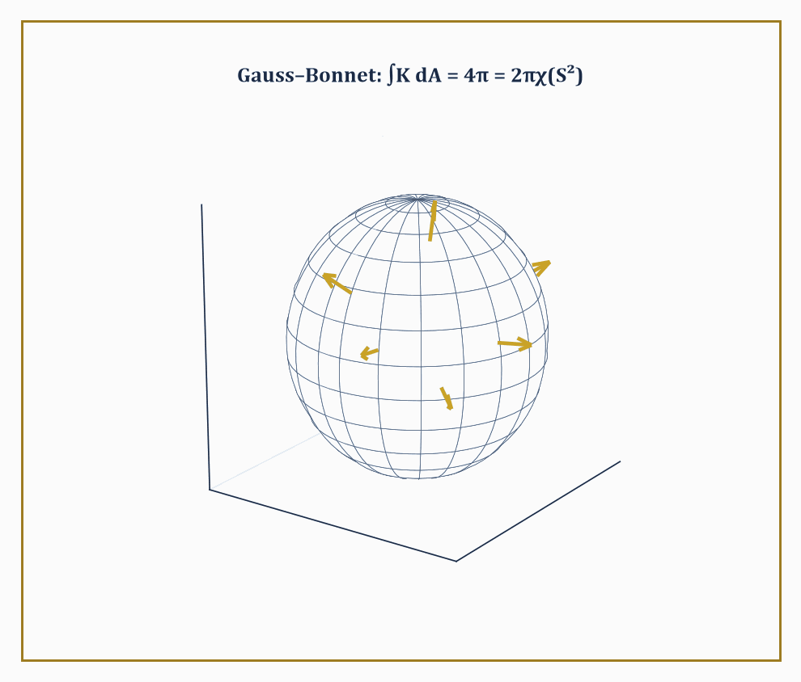
Figure 33.8 — The unit sphere, curving by exactly K = 1 at every point: integrate that curvature over the whole surface and Gauss–Bonnet hands back 4π = 2πχ(S²).
Every one of these pieces was built on convex bodies sitting inside a flat Euclidean space ℝⁿ — a setting chosen for its tractability, not because the ideas secretly require flatness.
The frontier of the subject asks the obvious next question: what happens to all of this once the ambient space is curved?
The answer, largely due to Alesker, is reassuring rather than catastrophic: smooth valuations make sense on arbitrary smooth manifolds, not merely on ℝⁿ, with a suitably generalized notion of curvature measure built from the manifold’s own Riemannian structure rather than borrowed — as every curvature measure in this chapter has so far been, unannounced — from an ambient Euclidean embedding it never asked for.
This is precisely where Chapter 34’s subject, tensors and manifolds, stops being a neighboring topic and starts being a prerequisite: to even state what a curvature measure means on a curved space, one first needs the tensorial language for curvature that Chapter 34 will build from scratch.
Numeric example — Gauss–Bonnet on the sphere, a first curved-space valuation. The cleanest possible preview of valuations on a curved manifold is a formula you may already know without having filed it under this name: the Gauss–Bonnet theorem.
On the unit sphere S² (radius 1), the Gaussian curvature K is constant and equal to 1 everywhere — a sphere of radius 1 curves ‘by exactly 1’ at every point, by definition of Gaussian curvature for a sphere of radius r being 1/r².
The total surface area of the unit sphere is 4π. So the integral of curvature over the entire surface is:
∫[S²] K dA = 1 × 4π = 4π
The Gauss–Bonnet theorem states this integral must equal 2π times the Euler characteristic of the surface:
∫[S²] K dA = 2πχ(S²)
The Euler characteristic of a sphere is the famous χ(S²) = 2 — check it on any convex polyhedron with the topology of a sphere, such as a tetrahedron:
4 vertices − 6 edges + 4 faces = 2
Then:
2πχ(S²) = 2π × 2 = 4π
This matches the direct curvature integral exactly.
This is a curvature measure — literally, Gaussian curvature integrated against area — recovering an intrinsic-volume-like topological invariant on a curved space, with no flat ambient ℝⁿ or Steiner formula in sight.
It is the natural manifold-level descendant of every corner-counting computation this chapter has performed on flat convex bodies, and it is the sort of identity Chapter 34 will generalize far beyond spheres.
Try it now — Compute ∫K dA for the unit sphere and compare with 2πχ. Answer →
A parallel algebraic strand runs through the study of constructible functions and characteristic cycles, where the Euler characteristic itself is treated as a kind of measure to be integrated against — ‘Euler integration’ — reproducing, in an algebraic-geometric register, the additivity law that opened this whole chapter in From Classical Formulas to Modern Valuations.
A constructible function is a finite linear combination of indicator functions of convex (or more generally definable) pieces, and its Euler integral is computed by the obvious rule: weight each piece’s Euler characteristic by its coefficient, and add.
Numeric example — an Euler integral of a simple constructible function. Let f be a function on the real line taking the value 2 on the closed interval [0,1], the value 3 on the closed interval [2,3], and 0 everywhere else, defined by:
f = 2·1_([0,1]) + 3·1_([2,3])
These are two disjoint compact pieces, chosen disjoint to sidestep any subtlety about how open and closed pieces interact at shared boundary points.
Since both [0,1] and [2,3] are compact and contractible, each has Euler characteristic 1 in every sense of the term worth worrying about here.
The Euler integral is then simply:
∫f dχ = 2·χ([0,1]) + 3·χ([2,3]) = 2(1) + 3(1) = 5
This is the same bookkeeping as Section 33.1’s very first inclusion–exclusion example, now dressed in the language of characteristic cycles: a valuation-weighted sum over disjoint convex pieces.
This is the entire content of ‘Euler integration’ at the level this chapter can responsibly present it, and precisely the operation that the deeper algebraic theory extends to vastly more elaborate constructible functions than this one.
The same circle of ideas resurfaces, disguised, in convex optimization (support functions and mixed volumes are only intrinsic volumes and their polarizations wearing a different hat) and in the statistical study of random geometric structures, where kinematic formulas compute exact expectations that would otherwise require simulation.
The deeper lesson of the entire chapter is worth stating plainly: the group of rigid motions, acting on the space of geometric objects, produces a finite-dimensional algebra of invariants whose multiplication table is the kinematic formula.
Geometry is thereby reduced, in a precise and rather startling sense, to representation theory and measure theory.
Advanced integral geometry is the systematic exploitation of that reduction — and, one suspects, will remain a going concern for just as long as there are groups willing to act and geometers willing to let them.
So that is the deal advanced integral geometry offers: hand over your intuition that ‘measuring a shape’ means picking one number — a length, an area, a volume — and depend on circumstance, and receive in exchange a complete, finite, classified list of every invariant measurement there could ever be, together with an exact multiplication table telling you how they interact under the one operation, the kinematic formula, that the whole subject cares about. Hadwiger’s theorem did the classifying. The principal kinematic formula and the algebra of valuations did the multiplying. Curvature measures did the localizing, spreading global numbers back out over boundaries, corners, and normal directions so that stereologists, tomographers, and the occasional geometric probabilist could put the whole apparatus to work on real, physical, section-by-section data.
It is worth pausing, here at the end of Chapter 33, to notice what has quietly happened to the word ‘measure’ across this series. Back in Chapter 19 (Volume 2) it meant a way of assigning length to lines and area to sets of lines — modest, concrete, countable on the fingers. Now it means an entire algebra, governed by representation theory, in which every classical formula you might once have memorized turns out to be one entry in a multiplication table. That is not a change of subject; it is the same idea, allowed to grow up.
Ahead lies Chapter 34, on tensors and manifolds, where the flat Euclidean stage this chapter insisted on will finally be struck for good, and curvature — which has made only cameo appearances here, at a square’s corners and on a sphere’s surface — becomes the main character in its own right, on spaces with no ambient ℝⁿ to fall back on at all. Bring the intrinsic volumes; they will need tensorial company from here on. The series continues. We have learned to let groups measure geometry.
Where this returns
The Euler characteristic as a computable invariant of point clouds and meshes returns in Computational Geometry (Volume 4).
Keep only this · Section 33.9: Looking Ahead: Valuations on Manifolds and Algebraic Integral Geometry
The idea. Valuations extend to curved manifolds — the Lipschitz–Killing curvatures, with Gauss–Bonnet as the first example — and to constructible functions, where integrating against the Euler characteristic adds up χ of the pieces.
Core.
Gauss–Bonnet: ∫K dA = 2πχ
Euler integral: ∫ f dχ = Σ (value × χ of its piece)
Typical mistake. Treating the Euler integral like the Lebesgue integral. A point and a closed interval both have χ = 1.
Minimal example. f = 1 on [0, 1]: ∫ f dχ = 1.
Practice. Easy to challenge; full worked answers, with the usual mistake, are in Answers to the Practice Sets at the back.
Easy — f = 2 on [0, 1], 3 on [2, 3], 0 elsewhere. Find ∫ f dχ. Answer →
Medium — Find ∫ f dχ for f = 1 on the open interval (0, 1). Answer →
Challenge — Sensors report f(x) = the number of targets detected at x, where each target is detected on a closed disk. Show that ∫ f dχ is the number of targets. Answer →
Chapter 33 recap · Integral Geometry (Advanced)
• A valuation adds like area: μ(K ∪ L) + μ(K ∩ L) = μ(K) + μ(L) when K ∪ L is convex.
• Steiner’s formula expands the volume of K + εB in powers of ε; the coefficients are the intrinsic volumes.
• Hadwiger: every continuous rigid-motion-invariant valuation is a combination of intrinsic volumes.
• The principal kinematic formula averages χ(K ∩ gL) over all motions; in the plane it is 2π(A_K + A_L) + P_K P_L.
• Crofton formulas, stereology and tomography turn these averages into measurements and probabilities.
• Advanced: curvature measures localize the intrinsic volumes, and the invariant valuations form a small graded algebra.

Check Your Understanding — Chapter 33
Answers are in the Answer Key at the back of the book — have a go before you look.
1. [Explain] Why does the two-body valuation law μ(K∪L) + μ(K∩L) = μ(K) + μ(L) not even apply to two disjoint unit disks, and how does ordinary area still manage to be additive for that pair?
See the answer →
2. [Compute] A 2×3 rectangle’s fattened area works out to vol(K+εB) = 6 + 10ε + πε². Read off its three intrinsic volumes V0, V1, V2 and say what each one equals geometrically.
See the answer →
3. [Explain] The zeroth curvature measure C0 of a square places all its mass at the four corners, none along the edges. Why, and how does the total reproduce V0(square) = 1?
See the answer →
4. [Explain] Santaló’s plane kinematic formula reads ∫χ(K∩gL)dg = 2π·V0(K)V2(L) + 2π·V2(K)V0(L) + 4·V1(K)V1(L). How does this express the Alesker product’s multiplication table, and why do no other pairs like V0·V0 or V0·V1 appear?
See the answer →
5. [Compute] Verify the Cauchy–Crofton formula on a circle of radius r: the length equals half the integral over all lines of the number of intersection points.
See the answer →
6. [Compute] Compute the intrinsic volumes V₀, V₁, V₂ of the unit square in the plane, and check them against the Steiner formula.
See the answer →
7. [Compute] Buffon’s needle: a needle of length L is dropped on a chapter ruled with lines a distance d ≥ L apart. Show the crossing probability is 2L/(πd) and evaluate for L = d.
See the answer →
8. [Compute] Find the mean width of a ball of radius r in ℝ³, and relate it to an intrinsic volume.
See the answer →
9. [Explain] A valuation satisfies inclusion–exclusion but need not be a measure. What exactly is the difference, and why does it matter here?
See the answer →
10. [Explain] Why does Hadwiger’s theorem require continuity, and what happens without it?
See the answer →
11. [Concept] Stereology infers three-dimensional quantities from two-dimensional sections. What makes that legitimate rather than wishful?
See the answer →
12. [Prove] Prove that the Euler characteristic is a valuation on the convex ring.
See the answer →
13. [Prove] Prove the Steiner formula: for a convex body K in ℝⁿ, the volume of its ε-neighborhood is a polynomial in ε of degree n.
See the answer →
14. [Prove] Prove the Cauchy–Crofton formula for a rectifiable plane curve.
See the answer →
15. [Prove] State Hadwiger’s theorem with its hypotheses in full, and prove the easy direction.
See the answer →
16. [Prove] Prove that a rigid-motion-invariant, continuous valuation on convex bodies in ℝⁿ that is also homogeneous of degree n must be a multiple of volume.
See the answer →
17. [Prove] Prove the principal kinematic formula in the plane for the Euler characteristic: ∫χ(K ∩ gL)dg = 2π[χ(K)A(L) + A(K)χ(L)] + P(K)P(L), for convex K and L.
See the answer →
18. [Challenge] Why are there exactly n + 1 intrinsic volumes in ℝⁿ, and not more or fewer?
See the answer →
19. [Challenge] Tomography reconstructs a body from its sections. What makes the inverse problem hard when the forward problem is a simple integral?
See the answer →
20. [Challenge] Normal cycles extend curvature measures to sets with corners and edges. What problem do they solve?
See the answer →
21. [Challenge] Averaging over random positions produces exact identities, not approximations. Why does randomness behave so unusually here?
See the answer →
22. [Challenge] Integral geometry and convex geometry keep meeting. Is convexity essential to the subject or merely convenient?
See the answer →
23. [Challenge] Alesker proved that the space of translation-invariant valuations carries a product. Why was that a turning point?
See the answer →
24. [Challenge] This chapter revisits Chapter 19 (Volume 2)’s material at a much higher level. What justifies returning to a subject rather than moving on?
See the answer →

Problems — Chapter 33
The questions above test whether the ideas landed. These ask you to use them. Solutions are in Solutions to the Problems at the back. Work them before you look.
1. [Compute] The unit disk has area π and perimeter 2π. The set of points within distance r of it is a disk of radius 1 + r. Expand its area in powers of r, and match the coefficients to area, perimeter, and π.
2. [Concept] Two compact convex sets in the plane can be slid rigidly. The kinematic formula averages, over all rigid motions, an Euler characteristic of the intersection. What does the average reduce to when one set is a disk and you are only counting whether they meet?
3. [Compute] A square of side 2 has area 4 and perimeter 8. Using the same Steiner pattern as the disk, area plus perimeter times r plus π r², write the area of its outer parallel set at distance r.
4. [Explain] Crofton’s formula recovers the length of a plane curve from an average, over lines, of the number of intersections. Why is a straight segment the right first case to check?

Math, Actually

Chapter 34

Tensors & Manifolds
Multilinear Algebra, Smooth Spaces, and the Art of Coordinate-Free Geometry
After an entire chapter spent reconstructing objects from their integrals — recovering a function from its shadows, a convex body from the widths it casts in every direction, a density from the X-rays a hospital takes of you before it will admit you have a broken rib — you might reasonably expect the series to reward you with something equally photogenic. Instead we are handing you a crate of index-laden machinery and asking you to help us build, from first principles, the very stage on which all that integral geometry was secretly being performed the whole time.
It turns out you cannot measure a width or a shadow without first choosing a notion of length, angle, and orientation at every point of the space you are measuring in, and nobody on the last chapter thought to tell you where those notions came from. We are going to tell you now, and it will take rather longer than a chalk-dust hand-wave, because the honest answer involves rebuilding linear algebra to cope with more than one vector at a time and then rebuilding space itself to cope with the fact that it might not be flat.
Linear algebra, several chapters back, taught you vectors and the linear maps between them. Multilinear algebra is what you get when you stop being satisfied with one vector at a time and start asking what a machine that eats several vectors — or several vectors and several covectors — and spits out a number, linearly in each slot, might look like. Such a machine is called a tensor, and you have met tensors before without the introduction being made formally: a bilinear form is a tensor, a linear map is a tensor in disguise, and the first and second fundamental forms that measured the curving of a surface back in Chapter 31 were tensors all along, doing geometry while nobody used the word.
The second half of this chapter asks a more ambitious question: what if the space you are doing geometry on does not live inside a Euclidean space at all, or lives there so awkwardly — a sphere, a torus, the set of all possible configurations of a robot arm — that insisting on a single global coordinate system does it violence? The answer is the smooth manifold: a space that looks like ordinary Euclidean space if you get close enough and squint, stitched together from many such local views by transition maps that are themselves smooth. Once you have manifolds, you can put tensors on them point by point, and the resulting tensor fields — vector fields, differential forms, metrics, curvature — are the grammar in which modern geometry, and modern physics, is written.
A small confession before we start, the kind this series is fond of: tensors are traditionally introduced to undergraduates by their transformation laws under a change of coordinates, a presentation that produces a great deal of anxiety and very little understanding, and turns the subject into what one of our authors’ more embittered colleagues used to call an orgy of index gymnastics. We will not do that to you. A tensor is, first and intrinsically, a multilinear object that does not care what basis you use; the transformation law is merely what happens to its components as a consequence of your choosing one basis rather than another, and it is a symptom, not a diagnosis. Keep the intrinsic picture primary, and the indices become bookkeeping rather than mysticism. Let us go coordinate-free — and then, once we understand why we’re allowed to, choose coordinates wisely and without guilt.
Why we need this now
Differential Geometry studied curves and surfaces sitting inside ℝ³, and Gauss showed that a surface’s curvature can be measured from within the surface itself. Many of the spaces that matter have no surrounding space to sit in: the configuration space of a pendulum, the set of all rotations, spacetime. To do geometry on them we need three tools, and this chapter builds them: tensors, for quantities that must not depend on the choice of coordinates; manifolds, for spaces glued together from coordinate charts; and differential forms, for integrating on such spaces.
With them, Gauss’s intrinsic curvature makes sense in any dimension, and Green’s, Stokes’ and Gauss’s theorems become one theorem. At each point the work is finite-dimensional linear algebra; Functional Analysis keeps the linear algebra and drops the finite dimension.
Before you begin — Chapter 34
By the end of this chapter you will be able to:
1. Build tensors from vectors and covectors, and tell apart the transformation laws of maps and forms.
2. Change the components of tensor fields between coordinate systems.
3. Describe smooth manifolds by charts, and check smoothness of transition maps.
4. Compute tangent vectors, flows and Lie brackets.
5. Compute exterior derivatives and pullbacks, and apply Stokes’ theorem on manifolds.
6. Use a Riemannian metric, its Christoffel symbols, and curvature.
Prerequisites. Linear algebra (bases, dual spaces, change of basis) from Linear Algebra (Volume 2); surfaces, geodesics and curvature from Differential Geometry; the vector-calculus theorems of Vector Calculus (Volume 2).
Estimated study time. About 11 hours, exercises included.

Section 34.1: Multilinear Algebra and Tensors
In which one vector at a time turns out to have been the beginner slope
Picture the area of a rectangle as a machine with two slots. Put in a width and a height, and one number comes out. It has a habit worth noticing. Double the width and the area doubles. Put the width back and double the height instead, and the area doubles again. Double both and it goes up four times. The machine answers in proportion to each input on its own, with the other held still. That habit — proportionality taken one slot at a time — is the entire idea of this section. A tensor on a vector space V is a machine of exactly that kind: a multilinear map that eats some number of copies of V and some number of copies of the dual space V* (the space of linear functionals on V, its covectors) and returns a scalar, linearly in every slot separately.
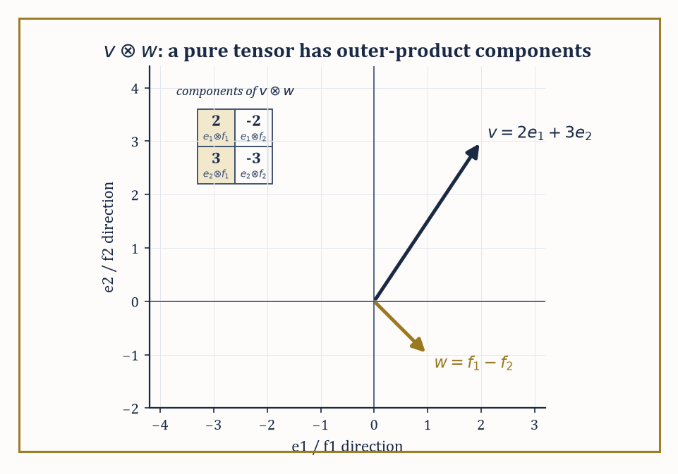
Figure 34.1 — The worked example v⊗w = 2e1⊗f1 − 2e1⊗f2 + 3e2⊗f1 − 3e2⊗f2, with its components laid out as the outer product they are.
A tensor that eats k copies of V* and l copies of V is called a (k,l)-tensor, or a tensor of type (k,l); k is the number of contravariant slots and l the number of covariant slots, terminology inherited from how the components behave under a change of basis, which we will get to honestly rather than by decree.
Vectors themselves are (1,0)-tensors in this scheme — a vector v defines a linear functional on V* by evaluation:
v(φ) = φ(v)
and covectors are (0,1)-tensors. A bilinear form is a (0,2)-tensor. A linear map V → V, via the pairing (φ,v) ↦ φ(Tv), is a (1,1)-tensor. Everything you did in linear algebra was secretly low-rank tensor theory.
Numeric example — a linear map as a (1,1)-tensor. Let V = ℝ² with standard basis e1, e2, and let T: V → V be the linear map with matrix A, so that T(e1) = 2e1 and T(e2) = e1 + 3e2:
A = [2 1; 0 3]
As a (1,1)-tensor, T is the map that eats a covector φ and a vector v and returns φ(Tv). Take φ = e¹ (the first coordinate functional, with e¹(e1) = 1 and e¹(e2) = 0) and v = e2.
Tv = T(e2) = e1 + 3e2
φ(Tv) = e¹(e1 + 3e2) = 1
In matrix language this is reading off the (1,2) entry of A, which is 1 — the (1,1)-tensor’s ‘components’ Tⁱⱼ are just the matrix entries Aᵢⱼ, and evaluating the tensor on a basis covector and a basis vector is how you read a matrix entry off a matrix. Nothing new has happened; we have merely learned to see an old friend (the matrix) as an instance of a new and more general species (the tensor).
Try it now — Expand (2e₁ + 3e₂) ⊗ (f₁ − f₂) by bilinearity. Answer →
The tensor product V ⊗ W of two vector spaces is built to be the universal recipient of bilinear maps out of V × W: there is a bilinear map ⊗: V × W → V ⊗ W, and every bilinear map β: V × W → U factors uniquely as a linear map ℓ: V ⊗ W → U composed with ⊗:
β = ℓ ∘ ⊗
In plainer terms, V ⊗ W is the space where ‘v tensor w’ lives as a new, formal object, and it is exactly big enough to encode every possible bilinear behavior of v and w without throwing any information away or keeping any redundant information around.
If dim V = m and dim W = n, then:
dim(V ⊗ W) = mn
with basis eᵢ ⊗ fⱼ for basis vectors eᵢ of V and fⱼ of W. Higher tensor products, and the space of (k,l)-tensors on V, are built the same way by iterating: (k,l)-tensors on V are precisely
V ⊗ ⋯ ⊗ V ⊗ V* ⊗ ⋯ ⊗ V* (k copies of V, l copies of V*)
Numeric example — an explicit tensor product. Let V = W = ℝ² with bases e1, e2 and f1, f2. Take v = 2e1 + 3e2 and w = f1 − f2. Expand v ⊗ w by bilinearity:
v ⊗ w = 2e1⊗f1 − 2e1⊗f2 + 3e2⊗f1 − 3e2⊗f2
Writing the coefficients of eᵢ⊗fⱼ as a 2×2 array (row i, column j) gives:
[2 −2; 3 −3]
which is the outer product of the column vectors (2,3) and (1,−1): entry (i,j) is (component i of v)×(component j of w). This is the general fact in miniature — a ‘pure’ tensor v ⊗ w always has components that are the outer product of the components of v and w — and it is also a warning: most tensors in V ⊗ W are sums of several such outer products and cannot be written as a single v ⊗ w.
(Try to write [1 0; 0 1] as a single outer product and you will spend an unpleasant afternoon discovering you can’t; its rank as a matrix is 2, not 1.)
From tensors of a given type you can manufacture new ones. Contraction pairs off one contravariant slot with one covariant slot and sums, generalizing the trace of a matrix (which is the contraction of a (1,1)-tensor with itself).
Symmetrization averages a tensor over all permutations of a chosen set of slots, producing something unchanged by swapping those slots; alternation averages with alternating signs, producing something that flips sign under a swap and vanishes whenever two of the swapped arguments coincide.
Applying alternation to all l covariant slots of a totally covariant tensor and keeping only the totally antisymmetric survivors builds the exterior algebra Λ•V*, whose degree-k piece Λᵏ V* is the home of the differential k-forms we will meet properly in Differential Forms and Exterior Calculus; applying symmetrization instead builds the symmetric algebra, home to quadratic forms, metrics, and polynomials in disguise.
Numeric example — symmetrizing and alternating a bilinear form. Take the (0,2)-tensor B with matrix [2 1; 0 3] from before, now read as a bilinear form B(u,v) rather than a linear map. Its symmetric part is:
Sym(B) = (B + Bᵀ)/2 = ([2 1; 0 3] + [2 0; 1 3])/2 = [4 1; 1 6]/2 = [2 0.5; 0.5 3]
This is symmetric, as promised, since swapping the two entries off the diagonal leaves it unchanged. Its antisymmetric part is:
Alt(B) = (B − Bᵀ)/2 = [0 1; −1 0]/2 = [0 0.5; −0.5 0]
Check the books balance:
Sym(B) + Alt(B) = [2 (0.5+0.5); (0.5−0.5) 3] = [2 1; 0 3] = B
This holds exactly as it must, since every bilinear form is the sum of its symmetric and antisymmetric parts and nothing has been lost or invented in the split.
Choose a basis of V, and every abstract tensor acquires components: a (k,l)-tensor becomes an array of numbers with k upper indices and l lower indices.
Choose a different basis, related to the first by a change-of-basis matrix P, and the components transform: each upper index gets multiplied by P⁻¹ (because vectors themselves, expanded in a new basis, pick up P⁻¹), and each lower index gets multiplied by P (because covectors, being linear functionals, transform the opposite way to keep the pairing between vectors and covectors basis-independent).
This is the celebrated transformation law, and the crucial thing to notice — the whole point of this section — is that it is derived, not postulated. A collection of numbers that happens to obey the right transformation law is a tensor’s components; a collection that does not is just numbers with delusions of grandeur.
Numeric example — two transformation laws from one array of numbers. Let A = [2 1; 0 3] represent a (1,1)-tensor (a linear map) and, separately, let the same array of numbers B = [2 1; 0 3] represent a (0,2)-tensor (a bilinear form) — same numbers, different species. Change basis via P = [1 1; 1 −1] (so the new basis vectors are e1+e2 and e1−e2); one computes P⁻¹ = [0.5 0.5; 0.5 −0.5].
The (1,1)-tensor transforms by similarity, A′ = P⁻¹AP: first AP, then P⁻¹ times that.
AP = [3 1; 3 −3]
A′ = P⁻¹(AP) = [3 −1; 0 2]
Note that the trace is preserved:
trace(A′) = 3+2 = 5 = trace(A) = 2+3
the trace, being a contraction, is basis-independent, as the theory promises. The (0,2)-tensor transforms by congruence instead, B′ = PᵀBP (here Pᵀ = P, since our P happens to be symmetric): BP is the same intermediate product as before, then P times that.
BP = [3 1; 3 −3]
B′ = P(BP) = [6 −2; 0 4]
So A′ = [3 −1; 0 2] but B′ = [6 −2; 0 4] — the identical array of numbers transforms into two genuinely different arrays, because ‘transforms like a tensor’ is meaningless until you say which kind of tensor you mean. This is why the sentence ‘is this a tensor?’ is only ever answerable once you have specified its type.
Abstract example — the exterior square of ℝ³. Let V = ℝ³ with basis e1, e2, e3. The space Λ²V, built by alternating (2,0)-tensors, has basis e1∧e2, e1∧e3, e2∧e3 — dimension C(3,2) = 3, matching the general formula dim Λᵏ V = C(n,k) for V of dimension n. Take u = (1,2,0) and v = (0,1,3), i.e. u = e1+2e2 and v = e2+3e3.
Expanding u∧v by bilinearity and using eᵢ∧eᵢ = 0 and eᵢ∧eⱼ = −eⱼ∧eᵢ, the coefficients work out as follows: of e1∧e2 is (1)(1)−(2)(0) = 1, of e1∧e3 is (1)(3)−(0)(0) = 3, and of e2∧e3 is (2)(3)−(0)(1) = 6.
u∧v = e1∧e2 + 3(e1∧e3) + 6(e2∧e3)
Swap the order — compute v∧u — and every coefficient flips sign, since wedging is antisymmetric; this is the alternation from two paragraphs ago, made concrete rather than merely asserted.
Keep only this · Section 34.1: Multilinear Algebra and Tensors
The idea. A tensor of type (p, q) is a multilinear function of q vectors and p covectors. Tensor products build tensors from vectors, and symmetric and alternating parts split bilinear forms. Linear maps are (1, 1)-tensors and bilinear forms (0, 2)-tensors: the same array of numbers can mean either, and the two transform differently.
Core.
dim(V ⊗ W) = dim V · dim W
dim ΛᵏV = C(n, k) for dim V = n
change of basis P: map A ↦ P⁻¹AP, form B ↦ PᵀBP
Typical mistake. Treating a matrix as just an array. A linear map and a bilinear form with the same matrix change differently under a change of basis.
Minimal example. Λ²ℝ³ has basis e₁∧e₂, e₁∧e₃, e₂∧e₃: dimension 3.
Practice. Easy to challenge; full worked answers, with the usual mistake, are in Answers to the Practice Sets at the back.
Easy — Find dim(ℝ³ ⊗ ℝ⁴) and dim Λ²ℝ⁴. Answer →
Medium — Split B = [2 1; 0 3] into symmetric and alternating parts. Answer →
Challenge — With P = [1 1; 0 1], compute P⁻¹AP and PᵀBP for A = B = [2 1; 0 3]. Answer →

Section 34.2: Tensor Fields and Transformation Laws
Or: how to tell a real tensor from an impostor with delusions
Everything in the previous section happened at a single point, with a single fixed vector space V. Geometry, being greedy, wants a tensor at every point of a region — a tensor field.
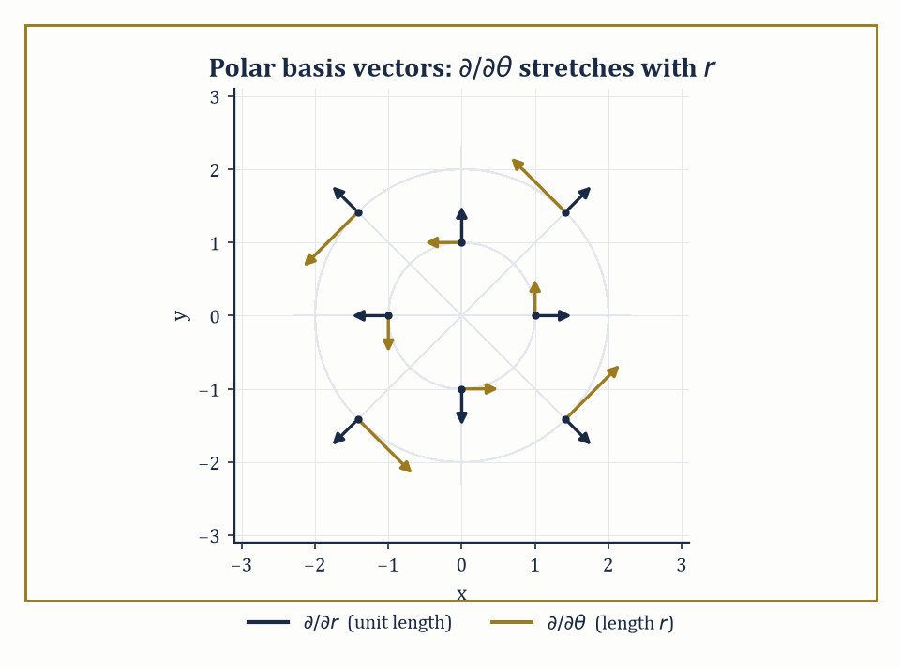
Figure 34.2 — Why the Christoffel symbols are not tensor components: the polar basis vectors themselves rotate and stretch from point to point, even though the underlying plane is flat.
On an open subset of ℝⁿ, a tensor field of type (k,l) assigns to each point p a (k,l)-tensor on the tangent space at p (which, on flat Euclidean space, is just another copy of ℝⁿ), and does so smoothly: the components, relative to the standard basis at each point, are smooth functions of position.
Under a change of coordinates — not just a change of basis at one point, but a different coordinate system covering the region — the components transform by the Jacobian matrix of the coordinate change and its inverse, index by index, just as in Multilinear Algebra and Tensors, except that the ‘change-of-basis matrix’ P is now itself a function of position, since the tangent directions of the new coordinates rotate and stretch as you move.
This transformation law is not only decorative; it is the practical test of tensorial legitimacy. If you hand a working mathematician a list of component functions in one coordinate system and ask whether they define a genuine tensor field, the honest test is to change coordinates and check whether the components transform the way the theory demands.
Fail the test, and what you have is a collection of numbers that happened to look tensor-like in one particular coordinate system by coincidence — flattering in Cartesian coordinates, treacherous everywhere else.
Numeric example — a covector field in polar coordinates. On ℝ², consider the 1-form (covector field) ω = x dy − y dx, i.e. with Cartesian components ω_x = −y, ω_y = x. Convert to polar coordinates x = r cosθ, y = r sinθ, using dx = cosθ dr − r sinθ dθ and dy = sinθ dr + r cosθ dθ.
Substituting:
x dy = r cosθ sinθ dr + r²cos²θ dθ
y dx = r sinθ cosθ dr − r²sin²θ dθ
Subtracting, the dr terms cancel exactly (r cosθ sinθ − r sinθ cosθ = 0) and the dθ terms add:
ω = r²(cos²θ+sin²θ) dθ = r² dθ
So in polar coordinates ω has components (ω_r, ω_θ) = (0, r²). Check this really is the transformation law and not a fluke: at the point (x,y) = (3,4), r = 5 and cosθ = 3/5, sinθ = 4/5, so the Jacobian entries are ∂x/∂r = 0.6, ∂x/∂θ = −4, ∂y/∂r = 0.8, ∂y/∂θ = 3.
The transformation law for a covector is ω′_μ = ω_x(∂x/∂x′^μ) + ω_y(∂y/∂x′^μ); with (ω_x,ω_y) = (−4,3):
ω′ᵣ = (−4)(0.6) + (3)(0.8) = −2.4+2.4 = 0
ω′_θ = (−4)(−4) + (3)(3) = 16+9 = 25 = r² (since r=5)
Both routes — substituting the coordinate change directly into the form, and applying the abstract transformation law to the components — agree, which is what ‘being a genuine tensor field’ means in practice.
Try it now — Write ω = x dy − y dx in polar coordinates. Answer →
Now for the cautionary tale the section is truly building toward. Christoffel symbols — you will meet them properly in Riemannian Metrics and Connections, Covariant Derivatives, and Curvature, but they are the coefficients that tell you how basis vectors twist as you move through curved or merely curvilinear coordinates — look, superficially, like the components of a (1,2)-tensor: three indices, transformation-law shaped equations in every textbook.
They are not a tensor. The proof is almost insultingly short.
Abstract example — why Christoffel symbols fail the test. In Cartesian coordinates on flat ℝ², the basis vectors ∂/∂x and ∂/∂y do not change direction or length as you move, so every Christoffel symbol vanishes identically:
Γ = 0 everywhere (Cartesian coordinates)
In polar coordinates on the very same flat plane, the basis vectors ∂/∂r and ∂/∂θ do rotate and rescale as you move (∂/∂θ gets longer the further out you go, and both directions rotate as θ increases), and one finds nonzero values such as:
Γʳ_θθ = −r (computed properly in Riemannian Metrics)
Now suppose, for contradiction, that the Christoffel symbols were the components of a genuine tensor. A basic fact about tensors, immediate from the transformation law, is that a tensor which is identically zero in one coordinate system is identically zero in every coordinate system — the transformation law multiplies zero by Jacobian factors and gets zero back, no matter how contorted the change of coordinates.
But the Christoffel symbols are zero in Cartesian coordinates and nonzero in polar coordinates, on the same underlying flat plane. That is a direct contradiction, so the Christoffel symbols cannot be tensor components.
What they actually are — the data of a connection, not a tensor — is the subject of Connections, Covariant Derivatives, and Curvature, and this small failure is the first hint, planted early so it can pay off later, that ‘connection’ and ‘tensor’ are different kinds of animal even though both come dressed in indices.
Tensor fields, understood this way, are the raw material of continuum mechanics (the stress tensor, the strain tensor), of electromagnetism (the field-strength tensor, which we will meet again in Looking Ahead: From Manifolds to Riemannian Geometry, Gauge Theory, and Relativity wearing the more fashionable name F = dA), and of general relativity (the metric tensor, the stress-energy tensor, the Riemann curvature tensor).
All of that machinery is presently confined to open subsets of Euclidean space, transforming under changes of coordinates that are still, ultimately, changes of coordinates on ℝⁿ. The next section removes that crutch entirely and lets the underlying space itself be curved, so that ‘a change of coordinates’ becomes ‘gluing one local view of the world to another,’ which is a considerably more honest description of what a map of the Earth is doing.
Keep only this · Section 34.2: Tensor Fields and Transformation Laws
The idea. A tensor field assigns a tensor to each point, and its components change by Jacobians: contravariant indices with ∂x′/∂x, covariant ones with ∂x/∂x′. A quantity whose components do not change this way, such as the Christoffel symbols, is not a tensor.
Core.
vector: v′ⁱ = (∂x′ⁱ/∂xʲ) vʲ
covector: ω′ᵢ = (∂xʲ/∂x′ⁱ) ωⱼ
a tensor that vanishes in one chart vanishes in all
Typical mistake. Calling the Christoffel symbols a tensor. On the plane they vanish in Cartesian coordinates and not in polar ones; a tensor could not do that.
Minimal example. df = (∂f/∂x) dx + (∂f/∂y) dy is a covector field.
Practice. Easy to challenge; full worked answers, with the usual mistake, are in Answers to the Practice Sets at the back.
Easy — Write d(x² + y²) in polar coordinates. Answer →
Medium — Write the vector field ∂/∂θ in Cartesian components. Answer →
Challenge — Write ∂/∂r in Cartesian components and check that ω(∂/∂r) = 0 in both charts for ω = x dy − y dx. Answer →

Section 34.3: Smooth Manifolds
A space that is locally boring and globally anything but
For most of history people lived on a sphere and drew flat maps of it, and the maps worked. A street plan of your town is flat, and nobody is misled by it, because over a few miles the curve of the Earth never comes up. No single flat sheet can carry the whole globe without tearing or stretching somewhere — but a drawer full of local sheets can, provided that where two of them overlap they agree about what is where. That is the whole construction. A smooth manifold of dimension n is a space that near every point looks like an ordinary flat piece of ℝⁿ, where looks like means there is a homeomorphism — a continuous matching, with a continuous matching back — from a neighborhood of the point onto an open subset of ℝⁿ. Each such matching is called a chart, which is the older word for a map.
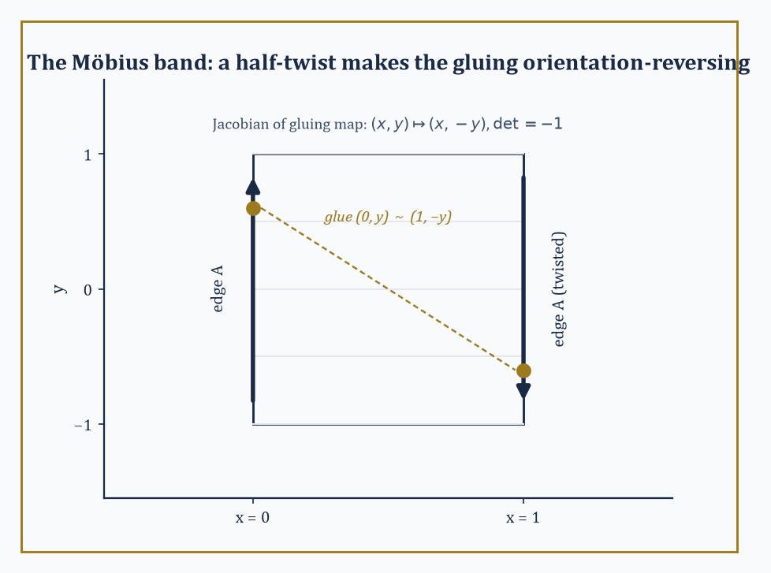
Figure 34.3 — The half-twisted gluing (0,y) ~ (1,−y) that makes the Möbius band the series’ smallest counterexample to orientability.
A collection of charts covering the whole space is an atlas, in shameless and deliberate analogy with a real atlas of the Earth: no single flat page can honestly represent the whole globe, but a book of overlapping local pages can, provided the pages agree with each other where they overlap.
That agreement condition is the heart of the definition: wherever two charts overlap, the transition map — go into the overlap via one chart’s coordinates, come back out via the other’s — must be a smooth (infinitely differentiable) map between open subsets of ℝⁿ.
This is what makes calculus possible on the manifold: you do calculus inside a chart, where you already know how, and the smooth transition maps guarantee that the answer does not depend on which chart you happened to pick.
Numeric example — the sphere via stereographic charts. Let S² = {(x,y,z) ∈ ℝ³ : x²+y²+z² = 1}. Stereographic projection from the north pole N = (0,0,1) sends any other point of the sphere to where the line through N and that point crosses the plane z=0, giving a chart φ_N : S²∖{N} → ℝ². Projection from the south pole S=(0,0,−1) gives a second chart φ_S : S²∖{S} → ℝ². Together they cover the entire sphere, since no point is omitted by both.
On the overlap (everything except the two poles), the transition map works out to an inversion in the unit circle:
φ_S∘φ_N⁻¹(u,v) = (u,v)/(u²+v²)
Check smoothness at a sample point:
at (u,v)=(1,0): (1,0)/1 = (1,0)
at (u,v)=(2,0): (2,0)/4 = (0.5,0)
The formula (u,v)/(u²+v²) is a ratio of smooth functions whose denominator u²+v² vanishes only at the origin — which corresponds to the point N, correctly excluded from this chart’s domain — so the transition map is smooth everywhere it is defined. Two charts, one honest overlap condition checked directly by formula: that is the entire content of ‘the sphere is a smooth 2-manifold,’ with no appeal to its being embedded in ℝ³ required at all.
Try it now — Stereographic projection from N = (0, 0, 1) is (x, y, z) ↦ (x/(1 − z), y/(1 − z)). Where does (1, 0, 0) go? Answer →
The zoo of examples is large and mostly familiar in disguise. Open subsets of ℝⁿ are manifolds trivially, with the identity map as their only chart. Spheres, tori, and real or complex projective spaces are manifolds by constructions much like the stereographic one above.
The general linear group GL(n,ℝ), the set of invertible n×n matrices, is a manifold because it is an open subset of the n²-dimensional space of all matrices — invertibility means nonzero determinant, and the determinant is a continuous (indeed polynomial) function, so its complement is a closed set and GL(n,ℝ) itself, being the complement of that closed set, is open.
Configuration spaces of mechanical systems — the space of all possible positions of a robot arm with several joints, say — are manifolds too, glued from the ranges of the joint angles.
Abstract example — GL(2,ℝ) as an open manifold. Identify the space of 2×2 real matrices with ℝ⁴ via [a b; c d] ↔ (a,b,c,d). The determinant map is continuous (it is a polynomial):
det(a,b,c,d) = ad − bc
So GL(2,ℝ) = det⁻¹(ℝ∖{0}) is open in ℝ⁴, hence a 4-dimensional manifold with the identity as a single global chart.
Concretely, the matrix [1 2; 3 4] has determinant:
(1)(4) − (2)(3) = 4 − 6 = −2 ≠ 0
so it lies in GL(2,ℝ); since det is continuous, every matrix close enough to it — say [1.01 2; 3 3.99] — is also in GL(2,ℝ), with determinant:
(1.01)(3.99) − (2)(3) = 4.0299 − 6 = −1.9701
still nonzero. That is openness made tangible: invertibility is a robust property, stable under small perturbation, which is exactly what ‘GL(n,ℝ) is open’ is asserting.
A map between manifolds is smooth if it looks smooth when read through charts on both ends — pull back the target chart, push forward the source chart, and check smoothness of the resulting map between open subsets of Euclidean space, where the word already has a meaning.
A diffeomorphism is a smooth map with a smooth inverse; diffeomorphisms are the isomorphisms of the category of manifolds, the maps that identify two manifolds as ‘the same’ for every purpose differential geometry cares about, even if they look utterly different as subsets of some ambient space.
A further piece of machinery, the partition of unity — a collection of smooth bump functions, each supported near one chart, summing to 1 everywhere — lets you take constructions that only make sense locally (inside one chart) and glue them into a single globally-defined object, provided the manifold is paracompact, a mild point-set condition satisfied by essentially every manifold you will meet in this series.
Numeric example — a diffeomorphism from an interval to the whole line. Define f: (−1,1) → ℝ by:
f(x) = x/(1−x²)
This is smooth on (−1,1) (the denominator never vanishes there), and one checks f′(x) = (1+x²)/(1−x²)² > 0 always, so f is strictly increasing, hence injective; as x → ±1, f(x) → ±∞, so f is also surjective onto ℝ, hence a bijection with a smooth inverse (by the inverse function theorem, since f′ never vanishes).
f(0.5) = 0.5/(1−0.25) = 0.5/0.75 = 2/3
f(−0.8) = −0.8/(1−0.64) = −0.8/0.36 ≈ −2.222
So the bounded open interval (−1,1) and the entire real line ℝ are diffeomorphic — as manifolds they are indistinguishable, even though one is a bounded set and the other is not, because ‘bounded’ is a metric notion and diffeomorphism only cares about the smooth structure, not the ruler you happened to measure it with.
Manifolds come with further attributes, each of which decides, without announcement, which theorems apply. A manifold is orientable if it admits an atlas in which every transition map has positive Jacobian determinant — informally, if ‘clockwise’ and ‘counterclockwise’ (or their higher-dimensional analogues) can be defined consistently across the entire space.
Compactness is the familiar topological notion, and boundary — present in a manifold-with-boundary, like a closed disk — introduces an edge where the local model is a half-space rather than the whole of ℝⁿ.
Abstract example — the Möbius band fails to be orientable. Build a band by gluing the two vertical edges of the strip [0,1] × (−1,1) via the identification (0,y) ~ (1,−y) — a half-twist before gluing. Near the seam, the transition map from one side’s local coordinates (x,y) to the other’s is:
(x,y) ↦ (x, −y), Jacobian matrix [1 0; 0 −1], determinant −1
Contrast with the cylinder, built the ordinary way by gluing (0,y) ~ (1,y) with no twist:
(x,y) ↦ (x,y), Jacobian the identity matrix, determinant +1
A negative-determinant transition is precisely the algebraic signature of an orientation-reversing gluing, and no amount of re-choosing charts on the Möbius band can fix every transition map to have positive determinant simultaneously — that impossibility is what ‘non-orientable’ means.
Walk a small clockwise loop around the band once, and it comes back counterclockwise; the ant on the Möbius band, as generations of illustrators have gleefully pointed out, ends up on ‘the other side’ without ever crossing an edge, because there was only ever one side to begin with.
Keep only this · Section 34.3: Smooth Manifolds
The idea. A smooth manifold is a space covered by charts to ℝⁿ whose transition maps are smooth. Spheres, open subsets of ℝⁿ such as GL(2, ℝ), and quotients such as the torus are manifolds; orientability asks whether the charts can all be chosen with positive Jacobians.
Core.
chart: homeomorphism φ: U → φ(U) ⊂ ℝⁿ
transition maps φ ∘ ψ⁻¹ smooth
stereographic: (x, y, z) ↦ (x/(1 − z), y/(1 − z))
Typical mistake. Trying to cover S² with one chart. It would make S² homeomorphic to an open subset of ℝ², which is impossible because S² is compact.
Minimal example. The circle: two angle charts, overlapping in two arcs.
Practice. Easy to challenge; full worked answers, with the usual mistake, are in Answers to the Practice Sets at the back.
Easy — Where does the south pole (0, 0, −1) go? Answer →
Medium — Where does (0, 0.6, 0.8) go? Answer →
Challenge — Show that the transition from the north chart to the south chart (x, y, z) ↦ (x/(1 + z), y/(1 + z)) is u ↦ u/|u|². Answer →

Section 34.4: Tangent Vectors, Vector Fields, and Flows
Three definitions of ‘direction’ that turn out to be secretly the same one
On a manifold that need not sit inside any ℝᴺ, ‘a vector at a point’ cannot mean ‘an arrow’, because there may be no surrounding space for the arrow to poke into. Three definitions of the tangent space at a point p rescue the notion, and — reassuringly, since a subject that offered three incompatible definitions of its central object would not deserve your tuition fees — all three turn out to be equivalent.
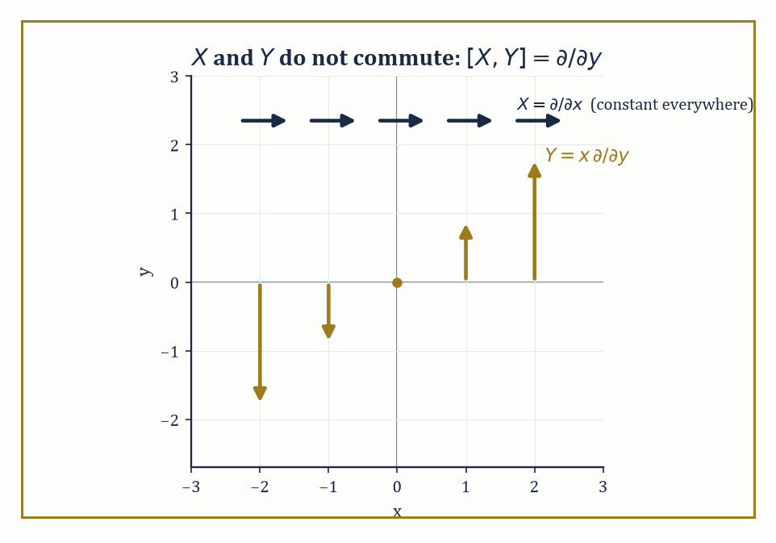
Figure 34.4 — X = ∂/∂x is the same everywhere, but Y = x ∂/∂y grows and flips sign with x — which is why flowing along one and then the other is not the same as doing it in the opposite order.
The first: a tangent vector is a derivation of the algebra of germs of smooth functions at p, meaning a linear map D from (germs of) smooth functions to ℝ satisfying the Leibniz rule:
D(fg) = f(p)D(g) + g(p)D(f)
This is the directional-derivative operator in disguise.
The second: a tangent vector is an equivalence class of smooth curves through p, two curves being equivalent if they have the same velocity at p, as detected by their effect on functions.
The third, more constructive: build the tangent bundle directly from charts, gluing copies of ℝⁿ (one per chart, with tangent vectors given in chart coordinates) via the derivative of each transition map, and the tangent space at p is the fiber of this bundle over p. A vector field is then a smooth choice of one tangent vector at every point — a smooth section of the tangent bundle.
Numeric example — two definitions of tangent vector agree. Work in ℝ² at the point p = (1,1), with the curve γ(t) = (1+2t, 1−t), so γ(0) = p and γ′(0) = (2,−1) =: v. Take the test function f(x,y) = x²+y².
Definition 2 (curves) computes:
d/dt|ₜ₌₀ f(γ(t)) = d/dt|ₜ₌₀[(1+2t)² + (1−t)²] = [2(1+2t)(2) + 2(1−t)(−1)]|ₜ₌₀ = 2(1)(2) + 2(1)(−1) = 4 − 2 = 2
Definition 1 (derivation / directional derivative) computes the directional derivative of f at p in direction v = (2,−1):
v·∇f(p) = (2,−1)·(2x,2y)|_((1,1)) = (2,−1)·(2,2) = 4 − 2 = 2
Both definitions hand back the number 2. This is not a coincidence for this one function; it holds for every smooth f, which is the content of the theorem that ‘equivalence class of curves’ and ‘derivation’ define the same tangent space, merely described from two different angles.
Try it now — Compute the Lie bracket of X = ∂/∂x and Y = x ∂/∂y. Answer →
Two vector fields do not, in general, commute: flow along X for a moment, then along Y, and you land somewhere different from flowing along Y first and then X. The Lie bracket [X,Y] measures just this failure to commute, to leading order, and is defined by:
[X,Y]f = X(Yf) − Y(Xf)
One must check this is again a derivation, i.e. again a vector field — a small miracle of cancellation.
The flow of a vector field X is the family of maps φₜ obtained by solving the ordinary differential equation dp/dt = X(p) with initial condition p(0) = the starting point; local existence and uniqueness hold on manifolds by the same theorem (Picard–Lindelöf) that guarantees them in ℝⁿ, since the equation is read inside a chart.
Numeric example — computing a Lie bracket. On ℝ², let X = ∂/∂x and Y = x ∂/∂y. Test both sides of [X,Y]f = X(Yf) − Y(Xf) on f(x,y) = x²y.
First:
Xf = ∂f/∂x = 2xy, so Y(Xf) = x·∂(2xy)/∂y = x·(2x) = 2x²
Second:
Yf = x·∂f/∂y = x·x² = x³, so X(Yf) = ∂(x³)/∂x = 3x²
So:
[X,Y]f = X(Yf) − Y(Xf) = 3x² − 2x² = x²
Now compare with the claimed bracket [X,Y] = ∂/∂y, obtained symbolically: X(Yf) = ∂/∂x(x·∂f/∂y) = ∂f/∂y + x∂²f/∂x∂y, while Y(Xf) = x·∂²f/∂y∂x, and the mixed partials cancel, leaving exactly ∂f/∂y. Applied to our f, ∂f/∂y = x², which matches the direct computation exactly.
So [∂/∂x, x∂/∂y] = ∂/∂y — the flows of ‘slide right’ and ‘slide up at a rate proportional to how far right you are’ fail to commute, and the bracket has correctly quantified the failure.
Numeric example — a flow by direct solution. Let V = x ∂/∂x on ℝ (or on the x-axis of ℝ², ignoring y). The flow solves dx/dt = x, x(0) = x₀, giving x(t) = x₀eᵗ by separation of variables.
Starting at x₀ = 2 and flowing for time t = ln 3:
x(ln 3) = 2·eˡⁿ³ = 2·3 = 6
Flowing for a further time t = ln 2 from there lands at:
6·eˡⁿ² = 6·2 = 12
which agrees with flowing from the start for total time ln 3 + ln 2 = ln 6:
x(ln 6) = 2·eˡⁿ⁶ = 2·6 = 12
The flow composes correctly, φₛ∘φₜ = φₛ₊ₜ, as the defining differential equation guarantees — flows form a one-parameter group, the continuous-time analogue of the additive group of real numbers, quietly present every time you solve dx/dt = x.
The tangent bundle TM (all tangent vectors at all points, glued together) and the cotangent bundle T*M (all covectors at all points) are themselves manifolds — of dimension 2n if M has dimension n, since you need n coordinates to say where you are and another n to say which tangent direction you mean.
Once you have a vector bundle like TM, the tensor-algebra machinery of Multilinear Algebra and Tensors can be repeated fiber by fiber, at every point simultaneously, producing tensor bundles: bundles whose fiber over p is the space of (k,l)-tensors on T_pM.
A tensor field, properly defined at last, is a smooth section of the appropriate tensor bundle — the definition Tensor Fields and Transformation Laws was implicitly using all along, now given a home that does not secretly require the manifold to sit inside a Euclidean space.
Numeric example — dimension count for a tensor bundle. Take M = ℝ³, so n = 3. The tangent bundle TM has dimension:
2n = 6
three coordinates to specify the base point, three more to specify the tangent vector sitting there. Now consider the bundle of (1,1)-tensors over M — the fiber over each point p is the space of (1,1)-tensors on T_pM, which (Multilinear Algebra and Tensors) has dimension:
n² = 9
one number for each entry of a 3×3 matrix. The total space of this tensor bundle is therefore itself a manifold of dimension:
n + n² = 3 + 9 = 12
three coordinates for the base point, nine more for the components of the tensor living above it. Repeat the count for the bundle of (0,2)-tensors, where the metric of Riemannian Metrics will shortly come to live, and you get exactly the same fiber dimension, n² = 9 — because a (k,l)-tensor space always has dimension nᵏ⁺ˡ regardless of how k and l are split between upper and lower indices, and only the transformation law, never the dimension, cares which is which.
Keep only this · Section 34.4: Tangent Vectors, Vector Fields, and Flows
The idea. A tangent vector is the velocity of a curve or, equivalently, a derivation on functions. Vector fields generate flows, and the Lie bracket [X, Y] = XY − YX measures how their flows fail to commute.
Core.
v(f) = (d/dt) f(γ(t)) at t = 0
[X, Y]f = X(Yf) − Y(Xf)
flow of V: (d/dt)φₜ = V(φₜ)
Typical mistake. Expanding XY and stopping. The second-order terms cancel in XY − YX; the bracket is again a vector field.
Minimal example. Flow of x ∂/∂x: x(t) = x₀eᵗ.
Practice. Easy to challenge; full worked answers, with the usual mistake, are in Answers to the Practice Sets at the back.
Easy — γ(t) = (1 + 2t, 1 − t) and f = x²y. Find (d/dt) f(γ(t)) at t = 0. Answer →
Medium — Check [∂/∂x, x ∂/∂y] = ∂/∂y on f = x²y. Answer →
Challenge — Find the flow of V = −y ∂/∂x + x ∂/∂y. Answer →

Section 34.5: Differential Forms and Exterior Calculus
The totally antisymmetric tensors get their own weather system
A river running through a net, a magnetic field crossing a sheet of metal, gravity pulling along a path — in each case you measure the quantity by choosing a patch or a line and asking how much passes through it. All of them share one habit: turn the patch over, and the answer comes back with the opposite sign. A differential k-form is the object built to be measured in exactly that way: a smooth field of totally antisymmetric (0,k)-tensors — a smooth section of the bundle Λᵏ T*M built by the exterior-algebra construction of Multilinear Algebra and Tensors, applied fiberwise.
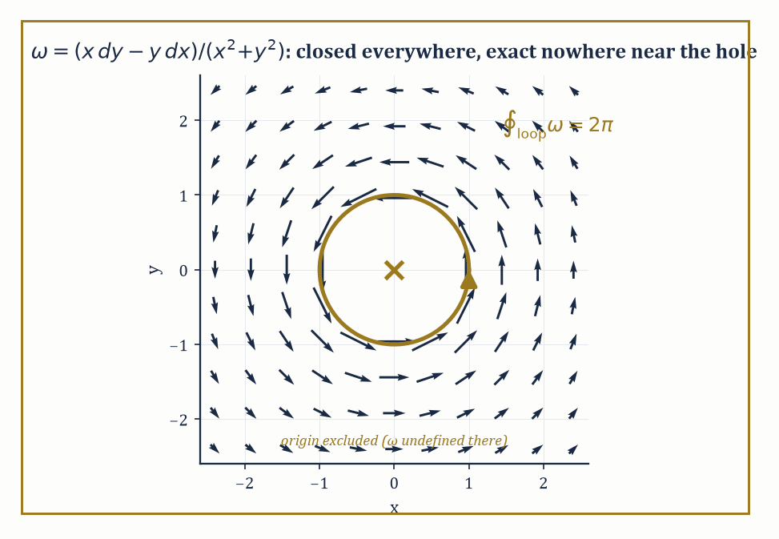
Figure 34.5 — The angle form ω, closed everywhere it is defined, circulating endlessly around the one point where it isn’t — the puncture is the entire reason it fails to be exact.
The exterior derivative d takes a k-form to a (k+1)-form and satisfies the fundamental identity:
d² = 0
Differentiate twice and you always get zero — a fact that looks like an algebraic curiosity until de Rham cohomology, two sections from now, turns it into a topological measuring instrument.
Two further operations act on forms: the interior product i_X (also written ι_X), which plugs a vector field X into the first slot of a form and lowers the degree by one, and the Lie derivative L_X, which differentiates a form along the flow of X.
Cartan’s magic formula ties the three operations together:
L_X = d∘i_X + i_X∘d
This is an identity that looks unmotivated until you have used it to shortcut a calculation you would otherwise have had to grind out by brute force, at which point it becomes, suddenly, the best formula you own.
Numeric example — computing an exterior derivative. On ℝ², take the 1-form ω = x²y dx + xy² dy, i.e. P = x²y, Q = xy². The general formula for a 1-form is:
dω = (∂Q/∂x − ∂P/∂y) dx∧dy
Here ∂Q/∂x = y² and ∂P/∂y = x², so:
dω = (y² − x²) dx∧dy
Check ω is not closed in general: dω = 0 only where y² = x², i.e. along the two lines y = ±x, not everywhere — so this particular ω is an example of a form that is neither closed nor exact almost everywhere, which is the generic (uninteresting) case; the interesting cases, coming next, are the exceptions.
Try it now — Compute dω for ω = x²y dx + xy² dy. Answer →
Abstract example — closed but not exact — the angle form. On ℝ²∖{0}, define:
ω = (x dy − y dx)/(x²+y²)
Tensor Fields and Transformation Laws already computed x dy − y dx = r² dθ in polar coordinates, so:
ω = r² dθ / r² = dθ
As dθ is (locally) the derivative of the coordinate function θ, one might reflexively call ω ‘exact’, and it is exact on any region where θ can be defined as a single continuous function — say, the plane with the positive x-axis removed.
But θ itself is not a well-defined smooth function on all of ℝ²∖{0}: walk once counterclockwise around the origin and θ increases by 2π rather than returning to its starting value, so there is no single global function α with dα = ω on the punctured plane.
Yet dω = 0 everywhere ω is defined (a direct computation, or simply: d(dθ) = 0 by the identity d² = 0, applied on any patch where θ is single-valued, and the resulting 2-form is globally consistent even though θ itself is not).
So ω is closed everywhere but not globally exact — the first, and archetypal, example of a closed form that fails to be exact, and the failure is caused entirely by the hole at the origin. This single example is the seed from which the entire subject of de Rham cohomology (Integration on Manifolds and Stokes’ Theorem) grows.
The Poincaré lemma is the local converse: on a contractible region (one that can be continuously shrunk to a point without leaving the region, such as a ball, or indeed any open subset of ℝⁿ that is star-shaped about a point), every closed form is exact.
The angle-form example shows this is a local statement — it holds on any small disk not containing the origin, and fails on the whole punctured plane because the punctured plane is not contractible (you cannot shrink a loop around the hole to a point without crossing the hole).
Pull-back by a smooth map f: N → M sends forms on M back to forms on N and commutes with d, meaning:
f*(dω) = d(f*ω)
This always holds — exterior calculus is natural, it does not care which manifold you are currently standing on, and this naturality is what lets Stokes’ theorem, in the next section, be stated once and mean the same thing on every manifold simultaneously.
Numeric example — pulling a form back along a circle. Let f: ℝ → ℝ² be f(t) = (cos t, sin t), the standard parametrization of the unit circle, and pull back ω = x dy − y dx from Tensor Fields and Transformation Laws along f. Compute dx = −sin t dt and dy = cos t dt from the parametrization, and substitute x = cos t, y = sin t:
f*ω = (cos t)(cos t dt) − (sin t)(−sin t dt) = cos²t dt + sin²t dt = (cos²t + sin²t) dt = dt
using the Pythagorean identity. So the pullback of ω along the unit circle is dt — a strikingly clean answer for a form that looked considerably less clean in Cartesian coordinates.
Integrating this pulled-back form from t = 0 to t = 2π gives:
∫[0, 2π] dt = 2π
the value ∫[unit circle] ω = 2π computed by other means in Integration on Manifolds and Stokes’ Theorem — naturality of the pullback under d, applied here in its integrated form, is what guarantees these two routes to the same number could never have disagreed.
Numeric example — checking Cartan’s magic formula. Let X = ∂/∂x on ℝ² and ω = y dx. Compute both sides of L_Xω = d(i_Xω) + i_X(dω) independently.
Right-hand side, first term:
i_Xω = i_X(y dx) = y·(i_X dx) = y·1 = y
(a function, since contracting a 1-form with a vector field lowers degree to 0), so d(i_Xω) = dy.
Right-hand side, second term:
dω = d(y dx) = dy∧dx = −dx∧dy
i_X(dx∧dy) = (i_Xdx)dy − dx(i_Xdy) = (1)dy − dx(0) = dy
so i_X(dω) = i_X(−dx∧dy) = −dy. Adding the two right-hand terms:
dy + (−dy) = 0
Left-hand side, computed directly: since X = ∂/∂x is a coordinate vector field:
L_X(y dx) = (Xy) dx + y·L_X(dx) = (∂y/∂x) dx + y·d(i_X dx) = 0·dx + y·d(1) = 0 + 0 = 0
Both sides equal 0. The identity holds in this case, as it must in every case — but seeing it hold, term by term, on a two-line example is worth more than watching the general proof scroll past.
Keep only this · Section 34.5: Differential Forms and Exterior Calculus
The idea. Differential forms are alternating tensor fields, and the exterior derivative d satisfies d² = 0 and unifies grad, curl and div. A closed form (dω = 0) need not be exact (ω = dη) on a space with holes; pullbacks and Cartan’s formula connect forms with maps and flows.
Core.
d(P dx + Q dy) = (Q_x − P_y) dx ∧ dy
d² = 0
Cartan: L_X ω = d(i_X ω) + i_X(dω)
Typical mistake. Concluding exact from closed. The angle form (x dy − y dx)/(x² + y²) is closed on the punctured plane but not exact: its integral around the unit circle is 2π.
Minimal example. dx ∧ dx = 0 and dy ∧ dx = −dx ∧ dy.
Practice. Easy to challenge; full worked answers, with the usual mistake, are in Answers to the Practice Sets at the back.
Easy — Compute d(x dy − y dx). Answer →
Medium — Pull back ω = x dy − y dx along f(t) = (cos t, sin t). Answer →
Challenge — Check Cartan’s formula for X = ∂/∂x and ω = y dx. Answer →

Section 34.6: Integration on Manifolds and Stokes’ Theorem
Green, Gauss, and Stokes turn out to have been the same theorem all along
An n-form on an oriented n-manifold can be integrated: cover the manifold by oriented charts, pull the form back into each chart (where it becomes an ordinary density that ordinary Riemann or Lebesgue integration already knows how to handle), multiply by a partition of unity to avoid double-counting the overlaps, and sum.
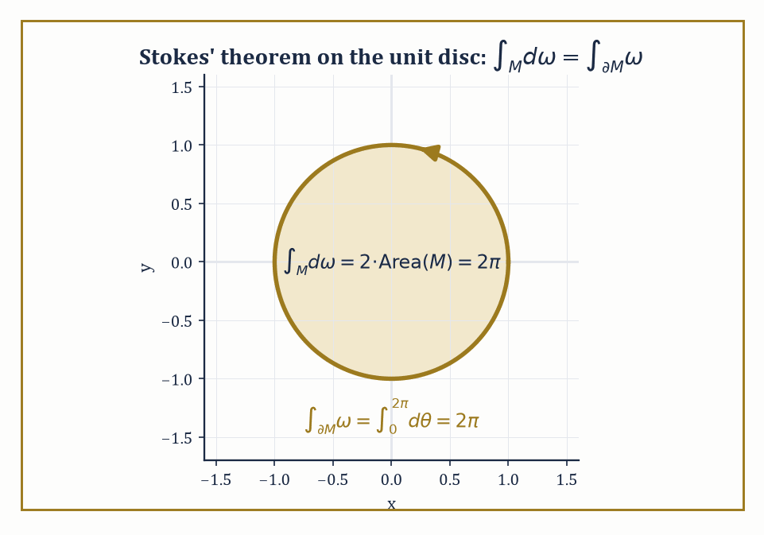
Figure 34.6 — Two routes to 2π on the unit disk — integrate dω over the interior, or ω over the boundary — arriving, as Stokes insists they must, at the same number.
The result does not depend on which atlas or which partition of unity you chose — a fact that requires the change-of-variables formula for multiple integrals, which is the statement that the Jacobian determinant is the correct correction factor, i.e. the transformation law of Multilinear Algebra and Tensors applied to a top-degree form.
A manifold-with-boundary inherits an induced orientation on its boundary (the ‘outward normal first’ convention, made precise) from the orientation of the manifold itself.
Stokes’ theorem is the single sentence that makes all of this worth building, for any (n−1)-form ω on an oriented n-manifold-with-boundary M:
∫[M] dω = ∫[∂M] ω
In words: the integral of the derivative over the whole space equals the integral of the original form over just the boundary.
Every ‘fundamental theorem’ you have met in this series is this one theorem wearing a costume: the fundamental theorem of calculus itself (M an interval, ∂M its two endpoints with signs), Green’s theorem in the plane, Gauss’s divergence theorem in space, and the classical Stokes’ theorem for surfaces bounded by curves are all the single identity ∫[M] dω = ∫[∂M] ω, specialized to different dimensions and different degrees of form.
Numeric example — Stokes’ theorem on the unit disk. Let M be the closed unit disk {x²+y² ≤ 1} in ℝ², oriented the standard way, with boundary the unit circle traversed counterclockwise. Take ω = x dy − y dx, the same 1-form from Tensor Fields and Transformation Laws, where we already found ω = r²dθ in polar coordinates.
Right-hand side of Stokes: on the unit circle r = 1, so ω restricts to dθ, and:
∫[∂M] ω = ∫[0, 2π] 1² dθ = 2π
Left-hand side:
dω = d(x dy) − d(y dx) = (dx∧dy) − (dy∧dx) = dx∧dy − (−dx∧dy) = 2 dx∧dy
Integrating:
∫[M] dω = ∫[M] 2 dx∧dy = 2·Area(M) = 2·π(1)² = 2π
Both sides equal 2π. Stokes’ theorem holds here not as an act of faith but as two independent computations landing on the same number, which is, after all, the only kind of confirmation mathematics ever really offers.
Try it now — Verify Stokes’ theorem on the unit disk for ω = x dy. Answer →
The classical vector-calculus theorems drop out as corollaries once the dictionary between vector fields and forms (via the metric — the same dictionary Riemannian Metrics will build properly) is in place: Green’s theorem is the n=2 case just verified above, Gauss’s divergence theorem is the n=3 case with a 2-form playing the role of flux, and the classical Kelvin–Stokes theorem relating a surface integral of curl to a line integral around its boundary is the n=2-inside-3 case.
What used to be three separate theorems, each proved by its own ad hoc argument and memorized separately by generations of engineering students, is revealed as one theorem, proved once, about the interaction of d and ∂.
Numeric example — integrating over a boundaryless manifold. The unit sphere S² has no boundary at all, so Stokes’ theorem forces, for any 2-form ω that happens to be exact:
∫[S²] dω = ∫[∂S²] ω = ∫_∅ ω = 0
A closed manifold kills every exact top-degree form’s integral automatically.
Yet the sphere’s own area form σ is manifestly not exact, since its integral is nonzero (computed directly, in spherical coordinates σ = sinφ dφ∧dθ):
∫[S²] σ = ∫[0, π]∫[0, 2π] sinφ dθdφ = 2π·[−cosφ]₀^π = 2π·(1−(−1)) = 2π·2 = 4π
and exactness would force it to vanish by the argument just given. This one nonzero number, 4π, is (up to normalization) exactly what de Rham cohomology records as the generator of H²(S²) ≅ ℝ — the statement, extracted purely by integrating a 2-form, that the sphere is not simply a boundary of something, which is truly just a fancy way of saying the sphere encloses a genuine hole in the middle, the same phenomenon Section 34.5’s punctured-plane example caught one dimension down.
Abstract example — what the hole obstructs. Recall from Differential Forms and Exterior Calculus that ω = (x dy − y dx)/(x²+y²) is closed but not exact on ℝ²∖{0}. Suppose, for contradiction, someone claims ω = dα for some smooth function α defined on the whole punctured plane.
Apply Stokes to the unit circle (the boundary of the unit disk) — but the unit disk itself contains the origin, where ω is not defined, so the disk is not a legitimate domain for this ω, and Stokes cannot be applied over the full disk. That failure is not a technicality to be waved away; it is the entire content of the phenomenon.
If instead we integrate honestly over the annulus 0.5 ≤ r ≤ 1 (which does avoid the origin and does have M itself as a legitimate domain, with ∂M consisting of two circles, the outer one counterclockwise and the inner one clockwise by the induced-orientation convention), Stokes gives:
∫[M] dω = 0 (since dω = 0 on the entire annulus)
which correctly forces the two boundary integrals to cancel:
∫ₒᵤₜₑᵣ ω = 2π and ∫ᵢₙₙₑᵣ ω = 2π
(both traversed counterclockwise as circles, but the inner one contributes with a minus sign as part of ∂M), so 2π − 2π = 0, consistent.
The nonzero value 2π attached to any single loop around the origin is what de Rham cohomology packages up as the statement H¹(ℝ²∖{0}) ≅ ℝ: a topological fact about the puncture, extracted entirely by differential calculus, with no topology textbook required.
Same structure, new language
Green’s, Stokes’ and Gauss’s theorems from Vector Calculus (Volume 2) are this one theorem in dimensions 2 and 3. The fundamental theorem of calculus from Integral (Volume 1) is its one-dimensional case.
Keep only this · Section 34.6: Integration on Manifolds and Stokes’ Theorem
The idea. Oriented manifolds integrate forms of top degree, and Stokes’ theorem ∫_M dω = ∫_∂M ω contains the fundamental theorem of calculus, Green’s, Stokes’ and Gauss’s theorems. It turns closed-but-not-exact forms into detectors of holes.
Core.
∫_M dω = ∫_∂M ω
∂M empty ⇒ ∫_M dω = 0
ω = dη ⇒ ∮ ω = 0 around every closed loop
Typical mistake. Ignoring orientation. Reversing the orientation of the boundary flips the sign.
Minimal example. M = [a, b]: ∫ₐᵇ f′ dx = f(b) − f(a).
Practice. Easy to challenge; full worked answers, with the usual mistake, are in Answers to the Practice Sets at the back.
Easy — Compute ∮ (x dy − y dx) around the unit circle. Answer →
Medium — Find the area of the ellipse x²/4 + y² ≤ 1 as ½∮(x dy − y dx). Answer →
Challenge — Why can the angle form on the punctured plane not be exact? Answer →

Section 34.7: Riemannian Metrics
Where the manifold finally learns to measure itself
Everything so far — charts, tangent vectors, forms, integration — works on a manifold with no notion of length or angle at all; you can integrate top-degree forms, but you cannot yet ask how long a curve is or whether two tangent vectors are perpendicular.
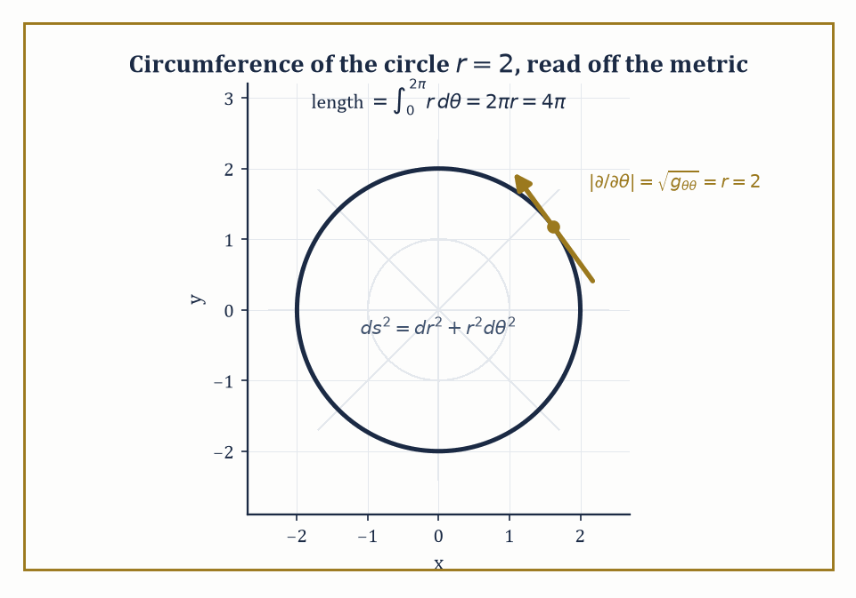
Figure 34.7 — The circle r=2, its tangent direction ∂/∂θ stretched to length r by the metric g = diag(1, r²), integrating out to the circumference 4π you already trusted.
A Riemannian metric supplies just that: a smoothly varying inner product g on each tangent space, i.e. a (0,2)-tensor field that is symmetric and positive-definite at every point. In coordinates, g is represented by a symmetric positive-definite matrix of smooth functions gᵢⱼ(x).
The metric lets you compute the length of a tangent vector:
|v| = √(g(v,v))
the length of a curve, by integrating the speed √(g(γ′,γ′)) along it; angles between vectors; and volumes, via √(det g), the correction factor that makes the integration of Integration on Manifolds and Stokes’ Theorem metric-aware.
It also supplies the musical isomorphisms — the metric-induced dictionary that lowers a vector’s index to produce a covector (v ↦ g(v,·), traditionally written v♭, ‘v flat’) and raises a covector’s index back (traditionally ω♯, ‘omega sharp’), the very dictionary Integration on Manifolds and Stokes’ Theorem promised and postponed.
Numeric example — circumference from the metric. The flat plane in polar coordinates carries the metric:
ds² = dr² + r²dθ², i.e. g = diag(1, r²): g_rr = 1, g_θθ = r², g_rθ = 0
The circle of radius r = 2 is parametrized by θ ↦ (2, θ), θ ∈ [0,2π), with velocity dr/dθ = 0, dθ/dθ = 1, so its speed at every point is:
√(g_θθ·1²) = √(r²) = r = 2
Its length is:
∫[0, 2π] 2 dθ = 4π
This is the familiar circumference formula 2πr with r = 2, recovered from the metric tensor rather than assumed, which is exactly the point: the metric is the object from which every geometric quantity you already trust is derived, and checking it reproduces a formula you already knew is how you convince yourself the machine is correctly built before trusting it on a question you don’t already know the answer to.
Try it now — With the polar metric dr² + r² dθ², find the circumference of the circle r = 2. Answer →
Numeric example — lowering an index with the musical isomorphism. Still with g = diag(1, r²) on the punctured plane in polar coordinates, take the vector v = ∂/∂θ at the point r = 2 (components vʳ = 0, vᶿ = 1). Its flat, v♭ = g(v, ·), has components (v♭)ᵢ = gᵢⱼ vʲ:
(v♭)ᵣ = g_rr vʳ + g_rθ vᶿ = (1)(0) + (0)(1) = 0
(v♭)_θ = g_θr vʳ + g_θθ vᶿ = (0)(0) + (r²)(1) = r² = 4 at r = 2
So v♭ = 4 dθ at that point — the covector ‘dual’ to the coordinate vector ∂/∂θ is not dθ, as it would naively be in a flat orthonormal frame, but r² dθ, because the metric itself is doing work: ∂/∂θ is a long vector far from the origin (its own length is √(g_θθ) = r = 2 here), and the musical isomorphism duly stretches its dual covector to match.
Raising the index again correctly undoes the stretch:
(dθ)♯ = gᶿᶿ ∂/∂θ = (1/r²)∂/∂θ
since gᶿᶿ = 1/g_θθ for a diagonal metric — the two musical isomorphisms are genuine inverses of one another, as any self-respecting isomorphism ought to be.
A Riemannian metric determines a unique connection compatible with it: the Levi-Civita connection, characterized by two conditions — it is torsion-free (symmetric in a sense the next section makes precise) and metric-compatible (parallel transport, defined in Connections, Covariant Derivatives, and Curvature, preserves lengths and angles measured by g).
Its Christoffel symbols are given by the Koszul formula, which, worked out in coordinates, expresses Γᵏᵢⱼ entirely in terms of first derivatives of the components gᵢⱼ — the metric alone determines the connection, with no further geometric input required, a fact that is genuinely remarkable and not merely notational bookkeeping.
Geodesics are the curves that are ‘as straight as the metric allows’: autoparallel with respect to the Levi-Civita connection, and equivalently the critical curves of the energy functional ∫ g(γ′,γ′) dt among curves with fixed endpoints. The Euler–Lagrange equations of that variational problem are the geodesic equation:
d²xᵏ/dt² + Γᵏᵢⱼ (dxⁱ/dt)(dxʲ/dt) = 0
Numeric example — Christoffel symbols of the flat plane in polar coordinates. For g = diag(1, r²), the Koszul formula reduces to Γᵏᵢⱼ = ½ gᵏˡ(∂_i gⱼₗ + ∂_j gᵢₗ − ∂_l gᵢⱼ) with gʳʳ = 1, gᶿᶿ = 1/r² (the inverse metric, since g is diagonal).
Γʳ_θθ = ½ gʳʳ(∂_θ g_θr + ∂_θ g_θr − ∂_r g_θθ) = ½(1)(0 + 0 − ∂_r(r²)) = ½(−2r) = −r
Γᶿ_rθ = ½ gᶿᶿ(∂_r g_θθ + ∂_θ g_θr − ∂_θ g_rθ) = ½(1/r²)(∂_r(r²) + 0 − 0) = ½(1/r²)(2r) = 1/r
By the symmetry Γᶿ_θr = Γᶿ_rθ = 1/r as well. All other Christoffel symbols (Γʳ_rr, Γʳ_rθ, Γᶿ_rr, Γᶿ_θθ) vanish, since the corresponding derivatives of g are all zero. At r = 5, concretely, Γʳ_θθ = −5 and Γᶿ_rθ = 0.2.
Plug into the geodesic equation for a radial line θ = const (so dθ/dt = 0 throughout): the equation reduces to:
d²r/dt² + Γʳ_θθ(dθ/dt)² = d²r/dt² + (−r)(0)² = d²r/dt² = 0
i.e. r moves at constant speed along a straight radial line — matching the elementary fact that straight lines through the origin are geodesics of the flat plane, now derived from the connection machinery rather than assumed from a picture.
This intrinsic approach to length, angle, and geodesics generalizes directly the intrinsic geometry of surfaces developed with such labor back in Chapter 31 — the first and second fundamental forms of that chapter are, respectively, the induced Riemannian metric and (roughly) the shape operator that measures how the surface’s own metric fails to be flat.
Riemannian geometry is what you get when you stop assuming the surface sits inside ℝ³ and instead take the metric g as the entire starting datum, deriving everything else — lengths, geodesics, and, in the next section, curvature — from it alone. The surface no longer needs an ambient space to be curved in; it can be curved, on its own terms.
Keep only this · Section 34.7: Riemannian Metrics
The idea. A Riemannian metric is a smoothly varying inner product on tangent spaces. It gives lengths, angles and volumes, identifies vectors with covectors (lowering and raising indices), and determines the Levi-Civita connection through the Christoffel symbols.
Core.
length: ∫ √(gᵢⱼ γ̇ⁱ γ̇ʲ) dt
lowering: vᵢ = gᵢⱼ vʲ
Γᵏᵢⱼ = ½ gᵏˡ(∂ᵢgⱼₗ + ∂ⱼgᵢₗ − ∂ₗgᵢⱼ)
Typical mistake. Lowering an index without the metric. In polar coordinates ∂/∂θ at r = 2 lowers to 4 dθ, not to dθ.
Minimal example. Euclidean metric in Cartesian coordinates: lowering changes nothing.
Practice. Easy to challenge; full worked answers, with the usual mistake, are in Answers to the Practice Sets at the back.
Easy — Find the length of the arc r = 3, 0 ≤ θ ≤ π/2. Answer →
Medium — Lower the vector ∂/∂θ at r = 2. Answer →
Challenge — Compute the Christoffel symbols of g = diag(1, r²). Answer →

Section 34.8: Connections, Covariant Derivatives, and Curvature
The section in which flatness finally gets a precise definition, and the sphere fails it magnificently
A connection on the tangent bundle (or, more generally, on any vector bundle) is the extra piece of structure that lets you differentiate a vector field Y in the direction of another vector field X, producing the covariant derivative ∇_XY.
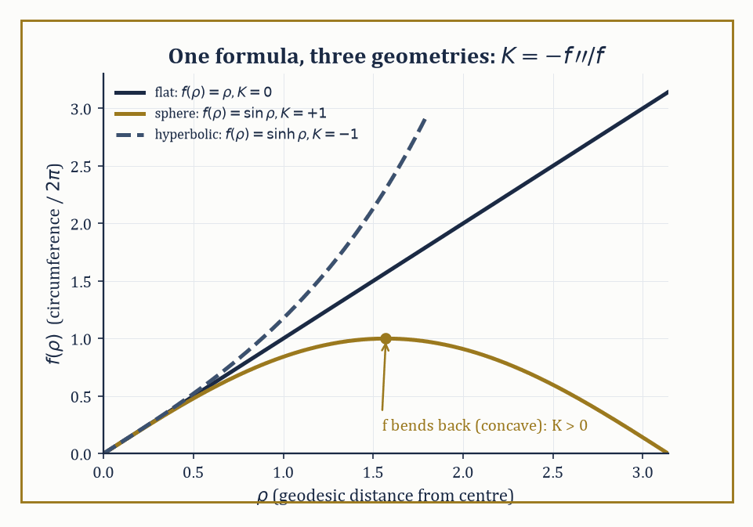
Figure 34.8 — K = −f″/f, plotted for the same f(ρ) in all three geometries at once: a straight line stays straight, a sine bends back on itself, a sinh runs away — zero, positive, and negative curvature, read directly off the shape of one function.
It must be tensorial in X (its value at a point depends only on the value of X at that point, not on how X behaves nearby — consistent with X being ‘a direction’, a purely local piece of data) and a derivation in Y (satisfying a Leibniz rule, since Y is being differentiated, not merely evaluated).
This is precisely the gap Tensor Fields and Transformation Laws left open: ordinary partial differentiation of vector-field components is not well-defined on a general manifold (the components live in different tangent spaces at different points, which cannot be compared without extra structure), and a connection is the extra structure that makes comparison — and hence differentiation — meaningful.
Torsion measures the failure of the connection to be ‘symmetric’ in the sense that matters:
T(X,Y) = ∇_XY − ∇_YX − [X,Y]
Curvature measures the failure of covariant differentiation in two different directions to commute the way ordinary partial derivatives on flat space always do:
R(X,Y)Z = ∇_X∇_YZ − ∇_Y∇_XZ − ∇_([X,Y])Z
The Riemann curvature tensor, obtained from R(X,Y)Z above by feeding in basis vector fields and reading off components Rˡᵢⱼₖ, is the fundamental local invariant of a connection.
It obeys a battery of symmetries (antisymmetry in its first pair of indices, antisymmetry in its second pair once fully lowered, and a symmetry under swapping the two pairs) and the Bianchi identities, which together cut the number of independent components down drastically from the naive n⁴.
Two useful contractions survive with clear geometric meaning: the Ricci curvature (contract one index of Riemann against another, producing a symmetric (0,2)-tensor) and the scalar curvature (contract once more, using the metric, producing a single function).
Sectional curvature packages the Riemann tensor’s information plane by plane — one real number for each 2-dimensional subspace of the tangent space — and reduces, in two dimensions, to the ordinary Gaussian curvature already met in Chapter 31.
Numeric example — the flat plane really is flat, Christoffel symbols notwithstanding. Riemannian Metrics found nonzero Christoffel symbols Γʳ_θθ = −r and Γᶿ_rθ = Γᶿ_θr = 1/r for the flat plane in polar coordinates — a fair worry, since nonzero connection coefficients might suggest nonzero curvature. Check directly, using the formula:
R^ρ_σμν = ∂_μΓ^ρ_νσ − ∂_νΓ^ρ_μσ + Γ^ρ_μλΓ^λ_νσ − Γ^ρ_νλΓ^λ_μσ
computing Rᶿ_rrθ (ρ=θ, σ=r, μ=r, ν=θ) term by term:
term 1: ∂_rΓᶿ_θr = ∂_r(1/r) = −1/r²
term 2: ∂_θΓᶿᵣᵣ = ∂_θ(0) = 0
term 3: Γᶿ_rλΓ^λ_θr = Γᶿ_rr·Γʳ_θr + Γᶿ_rθ·Γᶿ_θr = (0)(0) + (1/r)(1/r) = 1/r²
term 4: Γᶿ_θλΓ^λᵣᵣ = Γᶿ_θr·Γʳᵣᵣ + Γᶿ_θθ·Γᶿ_rr = (1/r)(0) + (0)(0) = 0
Assembling:
Rᶿ_rrθ = −1/r² − 0 + 1/r² − 0 = 0, for every value of r (check at r = 3 if you like: −1/9 − 0 + 1/9 − 0 = 0)
Curvature vanishes identically despite the connection coefficients not vanishing — the resolution the section promised: nonzero Christoffel symbols reflect nothing more than an inconvenient choice of coordinates on a space that remains, underneath the inconvenience, perfectly flat.
Try it now — For ds² = dρ² + f(ρ)² dφ², the curvature is K = −f″/f. What is K for f = sin ρ? Answer →
Numeric example — the plane, the sphere, and the saddle, unified by one formula. For any metric of the form ds² = dρ² + f(ρ)²dφ² (geodesic polar coordinates, with ρ measuring distance from a chosen point), the Gaussian curvature is given by the standard formula:
K(ρ) = −f″(ρ)/f(ρ)
Apply it three times. Flat plane: f(r) = r, so f″ = 0, giving:
K = −0/r = 0
matching the direct Riemann-tensor computation just above. Unit sphere, using geodesic polar coordinates from the north pole: f(ρ) = sin ρ, so f″(ρ) = −sin ρ, giving:
K = −(−sinρ)/sinρ = 1
matching the classical fact that the unit sphere has constant Gaussian curvature +1. Hyperbolic plane: f(ρ) = sinh ρ, so f″(ρ) = sinh ρ, giving:
K = −sinhρ/sinhρ = −1
matching the classical fact that the hyperbolic plane has constant curvature −1. Three metrics, one formula, three signs: zero, positive, negative — the entire trichotomy of two-dimensional geometry (Euclidean, spherical, hyperbolic) sitting inside a single ratio of a function to its own second derivative.
Curvature is not merely a number attached to a metric; it is operationally what parallel transport around a closed loop feels. Transport a tangent vector around a small loop, always keeping it ‘as parallel as the connection allows’ (∇ of the vector along the loop’s velocity is zero throughout), and it returns rotated — the holonomy of the loop — by an amount governed, to leading order, by the curvature enclosed.
Vanishing curvature is exactly equivalent to local flatness: zero curvature everywhere is the condition under which parallel transport around every sufficiently small loop returns the vector unrotated, which is why the flat-plane computation above, despite its nonzero Christoffel symbols, is entitled to call itself flat without embarrassment.
Numeric example — holonomy on the unit sphere, via Gauss–Bonnet. Take the spherical triangle cut out by an octant of the unit sphere — one point on the equator, walk a quarter of the equator to a second point, then up a meridian to the north pole, then back down a second meridian to the start. Each of its three corners is a right angle (π/2), so its angle sum is 3π/2, exceeding the Euclidean value of π by an excess of π/2.
Its area is exactly one-eighth of the sphere’s total area:
(4π)/8 = π/2
The Gauss–Bonnet relation for a geodesic triangle states that the angle excess equals ∫∫ K dA over the enclosed region; here K = 1 (constant, from the previous example), so:
∫∫K dA = 1·(π/2) = π/2
matching the angle excess precisely. Consequently, a tangent vector parallel-transported once around this triangle returns rotated by π/2 (a right angle) relative to where it started, purely as a consequence of the curvature enclosed: hard evidence, arithmetic rather than hand-waving, that curvature is not an abstraction invented to torment students but the literal amount by which the sphere refuses to let a vector come home unrotated.
Keep only this · Section 34.8: Connections, Covariant Derivatives, and Curvature
The idea. A connection differentiates vector fields along curves; the Levi-Civita connection is the unique torsion-free connection compatible with the metric. Curvature measures how covariant derivatives fail to commute — equivalently, how vectors rotate when transported around small loops.
Core.
(∇ᵢY)ᵏ = ∂ᵢYᵏ + Γᵏᵢⱼ Yʲ
R(X, Y)Z = ∇_X∇_Y Z − ∇_Y∇_X Z − ∇_[X, Y] Z
ds² = dρ² + f² dφ²: K = −f″/f
Typical mistake. Inferring curvature from nonzero Christoffel symbols. Polar coordinates on the flat plane have Γ ≠ 0 and R = 0.
Minimal example. f = ρ: K = 0, the plane.
Practice. Easy to challenge; full worked answers, with the usual mistake, are in Answers to the Practice Sets at the back.
Easy — Find K for f = sinh ρ. Answer →
Medium — Find K for f = R sin(ρ/R). Answer →
Challenge — A geodesic triangle on the sphere of radius 2 encloses area π. By what angle does a vector rotate when transported around it? Answer →

Section 34.9: Looking Ahead: From Manifolds to Riemannian Geometry, Gauge Theory, and Relativity
The grammar is finished; the essays are due next
Take stock of the toolkit assembled across this chapter: multilinear algebra and tensors (Multilinear Algebra and Tensors), the transformation laws that test whether a collection of numbers deserves the name (34.2), smooth manifolds as the spaces where all of this can happen without a Euclidean ambient space to lean on (34.3), tangent vectors, vector fields, and flows (34.4), differential forms and the exterior calculus that makes d² = 0 into a working tool rather than a curiosity (34.5), integration and Stokes’ theorem unifying a century of vector-calculus folklore into one identity (34.6), Riemannian metrics that let a manifold measure itself (34.7), and connections and curvature that let it know, intrinsically, whether it is bent (34.8).
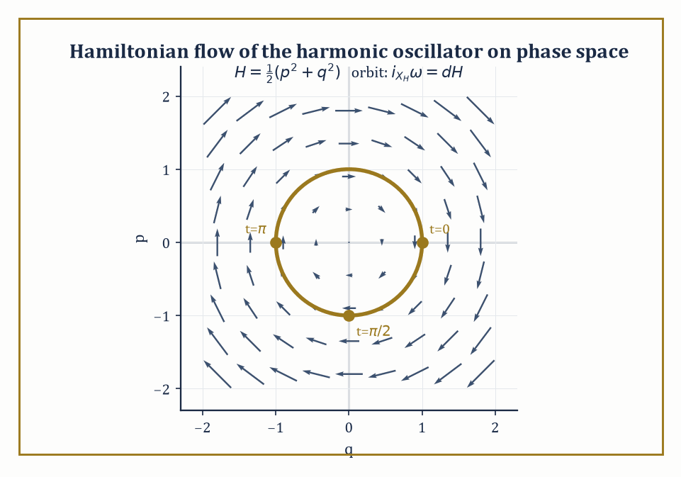
Figure 34.9 — The harmonic oscillator’s orbit in phase space, riding the Hamiltonian vector field defined by i_(X_H)ω = dH — classical mechanics, revealed as one closed curve inside a symplectic swirl.
This is not a miscellany; it is a single grammar, built in the order it had to be built, each section a prerequisite for the next.
Riemannian geometry proper takes the local curvature of Connections, Covariant Derivatives, and Curvature and asks what it forces globally: comparison theorems (a space that is ‘at least as curved as’ a sphere behaves, in aggregate, somewhat like a sphere), sphere theorems (enough curvature and not too much diameter forces you to actually be a sphere, topologically), and Ricci flow, the technique — heat-equation-flavored, evolving a metric in the direction that smooths out its own curvature — that Grigori Perelman used to settle the Poincaré conjecture and decline the million dollars that came with it, on the perfectly defensible grounds that a mathematician ought to be paid in theorems.
Gauge theory generalizes the connections of Connections, Covariant Derivatives, and Curvature from the tangent bundle to more general vector (or principal) bundles, and in doing so recovers electromagnetism and the strong and weak nuclear interactions as the geometry of connections on such bundles — a physicist’s field is, from this vantage, simply a curvature.
Numeric example — a round sphere under Ricci flow. A round sphere of radius r carries constant Gaussian curvature K = 1/r² (Section 34.8’s formula K = −f″/f with f(ρ) = r sin(ρ/r), suitably rescaled) and hence Ricci tensor Ric = K·g.
Under the Ricci flow equation:
∂g/∂t = −2 Ric
a round sphere stays round — the flow shrinks its radius — and substituting g = r(t)²·(unit-sphere metric) into the flow equation and matching coefficients gives:
d(r²)/dt = −2, so r(t)² = r₀² − 2t
Starting from the unit sphere, r₀ = 1, the radius shrinks to zero — the sphere flows into a point — at time t = 1/2, since 1 − 2(1/2) = 0.
This finite-time vanishing is the phenomenon Perelman had to control with great technical delicacy for far more complicated 3-manifolds, where the flow can develop ‘neckpinches’ rather than shrinking uniformly to a single point; the round-sphere case above is the one instance simple enough to solve by hand in three lines, and it is worth doing so once, so that the word ‘singularity’ in the Ricci-flow literature stops sounding like magic and starts sounding like the entirely explicit r₀²−2t running out of section.
Try it now — Under Ricci flow a round 2-sphere of radius r satisfies d(r²)/dt = −2. When does a sphere with r₀ = 1 shrink to a point? Answer →
Abstract example — electromagnetism as curvature. On ℝ⁴ (or a patch of it), let A be a 1-form — the electromagnetic vector potential — and set F = dA, a 2-form: the electromagnetic field-strength tensor, playing the role of a curvature 2-form for a connection on a U(1) (circle-group) bundle.
Take the toy example A = x dy on ℝ² (a ‘connection’ with only two of the four spacetime directions active, to keep the arithmetic honest and short):
F = dA = d(x)∧dy = dx∧dy
a constant 2-form — a uniform ‘magnetic field’ of strength 1, in the sense that the coefficient of dx∧dy is the constant function 1 everywhere.
That F is automatically closed (dF = d(dA) = 0, by d²=0, the very identity from Differential Forms and Exterior Calculus) is not a coincidence dressed up as physics — it is, read in three spatial dimensions with F reorganized into electric and magnetic field components, exactly two of Maxwell’s four equations (the two with no source term), true for purely geometric reasons before a single physical law has been invoked.
General relativity identifies spacetime itself with a four-dimensional Lorentzian manifold (a manifold with a metric of the ‘wrong’ signature, one minus sign among the four, encoding that time behaves differently from space) whose curvature — specifically the Einstein tensor, a particular combination of the Ricci and scalar curvatures of Connections, Covariant Derivatives, and Curvature — is set equal to the stress-energy tensor of whatever matter and energy are present.
‘Matter tells spacetime how to curve; curved spacetime tells matter how to move’ is the famous slogan, and by this point in the series you have every piece of vocabulary the slogan requires: matter is a source term built from tensor fields, spacetime is a Riemannian (strictly, Lorentzian) manifold, curving is the Riemann tensor’s business, and moving along the straightest available path is what a geodesic, from Riemannian Metrics, does.
Symplectic and contact geometry, meanwhile, take a different tensorial ingredient — a closed, nondegenerate 2-form, rather than a symmetric metric — as their starting datum, and produce the natural home of classical mechanics.
Numeric example — Hamilton’s equations from a symplectic form. On phase space ℝ² with coordinates (q,p), take the symplectic form ω = dq∧dp. Given an energy function H(q,p), the Hamiltonian vector field X_H is defined by the equation i_(X_H)ω = dH, and its flow is Hamilton’s equations.
For the harmonic oscillator H(q,p) = ½(p²+q²):
dH = p dp + q dq
Solving i_(X_H)ω = dH for X_H = a ∂/∂q + b ∂/∂p against ω = dq∧dp gives, after a short calculation:
X_H = p ∂/∂q − q ∂/∂p, i.e. dq/dt = p, dp/dt = −q
Starting from (q,p) = (1,0), the solution is:
q(t) = cos t, p(t) = −sin t
Check: dq/dt = −sin t = p = −sin t, and dp/dt = −cos t = −q = −cos t — both confirmed. At t = π/2, the orbit reaches (q,p) = (0,−1); at t = π, it reaches (−1,0).
The ‘straight lines’ of symplectic geometry are these energy-preserving orbits, and the entire apparatus of classical mechanics — conservation laws, integrable systems, chaos — is the geometry of the closed 2-form ω doing to phase space what the metric g did to Riemannian manifolds, with rotation instead of rotation-and-stretching as its symmetry.
The deeper lesson of this chapter is not any single theorem but the combination: multilinear algebra supplied the alphabet, and the flexible notion of a manifold supplied a page large enough, and strange enough, to write on. Together they produce a language expressive enough to hold both the concrete curving surfaces of Chapter 31 and the four-dimensional curved spacetime that governs whether you are currently falling, and it does so with the same nine sections of vocabulary regardless of which one you are describing. Tensors and manifolds are, without exaggeration, the grammar of modern geometry; everything from here on in the series that touches curvature, fields, or spaces-that-are-not-quite-Euclidean will assume you can read it fluently.
We have, as promised at the start, learned to do geometry without coordinates and then, once the intrinsic picture was secure enough not to collapse under the weight of an index, learned to choose coordinates again — wisely, locally, and without the faintest twinge of guilt. The next chapter performs a rather different act of liberation: having spent this one making finite-dimensional spaces behave, Chapter 35 abandons finite dimensions altogether and asks what happens to linear algebra and calculus when your ‘vectors’ are functions and your ‘space’ has infinitely many directions to be curved in — Hilbert spaces, Banach spaces, and the operators that act on them. Manifolds taught you to trust a space you could not fully see at once. Functional analysis is going to ask you to trust one you could never see at once even in principle, and to do calculus on it regardless.
The series continues. Mind the step; it is, as it happens, infinite-dimensional from here.
Where this returns
Symplectic geometry, gauge fields and curved spacetime return in Mathematical Physics (Volume 4).
Keep only this · Section 34.9: Looking Ahead: From Manifolds to Riemannian Geometry, Gauge Theory, and Relativity
The idea. The language of manifolds runs modern geometry and physics. Ricci flow deforms metrics toward uniform ones; gauge theory reads forces as curvatures of connections (F = dA in electromagnetism); Hamiltonian mechanics lives on symplectic manifolds.
Core.
Ricci flow: ∂g/∂t = −2 Ric
electromagnetism: F = dA, so dF = 0
Hamilton: q̇ = ∂H/∂p, ṗ = −∂H/∂q (ω = dq ∧ dp)
Typical mistake. Treating dF = 0 as an extra law. For F = dA it follows from d² = 0.
Minimal example. H = (p² + q²)/2: the flow rotates the (q, p)-plane.
Practice. Easy to challenge; full worked answers, with the usual mistake, are in Answers to the Practice Sets at the back.
Easy — Find the extinction time for r₀ = 3. Answer →
Medium — Write Hamilton’s equations for H = p²/2 + q⁴/4. Answer →
Challenge — Show that the gauge change A ↦ A + dλ leaves F = dA unchanged. Answer →
Chapter 34 recap · Tensors & Manifolds
• Tensors are multilinear maps; a linear map and a bilinear form with the same matrix transform differently.
• Tensor fields change components by Jacobians; the Christoffel symbols are not a tensor.
• A manifold is glued from charts with smooth transitions; tangent vectors are velocities or derivations, and the Lie bracket measures non-commuting flows.
• Differential forms with d (d² = 0) unify grad, curl and div; Stokes’ theorem ∫_M dω = ∫_∂M ω contains all the classical integral theorems.
• A Riemannian metric measures lengths and lowers indices; its connection and curvature tensor generalize Gauss’s curvature to any dimension.

Check Your Understanding — Chapter 34
Answers are in the Answer Key at the back of the book — have a go before you look.
1. [Explain] The array [2 1; 0 3] is used first as a (1,1)-tensor and then, unchanged, as a (0,2)-tensor. Why do these transform differently under the same change of basis, and why does that mean ‘is this a tensor?’ is not a well-posed question on its own?
See the answer →
2. [Explain] Explain, without just citing the transformation law, why the Möbius band fails to be orientable while the cylinder (built the same way but without the twist) succeeds.
See the answer →
3. [Explain] The 1-form ω = (x dy − y dx)/(x²+y²) on ℝ²∖{0} satisfies dω = 0 everywhere it is defined, yet it is not exact. Why isn’t this a contradiction, and what does it signal?
See the answer →
4. [Compute] Using K(ρ) = −f″(ρ)/f(ρ) for a metric ds² = dρ² + f(ρ)²dφ², compute the Gaussian curvature of the hyperbolic plane, where f(ρ) = sinh ρ.
See the answer →
5. [Compute] A vector has components (1, 0) in Cartesian coordinates at the point (1, 1). Find its components in polar coordinates there, and confirm the vector itself is unchanged.
See the answer →
6. [Compute] For ω = x dy − y dx in ℝ², compute dω, and evaluate ∮ω around the unit circle. Interpret the relationship.
See the answer →
7. [Compute] Compute the Christoffel symbols for the Euclidean plane in polar coordinates, and use them to confirm that straight lines are geodesics.
See the answer →
8. [Compute] Verify Stokes theorem ∫[M] dω = ∫[∂M] ω for ω = xy dx on the unit square [0,1]².
See the answer →
9. [Concept] Tensors are often introduced by their transformation law. What is that law actually protecting?
See the answer →
10. [Explain] Why must a manifold be described by an atlas of charts rather than one global coordinate system?
See the answer →
11. [Explain] Why are differential forms the natural things to integrate, rather than functions?
See the answer →
12. [Prove] Prove that d² = 0 for any differential form, and say what it implies.
See the answer →
13. [Prove] Prove that the tangent space at a point of an n-manifold is a vector space of dimension n, using the derivation definition.
See the answer →
14. [Prove] Prove the generalized Stokes theorem ∫[M] dω = ∫[∂M] ω.
See the answer →
15. [Prove] Prove that if a tensor equation holds in one coordinate system it holds in all.
See the answer →
16. [Prove] Prove that the Lie bracket [X, Y] = XY − YX of two vector fields is again a vector field.
See the answer →
17. [Prove] Prove that a Riemannian metric determines a unique torsion-free metric-compatible connection.
See the answer →
18. [Challenge] A tangent vector is defined as a derivation on functions. Why is that the right definition rather than a strange one?
See the answer →
19. [Challenge] The Riemann curvature tensor is often introduced as a formula in Christoffel symbols. What is it really measuring?
See the answer →
20. [Challenge] Vector calculus offers grad, div and curl; the exterior calculus offers only d. What is gained by the reduction?
See the answer →
21. [Challenge] Orientation is required to integrate a form, yet not to integrate a function. Why does the extra choice appear?
See the answer →
22. [Challenge] Physics insists on tensor equations. Is that a mathematical fastidiousness or a physical requirement?
See the answer →
23. [Challenge] A manifold is locally Euclidean but globally need not be. Where does the interesting content live?
See the answer →
24. [Challenge] Chapter 31 did surfaces in ℝ³; this chapter does manifolds with no ambient space. What was gained by removing the surroundings?
See the answer →

Problems — Chapter 34
The questions above test whether the ideas landed. These ask you to use them. Solutions are in Solutions to the Problems at the back. Work them before you look.
1. [Compute] In Minkowski space with η = diag(1, −1), compute the squared length of the vector (2, 1).
2. [Compute] v = (1, 2) and w = (3, −1) in the ordinary dot product. Compute v·w and the norms.
3. [Concept] A (1, 0) tensor eats nothing and returns a vector. A (0, 1) tensor eats a vector and returns a number. What is the ordinary name of each?
4. [Model] The tensor Tⁱʲ is symmetric, T¹² = T²¹ = 4, and the diagonal entries are 0. Contract it with the vector (1, 1) on the second index. What vector do you get?

Math, Actually

Chapter 35

Functional Analysis
Infinite-Dimensional Spaces, Operators, and the Art of Analysis in Function Spaces
The previous chapter spent its energy teaching tensors to behave themselves under a change of coordinates, which is more than can be said for most of us on a Monday morning. But notice what tensors had going for them throughout: at every point of the manifold, the tangent space was finite-dimensional. However exotic the manifold, however many indices you had upstairs and downstairs, you were still, at each instant, doing ordinary linear algebra on a space with a finite basis. That comfort now ends. Permanently.
Functional analysis is what happens when you take the vector spaces of linear algebra — spaces of vectors, with addition and scalar multiplication — and let the dimension run away to infinity by populating the space with functions instead of arrows. A function on an interval is, after all, just a vector with uncountably many coordinates, one for each point of the interval — an intuition rather than a literal identification, since a function space always imposes substantial restrictions on which such coordinate assignments are allowed. The trouble is that everything linear algebra taught you to take for granted simply stops being true. A linear map need not be continuous. A subspace need not have a complement. The unit ball, that reliable compact anchor of finite-dimensional geometry, becomes a vast, non-compact wilderness in which sequences wander off and never come back. Bolzano–Weierstrass, rest in peace.
So this chapter adds a second ingredient to the vector-space structure: a topology, a rigorous notion of ‘close to,’ without which words like ‘convergent,’ ‘continuous,’ and ‘complete’ are just noises. The central question throughout is which finite-dimensional intuitions survive the trip to infinite dimensions unscathed, which survive in a weakened form, and which have to be surrendered entirely and grieved for. Completeness, duality, the spectrum, compactness — these become the load-bearing walls of the whole subject, precisely because so much of the old scaffolding has been kicked away.
It is also, not incidentally, the actual language spoken by the rest of analysis: quantum mechanics is a sentence in Hilbert space, weak solutions of differential equations live in Sobolev spaces, and Fourier analysis turns out to be nothing but the spectral theory of one very patient operator. The next chapter, on measure theory, will hand us the rigorous integral this chapter has been leaning on unannounced throughout (that ∫ sign has been trading on your goodwill since What Functional Analysis Is); for now, we go infinite-dimensional, and we find out which of our instincts come with us.
Why we need this now
PDEs in Partial Differential Equations and integral equations in Differential and Integro-Differential Equations keep forcing functions to be treated as points. A sequence of approximate solutions has to converge somewhere; a weak solution has to live in some space; the Fredholm alternative is a statement about an operator on functions.
This chapter supplies those spaces: functions as vectors, norms as distances, operators as matrices with infinitely many columns.
Before you begin — Chapter 35
By the end of this chapter you will be able to:
1. Treat functions as points of normed spaces, and say why the choice of norm matters.
2. Work in Banach and Hilbert spaces: completeness, projections, Riesz representation.
3. Compute operator norms, duals and spectra.
4. State and use Hahn–Banach, uniform boundedness, open mapping and closed graph.
5. Use weak convergence and the compactness it restores.
6. Apply compact operators, the Fredholm alternative, the spectral theorem and Sobolev spaces to differential and integral equations.
Prerequisites. Vector spaces and inner products from Linear Algebra (Volume 2); completeness and compactness from Metric Spaces and Continuity and Compactness; the integral and differential equations of Differential and Integro-Differential Equations and Partial Differential Equations.
Estimated study time. About 12 hours, exercises included.

Section 35.1: What Functional Analysis Is
In Which the Word ‘Space’ Stops Meaning What You Think It Means
Functional analysis studies vector spaces of functions (or sequences, or more general infinite-dimensional objects) equipped with a topology — a rigorous notion of which points are ‘close’ to which — together with the continuous linear operators that map between such spaces respecting both the algebra and the topology.
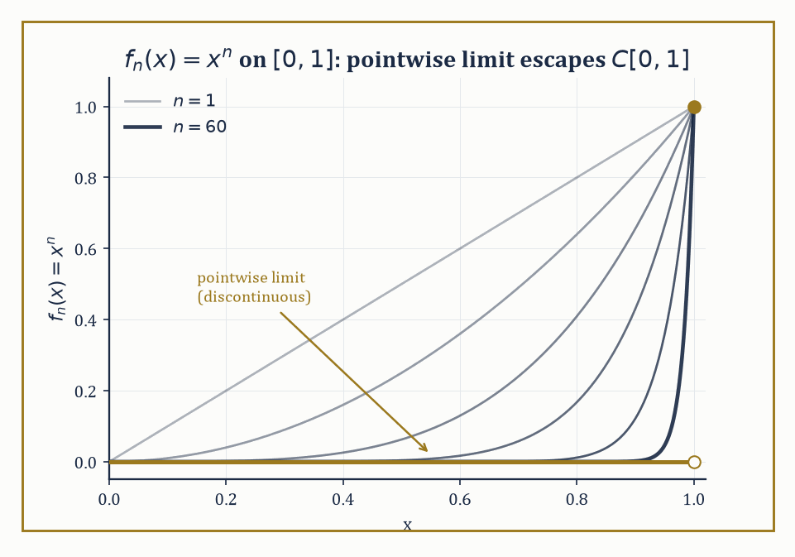
Figure 35.1 — Same sequence xⁿ, two topologies, two verdicts: pointwise it collapses to a jump at x=1; uniformly it never converges at all.
This is a double burden. Linear algebra only ever asked you to respect addition and scalar multiplication; here you must respect those and continuity simultaneously, and in infinite dimensions the two do not automatically get along.
A linear map between finite-dimensional spaces is always continuous — you may never have been told this because it never needed saying — but a linear map between infinite-dimensional spaces can be about as discontinuous as it likes, unless you go out of your way to forbid it.
Abstract example — Why the topology is not optional. Take the space C[0,1] of continuous functions on [0,1] and the sequence
fₙ(x) = xⁿ
Under pointwise convergence, this sequence behaves as follows:
fₙ(x) → 0 for every x in [0,1), and fₙ(1) = 1 for every n
So the pointwise limit is the function that is 0 on [0,1) and jumps to 1 at x = 1 — a function that is not continuous, and so does not even live in C[0,1].
Under the uniform (sup-norm) topology, the verdict is different again:
sup₀≤x≤1 |fₙ(x) − 0| = 1 for every n
(the supremum is approached as x → 1⁻), so fₙ does not converge to 0 uniformly either — consistent with the fact that a uniform limit of continuous functions must itself be continuous, and the pointwise limit above manifestly isn’t.
Same sequence, same set of functions, two different topologies, two different (and both entirely correct) answers to ‘does this converge, and to what?’ That ambiguity, made precise rather than argued about in a pub, is the entire reason the subject exists.
Try it now — For fₙ(x) = xⁿ on [0, 1], find the sup norm and the L¹ norm. Answer →
A quick terminological note before we go further: ‘operator’ and ‘functional’ name the same kind of object — a linear map respecting the topology — but convention reserves ‘functional’ for the special case where the output is a scalar (the target is the field ℝ or ℂ), while ‘operator’ covers the general case, including when the output is itself a function.
Every functional is an operator; not every operator is a functional.
Abstract example — The same rule, legal in one space and meaningless in another. On C[0,1] with the sup norm, consider the evaluation functional
δ₁(f) = f(1)
This is perfectly bounded:
|δ₁(f)| = |f(1)| ≤ ‖f‖∞
so ‖δ₁‖ ≤ 1, and testing on f ≡ 1 shows
‖δ₁‖ = 1 exactly
But the identical rule ‘evaluate at x = 1’ does not even make sense as a functional on L²[0,1], because elements of L² are equivalence classes of functions agreeing almost everywhere, and altering a function’s value at the single point x = 1 leaves its equivalence class completely unchanged — pointwise evaluation isn’t merely unbounded on L², it fails to be well-defined there in the first place.
Which functionals exist at all, not just which ones happen to be continuous, depends on which space and topology you have chosen.
The classical examples are the ones you will meet in every corner of analysis: C(K), the continuous functions on a compact set K, with the sup norm; the Lᵖ(μ) spaces of functions whose p-th power is integrable against a measure μ; Hilbert spaces of square-integrable functions; and Sobolev spaces, which additionally track a function’s derivatives.
These arise from wildly different problems — approximation theory, integral equations, quantum mechanics, elasticity — yet share enough structural DNA that a single abstract theory, developed once, answers questions in all of them simultaneously.
That is the entire economic case for abstraction: prove the Hahn–Banach theorem once, and never have to re-derive it separately for continuous functions, square-integrable functions, and sequences that happen to be absolutely summable.
Numeric example — A first citizen of the dual space. Define L : C[0,1] → ℝ by
L(f) = ∫₀¹ f(x) dx
On f(x) = x², we get
L(f) = ∫₀¹ x² dx = 1/3
On f(x) = 3x − 2, we get
L(f) = [3x²/2 − 2x]₀¹ = 3/2 − 2 = −1/2
Linearity is immediate from linearity of the integral:
L(af + bg) = aL(f) + bL(g)
for any scalars a, b. Boundedness follows from
|L(f)| = |∫₀¹ f(x) dx| ≤ ∫₀¹ |f(x)| dx ≤ ‖f‖∞
(the sup norm), so L is a bounded linear functional with operator norm ‖L‖ ≤ 1; testing against f ≡ 1 gives
L(f) = 1 = ‖f‖∞
so in fact ‖L‖ = 1 precisely. This unassuming object — ‘integrate the function’ — is the simplest nontrivial element of the dual space C[0,1]*, and it is worth remembering once Linear Operators and Duality makes duality the star of the show.
The name ‘functional analysis’ comes from ‘functional’: a function whose own domain is a space of functions, returning an ordinary number.
The archetype predates the abstract theory by two centuries — the calculus of variations, which asks questions of the form ‘which path minimizes this quantity,’ is the theory of functionals and their critical points, and it is where the whole subject’s instincts were first trained.
Numeric example — A functional from the calculus of variations. The length functional assigns to a path y on [0,1] the number
L[y] = ∫₀¹ √(1 + y′(x)²) dx
Take y(x) = 2x, the straight line from (0,0) to (1,2): y′(x) = 2 constant, so
L[y] = ∫₀¹ √(1+4) dx = √5 ≈ 2.236
— and indeed the straight-line distance from (0,0) to (1,2) is
√(1² + 2²) = √5
exactly as it should be, since a straight line’s arc length is just its endpoint distance. L assigns one real number to an entire function; making that assignment continuous, and asking which functions minimize or maximize it, is the calculus of variations, and it is the historical seed from which the entire abstract apparatus of this chapter eventually grew.
Functional analysis is therefore both a subject with its own theorems and machinery, and simultaneously the common grammar in which the rest of modern analysis is written — differential equations, harmonic analysis, probability, and quantum theory all eventually say what they mean in the vocabulary this chapter builds.
Keep only this · Section 35.1: What Functional Analysis Is
The idea. Functional analysis treats functions as points of infinite-dimensional vector spaces with a norm or an inner product. The choice of topology decides which sequences converge and which functionals are continuous; the continuous linear functionals form the dual space.
Core.
‖f‖_∞ = sup |f|, ‖f‖₁ = ∫ |f|
linear L continuous ⇔ |L(f)| ≤ C‖f‖ for some C
Typical mistake. Assuming all norms agree on a function space. In finite dimensions they are equivalent; on C[0, 1] they are not.
Minimal example. L(f) = f(0) on C[0, 1] with the sup norm: |L(f)| ≤ ‖f‖_∞.
Practice. Easy to challenge; full worked answers, with the usual mistake, are in Answers to the Practice Sets at the back.
Easy — Bound L(f) = ∫₀¹ f dx in terms of the sup norm. Answer →
Medium — Is f ↦ f(0) continuous on C[0, 1] with the L¹ norm? Answer →
Challenge — Compute the length functional L(y) = ∫₀¹ √(1 + y′²) dx for y = x² and compare it with the straight line from (0, 0) to (1, 1). Answer →

Section 35.2: Banach Spaces and Hilbert Spaces
Completeness: The One Thing You Cannot Do Without
Write down 1, then 1.4, then 1.41, then 1.414, and keep going. Every entry is a fraction, and the list is plainly settling: each new number sits closer to the one before than the last pair did. Yet the thing it settles toward is √2, which is not a fraction at all. Had fractions been the only numbers you owned, this perfectly well-behaved list would have been closing in on a hole in your own number system. Completeness is the promise that no such holes exist. A Banach space is a normed vector space with that promise kept: every Cauchy sequence — one whose terms eventually get and stay arbitrarily close to each other — converges to a limit that actually lives in the space.
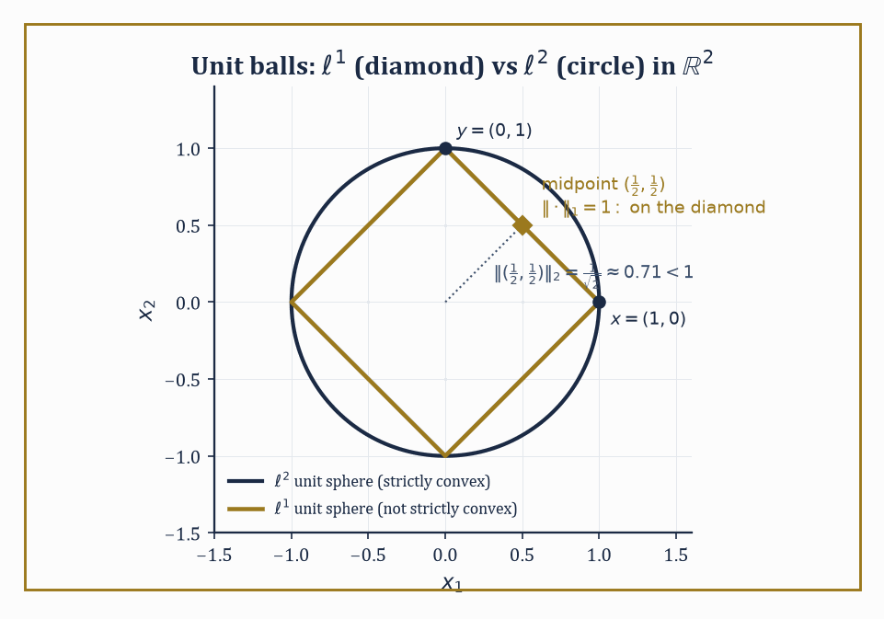
Figure 35.2 — The ℓ¹ diamond lets a whole edge sit on the unit sphere; the ℓ² circle bows a midpoint strictly inside — one figure, two verdicts on strict convexity.
This sounds like a technicality until you notice how much depends on it: the contraction-mapping theorem, the inverse-function theorem, and essentially every existence proof that runs ‘construct an approximating sequence, then take the limit’ silently assumes that the limit exists somewhere you’re allowed to look for it. Without completeness, you can build a sequence that homes in on a target and then discover the target was never in your space to begin with.
Numeric example — What incompleteness feels like. Work inside ℚ, the rationals, with the ordinary absolute value as norm. Let x₁ = 1, x₂ = 1.4, x₃ = 1.41, x₄ = 1.414, x₅ = 1.4142, …, the successive decimal truncations of √2.
This sequence is Cauchy: |xₙ − xₘ| shrinks below any prescribed tolerance once n and m are large enough, since the terms agree on more and more decimal digits, for instance:
|x₄ − x₅| = |1.414 − 1.4142| = 0.0002
Yet the sequence has no limit inside ℚ, because its only possible limit is √2, and √2 is irrational. ℚ is a perfectly respectable normed vector space over itself; it is not complete, and this single defect is why we do analysis in ℝ rather than ℚ. Banach spaces are the higher-dimensional refusal to repeat that mistake.
Try it now — Find the ℓ² norm of x = (1, 1/2, 1/4, …). Answer →
The working examples are C(K) (continuous functions on a compact set K, sup norm), Lᵖ(μ) (functions with ∫|f|ᵖ dμ < ∞, norm ‖f‖ₚ = (∫|f|ᵖ dμ)^(1/p)), and the sequence spaces ℓᵖ, consisting of infinite sequences x = (x₁, x₂, x₃, …) with ‖x‖ₚ = (Σₖ|xₖ|ᵖ)^(1/p) < ∞.
All three families are complete — this is a genuine theorem in each case, not a triviality — and all three reduce, when the underlying set is finite, to the familiar finite-dimensional normed spaces you already know.
Numeric example — A norm computed in ℓ². Let x = (1, 1/2, 1/4, 1/8, …), i.e. xₖ = (1/2)ᵏ⁻¹ for k = 1, 2, 3, …. Then:
‖x‖₂² = Σ[k ≥ 1] (1/2ᵏ⁻¹)² = Σ[k ≥ 1] 1/4ᵏ⁻¹
This is a geometric series with ratio 1/4, summing to:
1/(1 − 1/4) = 4/3
So:
‖x‖₂ = √(4/3) = 2/√3 ≈ 1.1547
The sequence is a quite good vector in ℓ², despite having infinitely many nonzero coordinates — this is the point of the space: it is the sequences for which such a sum converges at all.
A Hilbert space is a Banach space whose norm arises from an inner product ⟨·,·⟩ via:
‖x‖ = √⟨x,x⟩
The extra structure buys you angles, orthogonality, and orthonormal bases, and makes Hilbert spaces the most geometrically forgiving of the infinite-dimensional spaces.
The Riesz representation theorem says that every continuous linear functional f on a Hilbert space H has the form:
f(x) = ⟨x, y⟩
for a unique vector y ∈ H — the dual space, mysterious in general Banach spaces, collapses back into a copy of H itself. Every separable infinite-dimensional Hilbert space is isomorphic to every other one (they are all secretly ℓ²); the actual content of Hilbert space theory lies not in the spaces but in the operators that act on them, which is where Compact Operators and the Fredholm Alternative and Spectral Theory of Compact Self-Adjoint Operators are headed.
Numeric example — Riesz representation, finite-dimensional dress rehearsal. Take H = ℝ³ with the usual dot product, and the linear functional f(x,y,z) = 2x − y + 3z. Riesz representation (which in finite dimensions is just ‘every linear functional is dotting with some fixed vector’) says:
f(v) = v · w for w = (2, −1, 3)
Check the three basis vectors:
f(1,0,0) = 2 = (1,0,0)·w
f(0,1,0) = −1 = (0,1,0)·w
f(0,0,1) = 3 = (0,0,1)·w
and linearity does the rest. The infinite-dimensional statement is the same idea with the dot product replaced by an integral: a bounded functional on L²[0,1] such as
f(h) = ∫₀¹ h(x)g(x) dx
for fixed g ∈ L² is represented by that same g, and Riesz’s theorem is the guarantee that every bounded functional on L² arises this way — there are no bounded functionals on a Hilbert space that aren’t secretly ‘take the inner product with something.’
Not every Banach space is secretly a Hilbert space in disguise; whether a given norm comes from an inner product at all is decided by a single algebraic identity, the parallelogram law:
‖x+y‖² + ‖x−y‖² = 2‖x‖² + 2‖y‖² for every x, y
A norm satisfies this identity if and only if it arises from an inner product, so the law is a genuine litmus test, not just a curiosity left over from parallelograms in the plane.
Numeric example — ℓ¹ fails the parallelogram law. Work in ℓ¹ restricted to two coordinates, with x = (1,0), y = (0,1). Then x+y = (1,1), with:
‖x+y‖₁ = 1+1 = 2
and x−y = (1,−1), with:
‖x−y‖₁ = 1+1 = 2
The left side of the parallelogram law is:
‖x+y‖² + ‖x−y‖² = 4 + 4 = 8
The right side is:
2‖x‖₁² + 2‖y‖₁² = 2(1) + 2(1) = 4
Since 8 ≠ 4, the law fails outright — confirming, on two vectors you could check by hand, that the ℓ¹ norm does not come from any inner product, so ℓ¹ can never be a Hilbert space, however you might otherwise try to dress it up.
The shape of the unit ball matters more than it has any right to. A space is strictly convex if the line segment joining two distinct points of the unit sphere never touches the sphere except at its endpoints; this controls whether nearest-point projections onto convex sets are unique, and it underwrites, without ever being asked to take a bow, the uniqueness of best approximations and the good behavior of weakly convergent minimizing sequences in optimization.
Numeric example — ℓ¹ fails to be strictly convex; ℓ² succeeds. In ℓ¹ (restricting to two coordinates for clarity), take x = (1,0) and y = (0,1); both have ‖x‖₁ = ‖y‖₁ = 1. Their midpoint is (1/2, 1/2), with:
‖(1/2,1/2)‖₁ = 1/2 + 1/2 = 1
— the same norm as the endpoints. The entire segment between x and y sits on the unit sphere; strict convexity fails outright, and with it, uniqueness of nearest points.
Contrast ℓ² (equivalently ℝ² with the Euclidean norm): ‖x‖₂ = ‖y‖₂ = 1 still, but the midpoint has:
‖(1/2,1/2)‖₂ = √(1/4+1/4) = √(1/2) ≈ 0.7071 < 1
strictly inside the ball. ℓ² is strictly convex; ℓ¹ is not — a small numerical fact with large downstream consequences for how well-posed approximation problems are in each space.
Keep only this · Section 35.2: Banach Spaces and Hilbert Spaces
The idea. A Banach space is a complete normed space; a Hilbert space is one whose norm comes from an inner product, which brings angles, orthogonal projection and the Riesz representation of functionals. The parallelogram law characterizes Hilbert norms.
Core.
parallelogram: ‖x + y‖² + ‖x − y‖² = 2‖x‖² + 2‖y‖²
Riesz: f(x) = ⟨x, y_f⟩, ‖f‖ = ‖y_f‖
Cauchy–Schwarz: |⟨x, y⟩| ≤ ‖x‖‖y‖
Typical mistake. Assuming completeness. ℚ, or the polynomials with the sup norm, are normed but not complete.
Minimal example. ℝ³: f(x, y, z) = 2x − y + 3z is the inner product with (2, −1, 3), norm √14.
Practice. Easy to challenge; full worked answers, with the usual mistake, are in Answers to the Practice Sets at the back.
Easy — Find the ℓ¹, ℓ² and ℓ∞ norms of (3, 4). Answer →
Medium — Test the parallelogram law in ℓ¹ for x = (1, 0) and y = (0, 1). Answer →
Challenge — Project f(x) = x onto the constants in L²[0, 1], and find the distance. Answer →

Section 35.3: Linear Operators and Duality
Matrices, All Grown Up and Slightly Feral
A matrix stretches some directions more than others, and for many purposes the number that matters is the worst case: what is the largest factor by which it can lengthen any arrow? A transformation that turns the unit circle into an ellipse with half-axes 3 and 1 can lengthen an arrow by at most 3, so its operator norm is 3. In infinite-dimensional spaces, where the vectors are functions and the transformations include integrals and filters, such a worst-case factor may or may not exist. The transformations where it does, the bounded operators, are the well-behaved ones, and this section studies them together with their duals, the measurements a space allows.
A bounded linear operator T : X → Y between normed spaces is a linear map for which the following holds for some constant C and every x:
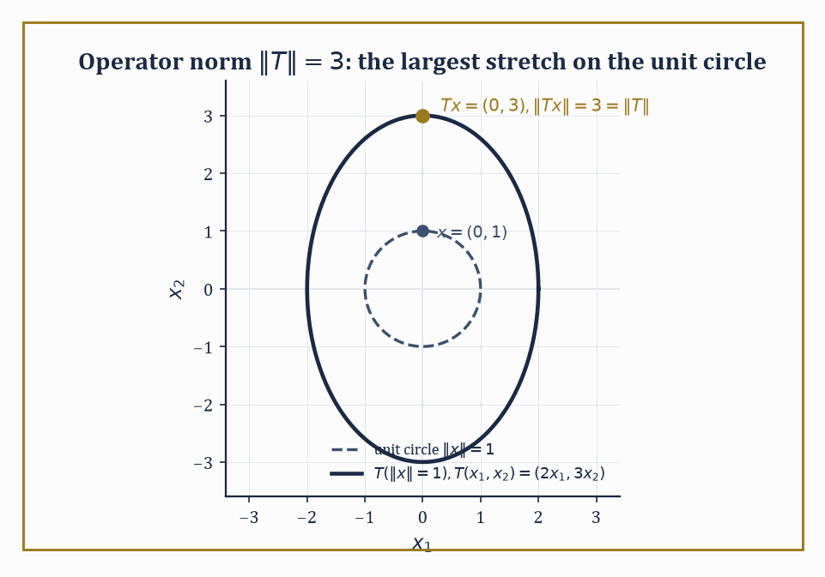
Figure 35.3 — T stretches the unit circle into an ellipse, and the operator norm is caught in the act at the one point that gets stretched the most.
‖Tx‖ ≤ C‖x‖
The smallest such C is the operator norm, measuring the worst-case stretching T can inflict:
‖T‖ = sup{‖Tx‖ : ‖x‖ ≤ 1}
In finite dimensions, every linear map is automatically bounded — this is one of those facts nobody mentions because it is always true there. In infinite dimensions it is not automatic at all, and Unbounded Operators and Sobolev Spaces will introduce operators (differentiation, chiefly) that are unbounded and have to be handled with real care.
Numeric example — Operator norm of a diagonal map. Let T : ℝ² → ℝ² be defined by:
T(x₁,x₂) = (2x₁, 3x₂)
with the Euclidean norm on both copies of ℝ². Then:
‖Tx‖² = 4x₁² + 9x₂²
and we maximize this subject to:
‖x‖² = x₁² + x₂² = 1
Since 9 > 4, the maximum is achieved by putting all the weight on x₂: x₁ = 0, x₂ = 1 gives:
‖Tx‖² = 9, so ‖Tx‖ = 3
No other unit vector does better (any mixture only trades a coefficient-9 contribution for a coefficient-4 one). So ‖T‖ = 3, the larger of the two diagonal entries — the operator norm of a diagonal matrix is exactly its largest entry in absolute value, i.e. its largest singular value, a fact that will resurface, dressed up, when we discuss eigenvalues of compact operators.
Try it now — Find the operator norm of T(x, y) = (3x, −y) on Euclidean ℝ². Answer →
The dual space X* is the space of all bounded linear functionals on X; it is always a Banach space, even when X itself is not complete (a pleasant and slightly surprising bonus). Applying the dual construction twice gives the bidual X**, and there is always a natural embedding J : X → X** defined by:
J(x)(f) = f(x) for f ∈ X*
X is called reflexive when J is not just injective (which is automatic, courtesy of Hahn–Banach) but onto — when X** contains nothing more than a relabeled copy of X.
Abstract example — ℓ¹ is not reflexive, and it is ℓ∞’s fault. It is a genuine theorem that:
(ℓ¹)* ≅ ℓ∞
Every bounded functional on ℓ¹ has the form
φ(x) = Σₖ xₖyₖ
for a unique bounded sequence y ∈ ℓ∞, with ‖φ‖ = ‖y‖∞. So far this looks like the finite-dimensional story.
The asymmetry appears one step later: (ℓ∞)* is emphatically not ℓ¹. It is a much larger and stranger space, containing functionals — generalized limits called Banach limits among them — that assign a sensible ‘limit’ to every bounded sequence, including ones like (1,0,1,0,1,0,…) that have no ordinary limit, and that cannot be written as Σ xₖyₖ for any y ∈ ℓ¹.
Consequence: the natural embedding of ℓ¹ into (ℓ¹)** = (ℓ∞)* misses almost everything; ℓ¹ is the standard example of a Banach space that is decidedly not reflexive, and the mismatch traces directly back to the lopsided relationship between ℓ¹ and ℓ∞.
The adjoint of a bounded operator T : X → Y is the operator T* : Y* → X* defined by:
(T*g)(x) = g(Tx)
For T an ordinary matrix with the standard dot products, T* is literally the transpose, so nothing new has happened yet. What is new is the spectrum:
σ(T) = {λ ∈ ℂ : T − λI is not invertible}
This generalizes the set of eigenvalues, but the word ‘generalizes’ is doing real work — for bounded operators on complex Banach spaces the spectrum is always nonempty and compact, an infinite-dimensional theorem with no honest finite-dimensional analogue (it is also precisely why complex scalars, not real ones, are compulsory here: a 90° rotation of ℝ² has no real eigenvalue at all, yet as a complex-linear map it has two, ±i).
Abstract example — The shift operator: a spectrum with no eigenvalues in it. Define the right shift S on ℓ²(ℕ) by:
S(x₁, x₂, x₃, …) = (0, x₁, x₂, …)
It is an isometry (‖Sx‖ = ‖x‖ exactly, since shifting doesn’t change the sum of squares), hence ‖S‖ = 1. It is injective (Sx = 0 forces every xₖ = 0), but not surjective — nothing maps to (1,0,0,…), since that would require a coordinate ‘before the first one.’
Try to solve Sx = λx coordinate by coordinate: the equations read:
0 = λx₁, x₁ = λx₂, x₂ = λx₃, …
For λ ≠ 0 this forces x₁ = 0, then x₂ = 0, and so on — the only solution is x = 0, so S has no eigenvalues whatsoever; the point spectrum is empty. And yet the full spectrum σ(S) is the entire closed unit disk:
{λ : |λ| ≤ 1}
every one of those scalars still makes S − λI fail to be invertible, just not via a kernel, the mechanism finite-dimensional habit expects. (Its adjoint, the left shift S*, is far more obliging: every λ with |λ| < 1 is an eigenvalue of S*.) This is the standard moment where ‘spectrum equals eigenvalues’ quietly stops being true, sometime around when the dimension count left ℕ behind.
The same ‘second dual is bigger’ pattern recurs throughout the subject, and it is worth seeing it in one more costume. The space c₀ of sequences converging to zero has dual:
(c₀)* ≅ ℓ¹
and that space’s own dual is:
(ℓ¹)* ≅ ℓ∞
so c₀’s bidual is ℓ∞, which strictly contains c₀ (the constant sequence (1,1,1,…) is bounded but does not converge to zero, so it lies in ℓ∞ but never in c₀). c₀ is therefore not reflexive either, for the structural reason ℓ¹ was not: somewhere in the chain of duals, ℓ∞ shows up and refuses to shrink back down.
Numeric example — The bidual gap for c₀, made concrete. Take the constant sequence:
w = (1,1,1,…)
As an element of ℓ∞ = (c₀)**, ‖w‖∞ = 1, so it certainly lives in the bidual. But w does not converge to zero, so w ∉ c₀ — and under the natural embedding J, J(x) is just x relabeled, so no x ∈ c₀ could possibly produce w. The natural embedding J : c₀ → c₀** therefore misses w entirely: c₀** is strictly larger than J(c₀), and c₀ is not reflexive, exhibited on a single sequence you can write down without any theory at all.
Duality is what lets us pair spaces of functions against spaces of measures or distributions, and it is the machine that produces weak formulations of differential equations: instead of demanding that a candidate solution satisfy an equation pointwise, we demand only that it satisfy the equation when tested — paired via duality — against every member of a suitable space of test functions.
Unbounded Operators and Sobolev Spaces and Looking Ahead: From Functional Analysis to Operator Algebras, Distributions, and PDEs will lean on this idea.
Keep only this · Section 35.3: Linear Operators and Duality
The idea. Bounded linear operators have a norm, ‖T‖ = sup ‖Tx‖/‖x‖. The dual X* consists of bounded functionals, and the bidual X** contains X. The spectrum generalizes eigenvalues; in infinite dimensions it can contain points that are not eigenvalues.
Core.
‖T‖ = sup over x ≠ 0 of ‖Tx‖/‖x‖
(ℓᵖ)* = ℓ^q, 1/p + 1/q = 1 (1 ≤ p < ∞)
σ(T) = {λ : T − λI has no bounded inverse}
Typical mistake. Finding the spectrum by looking for eigenvalues. The right shift on ℓ² has none, and its spectrum is the closed unit disk.
Minimal example. diag(a, b): norm max(|a|, |b|).
Practice. Easy to challenge; full worked answers, with the usual mistake, are in Answers to the Practice Sets at the back.
Easy — Find the norm of the right shift on ℓ². Answer →
Medium — Find the dual exponent of p = 3. Answer →
Challenge — Show that the right shift S(x₁, x₂, …) = (0, x₁, x₂, …) has no eigenvalues. Answer →

Section 35.4: The Fundamental Theorems
Three Theorems and a Quiet Funeral for Your Remaining Intuitions
The Hahn–Banach theorem says that a bounded linear functional defined on a subspace M of X can always be extended to the whole of X without increasing its norm. Two consequences make this the true foundation stone of the subject. First, dual spaces are never trivially small — for any nonzero x₀ ∈ X there is a functional f with
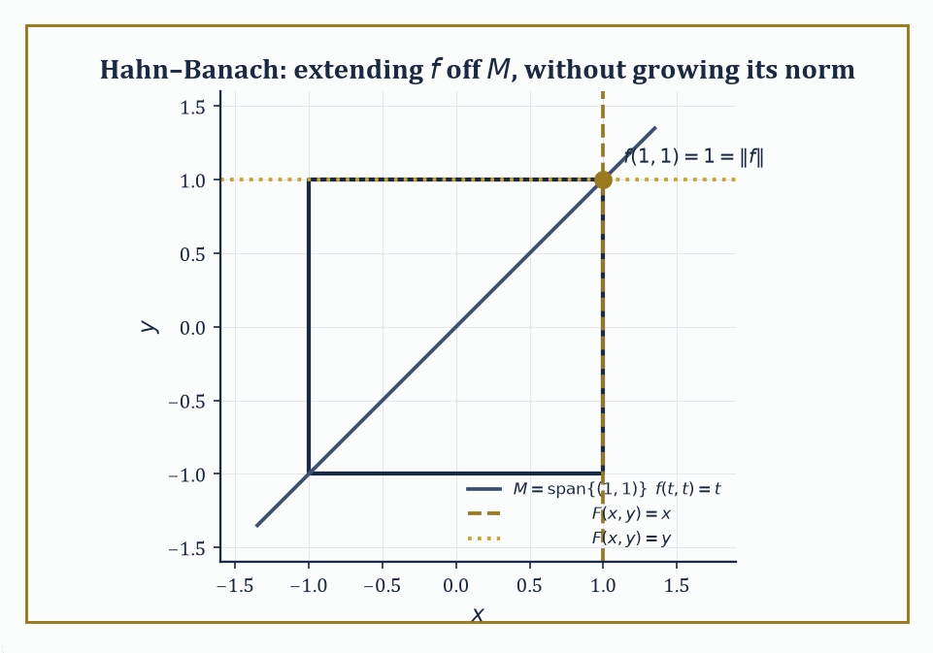
Figure 35.4 — In the sup-norm square, f’s norm-1 verdict on the diagonal M extends two different ways — F(x,y)=x and F(x,y)=y both hug the same corner without ever growing past it.
f(x₀) = ‖x₀‖, ‖f‖ = 1
so functionals genuinely ‘see’ every vector. Second, in its geometric form, the theorem says that two disjoint convex sets can always be separated by a hyperplane, i.e. by the level set of some continuous linear functional. Everything downstream in duality theory eventually cites this fact, directly or indirectly.
Numeric example — An extension, worked in full. Let X = ℝ² with the sup norm, and let M = span{(1,1)}, the diagonal line.
‖(x,y)‖∞ = max(|x|,|y|)
Define f on M by
f(t,t) = t for (t,t) ∈ M
Since |f(t,t)| = |t| = ‖(t,t)‖∞, the norm of f on M is exactly 1. Hahn–Banach guarantees a norm-1 extension F to all of ℝ²; here is one:
F(x,y) = x
Check it agrees with f on M:
F(t,t) = t
Check its norm: for ‖(x,y)‖∞ ≤ 1 we have |x| ≤ 1, so ‖F‖ ≤ 1, with equality at (1,0); so ‖F‖ = 1, matching ‖f‖. Note the extension is not unique — F(x,y) = y works equally well, since
F(t,t) = t, ‖F‖ = 1
by the same argument. And so does every convex combination
Fₛ(x,y) = sx + (1−s)y for s ∈ [0,1]
Fₛ(t,t) = st + (1−s)t = t
|Fₛ(x,y)| ≤ s|x| + (1−s)|y| ≤ max(|x|,|y|), with equality attainable, so ‖Fₛ‖ = 1 throughout
An entire one-parameter family of equally valid extensions — Hahn–Banach guarantees existence, never uniqueness.
Try it now — On the diagonal M = {(t, t)} in ℝ² with the sup norm, f(t, t) = t has norm 1. Give a norm-one extension to ℝ². Answer →
The open-mapping theorem says a surjective bounded operator between Banach spaces sends open sets to open sets — it cannot squash the target space down onto some thin, degenerate image.
The closed-graph theorem says that if the graph {(x, Tx)} of a linear operator T is closed as a subset of X × Y, then T is automatically bounded — you never have to verify continuity by hand once closedness of the graph is established, which in practice is often the easier thing to check.
The uniform-boundedness principle (Banach–Steinhaus) says that a family of bounded operators that is pointwise bounded — sup over the family of ‖Tₙx‖ is finite for each fixed x — is automatically uniformly bounded: sup over the family of the operator norms ‖Tₙ‖ is finite too.
Together these three are the workhorses that make linear functional analysis into a subject with theorems, rather than a subject with only definitions.
Abstract example — Banach–Steinhaus, run in reverse. Consider the coordinate functionals φₙ : ℓ² → ℝ given by
φₙ(x) = n·xₙ
Each is bounded, with
‖φₙ‖ = n
precisely (achieved at the standard basis vector eₙ, since ‖eₙ‖ = 1 and φₙ(eₙ) = n). Since ‖φₙ‖ = n → ∞, this family is not uniformly bounded.
Banach–Steinhaus, read contrapositively, then guarantees that pointwise boundedness must fail somewhere too: there exists some x ∈ ℓ² for which the numbers φₙ(x) = n·xₙ form an unbounded sequence.
This is worth pausing on, because it is not obvious how to exhibit such an x by hand — the tempting test vector
x = (1/n)ₙ
gives
φₙ(x) = 1 for every n
perfectly bounded, because that particular x was too well-behaved to expose the problem. The theorem’s entire value is that it proves such a badly-behaved x must exist somewhere in the space without needing to hand you a formula for one; constructing one explicitly is a real (if standard) exercise in choosing an ever-sparser subsequence of coordinates. This is the flavor of every Baire-category argument: an existence proof by contradiction, not a set of assembly instructions.
It is worth being precise about why the closed-graph theorem does not contradict Section 35.8’s later claim that differentiation is unbounded: the theorem requires the operator to be defined on the whole of a Banach space, not merely a subspace.
Differentiation is only densely defined — on the subspace of differentiable functions, not the whole of L² — and that missing ‘entire space’ hypothesis is the loophole through which unbounded operators escape the theorem’s grip.
Abstract example — A graph that is not closed, and why that is fine. Restrict d/dx to polynomials sitting inside L²[0,1], and suppose a sequence of polynomials pₙ converges in L² to some limit f, while their derivatives pₙ′ converge in L² to some limit g.
If the graph of d/dx (restricted to polynomials) were closed, this would force f to be differentiable with
f′ = g
It need not be: f can fail to be classically differentiable while still being weakly differentiable with weak derivative g — exactly the Sobolev-space phenomenon of Unbounded Operators and Sobolev Spaces.
So the graph of d/dx on this too-small domain is not closed, no contradiction with the closed-graph theorem arises (its domain was never the whole space to begin with), and the honest fix is to enlarge the domain to W^(1,2)[0,1], on which differentiation, suitably interpreted, is closed after all.
All three theorems rest on the Baire category theorem — a complete metric space cannot be written as a countable union of nowhere-dense sets — and this is the first genuine load-bearing use of completeness in the whole chapter. Section 35.2’s insistence on completeness was not decorative; here is the payoff.
Keep only this · Section 35.4: The Fundamental Theorems
The idea. Four theorems carry the subject. Hahn–Banach extends functionals without increasing the norm; uniform boundedness turns pointwise bounds into uniform ones; the open mapping theorem gives bounded bijections bounded inverses; the closed graph theorem says a closed operator between Banach spaces is bounded.
Core.
Hahn–Banach: extension F with ‖F‖ = ‖f‖
uniform boundedness: sup ‖Tₙx‖ < ∞ for every x ⇒ sup ‖Tₙ‖ < ∞
closed graph: X, Y Banach, graph closed ⇒ T bounded
Typical mistake. Using these theorems without completeness. On incomplete spaces uniform boundedness and closed graph can fail.
Minimal example. F(x, y) = x extends f(t, t) = t with norm 1.
Practice. Easy to challenge; full worked answers, with the usual mistake, are in Answers to the Practice Sets at the back.
Easy — Give another norm-one extension. Answer →
Medium — Which F(x, y) = ax + by are norm-one extensions? Answer →
Challenge — φₙ(x) = n xₙ on ℓ² has ‖φₙ‖ = n. Find x ∈ ℓ² with φₙ(x) unbounded, as uniform boundedness predicts. Answer →

Section 35.5: Weak Topologies and Reflexivity
Convergence, Now with Adjustable Standards
A committee can approve of you without any one member knowing you well. Ask each of them separately whether things are going in the right direction, collect a yes from every one, and you have a kind of agreement — weaker than anybody actually inspecting the work, but agreement nonetheless. Convergence can be arranged the same way. Rather than demand that a sequence get close in the ordinary sense, demand only that every measurement anyone is able to take of it settles down. The weak topology on a Banach space X is the coarsest topology under which every continuous linear functional in X* stays continuous. It is coarser than the norm topology, so it is easier for a sequence to converge weakly than to converge in norm. Weak convergence xₙ ⇀ x means that
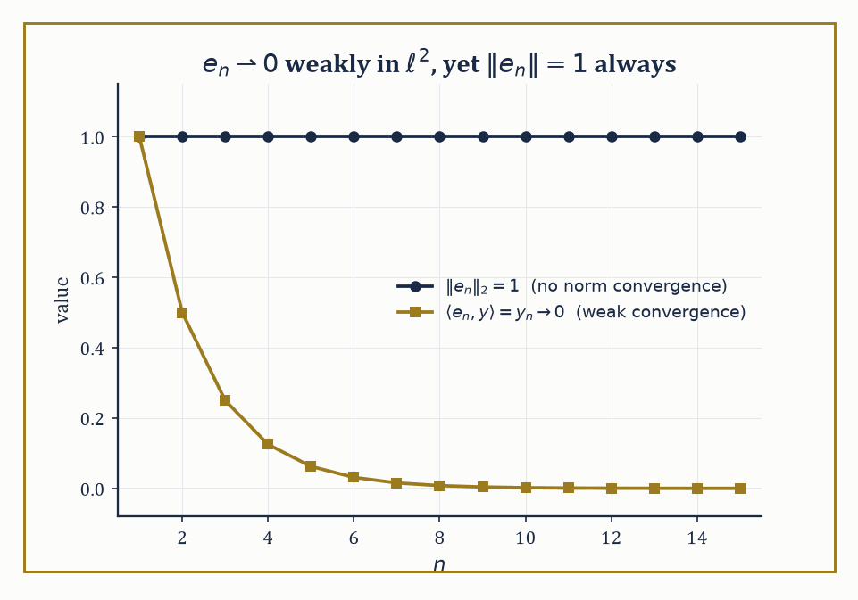
Figure 35.5 — eₙ never budges in norm, yet every honest pairing against it dies down to zero — the two faces of weak convergence, plotted side by side.
f(xₙ) → f(x) for every f ∈ X*
a much gentler requirement than norm convergence, which demands
‖xₙ − x‖ → 0
This gentleness is just why weak convergence is useful: sequences that refuse to converge in norm often converge weakly perfectly well.
Numeric example — Weak convergence without norm convergence. In ℓ², let eₙ be the standard basis vector with a 1 in position n and 0 elsewhere. For any fixed y = (y₁, y₂, y₃, …) ∈ ℓ²,
⟨eₙ, y⟩ = yₙ
Because Σₖ yₖ² converges (that is what y ∈ ℓ² means), the individual terms yₖ must tend to 0 as k → ∞ — a convergent series always has terms tending to zero. So
⟨eₙ, y⟩ = yₙ → 0 for every y ∈ ℓ²
which is the statement eₙ ⇀ 0 weakly. Yet
‖eₙ‖₂ = √(1²) = 1
for every single n, so
‖eₙ − 0‖ = 1
never shrinks — no norm convergence at all. The sequence marches weakly to the origin while staying permanently a unit distance away from it in the strong sense.
Try it now — Does eₙ converge weakly in ℓ²? In norm? Answer →
A useful corollary of Banach–Steinhaus (The Fundamental Theorems) is that every weakly convergent sequence is automatically bounded in norm — weak convergence, however gentle a demand, still cannot let a sequence run off to infinity. The eₙ example obeys this trivially, since ‖eₙ‖ = 1 throughout.
The corollary earns its keep in reverse: a sequence like gₙ = n·eₙ has
‖gₙ‖ = n → ∞
so it cannot converge weakly to anything at all, however innocuous some individual pairings ⟨gₙ, y⟩ might look for a well-chosen y. Unbounded norm is an automatic disqualification from weak convergence, no further checking required.
Numeric example — Unbounded norm disqualifies weak convergence outright. Let gₙ = n·eₙ in ℓ², so
‖gₙ‖₂ = n for every n
Suppose, for contradiction, that gₙ ⇀ g weakly for some g ∈ ℓ²; the boundedness corollary above would then force (‖gₙ‖) to be a bounded sequence. But
‖gₙ‖ = n → ∞
which is not bounded — contradiction. So gₙ cannot converge weakly to anything at all, full stop, regardless of how any individual pairing ⟨gₙ,y⟩ might behave for a particular y ∈ ℓ²; unboundedness alone settles the matter before a single pairing is computed.
On a dual space X*, there is an even coarser topology available: the weak* topology, the coarsest topology making every evaluation map f ↦ f(x) (for fixed x ∈ X) continuous.
Alaoglu’s theorem is the payoff: the closed unit ball of X* is always weak*-compact, with no completeness or reflexivity assumption on X required at all — a compactness statement that holds essentially for free, in stark contrast to how hard-won compactness is everywhere else in infinite dimensions.
Abstract example — Alaoglu in action. Take X = ℓ¹, so X* = ℓ∞ (Linear Operators and Duality). Let φₙ = eₙ, viewed as an element of ℓ∞ acting by
φₙ(x) = xₙ for x ∈ ℓ¹
Each φₙ has
‖φₙ‖∞ = 1
so the whole sequence sits inside the closed unit ball of ℓ∞, which Alaoglu guarantees is weak*-compact. Does it converge weak*? For any fixed x ∈ ℓ¹,
φₙ(x) = xₙ → 0
because Σₖ|xₖ| < ∞ forces the terms xₖ to vanish in the limit — so φₙ → 0 in the weak* topology, even though ‖φₙ‖∞ = 1 for every n and there is no norm convergence whatsoever. It is the exact mirror image of the previous example, one level up in the duality tower.
Reflexive spaces — Hilbert spaces, and Lᵖ for 1 < p < ∞ — enjoy the best of both worlds: their closed unit balls are weakly compact (a theorem of Kakutani), and the Eberlein–Šmulian theorem then tells us that for these spaces weak compactness and weak sequential compactness coincide, so every bounded sequence has a weakly convergent subsequence.
This is the natural habitat for variational arguments: build a minimizing sequence, use boundedness to extract a weakly convergent subsequence, then show the quantity you care about behaves well under weak limits.
Non-reflexive spaces (L¹, C(K), L∞) offer no such guarantee and demand craftier tools.
Abstract example — ℓ¹ again: this time, failing to be reflexive on purpose. ℓ¹ has an almost paradoxical property called the Schur property: in ℓ¹, weak convergence of a sequence actually implies norm convergence — the two notions that are supposed to be miles apart elsewhere collapse together here.
Since (eₙ) does not converge in norm —
‖eₙ − eₘ‖₁ = 2 for any n ≠ m
so it isn’t even Cauchy — the Schur property forbids it from converging weakly either — meaning (eₙ), a perfectly bounded sequence sitting in the closed unit ball of ℓ¹, has no weakly convergent subsequence at all.
The closed unit ball of ℓ¹ therefore fails to be weakly compact, and by Kakutani’s characterization, ℓ¹ is not reflexive — the same conclusion Linear Operators and Duality reached via the ℓ∞ duality mismatch, now reached by an entirely different route.
This is why weak convergence, not strong convergence, is so often the mode of convergence in which minimizing sequences of variational problems live: strong convergence is frequently too much to ask for, but weak convergence, in a reflexive space, is available almost for free.
This gentler style of convergence has one further consequence worth flagging before Compact Operators and the Fredholm Alternative: compact operators, whatever else they do, always turn weakly convergent sequences into norm-convergent ones.
If xₙ ⇀ x weakly and K is compact, then
Kxₙ → Kx in norm
compactness is strong enough to repair, on the far side of the operator, the very gap between weak and strong convergence that the ambient space could not close on its own.
This is often the actual mechanism by which compactness gets used in practice: build a weakly convergent minimizing sequence using reflexivity, then apply a compact operator to upgrade that convergence to something strong enough to survive being plugged into a nonlinear expression.
Keep only this · Section 35.5: Weak Topologies and Reflexivity
The idea. Weak convergence tests a sequence against every continuous functional. Bounded sequences in a reflexive space have weakly convergent subsequences, and in a dual space weak-* convergent ones (Banach–Alaoglu): the compactness that infinite-dimensional unit balls otherwise lack.
Core.
xₙ ⇀ x ⇔ f(xₙ) → f(x) for every f ∈ X*
weakly convergent ⇒ bounded
reflexive: bounded sequences have weakly convergent subsequences
Typical mistake. Expecting norm convergence from weak convergence. eₙ ⇀ 0 while ‖eₙ‖ = 1.
Minimal example. In ℓ², eₙ ⇀ 0.
Practice. Easy to challenge; full worked answers, with the usual mistake, are in Answers to the Practice Sets at the back.
Easy — Does n·eₙ converge weakly? Answer →
Medium — Find the weak limit of xₙ = e₁ + eₙ, and its norms. Answer →
Challenge — Check that the norm is weakly lower semicontinuous on xₙ = e₁ + eₙ, and say why the direct method of the calculus of variations needs this. Answer →

Section 35.6: Compact Operators and the Fredholm Alternative
Where Infinite Dimensions Grudgingly Behave Like Matrices Again
A compact operator K : X → Y maps bounded sets to precompact sets — sets whose closure is compact — which is a genuinely strong condition in infinite dimensions, since the unit ball itself is never compact there.
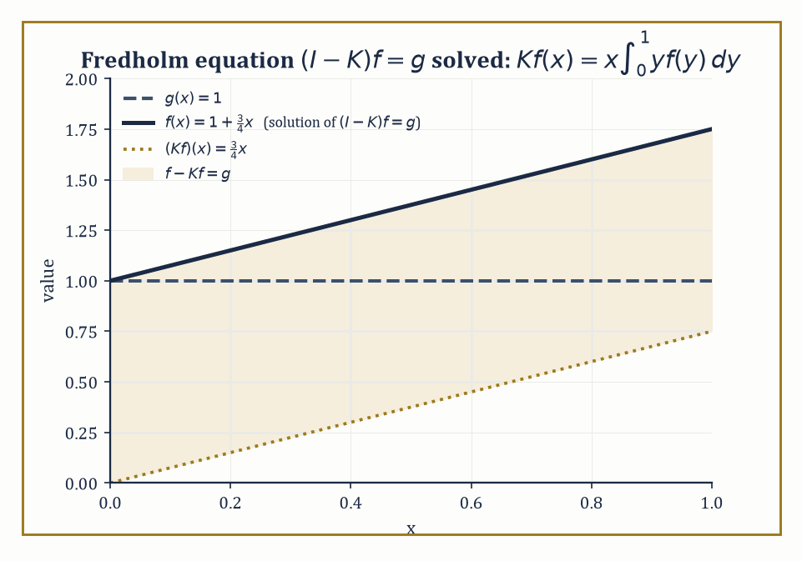
Figure 35.6 — The exact worked case g≡1: solving (I−K)f=g by hand hands back the straight line f(x)=1+¾x, and the shaded strip is the gap K quietly closes.
Finite-rank operators (those with finite-dimensional range) are automatically compact, and so is any operator that is a uniform limit of finite-rank operators; the classic working examples are integral operators with continuous or square-integrable kernels.
Compact operators are, in a precise sense, the infinite-dimensional objects that still remember how to act like finite matrices.
It is worth seeing directly why finite rank forces compactness, since everything else in this section builds on it.
If K has rank r, its entire range is a fixed r-dimensional subspace, and any bounded sequence of outputs (Kxₙ) is then a bounded sequence confined to that finite-dimensional subspace — where Bolzano–Weierstrass, alive and well in finite dimensions, guarantees a convergent subsequence.
Compactness of finite-rank operators is thus nothing but ordinary Bolzano–Weierstrass, smuggled into infinite dimensions through a finite-dimensional side door.
Numeric example — A rank-one integral operator and its eigenvalue. Define K on L²[0,1] by the following rule.
(Kf)(x) = x·∫₀¹ y f(y) dy
This is manifestly rank one (every output is a scalar multiple of the function x), hence compact. To find an eigenvalue, guess f(x) = x itself:
(Kf)(x) = x·∫₀¹ y·y dy = x·∫₀¹ y² dy = x·(1/3) = (1/3)x
So Kf = (1/3)f exactly:
Kf = (1/3)f
meaning f(x) = x is an eigenfunction with eigenvalue λ = 1/3. Because K has rank one, every function orthogonal to x (in the L² inner product) is annihilated by K, giving the eigenvalue 0 with infinite multiplicity.
So the full eigenvalue list is:
{1/3, 0, 0, 0, …}
a single nonzero eigenvalue and an infinite pile of zeros, precisely the pattern the Fredholm theory below predicts for compact operators in general.
Try it now — K f(x) = ∫₀¹ x y f(y) dy on L²[0, 1]. Find its nonzero eigenvalue. Answer →
Numeric example — Compactness of K, verified from the definition. Take any bounded sequence fₙ in L²[0,1] with ‖fₙ‖ ≤ 1, and apply the K defined above:
Kfₙ = cₙ·x, where cₙ = ∫₀¹ y fₙ(y) dy
By the Cauchy–Schwarz inequality:
|cₙ| ≤ ‖y‖_(L²)·‖fₙ‖_(L²) ≤ (1/√3)·1 = 1/√3
since:
‖y‖²_(L²) = ∫₀¹y² dy = 1/3
So (cₙ) is a bounded sequence of real numbers, and by ordinary Bolzano–Weierstrass on ℝ it has a convergent subsequence cₙₖ → c. Then:
Kfₙₖ = cₙₖ·x → c·x
in L² norm, since:
‖cₙₖx − cx‖ = |cₙₖ − c|·‖x‖ → 0
A bounded input sequence produced an output sequence with a convergent subsequence, as the definition of compactness demands — worked by hand rather than cited from a theorem.
The Fredholm alternative for a compact operator K states that I − K is invertible if and only if it is injective, and that when it fails to be injective, the kernel and the cokernel are finite-dimensional and of equal dimension.
Either the equation
(I − K)f = g
has a unique solution for every g, or the homogeneous equation
(I − K)f = 0
has finitely many independent solutions and g must satisfy finitely many compatibility conditions to be solvable at all — there is no messier third option, which is precisely the finite-dimensional-flavored good behavior that makes compact operators so valuable.
Numeric example — Solving (I − K)f = g explicitly. Using the same K as above, solve for a given g:
f(x) − x∫₀¹ y f(y) dy = g(x)
Since K’s only nonzero eigenvalue is 1/3 ≠ 1, the Fredholm alternative guarantees I − K is invertible; here is the solution formula.
Write c = ∫₀¹ y f(y) dy (an unknown constant), so:
f(x) = g(x) + cx
Substitute back into the definition of c:
c = ∫₀¹ y(g(y) + cy) dy = G + c·∫₀¹ y² dy = G + c/3, where G := ∫₀¹ y g(y) dy
Solving:
c − c/3 = G, so (2/3)c = G, giving c = (3/2)G
Hence:
f(x) = g(x) + (3/2)G·x
Test it with g(x) = 1 (the constant function):
G = ∫₀¹ y·1 dy = 1/2, so c = (3/2)(1/2) = 3/4, giving f(x) = 1 + (3/4)x
Verify directly:
∫₀¹ y f(y) dy = ∫₀¹ y(1 + (3/4)y) dy = 1/2 + (3/4)(1/3) = 1/2 + 1/4 = 3/4, so (Kf)(x) = (3/4)x, and f(x) − (Kf)(x) = 1 + (3/4)x − (3/4)x = 1 = g(x)
Confirmed.
The Fredholm alternative is precious because, for a general bounded operator on an infinite-dimensional space, injectivity and surjectivity can come apart completely — recall the shift operator S from Linear Operators and Duality, injective but not surjective, with no notion of ‘invertible’ rescued by either property alone.
What the alternative promises is that once attention narrows to operators of the shape I − K with K compact, that reassuring finite-dimensional reflex — injective if and only if surjective — is restored exactly.
Compactness is the specific ingredient that drags the operator back within reach of finite-dimensional intuition, which is exactly why it is worth caring about so much.
More generally, the spectrum of a compact operator consists entirely of eigenvalues of finite multiplicity, and these eigenvalues can accumulate only at zero — zero itself may or may not be an eigenvalue, but it is always the sole possible accumulation point.
This is the infinite-dimensional discipline that keeps compact operators tractable: however many eigenvalues there are, they cannot pile up anywhere interesting, only dwindle toward the origin, unnoticed, like most academic ambitions.
You have seen this before
This is the Fredholm alternative of Fredholm Integro-Differential Equations and Eigenvalue Problems, now as a theorem about every compact operator rather than a computation with one kernel.
Keep only this · Section 35.6: Compact Operators and the Fredholm Alternative
The idea. A compact operator maps bounded sets to sets with compact closure; it is a limit of finite-rank operators. Its nonzero spectrum consists of eigenvalues of finite multiplicity accumulating only at 0, and the Fredholm alternative governs I − K.
Core.
finite rank ⇒ compact; norm limits of compact operators are compact
(I − K)f = g solvable for all g ⇔ (I − K)f = 0 only for f = 0
nonzero eigenvalues: finite multiplicity, accumulating only at 0
Typical mistake. Calling the identity compact on an infinite-dimensional space. Its unit ball is not compact.
Minimal example. The rank-one kernel xy: one nonzero eigenvalue, 1/3.
Practice. Easy to challenge; full worked answers, with the usual mistake, are in Answers to the Practice Sets at the back.
Easy — Compute Kf for f = 1. Answer →
Medium — Solve (I − K)f = x. Answer →
Challenge — For (I − 3K)f = g, when does a solution exist? Answer →

Section 35.7: Spectral Theory of Compact Self-Adjoint Operators
Diagonalization, Rescued from the Wreckage
A symmetric matrix has a very convenient property: there is a set of perpendicular directions along which it simply stretches, and in those directions every calculation becomes multiplication by a number. The spectral theorem in this section carries that property into infinite dimensions, for a well-behaved class of operators called compact and self-adjoint. The vibrating string shows the payoff. Its natural modes are the sine waves that fit exactly between the fixed ends, with one, two, three or more humps, and any reasonable starting shape can be written as a sum of them. Each mode then simply oscillates at its own frequency, which is precisely the diagonalization the theorem guarantees.
A self-adjoint compact operator on a Hilbert space admits a full orthonormal basis of eigenvectors, and the eigenvalues are all real and tend to zero. Self-adjoint means it satisfies the following relation for all x, y:
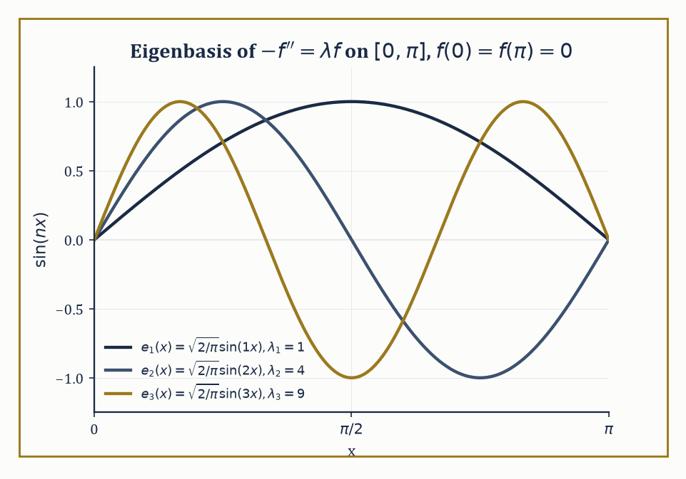
Figure 35.7 — The first three eigenfunctions of −f″=λf on [0,π] — the ordinary Fourier sine basis, caught in the act of being an eigenbasis.
⟨Kx,y⟩ = ⟨x,Ky⟩
This is the spectral theorem for compact self-adjoint operators, and it is nothing less than complete diagonalization, transported wholesale into infinite dimensions — after Section 35.6’s parade of things that go wrong in infinite dimensions, it is worth savoring one thing that goes precisely right.
Compact normal operators (which commute with their own adjoint but need not be self-adjoint) enjoy the same result with complex eigenvalues instead of real ones.
Numeric example — Diagonalizing the rank-one operator from Compact Operators and the Fredholm Alternative. The kernel k(x,y) = xy defining K in Compact Operators and the Fredholm Alternative is symmetric, which makes K self-adjoint on L²[0,1].
k(x,y) = xy = k(y,x)
We already found the eigenfunction f(x) = x with eigenvalue 1/3; normalizing it gives the unit eigenvector e₁(x) = √3·x.
‖x‖² = ∫₀¹ x² dx = 1/3, so ‖x‖ = 1/√3
e₁(x) = √3·x, with ‖e₁‖² = 3·∫₀¹x²dx = 3·(1/3) = 1 as required
Every function orthogonal to x contributes eigenvalue 0, so the full list of eigenvalues, arranged in decreasing size, is (1/3, 0, 0, 0, …) — real, as promised, and trivially ‘tending to zero’ since after the first term they are already there.
Try it now — For K with kernel xy, compute the Rayleigh quotient ⟨Kf, f⟩/⟨f, f⟩ at f = x. Answer →
Abstract example — Why compact self-adjoint eigenvalues must be real. Suppose Kx = λx for some nonzero x, with K self-adjoint (over ℂ, the inner product is conjugate-linear in the second slot):
Kx = λx, and ⟨Kx,y⟩ = ⟨x,Ky⟩ for all x,y
Then:
⟨Kx,x⟩ = ⟨λx,x⟩ = λ‖x‖²
While self-adjointness also gives ⟨Kx,x⟩ = ⟨x,Kx⟩, which is the conjugate of ⟨Kx,x⟩ — forcing ⟨Kx,x⟩ to be a real number:
⟨Kx,x⟩ = ⟨x,Kx⟩ = conjugate of ⟨Kx,x⟩
Since ‖x‖² is a positive real number, λ must itself be real:
λ = ⟨Kx,x⟩/‖x‖²
No complex eigenvalue can survive contact with self-adjointness, which is why physicists insist that quantum-mechanical observables be represented by self-adjoint operators: it is self-adjointness alone that guarantees every possible measurement outcome comes out a real number rather than a complex one.
The toy kernel above was deliberately simple; the motivating examples historically were Sturm–Liouville problems — second-order differential operators on an interval, subject to boundary conditions, whose eigenfunctions turn out to be the special functions (Legendre polynomials, Bessel functions, ordinary Fourier sines and cosines) that keep appearing throughout applied mathematics.
Numeric example — The classical Fourier sine basis as an eigenbasis. Consider the following boundary value problem on [0,π] with Dirichlet boundary conditions f(0) = f(π) = 0:
−f″(x) = λf(x)
Try f(x) = sin(nx) for a positive integer n:
f″(x) = −n²sin(nx), so −f″(x) = n²sin(nx) = n²f(x)
This is an eigenfunction with eigenvalue λₙ = n², for every n = 1, 2, 3, …. These eigenfunctions are pairwise orthogonal on [0,π]: for instance, taking n=1, m=2:
∫[0, π] sin(x)sin(2x) dx = ∫[0, π] sin(x)·2sin(x)cos(x) dx = 2∫[0, π] sin²(x)cos(x) dx = 2[sin³(x)/3]₀^π = 2(0 − 0)/3 = 0
The same pattern of cancellation holds for every n ≠ m. Normalized, √(2/π)·sin(nx) forms a complete orthonormal eigenbasis for this operator — which is the abstract spectral theorem’s conclusion, realized concretely as the ordinary Fourier sine series you may already have met while solving the heat equation on a rod with fixed-temperature ends.
This theorem is the rigorous, abstract backbone of every eigenfunction expansion you have ever used or will use: solving Sturm–Liouville problems, diagonalizing integral equations, and separating variables for the classical PDEs (heat, wave, Laplace) all secretly invoke just this result.
The Rayleigh quotient characterizes the eigenvalues variationally:
R(f) = ⟨Kf,f⟩ / ⟨f,f⟩
The largest eigenvalue is the maximum of R over all nonzero f, and this is the starting point for essentially every numerical eigenvalue algorithm in practical use, because maximizing or minimizing a ratio of quadratic forms is something computers are extremely good at.
Numeric example — Checking the Rayleigh quotient at the eigenvector. Using K and f(x) = x as before:
⟨Kf,f⟩ = ⟨(1/3)x, x⟩ = (1/3)‖x‖² = (1/3)(1/3) = 1/9, and ⟨f,f⟩ = ‖x‖² = 1/3
R(f) = (1/9)/(1/3) = 1/3
This is the eigenvalue we found directly — confirming, on a computable example, that the Rayleigh quotient evaluated at an eigenvector always returns the corresponding eigenvalue, and (since K’s largest eigenvalue is 1/3 and every other eigenvalue is 0) that this f in fact maximizes R over all of L²[0,1].
The min-max principle sharpens the Rayleigh quotient from a description of the largest eigenvalue into a recipe for every eigenvalue in turn: the k-th eigenvalue is obtained by optimizing the Rayleigh quotient over the subspace orthogonal to all the eigenfunctions already found, one rung of the ladder at a time.
Numeric example — Checking the second rung of the ladder. Continuing the Sturm–Liouville example, check the second eigenvalue against its own Rayleigh quotient. Take f(x) = sin(2x), orthogonal to the first eigenfunction sin(x) by the same cancellation computed earlier.
−f″(x) = 4sin(2x) = 4f(x), so ⟨−f″,f⟩ = 4⟨f,f⟩ = 4∫[0, π] sin²(2x) dx
Using sin²θ = (1−cos2θ)/2:
∫[0, π] sin²(2x) dx = ∫[0, π] (1 − cos4x)/2 dx = π/2 − [sin(4x)/8]₀^π = π/2
(the bracket vanishes at both endpoints). So:
⟨−f″,f⟩ = 4·(π/2) = 2π, and ⟨f,f⟩ = π/2, giving R(f) = 2π / (π/2) = 4 = 2²
This is λ₂, the second rung of the ladder λₙ = n² = 1, 4, 9, 16, …, each one recoverable from its own eigenfunction as the min-max principle promises.
Extending this machinery to bounded self-adjoint operators, and further still to unbounded self-adjoint operators via the spectral measure, is the technical foundation of the functional calculus — the ability to make sense of expressions like √T or eⁱᵀᵗ for an operator T — and hence of quantum mechanics itself, where observables are self-adjoint operators and the spectral theorem is what tells you which measurement outcomes are possible.
Same structure, new language
The spectral theorem for symmetric matrices from Linear Algebra (Volume 2) and the Sturm–Liouville expansions of Boundary-Value Problems and Sturm–Liouville Theory are both cases of this theorem.
Keep only this · Section 35.7: Spectral Theory of Compact Self-Adjoint Operators
The idea. A compact self-adjoint operator on a Hilbert space has real eigenvalues and an orthonormal basis of eigenvectors — the infinite-dimensional spectral theorem. The largest eigenvalue maximizes the Rayleigh quotient, and Sturm–Liouville expansions are an instance.
Core.
K = Σ λₙ ⟨·, eₙ⟩ eₙ
λ₁ = max ⟨Kf, f⟩/‖f‖²
self-adjoint: real eigenvalues, orthogonal eigenvectors
Typical mistake. Dropping self-adjointness. The Volterra operator f ↦ ∫₀ˣ f is compact and has no eigenvalues at all.
Minimal example. −f″ on [0, π] with f(0) = f(π) = 0: eigenvalues n², eigenfunctions sin nx.
Practice. Easy to challenge; full worked answers, with the usual mistake, are in Answers to the Practice Sets at the back.
Easy — Compute ∫ f′²/∫ f² for f = sin 2x on [0, π]. Answer →
Medium — Compute that quotient for f = x(π − x) on [0, π], and compare with λ₁ = 1. Answer →
Challenge — Show that the Volterra operator Vf(x) = ∫₀ˣ f(t) dt on L²[0, 1] has no eigenvalues. Answer →

Section 35.8: Unbounded Operators and Sobolev Spaces
Differentiation Refuses to Be Tamed, So We Negotiate Instead
Differentiation is the most important operator in analysis, and it is badly behaved. A function can be tiny everywhere and still have an enormous derivative: a rapid wiggle one hundredth of a unit high, repeating ten thousand times per unit of length, never exceeds a hundredth in size, yet its slope reaches 100. Worse, perfectly reasonable functions such as the absolute value have a corner where no ordinary derivative exists. This section deals with both problems. It treats differentiation as an operator defined only on suitable functions, and it widens the meaning of derivative to a weak sense in which the absolute value’s derivative is simply minus one on the left and plus one on the right.
Many of the operators analysts care about — differential operators chief among them — are unbounded: no constant C makes the following hold for every f in the space.
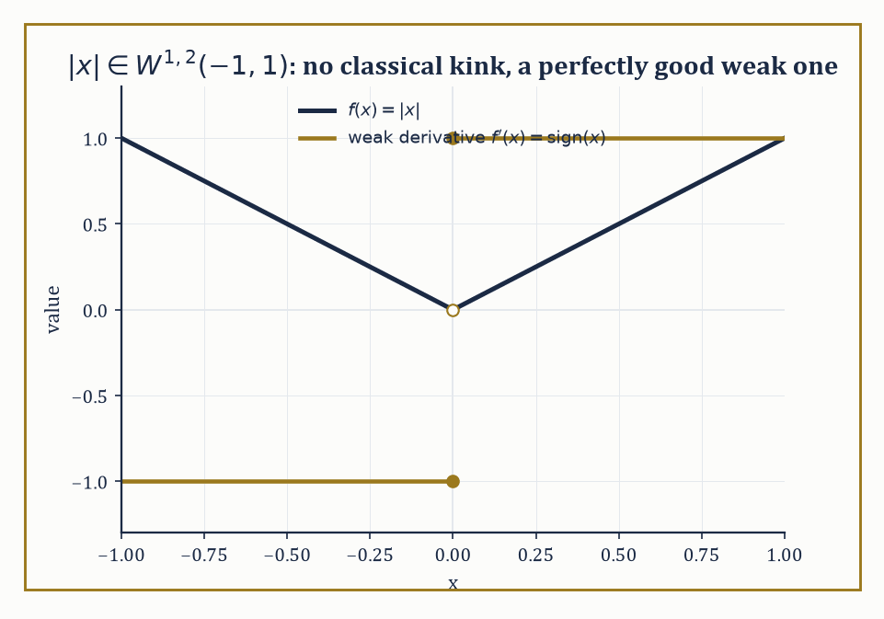
Figure 35.8 — |x| has a kink no classical derivative can survive, but sign(x) is standing by as its perfectly respectable weak derivative.
‖Tf‖ ≤ C‖f‖
Rather than pretending otherwise, we study them as densely defined operators (defined only on a dense subspace, the ‘domain,’ rather than the whole space), equipped with the graph norm ‖f‖² + ‖Tf‖².
The crucial properties become closedness of the graph and, where applicable, self-adjointness — the properties the closed-graph theorem of The Fundamental Theorems was already rehearsing us for, without saying so at the time.
Numeric example — Differentiation is unbounded. On L²[0,1], let fₙ be the function defined below.
fₙ(x) = sin(nπx)
Compute ‖fₙ‖².
∫₀¹ sin²(nπx) dx = ∫₀¹ (1 − cos(2nπx))/2 dx = 1/2 − [sin(2nπx)/(4nπ)]₀¹ = 1/2
The boundary term vanishes since sin(2nπ) = sin(0) = 0.
‖fₙ‖ = 1/√2
This is the same for every n. Now differentiate.
fₙ′(x) = nπ cos(nπx)
By the identical computation:
‖fₙ′‖² = n²π² · (1/2)
‖fₙ′‖ = nπ/√2
The ratio of these norms diverges.
‖fₙ′‖/‖fₙ‖ = nπ → ∞ as n → ∞
No single constant C can bound the following uniformly.
‖fₙ′‖ ≤ C‖fₙ‖
So d/dx is unbounded on L²[0,1], exactly as advertised.
Try it now — fₙ(x) = sin(nπx)/n on [0, 1]. Compute ‖fₙ′‖/‖fₙ‖ in L². Answer →
Self-adjointness for an unbounded operator is subtler than for a bounded one, precisely because the domain now matters.
An operator T is symmetric if the following holds for f, g in its domain.
⟨Tf,g⟩ = ⟨f,Tg⟩
But self-adjointness demands more: the domain of the adjoint T* must coincide exactly with the domain of T itself, not merely contain it.
An operator can be symmetric without being self-adjoint, and the gap between the two is where a surprising amount of mathematical physics actually lives — in questions of whether a given quantum-mechanical Hamiltonian admits a unique self-adjoint extension at all, and what happens to the physics if it admits several.
Abstract example — Symmetric but not self-adjoint: momentum on an interval. Let T be defined by Tf = −if′, acting on L²[0,1], with domain the functions f that are differentiable, have f′ ∈ L²[0,1], and satisfy f(0) = f(1) = 0.
Integration by parts gives the following.
⟨Tf,g⟩ − ⟨f,Tg⟩ = −i[f(x)g̅(x)]₀¹ = −i(f(1)g̅(1) − f(0)g̅(0)) = 0
This holds for every f in this domain and every g in the same domain, since both boundary terms vanish outright — so T is symmetric.
But the adjoint T* turns out to be defined on the larger domain of all f with f′ ∈ L²[0,1] and no boundary condition imposed whatsoever, because the boundary terms above only ever needed f to vanish at the ends, never g: the domain of T* strictly contains the domain of T, so T is symmetric without being self-adjoint.
Repairing this — choosing which boundary condition to impose, such as the one below, for a fixed phase θ — is the business of finding self-adjoint extensions.
f(1) = eⁱᶿf(0)
Different choices of θ describe genuinely different physical particles confined to the interval.
Sobolev spaces W^(k,p) consist of functions whose weak derivatives up to order k lie in Lᵖ — ‘weak derivative’ meaning a derivative defined not pointwise but by how the function behaves when integrated against test functions, which is how you extend differentiation to functions that flatly refuse to be classically differentiable everywhere.
W^(k,p) is a Banach space (a Hilbert space when p = 2), and it is the natural home for weak formulations of elliptic PDEs — a sort of halfway house for functions that cannot quite produce a classical derivative but are perfectly willing to behave themselves under an integral sign.
Numeric example — The weak derivative of |x|, checked against a test function. The claim is that the weak derivative of f(x) = |x| on (−1,1) is sign(x), even though |x| is not classically differentiable at 0.
The defining property to check is the following, for every smooth φ vanishing at ±1.
∫₋₁¹ |x| φ′(x) dx = −∫₋₁¹ sign(x) φ(x) dx
Take φ(x) = (1+x)²(1−x), chosen so φ(1) = 0, φ(−1) = 0, φ(0) = 1.
φ(x) = (1+x)²(1−x) = 1 + x − x² − x³
φ′(x) = −3x² − 2x + 1
Compute the left side.
∫₋₁¹ |x|(−3x² − 2x + 1) dx
Split by parity — |x|·(−3x²) = −3|x|³ and |x|·1 = |x| are even, while |x|·(−2x) = −2x|x| is odd and integrates to 0 over (−1,1) — leaving the following.
2∫₀¹(−3x³ + x) dx = 2[−3x⁴/4 + x²/2]₀¹ = 2(−3/4 + 1/2) = 2(−1/4) = −1/2
Now compute the right side.
−∫₋₁¹ sign(x)φ(x) dx = −[∫₀¹φ dx − ∫₋₁⁰φ dx]
With φ(x) = −x³ − x² + x + 1:
∫₀¹φ dx = [−x⁴/4 − x³/3 + x²/2 + x]₀¹ = −1/4 − 1/3 + 1/2 + 1 = 11/12
∫₋₁⁰φ dx = 0 − (−1/4 + 1/3 + 1/2 − 1) = 0 − (−5/12) = 5/12
So the right side is:
−[11/12 − 5/12] = −6/12 = −1/2
Both sides equal −1/2: the identity checks out on a genuine, non-symmetric test function, confirming sign(x) really is the weak derivative of |x|.
Sobolev embedding theorems trade differentiability for integrability: enough weak derivatives in Lᵖ buys you continuity, or Hölder continuity, or membership in a better Lᵍ, depending on the dimension and the relationship between k, p, and the dimension of the underlying domain.
The Rellich–Kondrachov theorem upgrades some of these embeddings from merely continuous to compact, which is the single fact that converts existence proofs for elliptic PDEs into direct applications of either the Fredholm alternative or the direct method in the calculus of variations.
Numeric example — A compact embedding, watched in real time. Let fₙ be given below, on [0,1].
fₙ(x) = sin(nπx)/n
By the computation two examples ago:
‖fₙ‖_(L²) = (1/n)(1/√2) → 0
Differentiating:
fₙ′(x) = π cos(nπx)
‖fₙ′‖_(L²) = π/√2
This is constant in n. Hence:
‖fₙ‖²_(W^(1,2)) = ‖fₙ‖² + ‖fₙ′‖² = 1/(2n²) + π²/2
This is bounded uniformly in n (it converges to π²/2): the sequence (fₙ) is bounded in the Sobolev space W^(1,2)(0,1).
In one dimension, functions in W^(1,2) are automatically Hölder-continuous, and bounded Sobolev sets are equicontinuous and uniformly bounded — the hypotheses of the Arzelà–Ascoli theorem, which is the concrete mechanism behind Rellich–Kondrachov in this setting.
And indeed fₙ → 0 uniformly on [0,1], since the following holds for every x.
|fₙ(x)| ≤ 1/n → 0
Boundedness in the stronger Sobolev norm has bought us genuine uniform convergence of a subsequence (here, the whole sequence), not only a weak limit.
Keep only this · Section 35.8: Unbounded Operators and Sobolev Spaces
The idea. Differential operators are unbounded: they live on dense domains, and whether they are self-adjoint depends on the domain, that is, on the boundary conditions. Weak derivatives and Sobolev spaces W^(k,p) are the right setting for PDEs, and compact embeddings (Rellich) supply compactness.
Core.
weak derivative g of f: ∫ f φ′ = −∫ g φ for every test function φ
‖f‖²_(W^(1,2)) = ‖f‖² + ‖f′‖²
Rellich: W^(1,2)(0, 1) ↪ L²(0, 1) is compact
Typical mistake. Treating symmetric as self-adjoint. −i d/dx on [0, 1] with f(0) = f(1) = 0 is symmetric, but its adjoint has a larger domain.
Minimal example. |x| on (−1, 1) has weak derivative sign(x).
Practice. Easy to challenge; full worked answers, with the usual mistake, are in Answers to the Practice Sets at the back.
Easy — Find the W^(1,2) norm squared of f = x on [0, 1]. Answer →
Medium — Check ∫ |x| φ′ dx = −∫ sign(x) φ dx on (−1, 1) for φ = x(1 − x²). Answer →
Challenge — Does the Heaviside step H on (−1, 1) have a weak derivative that is a function? Answer →

Section 35.9: Looking Ahead: From Functional Analysis to Operator Algebras, Distributions, and PDEs
The Series Keeps Building on What You Just Learned to Trust
We have now assembled the core of functional analysis: Banach and Hilbert spaces, bounded and unbounded operators, duality, the three fundamental theorems, weak topologies, compact operators, the spectral theorem, and Sobolev spaces.
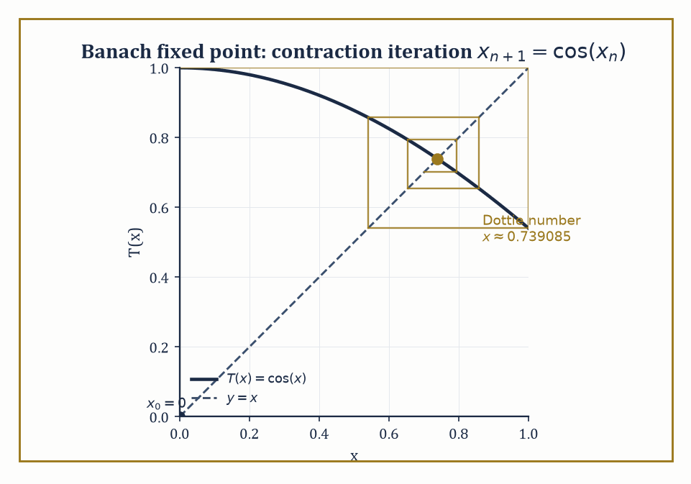
Figure 35.9 — The cobweb of x₀=0 under T(x)=cos(x), spiraling obediently into the Dottie number — completeness and a contraction doing all the work by themselves.
It is worth noticing what these tools bought us collectively — a genuine, working replacement for finite-dimensional linear algebra, rigid enough that the fundamental theorems constrain what operators can possibly do, and generous enough (via the spectral theorem) that a great many concrete problems still reduce to diagonalization in the end.
One direction these tools open onto is operator algebras: collections of bounded operators on a Hilbert space, closed under addition, multiplication, and taking adjoints, and complete in an appropriate norm.
C*-algebras are the abstraction of ‘algebras of operators that behave like B(H), the bounded operators on Hilbert space,’ characterized by the deceptively simple identity:
‖a*a‖ = ‖a‖²
for every element a.
Numeric example — The C*-identity, checked on a 2×2 matrix. Let A = [0 1; 0 0] act on ℂ² — a nilpotent matrix:
A² = 0
Its adjoint A* (conjugate transpose, here just the transpose since entries are real) is:
A* = [0 0; 1 0]
Multiplying — the (2,2) entry is 1·1 = 1, and every other entry vanishes on inspection — gives:
A*A = [0 0; 0 1]
This matrix is diagonal with eigenvalues 0 and 1, and since it is positive semidefinite, its operator norm equals its largest eigenvalue:
‖A*A‖ = 1
Separately, the singular values of A are the square roots of the eigenvalues of A*A, namely 0 and 1, so:
‖A‖ = 1 and ‖A‖² = 1
Indeed:
‖A*A‖ = 1 = ‖A‖²
The C*-identity holds, on the smallest interesting non-self-adjoint example available.
Try it now — Check the C-identity ‖AA‖ = ‖A‖² for A = [0 1; 0 0]. Answer →
Von Neumann algebras push the C*-algebra idea further, closing not merely in the operator norm but in the weaker weak-operator topology that Weak Topologies and Reflexivity introduced — a shift that lets them classify entire ‘types’ of infinite-dimensional behavior (type I, II, and III factors) with no finite-dimensional analogue whatsoever.
Anyone who enjoyed Chapter 34’s tensor algebras will recognize the family resemblance: an operator algebra is, in spirit, what happens when a tensor algebra’s multiplication table is allowed to interact with a genuine infinite-dimensional topology instead of politely stopping at finite rank.
Abstract example — A type I factor you already know. The algebra Mₙ(ℂ) of all n×n complex matrices, acting on H = ℂⁿ, is itself a von Neumann algebra: on a finite-dimensional space every operator topology worth naming coincides, so Mₙ(ℂ) is automatically closed in all of them, and it is already closed under taking adjoints.
It is also its own double commutant — the operators commuting with everything that commutes with Mₙ(ℂ) are (by Schur’s lemma) just the scalar multiples of the identity, and the operators commuting with those scalars are, in turn, all of Mₙ(ℂ) again — which is the algebraic definition a von Neumann algebra must satisfy.
Such finite matrix algebras, and B(H) itself for infinite-dimensional H, are precisely the ‘type I’ factors: the tame, essentially matrix-flavored end of the classification.
Types II and III appear only once you build algebras — typically from infinite discrete groups — with no matching decomposition into anything as simple as matrices on a fixed Hilbert space, which is why nothing in finite dimensions could have introduced them first.
A second direction is the theory of distributions — objects like the Dirac delta that are not functions at all, but are defined entirely by how they act on smooth test functions.
Riding alongside them is Fourier analysis conducted on tempered distributions, which extends the Fourier transform far beyond the functions for which the defining integral literally converges.
Numeric example — The derivative of a jump is a spike. Let H be the Heaviside step function restricted to (−1,1), defined by:
H(x) = 0 for −1 < x < 0, H(x) = 1 for 0 ≤ x < 1
As in the |x| example above, take a test function φ vanishing at the endpoints:
φ(x) = (1−x²)², so φ(0) = 1, φ(1) = φ(−1) = 0
The distributional derivative is defined by ⟨H′,φ⟩ := −⟨H,φ′⟩, which computes as:
⟨H′,φ⟩ = −∫₋₁¹ H(x)φ′(x) dx = −∫₀¹ φ′(x) dx = −[φ(1) − φ(0)] = −[0 − 1] = 1
Meanwhile, by the very definition of the Dirac delta:
⟨δ,φ⟩ := φ(0) = 1
The two agree — on this concrete test function, and by the identical argument on any test function whatsoever — confirming the famous fact that the distributional derivative of the Heaviside step function is the Dirac delta: differentiating a jump of height 1 produces an infinitely concentrated spike of total mass 1.
A third direction, nonlinear functional analysis, extends fixed-point theorems, monotone-operator theory, and degree theory from the linear operators of this chapter to nonlinear maps.
It is the abstract engine behind nonlinear PDEs and variational inequalities, where the Fredholm alternative’s clean dichotomy no longer applies and existence has to be fought for by other means.
Numeric example — A contraction, iterated by hand. The Banach fixed-point theorem says a contraction on a complete space has a unique fixed point, reachable by simple iteration. Take T(x) = cos(x) on [0,1]; since:
|T′(x)| = |sin(x)| ≤ sin(1) ≈ 0.8415 < 1
throughout [0,1], T is a genuine contraction there. Starting from x₀ = 0, the iteration proceeds:
x₁ = cos(0) = 1
x₂ = cos(1) ≈ 0.5403
x₃ = cos(0.5403) ≈ 0.8576
x₄ = cos(0.8576) ≈ 0.6543
x₅ = cos(0.6543) ≈ 0.7935
x₆ = cos(0.7935) ≈ 0.7014
The sequence is visibly homing in, if a little reluctantly, on the unique solution of x = cos(x), the so-called Dottie number, approximately 0.739085.
No cleverness required, just the completeness of [0,1] and the contraction property doing all the work, just as the theorem promises.
Lax–Milgram’s theorem makes a fitting capstone for the whole chapter: it takes a bounded, coercive bilinear form on a Hilbert space — the weak formulation of an elliptic PDE, living naturally in a Sobolev space — and produces, via nothing more exotic than Riesz representation applied cleverly, a unique weak solution.
Section 35.2’s geometric Hilbert-space theorem, Section 35.3’s duality, and Section 35.8’s Sobolev spaces are all cashed in together to solve a genuine differential equation, without ever writing down a classical solution formula at all.
The deeper lesson of the entire chapter is this: infinite-dimensional linear algebra, once equipped with the right topology, turns out to be both far more powerful and far more rigid than its finite-dimensional ancestor.
The fundamental theorems constrain what an operator is even allowed to do; the spectral theorem then recovers, for the well-behaved operators, a genuine form of diagonalization — and it is this combination of rigidity and payoff that makes so many concrete problems in analysis solvable at all.
Functional analysis is the linear algebra of the spaces in which analysis happens — Hilbert space for quantum mechanics, Sobolev spaces for elliptic PDEs, the weak topology for the calculus of variations, the spectrum for every eigenvalue problem too large to write down as a matrix. Everything downstream of this chapter — operator algebras, distributions, nonlinear PDEs — is this same toolkit, pointed at a slightly different target.
Notice, though, what has been borrowed without payment throughout, and never once flagged: every ∫ sign in every Lᵖ space, every weak derivative, every ‘almost everywhere’ has been leaning on an integral and a notion of measure that this chapter never defined. We have been doing analysis on the Lebesgue integral’s credit for thirty-five chapters now, and the bill is about to arrive.
The next chapter pays it: measure theory builds the rigorous notion of size, integral, and ‘almost everywhere’ that functional analysis has been assuming was already in place the whole time. It is, in its own way, the more honest chapter — less geometry, more bookkeeping — but the bookkeeping is exactly what makes every Lᵖ space in this one legitimate rather than merely convenient.
We came in with linear algebra done in infinite dimensions; we leave with a rigid, powerful, occasionally counterintuitive theory that constrains operators, diagonalizes the well-behaved ones, and quietly underwrites most of modern analysis. The series continues, and it is, as ever, still standing on rather less than you’d like — which, at this stage, counts as good news.
Keep only this · Section 35.9: Looking Ahead: From Functional Analysis to Operator Algebras, Distributions, and PDEs
The idea. Operator algebras — C*- and von Neumann algebras — study algebras of operators; distributions extend differentiation to every locally integrable function; fixed-point and monotonicity methods solve nonlinear PDEs.
Core.
C-identity: ‖AA‖ = ‖A‖²
distributional derivative of the Heaviside step: δ
Banach: a contraction on a complete space has one fixed point
Typical mistake. Expecting distributions to multiply. δ · δ has no meaning.
Minimal example. Mₙ(ℂ), all n × n complex matrices, is a von Neumann algebra.
Practice. Easy to challenge; full worked answers, with the usual mistake, are in Answers to the Practice Sets at the back.
Easy — Find the fixed point of T(x) = 1 + x/3 and three iterates from 0. Answer →
Medium — Differentiate |x| twice in the sense of distributions. Answer →
Challenge — Use the C*-identity to find ‖A‖ for A = [0 2; 0 0]. Answer →
Chapter 35 recap · Functional Analysis
• Functions are points of infinite-dimensional normed spaces, and the norm decides what converges and what is continuous.
• Banach spaces are complete; Hilbert spaces add an inner product, orthogonal projection and Riesz representation.
• Bounded operators have norms, duals and spectra; in infinite dimensions the spectrum can contain no eigenvalues at all.
• Hahn–Banach, uniform boundedness, open mapping and closed graph are the four structural theorems.
• Weak convergence restores compactness for bounded sequences in reflexive spaces.
• Compact operators behave like matrices (Fredholm alternative, spectral theorem); differential operators are unbounded and live in Sobolev spaces.

Check Your Understanding — Chapter 35
Answers are in the Answer Key at the back of the book — have a go before you look.
1. [Explain] In What Functional Analysis Is, the sequence fₙ(x) = xⁿ on [0,1] is analyzed under two different topologies. What does it converge to under each, and why does this show the topology isn’t optional?
See the answer →
2. [Compute] Compute the operator norm of T(x₁,x₂) = (2x₁, 3x₂) on ℝ² with the Euclidean norm, and state the general pattern it illustrates.
See the answer →
3. [Explain] Why is every finite-rank operator automatically compact?
See the answer →
4. [Explain] What is the weak derivative of f(x) = |x| on (−1,1), and why is a weak derivative needed here at all?
See the answer →
5. [Compute] Let T act on ℓ² by (Tx)ₙ = xₙ/n. Find ‖T‖, decide whether T is compact, and describe its spectrum.
See the answer →
6. [Compute] Let S be the unilateral shift on ℓ², S(x₁, x₂, …) = (0, x₁, x₂, …). Find its adjoint, and show S is an isometry but not unitary.
See the answer →
7. [Compute] In L²[0, 1], apply Gram–Schmidt to {1, x, x²} and identify the resulting polynomials.
See the answer →
8. [Compute] Show that the closed unit ball of ℓ² is not compact by exhibiting a sequence with no convergent subsequence.
See the answer →
9. [Explain] Why is completeness the hypothesis that appears in every major theorem of this chapter?
See the answer →
10. [Concept] What breaks in infinite dimensions that finite-dimensional intuition would not predict?
See the answer →
11. [Explain] Weak convergence is strictly weaker than norm convergence. Why is a weaker notion useful rather than only deficient?
See the answer →
12. [Prove] Prove the Riesz representation theorem: every bounded linear functional on a Hilbert space is an inner product against a unique vector.
See the answer →
13. [Prove] Prove the uniform boundedness principle.
See the answer →
14. [Prove] Prove Riesz’s lemma and deduce that the closed unit ball is compact only in finite dimensions.
See the answer →
15. [Prove] Prove that a compact operator on an infinite-dimensional Hilbert space cannot be invertible.
See the answer →
16. [Prove] Prove the Fredholm alternative for a compact operator K: I − K is injective if and only if it is surjective.
See the answer →
17. [Prove] Prove that an orthonormal set {eₙ} in a Hilbert space satisfies Bessel’s inequality, and state when equality holds.
See the answer →
18. [Challenge] Hilbert spaces are far better behaved than Banach spaces. What single property accounts for the difference?
See the answer →
19. [Challenge] Spectral theory is described as the infinite-dimensional generalization of diagonalization. What survives the generalization and what does not?
See the answer →
20. [Challenge] Distributions allow differentiation of functions that are not differentiable. What is the trick, and what is surrendered?
See the answer →
21. [Challenge] Sobolev spaces are described as the natural setting for PDE. What makes them natural rather than convenient?
See the answer →
22. [Challenge] Duality assigns to each space its space of functionals. Why has that turned out to be so productive?
See the answer →
23. [Challenge] Quantum mechanics is formulated in Hilbert space. Was that a mathematical convenience or forced by the physics?
See the answer →
24. [Challenge] This chapter generalizes linear algebra to infinite dimensions, and the next rebuilds integration. Why does measure theory come after rather than before?
See the answer →

Problems — Chapter 35
The questions above test whether the ideas landed. These ask you to use them. Solutions are in Solutions to the Problems at the back. Work them before you look.
1. [Compute] On [0, 1], with the L² inner product, compute the norm of f(x) = x.
2. [Compute] In ℝ², project (3, 1) onto the span of (1, 0).
3. [Concept] Cauchy–Schwarz says |⟨f, g⟩| ≤ ∥f∥ ∥g∥. When does equality hold?
4. [Explain] The Riesz representation theorem says every continuous linear functional on a Hilbert space is inner product against some fixed vector. Why does that vector’s norm equal the operator norm of the functional?

Math, Actually

Chapter 36

Measure Theory
Length, Area, Volume, and the Art of Integrating Almost Everywhere
In the previous chapter we spent our time admiring Banach spaces and Hilbert spaces, and among the exhibits we let pass without much comment were the Lᵖ spaces — those handsome, complete, infinite-dimensional creatures that made functional analysis feel so solid. We treated them the way one treats a well-turned-out dinner guest: pleasant company, obviously well-bred, no need to ask about the family. It is now time to ask about the family. Where do Lᵖ spaces actually come from? What, precisely, is being integrated, and with respect to what? The honest answer is that they are built out of measure theory, and if we do not go back and build that foundation properly, we shall spend the rest of the series standing on a foundation we never poured.
The proximate cause of all this is an embarrassment that the Riemann integral of school and first-year-university fame cannot survive. Take the function that is 1 at every rational number and 0 at every irrational number, restricted to the interval [0,1]. Every subinterval of [0,1], no matter how short, contains both rationals and irrationals — densely, insistently, no matter how you chop the interval up. So on every subinterval the function’s supremum is 1 and its infimum is 0, for every partition you could ever choose.
The upper Riemann sum is permanently 1; the lower Riemann sum is permanently 0. They never meet, so the Riemann integral refuses to exist. And yet the rationals in [0,1] are a countable set — a thin, scattered, essentially negligible thing next to the uncountable irrationals — and any sane notion of size ought to declare that thinness worth nothing. Calculus, for all its triumphs, has no vocabulary for saying so.
Measure theory supplies that vocabulary. The program of this chapter is to build, from the ground up, a rigorous notion of the size of a set — a measure — robust enough to survive countable operations (unions, limits, the works), and then to build an integral on top of it, the Lebesgue integral, that reduces to the familiar Riemann integral whenever the Riemann integral already made sense, and that keeps working long after the Riemann integral has thrown up its hands.
Along the way we will meet σ-algebras (the permissible collections of measurable sets), measures themselves, Carathéodory’s extension procedure, Lebesgue measure on Euclidean space, measurable functions, the Lebesgue integral, the great convergence theorems that are the entire point of the exercise, product measures and Fubini’s theorem, and finally Lᵖ spaces and the Radon–Nikodym theorem — at which point we will have gone back and issued those well-bred dinner guests their birth certificates.
A confession, before we begin: measure theory is the section in the series where analysis finally makes its peace with the infinite and, just as importantly, with the negligible. Sets of measure zero can be uncountable, can be topologically enormous, can look for all the world like they matter — and the theory will cheerfully tell you to ignore them anyway, because they never affect an integral. Learning to say “yes, but that only happens off a set of measure zero” with a straight face is both a technical skill and something closer to a philosophical disposition. Riemann taught us to integrate continuous functions. We are about to learn to integrate almost every function that analysis has ever produced — “almost every” doing quite a lot of quiet, load-bearing work in that sentence. Let’s measure.
Why we need this now
Functional Analysis supplied the spaces; this chapter supplies the integral that makes them work. L² was used there as if “∫ |f|² < ∞” were unambiguous and the space were complete. With Riemann’s integral neither is true; with Lebesgue’s both are, and the convergence theorems say exactly when limits and integrals commute.
Before you begin — Chapter 36
By the end of this chapter you will be able to:
1. Say why the Riemann integral is not enough, and what a measure must do.
2. Work with σ-algebras, measures and Lebesgue outer measure, including sets of measure zero.
3. Recognize measurable functions and build the Lebesgue integral from simple functions.
4. Use the monotone and dominated convergence theorems and Fatou’s lemma, and know when they fail.
5. Compute with product measures, Fubini and Tonelli.
6. Compute Lᵖ norms, check Hölder and Minkowski, and find Radon–Nikodym derivatives.
Prerequisites. Riemann integration and improper integrals from Integral (Volume 1); countability and the real line from Volume 2; Lᵖ-type norms and completeness from Functional Analysis.
Estimated study time. About 11 hours, exercises included.

Section 36.1: What Measure Theory Is
In Which Length Grows Up and Gets a Proper Job
At its heart, measure theory does one thing: it assigns to sets a non-negative number — their size — in a way that is systematic enough to support an entire theory of integration built on top of it. This sounds almost too modest to deserve its own chapter of the series, until you try to make it precise and discover that the obvious candidate, the Riemann integral’s implicit notion of size (intervals have length, and everything else is approximated by intervals), simply cannot cope with sets like the rationals.
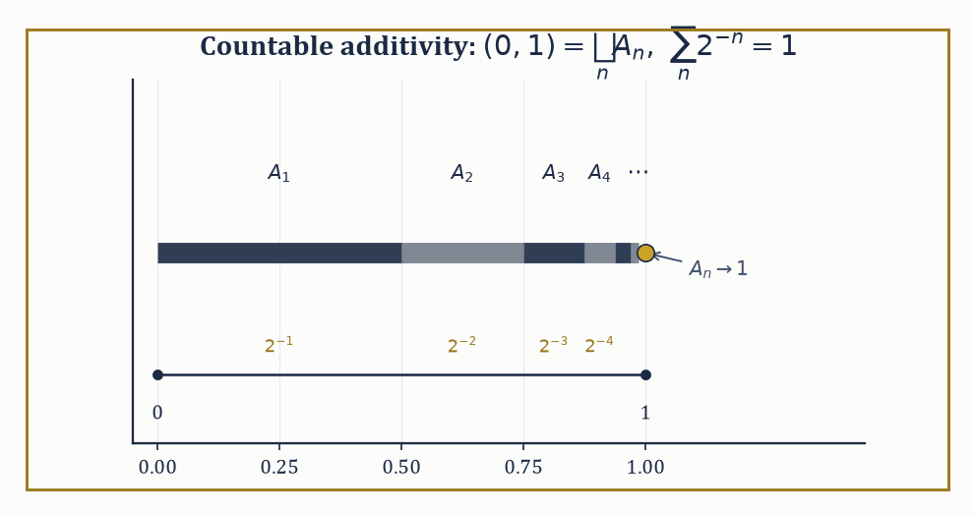
Figure 36.1 — The interval (0,1) split into countably many shrinking pieces Aₙ = (1−2⁻⁽ⁿ⁻¹⁾, 1−2⁻ⁿ), whose lengths 2⁻ⁿ sum, with countable additivity’s blessing, to exactly 1.
We saw this in the opening pages: the indicator function of the rationals on [0,1] has no Riemann integral, because upper and lower sums never converge to a common value, regardless of how finely you partition. Intuitively the rationals in [0,1] ought to have size zero — they are countable, after all, an infinitesimal smattering of points in a continuum — but Riemann’s machinery has no way to say this, because it only ever measures things by covering them crudely with finitely many intervals.
Numeric example — where Riemann gives up. Let f(x) = 1 if x is rational and 0 if x is irrational, for x ∈ [0,1] (the Dirichlet function). Take any partition 0 = x₀ < x₁ < ... < xₙ = 1. On each subinterval [xᵢ₋₁, xᵢ], however small, both rationals and irrationals are dense (between any two distinct reals there sit infinitely many of each), so sup f = 1 and inf f = 0 on that subinterval regardless of i or n.
U = Σᵢ (1)(xᵢ − xᵢ₋₁) = 1 for every partition
L = Σᵢ (0)(xᵢ − xᵢ₋₁) = 0 for every partition
Since U = 1 ≠ 0 = L always, no amount of refining the partition closes the gap, and the Riemann integral of f over [0,1] does not exist. We will return to this exact function in The Lebesgue Integral, where measure theory dispatches it in one line.
Try it now — Pieces Aₙ = (1 − 2^(−(n−1)), 1 − 2^(−n)) partition (0, 1) up to countably many points. Sum their lengths. Answer →
What a measure needs, to do better, is countable additivity: if A₁, A₂, A₃, ... are pairwise disjoint sets, then the measure of their union must equal the sum of their individual measures — and this has to hold even when there are infinitely many of them.
μ(⋃ₙ Aₙ) = Σₙ μ(Aₙ)
Merely finite additivity (the same statement, but only for finitely many disjoint sets at a time) is a much weaker and much less useful demand; analysis is fundamentally the study of limiting processes, and limiting processes are countable operations, so a notion of size that only respects finite unions will betray you the moment you try to pass to a limit under an integral sign, which is the operation the rest of this chapter exists to justify.
(Set functions that are only finitely additive can behave in deranged ways on unmeasurable pieces — the Banach–Tarski paradox, in which a ball is chopped into finitely many pieces and reassembled into two balls of the same size, lives in this gap. Countable additivity, tenure committees please note, is what keeps geometry from falling apart.)
Numeric example — countable additivity in action. Partition the interval (0,1) into the countably many pieces Aₙ = (1 − 2⁻⁽ⁿ⁻¹⁾, 1 − 2⁻ⁿ) for n = 1, 2, 3, .... So A₁ = (0, 1/2), A₂ = (1/2, 3/4), A₃ = (3/4, 7/8), A₄ = (7/8, 15/16), and so on — each interval picking up just where the last left off, shrinking geometrically as it marches toward 1.
The ordinary length of Aₙ is 2⁻ⁿ. These sets are pairwise disjoint and their union is (0,1) (minus the countably many boundary points, which we can ignore since single points have length zero — a fact we prove properly in Outer Measure and Lebesgue Measure). Countable additivity demands that the length of (0,1) equal the following sum.
Σ[n ≥ 1] 2⁻ⁿ = 1/2 + 1/4 + 1/8 + ... = 1
The infinite sum and the geometric picture agree — which is reassuring, since if they had not agreed, this whole chapter would be considerably shorter and considerably more embarrassing.
Lebesgue measure on Euclidean space ℝⁿ is the construction that does the job properly: it extends the familiar notions of length (n = 1), area (n = 2), and volume (n = 3 and beyond) to an enormous class of sets — vastly larger than “finite unions of rectangles” — while keeping two properties that any self-respecting notion of size must have: translation invariance (sliding a set around does not change its size) and countable additivity.
The Lebesgue integral, built from this measure in The Lebesgue Integral, extends the Riemann integral in the strongest sense possible: whenever a function is Riemann integrable, it is also Lebesgue integrable, and the two integrals agree exactly. The Lebesgue integral integrates a great many more functions besides, and — this is the real selling point — it interacts vastly better with limits, as the convergence theorems of Convergence Theorems will demonstrate at length.
Numeric example — agreement on a continuous function. Take f(x) = x² on [0,1], a perfectly civilized continuous function. The Riemann integral is the familiar one.
∫₀¹ x² dx = [x³/3]₀¹ = 1/3
The Lebesgue integral of the same function over the same interval, constructed by an entirely different route (approximating f from below by simple functions, as The Lebesgue Integral will show step by step), also evaluates to exactly 1/3. This is not a coincidence or a lucky special case: it is a theorem — Lebesgue integration agrees with Riemann integration on every function for which Riemann’s theory already gives an answer. The new theory does not contradict the old one; it keeps working after the old one has given up, as it will for the Dirichlet function above.
This is why measure theory is not a specialist detour but the load-bearing language beneath most of modern analysis. Probability theory is measure theory in which the total measure of the entire space is normalized to 1 (a random variable is a measurable function, an expectation is an integral).
Ergodic theory studies transformations that preserve a measure. Harmonic analysis and the theory of partial differential equations lean on Lebesgue integration and its convergence theorems at every turn, because the functions that show up as solutions to real equations are very rarely as polite as continuous functions with compact support. We are, in short, about to learn the grammar that the rest of the series has been quietly assuming we already knew.
Numeric example — probability as measure, expectation as integral. Take Ω = {1,2,3,4,5,6} (the outcomes of one die) equipped with the probability measure μ({k}) = 1/6 for each k, and let X: Ω → ℝ be the identity map X(ω) = ω — the measurable function that reports the number shown, i.e. the random variable. Its expectation is, by the definition promised above, nothing more than an integral against μ.
E[X] = ∫[Ω] X dμ = Σₖ₌₁⁶ k · μ({k}) = (1+2+3+4+5+6) · (1/6) = 21/6 = 3.5
This is the schoolroom answer for the expected value of a fair die, arrived at without a single new idea beyond “integrate a simple function” — which is the entire content of the claim that probability theory is measure theory wearing a different hat.
Keep only this · Section 36.1: What Measure Theory Is
The idea. The Riemann integral slices the domain and fails on functions such as the indicator of the rationals. Measure theory first decides which sets have a size and what that size is, then integrates by slicing the range. It also makes probability rigorous: an expectation is an integral against a probability measure.
Core.
countable additivity: μ(⋃ Aₙ) = Σ μ(Aₙ) for disjoint Aₙ
E[X] = ∫ X dP
Typical mistake. Expecting finite additivity to be enough. Limits of sets — and so limits of functions — need countable additivity.
Minimal example. A fair die: E[X] = (1 + 2 + … + 6)/6 = 3.5.
Practice. Easy to challenge; full worked answers, with the usual mistake, are in Answers to the Practice Sets at the back.
Easy — On a fair die, find E[X²]. Answer →
Medium — Why do upper and lower Riemann sums of the indicator of the rationals on [0, 1] never meet? Answer →
Challenge — Give the measure-theoretic answer for ∫₀¹ 1_ℚ and explain it. Answer →

Section 36.2: Algebras, σ-Algebras, and Measures
Bureaucracy for Sets, and Why the Countable Version Is the One That Matters
Before we can define a measure, we need to agree on which sets are allowed to have a measure at all — it turns out (Outer Measure and Lebesgue Measure will supply the villain) that not every subset of ℝ can be assigned a sensible size, so we need a well-behaved collection of permissible sets to work with.
Begin in a land registry, which is a real building full of real filing cabinets. Every parcel of land in the district has a folder. The folder says where the boundaries run, and from the boundaries anybody can work out the area.
Three sorts of question can be put to such an office, and it answers all three without difficulty. You can ask about a parcel it holds a folder for. You can ask about two parcels taken together, because the clerk fetches both folders and adds. And you can ask about everything in the district except one parcel, because the clerk takes the district total and subtracts. Combine parcels, or take everything-but — the office is closed for neither.
Notice that the office has quietly answered a question you did not ask. It has decided which pieces of land are entitled to have an area at all. A parcel with a folder has one. Something with no folder does not, and the clerk will not be drawn on it. That refusal is not laziness. It is the thing that makes the whole arrangement work, and the rest of this section is about taking it seriously.
To see why the refusal matters, try to invent a piece of land the office cannot cope with. Take the district and mark every point whose distance from the west fence, in meters, is a whole number of centimeters — nothing else, only those points. Ask the clerk for its area. There is no boundary to walk. There is no fence anybody could build. There is no folder, and there is no sensible answer, and the honest reply is that the question was never a fair one.
Now the part that costs something. Everything above held together because the clerk was combining folders two at a time, or ten at a time, or any number you could finish counting. Let the clerk combine infinitely many.
Here is what goes wrong, and it is worth doing slowly. Suppose the office will register any piece of land made of finitely many strips running north to south. Two such pieces joined together are still finitely many strips, so the office copes. The complement of such a piece is again finitely many strips, so the office copes with that too. By every test applied so far, the arrangement is sound.
Then somebody asks for the piece made of one thin strip at every rational distance from the west fence. Each individual strip is registered. There are only countably many of them, so they can be listed, first, second, third, forever. Yet the piece they make between them is not finitely many strips and never could be: it has points arbitrarily close to every location in the district, and so does the land left over. The office has been handed a request built entirely out of things it registered, and the answer is not in its cabinets.
So change the question. Not what is the area of this shape, but which collections of points are entitled to have an area in the first place?
That is a strange question to have to ask, and the reason it cannot be dodged is worth stating plainly. If you allow every conceivable set to have an area, the notion collapses — the next section builds the offending set explicitly, and it is a set that can be cut into pieces and reassembled into something of a different size, which no honest notion of area can survive. If instead you allow too few sets, you cannot take limits, and limits are the entire reason for building the theory. The subject lives in the gap.
The way out looks like cheating, and it is the same move topology made with distance. Stop trying to work out which sets have an area. Decide in advance which ones are admissible, write the list down, insist the list is closed under the operations you intend to perform, and decline to discuss anything else.
Before any notation, watch such a list being checked. Take a district with four plots, numbered 1 to 4, and register only these pieces: nothing at all, plots 1 and 2 together, plots 3 and 4 together, and the whole district.
nothing at all · {1, 2} · {3, 4} · the whole district
Test the office. Is the whole district registered? It is, by inspection. Take everything except plots 1 and 2 and you are left with plots 3 and 4, which is on the list. Take everything except plots 3 and 4 and you get plots 1 and 2, also on the list. Everything except nothing is the whole district, and everything except the whole district is nothing — both on the list. Now combine: plots 1 and 2 together with plots 3 and 4 make the whole district, on the list. Every other combination involves nothing-at-all or the-whole-district and hands back something already there.
Four pieces, six checks, no escape. The list is closed, and it is closed however many times you apply the operations, because there are only four pieces and you will run out of new things to make before you run out of patience.
Notice what the list never tells you. It never says why those pieces and not others. Nothing forced the choice; register plot 1 on its own instead and you get a different office, equally sound, answering a different set of questions. It also never tells you that plots 1 and 2 must have the same area as plots 3 and 4, or any area at all. Admissibility and size are two separate decisions, and this section settles only the first.
That list is an algebra of sets: a collection closed under taking complements and under combining finitely many members. Strengthen finitely to countably — allow the clerk to combine a list that runs on forever, so long as it can be counted — and you have a σ-algebra. The σ is doing exactly one job, and it is the job the north-to-south strips failed.
The abstract examples below run this same check on this same four-plot district, and then build the strip office in full to show precisely where it breaks.
An algebra of sets on a space X is a collection 𝒜 of subsets of X that contains X itself and is closed under complements and finite unions (and hence, by De Morgan’s laws, under finite intersections too — closure under complements turns unions into intersections and back for free).
A σ-algebra strengthens this to closure under countable unions and complements, which — again by De Morgan — gives closure under countable intersections as well.
Every σ-algebra is an algebra; the reverse need not hold, and the gap between them is the gap that makes σ-algebras the correct home for measures, since measures need to behave well under countably infinite operations, as What Measure Theory Is insisted.
Abstract example — a finite algebra. Let X = {1, 2, 3, 4}, and let 𝒜 be the following collection of subsets:
𝒜 = {∅, {1,2}, {3,4}, X}
Check the axioms directly. First, X ∈ 𝒜 by inspection. Next, check complements: the complement of {1,2} in X is {3,4}, which is in 𝒜; the complement of {3,4} is {1,2}, also in 𝒜; and the complement of ∅ is X, and vice versa. Now check unions:
{1,2} ∪ {3,4} = X ∈ 𝒜
and any union involving ∅ or X reproduces an existing member. So 𝒜 is closed under complements and finite unions — it is an algebra. Because X is finite, there are only finitely many subsets to worry about in the first place, so “closed under finite unions” and “closed under countable unions” coincide here, and 𝒜 is automatically a σ-algebra too. The interesting distinction between algebras and σ-algebras only bites on infinite spaces, which is exactly the next example.
Try it now — On X = {1, 2, 3, 4}, is {∅, {1, 2}, {3, 4}, X} a σ-algebra? Answer →
Abstract example — an algebra that is not a σ-algebra. On X = ℝ, let 𝒜 be the collection of all finite unions of intervals of the forms (a,b], (−∞,b], and (a,∞), together with ∅ and ℝ. One can check (it is a standard, if slightly tedious, exercise) that 𝒜 is closed under complements and finite unions, so it is an algebra.
Now consider the rational numbers ℚ. Each singleton {q} can be written as the degenerate interval [q,q], and ℚ is a countable union of such singletons:
ℚ = ⋃_(q∈ℚ) {q}
But ℚ is dense in ℝ and its complement (the irrationals) is also dense, so ℚ cannot be written as any finite union of intervals of the allowed forms — no finite union of intervals is simultaneously dense and has a dense complement. Hence ℚ ∉ 𝒜, even though it is a countable union of members of 𝒜.
This is precisely the failure that σ-algebras are built to repair: the σ-algebra generated by 𝒜 (the smallest σ-algebra containing it) does contain ℚ, and in fact turns out to be the Borel σ-algebra, generated by the open sets of ℝ — the σ-algebra on which essentially all of classical analysis is conducted.
Its completion with respect to Lebesgue measure, formed by throwing in every subset of every Borel null set, is the Lebesgue σ-algebra, and it is strictly larger still (Outer Measure and Lebesgue Measure).
A measure on a measurable space (X, Σ) — Σ being a σ-algebra on X — is a function μ: Σ → [0, ∞] satisfying the following: first,
μ(∅) = 0
and second, countable additivity:
μ(⋃ₙ Aₙ) = Σₙ μ(Aₙ)
for any countable collection of pairwise disjoint sets Aₙ ∈ Σ. That is the entire definition; everything else is special cases and consequences.
A measure is finite if μ(X) < ∞; it is σ-finite if X can be written as a countable union of sets each of finite measure (a weaker, extremely common condition that Lebesgue measure on ℝ satisfies without being finite itself); and it is a probability measure if μ(X) = 1 exactly, the special case that underlies the whole of probability theory.
Numeric example — three flavors of measure. Three flavors of measure illustrate the definitions in action, starting with counting measure on ℕ, defined by:
μ(A) = the number of elements of A (and μ(A) = ∞ if A is infinite)
For example:
μ({2,4,6}) = 3
μ(evens) = μ(odds) = ∞
μ(ℕ) = μ(evens) + μ(odds) = ∞ + ∞ = ∞
This is consistent with countable additivity in the extended arithmetic where ∞ absorbs everything. This measure is neither finite nor σ-finite in any useful sense on all of ℕ viewed as one block, though it is σ-finite if you slice ℕ into finite pieces like {1}, {2}, {3}, ....
Second, Lebesgue measure on ℝ has:
μ(ℝ) = ∞
so it is not finite. But ℝ can be written as an increasing union of bounded intervals:
ℝ = ⋃ₙ₌₁^∞ [−n, n]
and each of those intervals has finite measure:
μ([−n,n]) = 2n < ∞
for every n, so Lebesgue measure is σ-finite.
Third, the uniform (probability) measure on [0,1] is defined by:
μ(A) = the Lebesgue measure of A ∩ [0,1]
Here:
μ([0,1]) = 1
exactly, making it a genuine probability measure — the mathematical model of picking a real number uniformly at random from the unit interval.
One recurring technical headache is proving that two measures agree everywhere on a σ-algebra when you can only check that they agree on some smaller, more manageable generating collection — say, on all intervals, when you actually want equality on every Borel set.
Dynkin’s π-λ theorem is the standard tool: if a collection of sets is a π-system (closed under finite intersections) and two finite measures agree on that π-system and on the entire space, then they agree on the entire σ-algebra generated by the π-system.
The monotone class theorem is a close cousin, phrased in terms of classes of sets closed under increasing unions and decreasing intersections, and is used for the same purpose.
Both theorems exist because directly verifying countable additivity by hand on an arbitrary σ-algebra is usually hopeless; checking a simpler generating family and then invoking one of these theorems to extend the result is the standard workaround, and you will see it deployed constantly for the rest of your mathematical life.
Abstract example — why cumulative distribution functions determine measures. Suppose μ and ν are two probability measures on the Borel σ-algebra of ℝ, and suppose they agree on every interval of the form (−∞, x] for x ∈ ℝ — that is, they have the same cumulative distribution function.
The collection {(−∞,x] : x ∈ ℝ} is a π-system, since:
(−∞,x] ∩ (−∞,y] = (−∞, min(x,y)]
another set of the same form. This π-system generates the Borel σ-algebra (every open interval, hence every open set, can be built from countably many such half-lines by unions, complements, and intersections).
Both μ and ν are finite (indeed, both give the whole space measure 1), and they agree on the π-system by hypothesis.
Dynkin’s π-λ theorem then hands us, for free, that μ and ν agree on the entire Borel σ-algebra — not merely on half-lines, but on every Borel set whatsoever.
This single argument is the rigorous justification for a fact used constantly and casually throughout probability theory: a distribution function determines its probability measure completely.
Keep only this · Section 36.2: Algebras, σ-Algebras, and Measures
The idea. A σ-algebra is a family of sets closed under complements and countable unions; a measure is a countably additive function on it. Counting measure, Lebesgue measure and point masses are the basic examples, and a probability measure on ℝ is determined by its distribution function.
Core.
μ(∅) = 0, μ(⋃ Aₙ) = Σ μ(Aₙ) (disjoint)
continuity from below: Aₙ ↑ A ⇒ μ(Aₙ) → μ(A)
Borel σ-algebra: generated by the open sets
Typical mistake. Confusing an algebra with a σ-algebra. Finite unions of intervals form an algebra, but countable unions leave it.
Minimal example. Counting measure on ℕ: μ(A) = number of elements.
Practice. Easy to challenge; full worked answers, with the usual mistake, are in Answers to the Practice Sets at the back.
Easy — Find μ({1, 3, 5}) for counting measure and for δ₃. Answer →
Medium — Use continuity from below to find μ((0, 1)) from Aₙ = [1/n, 1 − 1/n]. Answer →
Challenge — The CDF of a probability measure μ is F(x) = μ((−∞, x]). Find μ((1, 3]) for F(x) = 1 − e^(−x), x ≥ 0. Answer →

Section 36.3: Outer Measure and Lebesgue Measure
Building Size From the Outside In, and Meeting the One Set That Refuses to Play
The construction of Lebesgue measure begins not with measurable sets but with every set — literally every subset of ℝⁿ, measurable or not — via a device called outer measure. The Lebesgue outer measure m*(A) of a set A ⊆ ℝⁿ is defined by covering A with a countable collection of rectangles (or cubes; either works) and taking the infimum, over all such coverings, of the total volume of the covering rectangles:
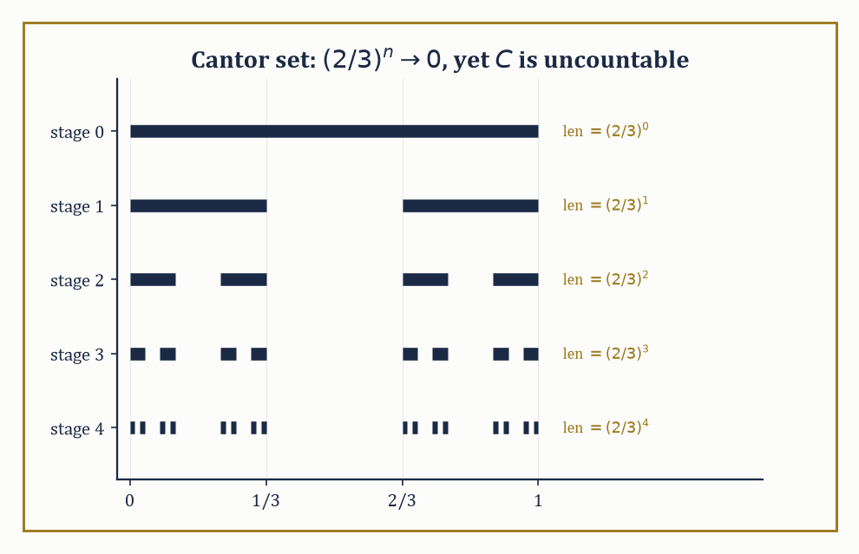
Figure 36.2 — Five stages of deleting middle thirds: the remaining length shrinks geometrically to zero, yet what survives in the limit is an uncountable set — measure zero and cardinality of the continuum, comfortably at once.
m*(A) = inf { Σₖ vol(Rₖ) : A ⊆ ⋃ₖ Rₖ, each Rₖ a rectangle }
This is defined for absolutely every set, which is the entire appeal — no measurability hypothesis is needed to ask “how small a covering can I manage?” The catch is that outer measure is only countably subadditive in general rather than additive:
m*(⋃ₙ Aₙ) ≤ Σₙ m*(Aₙ)
It can under-count the true size of a union when the pieces overlap in a pathological, non-measurable way. Carathéodory’s criterion is the fix: declare a set E measurable if it splits every test set A ⊆ ℝⁿ additively, meaning
m*(A) = m*(A ∩ E) + m*(A ∩ Eᶜ)
for every A. The sets satisfying this criterion form a σ-algebra, and outer measure restricted to that σ-algebra is, at last, a genuine countably additive measure — Lebesgue measure.
Numeric example — a finite set has outer measure zero. Let A = {0, 1, 2} ⊆ ℝ. Fix any ε > 0. Cover each point with an open interval of length ε/3:
cover 0 with (−ε/6, ε/6), cover 1 with (1 − ε/6, 1 + ε/6), cover 2 with (2 − ε/6, 2 + ε/6)
Each interval has length ε/3, and there are three of them, so this is a valid countable (here, finite) covering of A with total length
ε/3 + ε/3 + ε/3 = ε
Hence m*(A) ≤ ε. Since ε > 0 was arbitrary and outer measure is non-negative,
m*(A) = 0
The same argument, run over a countable enumeration with intervals of length ε/2ⁿ around the n-th point, shows that every countable set has Lebesgue outer measure zero — which is the fact that rescues the Dirichlet function of What Measure Theory Is in The Lebesgue Integral.
Try it now — Cover {0, 1, 2} by intervals of total length ε. What is its outer measure? Answer →
The Carathéodory-measurable sets include every Borel set — every open set, closed set, countable union or intersection thereof, and so on — plus a great deal more besides (the completion process of Algebras, σ-Algebras, and Measures throws in every subset of every null set).
What they do not include is everything: there exist subsets of ℝ that are not Lebesgue measurable at all, and constructing one genuinely requires the axiom of choice. The classical example is the Vitali set, and its existence is the theorem that keeps set theorists and analysts on permanently polite but wary terms — rather like two departments sharing a photocopier.
Abstract example — the Vitali set is not measurable. Define an equivalence relation on [0,1) by x ~ y iff x − y ∈ ℚ. This partitions [0,1) into uncountably many equivalence classes, each of which is countable. Using the axiom of choice, form a set V by picking exactly one representative from each class.
Let q₁, q₂, q₃, ... enumerate the rationals in [−1,1], and set
Vₙ = { v + qₙ (mod 1-ish, i.e. taken within [−1,2)) : v ∈ V }
i.e. each Vₙ is V translated by qₙ. Two facts, both provable directly from the construction: the Vₙ are pairwise disjoint (if Vᵢ and Vⱼ shared a point, two representatives of V would differ by a rational, contradicting the “exactly one representative per class” choice), and their union covers [0,1) while staying inside [−1,2) (every x ∈ [0,1) is equivalent to its class’s representative v ∈ V, so x = v + q for some rational q with |q| ≤ 1).
Now suppose, for contradiction, that Lebesgue measure could be defined on every subset of ℝ, consistently with translation invariance and countable additivity. Translation invariance forces
m(Vₙ) = m(V)
for every n. Countable additivity applied to the disjoint union then gives
1 ≤ m([0,1)) ≤ m(⋃ₙ Vₙ) = Σₙ m(Vₙ) ≤ m([−1,2)) = 3
If m(V) = 0, the sum is 0, contradicting the lower bound of 1. If m(V) = c > 0, the sum is a countably infinite total of a fixed positive number, which is ∞, contradicting the upper bound of 3. Either way, contradiction — so V cannot be assigned a Lebesgue measure consistent with the axioms.
This is why measurability is a genuine restriction and not merely bureaucratic caution: some sets really do have to be left out in the cold, and the axiom of choice is what is needed to manufacture one.
Lebesgue measure, restricted to the measurable sets, has the properties one would hope for: it is translation-invariant, meaning
m(A + x) = m(A)
for every set A and every vector x. It is also regular (the measure of any measurable set can be approximated from outside by open sets and from inside by compact sets), and it is the unique measure on the Borel σ-algebra assigning to every rectangle its ordinary geometric volume and behaving translation-invariantly.
In particular it recovers length, area, and volume exactly where those concepts already made sense — none of this is glamorous, it is the boring, well-behaved measure you were using without a second thought in your first calculus course, now finally issued its credentials in writing.
Numeric example — measuring a rectangle. In ℝ², the rectangle R = [0,2] × [0,3] has Lebesgue measure equal to its ordinary area:
m(R) = (2 − 0) × (3 − 0) = 6
This is definitional at the covering-by-rectangles stage of the construction (a single rectangle covers itself with total volume its own volume, so the outer measure of a rectangle is trivially at most its own volume; the matching lower bound, that no cheaper covering exists, is the geometric content of the construction). Translation invariance then tells us, for free and without recomputation, that the shifted rectangle [5,7] × [10,13] also has measure exactly 6.
A set of measure zero — a null set — need not be small in any other sense. It can be infinite; it can even be uncountable, which is the single most counter-intuitive fact in this entire chapter and worth sitting with for a moment.
The Cantor set is the standard demonstration: uncountable, closed, containing no interval whatsoever, and yet Lebesgue measure zero.
Numeric example — the Cantor set has measure zero. Build the Cantor set C by starting with [0,1] and repeatedly deleting the open middle third of every remaining interval.
Stage 0: [0,1], total remaining length 1. Stage 1: remove (1/3, 2/3), leaving [0,1/3] ∪ [2/3,1], total remaining length
1 − 1/3 = 2/3
Stage 2: remove the middle third of each of those two intervals, two removed pieces each of length 1/9, leaving total length
2/3 − 2/9 = 4/9 = (2/3)²
By induction, after n stages the remaining set has total length precisely (2/3)ⁿ (at each stage, every surviving interval loses its middle third, multiplying total remaining length by 2/3). The Cantor set C is the intersection of all these stages, so
m(C) ≤ (2/3)ⁿ
for every n, and since (2/3)ⁿ → 0 as n → ∞,
m(C) = 0
Yet C is uncountable: each point of C corresponds to an infinite sequence of “left third” / “right third” choices at every stage, giving a bijection with the set of infinite binary sequences {0,1}^ℕ, which has the cardinality of the continuum. So C has as many points as [0,1] itself, and yet takes up none of its length.
Two functions that agree everywhere except on a set like C — or any null set — will be given, in The Lebesgue Integral onward, exactly the same integral: they are identified, treated as the same object “almost everywhere,” which is the conceptual shift this entire chapter keeps promising and is now finally in a position to deliver.
Keep only this · Section 36.3: Outer Measure and Lebesgue Measure
The idea. Lebesgue outer measure covers a set by countably many intervals and takes the infimum of the total length. Restricted to the Carathéodory-measurable sets it is a measure that extends length. Countable sets and the Cantor set have measure zero; with the axiom of choice there are non-measurable sets.
Core.
m*(A) = inf Σ ℓ(Iₙ) over countable covers by intervals
Cantor set: 1 − Σ 2ⁿ⁻¹/3ⁿ = 0
Carathéodory: m(E) = m(E ∩ A) + m*(E ∖ A) for every E
Typical mistake. Thinking measure zero means small or countable. The Cantor set is uncountable and has measure zero.
Minimal example. The rectangle [0, 2] × [0, 3]: measure 6.
Practice. Easy to challenge; full worked answers, with the usual mistake, are in Answers to the Practice Sets at the back.
Easy — Find the measure of ℚ ∩ [0, 1]. Answer →
Medium — Find the total length removed in the first three stages of the Cantor construction. Answer →
Challenge — Why can the Vitali set V not be measurable? Answer →

Section 36.4: Measurable Functions
The Minimum Standard of Behavior Required Before Integration Is Even Discussed
Before integrating a function in the modern sense, you must be able to measure the set of points where it exceeds any given level: where is the temperature above 30 degrees, and how much of the region is that? Functions for which every such question has an answer are called measurable. The requirement is weak: continuous functions qualify, and so do functions with jumps and limits of such functions, even discontinuous limits. On the interval from 0 to 1, the curves of x to the power 1, 2, 3 and so on settle down to a function that is 0 everywhere except for a jump to 1 at the very end, and that limit is still measurable.
A function f: X → ℝ (or into the extended reals, allowing ±∞) between measurable spaces is measurable if the pre-image of every open set is a measurable set — equivalently, if f⁻¹((a, ∞)) is measurable for every real a, a considerably more checkable condition in practice.
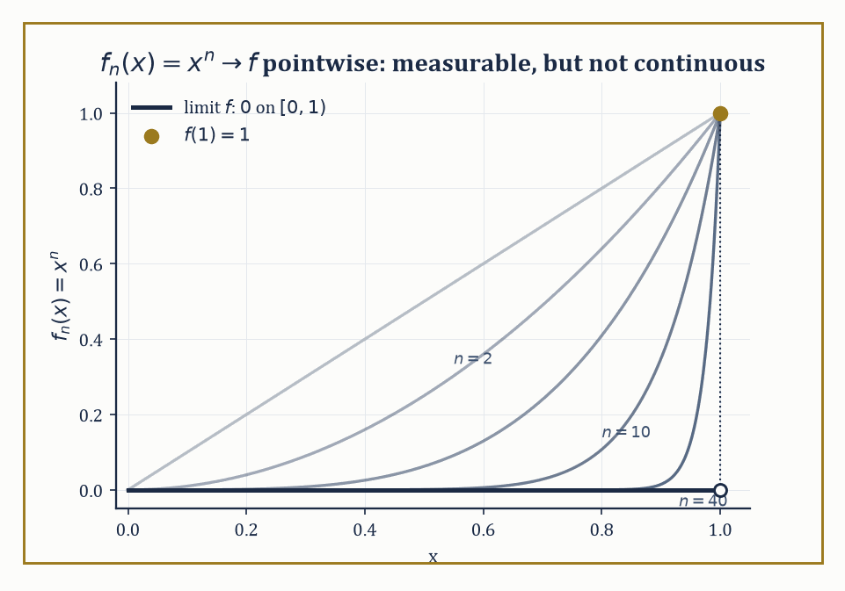
Figure 36.3 — The continuous curves fₙ(x)=xⁿ pile up, pointwise, into a limit with a genuine jump at x=1 — proof that measurability survives a limit far more graciously than continuity ever does.
f⁻¹((a, ∞)) is measurable for every real a
Measurability is a purely set-theoretic requirement, weaker than continuity, and it is the minimum amount of regularity a function needs before an integral can even be attempted, because the whole strategy of the Lebesgue integral (coming in The Lebesgue Integral) is to measure the sets on which f takes various values, and that only makes sense if those sets are, in fact, measurable. Think of measurability as the bouncer on the door of the integral: it asks precisely one question on the way in, and afterwards could not care less how badly the function behaves once admitted.
Numeric example — checking measurability directly. Let f(x) = x² on ℝ with the Borel σ-algebra. To check measurability it suffices to check that f⁻¹((a,∞)) is Borel for every a. Take a = 4.
f⁻¹((4,∞)) = {x ∈ ℝ : x² > 4} = {x : x > 2 or x < −2} = (−∞,−2) ∪ (2,∞)
This is a union of two open intervals — manifestly Borel (in fact open). The same style of computation works for every a (for a ≥ 0 you get two half-lines symmetric about 0; for a < 0 you get all of ℝ), so f is measurable.
This is no accident: every continuous function is automatically Borel measurable, because the pre-image of an open set under a continuous function is open, hence Borel, by definition of continuity — measurability is a strictly weaker demand than continuity, and continuous functions clear it without even trying. The Dirichlet function of What Measure Theory Is, despite being nowhere continuous, is also measurable: its pre-images are only ever ∅, ℚ, the irrationals, or ℝ, and ℚ is a countable union of singletons, hence Borel.
Try it now — Find f⁻¹((4, ∞)) for f(x) = x². Answer →
Measurability is remarkably robust under limits, which is the property continuity lacks and exactly the property that makes measure theory the right setting for analysis. If f₁, f₂, f₃, ... are all measurable and fₙ(x) → f(x) for every x (a pointwise limit), then f itself is automatically measurable — no extra hypothesis required. Continuous functions offer no such guarantee: a pointwise limit of continuous functions can be wildly discontinuous.
Numeric example — a discontinuous pointwise limit that is still measurable. Let fₙ(x) = xⁿ on [0,1], each one a perfectly continuous (hence measurable) function. For 0 ≤ x < 1, xⁿ → 0 as n → ∞ (a number strictly between 0 and 1, raised to higher and higher powers, shrinks to 0). For x = 1, xⁿ = 1 for every n, so the limit there is 1.
f(x) = 0 for x ∈ [0,1) and f(1) = 1
This is a function with a genuine jump discontinuity at x = 1, not continuous at all. Measurability nonetheless survives the limiting process intact: f is the indicator function of the single point {1} (up to the value elsewhere being 0), and {1} is a Borel set, so f is measurable. This is the general pattern: continuity is fragile under limits, measurability is not, which is why measure theory rather than continuity is the right load-bearing concept for a theory of integration that needs to survive limiting operations.
Simple functions — finite linear combinations of indicator functions of measurable sets — are the scaffolding used to build the Lebesgue integral in the next section.
s(x) = Σᵢ₌₁ᵏ cᵢ · 1_(Aᵢ)(x), for measurable sets Aᵢ and real constants cᵢ
Every non-negative measurable function f can be approximated from below by an increasing sequence of simple functions sₙ ↑ f, obtained by chopping the range of f into finer and finer horizontal slabs (rather than the vertical slabs of Riemann’s approach — this swap of vertical for horizontal is, in a real sense, the entire conceptual innovation of the Lebesgue integral).
Numeric example — approximating from below with a simple function. Let f(x) = x² on [0,2]. Build a simple function at dyadic resolution n = 2 (i.e. slabs of height 1/4): for each x, let sₙ(x) = k/4 where k/4 ≤ f(x) < (k+1)/4. Evaluate at x = 1.3: f(1.3) = 1.69. We need the integer k with k ≤ 6.76 < k+1, so k = 6.
6/4 = 1.5 ≤ 1.69 < 1.75 = 7/4
So sₙ(1.3) = 1.5, and indeed 1.5 ≤ 1.69 as required — the simple function sits below f at this point, as it must everywhere by construction. As n increases (finer horizontal slabs, e.g. width 1/8, then 1/16, ...), sₙ(1.3) climbs toward 1.69 from below: at resolution 1/8 the relevant k satisfies k/8 ≤ 1.69, giving k = 13.
sₙ(1.3) = 13/8 = 1.625
This is already closer, and is the general mechanism by which sup over all simple functions below f recovers f exactly.
The arithmetic of measurable functions behaves just as one would hope: sums, products, and quotients (wherever the denominator is non-zero) of measurable functions are measurable. The key trick — worth seeing once, because it recurs constantly — is that a strict inequality like f(x) + g(x) > a can be re-expressed using a countable index set even though the real line itself is uncountable, and countability is what a σ-algebra can absorb.
Abstract example — sums of measurable functions are measurable. Let f and g be measurable. Fix a ∈ ℝ. Claim:
{x : f(x) + g(x) > a} = ⋃_(q ∈ ℚ) ( {x : f(x) > q} ∩ {x : g(x) > a − q} )
Proof of the claim: if f(x) + g(x) > a, then f(x) > a − g(x), and by density of the rationals there is some rational q strictly between a − g(x) and f(x), giving f(x) > q and g(x) > a − q simultaneously — so x lies in the right-hand union. Conversely if x lies in the union for some rational q, then f(x) > q and g(x) > a − q, and adding these gives f(x) + g(x) > a directly.
The right-hand side is a countable union (indexed by ℚ, which is countable) of intersections of two measurable sets, hence measurable, since σ-algebras are closed under these operations. So {f + g > a} is measurable for every a, which is the definition of f + g being measurable. The same style of argument — replacing an uncountable search with a countable, dense substitute — handles products and quotients too.
Finally, the essential supremum and essential infimum are the measure-theoretically correct replacements for the ordinary supremum and infimum: they ignore what happens on sets of measure zero, precisely as the whole theory has been promising. Formally, ess sup f is the smallest bound that f respects almost everywhere, permitting arbitrarily bad behavior on a negligible set:
ess sup f = inf { M : μ({x : f(x) > M}) = 0 }
Numeric example — essential supremum ignores a single bad point. Let f(x) = 5 for every x ∈ [0,1] except f(0) = 100. The ordinary supremum is sup f = 100, dictated entirely by the single outlier at x = 0. But {x : f(x) > 5} = {0}, and μ({0}) = 0 (a single point is a null set, as shown in Outer Measure and Lebesgue Measure).
So M = 5 already satisfies μ({f > M}) = 0, while any M < 5 gives {f > M} = [0,1] (measure 1, not zero, since f = 5 > M everywhere else). Hence ess sup f = 5, not 100 — the essential supremum correctly reports that f is “really” bounded by 5, with the one misbehaving point at x = 0 rightly discounted as invisible to measure. This is the essential-supremum version of the identification-up-to-null-sets philosophy that will govern every integral computed from The Lebesgue Integral onward.
Keep only this · Section 36.4: Measurable Functions
The idea. A function is measurable when the preimages of intervals (a, ∞) are measurable. Measurable functions are closed under arithmetic and pointwise limits, are approximated from below by simple functions, and are identified when they agree almost everywhere.
Core.
f measurable ⇔ {f > a} measurable for every a
sₙ ↑ f with simple sₙ (f ≥ 0)
ess sup f = inf{M : f ≤ M a.e.}
Typical mistake. Treating a.e. equality as equality. Functions equal a.e. have the same integrals, but their values at single points can differ.
Minimal example. 1_[0, 1/2] is measurable: its level sets are ∅, [0, 1/2] and ℝ.
Practice. Easy to challenge; full worked answers, with the usual mistake, are in Answers to the Practice Sets at the back.
Easy — Find the essential supremum of f = 5 on [0, 1] with f(0) = 100. Answer →
Medium — Evaluate the dyadic simple approximation s₂ (steps of 1/4) of f = x² at x = 1.3. Answer →
Challenge — The continuous functions xⁿ on [0, 1] converge pointwise. To what, and is the limit measurable? Answer →

Section 36.5: The Lebesgue Integral
Slicing the Range Instead of the Domain, Which Is Cleverer Than It Sounds
The construction proceeds in three deliberate stages, each one leaning on the last. Stage one: for a non-negative simple function s(x), written as a sum over disjoint measurable sets Aᵢ with non-negative constants cᵢ,
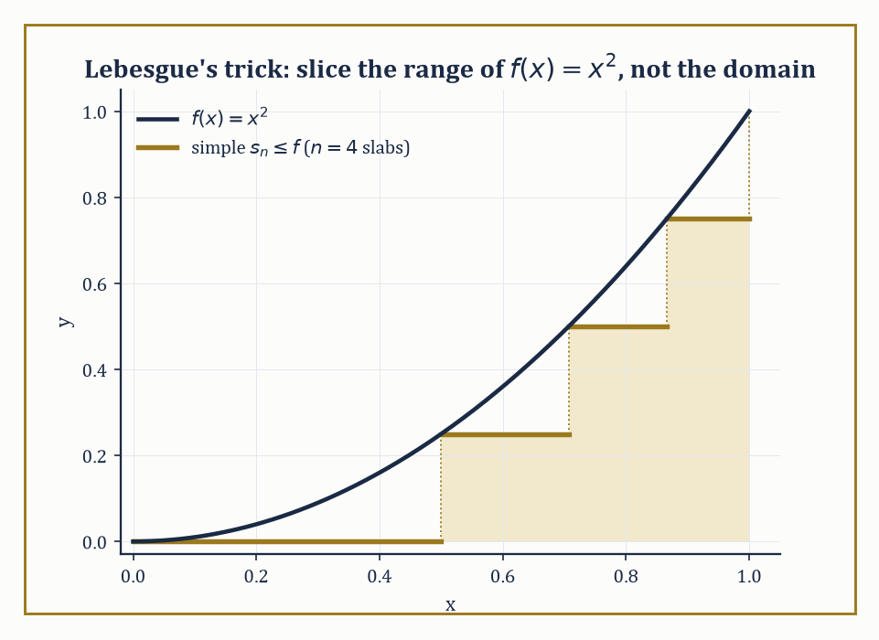
Figure 36.4 — Four horizontal slabs approximate f(x)=x² from below — Lebesgue’s entire innovation rendered as a staircase hugging the curve from underneath, rather than Riemann’s vertical strips.
Begin behind the counter of a shop at closing time, with a till full of coins and the job of finding out how much is in it.
There are two ways to do this, and you have certainly used the second. The first is to go through the day in order: the first customer paid this, the second paid that, the third paid the other, and you add as you go until you reach the end of the day. It works. It is also miserable, and one interruption puts you back at the start.
What anybody actually does is tip the drawer out and sort. All the pound coins into one heap, all the fifties into another, the twenties into a third. Then count each heap once — fourteen pounds, nine fifties, twenty-three twenties — and multiply. You have not added a single transaction. You have grouped by value, counted how much of the day sat at each value, and multiplied.
Both methods reach the same total, and for an ordinary day it hardly matters which you pick. Keep hold of the second one anyway, because it is the whole of this section, and the reason it is worth the detour will not be obvious until the first method fails.
Here is the failure. The chapter on integration taught you to find the area under a curve by chopping the horizontal axis into thin strips and adding up rectangles. That is the first method: go along in order, taking whatever you find. It needs each strip to have a reasonably definite height, and that seems a modest requirement until somebody hands you a quantity that is worth 1 at every fraction and 0 at every other number.
Chop that into strips as thin as you like. Every strip, however thin, contains fractions and also contains numbers that are not fractions — they are interleaved all the way down, and no amount of thinness separates them. So every strip contains both a 1 and a 0, and the tallest rectangle you could fit has height 1 while the shortest has height 0. The two estimates never approach one another. They stay one apart forever, and the method does not deliver a wrong answer so much as fail to deliver any answer at all.
Now try the sorting method on the same object, and watch the difficulty evaporate. How much of the line is worth 1? The fractions. How much of the line is worth 0? Everything else. Two heaps, two counts, done — provided somebody can tell you how much line each heap occupies.
So change the question. Not how much does the quantity come to on each stretch of the axis, but how much of the axis carries each value?
That reads like an easy swap, and there is a bill attached to it. To sort by value you must be able to measure the heaps, and the heaps are whatever they turn out to be — in this case the fractions scattered densely through the line, which is not an interval and not a finite union of intervals and not anything you could point at. Asking how much line the fractions occupy is exactly the question the previous sections were built to answer. The sorting method does not avoid the difficulty; it moves the difficulty into measure theory and demands it be settled first.
That is the trade, and it looks like cheating twice over: the integral is defined in terms of a measure, and the measure took two sections of machinery to construct. What is bought is worth the price, and this section and the next two are the receipt.
Before any notation, do the arithmetic by hand on the smallest case that shows anything. Take a quantity that is worth 2 everywhere from 0 to 1, and worth 5 everywhere from 1 to 3, and nothing anywhere else.
Sort it. There are two values, so there are two heaps. The value 2 is carried by the stretch from 0 to 1, which is 1 wide, contributing 2 times 1. The value 5 is carried by the stretch from 1 to 3, which is 2 wide, contributing 5 times 2.
2 × 1 + 5 × 2 = 2 + 10 = 12
Now check it the other way, by the familiar Riemann method. The picture is two rectangles standing side by side: one 1 wide and 2 tall, of area 2, and one 2 wide and 5 tall, of area 10. Twelve again. For a quantity this well behaved the two methods agree, as they must, and that agreement is not a coincidence to be admired but a requirement — a new definition of area that disagreed with the old one on rectangles would be a new definition of something else.
Notice what the sum never does. It never tells you how to handle a quantity that takes infinitely many values, and almost every quantity worth integrating takes infinitely many. The arithmetic above worked because there were two heaps and the sorting finished. Sort a curve by value and the sorting never finishes, so the number you want has to be approached rather than reached: take every finite-heap quantity that sits entirely below the curve, integrate each by the arithmetic above, and take the least upper bound of the answers. The figure alongside shows this happening with four slabs hugging a curve from underneath, and four is not nearly enough, and that is the point of the picture.
That is the Lebesgue integral: sort the range into heaps, measure how much of the domain sits in each heap, multiply, add, and then take limits from below. The symbol ∫ f dμ carries the same long s for sum you already know, and the dμ has quietly replaced the old dx — where dx assumed that width meant ordinary length, dμ asks the measure, whatever the measure happens to be, and that single substitution is what lets the whole construction run on the fractions and on far stranger sets besides.
The numeric example below works this same two-value quantity, in the same order, and arrives at the same 12.
s(x) = Σᵢ cᵢ · 1_(Aᵢ)(x) (Aᵢ disjoint measurable sets, cᵢ ≥ 0)
define the integral directly as the natural linear combination of measures:
∫s dμ = Σᵢ cᵢ · μ(Aᵢ)
There is no approximation here — this is the definition, chosen because it is the only sensible one (a rectangle of height c standing over a set of measure m should contribute c · m to the total).
Numeric example — integrating a simple function directly. Let s(x) = 2 · 1_([0,1])(x) + 5 · 1_((1,3])(x) on ℝ with Lebesgue measure. This is a simple function taking value 2 on [0,1], value 5 on (1,3], and value 0 elsewhere. By the definition above,
∫s dμ = 2 · μ([0,1]) + 5 · μ((1,3]) = 2 · 1 + 5 · 2 = 2 + 10 = 12
Geometrically this is the sum of the areas of two rectangles — a 1-wide, 2-tall rectangle contributing area 2, and a 2-wide, 5-tall rectangle contributing area 10 — which is precisely what the definition was designed to capture, and matches ordinary geometric intuition exactly.
Try it now — Integrate s = 2·1_[0, 1] + 5·1_(1, 3]. Answer →
Stage two: for an arbitrary non-negative measurable function f, define
∫f dμ = sup { ∫s dμ : s simple, 0 ≤ s ≤ f }
the supremum of the integrals of every simple function lying below f. This is where the “slice the range, not the domain” philosophy pays off: rather than partitioning the x-axis as Riemann does, we partition the y-axis into horizontal strips, ask how much of the domain lands in each strip (a measure question, always well-posed for a measurable function), and sum up height times measure. Because this only ever asks “how big is this set,” never “how does f behave locally,” it survives functions far too wild for Riemann’s vertical strips to handle.
Numeric example — recovering a familiar integral by slicing the range. Take f(x) = x² on [0,1], for which we already know the answer should be 1/3 (What Measure Theory Is). Build a simple function from below using n = 4 equal horizontal slabs, i.e. take the partition of [0,1] into [0, 0.25), [0.25, 0.5), [0.5, 0.75), [0.75, 1], and on each piece use the infimum of x² (which, since x² is increasing on [0,1], is its value at the left endpoint):
infimum values: 0², 0.25², 0.5², 0.75² = 0, 0.0625, 0.25, 0.5625
The resulting simple function’s integral is (length 0.25 on each piece) × (sum of these infima):
0.25 × (0 + 0.0625 + 0.25 + 0.5625) = 0.25 × 0.875 = 0.21875
This lies below the true value 1/3 ≈ 0.3333, as it must (it’s built from an under-approximation). Refining to n = 100 or n = 10000 equal slabs pushes this lower sum arbitrarily close to 1/3; the supremum over all such simple functions is exactly 1/3, matching the Riemann answer, confirming that the two theories agree here as promised.
Stage three: for a general (not necessarily non-negative) measurable function f, split it into its positive and negative parts,
f⁺(x) = max(f(x), 0) and f⁻(x) = max(−f(x), 0)
so that f = f⁺ − f⁻ and both pieces are non-negative and measurable. Define
∫f dμ = ∫f⁺ dμ − ∫f⁻ dμ
and call f integrable when both pieces on the right have finite integral (so that the subtraction is not the meaningless ∞ − ∞).
Numeric example — splitting into positive and negative parts. Let f(x) = x on [−1,1]. Then f⁺(x) = x for x ≥ 0 and 0 for x < 0; f⁻(x) = −x for x ≤ 0 and 0 for x > 0. Compute ∫f⁺:
∫f⁺ = ∫₀¹ x dx = [x²/2]₀¹ = 1/2
Compute ∫f⁻: by the mirror-image computation over [−1,0], this is also 1/2 (∫₀¹ x dx again, after the substitution x → −x). Both pieces are finite, so f is integrable, and
∫f dμ = 1/2 − 1/2 = 0
This matches the direct computation that ordinary calculus would give:
∫₋₁¹ x dx = [x²/2]₋₁¹ = 1/2 − 1/2 = 0
The three-stage machine reduces, on a function this tame, to nothing more exotic than what you already knew.
The Lebesgue integral agrees with the Riemann integral on every function where the latter is defined, but it defines an integral for a great deal more. The Dirichlet function of What Measure Theory Is, which broke the Riemann integral outright, is dispatched instantly: its integral is 0, because the set on which it takes the value 1 (the rationals) has measure zero, and a measurable function that is 0 almost everywhere integrates to 0.
Numeric example — resolving the Dirichlet function at last. Let f(x) = 1_ℚ(x) on [0,1], the indicator function of the rationals. As a simple function (it takes only two values, 1 and 0), its Lebesgue integral is, by the stage-one definition,
∫f dμ = 1 · μ(ℚ ∩ [0,1]) + 0 · μ((ℚ ∩ [0,1])ᶜ)
Since ℚ ∩ [0,1] is countable, it has Lebesgue measure zero (Section 36.3’s worked example on finite and countable sets). So
∫f dμ = 1 · 0 + 0 · 1 = 0
The function that defeated Riemann integration entirely is integrated in one line by Lebesgue’s machinery, and the answer — 0 — is the value intuition demanded back in What Measure Theory Is: the rationals are too thin to contribute anything.
One further subtlety deserves a mention before we move on: absolute integrability (∫|f| dμ < ∞, equivalently both f⁺ and f⁻ having finite integral) is what guarantees that a series of functions can be integrated term by term without the answer depending on the order in which the terms are summed. This mirrors, exactly, a fact about numerical series that most readers will already have met.
Abstract example — why absolute integrability matters. The alternating harmonic series
1 − 1/2 + 1/3 − 1/4 + ... = ln 2
converges, but only conditionally: it is not absolutely convergent, because Σ 1/n diverges. The Riemann rearrangement theorem states that a conditionally convergent series can be rearranged to converge to any target value whatsoever, or even to diverge, purely by reordering its terms — the sum is not an intrinsic property of the collection of terms unless absolute convergence holds. The same phenomenon threatens integration of a series of functions Σ fₙ: without absolute integrability,
∫Σ|fₙ| dμ < ∞
the value of ∫(Σ fₙ) dμ can depend on how the sum is organized or on the order limits are taken, and interchanging Σ and ∫ becomes illegitimate. Absolute integrability is the safety rail; the convergence theorems of the next section are, in large part, precise statements of exactly when that rail is available.
Finally, the integral inherits the good behavior one would expect of any respectable notion of total accumulated size: it is linear,
∫(af + bg) dμ = a∫f dμ + b∫g dμ (for integrable f, g and constants a, b)
it is monotone,
f ≤ g everywhere ⟹ ∫f dμ ≤ ∫g dμ
and it is countably additive over disjoint domains of integration — the integral over a countable disjoint union of measurable sets is the sum of the integrals over each piece, the same countable-additivity backbone that started this whole chapter now showing up one level higher, in the integral itself rather than merely in the measure beneath it.
Numeric example — linearity of the integral confirmed directly. Let f(x) = x and g(x) = 1 on [0,1], and take a = 2, b = 3, so af + bg is the function 2x + 3. Direct computation:
∫₀¹ (2x+3) dx = [x² + 3x]₀¹ = (1+3) − 0 = 4
Via linearity instead:
a∫f dμ + b∫g dμ = 2·∫₀¹ x dx + 3·∫₀¹ 1 dx = 2·(1/2) + 3·(1) = 1 + 3 = 4
Both routes give 4, confirming linearity on this pair. And since 2x+3 ≥ 3 > 0 = the zero function everywhere on [0,1], monotonicity gives
∫(2x+3) dμ ≥ ∫0 dμ = 0
which the computed value of 4 duly satisfies — no surprises, which is rather the point of a theorem like this one.
Keep only this · Section 36.5: The Lebesgue Integral
The idea. The Lebesgue integral is defined for simple functions as Σ value × measure, for nonnegative functions as the supremum over simple functions below, and for signed functions as ∫f⁺ − ∫f⁻. It agrees with the Riemann integral wherever that exists and is linear and monotone.
Core.
∫ Σ aᵢ 1_(Aᵢ) = Σ aᵢ μ(Aᵢ)
∫ f = sup{∫ s : 0 ≤ s ≤ f simple} (f ≥ 0)
∫ f = ∫ f⁺ − ∫ f⁻, integrable iff ∫ |f| < ∞
Typical mistake. Integrating conditionally convergent things. Σ (−1)ⁿ⁺¹/n converges, but as an integral against counting measure it is undefined, because Σ 1/n = ∞.
Minimal example. ∫₀¹ x² dx = 1/3, as before.
Practice. Easy to challenge; full worked answers, with the usual mistake, are in Answers to the Practice Sets at the back.
Easy — Compute ∫f⁺ and ∫f⁻ for f = x on [−1, 1]. Answer →
Medium — Approximate ∫₀¹ x² from below with 4 slabs of height 1/4. Answer →
Challenge — Verify linearity for 2x + 3 on [0, 1]. Answer →

Section 36.6: Convergence Theorems
The Actual Point of the Whole Exercise
Everything in the previous five sections exists in service of this one. The single biggest practical advantage of the Lebesgue integral over the Riemann integral is that it comes with theorems licensing the interchange of limits and integrals, under hypotheses mild enough to be useful constantly, rather than so restrictive as to be a curiosity.
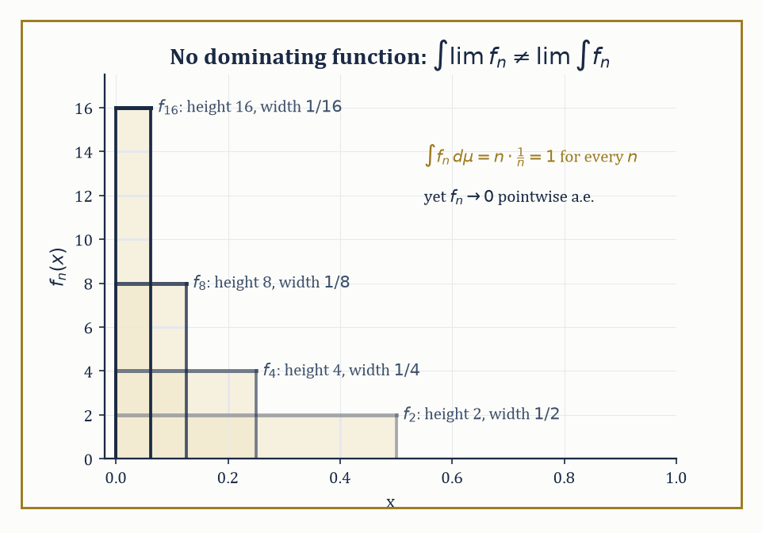
Figure 36.5 — Spikes fₙ = n·1_((0,1/n)) all carry integral exactly 1 while collapsing pointwise to 0 — the standard portrait of a sequence with no integrable function large enough to dominate it.
lim ∫fₙ = ∫lim fₙ
The monotone convergence theorem (MCT) is the first and simplest: if 0 ≤ f₁ ≤ f₂ ≤ f₃ ≤ ... is an increasing sequence of non-negative measurable functions converging pointwise to f, then ∫fₙ dμ → ∫f dμ, even when both sides are infinite.
Numeric example — monotone convergence in action. Let f(x) = x^(−1/2) on (0,1], which blows up near 0 but is still integrable there — a standard improper-Riemann-integral fact.
∫₀¹ x^(−1/2) dx = [2√x]₀¹ = 2
Define fₙ(x) = min(x^(−1/2), n), a truncation that caps the function at height n; each fₙ is bounded and increases pointwise to f as n grows (the cap gets less and less restrictive). The crossover point where x^(−1/2) = n is x = 1/n², so fₙ(x) = n for x ≤ 1/n² and fₙ(x) = x^(−1/2) for x > 1/n². Compute directly:
∫₀¹ fₙ dx = ∫[0, 1/n²] n dx + ∫[1/n², 1] x^(−1/2) dx = n · (1/n²) + [2√x]_(1/n²)¹ = 1/n + (2 − 2 · (1/n)) = 1/n + 2 − 2/n = 2 − 1/n
As n → ∞, 2 − 1/n → 2, precisely matching ∫₀¹ x^(−1/2) dx = 2 computed directly. MCT guarantees this convergence in advance, without needing the explicit closed form at all — a considerable saving of effort for less obliging functions.
Try it now — fₙ = 1_[n, n+1] on ℝ. Find the pointwise limit and lim ∫ fₙ. Answer →
Fatou’s lemma weakens the hypotheses further, dropping the monotonicity requirement entirely, but pays for it by weakening the conclusion from equality to an inequality: for any sequence of non-negative measurable functions fₙ,
∫(liminf fₙ) dμ ≤ liminf ∫fₙ dμ
Mass is allowed to “escape” in the limit — the integral of the limit can be strictly smaller than the limiting behavior of the integrals — but it can never mysteriously appear from nowhere.
Numeric example — Fatou’s lemma with strict inequality (the moving bump). Let fₙ(x) = 1_([n, n+1])(x) on ℝ — a bump of height 1 and width 1, marching off to infinity as n increases. For any fixed x ∈ ℝ, eventually n > x, so fₙ(x) = 0 for all sufficiently large n; hence liminf fₙ(x) = 0 for every single x, and
∫(liminf fₙ) dμ = ∫0 dμ = 0
Meanwhile ∫fₙ dμ = μ([n,n+1]) = 1 for every n, so liminf ∫fₙ dμ = liminf(1) = 1. Fatou’s lemma asserts
0 ≤ 1
which is true but very far from equality — the bump’s mass never vanishes, it just marches off toward infinity where no fixed point of the domain ever sees it again. This is the standard cautionary example for why Fatou gives an inequality, not an equation, and it is worth keeping in your back pocket every time a limit interchange looks suspiciously convenient.
The dominated convergence theorem (DCT) is the workhorse of the three: if fₙ → f pointwise (almost everywhere is enough) and there is a single integrable function g with |fₙ(x)| ≤ g(x) for all n and (almost) all x, then ∫fₙ dμ → ∫f dμ exactly.
The dominating function g is the crucial extra ingredient Fatou’s lemma lacked, and it is what rules out mass escaping to infinity, as it did in the moving-bump example above (no integrable g can dominate a bump of fixed height that keeps sliding rightward forever, since it would have to be at least 1 on all of [n, n+1] for every n, forcing ∫g = ∞).
Numeric example — dominated convergence resolving a limit cleanly. Let fₙ(x) = xⁿ on [0,1] — the same sequence used in Measurable Functions. We already established the pointwise limit: f(x) = 0 for x ∈ [0,1) and f(1) = 1, which equals 0 almost everywhere (the single point x = 1 is a null set).
Take g(x) = 1, the constant function, which is integrable on [0,1] since μ([0,1]) = 1 < ∞; and indeed
|fₙ(x)| = xⁿ ≤ 1 = g(x)
for every x ∈ [0,1] and every n, so the domination hypothesis holds cleanly. DCT then guarantees
∫₀¹ fₙ dx → ∫₀¹ f dx = 0
Checking directly:
∫₀¹ xⁿ dx = 1/(n+1)
and in fact 1/(n+1) → 0 as n → ∞. The theorem’s conclusion and the direct computation agree precisely, as they must.
It is instructive — and, frankly, rather satisfying — to see domination fail and watch the theorem’s conclusion fail right along with it, since this confirms the hypothesis was doing real work rather than sitting there for decoration.
Numeric example — no dominating function, and the limit fails. Let fₙ(x) = n · 1_((0, 1/n))(x) on (0,1) — a spike of height n over a shrinking interval of width 1/n. Compute
∫fₙ dμ = n · μ((0,1/n)) = n · (1/n) = 1
for every single n, a constant sequence of integrals, all equal to 1. Meanwhile, for any fixed x ∈ (0,1), once n exceeds 1/x we have 1/n < x, so fₙ(x) = 0 for all sufficiently large n; hence fₙ → 0 pointwise almost everywhere (everywhere except the single null point x = 0). So ∫fₙ dμ = 1 for every n, but
∫(lim fₙ) dμ = ∫0 dμ = 0
the limits do not interchange,
∫lim fₙ ≠ lim ∫fₙ
What went wrong is precisely the missing dominating function: the pointwise supremum of the fₙ near x behaves roughly like 1/x, which is not integrable near 0 (∫₀¹ (1/x) dx diverges), so no single integrable g can bound every fₙ at once, and DCT’s hypothesis fails rather than merely being inconvenient to check. This family of examples is also the standard illustration of a lack of uniform integrability, the refinement of these ideas that governs convergence in L¹ exactly, via Vitali’s convergence theorem.
Finally, it is worth knowing explicitly that pointwise almost-everywhere convergence, convergence in measure, and convergence in Lᵖ are different notions, related by a network of implications rather than a single equivalence — a fact analysts rely on daily and beginners routinely mix up.
Convergence in measure means fₙ → f in measure whenever, for every ε > 0,
μ({x : |fₙ(x) − f(x)| > ε}) → 0
Abstract example — convergence in measure without pointwise convergence anywhere. Build the “typewriter sequence”: sweep across [0,1) with intervals of width 1/2 (the intervals [0,1/2) and [1/2,1)), then with intervals of width 1/4 (four of them, sweeping left to right), then width 1/8 (eight of them), and so on, letting fₙ be the indicator function of the n-th interval in this ever-refining, ever-restarting sweep.
As n increases through a full sweep at resolution 1/2ᵏ,
∫fₙ dμ = 1/2ᵏ
and since every value of n eventually forces k → ∞,
∫fₙ dμ → 0
so fₙ → 0 both in L¹ and in measure. But fix any single point x ∈ [0,1): at every resolution level k, x falls inside exactly one of the 2ᵏ sweeping intervals, so fₙ(x) = 1 for that one n at level k and 0 for the other 2ᵏ − 1 values of n at that level. As the sweep proceeds through infinitely many levels, fₙ(x) takes the value 1 infinitely often and the value 0 infinitely often, for every single x — so the sequence fₙ(x) does not converge at any point whatsoever, despite converging beautifully in L¹ and in measure.
This is the standard counterexample showing convergence in measure (and in Lᵖ) is strictly weaker than pointwise almost-everywhere convergence — the two notions overlap but neither implies the other outright, and the precise map of which implications do hold (a subsequence of an Lᵖ-convergent sequence always has an almost-everywhere convergent subsequence, for instance) is standard analytic furniture worth memorizing once and for all.
You have seen this before
Uniform convergence, which let limits pass through Riemann integrals in Volume 1, is a special case: on a bounded interval a uniform bound is an integrable dominating function.
Keep only this · Section 36.6: Convergence Theorems
The idea. Three theorems pass limits through integrals: monotone convergence (increasing nonnegative sequences), Fatou’s lemma (an inequality for any nonnegative sequence) and dominated convergence (an integrable bound). Moving bumps and growing spikes show what goes wrong without the hypotheses.
Core.
MCT: 0 ≤ fₙ ↑ f ⇒ ∫ fₙ → ∫ f
Fatou: ∫ lim inf fₙ ≤ lim inf ∫ fₙ
DCT: fₙ → f a.e., |fₙ| ≤ g integrable ⇒ ∫ fₙ → ∫ f
Typical mistake. Applying dominated convergence with a bound that depends on n. The dominating function must be one fixed integrable g.
Minimal example. xⁿ on [0, 1], dominated by 1: ∫ xⁿ = 1/(n + 1) → 0.
Practice. Easy to challenge; full worked answers, with the usual mistake, are in Answers to the Practice Sets at the back.
Easy — Compute ∫₀¹ x^(−1/2) dx by monotone convergence on [1/n, 1]. Answer →
Medium — fₙ = n 1_(0, 1/n) on (0, 1). Find lim ∫ fₙ and ∫ lim fₙ. Answer →
Challenge — Find lim ∫₀¹ n x/(1 + n²x²) dx using a substitution, and say why dominated convergence would be hard to apply. Answer →

Section 36.7: Product Measures and Fubini’s Theorem
Changing the Order of Integration Without Getting Sued
Given two measure spaces (X, Σ[X], μ) and (Y, Σ[Y], ν), the product σ-algebra Σ[X] ⊗ Σ[Y] on X × Y is generated by the measurable rectangles A × B (A ∈ Σ[X], B ∈ Σ[Y]), and there is a unique product measure μ × ν on this σ-algebra characterized by its values on rectangles:
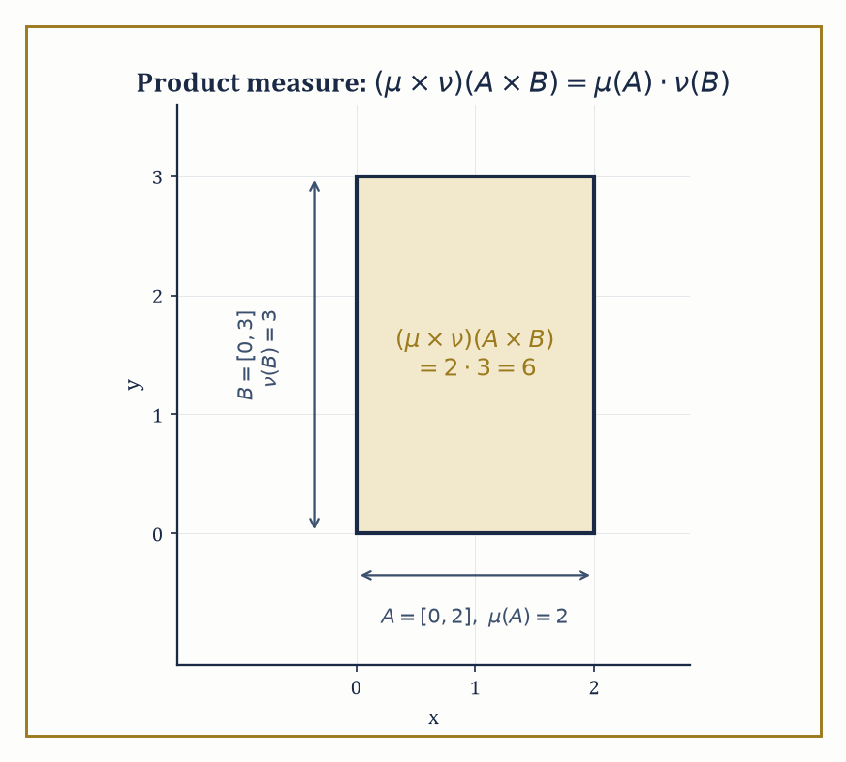
Figure 36.6 — The measurable rectangle [0,2]×[0,3]: product measure turns out to be nothing more mysterious than the ordinary area you already knew how to compute.
(μ × ν)(A × B) = μ(A) · ν(B)
This is the abstract machinery underlying every double integral you have ever computed, and Lebesgue measure on ℝ² is nothing more exotic than the product of Lebesgue measure on ℝ with itself — either a satisfying piece of economy or faintly disappointing, depending on how much you were hoping the plane had been hiding from you.
Numeric example — a product measure recovers ordinary area. Take X = Y = ℝ with Lebesgue measure μ = ν, and consider the rectangle R = [0,2] × [0,3] in the product space. By the defining property of the product measure:
(μ × ν)(R) = μ([0,2]) · ν([0,3]) = 2 · 3 = 6
— the ordinary area computed directly in Outer Measure and Lebesgue Measure. The product-measure construction and the earlier direct construction of Lebesgue measure on ℝ² are not merely consistent; they are, once the dust settles, the identical object, which is a small but reassuring coherence check on the whole theory.
Try it now — Compute ∫₀¹∫₀¹ xy dy dx. Answer →
Fubini’s theorem is the payoff: if f is integrable on the product space (X × Y, μ × ν) — meaning ∫∫|f| d(μ×ν) < ∞ — then the double integral can be computed as an iterated integral in either order, and both orders give the same answer:
∫[X] (∫[Y] f(x,y) dν(y)) dμ(x) = ∫[Y] (∫[X] f(x,y) dμ(x)) dν(y) = ∫∫ f d(μ×ν)
This is the rigorous justification for the “just swap the order of dx and dy” maneuver that every calculus student performs on instinct and very few are ever told requires a hypothesis.
Numeric example — Fubini’s theorem confirmed directly. Let f(x,y) = xy on [0,1] × [0,1], a bounded continuous function on a finite-measure space, hence certainly integrable. Compute one order:
∫₀¹ (∫₀¹ xy dy) dx
The inner integral, treating x as a constant, is:
∫₀¹ xy dy = x · [y²/2]₀¹ = x/2
Then:
∫₀¹ (x/2) dx = (1/2) · [x²/2]₀¹ = (1/2)(1/2) = 1/4
Now the other order:
∫₀¹ (∫₀¹ xy dx) dy
by the exact same computation with the roles of x and y swapped (the integrand is symmetric in x and y), also gives 1/4. Both orders agree, as Fubini’s theorem promises.
Tonelli’s theorem is Fubini’s more permissive sibling: it drops the integrability hypothesis entirely, at the cost of requiring f to be non-negative (rather than only measurable of either sign), and concludes that the iterated integrals are equal — possibly both infinite, but never disagreeing with each other. Tonelli is what you reach for first when you are not yet sure whether f is integrable at all, since checking non-negativity is usually far easier than checking ∫∫|f| < ∞ directly, and once Tonelli confirms the two iterated integrals agree and are finite, integrability follows and Fubini applies to the genuine (possibly signed) function you wanted.
Numeric example — Tonelli with an infinite answer. Let f(x,y) = 1 on the first quadrant [0,∞) × [0,∞), surely non-negative.
Compute one order of the iterated integral; the inner integral ∫[0, ∞] 1 dy diverges to ∞ for every fixed x, so the outer integral is also infinite:
∫[0, ∞] (∫[0, ∞] 1 dy) dx = ∫[0, ∞] ∞ dx = ∞
The other order gives the identical answer, ∞, by the same computation with x and y swapped. Tonelli’s theorem guarantees this agreement in advance — both orders equal ∞ — even though the function is nowhere close to being integrable in the finite sense (∫∫f d(μ×ν) = ∞, so Fubini’s actual hypothesis fails, but Tonelli never needed it to).
That the integrability (or non-negativity) hypothesis is not mere legal throat-clearing is demonstrated by a genuinely famous counter-example, in which the two iterated integrals of a perfectly innocent-looking function disagree outright.
Numeric example — a function where order of integration matters. Let f(x,y) = (x² − y²) / (x² + y²)² on (0,1) × (0,1). One can check, by differentiating, that y/(x²+y²) is an antiderivative of f with respect to y:
∂/∂y [ y/(x² + y²) ] = [(x²+y²) − y·2y] / (x²+y²)² = (x² − y²)/(x²+y²)² = f(x,y)
Hence:
∫₀¹ f(x,y) dy = [y/(x²+y²)]_(y=0)ʸ⁼¹ = 1/(x²+1) − 0 = 1/(1+x²)
Integrating this over x:
∫₀¹ 1/(1+x²) dx = [arctan x]₀¹ = arctan(1) − arctan(0) = π/4 − 0 = π/4
So one iterated integral equals π/4. For the other order, note f is antisymmetric under swapping its arguments:
f(x,y) = −f(y,x)
(swap x and y in the formula and the numerator flips sign while the denominator does not). By the identical computation with the roles relabeled:
∫₀¹ f(x,y) dx = −1/(1+y²)
∫₀¹ (−1/(1+y²)) dy = −π/4
So the two iterated integrals are π/4 and −π/4 — different numbers, not a computational slip. The resolution is that f is not integrable on the whole square in the ∫∫|f| < ∞ sense (the singularity at the origin is too severe once you stop letting positive and negative parts cancel each other), so neither Fubini nor Tonelli’s hypotheses are met, and the theorem does not apply — which is just why a hypothesis was needed in the first place.
Infinite products of measure spaces extend this machinery to countably many factors at once, and are the rigorous foundation for two constructions that show up constantly later in the series: an infinite sequence of independent random variables (each coordinate its own probability space, the entire sequence living on the infinite product) and infinite-dimensional Gaussian measures used in stochastic analysis. The product measure on a countable product is again characterized by its values on “cylinder sets” — sets determined by constraints on only finitely many coordinates at a time.
Numeric example — an infinite product measure for coin flips. Model an infinite sequence of fair coin flips as the product space {0,1}^ℕ, with each factor carrying the Bernoulli(1/2) measure (P(0) = P(1) = 1/2). The product measure assigns to the cylinder set “first three flips equal 1, 0, 1, remaining flips unconstrained” the following probability:
(1/2)(1/2)(1/2) = 1/8
— matching the elementary probability calculation you would do without any measure theory at all. What the product-measure machinery buys you, beyond confirming a calculation you already trusted, is a rigorous single measure defined consistently on the σ-algebra generated by all such cylinder sets — including events depending on infinitely many coordinates at once, such as “the long-run frequency of heads equals 1/2,” which no finite calculation could ever pin down but which the infinite product measure handles without difficulty, and which is the content of the strong law of large numbers waiting later in the series.
Keep only this · Section 36.7: Product Measures and Fubini’s Theorem
The idea. The product measure on X × Y gives rectangles the product of the side measures. Tonelli lets nonnegative functions be integrated in either order; Fubini does the same for integrable ones. Without integrability the iterated integrals can differ.
Core.
(μ × ν)(A × B) = μ(A) ν(B)
Tonelli: f ≥ 0 ⇒ either order
Fubini: ∫|f| < ∞ ⇒ either order
Typical mistake. Swapping the order without checking. For (x² − y²)/(x² + y²)² on the unit square the two iterated integrals are π/4 and −π/4.
Minimal example. [0, 2] × [0, 3]: 2 × 3 = 6.
Practice. Easy to challenge; full worked answers, with the usual mistake, are in Answers to the Practice Sets at the back.
Easy — Compute ∫₀¹∫₀² (x + y) dx dy. Answer →
Medium — For f = (x² − y²)/(x² + y²)², compute ∫₀¹ (∫₀¹ f dy) dx. Answer →
Challenge — Under the coin-flip product measure, find the probability that flips 1, 3 and 7 are all heads. Answer →

Section 36.8: Lᵖ Spaces and the Radon–Nikodym Theorem
In Which the Dinner Guests From the Opening Finally Receive Their Papers
How big is the vector ⟨3, 4⟩? The usual answer is its length, √(3² + 4²) = 5. A taxi driver on a grid of streets would say 3 + 4 = 7 blocks, and someone who cares only about the largest coordinate would say 4. All three are honest measures of size. Each gives 0 only for the zero vector, each doubles when the vector doubles, and each obeys the triangle inequality.
A function is like a vector with a coordinate at every point, and the same three measures have versions for functions, with sums becoming integrals. Take f(x) = x on [0, 1]:
add up the sizes: ∫₀¹ x dx = 1/2
square, add up, take the square root: √(∫₀¹ x² dx) = 1/√3 ≈ 0.577
take the largest value: 1
These are the L¹, L² and L∞ sizes of f, and the first worked example below gets the same three numbers. For any other power p the recipe is the same: raise to the power p, integrate, and take the pth root.
One adjustment is needed, and it comes from Outer Measure and Lebesgue Measure. Change f at a single point, say set f(1/2) = 100. No integral notices, because a single point has measure zero, so the L¹ and L² sizes stay the same. But now ‘f minus the altered f’ is not the zero function, and yet its size is 0, which a measure of size is not allowed to do. The cure is to treat two functions that agree except on a set of measure zero as the same function. For the same reason the ‘largest value’ must ignore null sets, which is why it becomes the essential supremum, still 1 here even after the change.
With that adjustment these sizes are genuine norms, and the spaces of functions on which they are finite are the Lᵖ spaces. The second half of the section asks a different question, about reweighting a measure by a density such as 2x, and that is where the Radon–Nikodym theorem comes in.
The space Lᵖ(X, μ), for 1 ≤ p < ∞, consists of all measurable functions f with
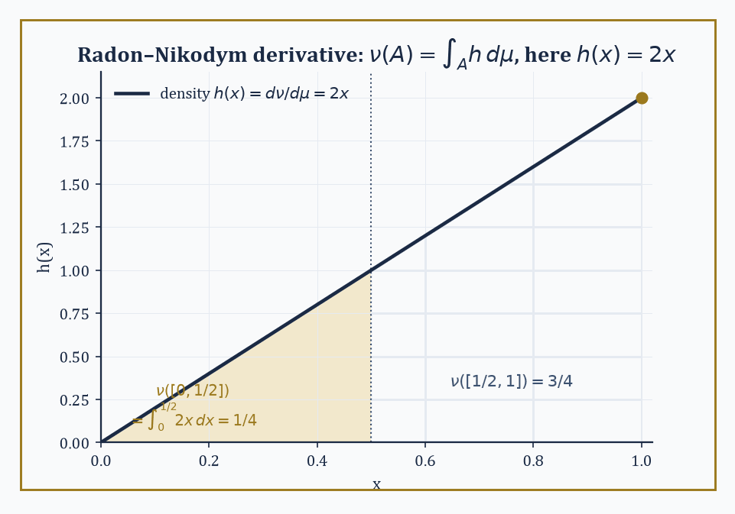
Figure 36.7 — The density h(x)=2x weights the upper half of [0,1] three times as heavily as the lower half — ν([0,½])=¼ against ν([½,1])=¾, read straight off the areas under the line.
∫|f|ᵖ dμ < ∞
(strictly, equivalence classes of such functions under “equal almost everywhere,” which is where Section 36.3’s philosophy of ignoring null sets finally becomes load-bearing rather than merely reassuring), equipped with the following norm:
‖f‖ₚ = (∫|f|ᵖ dμ)^(1/p)
Under this norm, Lᵖ is a Banach space — complete, meaning every Cauchy sequence of functions actually converges to a function still in the space, a fact whose proof leans directly on the monotone and dominated convergence theorems of Convergence Theorems.
When p = 2, the norm comes from an inner product,
⟨f,g⟩ = ∫fg dμ
and L² is a Hilbert space — the exact object that anchored so much of the previous chapter’s discussion of orthogonality and projection, now finally built from first principles rather than taken on trust.
Numeric example — three norms of the same function. Let f(x) = x on [0,1] with Lebesgue measure.
Compute ‖f‖₁:
‖f‖₁ = ∫₀¹ |x| dx = ∫₀¹ x dx = 1/2
Compute ‖f‖₂:
‖f‖₂ = (∫₀¹ x² dx)^(1/2) = (1/3)^(1/2) = 1/√3 ≈ 0.577
Compute ‖f‖∞ (the essential supremum, Section 36.4’s definition):
{x : |f(x)| > M} = (M, 1] for 0 ≤ M < 1
which has positive measure 1 − M whenever M < 1, and is empty (measure zero) once M ≥ 1; so
ess sup |f| = 1
Three different numbers — 0.5, 0.577, and 1 — from the same function, illustrating concretely that the Lᵖ norms measure different things (L¹ weights every value equally by its “mass,” L² penalizes large values more heavily via the square, L∞ cares only about the worst almost-everywhere behavior) and are not only notational variants of one idea.
Try it now — Find ‖x‖₁, ‖x‖₂ and ‖x‖_∞ on [0, 1]. Answer →
Hölder’s inequality states that
∫|fg| dμ ≤ ‖f‖ₚ · ‖g‖_q whenever 1/p + 1/q = 1
(p and q are called conjugate exponents) — this is the fundamental estimate relating a product of functions to the separate norms of the factors, and it specializes at p = q = 2 to the Cauchy–Schwarz inequality familiar from Hilbert space theory.
Minkowski’s inequality states that
‖f + g‖ₚ ≤ ‖f‖ₚ + ‖g‖ₚ
This is the triangle inequality for the Lᵖ norm, and is in fact what makes ‖·‖ₚ a genuine norm in the first place rather than merely a suggestively-named quantity.
Numeric example — checking Hölder and Minkowski on a concrete pair. Let f(x) = x and g(x) = 1 on [0,1], and take p = q = 2 (self-conjugate: 1/2 + 1/2 = 1).
For Hölder’s inequality, compute:
∫₀¹ |f g| dx = ∫₀¹ x dx = 1/2
Meanwhile:
‖f‖₂ · ‖g‖₂ = (1/√3) · (∫₀¹ 1² dx)^(1/2) = (1/√3) · 1 = 1/√3 ≈ 0.577
Indeed 0.5 ≤ 0.577, confirming Hölder’s inequality on this pair (not an equality here, since equality in Hölder requires f and g to be proportional, which x and 1 are not).
For Minkowski’s inequality, compute:
‖f + g‖₂ = (∫₀¹ (x+1)² dx)^(1/2)
Expand:
∫₀¹ (x² + 2x + 1) dx = 1/3 + 1 + 1 = 1/3 + 2 = 7/3
‖f+g‖₂ = (7/3)^(1/2) ≈ 1.528
And:
‖f‖₂ + ‖g‖₂ = 1/√3 + 1 ≈ 0.577 + 1 = 1.577
Indeed 1.528 ≤ 1.577, confirming Minkowski’s inequality holds strictly (not with equality, since equality in Minkowski at p = 2 requires f and g to be non-negative scalar multiples of one another).
For 1 ≤ p < ∞, the dual space (Lᵖ)* — the space of continuous linear functionals on Lᵖ — is identified with L^q, where q is the conjugate exponent of p; every continuous linear functional on Lᵖ takes the form
f ↦ ∫fg dμ
for a unique g ∈ L^q, and ‖g‖_q equals the operator norm of the functional it represents. This is the precise, constructive answer to the question the previous chapter left dangling: what does the dual of an Lᵖ space look like?
Numeric example — an explicit dual pairing. On L²[0,1] (self-dual, since q = 2 when p = 2), consider the linear functional
φ(f) = ∫₀¹ f(x) dx
This is represented, in the sense above, by g(x) = 1 (the constant function), since
φ(f) = ∫₀¹ f · 1 dx
matches the general form exactly. Compute:
‖g‖₂ = (∫₀¹ 1² dx)^(1/2) = 1
By Cauchy–Schwarz (Hölder at p=q=2),
|φ(f)| = |∫f·1| ≤ ‖f‖₂ ‖1‖₂ = ‖f‖₂
so the operator norm of φ is at most 1; and taking f = 1 itself gives
φ(1) = 1 = ‖1‖₂
so the bound is achieved and the operator norm equals exactly 1 — matching ‖g‖₂ = 1 precisely, as the duality theorem promises.
The Radon–Nikodym theorem addresses a different but related question: given two measures μ and ν on the same measurable space, when can ν be written as an integral against μ,
ν(A) = ∫[A] h dμ
for some non-negative measurable function h? The answer is: precisely when ν is absolutely continuous with respect to μ (written ν ≪ μ, meaning μ(A) = 0 forces ν(A) = 0 for every measurable A) and μ is σ-finite.
The function h, when it exists, is unique up to a set of μ-measure zero, and is called the Radon–Nikodym derivative, written dν/dμ. This is the abstract, measure-theoretic form of the fundamental theorem of calculus — a “density” recovering a whole measure from a single function — and it is the theorem that produces conditional expectations in probability theory.
Numeric example — a density and its Radon–Nikodym derivative. Let μ be Lebesgue measure on [0,1], and define ν(A) = ∫[A] 2x dx for every measurable A ⊆ [0,1], i.e. ν is built directly from the density h(x) = 2x.
First check ν is itself a genuine probability measure:
ν([0,1]) = ∫₀¹ 2x dx = [x²]₀¹ = 1
so total mass is exactly 1. Compute a specific value:
ν([0, 1/2]) = ∫[0, 1/2] 2x dx = [x²]₀^(0.5) = 0.25
so under ν, the “probability” of landing in the lower half of [0,1] is only 1/4, not 1/2, reflecting that the density h(x) = 2x weights larger x-values more heavily.
By construction, ν ≪ μ (any set of Lebesgue measure zero contributes zero to ∫[A] 2x dx as well, since the integral of any bounded function over a null set is zero), and the Radon–Nikodym derivative is, transparently,
dν/dμ = 2x
— the very function we started with. This example runs the theorem in the easy, constructive direction (building ν from a chosen h); the substance of the actual theorem is the harder converse direction, guaranteeing that whenever ν ≪ μ holds abstractly, some such h is guaranteed to exist, even when no explicit formula for it is available in advance.
Not every measure is absolutely continuous with respect to another — some measures are concentrated entirely on a set the reference measure considers negligible, a phenomenon called mutual singularity.
The Lebesgue decomposition theorem says that any (σ-finite) measure ν splits uniquely into an absolutely continuous part and a singular part relative to a given reference measure μ:
ν = ν_ac + ν_sing, with ν_ac ≪ μ and ν_sing concentrated on some μ-null set
Abstract example — decomposing a measure with an atom. Let μ be Lebesgue measure on ℝ, and let ν = δ₀ + (Lebesgue measure restricted to [0,1]), where δ₀ is the Dirac point mass at the origin, defined by δ₀(A) = 1 if 0 ∈ A and δ₀(A) = 0 otherwise.
The second summand, Lebesgue measure restricted to [0,1], is absolutely continuous with respect to μ, with density h(x) = 1_([0,1])(x) — this is the ν_ac piece.
The first summand, δ₀, is concentrated altogether on the single point {0}, and μ({0}) = 0 (a point is a null set, Outer Measure and Lebesgue Measure again), so δ₀ is supported on a μ-null set while giving that set full mass — the textbook definition of singularity with respect to μ.
So the Lebesgue decomposition of ν with respect to μ is precisely:
ν_ac = Lebesgue measure on [0,1] (density 1_([0,1])), ν_sing = δ₀
and no other decomposition into an absolutely continuous piece and a singular piece is possible, by the uniqueness clause of the theorem. Point masses, and their more exotic cousins like measures concentrated on Cantor-set-like fractals, are the standard source of singular parts throughout analysis and probability alike.
We have now acquired the core machinery: σ-algebras and measures, outer measure and Carathéodory’s extension, Lebesgue measure itself, measurable functions, the Lebesgue integral built in three careful stages, the convergence theorems that are the entire point of the enterprise, product measures and Fubini’s theorem, and finally Lᵖ spaces and the Radon–Nikodym theorem — at which point those well-bred dinner guests from the opening pages received their birth certificates in full.
The tools built here open directly onto several of the series’ remaining sections, further than we will go today. Probability theory is measure theory with total mass normalized to 1, plus the extra structure of independence, conditional expectation (which the Radon–Nikodym theorem produces essentially for free), and martingales. The theory of distributions generalizes measures and their densities into objects that can be differentiated arbitrarily many times, however wild the original measure.
Geometric measure theory extends the whole apparatus to Hausdorff measures of fractional dimension, currents, and sets of finite perimeter — measuring things that are not quite curves and not quite regions but something usefully in between. Ergodic theory studies transformations that preserve a measure, watching what a system does to itself over infinite time. And the spectral theory of operators on Lᵖ spaces, together with Fourier analysis on groups, both lean on the integration theory built in this chapter to make sense of infinite-dimensional linear algebra in the first place.
The deeper lesson, if this chapter has one, is that once sets can be measured and functions can be integrated with respect to that measurement, the whole of analysis acquires a flexibility the Riemann integral never had the infrastructure to provide. Pointwise statements give way to almost-everywhere statements; limits pass under integral signs on demand, given the right hypothesis; order of integration stops being sacred and becomes negotiable, given the right hypothesis; and a measure can be pulled apart into a density-bearing piece and a singular piece, given the right hypothesis. Nearly everything, it turns out, is “given the right hypothesis” — which is either the most honest sentence in this entire chapter or the closest thing analysis has to a motto, and possibly both at once.
Ahead lies a rather different sort of section. The next chapter sets aside limits, infinity, and null sets almost entirely and turns to Abstract Algebra: groups, rings, fields, the clean finite combinatorics of symmetry and structure, built without a single ε or δ in sight. After a chapter spent making peace with the infinite and the negligible, there is something almost restful about a subject where every statement is exactly true, with no “almost” attached to it — though give it a few chapters, and even algebra will find its own version of infinity to worry about. The series continues. We have learned to integrate almost everywhere.
Keep only this · Section 36.8: Lᵖ Spaces and the Radon–Nikodym Theorem
The idea. Lᵖ consists of functions with ∫ |f|ᵖ < ∞, identified a.e. Hölder and Minkowski make ‖·‖_p a norm, Riesz–Fischer makes Lᵖ complete, and the dual of Lᵖ is L^q. Radon–Nikodym says a measure absolutely continuous with respect to μ has a density dν/dμ.
Core.
Hölder: ∫ |fg| ≤ ‖f‖_p ‖g‖_q, 1/p + 1/q = 1
Minkowski: ‖f + g‖_p ≤ ‖f‖_p + ‖g‖_p
ν ≪ μ ⇒ ν(A) = ∫_A (dν/dμ) dμ
Typical mistake. Expecting a density when ν is not absolutely continuous. A point mass at 0 has no density with respect to Lebesgue measure.
Minimal example. ν(A) = ∫_A 2x dx: dν/dμ = 2x.
Practice. Easy to challenge; full worked answers, with the usual mistake, are in Answers to the Practice Sets at the back.
Easy — Check Hölder with f = x, g = 1, p = q = 2 on [0, 1]. Answer →
Medium — For ν with density 2x, find ν([0, 1/2]). Answer →
Challenge — Decompose ν = δ₀ + Lebesgue on [0, 1] with respect to Lebesgue measure μ. Answer →

Section 36.9: Looking Ahead: From Measure to Algebra, and Back to Probability
Where the Measuring Stops, and What It Was For
Stocktaking, before the subject changes. This chapter built a theory of size that survives sets too wild for length, area, and volume as school drew them. What Measure Theory Is said what the theory is for. Algebras, σ-Algebras, and Measures named the collections a measure is allowed to see, the σ-algebras, and the countable additivity that makes a countable union of null sets null. Outer Measure and Lebesgue Measure constructed Lebesgue measure from an outer measure. Measurable Functions said which functions are measurable. The Lebesgue Integral built the integral by partitioning the range. Convergence Theorems gave the convergence theorems that let a limit pass inside the integral when the hypotheses hold, and that refuse the exchange when they do not. Product Measures and Fubini’s Theorem gave product measures and Fubini’s theorem, so an integral over a rectangle can be done one variable at a time. Lᵖ Spaces and the Radon–Nikodym Theorem put the integrable functions into the spaces Lᵖ, and gave the Radon–Nikodym theorem: when one measure is absolutely continuous with respect to another, it is integration against a density.
The next chapter does not spend this machinery. Chapter 37 sets the measuring down and asks a different question: what an operation is, once the numbers have been washed off. Groups, rings, and fields are that question. The measure built here waits, and it is not wasted. Chapter 42 (Volume 4), and the sharper chapter after it, Chapter 43 (Volume 4), take probability to be measure theory with total mass one. The σ-algebra, the null sets, the integral, and the Radon–Nikodym derivative return there as expectation, almost-sure statements, and densities. Those chapters will not ask the reader to rebuild Lebesgue measure from the outside. They will ask the reader to still have it.
The series continues by changing the subject on purpose. The next chapter is abstract algebra. The sets measured on this chapter become, for a while, the places where operations live.
Try it now — A random variable X is uniform on [0, 2]. Find E[X] as an integral. Answer →
Where this returns
Probability built on these foundations, stochastic processes and ergodic theory return in Volume 4.
Keep only this · Section 36.9: Looking Ahead: From Measure to Algebra, and Back to Probability
The idea. Measure theory is the language of modern probability: random variables are measurable functions, expectation is integration, and the convergence theorems become laws of large numbers and limit theorems. It also prepares abstract algebra by showing structure — σ-algebras, Lᵖ spaces — defined by closure properties.
Core.
P(A) = μ(A), E[X] = ∫ X dP
variance: E[X²] − E[X]²
Typical mistake. Equating ‘probability zero’ with ‘impossible’. A uniform variable takes each single value with probability zero.
Minimal example. Uniform on [0, 1]: P(X ≤ t) = t.
Practice. Easy to challenge; full worked answers, with the usual mistake, are in Answers to the Practice Sets at the back.
Easy — Find the variance of X uniform on [0, 2]. Answer →
Medium — Find P(X ∈ ℚ) for X uniform on [0, 1]. Answer →
Challenge — Xₙ are independent coin flips (1 for heads). What does the strong law of large numbers say about (X₁ + … + Xₙ)/n, in measure-theoretic terms? Answer →
Chapter 36 recap · Measure Theory
• A measure assigns sizes to the sets of a σ-algebra and adds over countable disjoint unions.
• Lebesgue measure extends length; countable sets and the Cantor set have measure zero, and the Vitali set is not measurable.
• The Lebesgue integral slices the range instead of the domain and agrees with Riemann’s wherever Riemann’s exists.
• Monotone and dominated convergence let limits pass through integrals; moving bumps and spikes show why the hypotheses matter.
• Fubini and Tonelli swap the order of integration under integrability or nonnegativity.
• Lᵖ spaces are complete (Riesz–Fischer), and a measure absolutely continuous with respect to another has a density.

Check Your Understanding — Chapter 36
Answers are in the Answer Key at the back of the book — have a go before you look.
1. [Explain] Why does the Riemann integral fail to exist for the Dirichlet function (1 on the rationals, 0 on the irrationals, restricted to [0,1]), and what value does the Lebesgue integral assign instead?
See the answer →
2. [Explain] The Cantor set is uncountable, yet it has Lebesgue measure zero. Explain why these two facts don’t contradict each other.
See the answer →
3. [Compute] Use the dominated convergence theorem to justify that lim[n→∞] ∫₀¹ xⁿ dx = 0, and check the answer directly.
See the answer →
4. [Explain] Fubini’s theorem lets you swap the order of a double integral, but only under a hypothesis. Using the function f(x,y) = (x²−y²)/(x²+y²)² on (0,1)×(0,1), explain what goes wrong when that hypothesis fails.
See the answer →
5. [Compute] Show the Cantor set has Lebesgue measure zero, and reconcile that with its being uncountable.
See the answer →
6. [Compute] Evaluate ∫₀¹ 1_ℚ dx as a Lebesgue integral, and explain why the Riemann integral does not exist.
See the answer →
7. [Compute] Let fₙ(x) = n·1_((0,1/n))(x) on [0, 1]. Compute lim ∫fₙ and ∫lim fₙ, and identify which hypothesis fails.
See the answer →
8. [Compute] Use Fubini–Tonelli to evaluate ∫[0, ∞]∫[0, ∞] e⁻ˣʸsin x dy dx, stating which theorem licenses the exchange.
See the answer →
9. [Explain] Why does Lebesgue integrate so many more functions than Riemann, given both are limits of approximating sums?
See the answer →
10. [Explain] Why restrict to a σ-algebra rather than defining measure on all subsets?
See the answer →
11. [Concept] Measure theory declares functions equal if they agree almost everywhere. What is gained, and what is quietly given up?
See the answer →
12. [Prove] Prove Fatou’s lemma: ∫lim inf fₙ ≤ lim inf ∫fₙ for non-negative measurable fₙ.
See the answer →
13. [Prove] Prove the monotone convergence theorem.
See the answer →
14. [Prove] Prove that Lebesgue measure is translation invariant, and explain why that is not automatic.
See the answer →
15. [Prove] Prove that Lᵖ is complete for 1 ≤ p < ∞ (Riesz–Fischer).
See the answer →
16. [Prove] Prove the Radon–Nikodym theorem in outline, stating the hypotheses precisely.
See the answer →
17. [Prove] Prove that a countable union of null sets is null, and that this is exactly what countable additivity buys.
See the answer →
18. [Challenge] Probability theory is measure theory with total mass one. Is that a reformulation or does it change the subject?
See the answer →
19. [Challenge] The Banach–Tarski paradox decomposes a ball into finitely many pieces that reassemble into two balls. What does it actually prove?
See the answer →
20. [Challenge] Almost-everywhere convergence, convergence in measure, and Lᵖ convergence are all different. Why does analysis need so many notions of limit?
See the answer →
21. [Challenge] Fubini’s theorem needs a hypothesis, and the standard counterexample is often dismissed as artificial. Why should one take it seriously?
See the answer →
22. [Challenge] The Lebesgue integral is built by partitioning the range rather than the domain. Why is that the more powerful idea?
See the answer →
23. [Challenge] This chapter rescues functions that broke earlier theories. Is measure theory best seen as a repair, or as something more?
See the answer →

Problems — Chapter 36
The questions above test whether the ideas landed. These ask you to use them. Solutions are in Solutions to the Problems at the back. Work them before you look.
1. [Compute] Compute the Lebesgue integral over [0, 1] of the function that is 1 on [0, 1/2] and 0 elsewhere.
2. [Compute] Let fₙ be the indicator of [0, 1 − 1/n]. Find ∫ fₙ and the integral of the pointwise limit.
3. [Concept] The rational numbers in [0, 1] are countable and the irrational numbers there are not. Compare their Lebesgue measures.
4. [Concept] Fubini allows the two orders of a double integral to be swapped. Name the hypothesis that fails for a classic counterexample, in one sentence, without computing the integral.

Math, Actually

Chapter 37

Abstract Algebra
Groups, Rings, Fields, and the Art of Structure for Its Own Sake
The last chapter spent its entire budget teaching you to measure sets so unruly that length, area, and volume needed to be reinvented from first principles just to survive contact with them; we built σ-algebras, we built countable additivity, we built an entire integral robust enough to survive functions with no right to be integrated at all. It was hard-won machinery, earned the slow way, one epsilon at a time. This chapter asks you to set all of it down for a while and do something that feels, at first, suspiciously like a step backward: we are going to stop measuring things and start asking what an operation is.
Elementary algebra — the algebra of school, of solving for x — manipulates numbers according to rules everybody already half-knows by feel: addition is commutative, multiplication distributes over addition, every equation wants to be solved. Abstract algebra takes those rules, strips away the numbers they were originally attached to, and studies the rules themselves as objects of interest in their own right. It is, on first encounter, the moment many students report that mathematics has stopped being ‘about things’ and started being ‘about symbols’ — a complaint this narrator remembers filing personally, at approximately nineteen, in a cold lecture theater, before it turned out to be entirely wrong.
The feeling passes, and here is why: the symbols are names for symmetries, for number systems, for the transformations that recur, disguised, throughout the rest of mathematics. A group is not an abstraction floating free of content — it is what the rotations of a square, the arithmetic of a clock, and the shuffles of a deck of cards all have secretly in common, once you stop looking at what they are and start looking at how they behave. This chapter builds the vocabulary — groups, rings, fields, modules, extensions, and the beginnings of Galois theory — keeping a concrete example within arm’s reach at every step, because an abstraction with no example nearby is just a rumor.
Let’s abstract.
Why this abstraction exists
Topology kept only nearness and Measure Theory kept only size. This chapter keeps only operations. Watch, as you read, for four questions the chapter answers case by case but never asks out loud: what does a homomorphism preserve; why do quotients appear for groups, rings and modules alike; why do the same theorems — isomorphism theorems, kernels, products — recur in every setting; and why the maps between structures often say more than the elements do.
Before you begin — Chapter 37
By the end of this chapter you will be able to:
1. Recognize the same structure in different systems, and say what an isomorphism preserves.
2. Work with groups, subgroups, homomorphisms and Lagrange’s theorem.
3. Use group actions, the orbit–stabilizer theorem, cosets and quotient groups.
4. Work with rings, ideals and quotient rings, and factor in integral domains.
5. Classify finite abelian groups and read modules as generalized vector spaces.
6. Compute degrees of field extensions and small Galois groups.
Prerequisites. Modular arithmetic and permutations from Volume 1; vector spaces, matrices and eigenvalues from Linear Algebra (Volume 2); the structures met in Topology and Measure Theory.
Estimated study time. About 12 hours, exercises included.

Section 37.1: What Abstract Algebra Is
In Which We Stop Caring What the Symbols Stand For
Nine o’clock plus five hours is two o’clock, and a square tile turned four quarter turns is back where it began. Those two facts have nothing to do with one another. One is about time and the other about a piece of cardboard, and yet both count round and start again, by the same table. This chapter is about what such things share once you stop asking what they are made of. An algebraic structure is a set with one or more operations — rules for combining elements to produce new elements — required to obey a short list of axioms: rules about how the operation must behave, never about what the elements themselves are. That is the entire trick of the subject, and it is worth sitting with before we race off into groups and rings.
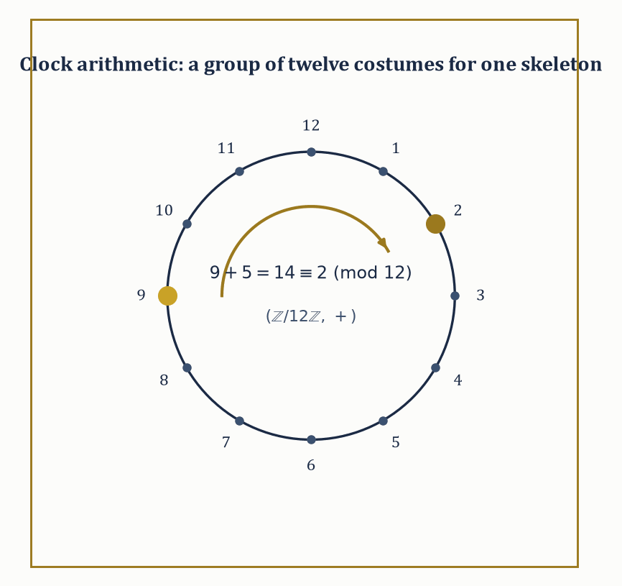
Figure 37.1 — Nine o’clock plus five hours is two o’clock — the same three-line checklist that governs the integers, wearing a wristwatch.
Begin with something you already do without thinking. Ask what time it will be five hours after nine o’clock and you answer two, without hesitation and without feeling that anything strange has happened. Fourteen o’clock never crosses your mind.
Now take something with no clock in it at all. Put a square tile on the table and give it a quarter turn. Give it another. Two more and the tile sits exactly as it started — four turns, and you have gone nowhere. Nobody had to teach you that either.
Two unrelated things: hours on a dial, and a tile on a table. One is time, the other is a shape. Both of them count round and start again.
So ask the question that neither one answers on its own. Not what nine plus five comes to, but why these two behave the same way.
Here is the difficulty, and it is worth feeling properly before we get rid of it. Everything you would normally reach for to compare two things has deserted you. You cannot say the tile is larger than three o’clock. You cannot add a quarter turn to a Tuesday. There is no quantity here to measure, no size and no value — nothing the two share except the pattern of how they combine.
The way round it looks like giving up. Throw away what the things are, and keep only the table of what happens when you combine them.
Count the quarter turns you have made altogether, and set them beside a four-hour clock:
turns 0+1 = 1 1+1 = 2 2+1 = 3 3+1 = 0
4-clock 0+1 = 1 1+1 = 2 2+1 = 3 3+1 = 0
The two rows are not similar. They are the same row. Anything true of one is true of the other, and you never needed to know that one was made of time and the other of cardboard.
Notice what the table never tells you: it never says what the objects are. Ask it whether 3 means three quarter turns or three o’clock and it has no opinion, because that was thrown away on purpose. The discarding is the subject itself, not a shortcut taken to save room.
That is a group, and nothing more alarming is going on. It is a set of things, a rule for combining two of them, and a short list of promises the rule keeps. The tile and the clock are the same group in different clothes.
Groups and Homomorphisms does this properly, and reaches the same four-element table again — written there as ℤ/4ℤ, which is only a name for what you have already checked by hand.
Elementary algebra asks: what is x, given that
2x + 3 = 7
Abstract algebra asks a different, stranger question: forget what x is — what can we say about any system in which an operation like ’+’ exists and behaves the way addition behaves? The moment you stop asking about the elements and start asking about the operation, you have crossed into abstract algebra, and there is, alas, no crossing back to innocence.
Abstract example — Two systems, one skeleton. Consider two sets side by side: the integers ℤ = {…,−2,−1,0,1,2,…} under addition, and the set ℕ = {0,1,2,3,…} under addition.
Both have an operation that is associative in either set,
(a+b)+c = a+(b+c)
and both have an identity element, 0,
a+0 = a
But only ℤ has inverses: for every a ∈ ℤ there is -a ∈ ℤ with
a+(−a) = 0
so that 5 has a partner −5 undoing it. In ℕ, 5 has no partner at all — there is no natural number n with
5+n = 0
So (ℤ,+) satisfies all the axioms we are about to call a ‘group’, while (ℕ,+) fails on inverses alone and is merely what algebraists call a monoid. Nothing about the elements changed between the two examples — 0,1,2,3,… sit inside both sets — what changed is which operation-axioms the whole package satisfies. That is the entire content of the definition of a group, stated in advance: it is a checklist, and ℕ fails item three.
Try it now — Do (ℤ/2ℤ, +) and ({1, −1}, ×) have the same structure? Answer →
The point of isolating these axioms is that wildly different concrete objects can satisfy the same checklist, and any theorem proved from the checklist alone — using nothing but ‘associative, identity, inverses’ — then applies to all of them simultaneously, without having to be reproved each time in a new costume. This is not a minor convenience; it is the entire reason the subject exists. A theorem about ‘groups’ is a theorem about integer addition, about the symmetries of a square, about the arithmetic of a twelve-hour clock, and about the shuffles of a deck of cards, all at once, because all four are secretly instances of the same three-line definition.
Abstract example — Same axioms, different costumes. The symmetries of a square — the eight ways to pick the square up and put it back down so it still looks like a square (four rotations by 0°, 90°, 180°, 270°, and four reflections) — form a group of eight elements under ‘do one symmetry, then another’.
The hours on a clock face, {0,1,2,…,11}, form a group of twelve elements under addition-then-wraparound — 9 o’clock plus 5 hours is 2 o’clock:
9+5 = 14 ≡ 2 mod 12
These two groups have nothing whatsoever to do with each other as objects — one is geometric, one is arithmetic, and they don’t even have the same number of elements (8 versus 12). Yet Lagrange’s theorem, which we meet properly in Groups and Homomorphisms, applies word-for-word to both, because both satisfy the group axioms. This is what it means to say abstract algebra studies the operation rather than the objects: the theorem doesn’t know or care whether it’s talking about a square or a clock.
Once a class of structures is defined, the natural next question is: when are two of them ‘the same’? Not identical as sets — that’s usually too strong to be useful — but the same in every way the operation can detect.
A map that preserves the operation is called a homomorphism; one that is also a perfect one-to-one correspondence is an isomorphism, and structures related by an isomorphism are, for every algebraic purpose, indistinguishable. Homomorphisms, isomorphisms, subobjects (substructures sitting inside a bigger one), and quotient objects (structures built by deliberately forgetting some distinctions) are the four nouns in which the rest of this chapter is written; get comfortable with them now, because they will not be explained again from scratch.
Numeric example — Spotting a disguise. Take (ℤ/2ℤ, +), the set {0,1} with addition mod 2 (so 1+1=0), and take ({1,−1}, ×), the two square roots of 1 under ordinary multiplication. These look like different objects — one is ‘clock arithmetic with two hours’, the other is ‘signs under multiplication’ — but map 0 to 1 and 1 to −1:
0 ↦ 1, 1 ↦ −1
Check that this preserves the operation. First, 0+0=0 should correspond to 1×1=1:
0+0=0 and 1×1=1
Indeed 0↦1 and 1↦1, so it checks out. Next, 1+1=0 should correspond to (−1)×(−1)=1:
1+1=0 and (−1)×(−1)=1
This checks out too, since 0↦1 on both sides. Finally, 0+1=1 should correspond to 1×(−1)=−1:
0+1=1 and 1×(−1)=−1
This also checks out, since 1↦−1. Every sum on the left matches a product on the right under this dictionary, and the map is a bijection (two elements to two elements, none missed, none doubled), so it is an isomorphism. Algebraically, ‘clock arithmetic mod 2’ and ‘multiplying signs’ are the same group wearing two different hats.
Abstract algebra is therefore two subjects wearing one name: a pure subject with its own internal architecture and aesthetic — some of the deepest and strangest theorems in all of mathematics live here — and simultaneously the load-bearing structural language underneath geometry, number theory, and a fair portion of theoretical physics. We spend this chapter building the checklist items in order of increasing richness: groups (one operation), rings (two operations), fields (two operations, one of them invertible), and beyond.
Keep only this · Section 37.1: What Abstract Algebra Is
The idea. Abstract algebra studies operations through their axioms rather than through particular numbers. Systems that look different — rotations of a square, residues, permutations — can share one skeleton, and a theorem proved for the skeleton holds for all of them at once.
Core.
group: associative, identity, inverses
isomorphism: a bijection that preserves the operation
Typical mistake. Judging structure by the names of the elements. ℤ/4ℤ and the rotations of a square are the same group under different labels.
Minimal example. ℤ under + is a group; ℕ under + is not: 1 has no inverse.
Practice. Easy to challenge; full worked answers, with the usual mistake, are in Answers to the Practice Sets at the back.
Easy — Is (ℤ, ×) a group? Answer →
Medium — Match the rotations of a square with ℤ/4ℤ. Answer →
Challenge — Can ℤ/4ℤ be isomorphic to ℤ/2ℤ × ℤ/2ℤ? Answer →

Section 37.2: Groups and Homomorphisms
Addition, Symmetry, and Rubik’s Cube, Unified by Spite
What Abstract Algebra Is left you with a four-element table, built twice over: once from the quarter turns of a square tile and once from a four-hour clock. That table is the group written ℤ/4ℤ — the whole numbers 0, 1, 2, 3 added with wrap-around — and everything in this section is that table, stated so it covers every other case as well.
Whatever you do to a Rubik’s cube, three things stay true. Doing nothing is an option. Any two twists performed one after the other amount to some single rearrangement. And anything you do can be undone. Those same three facts hold for turning a tile, for adding whole numbers, and for the hours on a clock. They are not a list somebody chose; they are what is left when you ask what any collection of reversible actions must satisfy. A group is a set G with a binary operation ∗ — a rule assigning to each ordered pair a,b ∈ G a third element a∗b ∈ G — obeying exactly those three demands, written out as axioms.
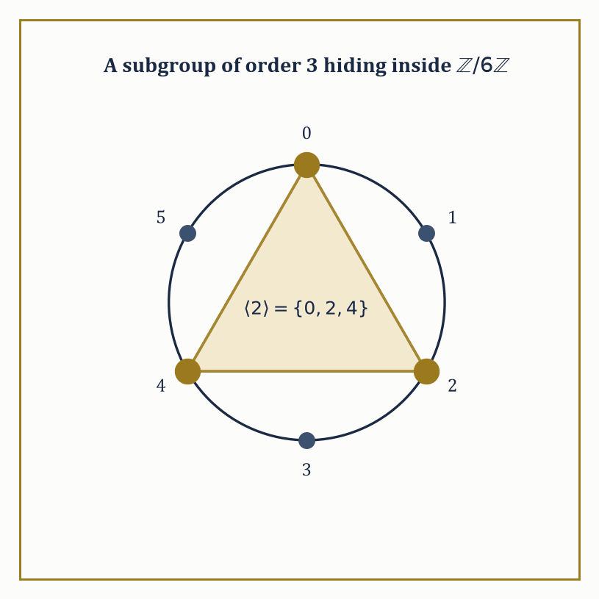
Figure 37.2 — The element 2 doesn’t generate all of ℤ/6ℤ — it generates exactly the golden triangle, a subgroup of order 3, because 3 divides 6.
First, associativity, so that a long chain of combinations needs no brackets, for all a,b,c:
(a∗b)∗c = a∗(b∗c)
Second, an identity element e ∈ G exists, for every a:
e∗a = a∗e = a
Third, inverses: for every a ∈ G there exists a⁻¹ ∈ G with:
a∗a⁻¹ = a⁻¹∗a = e
Nothing else is required — no commutativity, no finiteness, no numbers of any kind.
When the operation also commutes for all a,b —
a∗b = b∗a
— the group is called abelian, in honor of Niels Henrik Abel, who died young, poor, and two days before a letter arrived offering him a professorship; mathematics does have a sense of humor, and it is not always a kind one.
The integers under addition, the nonzero real numbers under multiplication, invertible n×n matrices under matrix multiplication (called GLₙ), and the permutations of n objects under composition (called Sₙ) are the four examples you should keep permanently on the shelf.
Numeric example — The smallest genuinely non-abelian group. Let G = S₃, the six ways to permute three labeled objects {1,2,3}: e (do nothing), the three transpositions (12), (13), (23) (swap a pair, fix the third), and the two 3-cycles (123), (132) (send 1→2→3→1, or the reverse).
Composition is ‘do the second permutation after the first’, reading right to left as functions usually are.
Check non-abelian-ness directly: apply (12) then (13) to the point 1. First (12) sends 1↦2, then (13) sends 2↦2 (it only touches 1 and 3), so the composite sends 1↦2.
Now the other order: apply (13) then (12) to 1: (13) sends 1↦3, then (12) sends 3↦3, so this composite sends 1↦3.
Since one composite sends 1↦2 and the other sends 1↦3, the two composites are different permutations.
So S₃ is a group of order 6 in which order matters — the smallest group where commutativity fails, which is why every account of the subject, this chapter included, reaches for it first.
Try it now — In S₃, compute (12)(13) and (13)(12), applying the right factor first. Answer →
A homomorphism φ: G → H between groups is a map satisfying, for all a,b, the following — it turns the operation in G into the operation in H, faithfully, even if it forgets other information:
φ(a∗b) = φ(a)∘φ(b)
Two subsets fall out of any homomorphism for free: the kernel, the elements crushed down to the identity —
ker φ = {a ∈ G : φ(a) = e_H}
— and the image, everything actually hit —
im φ = {φ(a) : a ∈ G}
Both are automatically subgroups (of G and H respectively) — the kernel because if φ(a)=φ(b)=e then φ(a∗b⁻¹)=e too, and the image because homomorphisms preserve the group operation by definition.
The first isomorphism theorem then says that quotienting G by the stuff the map kills gives you back, faithfully and isomorphically, what the map hit:
G / ker φ ≅ im φ
It is the algebraic version of ‘divide out the redundancy and what’s left is the honest content’ — a sentiment that also describes most academic committee meetings, minus the isomorphism.
Numeric example — Reduction mod 5. Let φ: ℤ → ℤ/5ℤ send each integer to its remainder on division by 5, so that:
φ(7)=2, φ(−3)=2 (since −3 = −1·5+2), φ(20)=0
This is a homomorphism from (ℤ,+) to (ℤ/5ℤ,+): check that φ(7+13) and φ(7)+φ(13) agree.
φ(7+13)=φ(20)=0
φ(7)+φ(13)=2+3=5≡0 mod 5
They agree, as they must for any pair, since remainders add correctly mod 5 by construction.
The kernel is:
ker φ = {n ∈ ℤ : n ≡ 0 mod 5} = 5ℤ = {…,−10,−5,0,5,10,…}
and the image is all of ℤ/5ℤ (every remainder is hit):
im φ = ℤ/5ℤ = {0,1,2,3,4}
The first isomorphism theorem predicts:
ℤ/5ℤ ≅ ℤ/5ℤ
which is admittedly not the most thrilling instance on record, but it is honest, and it is the mechanism by which ‘clock arithmetic’ is defined as a quotient of the integers in the first place.
A group is cyclic if it is generated by a single element g — that is, every element equals gⁿ (or, written additively, ng) for some integer n.
Cyclic groups are the atoms of abelian group theory: ℤ itself is cyclic (generated by 1), and ℤ/nℤ is the finite cyclic group of order n (generated by 1, wrapping around after n steps).
Every cyclic group is abelian, trivially:
gᵐ∗gⁿ = gᵐ⁺ⁿ = gⁿ∗gᵐ
though the converse fails badly — plenty of abelian groups need more than one generator.
Numeric example — A subgroup hiding inside a clock. In ℤ/6ℤ = {0,1,2,3,4,5} under addition mod 6, the element 1 generates the whole group (1,2,3,4,5,0,… by repeated addition — all six elements).
But the element 2 generates only a part of it:
2, 2+2=4, 4+2=6≡0
and then it repeats, giving:
⟨2⟩ = {0,2,4}
a cyclic subgroup of order 3 sitting inside the cyclic group of order 6, generated by an element that is not itself a generator of the entire thing. Note 3 divides 6, exactly as Lagrange’s theorem (next) demands.
Lagrange’s theorem states that if G is a finite group and H ≤ G is a subgroup, then the order (element-count) of H divides the order of G.
The proof is a counting argument — G splits into disjoint cosets of H, all of the same size |H|, so |G| is a whole-number multiple of |H| — and we will do that counting properly in Group Actions, Cosets, and Quotient Groups.
For now, treat it as the first hard constraint the theory hands you: it doesn’t tell you which subgroups exist, but it rules out most of the numbers a hopeful subgroup-order might have wanted to be.
Numeric example — What Lagrange forbids. S₃ has order 6, whose divisors are 1, 2, 3, 6. Lagrange’s theorem says every subgroup of S₃ must have one of these four orders — and indeed S₃ has representatives of all four.
The trivial subgroup has order 1, and three subgroups of order 2 are generated by each transposition, for example:
⟨(12)⟩={e,(12)}
there is a subgroup of order 3:
A₃=⟨(123)⟩={e,(123),(132)}
and S₃ itself has order 6.
What Lagrange’s theorem forbids is a subgroup of order 4 or 5 — no such subgroup exists, and now you know why without having to search for one: 4 and 5 don’t divide 6, so the search was always doomed.
That is the theorem’s real power — not telling you what’s there, but saving you the trouble of looking for what provably isn’t.
Keep only this · Section 37.2: Groups and Homomorphisms
The idea. A group is a set with an associative operation, an identity and inverses; a homomorphism respects the operation, and its kernel and image are subgroups. Lagrange’s theorem — subgroup orders divide the group order — is the first counting tool.
Core.
φ(ab) = φ(a) φ(b)
ker φ = {g : φ(g) = e} is a subgroup
Lagrange: |H| divides |G|
Typical mistake. Reading Lagrange backwards. A divisor of |G| need not be the order of a subgroup: A₄ has order 12 and no subgroup of order 6.
Minimal example. ℤ → ℤ/5ℤ, reduction mod 5: kernel 5ℤ.
Practice. Easy to challenge; full worked answers, with the usual mistake, are in Answers to the Practice Sets at the back.
Easy — Find the subgroup of ℤ/6ℤ generated by 2. Answer →
Medium — Find the kernel and image of φ: ℤ/6ℤ → ℤ/3ℤ, k ↦ k mod 3. Answer →
Challenge — Which orders can subgroups of S₃ have, and which occur? Answer →

Section 37.3: Group Actions, Cosets, and Quotient Groups
Groups Doing Things to Sets, and the Bookkeeping That Follows
On its own, a group is a list of moves nobody has made yet. It becomes useful the moment you let it loose on something: the quarter turns start turning an actual tile, the shuffles start rearranging an actual deck. Two demands keep that sensible. Doing nothing must leave everything where it was, and performing two moves in succession must have the same effect as performing the one move they amount to between them. A group action of G on a set X is a homomorphism from G into Sym(X), the group of all permutations of X — equivalently, a rule assigning to each g ∈ G a way of moving the points of X around, written g·x, such that the following hold for all g,h ∈ G and x ∈ X:
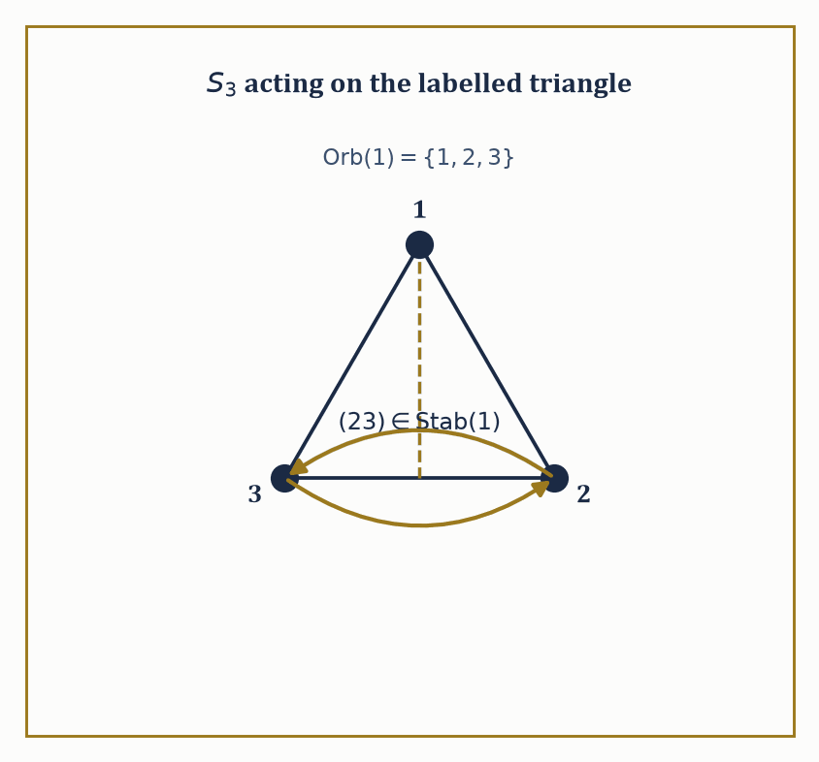
Figure 37.3 — The reflection (23) is the one symmetry that leaves vertex 1 where it found it — everything Stab(1) means, drawn as a single fold of the triangle.
e·x = x
(gh)·x = g·(h·x)
This is the formal machinery behind the informal idea of a group ‘acting on’ or ‘symmetrizing’ something: the rotation group of a cube acts on the cube’s eight corners, the permutation group Sₙ acts on {1,…,n} by definition, and a group can even act on itself, by left multiplication or by conjugation, tricks that turn out to be surprisingly powerful.
Numeric example — S₃ moving three points. S₃ acts on X = {1,2,3} in the obvious way: the permutation (12) sends 1↦2, 2↦1, 3↦3.
Check the action axiom on a composite by applying (13) first then (12) to the point 1.
(13) sends 1↦3
(12) sends 3↦3 (untouched)
So the composite (12)·((13)·1) sends 1 to 3.
This matches just what you get by first computing the single permutation (12)∘(13) and applying it to 1 directly, because the group action axiom (gh)·x = g·(h·x) is really just associativity of function composition wearing a trench coat — composition of permutations is function composition, and function composition is always associative, so the axiom is automatic rather than something that needs separate verification each time.
Try it now — S₃ acts on {1, 2, 3}. Find the orbit and the stabilizer of 1. Answer →
For a point x ∈ X, its orbit is the set of everywhere x can be moved to:
Orb(x) = {g·x : g ∈ G}
Its stabilizer is the set of elements that leave x fixed in place:
Stab(x) = {g ∈ G : g·x = x}
The stabilizer is always a subgroup of G (if g and h both fix x, so does gh, and so does g⁻¹). The orbit-stabilizer theorem ties the two together:
|Orb(x)| · |Stab(x)| = |G|
Intuitively, the group’s elements get sorted into |Orb(x)| bins, one per point the orbit reaches, and each bin has exactly |Stab(x)| elements in it (the ones that send x to that particular point) — so multiplying bins by bin-size recovers the whole group.
Numeric example — Counting orbit and stabilizer in S₃. Take the natural action of S₃ on X={1,2,3} and fix the point x=1. The orbit of 1 is everywhere 1 can be sent: (12) sends it to 2, (13) sends it to 3, e sends it to 1 — every point in X is reachable, so:
Orb(1) = {1,2,3}, size 3
The stabilizer of 1 is every permutation fixing 1 in place: e certainly does, and the only transposition not touching 1 is (23), which does too, so:
Stab(1) = {e,(23)}, size 2
The orbit-stabilizer theorem predicts:
|Orb(1)|·|Stab(1)| = 3×2 = 6 = |S₃|
Correct, and this is no coincidence — it is a theorem, not a lucky count.
For a subgroup H ≤ G, a left coset is a set for some fixed g ∈ G:
gH = {gh : h ∈ H}
The left cosets partition G into equal-sized pieces (each of size |H|), which is the counting argument behind Lagrange’s theorem promised in the last section. Right cosets Hg are defined the same way but need not agree with left cosets in general. When they do agree for every g — that is, when gH = Hg for all g ∈ G — the subgroup H is called normal, written H ⊴ G, and the set of cosets G/H then inherits a perfectly well-defined group operation, making G/H the quotient group:
(aH)(bH) = (ab)H
Without normality, this multiplication rule is ambiguous — different representatives of the same coset would give different answers — so normality is not a nicety, it is the precise condition under which ‘dividing a group by a subgroup’ is even meaningful.
Numeric example — Building ℤ/nℤ, and a quotient inside S₃. The cosets of the subgroup nℤ inside (ℤ,+) are the n residue classes mod n:
0+nℤ, 1+nℤ, …, (n−1)+nℤ
Since ℤ is abelian, every subgroup is automatically normal, so ℤ/nℤ is always a legitimate quotient group; this is, in fact, the official construction of clock arithmetic. For a non-abelian example, take H = A₃ = {e,(123),(132)} inside S₃. A₃ has index 2 (only two cosets: A₃ itself, and everything else), for example:
(12)A₃ = {(12),(13),(23)}
Any subgroup of index 2 is automatically normal — left and right cosets are forced to coincide because there are only two of them and one is always H itself, so the other (everything else) is forced to match on both sides. The quotient S₃/A₃ has exactly two elements, so:
S₃/A₃ ≅ ℤ/2ℤ
This is the unique group of order 2.
A simple group is one with no normal subgroups other than the trivial subgroup {e} and itself — it cannot be broken apart into a quotient in any nontrivial way, making it, in a precise sense, an atom of group theory.
Every finite group can be built up from simple groups via a chain of extensions (a composition series), rather as every integer factors into primes, and classifying the finite simple groups — completed, after decades of collective effort spanning tens of thousands of journal pages and more than one mathematician’s entire career, in the closing years of the twentieth century — is one of the largest proofs in the history of the subject. Nobody has read all of it. This is not a joke; it is true, and it is a fact the field has made an uneasy peace with.
Abstract example — The smallest non-abelian simple group. A₅, the even permutations of five objects, has order 60 (half of 5! = 120) and is simple: it has no normal subgroups except {e} and itself.
This is the smallest non-abelian simple group, and its simplicity is precisely the algebraic fact behind the impossibility of solving the general quintic equation by radicals — a connection we will make precise in Introduction to Galois Theory.
Contrast this with A₃ from the previous example: A₃ has order 3, which is prime, so by Lagrange its only subgroups are {e} and itself — every group of prime order is automatically simple (and cyclic, and abelian), for the boring reason that there’s no room for anything else to divide it.
A₅ is the first interesting simple group because its order, 60, has plenty of divisors, and yet none of the corresponding subgroups happens to be normal.
Same structure, new language
The first isomorphism theorem has a twin for rings (R/ker φ ≅ im φ) in Rings, Ideals, and Quotient Rings and for modules in Modules over Rings, and the rank–nullity theorem of Linear Algebra (Volume 2) is its dimension count. Three proofs of one statement suggest that the statement belongs to something more general than groups.
Keep only this · Section 37.3: Group Actions, Cosets, and Quotient Groups
The idea. A group action lets a group move a set; the orbit–stabilizer theorem counts orbits. Cosets partition a group, and when the subgroup is normal the cosets themselves form a quotient group. Kernels of homomorphisms are exactly the normal subgroups.
Core.
|orbit(x)| · |Stab(x)| = |G|
G/N is a group ⇔ N normal
first isomorphism theorem: G/ker φ ≅ im φ
Typical mistake. Forming G/H for a subgroup that is not normal. In S₃ the cosets of ⟨(12)⟩ do not multiply consistently.
Minimal example. ℤ/nℤ is the quotient of ℤ by nℤ.
Practice. Easy to challenge; full worked answers, with the usual mistake, are in Answers to the Practice Sets at the back.
Easy — How many cosets does ⟨(123)⟩ have in S₃? Answer →
Medium — Count the rotations of a cube using orbit–stabilizer on its faces. Answer →
Challenge — Use the first isomorphism theorem on sign: S₃ → {±1}. Answer →

Section 37.4: Rings, Ideals, and Quotient Rings
Two Operations Are Twice the Fun and Considerably More Than Twice the Bookkeeping
The whole numbers let you do two things, not one. You can add them and you can multiply them, and the two operations are not strangers to each other: multiplying a sum gives the same answer as multiplying the parts and adding afterwards. Three lots of seven-plus-two is three sevens plus three twos. You have relied on that since primary school without ever being asked to name it. Strip away everything about the whole numbers except those habits and what remains is a ring: a set R with two operations, usually called addition and multiplication, such that (R,+) is an abelian group, multiplication is associative, and multiplication distributes over addition on both sides:
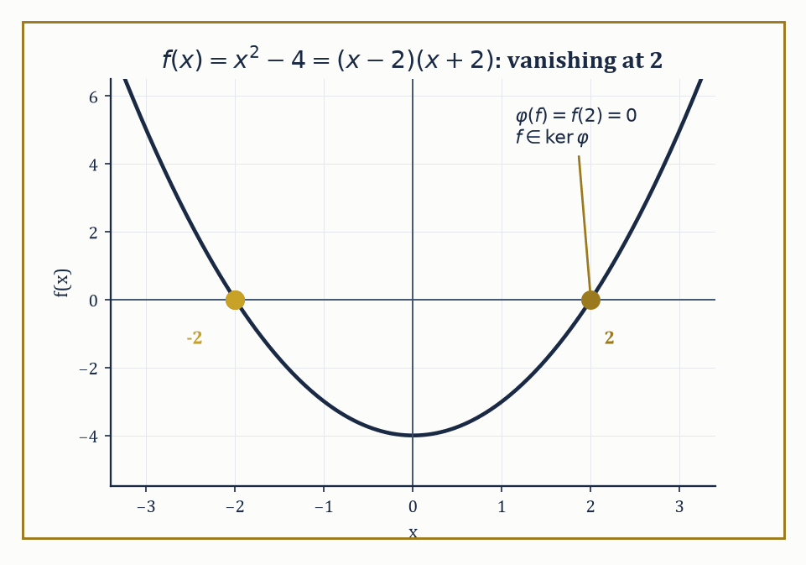
Figure 37.4 — x²−4 lands in the kernel of ‘evaluate at 2’ for the most literal reason possible: its graph passes right through the point.
a(b+c) = ab+ac
(a+b)c = ac+bc
That is the bare minimum; a commutative ring additionally requires ab=ba for all a,b, and a ring with identity requires a multiplicative identity 1 with 1·a = a·1 = a.
Most rings anyone cares about — the integers, polynomial rings, rings of continuous functions — are commutative rings with identity, and we will simply assume both from here on unless said otherwise.
The point of the two-operation package is that it captures, all at once, the integers, polynomials, matrices, and functions: wildly different objects, unified by satisfying the same eight-or-so axioms.
Numeric example — Distributivity, checked by hand. In the ring of integers, verify a(b+c)=ab+ac with a=3, b=4, c=5.
Left side: 3×(4+5) = 3×9 = 27
Right side: (3×4)+(3×5) = 12+15 = 27
They agree, as the axiom demands — and this is not a coincidence to be checked case by case, it is a fact about the integers that follows from how multiplication is built out of repeated addition, but the axiomatic approach assumes it as a starting rule so that the same proof technique transfers unchanged to polynomial rings, matrix rings, and any other ring anyone constructs tomorrow.
Try it now — In ℤ/6ℤ, compute 2 · 3. Answer →
An ideal I ⊆ R is a subset that is a subgroup under addition and additionally absorbs multiplication: for every r ∈ R and every i ∈ I, both ri and ir land back in I.
This absorption property is what makes ideals the right notion of ‘substructure to quotient by’ in ring theory, playing the role that normal subgroups played for groups — you cannot quotient a ring by an arbitrary subring and expect the multiplication to survive the process, but an ideal is built so that it does.
Numeric example — 3ℤ absorbs everything you throw at it. Let I = 3ℤ = {…,−6,−3,0,3,6,9,…}, the multiples of 3, inside R = ℤ.
Take an arbitrary ring element, say r=7, and an arbitrary element of I, say i=6=3×2.
7×6=42=3×14
This is indeed a multiple of 3, hence back in I.
This will hold no matter which multiple of 3 you pick and no matter which integer you multiply it by —
r·(3k) = 3(rk)
a multiple of 3 by construction — which is the absorption property, verified in general by one line of algebra rather than infinitely many separate checks.
Given an ideal I ⊴ R, the quotient ring R/I consists of the cosets a+I with addition and multiplication defined coset-wise; the absorption property is what makes multiplication well-defined on cosets (try to check this fails for a mere subring and you’ll see why ideals earn their keep).
A prime ideal P is one where ab ∈ P forces a ∈ P or b ∈ P — the ideal-theoretic generalization of a prime number being unable to divide a product without dividing one of the factors — and the quotient R/P by a prime ideal is always an integral domain (no zero divisors).
A maximal ideal M is one properly contained in no ideal except R itself, and the quotient R/M by a maximal ideal is always a field.
Every maximal ideal is prime (fields are automatically domains), but the converse can fail.
Numeric example — 5 is prime, 6 is not, and their quotients know it. Compare ℤ/5ℤ and ℤ/6ℤ. In ℤ/6ℤ, take 2 and 3: neither is 0, but
2×3=6≡0 mod 6
— a genuine zero divisor, because the ideal (6) is not prime (6 is composite, 6=2×3, and neither factor lies in (6) alone). So ℤ/6ℤ is not even an integral domain, let alone a field.
Now ℤ/5ℤ = {0,1,2,3,4}: since 5 is prime, (5) is a maximal ideal, so ℤ/5ℤ must be a field — every nonzero element has a multiplicative inverse.
Check this for 2: we need x with 2x≡1 mod 5. Try x=3:
2×3=6≡1 mod 5
Yes —
2⁻¹=3 in ℤ/5ℤ
This is the entire content of the fact that ℤ/pℤ is a field exactly when p is prime, seen from the ideal-theoretic side rather than the elementary-number-theory side.
A ring homomorphism φ: R → S preserves both operations:
φ(a+b)=φ(a)+φ(b)
φ(ab)=φ(a)φ(b)
and, if both rings have 1, usually φ(1)=1 by convention.
Exactly as with groups, the kernel is an ideal (not merely a subring — this is why ‘ideal’ had to be invented as a separate concept from ‘subring’), the image is a subring, and the first isomorphism theorem reads
R/ker φ ≅ im φ
word for word the group statement with ‘subgroup’ upgraded to ‘ideal’.
Numeric example — Evaluating a polynomial at x=2. Let φ: ℝ[x] → ℝ be evaluation at 2,
φ(f) = f(2)
This is a ring homomorphism:
φ(f+g)=f(2)+g(2)=φ(f)+φ(g)
φ(fg)=f(2)g(2)=φ(f)φ(g)
both immediate from how polynomial addition and multiplication are defined pointwise.
The kernel is every polynomial vanishing at 2 — for instance f(x)=x²−4 satisfies
f(2)=4−4=0
so f ∈ ker φ, and indeed x²−4 factors as (x−2)(x+2), visibly a multiple of (x−2).
In fact ker φ = (x−2), because a real polynomial vanishes at 2 exactly when (x−2) divides it (the factor theorem, from a much earlier chapter, making a guest appearance).
The image is all of ℝ, since every real number is f(2) for the constant polynomial f=that number.
So the first isomorphism theorem gives
ℝ[x]/(x−2) ≅ ℝ
dividing out ‘everything that vanishes at 2’ leaves you with precisely the value at 2, which is a satisfyingly literal reading of what a quotient is supposed to mean.
Keep only this · Section 37.4: Rings, Ideals, and Quotient Rings
The idea. A ring has addition and multiplication linked by distributivity. Ideals are the subsets that absorb multiplication, and quotients by them are again rings. Prime ideals give integral domains and maximal ideals give fields; ℤ/nℤ is a field exactly when n is prime.
Core.
ideal I: r·a ∈ I for all r ∈ R, a ∈ I
R/I field ⇔ I maximal
R/I domain ⇔ I prime
Typical mistake. Assuming every ring is commutative or has no zero divisors. Matrices and ℤ/6ℤ break both.
Minimal example. 3ℤ is an ideal of ℤ, and ℤ/3ℤ is a field.
Practice. Easy to challenge; full worked answers, with the usual mistake, are in Answers to the Practice Sets at the back.
Easy — Find the inverse of 3 in ℤ/7ℤ. Answer →
Medium — Find the kernel of evaluation at 2, ℝ[x] → ℝ. Answer →
Challenge — Is ℤ/8ℤ a field? An integral domain? Answer →

Section 37.5: Factorization in Integral Domains
Where Unique Factorization Turns Out to Be a Privilege, Not a Right
If two numbers multiply to nothing, one of them was nothing. You use this every time you solve an equation by factorizing: the product is zero, so one bracket must be zero, and that is where the answers come from. It feels less like a rule than like common sense. It is neither. On a twelve-hour clock, four times three is twelve, which reads as zero — and neither four nor three was zero to begin with. Factorizing there would hand you nonsense. An integral domain is a ring where that accident cannot happen: a commutative ring with identity 1≠0 and no zero divisors:
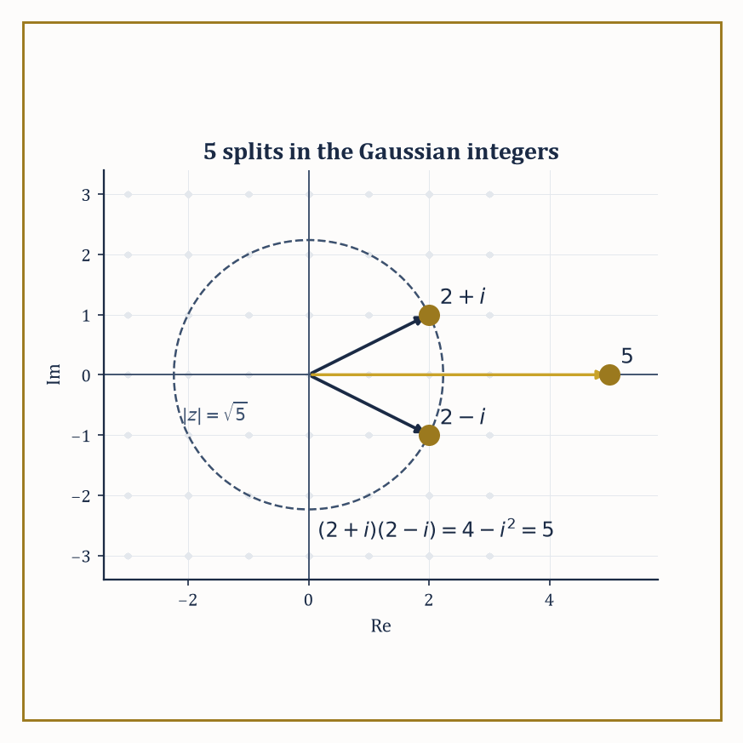
Figure 37.5 — 5 looks stubbornly prime from the real line, but step into the complex plane and it visibly splits into 2+i and its mirror image.
ab=0 forces a=0 or b=0
This single extra condition is what lets you ‘cancel’ in equations — if ab=ac and a≠0, then
a(b-c)=0
and since a≠0 the no-zero-divisors condition forces b-c=0, i.e. b=c — a manipulation every school pupil performs on instinct and no domain-theorist performs without first checking the ring qualifies.
Numeric example — Cancellation succeeds and fails. In ℤ/5ℤ, take the two products below.
2×3=6≡1 (mod 5)
2×4=8≡3 (mod 5)
These are different, consistent with cancellation being valid there (2 is nonzero, and ℤ/5ℤ is a domain, being a field). But in ℤ/6ℤ, take:
2×2=4 (mod 6)
2×5=10≡4 (mod 6)
the same product, yet 2≠5. Canceling the 2 would wrongly conclude 2=5. The reason cancellation fails is the zero-divisor problem from Rings, Ideals, and Quotient Rings:
2×3≡0 (mod 6)
so ℤ/6ℤ is not a domain, and the cancellation law — which secretly relies on being able to divide the equation a(b-c)=0 down to b-c=0 — has no right to hold there.
Try it now — Compute gcd(17, 5) by the Euclidean algorithm. Answer →
A unique factorization domain (UFD) is an integral domain in which every nonzero non-unit factors into irreducibles, and that factorization is unique up to order and multiplication by units (invertible elements) — this is the abstract version of the fundamental theorem of arithmetic.
A Euclidean domain is one equipped with a division algorithm: a size function (a ‘norm’) letting you divide with remainder, the remainder strictly smaller than the divisor, as with long division of integers.
Every Euclidean domain is automatically a principal ideal domain (PID, meaning every ideal is generated by a single element) — repeated division produces a generator via the same argument as the Euclidean algorithm for gcds — and every PID is automatically a UFD. So the implications run:
Euclidean ⟹ PID ⟹ UFD
three increasingly weaker guarantees of good factorization behavior, and the interesting mathematics tends to live in rings that satisfy one implication but not its converse.
Numeric example — The Euclidean algorithm, the mechanism underneath it all. In ℤ, find gcd(17,5) by repeated division with remainder.
17 = 3×5 + 2
5 = 2×2 + 1
2 = 2×1 + 0
The remainder hits zero, so the algorithm halts and the last nonzero remainder, 1, is gcd(17,5). This is the division algorithm that makes ℤ a Euclidean domain (with the ‘size’ function being ordinary absolute value), and the same mechanical procedure — divide, take the remainder, repeat until it hits zero — is what makes ℝ[x] and ℤ[i] (below) Euclidean too, just with a different notion of ‘size’ each time (degree for polynomials, norm for Gaussian integers).
The Gaussian integers ℤ[i] = {a+bi : a,b ∈ ℤ} form a Euclidean domain under the norm:
N(a+bi)=a²+b²
which is multiplicative,
N(zw)=N(z)N(w)
and lets you divide with a remainder of strictly smaller norm. Unique factorization then explains something that looks, from inside ordinary arithmetic, faintly magical: certain ordinary prime numbers stop being prime once you’re allowed complex integer factors.
Numeric example — 5 stops being prime in ℤ[i]. Compute the product of the two Gaussian-integer factors of 5.
(2+i)(2−i) = 2×2 + 2×(−i) + i×2 + i×(−i) = 4 − 2i + 2i − i² = 4 − (−1) = 5
So 5, stubbornly prime in ℤ, factors as (2+i)(2−i) in ℤ[i]. Both factors are irreducible in ℤ[i]: their norms are
N(2+i)=4+1=5, N(2−i)=4+1=5
and 5 is prime in ℤ, so neither factor can be broken down further (a further factorization would need norms multiplying to 5, and 5=5×1 is the only way, forcing one factor to be a unit). This phenomenon — an ordinary prime ‘splitting’ into two Gaussian-integer primes — is precisely governed by whether the prime is congruent to 1 mod 4 (5≡1 mod 4, and it splits) or 3 mod 4 (which stay prime, e.g. 3, 7, 11), a fact first understood by Fermat and one of the founding observations of algebraic number theory.
Not every ring of algebraic integers is so well-behaved. In ℤ[√−5] = {a+b√−5 : a,b ∈ ℤ}, unique factorization simply breaks.
The standard demonstration is worth working through slowly, because it is the example that historically convinced number theorists they needed an entirely new invariant — the ideal class group — to repair the damage.
Numeric example — Two different factorizations of 6. In ℤ[√−5], compute two different-looking factorizations of the same number.
2×3 = 6
(1+√−5)(1−√−5) = 1² − (√−5)² = 1 − (−5) = 1+5 = 6
Using the norm:
N(a+b√−5)=a²+5b²
we get:
N(2)=4, N(3)=9, N(1+√−5)=1+5=6, N(1−√−5)=6
None of 2, 3, 1+√−5, 1−√−5 can be broken down further: the norm form a²+5b² never equals 2 or 3 for integers a,b (checking small cases: for b=0 it gives perfect squares 0,1,4,9,…; for b=±1 it gives a²+5, i.e. 5,6,9,14,…; neither list contains 2 or 3), so no element of ℤ[√−5] has norm 2 or 3, which rules out any nontrivial factorization of 2, 3, or the two norm-6 elements.
So 6 = 2×3 = (1+√−5)(1−√−5) are two factorizations into irreducibles that are not merely rearrangements of each other by units (the only units in ℤ[√−5] are ±1) — genuine, unrepairable non-uniqueness. This single broken equation is the crack that opens onto the entire theory of ideal class groups, invented by Kummer and Dedekind specifically to patch it.
Deciding by hand whether a specific polynomial is irreducible would be hopeless without shortcuts, and Eisenstein’s criterion is the most useful one available. Consider a polynomial with integer coefficients:
f(x) = aₙxⁿ + … + a₁x + a₀
If there is a prime p dividing every coefficient except the leading one, with p² not dividing the constant term a₀, then f is irreducible over ℚ.
Gauss’s lemma underlies why: it says a polynomial with integer coefficients that factors over ℚ already factors over ℤ, so it suffices to rule out integer factorizations, and Eisenstein’s condition does just that by a clean argument mod p.
Numeric example — x³−2 is irreducible, by Eisenstein. Take:
f(x)=x³−2
with coefficients (1,0,0,−2) for x³,x²,x,constant. Choose p=2. Does 2 divide every coefficient except the leading 1? The coefficients to check are 0, 0, and −2 — 2 divides 0 (trivially) and 2 divides −2 — yes, all three. Does 2²=4 divide the constant term −2? No, 4 does not divide −2.
Both conditions of Eisenstein’s criterion are met, so x³−2 is irreducible over ℚ — it has no rational root and does not factor into a linear times a quadratic with rational coefficients. This one fact is the entire reason ∛2 generates a genuine degree-3 field extension of ℚ, a claim we will need and verify from a different angle in Field Extensions.
Keep only this · Section 37.5: Factorization in Integral Domains
The idea. Integral domains allow cancellation. Euclidean domains have a division algorithm, hence principal ideals, hence unique factorization. Gaussian integers keep unique factorization; ℤ[√−5] loses it, which is where ideals came from.
Core.
Euclidean ⇒ PID ⇒ UFD
N(a + bi) = a² + b² is multiplicative
Eisenstein: p | lower coefficients, p ∤ leading, p² ∤ constant ⇒ irreducible
Typical mistake. Assuming factorization is unique in every domain. In ℤ[√−5], 6 = 2 · 3 = (1 + √−5)(1 − √−5).
Minimal example. 5 = (2 + i)(2 − i) in ℤ[i].
Practice. Easy to challenge; full worked answers, with the usual mistake, are in Answers to the Practice Sets at the back.
Easy — Write 1 = 17a + 5b using the Euclidean steps. Answer →
Medium — Factor 13 in ℤ[i]. Answer →
Challenge — Show that 2 is irreducible in ℤ[√−5], using N(a + b√−5) = a² + 5b². Answer →

Section 37.6: Modules over Rings
Vector Spaces That Lost Their Field and Gained a Ring Instead
Vectors can be stretched by any amount you like: half a step, a third of a step, minus two and a quarter steps. That freedom comes from the numbers doing the stretching, which can be divided by. Take the division away and allow only whole-number stretches, and something changes. You can still double a thing or triple it, but you can no longer take half of it, and shapes appear that no vector space permits — collections with no basis at all, where some element is quietly destroyed by multiplying it. A module M over a ring R is what you have then: an abelian group (M,+) with a scalar multiplication R×M→M obeying the same wish-list of axioms as a vector space, except that R is only a ring, not necessarily a field.
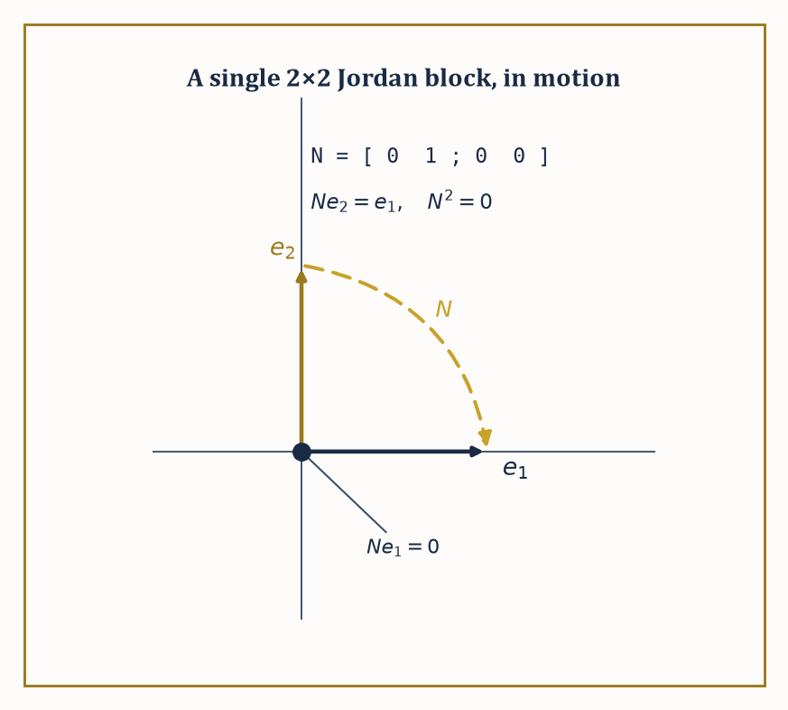
Figure 37.6 — N pushes e2 down onto e1 and e1 down onto nothing — one step from an eigenbasis, which is why a Jordan block is needed at all.
r(m+n) = rm + rn
(r+s)m = rm + sm
(rs)m = r(sm)
1m = m
This one relaxation changes everything: vector spaces over a field are extremely well-behaved (every vector space has a basis, every subspace has a complement), while modules over a general ring can be badly behaved in ways that turn out to be the interesting phenomena of number theory and topology in algebraic disguise.
Numeric example — The clock as a module over the integers. Every abelian group is automatically a ℤ-module in a forced, unique way: n·m means ‘add m to itself n times’ (and (−n)·m means do that to −m). Take M=ℤ/6ℤ as a ℤ-module, and compute the scalar action of 4 on the element [2].
4·[2] = [2]+[2]+[2]+[2] = [8] = [2]
(since 8 mod 6 = 2.) Note this module has no basis in the vector-space sense — there is no element [k] such that every element of ℤ/6ℤ is an integer multiple of [k] in a unique way, because, e.g.,
[3]+[3] = [0]
a genuine ‘linear’ relation with no analogue over a field. This failure of the free-basis property is precisely what distinguishes a general ℤ-module (an abelian group) from a ℤ-vector space (which doesn’t exist, since ℤ isn’t a field).
Try it now — List the abelian groups of order 12. Answer →
A free module is one that does have a basis — Rⁿ, with basis given by the standard ‘unit vectors’, is the model example, behaving like a vector space of dimension n even though R is only a ring.
A sequence of modules and homomorphisms is exact at B if the image of the incoming map equals the kernel of the outgoing map:
⋯ → A → B → C → ⋯
A short exact sequence
0 → A → B → C → 0
packages up the statement ‘A sits inside B as a submodule, and B/A is isomorphic to C’ into a single compact diagram, and it is the workhorse notation of homological algebra.
Worked example — A short exact sequence you can hold in your hand. Take the short exact sequence
0 → ℤ →(×2) ℤ → ℤ/2ℤ → 0
where the first map is multiplication by 2 and the second is reduction mod 2. Exactness at the first ℤ (injectivity of ×2) is immediate:
2a=2b forces a=b in ℤ
Exactness at ℤ/2ℤ (surjectivity of the reduction map) is immediate too: every residue class 0 or 1 is hit. The interesting check is exactness in the middle: is the image of ‘multiply by 2’ the kernel of ‘reduce mod 2’? The image of ×2 is the even integers,
2ℤ = {…,−4,−2,0,2,4,…}
The kernel of reduction mod 2 is also exactly the even integers — an integer reduces to 0 mod 2 when it’s even. Image equals kernel, so the sequence is exact at the middle term too, and the whole diagram is a short exact sequence: ‘the even integers sit inside ℤ, and ℤ modulo the evens is ℤ/2ℤ’ — an entirely unsurprising fact, now wearing the standard notation you will meet again in every homological argument from here to the end of the series.
The structure theorem for finitely generated modules over a PID is the crown result of this section: every such module decomposes as a direct sum of a free part and finitely many cyclic torsion pieces R/(pᵢ^kᵢ) for primes pᵢ of R.
Specialize R=ℤ and you get the classification of finite abelian groups — every finite abelian group is a direct sum of cyclic groups of prime-power order, uniquely, up to reordering.
Specialize R=K[x] for a field K and the module ‘a vector space with a chosen linear operator T acting on it’ and you recover the rational canonical form and the Jordan canonical form of a matrix, both from the same single theorem.
Numeric example — Every abelian group of order 12, listed exhaustively. Factor 12.
12 = 2²×3
The structure theorem says a finite abelian group of order 12 is determined by how the exponent 2 (on the prime 2) is split into a sum, combined with the prime-3 part.
The exponent 2 splits as 2 (one piece) or 1+1 (two pieces) — those are the only two partitions of 2 — giving cyclic factor ℤ/4ℤ or ℤ/2ℤ⊕ℤ/2ℤ for the 2-part, always paired with ℤ/3ℤ for the 3-part (3 being prime, no further splitting possible).
That yields exactly two abelian groups of order 12 up to isomorphism: ℤ/4ℤ⊕ℤ/3ℤ, which collapses (since gcd(4,3)=1) to the single cyclic group ℤ/12ℤ by the Chinese remainder theorem, and ℤ/2ℤ⊕ℤ/2ℤ⊕ℤ/3ℤ, which collapses to ℤ/2ℤ⊕ℤ/6ℤ (again using gcd(2,3)=1 to merge the second ℤ/2ℤ with ℤ/3ℤ into ℤ/6ℤ).
So: exactly two abelian groups of order 12, ℤ/12ℤ and ℤ/2ℤ⊕ℤ/6ℤ, and the structure theorem is what guarantees there are no others hiding anywhere.
The same theorem, run over R=ℂ[x] with M a finite-dimensional complex vector space acted on by a linear operator T (so that x acts as T), delivers the Jordan canonical form: every such M decomposes into cyclic pieces ℂ[x]/((x-λ)ᵏ), each one a ‘Jordan block’.
A Jordan block is a matrix that is λ down the diagonal, 1 along the superdiagonal, and 0 everywhere else — the closest a non-diagonalizable operator can get to being diagonal.
Numeric example — A 2×2 Jordan block, made concrete. Consider the matrix
N = [0 1; 0 0]
N cannot be diagonalized: its only eigenvalue is 0 (the characteristic polynomial is λ², double root at 0), but Nv=0 only for v in the 1-dimensional space spanned by (1,0) — there is no second, independent eigenvector to build a full eigenbasis from.
N is nonetheless the simplest possible non-diagonal matrix in a precise sense: it is nilpotent —
N² = 0 (the zero matrix)
computed directly by matrix multiplication — and a single Jordan block for eigenvalue 0. As a module over ℂ[x], this is ℂ[x]/(x²) — the module where x acts as N — and it is indecomposable: unlike ℤ/6ℤ (which splits as ℤ/2⊕ℤ/3), ℂ[x]/(x²) cannot be broken into smaller cyclic pieces, because x² is a prime-power (2²) rather than a product of distinct primes.
Modules that are not free still deserve measurement, and homological algebra supplies the instruments: Ext and Tor are functors that measure, respectively, the failure of a module to split off as a direct summand and the failure of tensor products to behave as simply as they do for vector spaces.
Projective modules (direct summands of free ones) and injective modules (their dual notion) are the well-behaved building blocks the theory is built from.
We will not compute an Ext group in this chapter — that machinery is better appreciated once category theory, immediately ahead of us, has supplied the vocabulary of functors properly — but it is worth knowing the words exist, since ‘Ext’ and ‘Tor’ will recur like old acquaintances throughout the later chapters of this series.
Studying maps, not elements
Exact sequences describe a module entirely through the maps into and out of it, without naming one element. That habit — a structure is known by its maps — is where Category Theory (Volume 4) begins.
Keep only this · Section 37.6: Modules over Rings
The idea. A module is a vector space over a ring instead of a field. Every abelian group is a ℤ-module, and finitely generated modules over a PID split into cyclic pieces — which classifies finite abelian groups and, over F[x], gives Jordan form. Exact sequences track how modules are assembled.
Core.
finite abelian group ≅ ∏ ℤ/pᵏℤ
exact: image of each map = kernel of the next
F[x]-module from a matrix A: x acts as A
Typical mistake. Expecting modules to have bases. ℤ/2ℤ is a ℤ-module with no basis: 2 kills every element.
Minimal example. 0 → ℤ →(×2) ℤ → ℤ/2ℤ → 0 is exact.
Practice. Easy to challenge; full worked answers, with the usual mistake, are in Answers to the Practice Sets at the back.
Easy — Is ℤ/6ℤ ≅ ℤ/2ℤ × ℤ/3ℤ? Answer →
Medium — Count the abelian groups of order 72 = 2³ · 3². Answer →
Challenge — A = [2 1; 0 2]. Find the minimal polynomial and the cyclic decomposition of the F[x]-module. Answer →

Section 37.7: Field Extensions
Building Bigger Number Systems by Politely Insisting a Root Exists
A field extension K ⊆ L is a field L containing a smaller field K as a subfield; the whole of L can then be regarded as a vector space over K (add elements of L as usual, scale by elements of K), and its dimension as such a vector space is the degree, written [L:K].
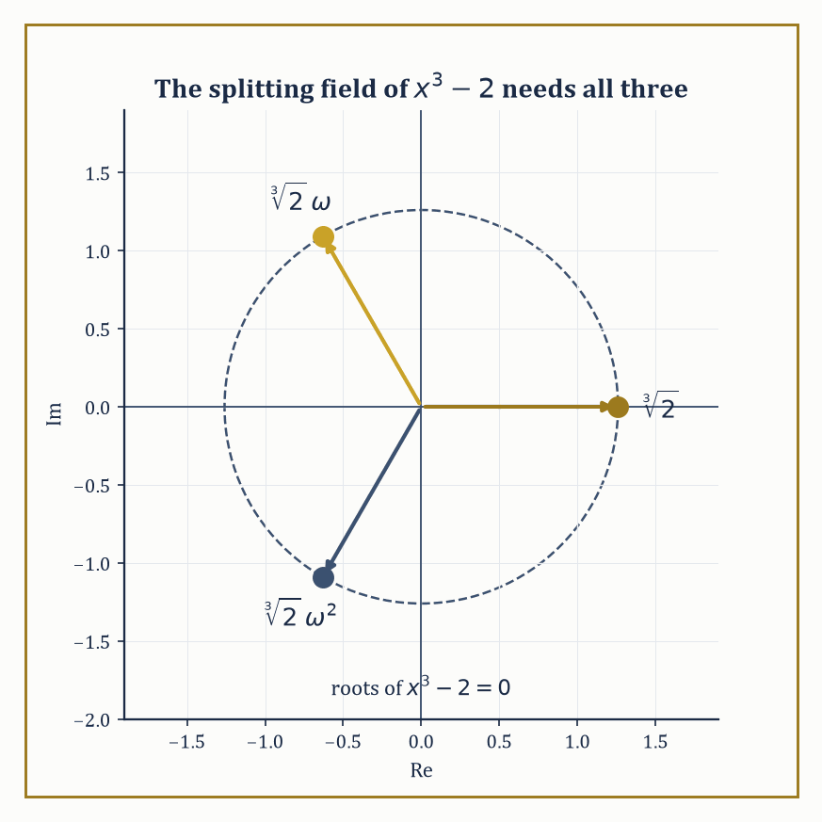
Figure 37.7 — ℚ(∛2) alone catches only one of these three roots — the splitting field has to reach for the other two, out in the complex plane, at a cost of degree 6.
When [L:K] is finite, L is called a finite extension of K; when every element of L satisfies some nonzero polynomial with coefficients in K, L is called an algebraic extension. Finite extensions are always algebraic (a standard argument using the pigeonhole principle on powers of an element inside a finite-dimensional space), though the converse can fail for infinite extensions.
Numeric example — [ℚ(√2):ℚ] = 2, basis and all. Let L=ℚ(√2)={a+b√2 : a,b∈ℚ}, the smallest field containing ℚ and √2. As a ℚ-vector space, L is spanned by {1,√2}: every element is a ℚ-linear combination of these two, by definition of the set.
Are they independent? If a+b√2=0 with a,b∈ℚ and b≠0, then
√2=−a/b
a rational number — but √2 is irrational (a fact from a much earlier chapter, provable by the classic infinite-descent argument on parity), contradiction. So {1,√2} is a basis, [ℚ(√2):ℚ]=2, and multiplication behaves as you’d hope:
(2+3√2)(1−√2) = 2−2√2+3√2−3×2 = 2+√2−6 = −4+√2
still of the form a+b√2, confirming L is closed under multiplication as a field extension must be.
Try it now — Find [ℚ(√2) : ℚ] and a basis. Answer →
Given an irreducible polynomial p(x) over K, adjoining a root α produces the simple extension
K(α) = K[x]/(p(x))
and [K(α):K] equals the degree of p — the minimal polynomial of α, the unique monic irreducible polynomial over K that α satisfies. This is the standard machine for building new fields to order: name the property you want a new element to have (namely, being a root of a specific irreducible polynomial), and the quotient construction manufactures a field in which that property holds, with no further questions asked about what α ‘really is’.
Numeric example — Building ℚ(∛2) to order. We showed in Factorization in Integral Domains (via Eisenstein with p=2) that x³−2 is irreducible over ℚ. So K(α)=ℚ[x]/(x³−2), where α is the class of x, is a genuine field, of degree [ℚ(∛2):ℚ]=3, with basis {1,α,α²} where α³=2 by construction.
Concretely, α behaves like the real cube root of 2:
(1+α)(1-α+α²) = 1-α+α²+α-α²+α³ = 1+α³ = 1+2 = 3
using α³=2 at the last step — you never need to know that α ‘is’ 1.259921… to compute correctly inside the field; the single defining relation α³=2 suffices for every algebraic manipulation.
A splitting field of a polynomial f over K is the smallest extension of K in which f factors completely into linear factors — it contains every root of f, and nothing algebraically superfluous besides. Splitting fields always exist and are unique up to isomorphism, by repeatedly adjoining roots one irreducible factor at a time.
An algebraic closure K̄ of K is a field containing a root of every nonzero polynomial over K (and every polynomial over K̄ itself); it exists for any field K (a fact that requires Zorn’s lemma — the axiom of choice in disguise — once K is infinite) and, like splitting fields, is unique up to isomorphism.
Numeric example — Two splitting fields, one small and one not. The polynomial x²+1 has no real root, but over L=ℝ(i)=ℂ it factors fully:
x²+1=(x-i)(x+i)
Since ℂ already contains both roots, [ℂ:ℝ]=2 is the splitting field, and in fact ℂ is algebraically closed (the fundamental theorem of algebra, from a much earlier chapter) — it is its own algebraic closure.
Contrast this with x³−2: its three roots are ∛2 (real), ∛2ω, and ∛2ω² (both complex), where ω=exp(2πi/3) is a primitive cube root of unity satisfying ω²+ω+1=0. The splitting field must contain ∛2 (degree 3 over ℚ) and ω (degree 2 over ℚ(∛2), since ω is not real but ∛2 generates only a real field), so by the tower law below,
[ℚ(∛2,ω):ℚ] = 3×2 = 6
considerably roomier than the degree-3 field ℚ(∛2) alone, which contains only one of the three roots.
For a tower of fields K ⊆ M ⊆ L, degrees multiply:
[L:K] = [L:M]·[M:K]
The proof is a basis-combination argument — if {mᵢ} is a basis for M over K and {ℓⱼ} a basis for L over M, then {mᵢℓⱼ} is a basis for L over K — and the multiplicativity is what turns field extension degrees into a powerful divisibility constraint, analogous to Lagrange’s theorem for groups.
Numeric example — The tower law, brick by brick. Build the tower ℚ ⊆ ℚ(√2) ⊆ ℚ(√2,√3). We know [ℚ(√2):ℚ]=2. For the next step, is √3 already inside ℚ(√2)? Suppose √3=a+b√2 for some a,b∈ℚ; squaring gives
3=a²+2b²+2ab√2
Since 3 and a²+2b² are rational and √2 is irrational, the coefficient of √2 must vanish: 2ab=0, so a=0 or b=0. If b=0, then a²=3, impossible for rational a. If a=0, then 2b²=3, i.e. b²=3/2, also impossible for rational b. So √3 ∉ ℚ(√2), meaning x²−3 stays irreducible over ℚ(√2), giving [ℚ(√2,√3):ℚ(√2)]=2.
The tower law then gives
[ℚ(√2,√3):ℚ] = 2×2 = 4
with basis {1,√2,√3,√6} — and indeed one can check this whole degree-4 field is generated by the single element √2+√3 alone (its minimal polynomial over ℚ turns out to be x⁴−10x²+1, degree 4, matching), an instance of the primitive element theorem that we state here without proof and will not need again until it resurfaces, transfigured, in Section 37.8’s fundamental theorem.
Keep only this · Section 37.7: Field Extensions
The idea. A field extension L ⊇ K is a K-vector space, and its dimension is the degree [L : K]. Adjoining a root of an irreducible polynomial of degree n gives degree n; degrees multiply in towers; splitting fields contain all roots of a polynomial.
Core.
[K(α) : K] = deg of the minimal polynomial of α
tower: [M : K] = [M : L][L : K]
K(α) ≅ K[x]/(m(x))
Typical mistake. Assuming a splitting field is generated by one root. The splitting field of x³ − 2 needs ∛2 and a cube root of unity: degree 6, not 3.
Minimal example. ℂ = ℝ(i), degree 2.
Practice. Easy to challenge; full worked answers, with the usual mistake, are in Answers to the Practice Sets at the back.
Easy — Find [ℚ(∛2) : ℚ]. Answer →
Medium — Find [ℚ(√2, √3) : ℚ]. Answer →
Challenge — Can ∛2 lie in ℚ(√2, √3)? Answer →

Section 37.8: Introduction to Galois Theory
In Which Symmetry Groups Reveal Which Equations Can Be Solved
For a field extension L/K, the Galois group Gal(L/K) consists of all field automorphisms of L that fix every element of K — bijective maps L→L preserving addition and multiplication, doing nothing whatsoever to K itself, but potentially permuting the elements of L that lie outside K.
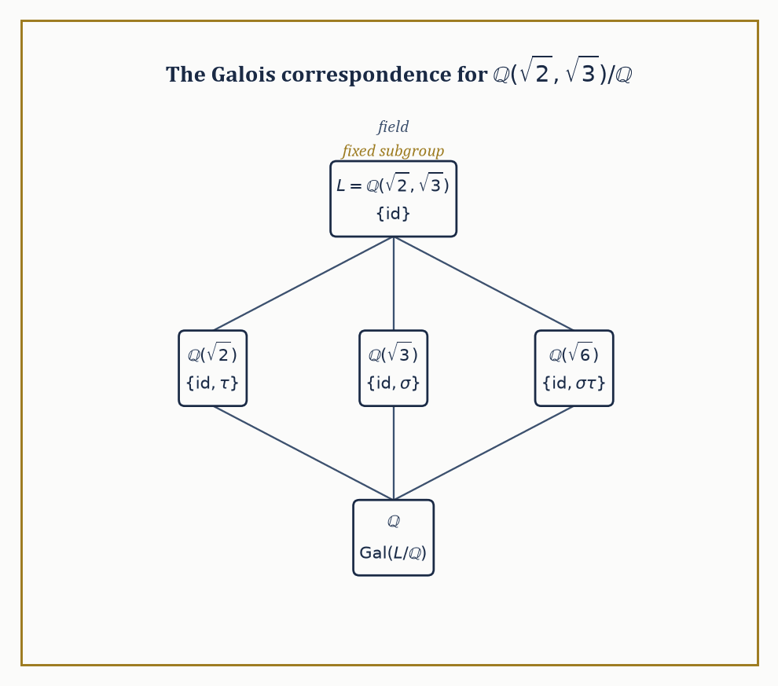
Figure 37.8 — Bigger field, smaller subgroup: the lattice of intermediate fields and the lattice of subgroups mirror each other exactly, one node per node.
When L/K is a finite Galois extension (meaning: normal, so L contains all roots of every irreducible polynomial over K that has one root in L, and separable, meaning no irreducible polynomial involved has repeated roots — automatic in characteristic zero, so ignore this clause unless you’re working over a finite field), the Galois group has order precisely [L:K], and the fundamental theorem of Galois theory sets up a perfect order-reversing correspondence: subgroups of Gal(L/K) correspond exactly to intermediate fields K⊆M⊆L, with bigger subgroups corresponding to smaller fields and vice versa.
Numeric example — The Galois group of ℚ(√2)/ℚ, found by hand. An automorphism σ of ℚ(√2) fixing ℚ is determined entirely by where it sends √2, because every element is a+b√2 with a,b∈ℚ fixed by σ. Since σ must preserve the relation (√2)²=2, we need
σ(√2)²=σ(2)=2
so σ(√2)=±√2 — only two possibilities. Both work: the identity (σ(√2)=√2), and the ‘conjugation’ map σ(a+b√2)=a-b√2. Check the second is a genuine homomorphism, starting from the fact that
(1+√2)(2+√2)=2+√2+2√2+2=4+3√2
so
σ((1+√2)(2+√2)) = σ(4+3√2) = 4−3√2
Separately,
σ(1+√2)σ(2+√2) = (1−√2)(2−√2) = 2−√2−2√2+2 = 4−3√2
They agree — σ really does preserve multiplication. So Gal(ℚ(√2)/ℚ) = {id, σ}, a group of order 2, matching [ℚ(√2):ℚ]=2 exactly as the theorem promises.
Try it now — Find the automorphisms of ℚ(√2) fixing ℚ. Answer →
The fundamental theorem is best appreciated by watching the correspondence in a case with more than one intermediate field to find, so that the ‘bijection’ part of the claim has some actual content to demonstrate rather than being vacuously true.
Numeric example — Four automorphisms, three intermediate fields, one Klein four-group. Take L=ℚ(√2,√3), with [L:ℚ]=4 as computed in Field Extensions. An automorphism fixing ℚ must send √2 to ±√2 and, independently, √3 to ±√3 (each is a root of its own minimal polynomial, x²−2 and x²−3 respectively, and roots must go to roots), giving four candidate automorphisms: id (√2↦√2, √3↦√3), σ (√2↦-√2, √3↦√3), τ (√2↦√2, √3↦-√3), and στ (√2↦-√2, √3↦-√3).
All four are genuine automorphisms, so Gal(L/ℚ) has exactly 4 elements, matching [L:ℚ]=4. Every non-identity element here squares to the identity (σ²: √2↦-√2↦√2, back to start), so the group is the Klein four-group ℤ/2ℤ×ℤ/2ℤ, not cyclic ℤ/4ℤ.
It has exactly three subgroups of order 2: {id,σ}, {id,τ}, {id,στ}. The fundamental theorem predicts three intermediate fields, and there they are: {id,σ} fixes the elements unmoved by σ, which is ℚ(√3) (σ negates √2 but fixes √3); {id,τ} fixes ℚ(√2); and {id,στ} fixes ℚ(√6) — check: στ sends
√6=√2·√3 ↦ (−√2)(−√3)=√6
unmoved, so √6 is indeed fixed by στ, giving the third intermediate field. Three subgroups, three intermediate fields, matched up as promised, and not one of them found by guesswork.
The single most famous application of this machinery is negative: it explains why there is no formula, built from addition, subtraction, multiplication, division, and root-extraction, that solves the general polynomial equation of degree five (or higher) in terms of its coefficients — in flat contradiction to the quadratic, cubic, and quartic formulas that had been known, with increasing difficulty, since the Renaissance.
Solvability of an equation by radicals corresponds, under Galois’s dictionary, to solvability of its Galois group — a purely group-theoretic property meaning the group can be broken down by a chain of normal subgroups with abelian quotients at every stage, mirroring the successive ‘take a root’ operations a radical formula performs.
Abstract example — Why S₅ refuses to cooperate. The Galois group of a ‘general’ degree-5 polynomial (one with algebraically independent, generic coefficients) is the full symmetric group S₅, of order 120. Consider its composition series:
S₅ ⊳ A₅ ⊳ {e}
where A₅ (order 60) is normal in S₅ with quotient S₅/A₅ ≅ ℤ/2ℤ, perfectly abelian and fine. The trouble is the next step down: A₅ itself, as noted in Group Actions, Cosets, and Quotient Groups, is simple — it has no normal subgroup at all except {e} and itself, so the composition series cannot be refined any further, and its only composition factor is A₅ itself, which is non-abelian.
A solvable group is required to have every composition factor abelian, and A₅ is not, so S₅ is not a solvable group. By Galois’s correspondence, this single group-theoretic fact — that A₅ is simple and non-abelian — is the entire, complete reason no radical formula for the general quintic can exist.
Abel proved this by other means in 1824; Galois’s contribution, arriving shortly after and costing him his life in a duel at twenty, was to explain why it was true and to hand every future equation, in every degree, a definitive yes-or-no test.
Galois theory is often called the crown of classical algebra, and it earns the title twice over: as a complete, satisfying resolution to a two-hundred-year-old open problem, and as the prototype for a pattern that recurs throughout later mathematics — a correspondence between geometric or algebraic objects and groups of symmetries that classify them completely.
Every ‘Galois correspondence’ encountered in later chapters, in covering space theory, in algebraic geometry’s étale fundamental group, in the deepest reaches of number theory’s Langlands program, is this same idea wearing yet another costume.
Keep only this · Section 37.8: Introduction to Galois Theory
The idea. The Galois group of an extension consists of the automorphisms fixing the base field. The fundamental theorem matches intermediate fields with subgroups, reversing inclusions, and solvability by radicals corresponds to solvable Galois groups — which S₅ is not.
Core.
|Gal(L/K)| = [L : K] for Galois L/K
intermediate fields ↔ subgroups (inclusion reversed)
solvable by radicals ⇔ Galois group solvable
Typical mistake. Assuming every quintic is unsolvable. Some, such as x⁵ − 2, are solvable; the general quintic is not.
Minimal example. Gal(ℂ/ℝ) = {id, complex conjugation}.
Practice. Easy to challenge; full worked answers, with the usual mistake, are in Answers to the Practice Sets at the back.
Easy — Find the Galois group of ℚ(√2, √3)/ℚ. Answer →
Medium — List the intermediate fields of ℚ(√2, √3)/ℚ, and the subgroups they correspond to. Answer →
Challenge — Why does the fundamental theorem rule out a general formula for degree 5? Answer →

Section 37.9: Looking Ahead: From Abstract Algebra to Algebraic Geometry, Number Theory, and Representation Theory
Where the Structure We Just Built Goes to Work
We have, over the last eight sections, assembled the core vocabulary of abstract algebra: groups (one operation, symmetry made precise), rings (two operations, arithmetic made general), fields (division added back in), modules (linear algebra freed from requiring a field), field extensions (building new number systems to order), and Galois theory (the symmetry group that decides which equations can be solved). It has been, by any honest reckoning, a great deal of checklist-checking and coset-counting for what looks, from a distance, like a fairly short list of axioms. The payoff is that this short list now unlocks a genuinely enormous amount of further mathematics, essentially for free.
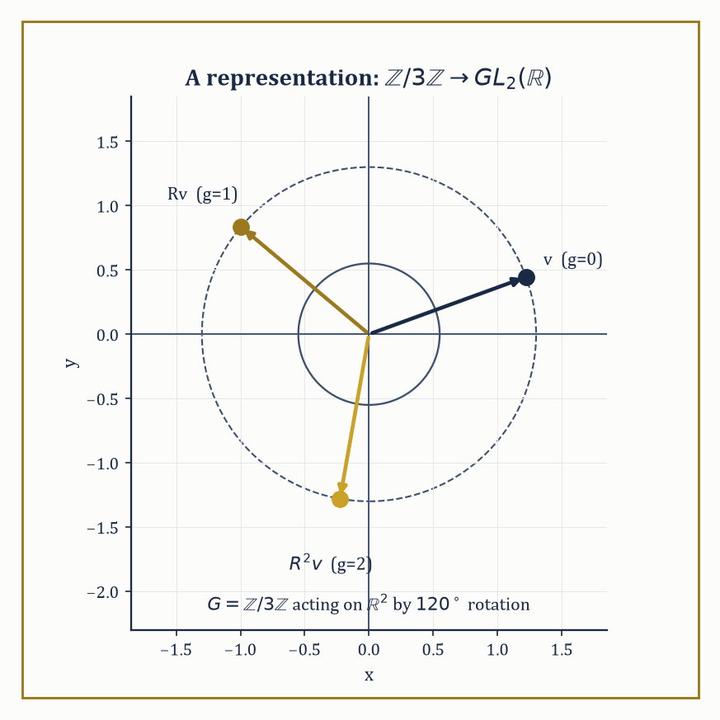
Figure 37.9 — The abstract group ℤ/3ℤ, made concrete: three applications of a 120° rotation return a vector to where it started.
Algebraic number theory takes the rings of integers inside number fields — generalizations of the Gaussian integers ℤ[i] and the ℤ[√−5] whose broken factorization caused so much trouble in Factorization in Integral Domains — and studies them via ideals rather than elements because element-factorization can fail. The ideal class group measures just how badly unique factorization fails (it is trivial when the ring is a UFD), and Dedekind zeta functions package arithmetic information about these rings into analytic objects, generalizing the Riemann zeta function this series has not yet met but will.
Abstract example — The ring of integers as a bridge to geometry. Consider the ring R, defined as the quotient
R=ℝ[x,y]/(x²+y²−1)
Its elements are polynomial functions on the unit circle — any polynomial identity involving x²+y² is simplified using the relation
x²+y²=1
R is precisely the ring of coordinate functions of the circle as an algebraic variety — the point set
{(x,y)∈ℝ² : x²+y²=1}
and the ring R determine each other completely, a correspondence formalized as ‘Spec’ in algebraic geometry. This is the same move as ℤ ↔ ‘the ring of integer-valued arithmetic’ generalized one dimension up: instead of a ring encoding number-theoretic data, it encodes geometric data. The entire modern subject of algebraic geometry is the systematic working-out of how much of a geometric shape can be recovered purely from its ring of functions — commutative algebra, unglamorously, turns out to be the technical engine underneath essentially all of it.
Try it now — A rotation by 120° represents ℤ/3ℤ on ℝ². What is R³? Answer →
Representation theory studies groups not in the abstract but acting concretely on vector spaces — a representation of G is a homomorphism G → GL(V) for some vector space V, which turns every abstract group into a group of matrices and every abstract question into a question of linear algebra, at the cost of having to classify all the different ways a given group can act. It is, in a sense, the reverse move to everything else in this chapter: rather than stripping numbers away to find the bare operation, representation theory takes the bare operation and hands it back a vector space to act on, chosen so as to make the group’s structure as visible as possible.
Numeric example — Rotating the plane by a third of a turn. Let G be the cyclic group of order three, represented on V=ℝ² by sending the generator 1 to the rotation matrix R, rotation by 120°:
G = ℤ/3ℤ = {0,1,2}
R = [cos 120° −sin 120°; sin 120° cos 120°] = [−1/2 −√3/2; √3/2 −1/2]
Check this respects the group structure: 1+1=2 in G should correspond to R² (rotating twice). Rotating by 120° twice is rotating by 240°, and indeed:
R² = [cos 240° −sin 240°; sin 240° cos 240°] = [−1/2 √3/2; −√3/2 −1/2]
Matrix multiplication of R by itself confirms this (the computation is routine trigonometric bookkeeping and comes out to the 240° matrix). And 1+1+1=0 in G should correspond to R³ = identity — three rotations of 120° bring you back to the start, i.e. a full 360° turn, exactly as required.
This tiny example already displays the whole point of the subject: the abstract cyclic group of order 3 has been made concrete as a specific, visualizable, matrix-multiplying symmetry of the plane, and every question about ℤ/3ℤ’s structure can now be answered by looking at rotations instead of by manipulating residues mod 3.
And underlying every construction in this chapter — homomorphism, kernel, quotient, universal property — sits a pattern that category theory, immediately ahead of us in Chapter 38 (Volume 4), finally gives a name and a grammar of its own: objects, arrows between them, and the diagrams that must commute. Where this chapter asked ‘what structures satisfy these axioms’, the next asks the question one level up: ‘what do groups, rings, fields, and even topological spaces have in common as categories, regardless of which axioms define their objects internally’ — the abstraction of the abstraction, and, mercifully, very nearly the last one this series will ask of you before the view starts paying for the journey.
The deeper lesson of this chapter is not any single theorem but the method itself: isolate the formal properties that make a familiar manipulation work, forget everything else about the objects involved, and discover that the resulting skeleton organizes vast, unrelated-looking tracts of mathematics under one roof. Number theory, geometry, and symmetry turn out to be speaking the same underlying language far more often than their surface vocabularies let on, and the fact that a rotation matrix, a residue class, and a coset can all be instances of the same three-line definition is not a curiosity to be filed away — it is, quietly, the central discovery of everything we have done since What Abstract Algebra Is.
Abstract algebra is the study of structure itself — not the structure of any one system, but the shared skeleton underneath many. Groups gave us symmetry with the numbers washed off; rings and fields gave us arithmetic generalized past recognition; Galois theory gave us a group that decides, definitively, which equations can and cannot be solved by the algebra your school teacher trusted implicitly. The classification of finite simple groups, the structure theorem for modules, and the impossibility of the quintic formula are not three unrelated facts — they are three consequences of the same handful of axioms, taken seriously and followed all the way to the end.
We have learned, over this chapter, to study operations without numbers attached — and the series continues regardless, indifferent to how comfortable we’ve grown.
The next chapter takes the compression one notch further. Category theory looks back at everything built here — groups and their homomorphisms, rings and their homomorphisms, vector spaces and their linear maps — and notices that ‘a collection of objects and the structure-preserving maps between them’ is itself a pattern worth naming, regardless of what the objects or the maps happen to be internally. It is the abstraction of abstraction, and by the time we reach it, this chapter’s groups, rings, and fields will have silently become mere examples of something even more general — which is, incidentally, the trick this chapter just finished performing on ordinary arithmetic.
Where this returns
Category Theory (Volume 4) answers the four questions of this chapter’s first box at once: functors are the maps between whole kinds of structure, and universal properties explain why quotients, products and kernels look the same everywhere.
Keep only this · Section 37.9: Looking Ahead: From Abstract Algebra to Algebraic Geometry, Number Theory, and Representation Theory
The idea. Abstract algebra opens three roads: algebraic geometry, where rings of functions describe shapes; algebraic number theory, where ideals restore unique factorization; and representation theory, where groups act by matrices.
Core.
ℝ[x, y]/(x² + y² − 1): functions on the circle
representation: ρ(gh) = ρ(g) ρ(h)
character: χ(g) = trace ρ(g)
Typical mistake. Thinking a representation must be faithful. The trivial representation sends everything to 1.
Minimal example. ℤ/2ℤ acting on ℝ by ±1.
Practice. Easy to challenge; full worked answers, with the usual mistake, are in Answers to the Practice Sets at the back.
Easy — Find the character of the 120° rotation representation of ℤ/3ℤ. Answer →
Medium — In ℝ[x, y]/(x² + y² − 1), simplify x² + y² + 3. Answer →
Challenge — Check the orthogonality ⟨χ, χ⟩ = (1/|G|)Σ|χ(g)|² for that representation, and say what it shows. Answer →
Chapter 37 recap · Abstract Algebra
• Abstract algebra studies operations through their axioms, so one theorem covers every system with the same skeleton.
• Groups, subgroups and homomorphisms; Lagrange: the order of a subgroup divides the order of the group.
• Actions give orbit–stabilizer; normal subgroups give quotient groups, and kernels are exactly the normal subgroups.
• Rings and ideals mirror groups and normal subgroups; ℤ/nℤ is a field exactly when n is prime, and unique factorization can fail.
• Finite abelian groups are products of cyclic groups; modules generalize vector spaces and explain Jordan form.
• Field degrees multiply in towers, and Galois groups match intermediate fields with subgroups.

Check Your Understanding — Chapter 37
Answers are in the Answer Key at the back of the book — have a go before you look.
1. [Explain] S₃ has order 6. Without checking every subset by hand, explain why S₃ cannot have a subgroup of order 4 or of order 5.
See the answer →
2. [Compute] Find 2⁻¹ in ℤ/5ℤ, and explain why ℤ/5ℤ is a field while ℤ/6ℤ is not even an integral domain.
See the answer →
3. [Explain] Every abelian group is automatically a ℤ-module, but why does ℤ/6ℤ, viewed as a ℤ-module, have no basis in the vector-space sense?
See the answer →
4. [Explain] What single group-theoretic fact explains why there is no formula, using only addition, subtraction, multiplication, division, and root-extraction, that solves the general quintic equation?
See the answer →
5. [Compute] List all subgroups of ℤ/12, verify Lagrange’s theorem, and identify which are cyclic.
See the answer →
6. [Compute] Construct the field with four elements and give its addition and multiplication tables.
See the answer →
7. [Compute] Determine the Galois group of x⁴ − 2 over ℚ, and describe the corresponding subfield lattice.
See the answer →
8. [Compute] In S₄, compute the conjugate of (1 2 3) by (1 4), and state the general rule.
See the answer →
9. [Explain] Why must a subgroup be normal for the quotient to be a group?
See the answer →
10. [Explain] A ring has two operations and a field has the same two. What exactly is the extra demand, and why does it change so much?
See the answer →
11. [Explain] Why is the general quintic unsolvable by radicals when the quartic is not?
See the answer →
12. [Prove] Prove Lagrange’s theorem: the order of a subgroup divides the order of the group.
See the answer →
13. [Prove] Prove the first isomorphism theorem: for a homomorphism φ : G → H, G/ker φ ≅ im φ.
See the answer →
14. [Prove] Prove that every finite integral domain is a field.
See the answer →
15. [Prove] Prove Cayley’s theorem: every group embeds in a symmetric group.
See the answer →
16. [Prove] Prove that the kernel of a homomorphism is normal, and that every normal subgroup is such a kernel.
See the answer →
17. [Prove] Prove the fundamental theorem of Galois theory in outline, stating the hypotheses.
See the answer →
18. [Challenge] The chapter opens by announcing that we stop measuring things and start asking what an operation is. What is gained by studying structure rather than objects?
See the answer →
19. [Challenge] Galois theory is usually presented as a result about polynomial equations. What is the more general lesson?
See the answer →
20. [Challenge] Simple groups are called the atoms of group theory, and their classification took thousands of pages. What does the analogy actually claim?
See the answer →
21. [Challenge] Rings, modules, groups and fields all have isomorphism theorems of the same shape. Why should the pattern repeat?
See the answer →
22. [Challenge] Symmetry is described as a group. Is that a definition, a discovery, or a convention?
See the answer →
23. [Challenge] This chapter ends the volume by studying structure itself. Why is that the right place to stop, and what does Chapter 38 (Volume 4) do that this chapter cannot?
See the answer →

Problems — Chapter 37
The questions above test whether the ideas landed. These ask you to use them. Solutions are in Solutions to the Problems at the back. Work them before you look.
1. [Compute] In ℤ/2ℤ × ℤ/2ℤ, what is the order of each non-identity element? Why is the group not cyclic?
2. [Explain] A₃ inside S₃ has index 2. Why does that alone make A₃ normal?
3. [Compute] In ℤ, the ideal (2) is the even integers. What is the quotient ring ℤ/(2)?
4. [Concept] x² − 2 is irreducible over ℚ. What does that say about ℚ[x] / (x² − 2)?

Epilogue — Between Volumes
This is a pause, not the end. The book continues in Volume 4.
Thirty-seven chapters are behind you. Differential equations, optimization, numerical methods, geometry, topology, functional analysis, measure theory, and abstract algebra are the working language of most of modern mathematics, and you have now met all of them at least once.
Before going on, consider rereading the chapter that resisted you. Measure theory and functional analysis in particular read very differently the second time, once you know where they are going.
When you are ready, Volume 4, From Category Theory to the Frontier, opens with category theory — the language that describes what all of these structures have in common — and ends with mathematics put to work on the world.
We have spent thirty-seven chapters asking what mathematical objects are. The next question is what mathematics looks like when the arrows between the objects become primary.

Answer Key
Answers to every “Check Your Understanding” question, grouped by chapter and in the same order they were asked.
Chapter 26: Differential and Integro-Differential Equations
1. Uniqueness needs the stronger Lipschitz condition, not mere continuity. The x-derivative of x^(1/3) is (1/3)x^(−2/3), which blows up as x → 0, so f is not Lipschitz near the starting point — nearby solutions are free to separate arbitrarily fast. Indeed both x(t) ≡ 0 and x(t) = (2t/3)^(3/2) satisfy the equation and start at x(0) = 0.
← Back to question
2. Take V(x) = x²/2, which is positive definite. Then V̇(x) = V′(x)·x′ = x·(−x³) = −x⁴, strictly negative for all x ≠ 0, so the origin is asymptotically stable — a conclusion linearization could not reach. The method certifies stability but says nothing about the rate: the decay here is the slow polynomial x⁴ rather than the exponential decay of a hyperbolic sink.
← Back to question
3. Carrying out the integral gives y(x) = x²/2 − x/2 = x(x − 1)/2. This matches the direct solution obtained by integrating y″ = 1 twice and applying y(0) = y(1) = 0, confirming the Green’s-function machine reproduces the answer without needing to know f in advance.
← Back to question
4. The system is asymptotically stable for 0 < a < π/2 and unstable for a > π/2, with a = π/2 sitting exactly on the stability boundary. At that value the characteristic root λ = iπ/2 lies on the imaginary axis, sustaining an undying oscillation of period 4 rather than decaying or blowing up.
← Back to question
5. [Compute] The characteristic polynomial is λ² + 3λ + 2 = 0, so λ = −1 and λ = −2. For λ = −1, (A + I)v = 0 gives v = (1, −1); for λ = −2, (A + 2I)v = 0 gives v = (1, −2). Hence x(t) = c₁e⁻ᵗ(1, −1) + c₂e⁻²ᵗ(1, −2). Both eigenvalues are real, distinct and negative, so the origin is a stable node: every trajectory decays to it, and since e⁻²ᵗ dies faster, trajectories align with the slow direction (1, −1) as t grows. The fast eigendirection governs the approach, the slow one governs the arrival — a distinction that matters enormously once you try to integrate this numerically in Chapter 29.
← Back to question
6. [Compute] For λ > 0 write λ = k². The general solution is y = A cos kx + B sin kx. y(0) = 0 forces A = 0; y(L) = 0 then needs B sin kL = 0 with B ≠ 0, so kL = nπ. Hence λₙ = (nπ/L)² and yₙ = sin(nπx/L), n = 1, 2, 3, …. (λ ≤ 0 gives only the zero solution — check this, it is where the boundary conditions do their work.) For orthogonality with n ≠ m, use the product-to-sum identity: ∫₀ᴸ sin(nπx/L)sin(mπx/L)dx = ½∫₀ᴸ [cos((n−m)πx/L) − cos((n+m)πx/L)]dx, and both cosine integrals vanish over the interval because n ± m are non-zero integers. The eigenfunctions are therefore mutually orthogonal, which is what licenses the Fourier expansion.
← Back to question
7. [Model] Equilibria solve x² − x + h = 0, giving x± = (1 ± √(1 − 4h))/2, which are real only when h ≤ ¼. Writing f(x) = x(1 − x) − h, we have f′(x) = 1 − 2x, so f′(x₊) = −√(1 − 4h) < 0 (stable) and f′(x₋) = +√(1 − 4h) > 0 (unstable). As h rises the two equilibria approach each other and merge at h = ¼, x = ½, where f′ = 0 — a saddle-node bifurcation. For h > ¼ there is no equilibrium at all: f < 0 everywhere and the population runs to zero in finite time. The practical sting is that collapse is not gradual. Harvesting just below ¼ leaves a viable stable state; a fractional increase destroys it outright, with no warning visible in the equilibrium value itself.
← Back to question
8. [Compute] Split A = 2I + N where N = [0 1; 0 0]. These commute, so eᴬᵗ = e²ᴵᵗeᴺᵗ = e²ᵗeᴺᵗ. Since N² = 0 the second exponential terminates after two terms: eᴺᵗ = I + Nt = [1 t; 0 1]. Hence eᴬᵗ = e²ᵗ[1 t; 0 1]. The diagonal answer fails because A is defective: the eigenvalue 2 has algebraic multiplicity 2 but only a one-dimensional eigenspace, so A is not diagonalizable. The missing eigenvector is precisely what the factor t is compensating for, and that t is why solutions here grow like te²ᵗ rather than pure exponentials.
← Back to question
9. [Explain] Linearization classifies an equilibrium by the eigenvalues of the Jacobian, and the argument works because a non-zero real part sets a definite exponential rate that the higher-order terms, being small near the equilibrium, cannot overturn. When an eigenvalue has zero real part that margin disappears, and the nonlinear terms become the deciding vote. The cleanest demonstration is a pair: x′ = −x³ and x′ = +x³ have identical linearizations at the origin, namely x′ = 0, yet the first is asymptotically stable and the second is unstable. No method that looks only at the linear part can possibly separate them, because the linear parts are the same object. This is exactly the boundary of the Hartman–Grobman theorem, and it is why Lyapunov functions are not an optional refinement but a necessity.
← Back to question
10. [Concept] An IVP fixes all the data at a single point and then marches forward; existence and uniqueness follow from a local contraction argument, and nothing downstream can contradict a choice already made. A BVP imposes conditions at two separated points, so the solution must satisfy a constraint it cannot see until it arrives. Solvability then becomes a global, algebraic question rather than a local, analytic one. Concretely, y″ + y = 0 with y(0) = y(π) = 0 has the infinite family y = c·sin x, while the same equation with y(0) = 0, y(π) = 1 has no solution at all — the equation has already decided what y(π) must be. The dividing line is whether the homogeneous problem admits a non-trivial solution, which is to say whether you have landed on an eigenvalue.
← Back to question
11. [Explain] With V̇ ≤ 0 the sublevel sets are trapping, so trajectories are bounded and V decreases monotonically to some limit — but that limit might be attained on a whole set rather than at the equilibrium, so Lyapunov alone yields stability without attraction. LaSalle observes that a bounded trajectory must approach the largest invariant set contained in {V̇ = 0}. If that set is the equilibrium alone, asymptotic stability follows. A damped pendulum makes the point: with V the total energy, V̇ = −c·ω² vanishes on the entire line ω = 0, yet the only way to stay there is to sit at the bottom, since anywhere else gravity immediately restores motion. The invariance requirement does the work the strict inequality would otherwise have done.
← Back to question
12. [Prove] Strategy: differentiate the determinant column by column, then use Φ′ = AΦ to replace each differentiated column, and let the other columns annihilate everything except one term. The pivotal step: d/dt det Φ = Σᵢ det(Φ with its i-th column replaced by the derivative of that column) — and the derivative of the i-th column is A times that column, which expands as a combination of all the columns. Every contribution except the aᵢᵢ one repeats a column already present, so its determinant is zero. Target: the surviving terms give W′ = (Σᵢ aᵢᵢ)W = tr(A)W. Note what this buys you: the Wronskian is either identically zero or never zero, since W(t) = W(t₀)exp∫tr A. Independence, once established anywhere, holds everywhere.
← Back to question
13. [Prove] Strategy: suppose two solutions, bound the growth of their difference by an integral of itself, and let Grönwall close the trap. Do not try to construct anything. The pivotal step: write both solutions in integral form and subtract, giving |x(t) − y(t)| ≤ ∫ |f(s, x) − f(s, y)|ds ≤ L∫|x(s) − y(s)|ds, where the Lipschitz constant is doing all the work. Target: with initial difference zero, Grönwalls inequality gives |x − y| ≤ 0·exp(L(t−t₀)) = 0, so the solutions coincide. Then look back at question 1: x^(1/3) is continuous but not Lipschitz at 0, and the proof fails at exactly the step where L would have appeared.
← Back to question
14. [Prove] Strategy: integrate by parts twice and show the boundary terms cancel — the whole result lives or dies on those terms, not on the interior. The pivotal step: two integrations by parts give ∫(L[u]v − uL[v])dx = [p(uv′ − u′v)] evaluated at the two endpoints, with the interior contributions canceling identically. Target: separated boundary conditions of the form αy(a) + βy′(a) = 0 make the bracket vanish at each endpoint independently, so ⟨L[u], v⟩ = ⟨u, L[v]⟩. Everything downstream — real eigenvalues, orthogonal eigenfunctions, completeness — follows from this one cancellation, so it is worth checking for yourself which boundary conditions do and do not achieve it. Periodic ones do; mixed ones with the wrong sign do not.
← Back to question
15. [Prove] Strategy: apply self-adjointness to the two eigenfunctions and let the eigenvalues separate. The pivotal step: from L[yₙ] = λₙ w yₙ and L[yₘ] = λₘ w yₘ, form ⟨L[yₙ], yₘ⟩ − ⟨yₙ, L[yₘ]⟩. Self-adjointness makes the left side zero, while the right side becomes (λₙ − λₘ)∫ w yₙ yₘ dx. Target: since λₙ ≠ λₘ, the integral must vanish, which is orthogonality in the weighted inner product. Notice that the weight is not decoration — it is forced on you by the equation, and using the unweighted inner product instead will give you a false answer whenever w is not constant.
← Back to question
16. [Prove] Strategy: do not count solutions directly. Build a linear map from the solution set to ℝⁿ and show it is an isomorphism. The pivotal step: fix t₀ ∈ I and define E(x) = x(t₀), evaluation at a point. Linearity is immediate; existence of a solution through every initial vector gives surjectivity, and uniqueness gives injectivity — so the entire result is existence-and-uniqueness in disguise. Target: E is an isomorphism, hence the solution space has dimension n. This is why n independent solutions are not merely sufficient but exactly the right number, and why a fundamental matrix is a basis rather than a lucky find.
← Back to question
17. [Prove] Strategy: convert the periodic problem into a constant-coefficient one by peeling off the periodic part. The pivotal step: the Floquet factorization Φ(t) = P(t)eᴮᵗ with P periodic and invertible, so P and P⁻¹ are bounded on ℝ and contribute nothing to long-term growth or decay. All asymptotic behavior therefore sits in eᴮᵗ, and eᴮᵀ = Φ(T) since P(T) = P(0) = I. Target: the Floquet multipliers, meaning the eigenvalues of Φ(T), govern stability — all strictly inside the unit circle gives asymptotic stability, any outside gives instability. Multipliers on the unit circle are the delicate case, and are exactly where parametric resonance lives.
← Back to question
18. [Prove] Strategy: iterate the operator and show the iterates shrink factorially, so that some power is a contraction even though the operator itself need not be. The pivotal step: if |K| ≤ M, an induction on the nested integrals gives |(Vⁿu)(t)| ≤ Mⁿtⁿ/n!·‖u‖, because each successive integration is over a shrinking simplex rather than the whole interval — this is the property a Fredholm equation lacks and the reason the two behave so differently. Target: MⁿTⁿ/n! → 0, so some Vⁿ is a contraction and the Banach fixed-point theorem applies on all of [0, T], not merely locally. The Neumann series Σ VⁿF then converges absolutely and sums to the resolvent.
← Back to question
19. [Challenge] It costs you the finite-dimensional state space, and almost everything that rested on it. To start an ODE you supply a point in ℝⁿ; to start u′(t) = −a·u(t − 1) you must supply an entire function on [−1, 0], because the equation will consult it. The state is therefore a point in a function space, and the phase space is infinite-dimensional. The consequences follow immediately: the characteristic equation becomes transcendental with infinitely many roots rather than polynomial with n, so a scalar delay equation can oscillate where a scalar ODE provably cannot; trajectories can cross in the projected picture because the projection has thrown away most of the state; and the tools you need are the ones Chapter 35 builds. Memory is not a complication added to an ODE — it is a different kind of object wearing similar notation.
← Back to question
20. [Challenge] Because the equation u = f + λKu is nothing more than (I − λK)u = f, and inverting (I − λK) is the operator version of dividing by (1 − x). The expansion (I − λK)⁻¹ = I + λK + λ²K² + … is the geometric series with the number x replaced by the operator λK, and the resolvent kernel is precisely the kernel of that sum. The analogy is exact, and so is its limitation: the scalar series needs |x| < 1 and the operator series needs ‖λK‖ < 1. What is remarkable about the Volterra case is that the factorial decay of the iterated kernels makes the series converge for every λ whatsoever, which has no scalar counterpart at all. Chapter 35 will name this the Neumann series and put it to work on operators that have nothing to do with integration.
← Back to question
21. [Challenge] What is bought is permission to reason about a nonlinear system using a linear picture near the equilibrium: the phase portraits can be deformed into one another continuously, so the qualitative classification — node, saddle, spiral, and which trajectories go where — transfers intact. What is given up is smoothness. The conjugacy is only a homeomorphism, not a diffeomorphism, so quantities that depend on derivatives, notably the rates of approach, need not survive. The theorem tells you the shape of the picture and deliberately refuses to tell you its speed. And the hypothesis is doing real work rather than tidying up: the moment an eigenvalue touches the imaginary axis the nonlinear terms acquire a vote, the conjugacy fails, and the phenomena that bifurcation theory studies are precisely the ones living on that forbidden line.
← Back to question
22. [Challenge] Not the sines and cosines — the self-adjointness. Fourier expansion works because −d²/dx² together with its boundary conditions is a self-adjoint operator, and self-adjointness is what forces the eigenvalues to be real, the eigenfunctions belonging to distinct eigenvalues to be orthogonal, and the family to be complete. Change the operator and you change the eigenfunctions but not the machinery: Bessel functions, Legendre polynomials and Hermite functions are all eigenfunction families of their own Sturm–Liouville problems, and each supports its own expansion theorem for the same reason. Seen this way, “expand in a Fourier series” and “expand in Legendre polynomials” are the same instruction addressed to different operators. Chapter 35 completes the thought by dropping the differential equation entirely and keeping only the self-adjointness.
← Back to question
23. [Challenge] In a completely literal sense: L is a linear operator, G is the kernel of L⁻¹, and y = ∫G(x, ξ)f(ξ)dξ is matrix inversion with the sum over indices replaced by an integral over a continuum. G(x, ξ) is the response at x to a unit impulse applied at ξ, so the integral is superposition — the same principle that lets you add forces, add voltages, and add solutions of any linear problem whatsoever. That is why the object reappears everywhere linearity does: as the fundamental solution of a PDE in Chapter 27, as the impulse response of a filter in signal processing, as the propagator in quantum mechanics in Chapter 47 (Volume 4). They are one construction viewed from four buildings. The moment a problem stops being linear, superposition fails and the Green’s function has nothing to superpose.
← Back to question
24. [Challenge] The principle is the Fredholm alternative: for a linear problem, either the homogeneous version has only the trivial solution and the inhomogeneous one is uniquely solvable for every right-hand side, or the homogeneous version has non-trivial solutions and the inhomogeneous one is solvable only when the data is orthogonal to them. There is no third possibility. A BVP that lands on an eigenvalue is in the second case, which is why y″ + y = 0 with y(0) = 0, y(π) = 1 is unsolvable — the forcing is not orthogonal to sin x. The same alternative governs when a matrix equation Ax = b is solvable, which is the finite-dimensional shadow of it, and it returns in full generality in Chapter 35 as a theorem about compact operators. It is one of the genuinely unifying facts in the book.
← Back to question
Chapter 27: Partial Differential Equations
1. As n grows, the initial data shrink uniformly to zero (amplitude 1/n → 0), but at any fixed y > 0 the solution’s amplitude, (1/n²)sinh(ny), grows without bound because sinh grows exponentially in n. An arbitrarily small change in the data thus produces an arbitrarily large change in the solution, which violates the continuous-dependence requirement of well-posedness.
← Back to question
2. Each characteristic starting at x0 moves as x(t) = x0(1−t), so every characteristic — regardless of its starting point x0 — reaches x = 0 simultaneously at t = 1. Because they all converge on one point at once, the solution’s slope uₓ = −1/(1−t) blows up as t → 1⁻, and no classical (single-valued, smooth) solution exists beyond that moment; a shock forms purely from the equation’s own nonlinearity.
← Back to question
3. The domain of dependence is [x0 − ct0, x0 + ct0] = [5 − 6, 5 + 6] = [−1, 11]. Any initial data outside this interval — say a bump centered at x = 20 — has exactly zero effect on u(5,3), because the two characteristic lines through (5,3) only reach back to that stretch of the initial line.
← Back to question
4. The Fourier sine coefficients are bₙ = 8/(πn³) for odd n, which decay like 1/n³, so b3 ≈ 0.094 is already about 27 times smaller than b1 ≈ 2.55 — the two-term sum (≈2.4522) is already close to the exact value π²/4 ≈ 2.4674. In time each mode decays as exp(−n²t), so the n=3 term dies out nine times faster in the exponent than the n=1 term, meaning the higher modes vanish almost immediately and the profile rapidly collapses onto the pure n=1 sine shape.
← Back to question
5. [Compute] Along a curve x(t) with dx/dt = c, the chain rule gives d/dt u(x(t), t) = uₜ + c·uₓ = 0, so u is constant on those curves. The characteristics are the straight lines x = x₀ + ct, hence u(x, t) = u(x − ct, 0) = exp(−(x−ct)²). In words: the initial bump travels rigidly to the right at speed c, neither spreading nor decaying. Every hyperbolic equation is a variation on this theme — information moves along characteristics at finite speed, which is why the wave equation has a light cone and the heat equation does not.
← Back to question
6. [Compute] Separating variables u = X(x)T(t) gives X″/X = T′/(kT) = −λ. The boundary conditions force the Sturm–Liouville problem of Chapter 26: λₙ = (nπ/L)², Xₙ = sin(nπx/L). The time factor solves T′ = −kλₙT, so Tₙ = exp(−k(nπ/L)²t). The initial data is already the pure third mode, so no expansion is needed: u(x, t) = sin(3πx/L)·exp(−9kπ²t/L²). In general the n-th mode decays like exp(−k(nπ/L)²t), so the rate grows as n². High-frequency detail is annihilated almost immediately while the fundamental lingers, which is why heat flow smooths data and why running it backwards is hopeless.
← Back to question
7. [Compute] dAlembert gives u(x, t) = ½[f(x + ct) + f(x − ct)] + (1/2c)∫[x−ct, x+ct] g(s)ds. With f = 0 only the integral survives, so u(x, t) = (1/2c)·|[x − ct, x + ct] ∩ [−1, 1]|, one over 2c times the length of the overlap. For large t the interval of integration swallows [−1, 1] entirely whenever |x| < ct − 1, giving u = 1/c there, while u = 0 outside |x| < ct + 1. The solution is a plateau of height 1/c spreading at speed c with ramped edges of width 2. Note the contrast with the heat equation: the disturbance has a sharp front and a region it has not yet reached at all.
← Back to question
8. [Compute] Characteristics carry constant u, so a characteristic leaving x₀ has speed u(x₀, 0) = −x₀ and satisfies x(t) = x₀ − x₀t = x₀(1 − t). Every characteristic therefore reaches x = 0 at t = 1, regardless of where it started — they all keep an appointment at the origin. Differentiating u(x, t) = −x₀ with x₀ = x/(1 − t) gives uₓ = −1/(1 − t), which blows up as t → 1⁻. The solution stays bounded (|u| ≤ |x₀|) while its slope becomes infinite: this is gradient catastrophe, and it is how shocks form. Beyond t = 1 no classical solution exists and one must pass to weak solutions with a jump condition.
← Back to question
9. [Explain] Because their solution operators do opposite things to high frequencies. Expanding in modes, the heat equation multiplies the n-th coefficient by exp(−kn²t), which for any t > 0 crushes large n faster than any polynomial — so the solution is infinitely differentiable immediately, no matter how rough the initial data. The wave equation multiplies by cos(nct) and sin(nct)/nc, which have modulus at most 1 and do not decay at all: the high frequencies are merely rotated, so whatever roughness was present is transported rather than removed. This is the analytic face of a geometric fact — heat propagates with infinite speed and averages, waves propagate at speed c and preserve. It is also why the heat equation cannot be run backwards: undoing exp(−kn²t) means multiplying by exp(+kn²t), which amplifies any noise catastrophically.
← Back to question
10. [Explain] Hadamard’s three conditions are existence, uniqueness, and continuous dependence on the data. The third is the one that bites. Backward heat flow has solutions and they are unique, but perturbing the data by ε·sin(nx) changes the solution at earlier times by ε·exp(+kn²t)sin(nx), which for large n is enormous however small ε is. Two data sets indistinguishable to any measurement therefore yield wildly different answers, so the problem is useless numerically even though it is perfectly well defined mathematically. This is not a defect of the method but of the question: information has genuinely been destroyed by the forward flow, and no amount of cleverness recovers it. Ill-posed problems are not forbidden — tomography is one — but they must be regularized, which means deciding in advance what to assume about the answer.
← Back to question
11. [Explain] Because the discriminant decides whether the equation has real characteristic directions, and characteristics are the curves along which information travels. Hyperbolic (B² − 4AC > 0) gives two real families, so data propagates along them at finite speed and singularities persist — waves. Parabolic (= 0) gives one repeated family, a degenerate case in which the equation smooths in the remaining direction — diffusion. Elliptic (< 0) gives no real characteristics at all, so there is no direction along which information can travel without mixing, every point depends on every other, and solutions are analytic in the interior — equilibrium. The algebra is not a coincidence: it is the same discriminant that decides whether a conic is a hyperbola, parabola or ellipse, and for the same reason.
← Back to question
12. [Prove] Strategy: prove it first for a strict subsolution, where the argument is elementary, then recover the general case by perturbation. Do not attempt the sharp statement directly. The pivotal step: if Δv > 0 strictly, then v can have no interior maximum, because at an interior maximum the Hessian is negative semi-definite and so Δv ≤ 0 — a contradiction. Now given harmonic u, set v = u + ε|x|², which satisfies Δv = 2nε > 0. Target: apply the strict case to v, then let ε → 0 to conclude max[Ω] u = max[∂Ω] u. The perturbation trick is worth remembering; it recurs throughout elliptic theory whenever a non-strict inequality blocks a direct argument.
← Back to question
13. [Prove] Strategy: subtract two solutions and show the difference has zero energy. The pivotal step: the difference w satisfies Δw = 0 in Ω and w = 0 on ∂Ω; multiply by w, integrate, and use Green’s first identity to move a derivative, giving ∫[Ω] |∇w|² = ∫[∂Ω] w·∂w/∂n − ∫[Ω] wΔw, in which both right-hand terms vanish — the first because w = 0 on the boundary, the second because w is harmonic. Target: ∫|∇w|² = 0 forces ∇w ≡ 0, so w is constant, and the boundary condition makes that constant zero. Note that this proof, unlike the maximum principle, transfers immediately to systems and to equations with variable coefficients, which is why it is the one that survives into Chapter 35.
← Back to question
14. [Prove] Strategy: substitute to reduce to the standard Gaussian integral; do not attempt to integrate directly. The pivotal step: put s = x/√(4kt), so that dx = √(4kt)ds and the prefactor cancels exactly, leaving (1/√π)∫exp(−s²)ds. Target: since ∫[−∞, ∞] exp(−s²)ds = √π, the total integral is 1 for every t, independent of t. That independence is the point: it says the heat equation conserves total heat, redistributing it without creating or destroying any. Check the consequence for yourself — as t → 0⁺ the kernel concentrates at the origin while keeping unit mass, which is precisely the statement that it converges to a delta.
← Back to question
15. [Prove] Strategy: do not try to show every solution separates — most do not. Show instead that the separated solutions span. The pivotal step: the eigenfunctions sin(nπx/L) form a complete orthogonal system in L²(0, L), a fact inherited from the self-adjointness established in Chapter 26, so any admissible initial condition can be expanded in them. Target: expand the data, evolve each mode by its own exponential factor, and sum; uniqueness (from the energy argument) then guarantees this is the solution, not merely a solution. The method is therefore complete exactly when the associated Sturm–Liouville system is, which is why it works on intervals, disks and spheres and fails on domains whose geometry admits no such basis.
← Back to question
16. [Prove] Strategy: abandon the differential form, which is meaningless at a jump, and work with the integral conservation law across a control interval containing the shock. The pivotal step: differentiate ∫ₐᵇ u dx with the shock position x(t) inside, splitting the integral at the shock — the moving endpoint contributes s(u_left − u_right), while the flux through the fixed ends contributes f(u_left) − f(u_right). Target: setting the total rate of change to zero gives s[u] = [f(u)], the stated condition. The lesson is more general than the formula: the conservation law is the physical object and the PDE is only its smooth shadow, which is why the jump condition cannot be derived from the PDE alone.
← Back to question
17. [Prove] Strategy: differentiate under the integral and integrate by parts once — the whole proof is that single integration by parts. The pivotal step: E′(t) = ∫(uₜ·uₜₜ + c²uₓ·uₓₜ)dx, and integrating the second term by parts turns c²∫uₓ uₓₜ into −c²∫uₓₓ uₜ plus a boundary term that vanishes by the decay assumption. Target: E′ = ∫uₜ(uₜₜ − c²uₓₓ)dx = 0, since the bracket is the equation itself. Then notice what this immediately gives you: uniqueness, since a solution with zero data has zero energy for all time and hence vanishes — an argument that never mentions characteristics and therefore survives in dimensions where dAlembert does not.
← Back to question
18. [Challenge] Because “infinite speed” is a statement about mathematical support, not about anything measurable. The heat kernel is strictly positive everywhere for any t > 0, so a point source is formally felt instantly at arbitrary distance — but the magnitude at distance d falls like exp(−d²/4kt), which is smaller than any physically meaningful quantity long before it could be detected. The model is wrong about a limit no experiment can probe, and right about everything that can be measured. When the distinction does matter, at very short times or in rarefied gases, one replaces it with a hyperbolic model carrying a finite propagation speed and pays for it with a much harder equation. This is a general lesson about modeling rather than a fact about heat: a defect that lives entirely below the noise floor is not a defect worth fixing.
← Back to question
19. [Challenge] It costs locality. With no real characteristic directions, there is no curve along which information travels independently, so a change to the boundary data anywhere alters the solution everywhere — the Dirichlet problem is irreducibly global, and you cannot solve it by marching. What it buys is regularity and rigidity. Harmonic functions are analytic in the interior no matter how rough the boundary data, satisfy the mean-value property exactly, and are pinned by the maximum principle so that the boundary completely controls the interior. The trade is a real one and it recurs: hyperbolic problems are local, causal and rough; elliptic problems are global, instantaneous and smooth. Parabolic equations, sitting between them, are global in space and causal in time, which is why they are the ones that look most like physics.
← Back to question
20. [Challenge] Existence. The classical formulation asks for an object that may simply not exist — Burgers equation proves this by destroying differentiability in finite time from perfectly smooth data — so insisting on classical solutions means having no theory exactly when the interesting behavior starts. The weak formulation multiplies by a test function and integrates by parts, moving every derivative onto the test function, which is as smooth as one likes. What was a requirement on the unknown becomes a requirement on something we chose ourselves. The price is that weak solutions can be non-unique, so an extra admissibility condition — an entropy condition, physically the statement that information is lost at a shock and not created — is needed to select the right one. Chapter 35 supplies the function spaces in which this is done properly.
← Back to question
21. [Challenge] That the domain be a product in some coordinate system in which the operator also separates — which is a demand on the geometry, not on cleverness. Separation replaces one PDE by several ODEs, and that substitution is only consistent if the boundary can be described by holding one coordinate fixed. A rectangle works in Cartesian coordinates, a disk and an annulus in polar, a sphere in spherical; there are exactly eleven coordinate systems in which the Laplacian separates, and a boot appears in none of them. For general domains one abandons explicit eigenfunctions and keeps only their existence, which is what spectral theory in Chapter 35 provides, or abandons exactness altogether and computes, which is Chapter 29. Both descendants exist because this method has a hard geometric ceiling.
← Back to question
22. [Challenge] They are all the kernel of the inverse of a linear operator, differing only in which operator and which subject you are standing in. Solve L u = δ centered at a point and you have the response to a unit impulse there; superpose over all source points and you have solved L u = f for arbitrary f. That is the whole content, and it works because the operator is linear and nothing else.
Change L to the Laplacian and it is called a Green’s function; to the heat operator and it is the heat kernel; to a filter and it is the impulse response of Chapter 40 (Volume 4); to the Schrödinger operator and it is the propagator of Chapter 47 (Volume 4). The moment linearity fails, superposition fails with it, and none of the four names means anything — which is precisely why nonlinear PDE is a different subject rather than a harder version of this one.
← Back to question
23. [Challenge] The integral conservation law is fundamental; the PDE is what it reduces to when the solution happens to be differentiable. The test is what each says at a discontinuity. The differential form uₜ + f(u)ₓ = 0 is undefined there, while the integral form d/dt∫u dx = flux in − flux out remains perfectly meaningful and in fact dictates the shock speed, as the Rankine–Hugoniot derivation shows. So the PDE is a convenience purchased under a smoothness assumption that the equation itself is free to violate. This ordering matters well beyond gas dynamics: whenever a model is derived from a balance principle, it is the balance that survives the singularity, and any numerical method that discretizes the differential form rather than the conservation form will get shock speeds wrong — a point Chapter 29 makes with some feeling.
← Back to question
24. [Challenge] Because it measures the same thing in all of them: how much a quantity at a point differs from the average of its neighbors. Up to a constant, Δu at a point is the limit of the mean value over a small sphere minus the value at the center. Any process that drives a quantity toward local agreement — heat toward uniform temperature, charge toward equipotential, a random walker toward indifference among directions, pixel intensities toward their neighbors — therefore has the Laplacian at its center, not by analogy but by construction. Harmonic functions are exactly those already in perfect agreement with their surroundings, which is why the mean-value property is not a theorem about the Laplacian so much as a restatement of what it is. Recognizing one operator behind four subjects is precisely what the journey is for.
← Back to question
Chapter 28: Calculus of Variations
1. For the arc-length Lagrangian L = √(1+y′²), L has no explicit y-dependence, so ∂L/∂y = 0 and the Euler–Lagrange equation collapses to d/dx(∂L/∂y′) = 0, meaning ∂L/∂y′ = y′/√(1+y′²) is constant along the extremal. Since t ↦ t/√(1+t²) is strictly increasing, this forces y′ itself to be constant, so y = mx + c — a straight line, with the boundary conditions pinning down m and c.
← Back to question
2. Invariance of L under time-translation (no explicit t-dependence) corresponds, via Noether’s theorem, to conservation of the Hamiltonian H = pq̇ − L, i.e. total energy. This is the Beltrami identity from The Calculus of Variations applied in time rather than in x — the worked oscillator example confirms H stays fixed at 2 as the system trades potential for kinetic energy and back.
← Back to question
3. [Compute] The Lagrangian is L = y′² + y², so ∂L/∂y = 2y and ∂L/∂y′ = 2y′. Euler–Lagrange, d/dx(∂L/∂y′) = ∂L/∂y, gives 2y″ = 2y, that is y″ = y. The general solution is y = A cosh x + B sinh x. Applying y(0) = 0 kills the cosh term, and y(1) = 1 gives B = 1/sinh 1. Hence y = sinh x / sinh 1. Note the shape of the answer: the y′² term penalizes steepness and the y² term penalizes size, and the extremal is the compromise — it stays as low as it can for as long as it can, then rises to meet the endpoint.
← Back to question
4. [Compute] Arc length is J[y] = ∫√(1 + y′²)dx, so L depends on y′ alone and ∂L/∂y = 0. Euler–Lagrange therefore reduces to d/dx(∂L/∂y′) = 0, meaning ∂L/∂y′ is constant. Computing, ∂L/∂y′ = y′/√(1 + y′²) = c. Solving for y′ gives y′² = c²(1 + y′²), so y′² (1 − c²) = c² and y′ is constant. A constant slope integrates to y = mx + b. The structural point is worth more than the answer: because L had no explicit y, the Euler–Lagrange equation immediately produced a conserved quantity. That is Noether’s theorem in its simplest form — an ignorable coordinate yields a first integral.
← Back to question
5. [Concept] It holds structurally. A functional maps functions to numbers as a function maps points to numbers; the first variation plays the role of the derivative; setting it to zero gives a stationarity condition, and the second variation plays the role of the second derivative test. Euler–Lagrange is the infinite-dimensional ∇f = 0. Where it breaks is in the topology. In ℝⁿ all norms are equivalent and closed bounded sets are compact, so a continuous function on one attains its minimum — the standard existence argument. In function spaces none of that survives: norms are inequivalent, bounded sets need not be compact, and a minimizing sequence may converge to nothing at all, or to something outside the space. Existence therefore becomes a genuine theorem rather than a remark, and supplying it is a large part of what Chapter 35 is for.
← Back to question
6. [Prove] Strategy: perturb by an arbitrary variation vanishing at the ends, differentiate under the integral at zero, integrate by parts to strip the derivative off the variation, then invoke arbitrariness. The pivotal step: writing y + εη and differentiating at ε = 0 gives ∫(L_y η + L_(y′) η′)dx = 0, and integrating the second term by parts converts it to −∫ η·d/dx(L_(y′))dx, with the boundary term killed by η(a) = η(b) = 0. Target: you reach ∫η(L_y − d/dx L_(y′))dx = 0 for every admissible η, and the fundamental lemma of the calculus of variations then forces the bracket to vanish pointwise. Be clear about where each hypothesis is used: fixed endpoints kill the boundary term, and arbitrariness of η is what converts an integral identity into a differential equation.
← Back to question
7. [Prove] Strategy: differentiate H along an extremal and use Euler–Lagrange to cancel everything. The pivotal step: dH/dx = y″L_(y′) + y′·d/dx(L_(y′)) − dL/dx, and expanding the total derivative dL/dx = L_x + L_y y′ + L_(y′)y″ makes the y″ terms cancel identically, leaving dH/dx = y′[d/dx(L_(y′)) − L_y] − L_x. Target: the bracket vanishes by Euler–Lagrange and L_x = 0 by hypothesis, so dH/dx = 0. This is conservation of energy in disguise: independence of x is time-translation invariance, and H is the Hamiltonian. Use it on the brachistochrone, where it reduces a second-order equation to a first-order one and makes the cycloid appear.
← Back to question
8. [Prove] Strategy: parametrize by arc length, expand the coordinate functions in Fourier series, and express both perimeter and area as sums of Fourier coefficients — then compare term by term. The pivotal step: with the curve parametrized on [0, 2π] after scaling so that P = 2π, Parseval turns the arc-length condition into Σn²(|aₙ|² + |bₙ|²) = 1, while Green’s theorem turns the area into a sum in which each term carries n rather than n². Target: since n² ≥ n for every n ≥ 1, the area sum is dominated by the length sum, giving A ≤ π with equality only when all coefficients beyond n = 1 vanish — which is the circle. The strategy is worth more than the result: a geometric inequality became an inequality between integers, and the equality case fell out of knowing which terms were dropped.
← Back to question
9. [Prove] Strategy: expand J[y + εη] to second order in ε and read off the conditions in turn. The pivotal step: the expansion is J[y] + εδJ + ½ε²δ²J + O(ε³); at an extremal δJ = 0, so the sign of J[y + εη] − J[y] is governed by ε²δ²J for small ε, and if δ²J were negative for some admissible η then taking ε small in that direction would strictly decrease J. Target: δ²J ≥ 0 for all admissible η, necessarily. Insufficiency is a matter of uniformity: δ²J > 0 for each fixed η does not prevent the infimum over η from being zero, so the higher-order terms can still win. Repairing this is what the Jacobi condition and the theory of conjugate points exist to do, and it is a genuine difference from the finite-dimensional case rather than a technicality.
← Back to question
10. [Prove] Strategy: treat the constraint exactly as in the finite-dimensional case — form the functional J − λK and require its first variation to vanish for all admissible variations, including those that violate the constraint. The pivotal step: for variations that preserve the constraint, δK = 0, and the argument that δJ = 0 on that subspace forces δJ to be proportional to δK on the whole space, since a linear functional vanishing on the kernel of another is a multiple of it. Target: δ(J − λK) = 0 identically, giving an Euler–Lagrange equation for the combined Lagrangian. That last algebraic fact about linear functionals is the whole content of the Lagrange multiplier method, in every dimension including infinite — which is why the finite-dimensional intuition transfers intact here even though so much else does not.
← Back to question
11. [Challenge] A reformulation, and its value lies precisely in that. Extremizing the action reproduces Newton’s equations exactly, so no new predictions arrive with it — but the reformulation is coordinate-free, which means it can be written in polar, spherical or any generalized coordinates without rederivation, and constraints can be imposed by restricting the space of paths rather than by introducing forces. More importantly it connects symmetry to conservation through Noether’s theorem, which is invisible in the Newtonian formulation, and it generalizes to fields, to relativity and to quantum mechanics, where the action reappears in the path integral. Teleological readings — that nature “seeks” the least action — are best resisted: the principle is stationarity, not minimality, and saddle points count.
← Back to question
12. [Challenge] Compactness. In ℝⁿ a minimizing sequence in a closed bounded set has a convergent subsequence, and continuity delivers the limit as a minimizer — the whole existence argument in one line. In a function space, closed bounded sets are not compact, so a minimizing sequence can wander off without converging to anything, or converge in a weak sense to an object outside the admissible class.
The classic failure is minimizing ∫₀¹(y′² − 1)²dx with y(0) = y(1) = 0: the infimum is zero, approached by sawtooth functions with ever finer teeth of slope ±1, but no admissible function attains it — the would-be minimizer oscillates infinitely fast. The modern repair is to weaken the topology until bounded sets become compact and then demand only lower semicontinuity of the functional, which is the direct method, and which is why Chapter 35 must exist before this chapter can be made rigorous.
← Back to question
13. [Challenge] No, and Huygens exploited it deliberately. Both properties trace to the same differential relation between arc length and height on the cycloid: the time of descent from any starting point to the lowest point is independent of where the descent began. The brachistochrone problem asks which curve minimizes descent time between two fixed points, and the tautochrone asks which curve makes descent time independent of the starting point; both are answered by the same geometry because both are governed by the relation ds/√h = constant. Huygens used the tautochrone property to design a pendulum clock whose period would not depend on amplitude — the practical problem that motivated the mathematics — and Bernoulli’s brachistochrone challenge came afterwards. The coincidence is a case of two questions turning out to be one question in disguise, which is the recurring experience of working through this book.
← Back to question
14. [Challenge] Because mean curvature is the derivative of area, and Gaussian curvature is not. Perturbing a surface normally by a small function φ changes area to first order by ∫2Hφ dA, so stationarity of area for every perturbation forces H ≡ 0 — mean curvature is literally the first variation of area, which is why the minimal-surface equation is a statement about H. Gaussian curvature answers a different question entirely: by the Theorema Egregium of Chapter 31 it is intrinsic, unchanged by bending, and by Gauss–Bonnet its integral is a topological invariant, so it cannot possibly be what an area-minimizing condition constrains. A soap film settles into H = 0 while its Gaussian curvature stays resolutely negative, and both facts are exactly as they should be.
← Back to question
15. [Challenge] The mechanism is Noether’s: if the action is unchanged by a continuous family of transformations, then the associated infinitesimal generator, contracted against the Euler–Lagrange expression, is a total derivative — and a total derivative that vanishes on solutions is a conserved current. Time-translation invariance yields energy, spatial translation yields momentum, rotation yields angular momentum, phase invariance yields charge. It took so long because it needs the variational formulation to even state: in the Newtonian picture there is no action to be invariant, so the symmetry has nothing to act on and the correspondence is invisible. This is the strongest argument for reformulating a subject you already understand — the new formulation can see structure the old one had no vocabulary for.
← Back to question
16. [Challenge] Because the two questions have almost disjoint difficulties. Characterization is analytic: it asks what conditions the answer must satisfy, and its obstacles are existence, regularity and the failure of compactness. Computation is algorithmic: it asks how to arrive at the answer with finite effort, and its obstacles are conditioning, convergence rate, and how the cost grows with dimension. A problem can be perfectly characterized and computationally hopeless — the Euler–Lagrange equation you cannot solve, which is exactly what Chapter 29 opens by admitting — or computationally routine while theoretically delicate, as large linear programs are. Confusing the two produces the two standard errors of the field: believing a closed form is a solution, and believing a converged iterate is a proof.
← Back to question
Chapter 29: Numerical Methods
1. Bisection halves the bracket every step (linear convergence), so error shrinks like (1/2)ⁿ but it can essentially never fail once it starts with a genuine sign-changing bracket. Newton’s method uses the tangent line and roughly squares its error each step (quadratic convergence, digits doubling), but that guarantee is only local — the chapter’s own example shows Newton started at x₀=0 on x³−x−2 overshooting to x₁=−2 and then bouncing around the negative axis for several iterations instead of approaching the root near 1.52, which is why practical solvers wrap it in a line search or trust region.
← Back to question
2. For equally spaced interpolation nodes, the nodal polynomial’s peaks near the interval’s endpoints grow so large as the polynomial degree increases that, for sharply peaked functions, the interpolation error near the endpoints diverges rather than improves as more nodes are added. Chebyshev nodes, defined by xₖ = cos((2k−1)π/(2n)), cluster tightly near the endpoints (in the chapter’s five-node example the gap to the boundary is roughly ten times narrower than the gap near the center) precisely where equally spaced nodes are weakest, which shrinks the nodal polynomial’s peak there and tames the divergence.
← Back to question
3. A tiny 0.0001 change in the input produced a change of over 1.4 in the solution — an amplification factor above ten thousand — because A is nearly singular (its determinant, 0.0001, is minuscule relative to its entries). This is what a large condition number signals: for an ill-conditioned matrix like this one (condition number around 40,000), even rounding error far smaller than you could ever observe can turn the computed answer into something qualitatively wrong.
← Back to question
4. Forward Euler’s amplification factor for y′=λy is 1+hλ; here 1+0.1(−50) = −4, which has magnitude 4, far outside the stable range |1+hλ|≤1, so each step quadruples the error and flips its sign. Backward Euler’s amplification factor is instead 1/(1+50h), which stays within the unit disk for any h>0 whenever λ has negative real part — it is unconditionally stable (A-stable) for decaying problems, which is why implicit methods, despite needing an equation solved at every step, are the standard tool for stiff systems like this one.
← Back to question
5. [Compute] Newton’s iteration is xₙ₊₁ = xₙ − f(xₙ)/f′(xₙ) = xₙ − (xₙ² − 2)/(2xₙ), which simplifies to the Babylonian rule xₙ₊₁ = (xₙ + 2/xₙ)/2. From x₀ = 1: x₁ = (1 + 2)/2 = 1.5, and x₂ = (1.5 + 1.3333…)/2 = 1.416666…. Against √2 = 1.41421356…, the errors are 0.414, 0.0858 and 0.00245. Correct digits run roughly 0, 1, then 3 — and a third step gives 1.4142157, correct to 6. The digit count is doubling, which is quadratic convergence: the error at each step is proportional to the square of the previous one, so once you are close, each iteration costs one function evaluation and buys twice the accuracy.
← Back to question
6. [Compute] With h = 0.25 the nodes are 0, 0.25, 0.5, 0.75, 1 and the values are 1, 0.939413, 0.778801, 0.569783, 0.367879. The trapezoidal rule gives h[½f₀ + f₁ + f₂ + f₃ + ½f₄] = 0.25[0.5 + 0.939413 + 0.778801 + 0.569783 + 0.183940] = 0.742984. The true value is 0.746824, so the actual error is 0.00384. The error bound is |E| ≤ (b − a)h²·max|f″|/12; here f″ = (4x² − 2)exp(−x²) has maximum modulus 2 at x = 0, giving |E| ≤ 1·0.0625·2/12 = 0.0104. The bound holds and is pessimistic by about a factor of three, which is typical — bounds must cover the worst placement of the second derivative, and the worst case rarely occurs.
← Back to question
7. [Compute] The 2-norm condition number is the ratio of largest to smallest singular value: κ = 100/0.01 = 10⁴. The rule of thumb is that solving Ax = b loses about log₁₀κ digits, so roughly 4 here. Double precision carries about 16 significant digits, so expect around 12 to survive — uncomfortable but usable. The point to internalize is that this has nothing to do with the algorithm: even a backward-stable solver returns the exact answer to a slightly perturbed problem, and κ measures how much that perturbation is amplified. A condition number of 10¹⁶ would consume the entire precision budget and return an answer with no correct digits at all, however good the code.
← Back to question
8. [Compute] Forward Euler gives yₙ₊₁ = yₙ + h(−10yₙ) = (1 − 10h)yₙ, so the amplification factor is 1 − 10h, and stability requires |1 − 10h| ≤ 1, that is 0 < h ≤ 0.2. At h = 0.25 the factor is 1 − 2.5 = −1.5, so from y₀ = 1 we get y₁ = −1.5 and y₂ = 2.25. The numerical solution oscillates and grows while the true solution e⁻¹⁰ᵗ decays monotonically to zero — a qualitative failure, not a small inaccuracy. Note that the method is still consistent and still first-order accurate; consistency and stability are independent properties, and the Lax equivalence theorem says convergence needs both.
← Back to question
9. [Explain] This is Runge’s phenomenon, and the culprit is the node distribution rather than the degree. The interpolation error carries the factor ∏(x − xᵢ), and with equally spaced nodes that product is enormously larger near the ends of the interval than in the middle — the imbalance growing exponentially with n. For a function like 1/(1 + 25x²) the derivative growth cannot compensate, so the error at the edges diverges as more points are added, even while the fit at the center improves. The repair is to cluster the nodes toward the endpoints, and Chebyshev nodes do exactly that, equalizing the product across the interval. The lesson generalizes well beyond interpolation: with polynomial approximation, where you sample matters more than how often.
← Back to question
10. [Explain] Truncation error comes from replacing a limit with a finite difference and falls as h shrinks — for the forward difference it is O(h). Rounding error comes from subtracting two nearly equal floating-point numbers and dividing by something small; the numerator loses significance while the divisor magnifies what is left, so it grows like ε/h. The total behaves like Ch + ε/h, which is U-shaped: it falls, reaches a minimum near h ≈ √(ε/C), then rises. In double precision that optimum sits around h ≈ 10⁻⁸ for a first-order difference, giving roughly eight correct digits and no more, however hard you try. This is catastrophic cancellation, and it is why complex-step differentiation and automatic differentiation exist — both sidestep the subtraction entirely.
← Back to question
11. [Explain] Because consistency is a statement about a single step and convergence is a statement about the accumulation of very many. A consistent scheme has local truncation error tending to zero with the step, so each individual step is a faithful approximation — but reaching a fixed final time requires O(1/h) steps, and if each step amplifies existing error by a factor greater than one, the amplification compounds geometrically while the per-step error only shrinks linearly. Forward Euler on y′ = −10y with h = 0.25 makes the point concretely: perfectly consistent, and it produces −1.5 where the answer is about 0.08. Stability is the requirement that errors do not grow faster than the number of steps can be beaten by their shrinking size, and it is exactly the missing hypothesis.
← Back to question
12. [Prove] Strategy: Taylor-expand f about the root, substitute into the iteration, and read off the order — do not attempt to estimate the iterates directly. The pivotal step: writing eₙ = xₙ − r and expanding f(xₙ) and f′(xₙ) about r, the iteration eₙ₊₁ = eₙ − f(xₙ)/f′(xₙ) simplifies, after canceling the first-order terms that Newton’s method was designed to cancel, to eₙ₊₁ = [f″(ξ)/2f′(r)]eₙ² + higher order. Target: |eₙ₊₁| ≤ C|eₙ|² with C = |f″(r)/2f′(r)|, which is quadratic convergence. Two hypotheses are doing real work and are worth locating in your derivation: f′(r) ≠ 0, or the denominator degenerates and convergence drops to linear; and starting close enough, since the estimate is local and says nothing globally.
← Back to question
13. [Prove] Strategy: divide an arbitrary polynomial by the orthogonal polynomial whose roots are the nodes, and handle quotient and remainder separately. The pivotal step: write p = qπₙ + r with deg q, deg r ≤ n − 1, where πₙ is the degree-n orthogonal polynomial. Then ∫qπₙ = 0 because q has degree below n and πₙ is orthogonal to all such — this is the whole trick — while the quadrature sum of qπₙ vanishes because πₙ is zero at every node. Target: both the exact integral and the quadrature reduce to the same thing applied to r, which has degree ≤ n − 1 and is integrated exactly by construction. Hence equality for deg p ≤ 2n − 1. The count is sharp: πₙ² has degree 2n and is not integrated exactly, since its integral is positive while the quadrature gives zero.
← Back to question
14. [Prove] Strategy: get the error on a single subinterval by an exact integration by parts or a Taylor argument, then sum. The pivotal step: on one subinterval of width h the error is −(h³/12)f″(ξ) for some interior ξ, which you can obtain by integrating the interpolation error (x − a)(x − b)f″(ξ)/2 across the interval. Target: summing over the (b − a)/h subintervals gives a total of −(b − a)h²f″(η)/12, so the global error is O(h²) even though the local error was O(h³). That drop of one order between local and global is universal and worth internalizing — the number of subintervals grows like 1/h, and it is exactly why a first-order local truncation error yields a first-order global method in ODE solvers too.
← Back to question
15. [Prove] Strategy: for invertibility, assume Ax = 0 with x ≠ 0 and look at the largest component. For convergence, bound the infinity norm of the iteration matrix. The pivotal step: pick i maximizing |xᵢ|; row i of Ax = 0 gives aᵢᵢxᵢ = −Σ[j≠i]aᵢⱼxⱼ, and taking absolute values with |xⱼ| ≤ |xᵢ| yields |aᵢᵢ| ≤ Σ[j≠i]|aᵢⱼ|, contradicting strict dominance. Target: hence x = 0 and A is invertible. For Jacobi, the iteration matrix is −D⁻¹(L + U), whose i-th row sums in modulus to Σ[j≠i]|aᵢⱼ|/|aᵢᵢ| < 1, so its infinity norm is below 1 and the iteration is a contraction. Note that dominance is sufficient but not necessary — plenty of matrices outside this class converge perfectly well.
← Back to question
16. [Prove] Strategy: show the error term for a single Simpson panel involves the fourth derivative, which annihilates cubics. Symmetry, not algebra, is what does the work. The pivotal step: on the panel [−h, h] with nodes at −h, 0, h, integrate the cubic monomial x³ exactly (getting zero by oddness) and apply the rule (h/3)[f(−h) + 4f(0) + f(h)] to it — the odd symmetry of the nodes about the center makes the outer terms cancel and the middle term vanish, so the rule also returns zero. Target: since the rule is exact for 1, x, x² by construction and for x³ by this cancellation, it is exact for all cubics, and the leading error term is therefore proportional to f⁗. This is why Simpson gains a full order for free, and why symmetric quadrature rules generally outperform their nominal degree.
← Back to question
17. [Prove] Strategy: show the residuals are mutually orthogonal, then count dimensions. The pivotal step: the method constructs search directions that are A-conjugate and residuals that are orthogonal in the ordinary inner product; each new residual is orthogonal to all previous ones, so a set of k non-zero residuals is linearly independent in ℝⁿ. Target: there cannot be more than n mutually orthogonal non-zero vectors, so some residual within n steps must vanish, and a zero residual means the exact solution. Then appreciate why the theorem is nearly useless in practice: in floating point the orthogonality degrades and termination is lost, so conjugate gradient survives as an iterative method judged by its convergence rate — governed by √κ — rather than as the direct method this proof suggests.
← Back to question
18. [Challenge] It proves theorems about the gap between what you computed and what you wanted, which is a mathematical object in its own right. Convergence orders, stability thresholds, condition numbers and error bounds are all statements requiring proof, and several are sharp. The discipline’s signature idea is backward error analysis: rather than asking how far the computed answer is from the true one — often unknowable — ask what problem the computed answer solves exactly. A backward-stable algorithm returns the exact solution of a nearby problem, and the accuracy question then splits cleanly into algorithm quality and problem conditioning. That reframing is a genuine conceptual contribution, not a concession, and it is why “approximate” here never means “vague”.
← Back to question
19. [Challenge] Because cost decides what is knowable in a universe with finite resources. Cramer’s rule and Gaussian elimination both solve linear systems exactly, but one costs O(n!) and the other O(n³); for n = 30 the first exceeds the age of the universe and the second is instantaneous. A mathematically valid method that cannot be executed answers no question anyone can ask. This is why complexity is a mathematical subject rather than an engineering footnote, why the discovery that matrix multiplication needs fewer than n³ operations was a genuine theorem, and why fast algorithms redraw the boundary of the possible: the FFT of Chapter 17 (Volume 2) turned O(n²) into O(n log n) and thereby created digital signal processing, which did not previously exist as a practical field.
← Back to question
20. [Challenge] Almost every algebraic manipulation you would perform without thinking. Rearranging a sum changes the answer; (a + b) + c and a + (b + c) can differ, so summation order is part of the algorithm rather than an incidental detail, and parallel reductions become non-deterministic. Compilers cannot freely reassociate expressions, mathematically equivalent formulas are not numerically equivalent, and the quadratic formula must be rewritten to avoid subtracting nearly equal numbers when b² ≫ 4ac. What gets rebuilt is the notion of correctness itself: an implementation is judged not by whether it computes the formula but by whether it is backward stable, and compensated schemes such as Kahan summation exist to recover accuracy the algebra silently assumed. Floating point is not real arithmetic with small errors; it is a different arithmetic.
← Back to question
21. [Challenge] Because it changes the achievable error for a fixed budget, which is a mathematical statement about approximation rates. A uniform grid must resolve the worst feature everywhere, so a solution with a single sharp layer forces a fine mesh across the whole domain and the cost scales with the difficulty of the hardest point raised to the dimension. Adaptive refinement, guided by a posteriori error estimates, concentrates degrees of freedom near the layer and can recover the optimal rate at a cost governed by the average difficulty instead. The estimator is the mathematical content: it must be computable from the numerical solution alone and must bound the true error reliably, which is a theorem, not a heuristic. Without it, refinement is guesswork with a convincing interface.
← Back to question
22. [Challenge] Because accuracy was measured against Taylor expansion, and Taylor expansion presupposes the derivatives that a shock destroys. A high-order scheme derived from the differential form of a conservation law can converge beautifully to a solution with the wrong shock speed, because the differential form is not what holds across the jump — the integral conservation law is, as Chapter 27 argued. The Lax–Wendroff theorem makes the repair precise: a conservative scheme, one written as a difference of numerical fluxes, converges to a genuine weak solution if it converges at all. Non-conservative schemes carry no such guarantee. This is one of the clearest cases in the book where the right discretization is chosen by the mathematics of the continuous problem rather than by an accuracy count.
← Back to question
23. [Challenge] Because independence of dimension is the entire point, and every competitor lacks it. A tensor-product quadrature rule with m points per axis needs mᵈ points in d dimensions, so a modest 10 points per axis in 20 dimensions demands 10²⁰ evaluations — the curse of dimensionality, and it is not a defect of any particular rule but a consequence of trying to cover a space whose volume grows exponentially. Monte Carlo’s error depends on the variance of the integrand and the sample count alone, so 10⁶ samples give the same accuracy in 20 dimensions as in 2. The rate is bad and the scaling is unbeatable, and in high dimensions scaling wins outright. Quasi-Monte Carlo improves the rate toward 1/N while keeping much of the dimensional robustness, which is why it dominates computational finance.
← Back to question
24. [Challenge] Convergence is an asymptotic statement about a limit you will never reach; trust is a statement about the finite computation you actually performed. A convergent method can be useless if the constant is enormous, if the asymptotic regime begins beyond any affordable resolution, or if convergence is only guaranteed under smoothness the problem does not possess. Trust requires more: a computable error estimate, stability under the perturbations that floating point inevitably introduces, and behavior that degrades gracefully rather than catastrophically when the assumptions fail. This is why the mature parts of the field emphasize a posteriori estimates over a priori rates, and why the most valuable property of an algorithm is often not accuracy but the ability to tell you when it has failed.
← Back to question
Chapter 30: Optimization: Theory and Algorithms
1. Infeasible means the feasible set S is empty (e.g. requiring x≥5 while also keeping x≤4); unbounded means the objective can be driven to ±∞ while staying feasible — which in this model needs all three bounding constraints gone at once (x≤4, 2y≤12, and the shaping constraint), since removing the shaping constraint alone still leaves a bounded box. In practice both are overwhelmingly modeling errors, not mathematical curiosities — a missing constraint, a flipped sign, or a promise the model cannot keep.
← Back to question
2. u2 is the shadow price of finishing-machine capacity: each extra hour of finishing capacity would raise the optimal daily profit by £1.50. u1=0 because the cutting-machine constraint (x≤4) is slack at the optimum (x=2<4); by complementary slackness, any non-binding constraint must have a zero dual price.
← Back to question
3. The two active constraint gradients at (1,0), (0,1) and (0,−1), are parallel (one is the negative of the other), so they are linearly dependent and the constraint qualification (LICQ) fails. Because of that, no choice of multipliers can make the stationarity equation balance the objective’s gradient (−1,0), even though (1,0) is a genuine minimizer — the certificate machinery cannot be invoked there.
← Back to question
4. The centroid of the two remaining vertices A and B is (2,1). Reflecting C through it gives (2,1)+((2,1)−(2,4)) = (2,−2), where f(2,−2)=4+4=8. Since 8 beats both the worst vertex (20) and the second-worst (10), the reflection is accepted outright and C is replaced by (2,−2).
← Back to question
5. [Compute] The Hessian is diag(2, 20), so the curvature bounds are μ = 2 and L = 20 and the condition number is κ = L/μ = 10. For a quadratic the optimal fixed step is α = 2/(L + μ) = 2/22 = 1/11, and the error then contracts by the factor (κ − 1)/(κ + 1) = 9/11 ≈ 0.818 per iteration. Reducing the error by a factor of 10 therefore takes about ln(10)/ln(11/9) ≈ 11 iterations. Notice what dominates: nothing here depends on where you started or on the size of f, only on the ratio of the curvatures. A poorly scaled problem is slow for geometric reasons, and rescaling the variables — here replacing y by y/√10 — is worth more than any amount of tuning.
← Back to question
6. [Compute] The feasible region is a polygon with vertices at (0, 0), (4, 0), (3, 1) and (0, 2). Check the interesting one: at (3, 1), x + y = 4 ✓ and x + 3y = 6 ✓, so both constraints are tight. The objective takes the values 0, 12, 11 and 4 respectively, so the maximum is 12 at (4, 0), where only the first constraint is active. Two things are worth noticing. The optimum sits at a vertex, as it must for a linear objective on a polytope, and the vertex where the most constraints are tight is not the best one — a useful corrective to the intuition that binding constraints indicate optimality.
← Back to question
7. [Compute] Write the constraint as g(x, y) = 2 − x − y ≤ 0 with multiplier λ ≥ 0. Stationarity of the Lagrangian gives 2x − λ = 0 and 2y − λ = 0, so x = y = λ/2. Complementary slackness requires λg = 0, so either λ = 0 or the constraint is active. If λ = 0 then x = y = 0, which violates feasibility. Hence the constraint is active: x + y = 2, giving x = y = 1 and λ = 2, with objective value 2. Both KKT conditions are satisfied — λ = 2 ≥ 0 and g = 0 — and since the problem is convex, KKT is sufficient as well as necessary, so this is the global minimum rather than merely a candidate.
← Back to question
8. [Compute] For f(x) = ½xᵀAx − bᵀx with A symmetric positive definite, the gradient is Ax − b and the Hessian is A. Newton’s step is x₁ = x₀ − A⁻¹(Ax₀ − b) = x₀ − x₀ + A⁻¹b = A⁻¹b, which is exactly the minimizer, from any x₀ and independent of conditioning. The implication for general f is that Newton’s method is exact on the local quadratic model and therefore converges quadratically once the model is accurate — near the optimum. Far away the model can be a poor guide, and if the Hessian is indefinite the step may head toward a saddle or a maximum, which is why practical implementations modify the Hessian or impose a trust region rather than trusting the raw step.
← Back to question
9. [Explain] Because the two methods use different information about the geometry. Gradient descent follows the steepest direction in the coordinates you happened to choose, and when the level sets are elongated ellipses that direction points largely across the valley rather than along it — so progress per step is throttled by the ratio of the curvatures, giving the factor (κ − 1)/(κ + 1). Newton’s method premultiplies by the inverse Hessian, which is precisely the linear change of variables that turns those ellipses into spheres; in the transformed coordinates every direction has the same curvature and κ is irrelevant. The price is computing and inverting the Hessian, O(n³) per step against O(n) for a gradient, which is why quasi-Newton methods exist: they approximate the same rescaling from gradient differences alone.
← Back to question
10. [Explain] Because a critical point is a minimum only if every one of the n Hessian eigenvalues is positive, and that becomes an increasingly special demand as n grows. If the eigenvalues behave like independent signs, a random critical point is a minimum with probability about 2⁻ⁿ, while having at least one negative and one positive eigenvalue — a saddle — is overwhelmingly typical. So in high dimensions the landscape is dominated by saddles, and the ones that cause trouble are those where the escape directions have very small negative curvature, since gradient methods crawl there and appear to have converged. This reframes the practical problem: the difficulty is not being trapped, because there is almost always a way down, but detecting it and moving along it efficiently.
← Back to question
11. [Concept] That worst-case complexity is a statement about adversarially constructed inputs, and the Klee–Minty cubes exhibiting exponential behavior are precisely such constructions — they do not resemble problems arising from applications. The rigorous resolution is smoothed analysis: if a worst-case instance is perturbed by a small random amount, the expected running time of simplex becomes polynomial, so exponential instances are isolated points rather than a region of input space. The broader lesson applies well beyond linear programming. Worst-case complexity is the right tool for guarantees and the wrong tool for prediction, which is why interior-point methods — polynomial in the worst case — did not simply retire simplex when they arrived, and why both are still shipped in serious solvers.
← Back to question
12. [Prove] Strategy: get a one-step decrease from smoothness, then convert the gradient size into a gap from optimality using strong convexity. Two inequalities, applied in that order. The pivotal step: L-smoothness gives f(x⁺) ≤ f(x) − (1/2L)‖∇f(x)‖², so each step buys a decrease proportional to the squared gradient; strong convexity gives the Polyak–Łojasiewicz inequality ‖∇f(x)‖² ≥ 2μ(f(x) − f*), which converts that decrease into a fixed fraction of the remaining gap. Target: combining them yields f(x⁺) − f* ≤ (1 − μ/L)(f(x) − f*), so the gap contracts geometrically with factor 1 − 1/κ. Note where each hypothesis acts — smoothness bounds how much you may step without overshooting, strong convexity guarantees the gradient is large while you are far away.
← Back to question
13. [Prove] Strategy: evaluate the Lagrangian at a feasible primal point and bound it in both directions; the whole result is one inequality applied twice. The pivotal step: for feasible x with g(x) ≤ 0 and λ ≥ 0, the term λᵀg(x) is non-positive, so L(x, λ) = f(x) + λᵀg(x) ≤ f(x). Taking the infimum over x on the left gives the dual function, which can only decrease it further. Target: d(λ) = infₓ L(x, λ) ≤ f(x) for every feasible x and every λ ≥ 0, hence max d ≤ min f. Notice that convexity was never used — weak duality holds for any problem whatsoever, which is what makes the dual a universal source of lower bounds and therefore a stopping certificate.
← Back to question
14. [Prove] Strategy: apply the definition of convexity along the segment from x to y, rearrange to isolate a difference quotient, and take a limit. The pivotal step: convexity gives f(x + t(y − x)) ≤ (1 − t)f(x) + tf(y); subtract f(x) and divide by t > 0 to obtain [f(x + t(y − x)) − f(x)]/t ≤ f(y) − f(x), where the left side is a difference quotient in the direction y − x. Target: letting t → 0⁺ turns the left side into the directional derivative ∇f(x)ᵀ(y − x), giving the stated inequality. This is the property that makes convex optimization tractable: a single gradient evaluation yields a global lower bound on the entire function, which is exactly what local information cannot do in general.
← Back to question
15. [Prove] Strategy: take two optimal points, form a convex combination, and show it is both feasible and optimal — nothing more is needed. The pivotal step: if x and y are both optimal with common value f*, then for t ∈ [0, 1] the point xₜ = (1 − t)x + ty is feasible because the feasible set is convex, and convexity of f gives f(xₜ) ≤ (1 − t)f* + tf* = f*. Target: f(xₜ) cannot be below f* since f* is the minimum, so f(xₜ) = f* and xₜ is optimal. The consequence is worth stating: a convex problem never has isolated alternative optima — either the minimizer is unique or there is a whole convex set of them, which is why degenerate linear programs have entire optimal faces rather than scattered optimal vertices.
← Back to question
16. [Prove] Strategy: induct on the number of points, folding the first n − 1 into a single weighted average and applying the two-point definition. The pivotal step: write the n-point combination as a two-point combination — one part the last point, the other part the renormalized average of the first n − 1 — so that the base case applies and the inductive hypothesis handles the inner average. Target: f(Σλᵢxᵢ) ≤ Σλᵢf(xᵢ) whenever λᵢ ≥ 0 and Σλᵢ = 1. Then check that the renormalization is legitimate when some λᵢ vanish, since that is the only place the argument can fail. Passing to the integral form f(E[X]) ≤ E[f(X)] needs a limit and is where Chapter 36 becomes necessary.
← Back to question
17. [Prove] Strategy: assume two, take their midpoint, and use strictness to contradict minimality. The pivotal step: if x ≠ y are both minimizers with value f*, strict convexity gives f((x + y)/2) < ½f(x) + ½f(y) = f*, with the inequality strict precisely because x ≠ y. Target: the midpoint is feasible by convexity of the set and has value below f*, contradicting the assumption that f* is the minimum. Note how little is required: no differentiability, no compactness, and no assumption that a minimizer exists at all — the statement is conditional. Existence is a separate question needing coercivity or compactness, and conflating the two is a common error.
← Back to question
18. [Prove] Strategy: chain the weak-duality inequalities and observe that a zero gap forces every intermediate inequality to be an equality. The pivotal step: for feasible x and λ ≥ 0, weak duality gave d(λ) ≤ L(x, λ) ≤ f(x); if d(λ) = f(x), then both inequalities are tight, and the second being tight means λᵀg(x) = 0. Target: since each term λᵢgᵢ(x) is non-positive, a zero sum forces every term to vanish individually — which is complementary slackness, constraint by constraint. The practical reading is that an inactive constraint must have zero multiplier and a positive multiplier must sit on an active constraint, so the multipliers tell you which constraints are actually doing work.
← Back to question
19. [Challenge] The practitioners, and for a reason that is mathematical rather than cultural. Linearity buys you a particular algorithm; convexity buys you the meaning of the answer. In a convex problem a local minimum is global, a vanishing gradient certifies optimality, duality supplies a computable bound on how far you still are, and an algorithm that stops has proved something. In a non-convex problem none of that survives: the same stopping condition proves only that the search stopped. Enormous convex problems with millions of variables are solved routinely, while small non-convex ones can be intractable — semidefinite programs are wildly nonlinear and entirely tractable, quadratic programs with an indefinite matrix are NP-hard. Linearity is a special case of the property that matters, not the property itself.
← Back to question
20. [Challenge] Because the relevant currency is progress per unit of computation, not accuracy per step. With N training points, a full gradient costs N evaluations, while a single sample costs one and points in roughly the right direction in expectation — so in the time the exact method takes one careful step, the stochastic method takes N rough ones, and early on the rough ones are more than good enough. Precision only begins to matter near the optimum, which is why step sizes are decayed. There is a second, subtler benefit: the noise perturbs iterates off saddle points and out of sharp narrow minima, so the inexactness acts as a mild regularizer. The exact gradient is a more faithful answer to a question that, early in the optimization, nobody needed answered precisely.
← Back to question
21. [Challenge] No. It says that averaged over all possible objective functions, every algorithm has identical expected performance — and that average is the whole trick, because it weights the astronomically many structureless, essentially random functions equally with the vanishingly few structured ones. Real problems are drawn from that tiny structured subset: they are smooth, or convex, or have exploitable sparsity, or their variables interact locally. An algorithm matched to the structure genuinely outperforms, and the theorem is silent about that because it has averaged the structure away. The correct reading is therefore a warning against expecting universal methods, not a license for indifference between them — and it explains why the first question about any optimization problem should be what structure it has, rather than which solver to reach for.
← Back to question
22. [Challenge] Because the boundary of a high-dimensional polytope has combinatorially many vertices and the number of edges to traverse can grow badly with dimension, whereas the interior is a smooth space in which Newton’s method applies. Interior-point methods add a barrier that blows up at the boundary, converting the constrained problem into a sequence of smooth unconstrained ones, and each is solved by a Newton step whose cost depends on the sparsity of the linear algebra rather than on the combinatorics of the polytope. The result is a polynomial worst-case bound and, more importantly, iteration counts that barely grow with problem size — typically a few dozen regardless of dimension. The move is a general one and worth recognizing: replace a discrete search with a continuous one and inherit the machinery of calculus.
← Back to question
23. [Challenge] That the optimum sits where constraints bind and the objective is flat, which is exactly where sensitivity to the data is greatest. If the coefficients came from estimates, the true optimum is somewhere else, and a solution tuned to the last digit of a guess can be badly infeasible under the actual values — the multiplier λ measures precisely this sensitivity, and a large one is a warning rather than a triumph. The disciplined response is to change the problem rather than distrust the answer: robust optimization seeks the best solution that remains feasible for every realization in an uncertainty set, and stochastic programming optimizes an expectation. Both accept a worse nominal value in exchange for a solution that survives contact with the data, which is usually the trade a practitioner wanted in the first place.
← Back to question
24. [Challenge] Because integration must account for the whole domain while optimization need only find one point in it. A quadrature rule has to sample everywhere the integrand has mass, and the volume to be covered grows exponentially — hence the mᵈ catastrophe of Chapter 29. An optimizer follows a single trajectory downhill, and gradient information is a vector of length n rather than a survey of the space, so the cost per step grows linearly while the number of steps depends on conditioning rather than on dimension. This is why training a model with millions of parameters is routine while integrating over the same space is hopeless. The exception proves the rule: global optimization, which must certify that no better point exists anywhere, is exactly as cursed as integration, because it too has been made to account for the whole domain.
← Back to question
25. Setting ∇f = 0 gives 2x − 4 = 0 and 4y − 4 = 0, so the critical point is (2, 1). The Hessian is the constant diagonal matrix [2 0; 0 4], with eigenvalues 2 and 4, both positive, so it is positive definite and (2,1) is a local minimum — and since f is a convex quadratic, it is in fact the global minimum, with value f(2,1) = −6.
← Back to question
26. A convex function’s epigraph is a convex set, which forces the chord between any two points on the graph to sit on or above the graph (Jensen’s inequality). This structural fact rules out the landscape having more than one basin: there is no way for a merely locally good valley to coexist with a better one elsewhere, so every local minimum is automatically global, and the set of minimizers is itself convex.
← Back to question
27. [Model] With sides x and 20 − x, the area is A(x) = x(20 − x) = 20x − x². Then A′ = 20 − 2x = 0 gives x = 10, and A″ = −2 < 0 confirms a maximum, so the square of side 10 has area 100. By AM–GM, √(xy) ≤ (x + y)/2 = 10, so xy ≤ 100 with equality precisely when x = y. The calculus finds the critical point and then checks it; AM–GM proves the bound for every admissible rectangle at once and identifies exactly when it is attained. The first is a search, the second is a certificate — and a certificate is worth more, because it needs no assumption of differentiability and leaves nothing to verify afterwards.
← Back to question
28. [Compute] Set ∇f = λ∇g with g = x + 2y − 5. Then 2x = λ and 2y = 2λ, so x = λ/2 and y = λ. Substituting into the constraint: λ/2 + 2λ = 5, giving λ = 2, hence x = 1, y = 2 and f = 5. Geometrically the solution is the point of the line closest to the origin, and the gradient condition says the level circle of f is tangent to the line there. The multiplier is the sensitivity: if the constraint is relaxed to x + 2y = 5 + ε, the optimal value changes by approximately λε = 2ε. That reading is why λ is called a shadow price in economics — it is what one more unit of the constrained resource is worth.
← Back to question
29. [Explain] The condition ∇f = 0 comes from requiring that no direction gives first-order improvement, and at an interior point every direction is available, so the gradient must vanish outright. On a boundary the admissible directions form only a cone, and the gradient may point outwards — improvement exists but is forbidden. What replaces the equation is an inequality: the directional derivative must be non-negative for every feasible direction. In the smooth constrained setting this becomes the Karush–Kuhn–Tucker conditions, where each inequality constraint carries a multiplier that is zero if the constraint is slack and non-negative if it is active. This is why linear programming has no interior optima at all: the objective has a nowhere-zero gradient, so every optimum is pushed to a vertex.
← Back to question
30. [Concept] It collapses the distinction between local and global. For a convex function on a convex set, any local minimum is a global minimum, so a descent method that gets stuck has nevertheless finished, and a vanishing gradient is a certificate rather than a hint. Non-convex problems offer no such guarantee: an algorithm that halts has proved nothing about the rest of the space, and one is reduced to restarts, heuristics and hope. Convexity also brings duality, giving computable lower bounds and therefore a way to measure how far from optimal you currently are. The practical dividing line in optimization is not linear versus nonlinear, as is often assumed, but convex versus non-convex — a distinction this chapter takes as its organizing principle.
← Back to question
31. [Prove] Strategy: assume a strictly better point exists elsewhere and walk toward it along the segment, using convexity to show you improve immediately — contradicting locality. The pivotal step: if f(z) < f(x) and x is a local minimum, consider xₜ = (1 − t)x + tz, which lies in the set by convexity. Then f(xₜ) ≤ (1 − t)f(x) + tf(z) < f(x) for every t ∈ (0, 1]. Target: taking t small enough puts xₜ inside any neighborhood of x while strictly beating f(x), contradicting local minimality. Notice that the argument uses convexity of the set and of the function separately, and that it needs no differentiability whatsoever — which is exactly why convex analysis handles kinks that classical calculus cannot.
← Back to question
32. [Challenge] Because a constrained problem can always be relaxed by charging a price for violation rather than forbidding it, and any price gives a valid bound. Form the Lagrangian, minimize it freely over the variables for a fixed price vector, and you obtain a number that cannot exceed the true constrained optimum — the constraint has been made optional, so the relaxed problem is at least as easy.
Maximizing that bound over all prices is the dual problem, and weak duality is nothing more than the observation just made. Strong duality, where the two values coincide, needs convexity plus a regularity condition; the gap when it fails is a genuine measure of non-convexity. The practical payoff is that duality supplies a certificate: any feasible pair brackets the answer, so you know how far you still have to go — which is precisely what a descent method alone can never tell you.
← Back to question
Chapter 31: Differential Geometry
1. At r = 0.5 the ant measures C ≈ 3.012 against the flat prediction π ≈ 3.142 — a real, repeatable shortfall of about four per cent. Because the ant computes this using only distances measured along the surface, without ever leaving it or looking from outside, the shortfall (and the curvature it signals) is detectable purely from within — just what ‘intrinsic’ means.
← Back to question
2. Since the first fundamental form is unchanged by rolling, every length, angle, and area an inhabitant measures on the cylinder matches what it would have measured on the original flat sheet — the cylinder is isometric to the plane and intrinsically flat, despite looking bent from outside. A sphere’s first fundamental form (E=R², G=R²sin²θ) can never be made to equal a flat sheet’s du²+dv², which is why flat paper wrinkles or tears when forced onto a sphere.
← Back to question
3. At the origin E=1, F=0, G=1 and e=0, f=1, g=0, so K = (eg − f²)/(EG − F²) = (0 − 1)/(1 − 0) = −1. The negative value marks the origin as a hyperbolic point: the surface curves upward along one principal direction and downward along the perpendicular one, a genuine saddle rather than a bowl.
← Back to question
4. For a geodesic triangle, Gauss–Bonnet gives (α+β+γ) − π = ∫∫K dA. The angle excess is 3π/2 − π = π/2. Since K ≡ 1 on the unit sphere, ∫∫K dA over the triangle equals its area, π/2 — matching the angle excess exactly, as the theorem requires.
← Back to question
5. [Compute] Differentiating, r′ = (−a sin t, a cos t, b) with |r′| = √(a² + b²), and r″ = (−a cos t, −a sin t, 0). The cross product r′ × r″ has magnitude a√(a² + b²), so κ = |r′ × r″|/|r′|³ = a√(a² + b²)/(a² + b²)^(3/2) = a/(a² + b²). For torsion, r‴ = (a sin t, −a cos t, 0) and τ = (r′ × r″)·r‴/|r′ × r″|² = b/(a² + b²). Both are constant, which characterizes the helix. Curvature measures how fast the curve turns within its own plane of bending; torsion measures how fast that plane itself rotates, so a curve with τ = 0 is planar. Setting b = 0 recovers a circle with κ = 1/a and τ = 0, as it must.
← Back to question
6. [Compute] For a graph, κ = |y″|/(1 + y′²)^(3/2). Here y′ = 2x and y″ = 2. At the origin y′ = 0, so κ = 2/1 = 2. At x = 1, y′ = 2 and κ = 2/(1 + 4)^(3/2) = 2/5^(3/2) = 2/11.18 ≈ 0.179. The curvature has dropped by a factor of eleven even though the second derivative is constant. The reason is the denominator: curvature is defined with respect to arc length, not to x, and where the curve is steep a unit of x buys much more than a unit of arc. The second derivative alone is a coordinate-dependent quantity; curvature is the geometric one, which is why it and not y″ is what survives a change of parametrization.
← Back to question
7. [Compute] Parametrize by r(θ, φ) = R(sin θ cos φ, sin θ sin φ, cos θ). Then r_θ = R(cos θ cos φ, cos θ sin φ, −sin θ) and rᵩ = R(−sin θ sin φ, sin θ cos φ, 0). Hence E = r_θ·r_θ = R², F = r_θ·rᵩ = 0, and G = rᵩ·rᵩ = R²sin²θ, giving ds² = R²dθ² + R²sin²θ dφ². A circle of latitude has θ fixed, so ds = R sin θ dφ and the length is ∫[0, 2π] R sin θ dφ = 2πR sin θ. At the equator θ = π/2 this is 2πR; near the pole sin θ → 0 and the circle shrinks to nothing. Everything measurable within the surface — lengths, angles, areas — is already contained in these three functions.
← Back to question
8. [Compute] A cylinder bends in one direction only. The principal curvatures are κ₁ = 1/R around the circular cross-section and κ₂ = 0 along the straight rulings. Hence the Gaussian curvature is K = κ₁κ₂ = 0 and the mean curvature is H = (κ₁ + κ₂)/2 = 1/(2R). The cylinder is therefore flat in Gauss’s sense despite being visibly curved in space, which is exactly right: you can roll a sheet of paper into a cylinder without stretching it, so no intrinsic measurement inside the surface can detect the bending. Triangles on a cylinder have angle sum 180°. That K and H disagree so sharply here is the cleanest possible illustration that one of them is intrinsic and the other is not.
← Back to question
9. [Concept] Intrinsic means determined by the first fundamental form alone — by measurements of length and angle made entirely within the surface, with no reference to any surrounding space. A two-dimensional inhabitant could measure Gaussian curvature by drawing a circle of radius r about a point and comparing its circumference to 2πr, or by measuring the angle sum of a triangle; both deviate in proportion to K. That inhabitant could never measure mean curvature, because H depends on how the surface sits in the ambient space, and bending the surface without stretching changes H while leaving every internal measurement untouched. The plane and the cylinder are the standard witnesses: identical intrinsically, different extrinsically. This is what makes K, and not H, the quantity general relativity can use.
← Back to question
10. [Concept] A geodesic is defined by a local condition — zero geodesic curvature, equivalently acceleration purely normal to the surface, equivalently stationarity of the arc-length functional. Stationary does not mean minimal, exactly as in Chapter 30: a critical point may be a minimum, a maximum or neither. On a sphere the great circle through two points is a geodesic in both directions, but one arc is short and the complementary arc is long, and both satisfy the same differential equation. Beyond the conjugate point — the antipode, in the spherical case — the geodesic stops minimizing even locally. So “straightest” is the honest description and “shortest” is a bonus that holds only up to the first conjugate point, which is precisely the second-variation question the Jacobi equation answers.
← Back to question
11. [Explain] The Theorema Egregium. A map that preserved all lengths would be an isometry, and an isometry preserves Gaussian curvature; the sphere has K = 1/R² > 0 while the plane has K = 0, so no such map exists on any patch, however small. Every projection must therefore distort something, and the cartographer’s trade is choosing which. Mercator preserves angles and is conformal, which is why it was navigationally supreme, at the cost of areas that inflate without bound toward the poles. Equal-area projections such as Mollweide keep areas honest and shear the shapes. The impossibility is not a failure of ingenuity or of projection technique — it is a theorem about curvature, and it applies equally to flattening an orange peel or cutting a spherical dress pattern from flat cloth.
← Back to question
12. [Prove] Strategy: differentiate the orthonormality relations among T, N, B and let the antisymmetry do the work — do not compute components. The pivotal step: for any orthonormal frame, differentiating Tᵢ·Tⱼ = δᵢⱼ shows the matrix of derivatives in that frame is antisymmetric, so it has at most three independent entries; two of them are named κ and τ and the third vanishes because B′ has no T component, which follows from differentiating B·T = 0 and using T′ = κN. Target: T′ = κN, N′ = −κT + τB, B′ = −τN. The lesson generalizes well past curves: writing a moving frame’s derivative in the frame itself turns geometry into a small antisymmetric matrix, and the same device produces the connection forms in Chapter 34.
← Back to question
13. [Prove] Strategy: this is Chapter 28 applied to the arc-length functional on a surface — set up Euler–Lagrange for L = √(gᵢⱼ ẋⁱẋʲ) and simplify using a unit-speed parametrization. The pivotal step: the square root is awkward, so reparametrize by arc length so that L = 1 along the curve, after which extremizing ∫L is equivalent to extremizing the energy ∫gᵢⱼẋⁱẋʲ — a quadratic Lagrangian with the same critical points and none of the algebraic mess. Target: Euler–Lagrange for the energy gives ẍᵏ + Γᵏᵢⱼẋⁱẋʲ = 0, with the Christoffel symbols appearing exactly as the terms needed to make the acceleration’s tangential part vanish. Confirm for yourself that on the plane in Cartesian coordinates every Γ vanishes and the equation reduces to ẍ = 0, straight lines.
← Back to question
14. [Prove] Strategy: show the second fundamental form is symmetric, then invoke the spectral theorem for self-adjoint operators on a two-dimensional inner-product space. The pivotal step: symmetry of II reduces to the equality of mixed partials — II(rᵤ, rᵥ) = −N·rᵤᵥ and II(rᵥ, rᵤ) = −N·rᵥᵤ, which agree because rᵤᵥ = rᵥᵤ for a smooth parametrization. That is the entire content; everything else is linear algebra. Target: a self-adjoint operator on a real inner-product space has real eigenvalues and orthogonal eigenvectors, which are the principal curvatures and principal directions. It is worth noticing that a geometric fact — that the directions of maximum and minimum bending are perpendicular — rests on nothing more than the symmetry of second derivatives.
← Back to question
15. [Prove] Strategy: do not attempt to eliminate the second fundamental form by brute force. Use the Gauss equation, which expresses the intrinsic curvature tensor in terms of the second fundamental form, and read it backwards. The pivotal step: the compatibility condition obtained by equating mixed third derivatives of the parametrization yields R₁₂₁₂ = LN − M², where the left side is built from the metric and its derivatives alone while the right side is det(II). Since K = (LN − M²)/(EG − F²), both numerator and denominator are then expressible through E, F, G and their derivatives. Target: K is intrinsic. Gauss called it remarkable for good reason — K was defined extrinsically, via the Gauss map into the ambient space, and turns out not to need the ambient space at all.
← Back to question
16. [Prove] Strategy: use vanishing curvature to construct coordinates in which the metric becomes the identity — curvature is exactly the obstruction to doing so. The pivotal step: K = 0 makes the compatibility conditions integrable, so one can solve for a pair of orthogonal unit vector fields whose flows commute; their flow parameters serve as coordinates in which E = G = 1 and F = 0. Target: in those coordinates ds² = du² + dv², which is the Euclidean metric, so the map to the plane preserves all lengths. Two cautions worth carrying away: the result is strictly local, since a cylinder is flat yet not globally isometric to the plane; and the converse direction is the Theorema Egregium, so the two statements together say curvature is precisely the local obstruction to flatness.
← Back to question
17. [Prove] Strategy: apply the local Gauss–Bonnet formula and let the geodesic hypothesis kill the boundary term. The pivotal step: the general statement is ∫∫K dA + ∮κ_g ds + Σ(exterior angles) = 2π, and along a geodesic the geodesic curvature κ_g vanishes identically — which is what makes a geodesic triangle the right object to test with. Target: with the line integral gone, and each exterior angle equal to π minus the corresponding interior angle, the identity rearranges to Σ(interior angles) − π = ∫∫K dA. Check the sphere of radius R: a triangle with three right angles has excess π/2 and area πR²/2, and K = 1/R² reproduces it exactly. The Euclidean case is the special case K = 0, which returns the 180° theorem of Chapter 5 (Volume 1).
← Back to question
18. [Challenge] Because first-order data is always trivializable. At any point of a smooth curve or surface you may choose coordinates in which the first derivatives take a standard form — the tangent line horizontal, the tangent plane the xy-plane — so nothing invariant survives at that order; every smooth curve looks alike to first order, which is the content of the statement that it has a tangent. Curvature is the first quantity that resists this normalization, measuring the failure of the object to agree with its own tangent approximation. The same pattern recurs throughout the book: in Riemannian geometry one can always choose normal coordinates making the metric Euclidean to first order at a point, and the curvature tensor is precisely the second-order residue that no coordinate choice can remove. Invariants live where the freedom runs out.
← Back to question
19. [Challenge] It is surprising because the two sides have no business knowing about each other. Gaussian curvature is local, metric and continuously variable — dent the surface and K changes everywhere. The Euler characteristic is global, combinatorial and integer-valued, computable by counting vertices, edges and faces of any triangulation. Gauss–Bonnet says that when you integrate all that local, deformable data over a closed surface, every variation cancels and an integer remains: ∫∫K dA = 2πχ. Push a bump up somewhere and you must pay for it with negative curvature elsewhere, exactly. This is the earliest index theorem, and its descendants — Poincaré–Hopf, Riemann–Roch, Atiyah–Singer — all assert the same kind of thing: an analytic quantity computed by integration turns out to be a topological invariant in disguise.
← Back to question
20. [Challenge] Because there is no higher-dimensional space available to sit in, and postulating one would be unobservable metaphysics. Spacetime is all there is; no experiment can step outside it to see it bending. So the theory must be phrased entirely in quantities an inhabitant can measure — lengths, angles, times, and the paths of freely falling bodies — which is exactly the intrinsic data of the first fundamental form and its curvature. The Theorema Egregium is what makes this possible: it guarantees there is a meaningful notion of curvature requiring no embedding. Einstein’s equation then relates that intrinsic curvature to the energy present, and gravitation stops being a force and becomes the statement that free particles follow geodesics — Chapter 34’s machinery applied to a four-dimensional Lorentzian manifold.
← Back to question
21. [Challenge] Because curvature is the rate at which the normal turns, and the Gauss map is exactly the function whose derivative measures that. A flat surface has a constant normal, so its Gauss map is a constant and its derivative vanishes — zero curvature. A sharply bent surface sweeps its normal over a large region of the sphere for a small displacement, so the derivative is large. That derivative is the shape operator, its eigenvalues are the principal curvatures, and its determinant — the local area scaling factor of the Gauss map — is the Gaussian curvature. This is why K is a determinant rather than a sum: it answers the question of how much spherical area one unit of surface area consumes. Choosing the right map to differentiate converts a vague notion of bending into a linear operator, which is a move the whole subject repeats.
← Back to question
22. [Challenge] The dimension of the object against the dimension of the space it sits in, filtered through what a change of coordinates can remove. A curve in three-space has a one-dimensional tangent and a two-dimensional normal plane, so the frame can rotate in two independent ways as you advance — hence two invariants, and the fundamental theorem of curves says κ and τ determine the curve up to rigid motion. A surface has a two-dimensional tangent plane and the shape operator acting on it is a symmetric 2×2 matrix, which carries two eigenvalues. In general the count is the number of independent components of the second fundamental form left after the coordinate freedom is used up, and in higher dimensions the Riemann tensor’s component count grows quickly — which is why four-dimensional geometry is so much richer than surface theory, and so much harder.
← Back to question
23. [Challenge] A constraint. The film is free to take any shape spanning its wire, so area is minimized outright and the first variation vanishes unconditionally, giving H = 0. The bubble encloses a fixed volume of air, so it minimizes area subject to a constraint — and by the Lagrange multiplier argument of Chapter 28 the first variation of area must be proportional to the first variation of volume rather than zero. That proportionality constant is the multiplier, and it appears geometrically as a constant value of H and physically as the pressure difference across the film, related by the Young–Laplace law. The sphere is then the unique closed surface of constant mean curvature, which is why bubbles are round. A single constraint converted a minimal surface into a constant-mean-curvature one, and the multiplier is something you can measure with a pressure gauge.
← Back to question
24. [Challenge] Robustness, and with it a different class of theorem. Geometry gives sharp, quantitative answers that depend on every detail of the metric, so its conclusions are fragile — perturb the surface and every curvature changes. Topology keeps only what survives arbitrary continuous deformation, so its conclusions are coarse but indestructible: the genus of a surface, the number of holes, the Euler characteristic. That coarseness is what makes topological invariants usable as certificates, since they cannot be destroyed by approximation, noise or discretization. The two chapters then meet again in Gauss–Bonnet, which shows the geometric integral computing the topological invariant, and in Morse theory, where the critical points of a function on a surface count its topology. Discarding structure deliberately, to see what remains, is one of the book’s recurring strategies.
← Back to question
Chapter 32: Topology
1. A homeomorphism between two spaces forces their fundamental groups to be isomorphic. The trivial group and the infinite group ℤ cannot be isomorphic, so no homeomorphism between S¹ and D² can exist. The whole point of algebraic topology is exactly this move: a geometric question about bending gets settled by a purely algebraic mismatch.
← Back to question
2. Every point of (0,1) lies in some Uₙ, so the collection is a genuine open cover. But any finite sub-collection has a largest index N, and its union is only (1/N, 1), which misses points like 1/(2N). Since no finite subcollection can cover the whole interval, (0,1) is not compact — the failure traces to the missing boundary point 0.
← Back to question
3. The topologist’s sine curve: the graph of sin(1/x) for 0 < x ≤ 1, together with the vertical segment {0} × [−1,1]. It is connected because the oscillating curve’s closure necessarily includes the whole segment, so no open splitting is possible. But no continuous path can run from the segment onto the curve, since such a path would need infinitely many oscillations in a finite time interval near x = 0, which continuity forbids.
← Back to question
4. Using χ = 2 − 2g: −2 = 2 − 2g gives g = 2. That is the double torus (a sphere with two handles glued on in a connected sum).
← Back to question
5. [Compute] The map f(x) = tan(π(x − ½)) sends (0, 1) bijectively onto ℝ, is continuous, and has continuous inverse f⁻¹(y) = ½ + arctan(y)/π, so (0, 1) ≅ ℝ. Now [0, 1] is compact, being closed and bounded in ℝ by Heine–Borel, while neither (0, 1) nor ℝ is: the open cover of (0, 1) by the intervals (1/n, 1) has no finite subcover, since any finite collection omits points near 0. Compactness is preserved by homeomorphism, so [0, 1] is homeomorphic to neither. The instructive part is that boundedness alone is not the distinguishing property — (0, 1) is bounded and behaves like the whole line. It is the missing endpoints that matter, and compactness is the property that notices.
← Back to question
6. [Compute] [0, 1] is closed and bounded, hence compact. (0, 1) is bounded but not closed — the limit points 0 and 1 are missing — so not compact. The set {1/n} is bounded but not closed: 0 is a limit point not belonging to it, so not compact; concretely, the cover by small intervals about each 1/n has no finite subcover, because any finite subfamily misses all but finitely many terms. Adding the single point 0 repairs exactly this: {0} ∪ {1/n} is closed and bounded, hence compact. That last example is worth keeping. One point converted a non-compact set into a compact one, which shows how delicately compactness depends on containing your limits rather than on size.
← Back to question
7. [Compute] The interior is empty: every interval about a rational contains irrationals, so no point has a neighborhood lying wholly inside the set. The closure is all of [0, 1], since the rationals are dense and every real in [0, 1] is a limit of rationals there. The boundary is closure minus interior, so it is the whole of [0, 1] as well. A set can therefore be entirely boundary — it has no inside at all, and is topologically all edge. This is why the naive picture of a set as a region with an interior and a rim is unreliable, and it is the same pathology that forced measure theory in Chapter 36 to abandon “length” as anything to do with intervals.
← Back to question
8. [Compute] For the sphere, take the tetrahedron: V = 4, E = 6, F = 4, so χ = 4 − 6 + 4 = 2. For the torus, take the standard square with opposite edges identified and triangulate: the identification leaves V = 1, E = 3 and F = 2, giving χ = 1 − 3 + 2 = 0. In general a closed orientable surface of genus g has χ = 2 − 2g, so the sphere has g = 0 and the torus g = 1, matching the count of holes. The number is independent of which triangulation you choose, which is the whole point — χ is a topological invariant, and Gauss–Bonnet in Chapter 31 showed it is also what the curvature integral computes.
← Back to question
9. [Concept] In the sense that it converts local information into global information, which is exactly what finiteness does. If each point of a finite set has a property on some neighborhood, you can take the smallest of finitely many neighborhoods and get the property uniformly. Compactness reproduces this by allowing any open cover to be replaced by a finite subcover, so the same argument runs on infinite sets. Every classical consequence follows this pattern: a continuous function on a compact set is bounded, attains its bounds, and is uniformly continuous — each a statement that a pointwise property becomes uniform. The failures are just as instructive: on (0, 1) the function 1/x is continuous and unbounded, and the argument breaks precisely where the finite subcover is unavailable.
← Back to question
10. [Explain] Because the ε–δ definition mentions distance, and distance is extra structure that many useful spaces do not have. The quotient of a space by an equivalence relation, the Zariski topology in algebraic geometry, and the weak topology on an infinite-dimensional space are all genuinely topological and not naturally metric, yet continuity means something in each. The open-set definition keeps only what the ε–δ version was really using — that you can pull back neighborhoods — and discards the numerical measurement it happened to be phrased with. That is the recurring move of the chapter: identify the minimum structure a concept requires, then define it there. The reward is that theorems proved this way apply in every setting where the minimum structure exists.
← Back to question
11. [Explain] Limits stop being unique. In a non-Hausdorff space two distinct points may fail to have disjoint neighborhoods, and a sequence can then converge to both — in the line with a doubled origin, a sequence approaching zero converges to each of the two origins at once. Everything built on limits becomes ambiguous: “the” limit of a function is no longer well defined, compact sets need not be closed, and uniqueness arguments that quietly assume a limit is a single object collapse. Hausdorff is assumed almost universally because it is cheap — every metric space satisfies it — and because it restores the behavior analysts depend on. Non-Hausdorff spaces are not pathological curiosities, though: the Zariski topology is not Hausdorff, and algebraic geometry works with it deliberately.
← Back to question
12. [Prove] Strategy: pull an arbitrary open cover of the image back through the map, use compactness upstairs, then push the finite subcover forward. Three moves, no estimates. The pivotal step: given an open cover {Vα} of f(X), the preimages {f⁻¹(Vα)} are open by continuity and cover X, so compactness of X yields finitely many indices covering X. Target: the corresponding finitely many Vα then cover f(X), because every point of the image has a preimage lying in one of the chosen f⁻¹(Vα). Note what is not required — no metric, no Hausdorff assumption, no injectivity. This one proof yields the extreme value theorem immediately, since a compact subset of ℝ is closed and bounded and therefore contains its supremum.
← Back to question
13. [Prove] Strategy: argue by contradiction using the separation definition of connectedness, and pull the separation back. The pivotal step: if f(X) were disconnected, write it as a union of two disjoint non-empty relatively open sets U and V; then f⁻¹(U) and f⁻¹(V) are open by continuity, disjoint because U and V are, non-empty because U and V meet the image, and their union is X. Target: that is a separation of X, contradicting connectedness. Then observe what falls out: taking X = [0, 1] and f real-valued gives the intermediate value theorem, since a connected subset of ℝ is an interval. A theorem usually proved with bisection arguments turns out to be a two-line consequence of connectedness.
← Back to question
14. [Prove] Strategy: fix a point outside the set and separate it from every point of the set at once, using compactness to make “every” into “finitely many”. The pivotal step: for each k in the compact set K, Hausdorff gives disjoint open sets Uₖ ∋ k and Vₖ ∋ x; the Uₖ cover K, so finitely many suffice, and the corresponding finite intersection of the Vₖ is open — this is where compactness is indispensable, since an infinite intersection of open sets need not be open. Target: that finite intersection is a neighborhood of x missing K entirely, so the complement of K is open. Check the necessity of Hausdorff by finding a space where a compact set fails to be closed; the indiscrete topology supplies one immediately.
← Back to question
15. [Prove] Strategy: suppose a separation exists, and use the least upper bound property to find a point that can belong to neither piece. The pivotal step: write [0, 1] = A ∪ B with A, B disjoint, non-empty and relatively open, with 0 ∈ A, and set c = sup{x : [0, x] ⊆ A}. Then examine which set c belongs to: if c ∈ A, openness pushes a whole interval past c into A, contradicting the supremum; if c ∈ B, openness gives an interval below c inside B, contradicting that everything below c lies in A. Target: c can lie in neither, so no separation exists. The completeness of ℝ is doing the essential work here, which is why the same statement fails for the rationals — ℚ ∩ [0, 1] is totally disconnected, and the supremum simply is not there.
← Back to question
16. [Prove] Strategy: the only thing missing is continuity of the inverse, which is equivalent to f being a closed map — so prove that instead. The pivotal step: let C ⊆ X be closed; a closed subset of a compact space is compact, so f(C) is compact by the earlier result, and a compact subset of a Hausdorff space is closed by the result before that. Hence f maps closed sets to closed sets. Target: a continuous closed bijection has continuous inverse, so f is a homeomorphism. This is genuinely useful, because it removes the obligation to construct the inverse explicitly. Both hypotheses are essential: x ↦ exp(2πix) from [0, 1) to the circle is a continuous bijection and not a homeomorphism, and [0, 1) is not compact.
← Back to question
17. [Prove] Strategy: use the covering map ℝ → S¹, t ↦ exp(2πit), and turn loops into paths upstairs. Do not attempt to manipulate loops directly. The pivotal step: the path-lifting and homotopy-lifting properties of a covering map say every loop in S¹ based at 1 lifts uniquely to a path in ℝ starting at 0, and homotopic loops lift to paths with the same endpoint. That endpoint is an integer, and the assignment loop ↦ endpoint is the degree. Target: degree is a well-defined homomorphism, surjective because t ↦ exp(2πint) has degree n, and injective because a loop of degree 0 lifts to a loop in ℝ, which is contractible. Hence π₁(S¹) ≅ ℤ. Almost everything else on this chapter — Brouwer in dimension two, the fundamental theorem of algebra topologically — descends from this single computation.
← Back to question
18. [Prove] Strategy: cover the product by connected pieces that all share a common point, and use the fact that a union of connected sets with a point in common is connected. The pivotal step: fix (a, b). For each x, the “cross” consisting of the slice {x} × Y together with the slice X × {b} is connected, being a union of two connected sets meeting at (x, b) — each slice is homeomorphic to a factor and therefore connected. Target: every such cross contains (a, b), the crosses cover X × Y, and a union of connected sets sharing a point is connected. The technique matters more than the theorem: building connectedness from overlapping connected pieces is how path-connectedness arguments and the classification of surfaces both proceed.
← Back to question
19. [Challenge] The order in which loops wind, which matters as soon as there is more than one hole. On a figure-eight, going round the left loop then the right is genuinely different from the reverse, and π₁ is the free group on two generators — as non-abelian as a group can be. Counting holes gives only the abelianization, which is first homology, and that deliberately forgets the ordering. The distinction is not academic: the complements of two knots can have identical homology while their fundamental groups differ, so π₁ tells knots apart when homology cannot. The price of the extra power is computability — homology groups can be computed algorithmically, whereas deciding whether two group presentations describe the same group is undecidable in general.
← Back to question
20. [Challenge] Because two dimensions are too cramped for anything interesting to happen and four are roomy enough for general position arguments to work, while three is caught between. In a surface, a closed curve separates or does not, and the possibilities are exhausted by genus and orientability — that is the whole classification. In dimension five and above, the Whitney trick lets embedded disks be pushed off one another, and surgery theory proceeds. In dimension three there is not enough room for the Whitney trick and too much room for the surface arguments: knotting becomes possible, and the fundamental group can be any finitely presented group at all. Thurstons geometrization program and Perelmans proof were needed precisely because no soft argument was ever going to reach it.
← Back to question
21. [Challenge] Because the standard proof works entirely by contradiction against a topological obstruction. If a continuous self-map of the disk had no fixed point, then for each x the ray from f(x) through x meets the boundary in a well-defined point, and that assignment is a continuous retraction of the disk onto its boundary circle. Such a retraction would induce a group homomorphism from π₁ of the disk, which is trivial, onto π₁ of the circle, which is ℤ — impossible, since no homomorphism from the trivial group is surjective onto ℤ. The fixed point exists because the circle has a hole and the disk does not. This is the characteristic shape of a topological existence proof: nothing is constructed, and the conclusion follows from the impossibility of the alternative.
← Back to question
22. [Challenge] The Euler characteristic, via the Poincaré–Hopf theorem: a continuous tangent vector field on a closed surface has zeros whose indices sum to χ. The sphere has χ = 2, so a nowhere-zero field is impossible and every attempt at combing leaves at least one cowlick. The torus has χ = 0, so the obstruction vanishes and the obvious field pointing round the tube works everywhere. This connects three chapters at once — χ is combinatorial from a triangulation, analytic from ∫K dA by Gauss–Bonnet, and now dynamical as a count of zeros of a vector field. The practical consequence is real: it is why there is always a point of zero horizontal wind on Earth, and why every hair whorl has a center.
← Back to question
23. [Challenge] By reintroducing distance as a parameter and watching what survives. Given a point cloud, thicken each point to a ball of radius ε and record the topology of the union; as ε grows from zero, components merge and loops appear and later fill in. Each topological feature therefore has a birth and a death radius, and the ones that persist across a wide range of ε are features of the underlying shape rather than of the sampling. Noise produces features that are born and die almost immediately. The insight is that topology’s indifference to distance is exactly what makes it robust — the answer cannot be perturbed by small measurement errors — while the filtration parameter restores enough geometry to distinguish signal from noise. It is a genuine application of coarseness as a virtue.
← Back to question
24. [Challenge] That every invariant is defined by what it refuses to notice, so choosing what to forget is the same act as choosing what to study. Congruence keeps lengths, similarity keeps only ratios, affine equivalence keeps only parallelism, and topological equivalence keeps barely more than connection — each step widens the group of allowed transformations and coarsens the resulting classification. Klein’s Erlangen program made this the organizing principle of geometry: a geometry is a group acting on a space, and its theorems are the statements invariant under that group. The trade is always the same. Finer invariants distinguish more objects but are fragile and hard to compute; coarser ones distinguish less but survive deformation, approximation and noise, which is why the coarse ones end up being the useful ones.
← Back to question
Chapter 33: Integral Geometry (Advanced)
1. The law is only ever asserted when K∪L is itself convex, and two disjoint disks have a non-convex union (a straight line between the two disks leaves the union), so the axiom is silent about that pair. Ordinary area still satisfies plain additivity for disjoint sets because the intersection is empty, giving Area(K∪L) = Area(K) + Area(L) via Area(K∩L) = 0 — a separate fact that doesn’t need the convexity-restricted valuation axiom at all.
← Back to question
2. Matching against the Steiner formula πε²V0 + 2εV1 + V2 term by term gives V0 = 1 (the constant matching the πε² coefficient, and indeed any convex body has Euler characteristic 1), V1 = 5 (from 2εV1 = 10ε, exactly half the perimeter 10), and V2 = 6 (the constant term, the rectangle’s plain area).
← Back to question
3. C0 localizes the Euler characteristic, and for a convex polygon that mass sits entirely at vertices, weighted by (exterior turning angle)/2π; a square’s exterior angle at each right-angle corner is π/2, giving mass (π/2)/(2π) = 1/4 per corner. Flat edges have zero turning, so they contribute nothing, and summing the four corners’ 1/4 gives exactly 1, matching V0.
← Back to question
4. Each term is a structure constant of the Alesker product read off directly: the pair (V0,V2) and (V2,V0) each contribute 2π, and (V1,V1) contributes 4, so the whole formula is the algebra’s multiplication table for degree-2 (top-degree) output in the plane. Pairs such as V0·V0 (degrees 0+0=0) or V0·V1 (degrees 0+1=1) never appear because the algebra is graded and only pairs whose degrees sum to n=2 can produce a nonzero top-degree product — this is Poincaré duality already visible in the formula.
← Back to question
5. [Compute] Parametrize lines by (p, θ) with p the signed distance from the origin and θ the normal direction, so the invariant measure is dp dθ. A line meets the circle in two points when |p| < r and in none when |p| > r. The Cauchy–Crofton formula says L = ½∫∫ n(p, θ) dp dθ, so here the integral is ∫[0, π] ∫₋ᵣʳ 2 dp dθ = ∫[0, π] 4r dθ = 4πr, and half of that is 2πr. That is the circumference, as required. The formula is worth pausing on: a length has been computed without any differentiation or parametrization of the curve, using only a count of crossings. That is why it extends to curves too rough to differentiate, and why it is the natural starting point for the whole chapter.
← Back to question
6. [Compute] For a convex body in ℝ², the Steiner formula gives the area of the ε-neighborhood as area + ε·perimeter + πε². The unit square has area 1 and perimeter 4, so the ε-neighborhood has area 1 + 4ε + πε². Matching against the normalization V₂ + 2εV₁ + πε²V₀ gives V₂ = 1 (the area), V₁ = 2 (half the perimeter), and V₀ = 1 (the Euler characteristic). All three intrinsic volumes are read off as coefficients of a single polynomial in ε. Note that V₀ = 1 for any convex body whatsoever, since a convex set is contractible — the Euler characteristic carries no size information at all, which is exactly why it is the invariant that survives at the top of the list.
← Back to question
7. [Compute] Let x be the distance from the needle’s center to the nearest line, uniform on [0, d/2], and θ the acute angle to the lines, uniform on [0, π/2], independently. The needle crosses when x ≤ (L/2)sin θ. The probability is therefore P = (2/d)(2/π)∫[0, π/2] (L/2)sin θ dθ = (2L/(πd))·[−cos θ]₀^(π/2) = 2L/(πd). For L = d this is 2/π ≈ 0.6366. The historical sting is that the formula contains π, so dropping needles and counting crossings estimates π — a Monte Carlo method predating the name by two centuries. It is also Cauchy–Crofton in disguise: the expected number of crossings is proportional to length, which is the whole content of this chapter.
← Back to question
8. [Compute] The width of a convex body in direction u is the distance between the two supporting planes perpendicular to u. For a ball every direction gives the same width, namely the diameter 2r, so the mean over the sphere of directions is also 2r. The relation to the intrinsic volumes comes from the Steiner formula in ℝ³: the volume of the ε-neighborhood of a convex body is V + εS + (4π/3)ε³ plus the mean-width term, and for the ball this reproduces (4/3)π(r + ε)³ on expansion. Mean width is, up to normalization, the first intrinsic volume V₁ — the one-dimensional measurement in a three-dimensional body. Each Vⱼ is the j-dimensional content seen by averaging over all j-planes, which is what makes the family a graded ruler rather than a list of unrelated quantities.
← Back to question
9. [Explain] A measure is countably additive on a σ-algebra of arbitrary measurable sets. A valuation is only finitely additive, in the inclusion–exclusion form φ(K ∪ L) + φ(K ∩ L) = φ(K) + φ(L), and it is defined only on a restricted class of well-behaved sets — the convex bodies, or finite unions of them. The Euler characteristic is the decisive example: it is a perfectly good valuation, since gluing two convex pieces along a convex intersection obeys the identity, but it is emphatically not a measure.
It takes negative values on some sets, assigns 1 to a single point regardless of size, and has no hope of countable additivity — a countable union of points would have to have Euler characteristic equal to its cardinality. Restricting the domain is what buys the Euler characteristic entry to the theory, and it is the reason this chapter is not simply a corner of Chapter 36.
← Back to question
10. [Explain] Because without continuity the classification is wildly false. Continuity is taken with respect to the Hausdorff metric on convex bodies, and it is the hypothesis that forbids pathological valuations built by non-constructive means. Drop it and one can use a Hamel basis for ℝ over ℚ to manufacture additive functionals that are rigid-motion invariant, satisfy inclusion–exclusion, and are nothing like any linear combination of intrinsic volumes — they are not even measurable, and they exist only by the axiom of choice. So continuity is not a technical convenience smoothing a proof; it is what makes the theorem true. This is a recurring pattern worth recognizing: a classification theorem asserting “these are all of them” almost always carries a regularity hypothesis excluding objects that exist only through choice.
← Back to question
11. [Concept] The kinematic formulas, which state that the expected value of an intrinsic volume of a random section is a fixed multiple of an intrinsic volume of the whole body. The randomness is not a nuisance to be tolerated but the mechanism itself: averaging over all positions and orientations with the invariant measure makes the constants exact and independent of the body’s shape. So measuring the area fraction on random sections gives the volume fraction, and counting intersections of a test line with surfaces gives the surface area — no assumption of sphericity or any other shape model required, which is precisely where naive approaches go wrong. The catch is in the sampling: the sections must be uniform and isotropic in the correct invariant sense, and a biologist cutting preferentially along a convenient axis breaks the theorem rather than the microscope.
← Back to question
12. [Prove] Strategy: verify inclusion–exclusion on convex bodies first, where it is nearly trivial, then extend to finite unions by induction. The pivotal step: for convex K and L with K ∪ L also convex, all four sets K, L, K ∩ L and K ∪ L are convex and hence contractible, so each has χ = 1, and the identity χ(K ∪ L) + χ(K ∩ L) = χ(K) + χ(L) reads 1 + 1 = 1 + 1. Target: the identity holds on convex bodies, and induction on the number of pieces extends it to the convex ring, using the fact that intersections of convex sets are convex. What makes this delicate is that χ is not monotone and not non-negative, so none of the usual measure-theoretic instincts apply — the valuation axioms are all you have.
← Back to question
13. [Prove] Strategy: decompose the neighborhood by nearest-point projection onto K, and organize the pieces by the dimension of the face they sit over. Do not integrate directly. The pivotal step: every point within ε of K has a unique nearest point in K — this is where convexity is indispensable — so the ε-neighborhood is partitioned by which face of K the projection lands on, and the piece over a j-dimensional face contributes a product of a j-dimensional content and an (n − j)-dimensional normal ball of radius ε, hence a term proportional to εⁿ⁻ʲ. Target: summing over j gives vol(K_ε) = Σⱼ εⁿ⁻ʲ·ωₙ₋ⱼ·Vⱼ(K), a polynomial whose coefficients define the intrinsic volumes. Note the definition arrives as a by-product: the Vⱼ are not postulated, they are whatever the coefficients turn out to be.
← Back to question
14. [Prove] Strategy: prove it for a line segment by direct computation, then extend by additivity and approximation. Both halves are essential and the second is where the work is. The pivotal step: for a segment of length ℓ, the measure of lines meeting it is computed in (p, θ) coordinates and comes out proportional to ℓ with a constant independent of position and direction — that invariance is exactly what the rigid-motion-invariant measure dp dθ was chosen to deliver. Target: both sides are additive over concatenation, so the formula holds for polygons; a rectifiable curve is a limit of inscribed polygons whose lengths converge to its length, and monotone convergence transfers the identity. The result then applies to curves with no tangent anywhere, which no differential argument could reach.
← Back to question
15. [Prove] Statement, hypotheses first because they carry the content: let φ be a functional defined on the convex bodies of ℝⁿ — non-empty compact convex sets — which is (i) a valuation, so φ(K ∪ L) + φ(K ∩ L) = φ(K) + φ(L) whenever K, L and K ∪ L are all convex; (ii) invariant under rigid motions, meaning rotations, reflections and translations; and (iii) continuous with respect to the Hausdorff metric. Then φ is a linear combination of the n + 1 intrinsic volumes V₀, …, Vₙ, with constant real coefficients.
Strategy for the easy direction: verify that each Vⱼ satisfies all three hypotheses, so every such combination qualifies. The pivotal step: the Vⱼ arise as Steiner coefficients, and both sides of the Steiner formula are rigid-motion invariant and continuous, so the coefficients inherit both properties; additivity follows from additivity of volume. Target: the span of the intrinsic volumes lies inside the space of such φ. The converse — that nothing else does — is the hard half and the actual theorem.
← Back to question
16. [Prove] Strategy: use homogeneity to isolate a single Steiner coefficient, then pin the constant by evaluating on one body. The pivotal step: Hadwiger expresses φ as Σcⱼ Vⱼ, and each Vⱼ is homogeneous of degree j — that is, Vⱼ(λK) = λʲVⱼ(K) — so imposing φ(λK) = λⁿφ(K) forces every cⱼ with j ≠ n to vanish, since the degrees are distinct and a polynomial identity in λ matches term by term. Target: φ = cₙVₙ, and evaluating on the unit cube fixes cₙ. This degree-splitting argument is the workhorse of the subject: homogeneity acts as a grading, and imposing a degree selects one component of the Hadwiger decomposition. Try it with degree n − 1 and you will isolate surface area.
← Back to question
17. [Prove] Strategy: do not attack the general case. Both sides are continuous valuations in K for each fixed L, so Hadwiger applies and the identity reduces to determining finitely many coefficients. The pivotal step: by Hadwiger, the left-hand side must be a combination c₀χ(K) + c₁P(K) + c₂A(K) with coefficients depending only on L; and by symmetry of the construction those coefficients are themselves invariant valuations in L. Target: evaluating on convenient pairs — disks of varying radius, where every quantity is explicit — determines the constants and yields the stated formula. This is the characteristic use of a classification theorem: it converts an integral-geometric identity into a finite computation, and the same tactic proves the higher-dimensional and higher-degree kinematic formulas.
← Back to question
18. [Challenge] Because they are the coefficients of a degree-n polynomial, and a degree-n polynomial has n + 1 coefficients. The Steiner formula says the volume of the ε-neighborhood is polynomial in ε of degree exactly n, so there are n + 1 numbers to extract, and Hadwiger says nothing else invariant exists. Each corresponds to a dimension: Vₙ is volume, Vₙ₋₁ is half the surface area, V₁ is proportional to mean width, and V₀ is the Euler characteristic — a complete ruler from n-dimensional bulk down to pure topology. The count is therefore forced by dimension rather than chosen, which is the satisfying part. It also explains the plane’s familiar trio: area, perimeter and Euler characteristic are not merely the obvious things to measure, they are provably everything there is.
← Back to question
19. [Challenge] Because integration is smoothing, and undoing smoothing amplifies whatever noise is present. The Radon transform integrates a function over lines, damping high frequencies, so its inverse must multiply them back up — the filtered back-projection filter grows linearly in frequency. Measurement noise, which is mostly high-frequency, is amplified exactly where the signal is weakest, so the problem is ill-posed in Hadamard’s sense of Chapter 27: solutions exist and are unique, but do not depend continuously on the data. Every practical scanner therefore regularizes, trading resolution for stability, and the choice of filter is a choice about what to assume. Limited-angle tomography is worse still, since some frequencies are not measured at all and must be supplied by prior assumption rather than recovered.
← Back to question
20. [Challenge] The problem that curvature is defined by second derivatives, and a cube has none at its edges — yet a cube plainly has the same Steiner polynomial behavior as a smooth body, so its curvature measures ought to exist. The normal cycle resolves this by working not on the body but on its unit normal bundle, which remains a well-behaved object even when the boundary is not smooth: at a corner the normals fan out over a whole spherical region, and the curvature that a smooth body carries continuously is concentrated there as a singular contribution. Integrating the appropriate differential forms over this cycle recovers the intrinsic volumes for smooth and polyhedral bodies alike, by one formula. It is the same maneuver as weak solutions in Chapter 27 — move to an object where the derivative survives, rather than insisting the original be differentiable.
← Back to question
21. [Challenge] Because the averaging is taken against the invariant measure of the motion group, and invariance forces the result to be a group-theoretic constant rather than a statistical estimate. There is no sampling error to control: the integral over all rigid motions is a deterministic quantity, and the probabilistic language is a convenient description of a group average. This is why Buffon’s needle yields π exactly in expectation while any finite experiment only estimates it, and why the kinematic constants are the same for every body. The general lesson recurs wherever a symmetry group acts: averaging over the group projects onto the invariants, which is the same mechanism behind character theory in representation theory and behind Noether’s theorem in Chapter 28.
← Back to question
22. [Challenge] Convenient at first and then structural, but not essential. Convexity guarantees the unique nearest-point projection that makes the Steiner formula a polynomial, and it supplies the class on which Hadwiger’s classification is stated — so it is doing real work in the foundations. But the theory extends: the convex ring of finite unions, then sets of positive reach, then via normal cycles to a large class of singular spaces, and through Alesker’s work to manifolds where no notion of convexity exists at all. What survives every extension is the pair of properties that mattered — a valuation obeying inclusion–exclusion, and invariance under a group of motions. Convexity was the setting in which those were first visible, rather than the reason they hold.
← Back to question
23. [Challenge] Because it converted a list into an algebra. Before it, Hadwiger gave a vector space of invariant valuations with a known basis, and the kinematic formulas were separate identities to be derived one at a time. Alesker’s irreducibility theorem and the product he constructed made that space a graded algebra in which the kinematic formulas become statements about multiplication — computable structurally rather than case by case. The shift is the familiar one of the later chapters: a set of objects becomes an algebraic structure, and questions about the objects become questions about the structure. It also opened Hermitian integral geometry over ℂⁿ, where the invariance group is unitary and the classification is genuinely richer, so the subject stopped being a completed chapter of convex geometry and became an active one.
← Back to question
24. [Challenge] That the second visit asks a different question. Chapter 19 (Volume 2) asked what happens when you average over lines and produced Cauchy–Crofton — a formula. This chapter asks what the complete space of quantities is that could be averaged, and produces Hadwiger — a classification. Moving from an example to the exhaustive description of all possible examples requires machinery the earlier chapter could not carry: the convex ring, the Hausdorff metric, and enough algebra to state what “all of them” means. That escalation from computing one thing to classifying everything of its kind is the shape of the whole book, and it is why several subjects appear twice. The pairs are not repetition; the first visit supplies the phenomenon and the second supplies its boundary.
← Back to question
Chapter 34: Tensors & Manifolds
1. A (1,1)-tensor’s components transform by similarity (A′ = P⁻¹AP) while a (0,2)-tensor’s transform by congruence (B′ = PᵀBP), because upper indices pick up P⁻¹ and lower indices pick up P. Applied to the same numbers with P = [1 1; 1 −1], the two rules give different results (A′ = [3 −1; 0 2] vs B′ = [6 −2; 0 4]). So a bare array of numbers only becomes a tensor’s components once you fix its type (k,l); the question only becomes answerable after that choice is made.
← Back to question
2. Both are built by gluing the edges of a strip, but the Möbius band’s gluing is (x,y)~(1,−y) (a half-twist) versus the cylinder’s untwisted (x,y)~(1,y). The transition map near the Möbius seam is (x,y)↦(x,−y), with Jacobian determinant −1, while the cylinder’s transition map is the identity, determinant +1. A negative-determinant transition is the algebraic signature of an orientation-reversing gluing, and no re-choice of charts can make every transition on the Möbius band positive simultaneously — that impossibility is what non-orientability means.
← Back to question
3. In polar coordinates ω = dθ, and dθ looks like the derivative of a function, but θ itself is not a well-defined single-valued smooth function on the whole punctured plane — walking once around the origin increases it by 2π. So there is no single global α with dα = ω, even though ω is closed on every small patch avoiding the origin. This is not a contradiction of the Poincaré lemma because the punctured plane is not contractible; the failure is caused entirely by the hole, and it is the phenomenon Integration on Manifolds and Stokes’ Theorem goes on to package as H¹(ℝ²∖{0}) ≅ ℝ via de Rham cohomology.
← Back to question
4. f″(ρ) = sinh ρ (since the second derivative of sinh is itself), so K = −sinh ρ / sinh ρ = −1. This matches the classical fact that the hyperbolic plane has constant curvature −1, completing the trichotomy alongside the flat plane (K = 0, f = r) and the unit sphere (K = +1, f = sin ρ) from the same single formula.
← Back to question
5. [Compute] At (1, 1) we have r = √2 and θ = π/4. The transformation law for a contravariant vector is Ṽⁱ = (∂x̃ⁱ/∂xʲ)Vʲ. With r = √(x² + y²) and θ = arctan(y/x): ∂r/∂x = x/r = 1/√2 and ∂θ/∂x = −y/r² = −1/2. Hence Vʳ = 1/√2 and Vᶿ = −1/2. To confirm nothing changed, expand in the coordinate bases: the polar basis vectors at this point are ∂ᵣ = (1/√2)(1, 1) and ∂_θ = (−1, 1). Then (1/√2)∂ᵣ + (−1/2)∂_θ = (1/2, 1/2) + (1/2, −1/2) = (1, 0). The components changed and the vector did not, which is the entire point of the transformation law: components are bookkeeping, the geometric object is what survives.
← Back to question
6. [Compute] The exterior derivative is dω = d(x) ∧ dy − d(y) ∧ dx = dx ∧ dy − dy ∧ dx. Since the wedge is antisymmetric, dy ∧ dx = −dx ∧ dy, so dω = 2 dx ∧ dy. For the line integral, parametrize by x = cos t, y = sin t: ω = cos t·(cos t dt) − sin t·(−sin t dt) = (cos²t + sin²t)dt = dt, so ∮ω = 2π. By Stokes, this should equal ∫∫dω over the disk, which is ∫∫2 dx dy = 2·π = 2π. They agree. Notice that ω computes twice the swept area, which is Green’s theorem in the guise of the exterior calculus — and the antisymmetry of the wedge is what produced the factor 2.
← Back to question
7. [Compute] The metric is ds² = dr² + r²dθ², so g_rr = 1, g_θθ = r², and the inverse is g^rr = 1, g^θθ = 1/r². Using Γᵏᵢⱼ = ½g^kl(∂ᵢg_jl + ∂ⱼg_il − ∂_l g_ij), the only non-vanishing derivative is ∂ᵣg_θθ = 2r, giving Γʳ_θθ = −r and Γᶿ_rθ = Γᶿ_θr = 1/r; all others vanish. The geodesic equations become r̈ − rθ̇² = 0 and θ̈ + (2/r)ṙθ̇ = 0. A radial line θ = constant, r = t satisfies both trivially. The instructive part is that the Christoffel symbols are non-zero even though the space is flat: they measure the curvature of the coordinate system, not of the space, which is why they are not tensors.
← Back to question
8. [Compute] First dω = d(xy) ∧ dx = (y dx + x dy) ∧ dx = x dy ∧ dx = −x dx ∧ dy. So ∫∫dω = −∫₀¹∫₀¹ x dx dy = −½. Now the boundary, traversed counterclockwise. On the bottom edge y = 0 so ω = 0. On the right edge x = 1 with dx = 0, so ω = 0. On the top edge y = 1, x running from 1 to 0: ∫ω = ∫₁⁰ x·1 dx = −½. On the left edge x = 0 so ω = 0. The total is −½, matching. Only two edges contributed, and the orientation supplied the sign — get the traversal direction wrong and you obtain +½, which is the most common way to fail this calculation.
← Back to question
9. [Concept] The existence of the object independent of any description of it. A tensor is a multilinear map on tangent vectors and covectors — a machine that eats geometric inputs and returns a number — and that machine exists before any coordinates are chosen. Once you do choose coordinates you get components, and the transformation law is precisely the condition that different choices describe the same machine. Its practical value is that it makes tensor equations coordinate-independent: if every component of a tensor vanishes in one chart, the law forces them to vanish in all, so a tensor identity proved in a convenient chart is proved everywhere. That is why physical laws are written tensorially — not for elegance, but because a law that held only in particular coordinates would be a statement about the observer rather than the world.
← Back to question
10. [Explain] Because for most manifolds no global chart exists, and the obstruction is topological rather than a failure of ingenuity. A single chart would be a homeomorphism onto an open subset of ℝⁿ, so it would make the manifold contractible and non-compact; the sphere is compact and the torus has non-trivial loops, so neither admits one. The atlas is the device that lets the manifold be locally Euclidean — enough to do calculus — without being globally Euclidean. The transition maps between overlapping charts then carry all the global information, and the definition’s real content is that they are smooth, so differentiability is a well-posed notion independent of chart. This is why the subject exists: the interesting spaces are exactly those where one coordinate system will not do.
← Back to question
11. [Explain] Because integration must be independent of coordinates, and only forms transform the right way. Changing variables in an integral introduces the Jacobian determinant, and a k-form is by construction antisymmetric in its k arguments, which is exactly the condition that makes it pick up a determinant under a change of basis — so ∫ω is chart-independent while ∫f dx is not. This also explains the volume element: dx ∧ dy is not notation but an antisymmetric object whose transformation supplies the Jacobian automatically. Integrating a function requires extra structure, namely a metric or a chosen volume form, to convert it to a top-degree form first. Forms are what the integral sign was always secretly demanding.
← Back to question
12. [Prove] Strategy: reduce to a single term in coordinates and let the symmetry of second partials meet the antisymmetry of the wedge. The pivotal step: for a function f, d²f = Σᵢⱼ (∂²f/∂xⁱ∂xʲ) dxⁱ ∧ dxʲ, in which the coefficient is symmetric in i and j by equality of mixed partials while dxⁱ ∧ dxʲ is antisymmetric — so the terms cancel in pairs. Target: the general case follows since d is an antiderivation and every form is locally a sum of f dxᴵ. The implication is the whole of de Rham theory: every exact form is closed, so the quotient of closed forms by exact ones is well defined, and it measures the failure of the converse — which turns out to compute the topology of the manifold.
← Back to question
13. [Prove] Strategy: show the coordinate derivations span and are independent; do not attempt to visualize arrows. The pivotal step: for a derivation X at p, apply it to a function written via Hadamard’s lemma as f(x) = f(p) + Σᵢ(xⁱ − pⁱ)gᵢ(x) with gᵢ(p) = ∂f/∂xⁱ(p). The Leibniz rule kills the constant term and evaluates the rest, giving X(f) = Σᵢ X(xⁱ)·∂f/∂xⁱ(p) — so X is determined by the n numbers X(xⁱ). Target: the coordinate derivations ∂/∂xⁱ|ₚ span, and they are independent because applying X to the coordinate function xʲ returns the j-th coefficient. Hence dimension n. Note what has been achieved: a definition of tangent vector needing no ambient space, which is what permits abstract manifolds at all.
← Back to question
14. [Prove] Strategy: partition of unity to reduce to a single chart, then a direct computation on a half-space where it is the fundamental theorem of calculus. The pivotal step: choose a partition of unity subordinate to an atlas, so ω = Σωα with each ωα supported in one chart; both sides are linear in ω, so it suffices to prove it for each piece.
In a chart modeled on the upper half-space, expanding dω and integrating in the appropriate variable, all terms integrate to zero except the one whose variable meets the boundary — and that one is exactly the fundamental theorem of calculus. Target: summing over α gives the result. Everything hard has been moved into the partition of unity, which is the device that converts a local theorem into a global one, and Green, Gauss and classical Stokes are the cases n = 2 and n = 3.
← Back to question
15. [Prove] Strategy: apply the transformation law to the difference of the two sides. The pivotal step: let T be the difference tensor, so the hypothesis is that every component of T vanishes in one chart; the transformation law expresses each new component as a linear combination of the old ones, with coefficients built from the Jacobian. Target: a linear combination of zeros is zero, so every component vanishes in every chart, and T = 0 identically. Trivial as an argument and consequential as a technique: it licenses proving identities in whatever chart makes them easiest — normal coordinates at a point, where the metric is Euclidean to first order and the Christoffel symbols vanish — and then asserting them everywhere. The hypothesis that both sides are tensors is doing all the work, which is why it must be checked rather than assumed.
← Back to question
16. [Prove] Strategy: vector fields are derivations, so the only thing to verify is the Leibniz rule — and the point is that the second-order terms cancel. The pivotal step: expand [X, Y](fg) using the derivation property of X and Y separately. Each of XY(fg) and YX(fg) produces terms in which both derivatives fall on the same factor, and those are symmetric in X and Y, so they cancel in the difference. Target: what survives is f·[X, Y](g) + g·[X, Y](f), the Leibniz rule, so the bracket is a derivation and hence a vector field. The composition XY alone is not, because its second-order terms do not cancel — which is precisely why the bracket rather than the product is the natural operation, and why it becomes the Lie algebra structure.
← Back to question
17. [Prove] Strategy: assume such a connection exists and derive a formula for it; uniqueness and existence then both follow from the formula. The pivotal step: write metric compatibility three times, cycling the roles of the three vector fields, then add two and subtract the third. The torsion-free condition converts each ∇ᵤv − ∇ᵥu into [u, v], and almost everything cancels, leaving the Koszul formula expressing 2⟨∇ᵤv, w⟩ purely in terms of the metric and brackets. Target: the right-hand side involves no connection at all, so ∇ is determined uniquely; and defining ∇ by that formula and verifying the axioms gives existence. This is the fundamental theorem of Riemannian geometry, and it is what lets general relativity specify geometry by a metric alone — the connection, and hence the curvature, comes free.
← Back to question
18. [Challenge] Because it keeps exactly what a direction does and discards what it cannot mean on an abstract manifold. An arrow needs a surrounding space to point through, which may not exist; a curve through the point works but many curves give the same direction, so one must quotient. What survives both objections is the operation a direction performs: it differentiates functions, linearly and with the Leibniz rule. Taking that as the definition needs no ambient space and no equivalence classes, and it recovers the familiar picture immediately, since the coordinate derivations form a basis. This is the characteristic move of the later chapters — define an object by what it does rather than what it is made of — and it is the same instinct that produces category theory in Chapter 38 (Volume 4).
← Back to question
19. [Challenge] The failure of parallel transport to be path-independent. Carry a vector around a small closed loop, keeping it as parallel as the connection allows, and in flat space it returns unchanged; in curved space it comes back rotated, and the rotation per unit area enclosed, in the limit of a small loop, is the curvature tensor. Equivalently it is the failure of covariant derivatives to commute, R(X, Y) = ∇_X∇_Y − ∇_Y∇_X − ∇_[X,Y], which is the same statement algebraically. This is why curvature is a tensor despite being built from Christoffel symbols that are not: the non-tensorial parts measure the coordinate system and cancel in the combination, leaving only what the geometry does. On a sphere the effect is visible — walk a quarter of the equator, up to the pole and back, and your vector has turned by ninety degrees.
← Back to question
20. [Challenge] Dimension-independence, coordinate-independence, and the collapse of four theorems into one. Grad, div and curl are d acting on forms of degree 0, 2 and 1 respectively, and the reason there are three of them is an accident of three dimensions — curl exists only because a 2-form in ℝ³ has the same number of components as a vector, which fails in every other dimension. The identities curl(grad) = 0 and div(curl) = 0 are both d² = 0. The fundamental theorem of calculus, Green’s theorem, the divergence theorem and classical Stokes are all ∫dω = ∫ω. And the vector-calculus formulation is silently tied to Cartesian coordinates and a metric, which is why it must be relearned in spherical coordinates while forms need no revision at all.
← Back to question
21. [Challenge] Because a k-form is antisymmetric, so swapping two coordinates flips its sign — and the integral must therefore know which ordering of the coordinates counts as positive. That choice is an orientation. On a non-orientable manifold no consistent choice exists: transport a frame once around a Möbius band and it returns reversed, so any local convention fails to close up globally, and top-degree forms cannot be integrated over it at all. Integrating a function avoids the issue because a density transforms with the absolute value of the Jacobian rather than its signed value, discarding exactly the information orientation supplies. The price of that convenience is losing Stokes, since the boundary orientation is what makes the signs on the two sides match.
← Back to question
22. [Challenge] A physical requirement, and one with empirical content. A law expressed in components that do not transform tensorially is a statement about a particular observer’s coordinates, so different observers would deduce different physics from the same situation — which is either false or means the coordinates are secretly physical. Writing laws tensorially builds in the principle that physics does not depend on the observer, and general covariance is the strong form: the laws take the same form in every coordinate system whatever. The payoff is not merely tidiness. Once Einstein required this, the possible forms of the field equations were drastically restricted, and the requirement plus a few natural conditions nearly forces the equation — the mathematics chose the theory rather than merely recording it.
← Back to question
23. [Challenge] Entirely in the transition maps and what they cannot be made to do. Locally every n-manifold is indistinguishable from ℝⁿ, so no local measurement can detect the difference and all the structure is in how the charts are glued. That gluing is what produces the topological invariants, the obstruction to a global coordinate system, and the twisting of bundles — a Möbius band and a cylinder have identical charts and differ only in one transition maps sign. The pattern recurs across the book: sheaves, covering spaces and fiber bundles all formalize the same insight, that when the local picture is uniform, the mathematics is in the assembly. Curvature is the local shadow of that assembly, which is why it links the two.
← Back to question
24. [Challenge] Honesty about what is observable, and access to spaces that have no surroundings to remove. Surface theory could always appeal to the normal direction, and several of its quantities — mean curvature, the second fundamental form — depend on that appeal, so they describe the embedding as much as the surface. Intrinsic geometry keeps only what an inhabitant could measure, which the Theorema Egregium showed was already enough for curvature. The gain is that spacetime, configuration spaces in mechanics, and the parameter spaces of statistics are all manifolds with no natural ambient space, and none of them could be treated at all otherwise. Nash later proved every Riemannian manifold can be embedded in some ℝᴺ — but the embedding is not canonical, which is exactly why building the theory on it would have been a mistake.
← Back to question
Chapter 35: Functional Analysis
1. Pointwise, fₙ(x) → 0 for x in [0,1) and fₙ(1) = 1 always, so the limit jumps at x=1 and isn’t even continuous — it doesn’t live in C[0,1]. Under the uniform (sup-norm) topology, sup|fₙ(x)−0| = 1 for every n, so fₙ doesn’t converge to 0 uniformly either, consistent with the fact that a uniform limit of continuous functions must itself be continuous. Same sequence, same space of functions, two topologies, two different (and both correct) verdicts on convergence.
← Back to question
2. ‖Tx‖² = 4x₁² + 9x₂², maximized on the unit circle by putting all weight on x₂ (since 9 > 4), giving ‖Tx‖² = 9 and ‖T‖ = 3. In general, the operator norm of a diagonal matrix equals its largest entry in absolute value — its largest singular value.
← Back to question
3. If K has rank r, its entire range is a fixed r-dimensional subspace, so any bounded sequence of outputs (Kxₙ) is a bounded sequence confined to that finite-dimensional subspace. Ordinary Bolzano–Weierstrass, which holds in any finite-dimensional space, then guarantees a convergent subsequence — so compactness of finite-rank operators is just Bolzano–Weierstrass smuggled into infinite dimensions through a finite-dimensional side door.
← Back to question
4. The weak derivative is sign(x). Classically, |x| has a kink at x=0 and no derivative exists there, but weak differentiation only requires the identity ∫|x|φ′(x)dx = −∫sign(x)φ(x)dx to hold for every smooth test function φ vanishing at the endpoints — and it does, as verified directly on a concrete test function. This lets differentiation be extended to functions that refuse to be classically differentiable everywhere.
← Back to question
5. [Compute] For any x, ‖Tx‖² = Σ|xₙ|²/n² ≤ Σ|xₙ|² = ‖x‖², so ‖T‖ ≤ 1, and testing on e₁ gives ‖Te₁‖ = 1, so ‖T‖ = 1 exactly. T is compact: it is the operator-norm limit of the finite rank truncations Tₙ that keep only the first n coordinates, since ‖T − Tₙ‖ = 1/(n + 1) → 0, and a norm limit of finite-rank operators is compact. The eigenvalues are 1/n with eigenvectors eₙ, and the spectrum is {1/n : n ∈ ℕ} ∪ {0}. Note that 0 belongs to the spectrum without being an eigenvalue — T is injective, but its inverse is unbounded. That is characteristic of compact operators in infinite dimensions and has no finite-dimensional analogue.
← Back to question
6. [Compute] For the adjoint, ⟨Sx, y⟩ = Σₙ xₙ ȳₙ₊₁ = ⟨x, S*y⟩, so S*(y₁, y₂, y₃, …) = (y₂, y₃, …) — the backward shift. Now ‖Sx‖² = Σ|xₙ|² = ‖x‖², so S is an isometry and S*S = I. But SS* is the projection killing the first coordinate, so SS* ≠ I and S is not unitary: it is injective and not surjective, since nothing maps onto e₁. In finite dimensions that is impossible — an injective operator on a finite-dimensional space is automatically surjective — so the shift is the cleanest witness that infinite dimensions are genuinely different. It also shows a one-sided inverse need not be two-sided.
← Back to question
7. [Compute] Start with e₀ = 1, which has ‖1‖² = ∫₀¹1 dx = 1, so e₀ = 1. Next, ⟨x, 1⟩ = ∫₀¹x dx = ½, so subtract: x − ½. Its norm² is ∫₀¹(x − ½)²dx = 1/12, so e₁ = √12(x − ½) = √3(2x − 1). For x², we need ⟨x², 1⟩ = 1/3 and ⟨x², e₁⟩ = √12∫₀¹x²(x − ½)dx = √12(1/4 − 1/6) = √12/12 = 1/√12. Subtracting both projections gives x² − x + 1/6, with norm² = 1/180, so e₂ = √180(x² − x + 1/6). These are the shifted Legendre polynomials, normalized. The point is that orthogonality is relative to the inner product — the same monomials on [−1, 1] give the ordinary Legendre polynomials, and with a weight they give Chebyshev or Hermite instead.
← Back to question
8. [Compute] Take the standard basis vectors eₙ, all of norm 1, so the sequence lies in the closed unit ball. For n ≠ m, ‖eₙ − eₘ‖² = ‖eₙ‖² + ‖eₘ‖² = 2, so ‖eₙ − eₘ‖ = √2 for every distinct pair. No subsequence can be Cauchy, since all mutual distances are √2, and hence none converges. The ball is closed and bounded and not compact — Heine–Borel fails. What the sequence does do is converge weakly to 0, since ⟨eₙ, y⟩ = yₙ → 0 for every y ∈ ℓ², which is exactly why weak topologies were invented: they restore enough compactness for existence arguments while accepting a weaker notion of limit.
← Back to question
9. [Explain] Because all three cornerstone theorems — uniform boundedness, open mapping and closed graph — are consequences of the Baire category theorem, and Baire requires completeness. Without it the conclusions genuinely fail: on the incomplete space of finitely supported sequences one can build a sequence of functionals that is pointwise bounded and not uniformly bounded, so uniform boundedness is false there, not merely unproved. Completeness is also what makes limits usable — a Cauchy sequence of approximations converges to something inside the space, which is the whole reason for taking closures in the first place. This is why the working objects are Banach and Hilbert spaces rather than arbitrary normed spaces: the incomplete ones are not pathological, they are simply places where the theory has nothing to say.
← Back to question
10. [Concept] Compactness of the closed unit ball, and with it a great deal that quietly depended on it. In ℝⁿ, closed and bounded implies compact, so bounded sequences have convergent subsequences and continuous functions on closed bounded sets attain their extrema — the standard existence argument. Riesz’s lemma shows the unit ball is compact if and only if the space is finite-dimensional, so in infinite dimensions the argument is unavailable, and this is exactly the failure that wrecked the direct method in Chapter 28. A second surprise is that not all norms are equivalent, so the topology depends on which norm you chose. The repairs are the weak topologies, in which bounded sets do become relatively compact, at the cost of limits that are weaker than one might like.
← Back to question
11. [Explain] Because it buys compactness, and compactness is what existence proofs need. By Banach–Alaoglu the closed unit ball is weakly-* compact, and in a reflexive space bounded sequences have weakly convergent subsequences — so a minimizing sequence, which is bounded, has a limit to work with. The bargain is explicit: convergence is weaker, so the functional being minimized must be correspondingly better behaved, and one requires weak lower semicontinuity rather than continuity. That is the direct method of the calculus of variations, and it is why convexity keeps appearing — convex functionals that are norm-continuous are automatically weakly lower semicontinuous. The eₙ example shows the cost concretely: eₙ ⇀ 0 while ‖eₙ‖ = 1, so the norm is not weakly continuous, only weakly lower semicontinuous.
← Back to question
12. [Prove] Strategy: use the kernel. If the functional is zero the result is trivial, so assume not, and exploit the orthogonal decomposition that Hilbert space uniquely provides. The pivotal step: ker f is a closed proper subspace, so its orthogonal complement contains a unit vector z; for any x, the vector x − (f(x)/f(z))z lies in ker f, and taking the inner product with z makes the kernel term vanish. Target: rearranging gives f(x) = ⟨x, f(z)‾z⟩, so y = f(z)‾z represents f, and uniqueness follows since a vector orthogonal to everything is zero. Notice what is doing the work: the existence of orthogonal complements, which needs completeness and the parallelogram law. This fails in general Banach spaces, and it is the single reason Hilbert space theory is so much more complete than Banach space theory.
← Back to question
13. [Prove] Strategy: Baire category. Partition the space by how large the operators get, and argue that one piece must have interior. The pivotal step: let Eₙ = {x : sup[α]‖T_α x‖ ≤ n}, each closed as an intersection of closed sets, with union the whole space by pointwise boundedness. Completeness lets Baire apply, so some E_N has non-empty interior, containing a ball B(x₀, r). Target: for ‖h‖ < r, both x₀ and x₀ + h lie in E_N, so ‖T_α h‖ ≤ 2N by the triangle inequality, and scaling gives ‖T_α‖ ≤ 2N/r uniformly. The shape of the argument is worth absorbing: a pointwise hypothesis becomes uniform because a complete space cannot be a countable union of nowhere-dense pieces. Open mapping and closed graph are proved by the same move.
← Back to question
14. [Prove] Strategy: for the lemma, pick a point outside a proper closed subspace and normalize its distance; for the deduction, build a separated sequence inductively. The pivotal step: given a closed proper subspace Y and θ ∈ (0, 1), choose x ∉ Y and y₀ ∈ Y nearly achieving d = dist(x, Y); then z = (x − y₀)/‖x − y₀‖ is a unit vector with dist(z, Y) ≥ θ — the near-achievement of the infimum is exactly what makes this work, and why θ cannot in general be taken to be 1. Target: if the space is infinite-dimensional, apply the lemma repeatedly to the span of the vectors chosen so far, producing unit vectors pairwise at distance at least ½. Such a sequence has no convergent subsequence, so the ball is not compact.
← Back to question
15. [Prove] Strategy: suppose it is, and derive compactness of the unit ball — which Riesz has just forbidden. The pivotal step: if T is compact and invertible with bounded inverse, then I = T⁻¹T is a composition of a bounded operator with a compact one, and that composition is compact — so the identity is compact. Target: the identity being compact means the image of the unit ball under I, namely the unit ball itself, is relatively compact, contradicting Riesz in infinite dimensions. Hence no compact operator is invertible, so 0 always belongs to the spectrum. The diagonal operator of question 5 illustrates it: injective, dense range, and an unbounded inverse — the failure is quantitative rather than a matter of the kernel.
← Back to question
16. [Prove] Strategy: this is the infinite-dimensional echo of rank–nullity, and the proof is to show the range is closed and then run a dimension-counting argument on finite-dimensional pieces. The pivotal step: compactness forces ker(I − K) to be finite-dimensional, since the identity restricted to it equals K restricted to it and Riesz applies; and it forces the range of I − K to be closed, which is the technical heart and needs the finite dimensionality just obtained. Target: with the range closed, one shows dim ker(I − K) = dim coker(I − K), so one vanishes exactly when the other does. This is the same alternative that governed solvability of boundary-value problems in Chapter 26, now in its general form, and it explains why integral equations behave so much like matrix equations.
← Back to question
17. [Prove] Strategy: expand the norm of the difference between x and its partial projection, and use non-negativity. The pivotal step: for each N, 0 ≤ ‖x − Σ[n≤N]⟨x, eₙ⟩eₙ‖² = ‖x‖² − Σ[n≤N]|⟨x, eₙ⟩|², where the cross terms collapse by orthonormality — that collapse is the entire computation. Target: rearranging gives Σ[n≤N]|⟨x, eₙ⟩|² ≤ ‖x‖² for every N, so the full series converges and Bessel’s inequality holds. Equality for all x — Parseval — holds precisely when the orthonormal set is complete, meaning its closed span is the whole space; the inequality is therefore a measure of how much of x the set fails to see, and it is why completeness of a basis is a separate condition from orthonormality.
← Back to question
18. [Challenge] The inner product, and specifically the orthogonal decomposition it provides. In a Hilbert space every closed subspace has an orthogonal complement, so the space splits and projections exist — and from that one fact come the Riesz representation theorem, the self-duality, the existence of orthonormal bases, and the whole of spectral theory. In a general Banach space closed subspaces need not be complemented at all, so none of that machinery is available and results must be obtained by much weaker means. The parallelogram law is the diagnostic: a norm comes from an inner product exactly when it holds, which is why L² is the only Lᵖ that is a Hilbert space and why so much of applied analysis quietly arranges to work in L².
← Back to question
19. [Challenge] What survives is the decomposition of a self-adjoint operator into a superposition of scalings, and the reality of the spectrum. What does not survive is the eigenvector basis. Multiplication by x on L²[0, 1] is self-adjoint with spectrum [0, 1] and has no eigenvectors whatsoever, because the equation xf = λf forces f to vanish almost everywhere. The repair is the spectral theorem in its integral form: instead of a sum over eigenvalues one has an integral against a projection-valued measure, so the sum becomes ∫λ dE(λ). Compact self-adjoint operators are the well-behaved exception, retaining a genuine eigenbasis — which is why integral equations with compact kernels feel so much like matrices while differential operators do not.
← Back to question
20. [Challenge] The trick is to move the derivative onto a test function by integration by parts and then take the resulting identity as the definition. Since the test functions are as smooth as one likes, the derivative always exists in this sense, and every distribution is infinitely differentiable — the Dirac delta is the derivative of the Heaviside step, and has derivatives of all orders. What is surrendered is pointwise meaning and, more seriously, multiplication: there is no consistent way to multiply two distributions in general, which is exactly why nonlinear PDE is so much harder than linear PDE and why renormalization is required in quantum field theory. The pattern is the same as weak solutions in Chapter 27 and normal cycles in Chapter 33: shift the difficulty onto an object chosen to be well behaved.
← Back to question
21. [Challenge] That they are exactly the completion of smooth functions in the norm the energy of the problem supplies. A variational problem produces a quadratic form involving derivatives, and the associated norm is the Sobolev norm; completing in it gives a space in which minimizing sequences converge, which is what existence proofs require. Insisting on classical differentiability would exclude the limits and leave nothing to converge to. The embedding theorems then say how much classical regularity a Sobolev function actually has, and the answer depends on dimension — which is why the same equation is easy in two dimensions and delicate in three. So the space is chosen by the equation rather than for convenience, and the modern strategy follows: prove existence in the weak space first, then prove the weak solution is smooth.
← Back to question
22. [Challenge] Because probing an object with all possible linear measurements often reveals more than inspecting it directly, and the dual is frequently the more tractable object. Weak convergence is defined through the dual and gives the compactness that norm convergence denies; the Hahn–Banach theorem guarantees enough functionals to separate points, which is what makes the strategy viable at all; and reflexivity, when the double dual returns you home, is exactly the condition under which bounded sequences have weakly convergent subsequences. Concretely, the dual of L¹ is L∞ and the dual of C[0, 1] is a space of measures — so measure theory arrives as the answer to a question about continuous functions. The idea recurs in the next chapter as the Yoneda lemma: an object is determined by its maps to everything else.
← Back to question
23. [Challenge] Forced, and the fit is unusually tight. States must superpose, which demands a vector space; probabilities must come from amplitudes, which demands an inner product and a norm of one; observables must have real values and orthogonal outcomes, which demands self-adjoint operators; and the spectrum must be able to be discrete, continuous or both, which is precisely what the spectral theorem delivers. The historical order is telling: Heisenberg’s matrix mechanics and Schrödinger’s wave mechanics looked entirely different until von Neumann showed both were Hilbert space in disguise — ℓ² and L² being isomorphic — and the apparent rivalry dissolved. Even the awkward parts are informative, since position and momentum are unbounded operators defined only on dense domains, and the domain questions are where the mathematical subtleties of the theory actually live.
← Back to question
24. [Challenge] Pedagogically because the motivation is clearer in this order, and structurally because the debt only becomes visible once incurred. This chapter has used L² and Lᵖ throughout — as the model Hilbert space, as the setting for Fourier analysis, as the home of Sobolev spaces — while treating the integral informally. But the completeness of Lᵖ, which every argument here depends on, is the Riesz–Fischer theorem, and it is false for the Riemann integral: the Riemann-integrable functions are not complete in the L² norm. So the machinery of this chapter rests on the next one, and reversing the order would mean building measure theory before the reader had seen anything that needed it. The book chooses motivation over logical order, and then says so — which is the same choice the note on foundations defended for Chapter 25 (Volume 2).
← Back to question
Chapter 36: Measure Theory
1. On every subinterval of every partition, both rationals and irrationals are dense, so the supremum is always 1 and the infimum always 0 — the upper Riemann sum is permanently 1 and the lower sum permanently 0, and they never converge. The Lebesgue integral sidesteps this entirely: since the rationals in [0,1] are countable and therefore have measure zero, f is 0 almost everywhere, and its Lebesgue integral is exactly 0.
← Back to question
2. Measure zero comes from the construction: at each stage the middle third of every surviving interval is deleted, multiplying the total remaining length by 2/3, so after n stages only (2/3)ⁿ of length is left, and this tends to 0 as n grows, giving the full Cantor set measure 0. Uncountability comes from a completely different feature — each point corresponds to an independent left/right choice at every stage, giving a bijection with the infinite binary sequences {0,1}^ℕ. Cardinality and measure are independent properties of a set, and the Cantor set is the standard proof of it.
← Back to question
3. fₙ(x) = xⁿ converges pointwise to 0 for x ∈ [0,1) and to 1 at x = 1, so fₙ → 0 almost everywhere (the single point x=1 is null). The constant function g(x) = 1 is integrable on [0,1] and dominates every fₙ since |xⁿ| ≤ 1. DCT then gives ∫fₙ → ∫0 = 0. Directly, ∫₀¹ xⁿ dx = 1/(n+1), which indeed tends to 0.
← Back to question
4. Fubini requires absolute integrability, ∫∫|f| d(μ×ν) < ∞. Computing the two iterated integrals directly gives π/4 in one order and −π/4 in the other — different numbers, not an arithmetic slip, because f is antisymmetric under swapping x and y. The singularity at the origin is too severe once you stop letting positive and negative contributions cancel, so |f| is not integrable there, Fubini’s hypothesis fails, and its conclusion (order doesn’t matter) doesn’t apply.
← Back to question
5. [Compute] At stage n the construction retains 2ⁿ intervals each of length 3⁻ⁿ, so the total length is (2/3)ⁿ. The Cantor set is contained in every stage, so its outer measure is at most (2/3)ⁿ for all n, and letting n → ∞ gives measure exactly 0. Yet it is uncountable: every point corresponds to a unique base-3 expansion using only the digits 0 and 2, and mapping 0 ↦ 0, 2 ↦ 1 gives a bijection onto binary expansions, hence onto [0, 1]. So the set has the cardinality of the continuum and no length whatsoever. The reconciliation is that cardinality and measure are answering different questions — how many points, versus how much room they occupy — and nothing forces them to agree.
← Back to question
6. [Compute] The rationals in [0, 1] form a countable set, and any countable set has Lebesgue measure zero: cover the k-th rational by an interval of length ε2⁻ᵏ, giving total length ε for every ε > 0. The Lebesgue integral of an indicator is the measure of the set, so ∫₀¹1_ℚ dx = 0. For Riemann, every subinterval of every partition contains both rationals and irrationals, so every upper sum is 1 and every lower sum is 0 regardless of how fine the partition is; the sums never approach one another and the integral does not exist. The diagnosis is that Riemann partitions the domain, where this function is maximally badly behaved, while Lebesgue partitions the range, where it takes only two values.
← Back to question
7. [Compute] Each fₙ has ∫₀¹fₙ = n·(1/n) = 1, so lim ∫fₙ = 1. Pointwise, for any fixed x > 0 we have fₙ(x) = 0 once n > 1/x, and fₙ(0) = 0 throughout, so fₙ → 0 pointwise and ∫lim fₙ = 0. The two differ. Monotone convergence does not apply because the sequence is not increasing; dominated convergence does not apply because any dominating g would need g ≥ n on (0, 1/n) for every n, forcing g ≥ 1/x, which is not integrable on (0, 1). Fatou still holds and is consistent: ∫lim inf fₙ = 0 ≤ 1 = lim inf ∫fₙ. The mass has escaped by concentrating rather than by spreading, and no hypothesis was violated — they simply were not met.
← Back to question
8. [Compute] Do the inner integral first: ∫[0, ∞]e⁻ˣʸdy = 1/x for x > 0. So the double integral is ∫[0, ∞] (sin x)/x dx = π/2, the Dirichlet integral. The subtlety is the license. Tonelli applies to non-negative integrands, and sin x changes sign, so it does not apply directly; Fubini requires absolute integrability, and ∫∫e⁻ˣʸ|sin x| dy dx = ∫|sin x|/x dx diverges. So neither theorem applies to the improper integral as written, and the standard remedy is to work on [0, R], where everything is finite and Fubini is legitimate, then take R → ∞ with care. The example is worth keeping precisely because the answer is correct and the naive justification is not.
← Back to question
9. [Explain] Because they slice in different directions. Riemann partitions the domain and needs the function to be nearly constant on small intervals, which is a demand on continuity — the Riemann-integrable functions on a bounded interval are exactly the bounded ones that are continuous almost everywhere. Lebesgue partitions the range, grouping together all points where the function takes nearly the same value however scattered they are, and the demand becomes measurability of those level sets, which is far weaker. The indicator of the rationals shows the gap at its widest. There is a second, more important advantage: the Lebesgue integral has good convergence theorems, so limits pass through integrals under checkable hypotheses, and it is that rather than exotic examples which makes it the foundation for everything above.
← Back to question
10. [Explain] Because it cannot be done. Vitali’s construction takes the equivalence classes of [0, 1] under rational translation and, using the axiom of choice, selects one representative from each; the resulting set V has the property that countably many rational translates of it are disjoint and cover [0, 1]. If V had a measure m, countable additivity and translation invariance would force the total to be either 0 or ∞, never 1 — a contradiction. So no translation-invariant, countably additive measure exists on all subsets of the line. The σ-algebra is the concession that makes the theory possible, and it is generous enough for every set anyone constructs explicitly. The axiom of choice is genuinely implicated: models of set theory without it exist in which every set is measurable.
← Back to question
11. [Concept] What is gained is that Lᵖ becomes a normed space at all. Without the identification, ‖f‖ = 0 would not force f = 0 — a function vanishing except at one point has zero integral — so the norm axioms fail and nothing downstream works. Passing to equivalence classes repairs this and delivers the completeness that Chapter 35 depends on. What is given up is the pointwise value: an element of L² is not a function but a class, so asking for f(½) is meaningless, and the trace of a Sobolev function on a boundary — a set of measure zero — requires a separate theorem rather than mere restriction. This matters in practice, since boundary conditions for PDE are imposed exactly on such null sets, and the trace theorems exist to make that legitimate.
← Back to question
12. [Prove] Strategy: build an increasing sequence that monotone convergence can handle, and compare. The pivotal step: set gₙ = inf[k≥n] fₖ, which is measurable, non-negative and increasing in n, with limit lim inf fₙ; monotone convergence applies to gₙ and gives ∫gₙ → ∫lim inf fₙ. Meanwhile gₙ ≤ fₖ for every k ≥ n, so ∫gₙ ≤ inf[k≥n]∫fₖ. Target: taking n → ∞ in that inequality yields ∫lim inf fₙ ≤ lim inf ∫fₙ. The inequality can be strict, as the escaping spike of question 7 shows, so it is not a defect of the proof — and dominated convergence is then obtained by applying Fatou to g + fₙ and g − fₙ, which is the cleanest way to remember where the domination is used.
← Back to question
13. [Prove] Strategy: one inequality is immediate from monotonicity of the integral; the other needs a simple-function argument with a slack factor. The pivotal step: for the hard direction, take a simple function s with 0 ≤ s ≤ f = lim fₙ, fix c ∈ (0, 1), and set Eₙ = {x : fₙ(x) ≥ cs(x)}. These sets increase to the whole space because fₙ ↑ f ≥ s > cs wherever s > 0 — and the factor c is exactly what makes that inclusion eventually hold rather than merely in the limit. Target: ∫fₙ ≥ c∫[Eₙ]s, and continuity of measure from below gives ∫[Eₙ]s → ∫s; letting c → 1 and taking the supremum over s yields lim ∫fₙ ≥ ∫f. Every convergence theorem on this chapter descends from this one.
← Back to question
14. [Prove] Strategy: prove it for the generating class and let the construction carry it. The pivotal step: outer measure is defined by infima over countable covers by intervals, and translating a cover of E by t produces a cover of E + t by intervals of identical lengths — the correspondence is a bijection between covers, so the two infima coincide and outer measure is translation invariant. Target: Carathéodory measurability is defined purely in terms of outer measure, so the measurable sets are also translation invariant as a class, and the measure inherits the property. It is not automatic because a measure is just a countably additive set function and most are not invariant — a Gaussian measure certainly is not. Invariance is a special property of this construction, and it is precisely what the Vitali set exploits to prove non-measurable sets exist.
← Back to question
15. [Prove] Strategy: it suffices to show every absolutely convergent series converges, which is equivalent to completeness and much easier to arrange; then use monotone convergence to build the limit. The pivotal step: given Σ‖fₙ‖ₚ < ∞, apply monotone convergence to the increasing partial sums of |fₙ| to show Σ|fₙ| is finite almost everywhere — this is where the measure theory earns its place, since the pointwise limit must be constructed before it can be shown to be the Lᵖ limit. Target: the series therefore converges pointwise a.e. to some f, dominated convergence gives ‖f − Σ[n≤N]fₙ‖ₚ → 0, and f ∈ Lᵖ. This is the theorem that makes L² a Hilbert space, and it is false for the Riemann integral — which is the concrete reason Chapter 35 needed this chapter underneath it.
← Back to question
16. [Prove] Statement first, because the hypotheses are the content: if ν and μ are σ-finite measures on the same measurable space and ν is absolutely continuous with respect to μ — meaning μ(E) = 0 implies ν(E) = 0 — then there is a μ-a.e. unique non-negative measurable f with ν(E) = ∫[E] f dμ. Strategy: von Neumann’s proof, which routes through Hilbert space.
The pivotal step: apply the Riesz representation theorem of Chapter 35 to the bounded functional g ↦ ∫g dν on L²(μ + ν), obtaining a representing function h; absolute continuity then forces 0 ≤ h < 1 a.e., and f = h/(1 − h) is the density. Target: verifying that f reproduces ν. Both hypotheses bite — σ-finiteness fails for counting measure against Lebesgue measure, and without absolute continuity no density can exist, since a point mass cannot be written as an integral against Lebesgue measure.
← Back to question
17. [Prove] Strategy: cover each set to within a geometrically shrinking tolerance and sum. The pivotal step: given null sets Eₖ and ε > 0, cover Eₖ by a countable family of intervals of total length below ε2⁻ᵏ, which is possible since each has outer measure zero. The union of all these families is still countable — this is the step that fails for uncountable unions, and it is the whole reason the theorem is stated for countably many. Target: the total length is at most Σε2⁻ᵏ = ε, and as ε was arbitrary the union has outer measure zero. That an uncountable union of null sets need not be null is immediate: [0, 1] is the union of its singletons. This is why “almost everywhere” is stable under the countable operations of analysis and not under arbitrary ones.
← Back to question
18. [Challenge] It changes what can be proved, because the strong theorems of probability are measure-theoretic statements that classical probability could not even phrase. A random variable is a measurable function, expectation is an integral, and independence is a product-measure condition — so far a translation. But the strong law of large numbers is an almost-everywhere convergence statement, which needs a measure to say “almost”, and conditional expectation is defined by Radon–Nikodym, since conditioning on a continuous variable conditions on an event of probability zero and no elementary definition survives. Kolmogorov’s axiomatization therefore did not merely tidy the subject; it made stochastic processes, martingales and Brownian motion possible, none of which can be formulated without the measure-theoretic apparatus.
← Back to question
19. [Challenge] That the pieces cannot be measurable, and therefore that “volume” cannot be extended to all subsets of ℝ³ while remaining finitely additive and rigid-motion invariant. Nothing is being created: the pieces are constructed with the axiom of choice, are non-measurable, and have no volume to add up, so no conservation law is violated. The paradox is a statement about the axiom of choice and the richness of the rotation group in three dimensions rather than about geometry — and tellingly it fails in the plane, where the group of rigid motions is amenable and a finitely additive invariant extension does exist. Read correctly it is not a paradox but a proof: it is the sharpest available demonstration that restricting to a σ-algebra was forced rather than fastidious.
← Back to question
20. [Challenge] Because they are genuinely inequivalent and each is the right one for a different question. The escaping spike of question 7 converges pointwise and in measure but not in L¹; the typewriter sequence of indicator functions sweeping across [0, 1] converges in measure and in L¹ but at no point at all. On a finite measure space a.e. convergence implies convergence in measure, and Lᵖ convergence implies a subsequence converging a.e., but the implications reverse only under extra hypotheses such as domination or uniform integrability. What the multiplicity really reflects is that “close” can mean at every point, at most points, or on average, and these are different demands — so the working skill is choosing the mode that matches the theorem you want, not memorizing the diagram of implications.
← Back to question
21. [Challenge] Because the same failure appears wherever conditional convergence does, and it is the rule rather than the exception in applications. The function (x² − y²)/(x² + y²)² on the unit square gives π/4 in one order and −π/4 in the other, and the reason is precisely that its absolute integral diverges: positive and negative mass are both infinite, so the answer depends on the order of cancellation, exactly as with a conditionally convergent series. Tonelli sidesteps this by demanding non-negativity, which is why the standard practice is to apply Tonelli to |f| first and only then invoke Fubini. Swapping an integral and a sum, differentiating under an integral sign, and exchanging limits are all the same maneuver, and all need the same kind of check.
← Back to question
22. [Challenge] Because it makes the difficulty proportional to the complexity of the function’s level sets rather than to its oscillation. Partitioning the domain requires the function to be nearly constant on small intervals, which is a strong smoothness demand and one that wildly oscillating functions simply fail. Partitioning the range asks instead how much domain maps into each small band of values, which is a question about measure and is answerable for any measurable function however scattered its level sets are. The famous analogy is counting a pile of coins by denomination rather than by picking them up in order. The deeper consequence is generality: nothing in the construction mentions ℝ, so the same definition integrates over any measure space at all — which is what lets probability, ergodic theory and harmonic analysis on groups share one integral.
← Back to question
23. [Challenge] As a change of subject that happens to include the repair. Presented as a repair it looks like an elaborate response to the indicator of the rationals, which no one needed to integrate. What actually arrived was the general notion of size — applicable to sets in any space, with no reliance on the geometry of the line — and with it probability, ergodic theory, information theory’s entropy, and the Lᵖ spaces that the whole of modern analysis inhabits. Lebesgue’s own emphasis was on the convergence theorems rather than the exotic examples, and he was right: being able to pass a limit through an integral under a checkable hypothesis is worth more than any single function rescued. The pathological examples are the advertisement; the convergence theorems are the product.
← Back to question
Chapter 37: Abstract Algebra
1. By Lagrange’s theorem, the order of any subgroup of a finite group must divide the order of the whole group. The divisors of 6 are 1, 2, 3, and 6 — 4 and 5 are not among them, so no subgroup of those orders can exist, and there is no need to search for one.
← Back to question
2. Since 2×3=6≡1 (mod 5), 2⁻¹=3 in ℤ/5ℤ. ℤ/5ℤ is a field because 5 is prime, so the ideal (5) is maximal. ℤ/6ℤ fails to be a domain because 6=2×3 is composite, making (6) non-prime — indeed 2×3≡0 (mod 6) with neither factor zero, a genuine zero divisor.
← Back to question
3. A basis would require some element [k] such that every element is a unique integer multiple of [k]. But [3]+[3]=[0] is a nontrivial ‘linear’ relation among module elements with no counterpart over a field — no element of ℤ/6ℤ generates the whole module freely, so the free-basis property that vector spaces always have simply fails here.
← Back to question
4. The Galois group of a generic degree-5 polynomial is S₅, whose composition series S₅ ⊳ A₅ ⊳ {e} bottoms out at A₅, which is simple and non-abelian. Solvability by radicals requires every composition factor of the Galois group to be abelian, and since A₅ is not, S₅ is not a solvable group — so no radical formula can exist.
← Back to question
5. [Compute] The subgroups of ℤ/12 correspond to divisors of 12, one for each: ⟨0⟩ of order 1, ⟨6⟩ = {0, 6} of order 2, ⟨4⟩ = {0, 4, 8} of order 3, ⟨3⟩ = {0, 3, 6, 9} of order 4, ⟨2⟩ = {0, 2, 4, 6, 8, 10} of order 6, and the whole group of order 12. Every order divides 12, as Lagrange requires, and every divisor actually occurs — a converse that holds for cyclic groups but not in general. All are cyclic, being subgroups of a cyclic group. Note that the converse of Lagrange fails elsewhere: the alternating group A₄ has order 12 but no subgroup of order 6, so divisibility is necessary and not sufficient.
← Back to question
6. [Compute] GF(4) cannot be ℤ/4, which has zero divisors since 2·2 = 0. Build it instead as GF(2)[x]/(x² + x + 1), the polynomial being irreducible over GF(2) because it has no root there — checking 0 and 1 both give 1. Writing α for the class of x, the elements are {0, 1, α, α + 1} with the relation α² = α + 1. Addition is componentwise mod 2, so every element is its own negative and the additive group is the Klein four-group. For multiplication, α·α = α + 1, α·(α + 1) = α² + α = 1, and (α + 1)² = α² + 1 = α. So the non-zero elements form a cyclic group of order 3 generated by α. Every finite field has prime-power order, and its multiplicative group is always cyclic.
← Back to question
7. [Compute] The roots are ±⁴√2 and ±i⁴√2, so the splitting field is ℚ(⁴√2, i), of degree 8 over ℚ — degree 4 for ⁴√2, since x⁴ − 2 is irreducible by Eisenstein at 2, then degree 2 for i, which is not real. The Galois group therefore has order 8. It is generated by σ : ⁴√2 ↦ i⁴√2 fixing i, of order 4, and complex conjugation τ of order 2, with the relation τστ = σ⁻¹. That is the dihedral group D₄, the symmetries of a square — visible in the roots, which form a square in the complex plane. The Galois correspondence then gives ten subfields matching the ten subgroups of D₄, inclusion-reversing, with the three subgroups of index 2 corresponding to the three quadratic subfields ℚ(i), ℚ(√2) and ℚ(i√2).
← Back to question
8. [Compute] Conjugation acts by relabeling: (1 4)(1 2 3)(1 4)⁻¹ is the cycle obtained by applying (1 4) to each entry of (1 2 3). Since 1 ↦ 4, 2 ↦ 2 and 3 ↦ 3, the result is (4 2 3). The general rule is that for any permutation π, conjugating a cycle (a₁ … aₖ) by π gives (π(a₁) … π(aₖ)) — so conjugation preserves cycle type and nothing else. Two permutations in Sₙ are therefore conjugate exactly when they have the same cycle type, and the conjugacy classes of Sₙ are indexed by the partitions of n. This is why cycle type is the natural invariant, and it is the fact that makes the character theory of the symmetric group combinatorial.
← Back to question
9. [Explain] Because the operation on cosets must be well defined, and normality is exactly the condition guaranteeing it. Define (aH)(bH) = abH; if a and a′ represent the same coset, so a′ = ah, the product becomes a′bH = ahbH, and this agrees with abH only if hb ∈ bH for every h ∈ H and b ∈ G — that is, only if b⁻¹Hb ⊆ H, which is normality. Without it the answer depends on which representatives you happened to pick, so no operation exists at all. Seen from the other side, normal subgroups are precisely the kernels of homomorphisms, so quotients and homomorphisms are two descriptions of one phenomenon: you may collapse exactly the subgroups that some map already collapses.
← Back to question
10. [Explain] The extra demand is that every non-zero element be invertible under multiplication. It changes everything because division is what lets linear algebra work: over a field every vector space has a basis, every matrix has a rank, and systems of linear equations behave as expected. Over a general ring none of that survives — modules over ℤ are abelian groups, and ℤ/6 has torsion, so there is no basis. A second consequence is the absence of zero divisors: in a field ab = 0 forces a = 0 or b = 0, so polynomials have at most as many roots as their degree, while over ℤ/8 the polynomial x² has four roots. Most of the subject’s complexity comes from studying rings that are not fields, and the hierarchy — integral domain, UFD, PID, Euclidean domain, field — measures how much of division has been given up.
← Back to question
11. [Explain] Because solvability by radicals corresponds exactly to solvability of the Galois group, and the symmetric groups become non-solvable at n = 5. Each radical extension adjoins an n-th root and enlarges the group by an abelian layer, so a formula in radicals exists precisely when the group can be built from abelian pieces — a composition series with abelian factors. For S₄ that series exists: S₄ ⊳ A₄ ⊳ V₄ ⊳ 1, with quotients of orders 2, 3 and 4, all abelian, which is why Cardano’s formulae exist. For S₅ the series stops at S₅ ⊳ A₅ ⊳ 1, and A₅ is simple and non-abelian, so the chain cannot be refined. The obstruction is group-theoretic rather than a failure of algebraic ingenuity, and this is the sense in which no formula can exist rather than merely not having been found.
← Back to question
12. [Prove] Strategy: show the left cosets partition the group and all have the same size; then count. The pivotal step: the relation a ~ b iff a⁻¹b ∈ H is an equivalence relation whose classes are the left cosets, so the cosets partition G; and the map h ↦ ah is a bijection from H to aH, since it has inverse x ↦ a⁻¹x. Target: G is partitioned into [G : H] cosets each of size |H|, so |G| = [G : H]·|H| and |H| divides |G|. Two corollaries fall out immediately and are worth deriving: the order of any element divides |G|, since it generates a cyclic subgroup; and any group of prime order is cyclic and has no proper subgroups at all.
← Back to question
13. [Prove] Strategy: define the obvious map on cosets and check it is well defined — that check is the theorem, everything else is routine. The pivotal step: set K = ker φ and define φ̄(aK) = φ(a). Well-definedness needs that a′ = ak implies φ(a′) = φ(a)φ(k) = φ(a), which holds because k ∈ ker φ — and this is exactly why the kernel, and no smaller subgroup, is the right thing to quotient by. Target: φ̄ is a homomorphism, injective because φ̄(aK) = e forces a ∈ K, and surjective onto im φ by construction. The theorem is the formal statement that a homomorphism does exactly two things, collapse its kernel and embed what remains, and it is the model for the analogous statements about rings, modules and ultimately objects in any abelian category.
← Back to question
14. [Prove] Strategy: show that multiplication by a fixed non-zero element is injective, then use finiteness to upgrade injective to surjective. The pivotal step: for a ≠ 0, the map x ↦ ax is injective, because ax = ay gives a(x − y) = 0 and the absence of zero divisors forces x = y. Target: an injective map from a finite set to itself is surjective, so 1 is in the image and there exists b with ab = 1 — hence a is invertible, and the domain is a field. Finiteness is doing indispensable work: ℤ is an infinite integral domain and emphatically not a field. The result explains why ℤ/p is a field precisely when p is prime, and why every finite field has prime-power order.
← Back to question
15. [Prove] Strategy: let the group act on itself by left multiplication and read off the resulting permutation representation. The pivotal step: for g ∈ G define λ_g : G → G by λ_g(x) = gx; each λ_g is a bijection with inverse λ_(g⁻¹), so λ_g ∈ Sym(G), and λ_(gh) = λ_g ∘ λ_h makes g ↦ λ_g a homomorphism. Target: the kernel is trivial, since λ_g = id forces gx = x for all x and hence g = e, so the map is an embedding. The theorem’s reputation is mixed and deservedly so: it is theoretically satisfying, showing permutation groups are fully general, and practically weak, since embedding a group of order n into Sₙ of order n! is a poor exchange. Its real descendant is the Yoneda lemma of Chapter 38 (Volume 4), which is the same idea one level up.
← Back to question
16. [Prove] Strategy: one direction is a computation; the other requires constructing a homomorphism, and the quotient supplies it. The pivotal step: for k ∈ ker φ and any g, φ(gkg⁻¹) = φ(g)φ(k)φ(g)⁻¹ = φ(g)eφ(g)⁻¹ = e, so gkg⁻¹ ∈ ker φ and the kernel is normal. Conversely, given N normal, the quotient G/N is a group precisely because of normality, and the projection π : G → G/N sending g ↦ gN is a homomorphism whose kernel is exactly N. Target: the two notions coincide. This equivalence is what makes normal subgroups the right object of study rather than an arbitrary condition — they are not a technical restriction but a complete description of the ways a group can be mapped onto a smaller one.
← Back to question
17. [Prove] Statement and hypotheses first: let L/K be a finite Galois extension — normal and separable — with group G = Gal(L/K). Then the maps H ↦ Lᴴ and F ↦ Gal(L/F) are mutually inverse, inclusion-reversing bijections between the subgroups of G and the intermediate fields, with [L : Lᴴ] = |H|, and Lᴴ/K is Galois exactly when H is normal in G, in which case Gal(Lᴴ/K) ≅ G/H. Strategy: prove Artins lemma, that [L : Lᴴ] = |H| for any finite group of automorphisms, then deduce both composites are the identity. The pivotal step: Artins lemma gives one inequality by a linear independence of characters argument and the other by exhibiting enough elements, and it is the technical core. Separability is essential — in characteristic p the extension defined by xᵖ − t has a trivial automorphism group despite being non-trivial, and the correspondence collapses.
← Back to question
18. [Challenge] Every theorem proved once applies everywhere the structure occurs. Lagrange’s theorem was proved about abstract groups and therefore holds for permutations, for symmetries of crystals, for modular arithmetic and for elliptic curves — none of which needed separate treatment. This is the same economy that let one Stokes theorem replace four vector calculus theorems in Chapter 34. The deeper gain is recognition: once you know what a group is, you notice groups in places where nobody had thought to look, and the shared structure transfers technique between fields that appear unrelated. The cost is the one every reader feels on first contact — the definitions are unmotivated until you have met enough examples for the abstraction to be a summary rather than an imposition, which is why this chapter sits at the top of the volume and not the bottom.
← Back to question
19. [Challenge] That a hard question about objects can become a tractable question about their symmetries. The original problem — find a formula for the roots — resisted for three centuries, and Galois replaced it with a question about the group permuting those roots, which is finite and combinatorial and answerable. The translation is faithful in both directions, so nothing is lost, and the intractable becomes routine. This move recurs everywhere in mathematics: the fundamental group converts questions about spaces into questions about groups in Chapter 32, representation theory converts questions about groups into linear algebra, and class field theory converts questions about number fields into questions about abelian extensions. Galois’s insight was not really about quintics; it was that symmetry is a computable shadow of structure.
← Back to question
20. [Challenge] That every finite group is built from simple groups in a determined way, as every integer is built from primes. The Jordan–Hölder theorem supplies the precision: any two composition series of a finite group have the same length and the same multiset of simple quotients, so the factors are an invariant of the group. The analogy then breaks in one important place — knowing the factors does not determine the group, because the extension problem of how the pieces are assembled has many solutions. ℤ/4 and the Klein four-group have identical composition factors and are not isomorphic. So the classification of finite simple groups, monumental as it is, completes only half the program: the atoms are known and the chemistry is not.
← Back to question
21. [Challenge] Because the pattern does not belong to any of them. Each of these subjects has a notion of structure-preserving map, of the part collapsed by such a map, and of the object formed by collapsing it — kernels and quotients — and the isomorphism theorems say only that these fit together consistently. That is a statement about the shape of the theory rather than about groups or rings, and proving it four times is a signal that the right level of abstraction has not yet been reached. Category theory in Chapter 38 (Volume 4) supplies it: in an abelian category the isomorphism theorems are proved once, and every instance follows. Noticing that you are repeating yourself is often the beginning of the next chapter, and this is the clearest example in the book.
← Back to question
22. [Challenge] A discovery about what symmetry has to be, subsequently adopted as a definition. If a symmetry is a transformation leaving something unchanged, then doing nothing is a symmetry, two symmetries in succession give a symmetry, and any symmetry can be undone — identity, closure and inverses, with associativity free because composition of functions is associative. The group axioms are not an arbitrary list but exactly the properties symmetry cannot fail to have, which is why they were arrived at from several directions at once: Galois from equations, Klein from geometry, and crystallographers from physical materials. It is also why groups appear wherever invariance does, and why physicists reach for them the moment a conservation law appears — Noether in Chapter 28 being the formal statement of that reflex.
← Back to question
23. [Challenge] It is the right stopping point because the reader has by now accumulated enough examples for abstraction to be a summary rather than an imposition — groups of symmetries from Chapter 31, fundamental groups from Chapter 32, operator algebras from Chapter 35, all seen before being named. Abstract algebra collects them and asks what an operation is.
What it cannot do is compare structures of different kinds: it studies groups, and rings, and modules, but the observation that all three have the same isomorphism theorems is not a statement any of them can make about itself. Category theory takes the morphisms as primary rather than the objects, so it can say that a group and a topological space relate in the same way as a ring and a module. The next chapter studies the relationships between structures, which is the only direction left once structure itself has been studied.
← Back to question

Solutions to the Problems
Full workings for the problem sets at the end of each chapter. The Answer Key handles the Check Your Understanding questions. This section handles the problems.

Chapter 26
1. Separating variables, or recognizing the equation, gives x(t) = 3e⁻²ᵗ. As t grows, the exponential decays to 0, so every solution that starts at 3 returns to the equilibrium. The equilibrium at 0 is asymptotically stable.
2. The iteration is φₙ₊₁(t) = 1 + ∫ from 0 to t of φₙ. From φ₀ = 1 one gets φ₁(t) = 1 + t, then φ₂(t) = 1 + t + t²/2. These are the first terms of eᵗ.
3. Write f(x) = x − x², so f′(x) = 1 − 2x. Then f′(0) = 1 > 0, and the equilibrium at 0 is unstable. f′(1) = −1 < 0, and the equilibrium at 1 is asymptotically stable.
4. The equations are uncoupled. x(t) = x₀ eᵗ and y(t) = y₀ e⁻ᵗ. One direction runs away and the other returns, so the origin is a saddle.

Chapter 27
1. uₜ = −4 e⁻⁴ᵗ sin(2x) and uₓₓ = e⁻⁴ᵗ times −4 sin(2x), so the two sides agree. At x = 0 and at x = π the sine is 0 for every t.
2. For a second-order equation A u_xx + B u_xy + C u_yy, the sign of B² − 4AC decides. Laplace has A = C = 1 and B = 0, so the discriminant is −4 and the equation is elliptic. The wave equation, in t and x, has discriminant 4c² > 0 and is hyperbolic. The heat equation is first order in t, which is the parabolic case.
3. Substitute: X T′ = X′′ T. Divide by XT, assuming it is not zero: T′/T = X′′/X. The left side depends only on t and the right only on x, so both equal a constant. For solutions that stay bounded and meet zero boundary conditions, that constant is a negative number, −λ.
4. The decay rate is n². The slowest decay is n = 1, the term e⁻ᵗ sin(x). Every higher mode is smaller by a factor exp(−(n² − 1)t), which goes to 0.

Chapter 28
1. The integrand L = (y′)² does not depend on y. Then ∂L/∂y′ = 2y′, and the Euler–Lagrange equation says the derivative of 2y′ with respect to x is 0. So y′′ = 0, and y is a straight line, y = ax + b.

Chapter 29
1. The update is x − f(x)/f′(x), and f′(x) = 2x. So x₁ = 1 − (1 − 2)/2 = 1 − (−1)/2 = 1.5.
2. The midpoint is 3/2. f(3/2) = 9/4 − 2 = 1/4 > 0, while f(1) = −1 < 0, so the root lies in [1, 3/2]. The half [3/2, 2] is discarded.
3. The step is 1/2. The samples are 0, 1/4, and 1. The rule gives (1/4)(0 + 2·(1/4) + 1) = (1/4)(3/2) = 3/8. The exact integral is 1/3, and 3/8 − 1/3 = 1/24.
4. They are the coefficients of those correction terms. The first few are 1, −1/2, 1/6, 0, −1/30, and every odd one after the second is 0.

Chapter 30
1. The derivative is 2x, so the step is x − (1/10)·2x. From 1 this is 1 − 1/5 = 4/5.
2. The iterates converge to a minimizer. A single step does not land on it, unless you started at a very special point, as the previous problem shows: 4/5 is closer to 0 than 1 was, and it is not 0.
3. ∇f = (2x, 8y), so at (1, 1) it is (2, 8). The step subtracts (1/8) of that: (1 − 1/4, 1 − 1) = (3/4, 0).
4. f′ = 2x and f′′ = 2. The Newton step subtracts f′/f′′ = x, so it sends every start to 0, which is the minimum.
5. f′(x) = 2x − 4, so the only critical point is x = 2. f′′(x) = 2 > 0, so it is a minimum, and f(2) = −3.
6. Set y = 1 − x. Then g(x) = x² + (1 − x)², and g′(x) = 2x − 2(1 − x) = 4x − 2. So x = 1/2 and y = 1/2. The value is 1/2. The second derivative g′′ = 4 > 0, so it is a minimum.
7. At the minimum, the level curve of f is tangent to the constraint curve, so ∇f is parallel to ∇g. The multiplier is the scalar that makes ∇f = λ ∇g.

Chapter 31
1. y′ = 2x and y′′ = 2. Curvature is |y′′| / (1 + (y′)²)^(3/2). At x = 0 this is 2 / 1 = 2.
2. Curvature is 1/3. Arc length is radius times angle, so 3·(π/3) = π.
3. A geodesic has geodesic curvature 0: it does not turn inside the surface. The normal curvature remains, and it is the bending of the surface itself along that direction.
4. Area is 4π, and the integral of Gaussian curvature 1 is 4π. Gauss–Bonnet says this equals 2π times the Euler characteristic, so χ = 2, the sphere.

Chapter 32
1. The line falls into two rays, and no path can jump the missing point. The plane remains path-connected: any two points can be joined by a path that bends around the hole.
2. χ = 4 − 6 + 4 = 2. That is the sphere.
3. A loop may wind around either factor, and the two windings commute, so the group is ℤ × ℤ. It is not ℤ because it needs two independent generators.
4. χ = 2 − 2g, so −4 = 2 − 2g, hence 2g = 6 and g = 3.

Chapter 33
1. The enlarged area is π(1 + r)² = π + 2π r + π r². The constant term is the original area, the coefficient of r is the perimeter, and the coefficient of r² is π, the area of the unit disk in the normal plane. That is Steiner’s formula in the plane.
2. It becomes a statement about how large a set of positions makes them intersect. The leading term is the product of the areas, and the next terms mix area with perimeter. The point of the formula is that the average depends only on those intrinsic volumes, not on the particular shape beyond them.
3. 4 + 8r + π r². The π r² is the four quarter-disks at the corners, which assemble into one full disk. The 8r is the four rectangles along the sides.
4. Because you can compute both sides by hand. The length is the distance between the endpoints, and the average number of crossings of a random line is proportional to that same distance. If the two sides disagree for a segment, the constant in front of the formula is wrong.

Chapter 34
1. η(v,v) = 2² − 1² = 3. The vector is spacelike.
2. The dot product is 3 − 2 = 1. The norms are √5 and √(9 + 1) = √10.
3. A (1, 0) tensor, once a basis is chosen, is a vector. A (0, 1) tensor is a covector, a linear functional.
4. (Tⁱ¹ + Tⁱ²). For i = 1 this is 0 + 4 = 4. For i = 2 this is 4 + 0 = 4. The result is (4, 4).

Chapter 35
1. ∥f∥² = ∫ from 0 to 1 of x² dx = 1/3, so the norm is 1/√3.
2. The line is the x-axis. The projection is (3, 0). The remainder (0, 1) is orthogonal to (1, 0).
3. When one function is a scalar multiple of the other. For the constant function 1 against itself, both sides equal the length of the interval, which is the equality case.
4. The functional of a unit vector is at most the norm of the representing vector, by Cauchy–Schwarz, and that bound is achieved by feeding it the representing vector itself, normalized. So the two norms agree.

Chapter 36
1. The set where it equals 1 has measure 1/2, and it is 0 on a set of measure 1/2. The integral is 1/2.
2. Each integral is 1 − 1/n. The pointwise limit is the indicator of [0, 1), whose integral is 1, and 1 − 1/n tends to 1. The hypotheses of monotone convergence, or of dominated convergence with dominant 1, are met.
3. A countable set is a union of points, each of measure 0, so the rationals have measure 0. The irrationals are the complement, so they have measure 1. Uncountable does not force positive measure: the Cantor set is the counterexample in the other direction.
4. The integral of the absolute value is infinite. Without an integrable dominant, or without absolute integrability, the two iterated integrals may exist and disagree.

Chapter 37
1. Each non-identity element has order 2: adding it twice returns the identity. A cyclic group of order 4 would contain an element of order 4. This group does not, so it is not cyclic.
2. A subgroup of index 2 has only two cosets, the subgroup itself and its complement, and left and right cosets both have to be that same partition. So left and right cosets agree.
3. Two integers become the same in the quotient when their difference is even. There are two classes, even and odd, and the quotient is the field ℤ/2ℤ.
4. The ideal (x² − 2) is maximal, because the polynomial is irreducible, so the quotient is a field. It is ℚ(√2).

Answers to the Practice Sets
Worked answers to every Try it now check and every Keep only this practice question, section by section. Each answer shows the reasoning, not only the result, and names the mistake that question most often provokes. Follow “← Back” to return to the question.
Chapter 26: Differential and Integro-Differential Equations
Section 26.1: Ordinary Differential Equations Revisited
Try it now. y₁(t) = 1 + ∫₀ᵗ 1 ds = 1 + t, and y₂(t) = 1 + ∫₀ᵗ (1 + s) ds = 1 + t + t²/2. These are the first terms of eᵗ. Common mistake: dropping the initial value 1 in front of the integral. ← Back
Easy. y(t) = 5e⁻²ᵗ, so y(1) = 5e⁻² ≈ 0.677. Common mistake: writing 5e², which grows instead of decaying. ← Back
Medium. Written as a system, tr A = −3, so W(t) = W(0)e⁻³ᵗ. With e⁻ᵗ and e⁻²ᵗ: W = e⁻ᵗ(−2e⁻²ᵗ) − (−e⁻ᵗ)e⁻²ᵗ = −e⁻³ᵗ, which has that form. Common mistake: using e³ᵗ; the trace is minus the coefficient of y′. ← Back
Challenge. A² = 0, so the series stops: exp(tA) = I + tA = [1 t; 0 1]. Then y(t) = (1 + 2t, 2). Common mistake: exponentiating the entries one by one, which gives [1 e; 1 1] at t = 1 and is wrong. ← Back
Section 26.2: Systems, Stability, and Lyapunov Functions
Try it now. The matrix [−1 1; −1 −1] has eigenvalues −1 ± i: negative real part, nonzero imaginary part, so the origin is a stable spiral. Common mistake: calling it a center because of the imaginary part. ← Back
Easy. −2 and −5, both negative and real: a stable node. Common mistake: calling it a saddle; a saddle needs eigenvalues of opposite sign. ← Back
Medium. V̇ = 2x(−x³) + 2y(−y) = −2x⁴ − 2y², negative except at the origin, so the origin is asymptotically stable. Common mistake: stopping at the linearization, whose eigenvalues 0 and −1 decide nothing. ← Back
Challenge. V̇ = ω(−sin θ − ω) + sin θ · ω = −ω². This is only ≤ 0, since it vanishes on the whole line ω = 0, so Lyapunov’s theorem gives stability but not convergence. LaSalle: trajectories approach the largest invariant set inside {ω = 0}. If ω stays 0, then ω′ = −sin θ = 0, so near the origin θ = 0. The origin is asymptotically stable. Common mistake: claiming V̇ < 0. ← Back
Section 26.3: Boundary-Value Problems and Sturm–Liouville Theory
Try it now. y = a + bx; y(0) = 1 gives a = 1, y(1) = 3 gives b = 2, so y = 1 + 2x. Common mistake: treating the second condition as a slope, y′(0) = 3. ← Back
Easy. ∫₀^π sin x sin 2x dx = ∫₀^π 2 sin²x cos x dx = [2 sin³x/3]₀^π = 0. Common mistake: integrating over [0, π/2], where the integral is 2/3, not 0. ← Back
Medium. λₙ = (nπ/L)² and yₙ = sin(nπx/L), n = 1, 2, 3, … Common mistake: including n = 0, which gives the zero function, not an eigenfunction. ← Back
Challenge. ∫₀¹ u′² dx = ∫₀¹ (1 − 2x)² dx = 1/3 and ∫₀¹ u² dx = ∫₀¹ x²(1 − x)² dx = 1/30, so the quotient is 10. Since π² ≈ 9.87, the bound 10 is above λ₁ by under 2%. Common mistake: expecting a lower bound; the Rayleigh quotient always overestimates λ₁. ← Back
Section 26.4: Green’s Functions for ODEs
Try it now. Both branches give 0.5 × (−0.5) = −0.25. Common mistake: a positive value; for y″ = f with these boundary conditions a positive source pushes the solution down. ← Back
Easy. y(x) = x(x − 1)/2, so y(0.5) = −1/8. Common mistake: +1/8; the solution sags below zero. ← Back
Medium. G(0.2, 0.6) = 0.2 × (0.6 − 1) = −0.08 (first branch); G(0.6, 0.2) = 0.2 × (0.6 − 1) = −0.08 (second branch). Equal, as symmetry demands. Common mistake: using the same branch for both. ← Back
Challenge. For x < ξ, G = Ax (so G(0) = 0); for x > ξ, G = B (constant, so G′(1) = 0). Continuity gives Aξ = B; the jump G′(ξ⁺) − G′(ξ⁻) = 0 − A = 1 gives A = −1. So G(x, ξ) = −min(x, ξ). Check with f = 1: y = x²/2 − x, which has y″ = 1, y(0) = 0, y′(1) = 0. Common mistake: a jump of −1, which flips the sign of G. ← Back
Section 26.5: What Integro-Differential Equations Are
Try it now. u″ = u, with u(0) = 1 and u′(0) = 0 (the integral is 0 at t = 0). So u = cosh t. Common mistake: taking u′(0) = 1 and getting eᵗ. ← Back
Easy. ∫₀ᵗ 1 · s ds = t²/2. Common mistake: multiplying the functions, which gives t. ← Back
Medium. ℒ gives 1/(s + 1) · 1/s = 1/s − 1/(s + 1), so e⁻ᵗ * 1 = 1 − e⁻ᵗ. Directly: ∫₀ᵗ e^(−(t − s)) ds = 1 − e⁻ᵗ. Common mistake: transforming e⁻ᵗ as 1/(s − 1). ← Back
Challenge. u₁ = 1 + t²/2; u₂ = 1 + ∫₀ᵗ (t − s)(1 + s²/2) ds = 1 + t²/2 + t⁴/24. The pattern is the series of cosh t; indeed the equation is the integral form of u″ = u, u(0) = 1, u′(0) = 0. Common mistake: forgetting the factor (t − s) and integrating u alone. ← Back
Section 26.6: Volterra Integro-Differential Equations
Try it now. sU − 1 = −U/s, so U = s/(s² + 1) and u = cos t. Common mistake: dropping the initial value in ℒ{u′} = sU − u(0). ← Back
Easy. U = (1/s²)/(1 − 1/s) = 1/(s(s − 1)) = 1/(s − 1) − 1/s, so u = eᵗ − 1. Check: u′ = 1 + u and u(0) = 0. Common mistake: writing F = 1/s for f = t. ← Back
Medium. K̂ = 2/s, so R̂ = (2/s)/(1 − 2/s) = 2/(s − 2) and R(t) = 2e²ᵗ. Common mistake: R = K; the resolvent sums all the repeated echoes of the kernel. ← Back
Challenge. ℒ{t} = 1/s², so U = 1/s − U/s², U(1 + 1/s²) = 1/s and U = s/(s² + 1): u = cos t. The memory pushes back against u in proportion to its accumulated past, like a spring, so u overshoots and returns. Common mistake: getting cosh t, which comes from the plus sign. ← Back
Section 26.7: Fredholm Integro-Differential Equations and Eigenvalue Problems
Try it now. Any solution has the form y = cx. Then cx = λx · c∫₀¹ t² dt = λcx/3, so λ = 3. Common mistake: ∫₀¹ t dt = 1/2 instead of ∫₀¹ t · t dt = 1/3. ← Back
Easy. y = x(1 + A) with A = ∫₀¹ t y dt = (1 + A)/3, so A = 1/2 and y = 3x/2. Common mistake: solving as if A were known in advance. ← Back
Medium. Write y = f + 3Bx with B = ∫₀¹ t y dt. Then B = ∫₀¹ t f dt + B, which needs ∫₀¹ t f(t) dt = a/2 + b/3 = 0. Then B is free, so solutions are not unique. Common mistake: expecting a unique solution at an eigenvalue. ← Back
Challenge. y = λ(A + Bx) with A = ∫₀¹ y dt and B = ∫₀¹ t y dt gives (A, B) = λM(A, B) with M = [1 1/2; 1/2 1/3]. M has eigenvalues μ = (4 ± √13)/6, so λ = 1/μ = 6/(4 ± √13) ≈ 0.789 and 15.21. Common mistake: reporting μ instead of λ = 1/μ. ← Back
Section 26.8: Delay Equations and Equations with Memory
Try it now. On [0, 1], t − 1 lies in [−1, 0], so u′ = −1 and u = 1 − t. Common mistake: solving u′ = −u and getting e⁻ᵗ. ← Back
Easy. On [1, 2], u′(t) = −u(t − 1) = −(2 − t), so u(t) = −2t + t²/2 + 3/2 and u(2) = −1/2. Common mistake: restarting from u(1) = 1; in fact u(1) = 0. ← Back
Medium. e^(−iπ/2) = −i, so −(π/2)(−i) = iπ/2. A root on the imaginary axis means a pure oscillation, of period 4: the equation sits on the edge of stability. Common mistake: e^(−iπ/2) = i. ← Back
Challenge. g(λ) = λ − be^(−λ) has g(0) = −b < 0, g′ = 1 + be^(−λ) > 0 and g → ∞, so it has exactly one root on (0, ∞). That root gives a solution e^(λt) that grows: the zero solution is unstable. Common mistake: arguing from λ = b, the root without delay. ← Back
Section 26.9: Looking Ahead: From Integro-Differential Equations to PDEs and Functional Analysis
Try it now. About N²/2 = 5 × 10⁷. Common mistake: N = 10⁴; the cost is quadratic, not linear. ← Back
Easy. By 4, since N² quadruples. Common mistake: 2. ← Back
Medium. I′ = u(t) − ∫₀ᵗ e^(−(t − s)) u(s) ds = u − I. One update per step replaces the full re-sum, so the cost drops from about N²/2 to about N. Common mistake: forgetting the boundary term u(t) when differentiating. ← Back
Challenge. With I as in the Medium question, u′ = −I and I′ = u − I, I(0) = 0. Then u″ = −I′ = −u − u′, so u″ + u′ + u = 0 with u(0) = 1, u′(0) = 0: u = e^(−t/2)(cos(√3t/2) + sin(√3t/2)/√3). Common mistake: u′(0) = 1; the integral is 0 at t = 0. ← Back
Chapter 27: Partial Differential Equations
Section 27.1: What a Partial Differential Equation Actually Is
Try it now. uₜ = −e⁻ᵗ sin x and uₓₓ = −e⁻ᵗ sin x. They agree. Common mistake: differentiating sin x once instead of twice. ← Back
Easy. Second order. It is nonlinear because of uuₓ; it is quasilinear, since the highest derivative appears linearly. Common mistake: calling it linear because uₓₓ appears linearly. ← Back
Medium. For u₁: uₜ = −x/(1 + t)² and uuₓ = x/(1 + t)², sum 0. For 2u₁: uₜ = −2x/(1 + t)² and uuₓ = 4x/(1 + t)², sum 2x/(1 + t)² ≠ 0. No. Common mistake: assuming that scaling preserves solutions, as it does for linear equations. ← Back
Challenge. The data has size at most 1/n = 0.1. At x = π/20, sin(10x) = 1, so u = sinh(10)/100 ≈ 110. As n grows the data shrinks to zero while the solution at y = 1 explodes: no continuous dependence, so the problem is ill posed. Common mistake: concluding that the solution fails to exist; it exists, it is just unstable. ← Back
Section 27.2: First-Order Equations and the Method of Characteristics
Try it now. u is constant along x − 3t = constant, so u = (x − 3t)². Common mistake: (x + 3t)², which moves the profile the wrong way. ← Back
Easy. u = exp(−(5 − 4)²) = e⁻¹ ≈ 0.368. Common mistake: exp(−(5 + 4)²), from the wrong sign. ← Back
Medium. Characteristics: x = x₀ − x₀t = x₀(1 − t), with u = −x₀. So u = −x/(1 − t), which blows up at t = 1, when every characteristic meets at x = 0. Common mistake: u = −x + t, from treating u as a constant speed. ← Back
Challenge. f′(x) = −2x/(1 + x²)². Its minimum is at x = 1/√3, where f′ = −9/(8√3) ≈ −0.650. So t* = 8√3/9 ≈ 1.54. Common mistake: taking the minimum of f instead of f′. ← Back
Section 27.3: Classification of Second-Order Equations
Try it now. A = 1, B = 4, C = 3, so B² − 4AC = 16 − 12 = 4 > 0: hyperbolic. Common mistake: using 2B in place of B; the discriminant depends on how the mixed term is written. ← Back
Easy. B² − 4AC = 0 − 4(1)(−9) = 36 > 0: hyperbolic, a wave equation with speed 3. Common mistake: −36, from dropping the minus sign of C. ← Back
Medium. B² − 4AC = −4x, negative exactly when x > 0. It is parabolic on x = 0 and hyperbolic for x < 0. Common mistake: answering x < 0. ← Back
Challenge. The matrix is [1 1 0; 1 1 0; 0 0 1] (the mixed term splits as 1 + 1). Its eigenvalues are 2, 1 and 0. A zero eigenvalue with the others of one sign: parabolic (degenerate). Common mistake: putting 2 off the diagonal, which gives eigenvalues 3, −1, 1 and the wrong type. ← Back
Section 27.4: The Wave Equation
Try it now. u = ½[f(1 − 2) + f(1 + 2)] = ½(1 + 9) = 5. Common mistake: forgetting the factor ½. ← Back
Easy. Those on [5 − 6, 5 + 6] = [−1, 11]. Common mistake: [2, 8], which forgets the factor c. ← Back
Medium. u = ½∫ cos s ds over [x − t, x + t] = ½[sin(x + t) − sin(x − t)] = cos x sin t. Common mistake: dropping the ½. ← Back
Challenge. uₜ = −c sin x sin(ct) and uₓ = cos x cos(ct). Using ∫₀^π sin²x dx = ∫₀^π cos²x dx = π/2: E = ½[c² sin²(ct) + c² cos²(ct)]π/2 = c²π/4, independent of t. Common mistake: forgetting c² on the uₓ² term. ← Back
Section 27.5: The Heat Equation
Try it now. Φ = 1/√(4π) ≈ 0.282. Common mistake: 1/(4π), which drops the square root. ← Back
Easy. Its factor is exp(−9t), so t = 1. Common mistake: t = 3, from n instead of n². ← Back
Medium. u(0, 2) = 9^(−1/2) = 1/3. Common mistake: 1/9, from dropping the square root. ← Back
Challenge. u = e⁻ᵗ sin x + 0.5e⁻⁹ᵗ sin 3x. The ratio is 0.5e⁻⁸ᵗ = 0.01, so e⁻⁸ᵗ = 0.02 and t = ln 50/8 ≈ 0.49. Common mistake: using e⁻⁹ᵗ for the ratio; both modes decay, so their ratio decays like e⁻⁸ᵗ. ← Back
Section 27.6: Laplace’s Equation and Harmonic Functions
Try it now. uₓₓ + uᵧᵧ = 2 − 2 = 0. Yes. Common mistake: testing x² + y², which has Laplacian 4. ← Back
Easy. uₓₓ = eˣ cos y and uᵧᵧ = −eˣ cos y, so Δu = 0. Common mistake: a sign error in the second y-derivative of cos y. ← Back
Medium. By the mean-value property u(0, 0) is the average over the circle: 3, since cos θ and sin 2θ average to 0. Common mistake: evaluating the boundary function at θ = 0, which gives 4. ← Back
Challenge. u = r² cos 2θ = x² − y², which is harmonic and equals cos 2θ at r = 1. At (0.5, 0), u = 0.25. Common mistake: u = cos 2θ inside the disk, which is not harmonic and is undefined at the center. ← Back
Section 27.7: Separation of Variables and Eigenfunction Expansions
Try it now. u = e⁻⁴ᵗ sin 2x. Common mistake: e⁻²ᵗ; the rate is n². ← Back
Easy. b₁ = (2/π)∫₀^π sin x dx = (2/π) × 2 = 4/π ≈ 1.27. Common mistake: forgetting the factor 2/π. ← Back
Medium. bₙ = (2/π)(1 − cos nπ)/n, which is 4/(nπ) for odd n and 0 for even n. So u ≈ (4/π)(e⁻ᵗ sin x + e⁻⁹ᵗ sin 3x/3). Common mistake: including a sin 2x term; b₂ = 0. ← Back
Challenge. The steady state is v = x. Then w = u − x has zero boundary values and w(x, 0) = −x, with coefficients bₙ = 2(−1)ⁿ/n. So u = x + Σ 2(−1)ⁿ e^(−n²t) sin(nx)/n. At t = 0 the sum is −x, as it must be. Common mistake: separating u directly; sin(nx) cannot satisfy u(π) = π. ← Back
Section 27.8: Green’s Functions, Maximum Principles, and Energy Methods
Try it now. On the boundary, y² = 4 − x², so u = 2x² − 4 ranges over [−4, 4]: maximum 4 at (±2, 0), minimum −4 at (0, ±2). By the maximum principle no interior value lies outside. Common mistake: looking for an interior critical point; (0, 0) is a saddle. ← Back
Easy. u = x(1 − x)/2, so u(1/2) = 1/8. Common mistake: −1/8; for −u″ = 1 the solution bulges upward. ← Back
Medium. The boundary values range over [−1, 3], so −1 ≤ u ≤ 3 throughout; the mean-value property gives u(0, 0) = 1. Common mistake: expecting the maximum inside the disk. ← Back
Challenge. If u₁ and u₂ solve it, w = u₁ − u₂ has −w″ = 0 and w(0) = w(1) = 0. Multiply by w and integrate by parts: 0 = ∫₀¹ −w w″ dx = ∫₀¹ w′² dx − [w w′]₀¹ = ∫₀¹ w′² dx. So w′ = 0, w is constant, and w = 0 from the boundary values. Common mistake: dropping the boundary term without saying why it vanishes. ← Back
Section 27.9: Looking Ahead: From Classical PDEs to Modern Theory and Applications
Try it now. By Rankine–Hugoniot, s = (u_L + u_R)/2 = 1. Common mistake: s = 2, the speed of the faster state. ← Back
Easy. Re = 1 × 0.1/10⁻⁶ = 10⁵. Common mistake: 10⁻⁷, from multiplying by ν. ← Back
Medium. Δt ≤ Δx²/2 = 0.005. Common mistake: 0.05, from Δx/2. ← Back
Challenge. With r = 1/2 it becomes 1 + 0.5(−2) = 0. With r = 1 it becomes −1: a sign flip the true heat flow never produces. Repeated, the flips grow — the scheme is unstable for r > 1/2. Common mistake: thinking a small error at one step is harmless; instability amplifies it at every step. ← Back
Chapter 28: Calculus of Variations
Section 28.1: The Calculus of Variations: The Euler–Lagrange Equation
Try it now. ∂L/∂y = 0 and ∂L/∂y′ = 2y′, so d/dx(2y′) = 0: y″ = 0, and the extremals are straight lines. Common mistake: setting ∂L/∂y′ = 0, which only gives the constant functions. ← Back
Easy. d/dx(2y′) − 2y = 0, so y″ = y. Common mistake: y″ = −y, from a sign slip with ∂L/∂y. ← Back
Medium. Euler–Lagrange: 2y″ − 2 = 0, so y″ = 1 and y = x²/2 + bx. y(1) = 0 gives b = −1/2: y = (x² − x)/2. Common mistake: y″ = −1, which forgets that ∂L/∂y = 2 enters with a minus sign. ← Back
Challenge. y′ ∂L/∂y′ − L = yy′²/√(1 + y′²) − y√(1 + y′²) = −y/√(1 + y′²), so y = c√(1 + y′²). For y = cosh x, √(1 + sinh²x) = cosh x, which holds with c = 1. Common mistake: using the full Euler–Lagrange equation and getting lost; the first integral is the short way. ← Back
Section 28.2: First Integrals, Constraints, and Variable Endpoints
Try it now. The natural boundary condition ∂L/∂y′ = 2y′(1) = 0. With y″ = 0 and y(0) = 0, the extremal is y ≡ 0. Common mistake: imposing y(1) = 0 anyway. ← Back
Easy. y′ = 6 − 12x, so J = 36∫₀¹ (1 − 2x)² dx = 36/3 = 12. Common mistake: integrating y² instead of y′². ← Back
Medium. Euler–Lagrange: 2y″ + 2 = 0, so y = −x²/2 + bx. Natural condition 2y′(1) = 0 gives b = 1: y = x − x²/2. Common mistake: setting y(1) = 0, which gives a different curve and a larger value of J. ← Back
Challenge. Fermat’s principle minimizes ∫ ds/v, with ∂L/∂y′ = y′/(v√(1 + y′²)) = sin θ/v. The corner condition makes it continuous across the interface: sin θ₁/v₁ = sin θ₂/v₂. So sin θ₂ = 0.75 × 0.5 = 0.375 and θ₂ ≈ 22.0°. Common mistake: inverting the ratio and getting sin θ₂ = 0.667; light bends toward the normal in the slower medium. ← Back
Section 28.3: The Second Variation and Sufficient Conditions
Try it now. L_(y′y′) = 2 > 0, so the strengthened Legendre condition holds. Common mistake: differentiating with respect to y instead of y′. ← Back
Easy. L_(y′) = y′/√(1 + y′²) and L_(y′y′) = (1 + y′²)^(−3/2) > 0. Common mistake: (1 + y′²)^(−1/2). ← Back
Medium. Those of length at most π. An arc longer than π passes the conjugate point at distance π, and the other way round the great circle is shorter. Common mistake: 2π, the length of the whole circle. ← Back
Challenge. P = 2 and Q = −2, so the Jacobi equation (Pu′)′ − Qu = 0 is u″ + u = 0. With u(0) = 0, u = sin x, which vanishes again at π: the first conjugate point. So y = 0 is a minimum for b < π. For b > π, y = sin(πx/b) gives J = (b/2)(π²/b² − 1) < 0. Common mistake: concluding minimality for all b because P > 0. ← Back
Section 28.4: Hamilton’s Principle and Classical Mechanics
Try it now. d/dt(q̇) = −4q, so q̈ = −4q: oscillation with angular frequency 2. Common mistake: q̈ = −2q, from forgetting the factor 2 in ∂(2q²)/∂q. ← Back
Easy. mẍ = −mg, so ẍ = −g. Common mistake: ẍ = g; the potential mgx pushes toward smaller x. ← Back
Medium. p = q̇ and H = ½q̇² + 2q². With q̇ = 2 cos 2t: H = 2 cos²2t + 2 sin²2t = 2. Common mistake: H = T − V; the Hamiltonian is T + V here. ← Back
Challenge. θ does not appear in L, so p_θ = ∂L/∂θ̇ = mr²θ̇ is conserved: angular momentum. Common mistake: mrθ̇, which drops one factor of r. ← Back
Section 28.5: Classical Applications: Geodesics, Minimal Surfaces, Isoperimetry
Try it now. Unroll the cylinder into a plane: the points are π/2 apart horizontally and 1 vertically, so the distance is √(π²/4 + 1) ≈ 1.86. Common mistake: adding the two legs, π/2 + 1. ← Back
Easy. A = 1 and P = 4: 4πA ≈ 12.57 ≤ 16 = P². Common mistake: comparing A with P, which has the wrong units. ← Back
Medium. The horizontal separation is the arc 2π (either way round), the vertical one 3, so the distance is √(4π² + 9) ≈ 6.96. Common mistake: using the angle π as the horizontal distance; arc length is radius × angle. ← Back
Challenge. y′ = sinh(x/c) and y″ = cosh(x/c)/c, so yy″ = cosh²(x/c) = 1 + sinh²(x/c) = 1 + y′². Common mistake: dropping the 1/c in y″, which leaves a stray factor c. ← Back
Section 28.6: Looking Ahead: From Classical Variational Calculus to Optimal Control and Geometric Analysis
Try it now. u ≡ 1, so x = t and the cost is 1. It is the straight-line problem of The Calculus of Variations: The Euler–Lagrange Equation in control language. Common mistake: u = 0, which never reaches x(1) = 1. ← Back
Easy. u ≡ 1/2, with cost 2 × 1/4 = 1/2. Common mistake: u = 1, which overshoots to x(2) = 2. ← Back
Medium. u = 2t gives x = t², which also reaches 1, at cost ∫₀¹ 4t² dt = 4/3 > 1. Common mistake: concluding both are optimal because both reach the target. ← Back
Challenge. yₙ′ = n/((1 + n²x²) arctan n), and x²n²/(1 + n²x²) ≤ 1, so J[yₙ] ≤ ∫₋₁¹ dx/((1 + n²x²) arctan²n) = 2/(n arctan n) → 0. A minimizer would have J = 0, so xy′ = 0 and y′ = 0 almost everywhere: y constant, which cannot meet y(−1) = −1 and y(1) = 1. Common mistake: taking the pointwise limit, a step function, as the minimizer; it is not admissible. ← Back
Chapter 29: Numerical Methods
Section 29.1: What Numerical Methods Are
Try it now. (sin 1.1 − sin 1)/0.1 ≈ (0.89121 − 0.84147)/0.1 ≈ 0.4974, about 0.043 too low. Common mistake: using degrees on the calculator. ← Back
Easy. 8 times: doubling n multiplies n³ by 8. Common mistake: 2 times. ← Back
Medium. (sin 1.05 − sin 1)/0.05 ≈ 0.5190, error ≈ −0.021, about half of −0.043. That is what O(h) predicts. Common mistake: expecting the error to quarter; that is O(h²), the central difference. ← Back
Challenge. Minimizing Ch + ε/h gives h = √(ε/C) = 10⁻⁸ and a total error of about 2 × 10⁻⁸: roughly eight correct digits. Common mistake: h = ε, which makes the rounding term about 1. ← Back
Section 29.2: Root-Finding and Nonlinear Equations
Try it now. f(1) = −2, f(2) = 4, and f(1.5) = 3.375 − 1.5 − 2 = −0.125 < 0, so keep [1.5, 2]. Common mistake: keeping [1, 1.5], where f does not change sign. ← Back
Easy. 2ⁿ > 10⁶ first at n = 20, since 2²⁰ = 1,048,576. Common mistake: 6, one per decimal digit. ← Back
Medium. f(1.5) = −0.125 and f′(1.5) = 3(2.25) − 1 = 5.75, so x₁ = 1.5 + 0.125/5.75 ≈ 1.52174. The root is 1.52138. Common mistake: subtracting 0.125/5.75 instead of adding; the sign of f matters. ← Back
Challenge. f″/(2f′) = 2/(4√2) ≈ 0.354 and e₀ ≈ 0.0858, so e₁ ≈ 0.354 × 0.00736 ≈ 0.0026. The actual x₁ = 1.41667 has e₁ ≈ 0.0025. Common mistake: using e₀ instead of e₀². ← Back
Section 29.3: Interpolation, Approximation, and Splines
Try it now. p = a + bx + cx²: a = 1, b + c = 1, 3b + 9c = 9, so c = 1, b = 0 and p = 1 + x². p(2) = 5. Common mistake: averaging the neighbors, 6. ← Back
Easy. cos(π/4) and cos(3π/4), that is ±0.7071. Common mistake: ±1, the endpoints. ← Back
Medium. Normal equations: 3a + 3b = 4 and 3a + 5b = 7, so b = 1.5 and a = −1/6. Common mistake: drawing the line through the first and last points, y = 1.5x, which is not the least-squares fit. ← Back
Challenge. |f″| ≤ 1 and |(x − 0)(x − π/2)| = π²/16 at x = π/4, so the error is at most π²/32 ≈ 0.31. Actually sin(π/4) − 0.5 ≈ 0.21, within the bound. Common mistake: forgetting the 1/2! in the error formula. ← Back
Section 29.4: Numerical Differentiation and Integration
Try it now. (sin 1.1 − sin 0.9)/0.2 ≈ 0.53940, error ≈ −0.0009, about fifty times smaller than the forward difference. Common mistake: dividing by h instead of 2h. ← Back
Easy. (1/2)(0 + 1) = 0.5, against the exact 1/3. Common mistake: forgetting the factor h/2. ← Back
Medium. (4 × 0.5400772 − 0.5394023)/3 ≈ 0.5403022, against cos 1 = 0.5403023. Common mistake: dividing by 4 instead of 3. ← Back
Challenge. (0.5/3)(0 + 4 × 0.125 + 1) = 0.25 = 1/4. Simpson’s error involves the fourth derivative, which is 0 for a cubic. Common mistake: expecting exactness only up to quadratics, the degree Simpson is built from. ← Back
Section 29.5: Numerical Linear Algebra
Try it now. Subtract 2 × row 1 from row 2: U = [2 1; 0 1] and L = [1 0; 2 1]. Common mistake: putting −2 in L; L stores the multiplier itself. ← Back
Easy. Ly = b: y₁ = 3, y₂ = 7 − 6 = 1. Ux = y: x₂ = 1, 2x₁ + 1 = 3, so x₁ = 1. Common mistake: solving Ux = b directly, skipping L. ← Back
Medium. x = (11 − 0)/5 = 2.2 and y = (7 − 0)/5 = 1.4. The solution is (2, 1). Common mistake: using the new x when updating y; that is Gauss–Seidel. ← Back
Challenge. A(1, 0) = (2, 1) and A(2, 1) = (5, 4). For x = (5, 4), Ax = (14, 13), so xᵀAx/xᵀx = 122/41 ≈ 2.976, close to the true 3. The error shrinks by the ratio 1/3 of the eigenvalues each step. Common mistake: reading the eigenvalue off one component ratio, 14/5 = 2.8, which converges more slowly. ← Back
Section 29.6: Numerical Methods for Ordinary Differential Equations
Try it now. y₁ = 1 + 0.1 × 1 = 1.1, against e^0.1 ≈ 1.10517. Common mistake: using the slope at the end of the step; that is backward Euler. ← Back
Easy. y₃ = 1.1³ = 1.331, against e^0.3 ≈ 1.350. Common mistake: 1.3, from adding 0.1 three times. ← Back
Medium. |1 − 50h| ≤ 1 gives h ≤ 0.04. Common mistake: h ≤ 0.02, the condition for the numerical solution never to change sign, which is stricter than stability. ← Back
Challenge. h_new = 0.2 × (10⁻⁷/10⁻⁵)^(1/5) = 0.2 × 0.398 ≈ 0.08. Common mistake: dividing h by 100, as if the error were proportional to h. ← Back
Section 29.7: Numerical Methods for Partial Differential Equations
Try it now. uⱼ ← uⱼ + ½(uⱼ₊₁ − 2uⱼ + uⱼ₋₁) gives (0, 0.5, 0, 0.5, 0). Common mistake: updating in place, so that later points use new values. ← Back
Easy. Δt ≤ Δx²/2 = 0.00125. Common mistake: 0.025, from Δx/2. ← Back
Medium. (0, 1, −1, 1, 0). A negative temperature appears from nonnegative data: the scheme is unstable. Common mistake: concluding that one bad step does no harm; the oscillation grows. ← Back
Challenge. 3u₁ − u₂ = 0, −u₁ + 3u₂ − u₃ = 1, −u₂ + 3u₃ = 0. So u₁ = u₃ = u₂/3 and (7/3)u₂ = 1: u = (1/7, 3/7, 1/7). All positive; heat has leaked out through the boundaries. Common mistake: using the explicit update with the same r. ← Back
Section 29.8: Consistency, Stability, and Convergence
Try it now. ξ = 1 − 5 = −4, and |ξ| > 1: unstable. Common mistake: looking only at the sign; the size of ξ decides. ← Back
Easy. 2 × 0.04/0.1 = 0.8 ≤ 1, so the CFL condition holds. Common mistake: 0.08, from forgetting a. ← Back
Medium. At sin² = 1, ξ = 1 − 2.4 = −1.4, and |ξ| > 1: unstable. Common mistake: checking only the smooth mode k = 0, where ξ = 1. ← Back
Challenge. ξ ≤ 1 always, since r ≥ 0. ξ ≥ −1 means 4r sin²(θ/2) ≤ 2 for all θ; the worst case is sin² = 1, giving 4r ≤ 2, that is r ≤ 1/2. Common mistake: checking only ξ ≤ 1, which holds for every r. ← Back
Section 29.9: Looking Ahead: From Elementary Numerics to High-Performance and Adaptive Methods
Try it now. 1/(1 − 0.9) = 10, however many processors. Common mistake: unlimited speedup. ← Back
Easy. 1/(0.1 + 0.09) ≈ 5.3. Common mistake: 10, the limit for infinitely many processors. ← Back
Medium. 10,000: the error falls like 1/√N, so a tenth of the error costs a hundred times the samples. Common mistake: 1,000. ← Back
Challenge. The grid needs 10¹⁰ evaluations; its cost grows like 10ᵈ. Monte Carlo’s error depends on N alone, so 10⁴ samples give an error of order 10⁻² times the spread of the integrand in any dimension. Common mistake: assuming the grid stays affordable because 10 points per axis is coarse. ← Back
Chapter 30: Optimization: Theory and Algorithms
Section 30.1: Modeling and the Landscape of Optimization Problems
Try it now. 3(4) + 5(3) = 27 and 3(2) + 5(6) = 36. Common mistake: evaluating at a point such as (4, 6), which violates 3x + 2y ≤ 18. ← Back
Easy. 2 ≤ 4, 2 × 6 = 12 ≤ 12, 3 × 2 + 2 × 6 = 18 ≤ 18. The second and third hold with equality: binding. Common mistake: calling x ≤ 4 binding; there is slack of 2. ← Back
Medium. No. Every (t, t) with t ≥ 0 is feasible and gives 2t, which grows without bound. Common mistake: concluding boundedness because one constraint is present. ← Back
Challenge. Write the second as −x − y ≤ −2 and add it to the first: 0 ≤ −1, a contradiction. The multipliers (1, 1) are the certificate (Farkas’ lemma). Common mistake: testing a few points; a certificate proves infeasibility for all points at once. ← Back
Section 30.2: Linear Programming
Try it now. 0 + 3 = 3 ≥ 3 and 3 + 2 = 5 ≥ 5, so it is feasible; its value is 0 + 18 + 18 = 36, equal to the primal optimum. Both are therefore optimal. Common mistake: maximizing the dual; the dual of a maximization is a minimization. ← Back
Easy. 30 and 12, both below 36. Common mistake: skipping vertices; the simplex method never does. ← Back
Medium. It is the shadow price of the second constraint: one more unit of capacity there (2y ≤ 13) raises the optimal profit by 1.5, as long as the same constraints stay binding. Common mistake: reading it as a quantity to produce. ← Back
Challenge. Vertices: (0, 0) → 0, (4, 0) → 8, (0, 2) → 6, and (3, 1), where both constraints bind → 9. Maximum 9 at (3, 1). The dual, minimize 4u₁ + 6u₂ subject to u₁ + u₂ ≥ 2, u₁ + 3u₂ ≥ 3, is solved by u = (3/2, 1/2) with value 9. Common mistake: missing the vertex (3, 1), where the two constraints meet. ← Back
Section 30.3: Unconstrained Nonlinear Optimization
Try it now. ∇f = (2x − 2, 2y) = 0 gives (1, 0). The Hessian 2I is positive definite: a minimum, f(1, 0) = −1, and since f is a convex quadratic it is global. Common mistake: classifying by f’s value instead of by the Hessian. ← Back
Easy. The only critical point is (0, 0). The Hessian [2 −4; −4 2] has eigenvalues 6 and −2, of opposite signs: a saddle. Common mistake: concluding a minimum from the positive diagonal entries. ← Back
Medium. ∇f = (2, 20), so the new point is (1 − 0.1, 1 − 1) = (0.9, 0). The steep direction is solved in one step, the shallow one barely moves. Common mistake: using the same step for both coordinates as if the bowl were round. ← Back
Challenge. s = (−0.1, −1) and y = (−0.2, −20); H s = (2 × (−0.1), 20 × (−1)) = y. The curvature along s is (0.02 + 20)/(0.01 + 1) ≈ 19.8, close to the steep eigenvalue 20, because the step went mostly in y. Common mistake: dividing by sᵀy instead of sᵀs. ← Back
Section 30.4: Constrained Nonlinear Optimization
Try it now. (2x, 2y) = λ(1, 1) gives x = y, so x = y = 1, λ = 2 and f = 2. Common mistake: setting ∇f = 0, which gives the infeasible point (0, 0). ← Back
Easy. (1, 1) = λ(2x, 2y) gives x = y, so x² = 1. The candidates (1, 1) and (−1, −1) give 2 and −2: the minimum is −2 at (−1, −1). Common mistake: stopping at the first candidate, which is the maximum. ← Back
Medium. 2x + μ(x − 1) = 0 gives x = μ/(2 + μ): 0.833 at μ = 10, and → 1 as μ → ∞. The iterates are always slightly infeasible. Common mistake: expecting the exact answer at a finite μ. ← Back
Challenge. The unconstrained minimizer (0, 0) is infeasible, so the constraint is active: (2x, 2y) = λ(1, 2) gives x = λ/2, y = λ, and x + 2y = 5λ/2 = 2 gives λ = 4/5 ≥ 0. So (0.4, 0.8) with f = 0.8; complementary slackness holds because the constraint is active. Common mistake: accepting a negative multiplier; λ < 0 would mean the constraint is not really pushing. ← Back
Section 30.5: Convexity and Convex Optimization Algorithms
Try it now. f″(x) = eˣ + 2 > 0 everywhere, so f is strictly convex. Common mistake: checking only that f′ is zero somewhere. ← Back
Easy. Clip each coordinate: (1, 0). Common mistake: scaling the vector to length 1. ← Back
Medium. Soft-thresholding: 3 − 1 = 2, and 0 because |0.4| < 1. Small values are set exactly to zero — the source of sparsity. Common mistake: subtracting 1 from 0.4 and getting −0.6. ← Back
Challenge. On ℝ: the chord from −2 to 0 has midpoint value (−8 + 0)/2 = −4, below f(−1) = −1, so the chord dips under the graph. On [0, ∞), f″ = 6x ≥ 0, so f is convex there. Common mistake: concluding convexity from f′ = 3x² ≥ 0; that shows f is increasing, not convex. ← Back
Section 30.6: Duality in Practice
Try it now. Minimizing over x gives x = λ/2, so g(λ) = 2λ − λ²/4. Its maximum is at λ = 4, with g = 4 = f(2): no duality gap. Common mistake: maximizing over x instead of minimizing. ← Back
Easy. g(2) = 3 ≤ 4: a valid lower bound that is not tight. Common mistake: expecting every λ to give the optimum. ← Back
Medium. Take items in order of value per weight: A (6), B (5), then C (4). A and B use 30 units for 160; 20/30 of C adds 80. Bound: 240. Common mistake: ranking by value alone, which takes C first. ← Back
Challenge. B + C weighs 50 and is worth 220; A + C gives 180, A + B 160. Optimum 220, gap 240 − 220 = 20, about 9%. Common mistake: rounding the LP solution down to A + B (160). ← Back
Section 30.7: Integer and Combinatorial Optimization
Try it now. (5 − 1)!/2 = 12. Common mistake: 5! = 120, which counts each tour 10 times (5 starting points, 2 directions). ← Back
Easy. 9!/2 = 181,440. Common mistake: 10! = 3,628,800. ← Back
Medium. C = 0: A and B fit, bound 160. C = 1: 20 units remain, filled by A (10) and half of B, bound 120 + 60 + 50 = 230. Common mistake: forgetting that C = 1 uses 30 units of capacity. ← Back
Challenge. Branch C = 1 on B. B = 1: weight 50, value 220, integer — the incumbent. B = 0: A + C = 180 < 220, pruned. Branch C = 0 has bound 160 < 220, pruned. Optimum: B + C = 220. Common mistake: exploring the C = 0 branch further; its bound already rules it out. ← Back
Section 30.8: Derivative-Free, Stochastic, and Large-Scale Methods
Try it now. ∇f(0) = (1/3)Σ(0 − aᵢ) = −3, so w = 3, the mean and the minimizer. Common mistake: forgetting the factor 1/n. ← Back
Easy. ∇f₁(0) = 0 − 1 = −1, so w = 0.5. Common mistake: moving away from a₁, a sign error. ← Back
Medium. ∇f₂(0.5) = 0.5 − 5 = −4.5, so w = 0.5 + 2.25 = 2.75: each step pulls w toward the one data point it used. Common mistake: averaging the data instead of stepping. ← Back
Challenge. In x: 2x + y = 0 gives x = −0.5. Then in y: x + 2y = 0 gives y = 0.25. f drops from 3 to 0.1875, but the minimizer (0, 0) is not reached: the xy term couples the variables. Common mistake: updating both coordinates from the old point at once. ← Back
Section 30.9: Looking Ahead: From Algorithms to Advanced Optimization and Applications
Try it now. 0.25 × 0.04 + 0.25 × 0.09 = 0.0325, below both. Common mistake: averaging the variances, 0.065. ← Back
Easy. 10%. Common mistake: expecting diversification to lower the return; it lowers the risk. ← Back
Medium. w = 0.09/0.13 ≈ 0.692 in the first asset; variance 0.04 × 0.09/0.13 ≈ 0.0277, a standard deviation of about 16.6%. Common mistake: w = 0.04/0.13, which weights the riskier asset more. ← Back
Challenge. With two assets the target fixes the weight: 0.08w + 0.12(1 − w) = 0.10 gives w = 0.5, with variance 0.0325 (σ ≈ 18%). Only with three or more assets does the target leave a choice to optimize. Common mistake: taking the minimum-variance portfolio, which returns only about 9.2%. ← Back
Chapter 31: Differential Geometry
Section 31.1: What Differential Geometry Is
Try it now. 2π sin 0.5 ≈ 3.012, against 2π × 0.5 ≈ 3.142: about 0.13 short. The shortfall is the curvature showing. Common mistake: using the straight-line (chord) radius instead of the distance measured along the sphere. ← Back
Easy. 2π sin(π/2) = 2π — the equator — against the flat value π² ≈ 9.87. Common mistake: taking r = π/2 as an angle in degrees. ← Back
Medium. 2πr³/6 = 2π/6000 ≈ 0.00105. The shortfall grows like r³, so it is invisible for small circles. Common mistake: expecting a shortfall proportional to r. ← Back
Challenge. sin x ≈ x − x³/6 gives C ≈ 2πR(r/R − r³/(6R³)) = 2πr − πr³/(3R²). So K = 1/R² ≈ 3(2πr − C)/(πr³), computed from lengths alone. Common mistake: forgetting to scale the angle r/R. ← Back
Section 31.2: Curves in the Plane and in Space
Try it now. |r′(t)| = |(−sin t, cos t, 1)| = √2, so the length is 2π√2 ≈ 8.89. Common mistake: 2π, the length of the shadow circle. ← Back
Easy. κ = 1/3. Common mistake: κ = 3; a bigger circle turns more slowly. ← Back
Medium. κ = |y″|/(1 + y′²)^(3/2) = 2/1 = 2. Common mistake: κ = 0 because the slope is 0 there. ← Back
Challenge. r′ = (−sin t, cos t, 1), r″ = (−cos t, −sin t, 0), r′ × r″ = (sin t, −cos t, 1) with length √2, and |r′|³ = 2√2. So κ = 1/2. Common mistake: κ = 1, the curvature of the shadow circle. ← Back
Section 31.3: The Frenet–Serret Apparatus
Try it now. r′(0) = (0, 1, 1), so T = (0, 1, 1)/√2. Common mistake: forgetting to normalize. ← Back
Easy. B = T × N = (0, 0, 1), constant, because the curve stays in one plane. Common mistake: a binormal that rotates with the curve. ← Back
Medium. r‴ = (sin t, −cos t, 0), so (r′ × r″)·r‴ = sin²t + cos²t = 1, and |r′ × r″|² = 2: τ = 1/2. Common mistake: τ = 1/√2, from dividing by |r′ × r″| instead of its square. ← Back
Challenge. For a = b = 1 both are 1/2, as computed above. κ = τ forces a = b; then a/(2a²) = 1 gives a = b = 1/2. Common mistake: a = b = 1, which gives 1/2, not 1. ← Back
Section 31.4: Surfaces and the First Fundamental Form
Try it now. r_u = (1, 0, 0) and r_v = (0, 1, 0), so E = 1, F = 0, G = 1. Common mistake: taking F = 1; F is the dot product r_u · r_v. ← Back
Easy. √(EG − F²) dθ dφ = R² sin θ dθ dφ. Common mistake: R² dθ dφ, which forgets that circles of latitude shrink toward the poles. ← Back
Medium. ∫₀^(2π) ∫₀^π R² sin θ dθ dφ = 2π × 2 × R² = 4πR². Common mistake: integrating θ over [0, 2π], which gives 0. ← Back
Challenge. Along it only φ changes, so the length is ∫₀^(2π) √G dφ = 2π × 2 sin(π/3) = 2π√3 ≈ 10.9. Common mistake: 2π × 2, the length of the equator. ← Back
Section 31.5: The Second Fundamental Form and Curvature
Try it now. K = 1/R² = 1/4. Common mistake: 1/2, the curvature of a great circle. ← Back
Easy. f_xx = f_yy = 2 and f_xy = 0, with zero gradient, so K = 4. Common mistake: K = 2, from adding instead of multiplying. ← Back
Medium. With zero gradient they are the eigenvalues of the Hessian: 2 and 2. So H = 2. Common mistake: H = 4, the sum without the factor ½. ← Back
Challenge. f_x = y = 1, f_y = x = 1, f_xx = f_yy = 0, f_xy = 1, so K = (0 − 1)/(1 + 1 + 1)² = −1/9. Common mistake: −1, the value at the origin; the denominator matters away from it. ← Back
Section 31.6: Geodesics
Try it now. r = (cos t, sin t, 0) has r″ = −(cos t, sin t, 0), which points along the normal to the sphere. No tangential acceleration: a geodesic. Common mistake: concluding no, because the acceleration is not zero. ← Back
Easy. Yes: it is half of a great circle. Common mistake: no, because it is not a circle of latitude. ← Back
Medium. Those with u = at + b and v = ct + d: they unroll to straight lines. These are the helices, together with the vertical lines (a = 0) and the horizontal circles (c = 0). Common mistake: excluding the circles. ← Back
Challenge. r = (ρ cos t, ρ sin t, 1/2) with ρ = √3/2 has r″ = −ρ(cos t, sin t, 0). The normal at r is r itself, which has z-component 1/2, while r″ has z-component 0. So r″ is not normal and has a tangential part: not a geodesic. Common mistake: checking only that the speed is constant. ← Back
Section 31.7: The Gauss–Bonnet Theorem
Try it now. K = 1/9 and the area is 36π, so ∫K dA = 4π. Common mistake: expecting it to grow with the radius. ← Back
Easy. χ = 0, so ∫K dA = 0: the positive curvature outside cancels the negative curvature inside. Common mistake: 4π, as for the sphere. ← Back
Medium. Excess 210° − 180° = 30° = π/6, so the area is π/6. Common mistake: working in degrees and reporting 30. ← Back
Challenge. χ = 2 − 2g = −2, so ∫K dA = −4π. Since the total is negative, the surface must have regions of negative curvature, though it may also have positive ones. Common mistake: concluding K < 0 everywhere. ← Back
Section 31.8: Intrinsic Geometry and the Theorema Egregium
Try it now. K depends only on E, F, G and their derivatives, which are the plane’s. So K = 0. Common mistake: K = 1 because the cylinder looks round. ← Back
Easy. By the enclosed total curvature, π/2. Common mistake: 0, as in the plane. ← Back
Medium. √(EG) = sin u, E_v = 0, G_u/√(EG) = 2 cos u, whose u-derivative is −2 sin u. So K = −(1/(2 sin u))(−2 sin u) = 1. Common mistake: dropping the minus sign in front. ← Back
Challenge. √(EG) = cosh u and G_u/√(EG) = 2 sinh u, whose derivative is 2 cosh u. So K = −(1/(2 cosh u))(2 cosh u) = −1: constant negative curvature. Common mistake: +1, the sphere’s value. ← Back
Section 31.9: Looking Ahead: From Surfaces to Manifolds, Riemannian Geometry, and Relativity
Try it now. K = 0 everywhere, so the total is 0, matching 2πχ with χ = 0. Common mistake: expecting the gluing to create curvature. ← Back
Easy. 0, by Gauss–Bonnet: a torus or a Klein bottle. Common mistake: 2. ← Back
Medium. No: ∫K dA > 0 forces χ > 0, so it is a sphere. Common mistake: yes, by inflating a doughnut; the inner rim always has K < 0. ← Back
Challenge. 1, 6 and 20. In dimension 2 there is one component: the Gaussian curvature K is the whole story. Common mistake: n⁴ = 16 for n = 2; the symmetries cut it down to 1. ← Back
Chapter 32: Topology
Section 32.1: What Topology Is
Try it now. A homeomorphism f would carry S¹ minus p onto ℝ minus f(p), and homeomorphisms preserve connectedness. Connected cannot map onto disconnected. Common mistake: arguing that S¹ is bounded and ℝ is not; boundedness is not a topological invariant. ← Back
Easy. Two, and one. So no homeomorphism can send the crossing point anywhere on a circle. Common mistake: four, counting the arcs at the crossing as separate pieces; each loop minus the point is one open arc. ← Back
Medium. No: [0, 1] is compact and (0, 1) is not, and compactness is preserved by homeomorphisms. Common mistake: yes, because they differ by only two points. ← Back
Challenge. Removing the junction point splits T into three pieces. Removing any point of [0, 1] leaves at most two. A homeomorphism would preserve the number of pieces. Common mistake: counting endpoints, which homeomorphisms need not visibly preserve. ← Back
Section 32.2: Metric Spaces and Continuity
Try it now. |x² − 4| = |x − 2||x + 2| < 0.02 × 4.02 ≈ 0.080 < 0.1. Yes. Common mistake: bounding |x + 2| by 4; near 2 it can be slightly more. ← Back
Easy. |3| + |4| = 7, against the Euclidean 5. Common mistake: 5, which is the Euclidean distance. ← Back
Medium. x* = 2. Iterates: 1, 1.5, 1.75, each halving the distance to 2. Common mistake: x* = 1, from solving 0.5x + 1 = 1.5. ← Back
Challenge. Positivity and symmetry are clear. Let g(t) = t/(1 + t), which is increasing and satisfies g(a + b) = a/(1 + a + b) + b/(1 + a + b) ≤ g(a) + g(b). Then d(x, z) = g(|x − z|) ≤ g(|x − y| + |y − z|) ≤ d(x, y) + d(y, z). Common mistake: checking the triangle inequality for a few numbers only. ← Back
Section 32.3: Topological Spaces and Continuous Maps
Try it now. Unions and intersections of these sets stay in the list ({a} ∪ {a, b} = {a, b}, {a} ∩ {a, b} = {a}), and ∅ and X are included. Yes. Common mistake: requiring complements to be open too. ← Back
Easy. Interior (0, 1), closure [0, 1], boundary {0, 1}. Common mistake: boundary {1} only. ← Back
Medium. No: {a} ∪ {b} = {a, b} is missing. Common mistake: checking intersections only. ← Back
Challenge. f(x) = tan(π(x − 1/2)) is a continuous bijection, with continuous inverse y ↦ 1/2 + arctan(y)/π. Common mistake: f(x) = 1/x, which is not onto ℝ. ← Back
Section 32.4: Connectedness and Path-Connectedness
Try it now. γ(t) = (3t, 4t) for t ∈ [0, 1]. Common mistake: forgetting that a path must start and end at the given points. ← Back
Easy. Three: (−∞, −1), (−1, 1) and (1, ∞). Common mistake: two. ← Back
Medium. f(0) = −1 and f(1) = 1. The image of the connected set [0, 1] is connected, hence an interval, and it contains −1 and 1, so it contains 0. Common mistake: needing a formula for the root; existence is all the argument gives. ← Back
Challenge. det is continuous and maps them onto ℝ minus {0}, which is disconnected. A connected space cannot have a disconnected continuous image; the pieces are det > 0 and det < 0. Common mistake: arguing from a single path that fails; you need an invariant such as the sign of det. ← Back
Section 32.5: Compactness
Try it now. Minimum 0 at x = 0, maximum 9 at x = 3. Both are attained, as compactness promises. Common mistake: 4, from checking only x = −2. ← Back
Easy. Yes, no (unbounded), yes (closed and bounded; it contains its limit point 0). Common mistake: rejecting the third because it is infinite. ← Back
Medium. No: it is unbounded near 0. The extreme value theorem needs a compact domain, and (0, 1] is not closed. Common mistake: blaming the function, which is continuous. ← Back
Challenge. Take an open cover of F. Add the open set X minus F to get a cover of X, extract a finite subcover, and drop X minus F: what remains is a finite subcover of F. Common mistake: covering F by sets not open in X without saying why that is allowed. ← Back
Section 32.6: Separation Axioms and Countability
Try it now. No: the only open set containing 2 is {1, 2}. So the space is T₀ but not T₁. Common mistake: counting the closed set {2} as open. ← Back
Easy. No: every singleton is open and must be a union of basis sets, so each must itself be in the basis — uncountably many. Common mistake: yes, by analogy with the usual topology. ← Back
Medium. f(x) = d(x, A)/(d(x, A) + d(x, B)): it is 0 for x ≤ 0, x on [0, 1], and 1 for x ≥ 1. Common mistake: a step function, which is not continuous. ← Back
Challenge. T₁: ℝ minus {y} is open, contains x and not y. Not Hausdorff: two nonempty open sets have finite complements, so their intersection has finite complement in an infinite set and cannot be empty. Common mistake: proving T₁ and stopping. ← Back
Section 32.7: Homotopy and the Fundamental Group
Try it now. H(t, s) = (1 − s)(cos t, sin t) for s ∈ [0, 1]. Common mistake: trying the same in ℝ² minus the origin, where the straight-line homotopy passes through the hole. ← Back
Easy. 3. Common mistake: 1, because the image is the same circle. ← Back
Medium. 2 + (−1) = 1: concatenation adds winding numbers. Common mistake: multiplying them. ← Back
Challenge. Draw the torus as a square with opposite sides glued. Its boundary, read around, is the loop aba⁻¹b⁻¹, and it bounds the square, a disk; so it contracts to a point and ab = ba. Common mistake: arguing that every group of loops is abelian; the figure-eight shows otherwise. ← Back
Section 32.8: Covering Spaces and Classification of Surfaces
Try it now. Exactly the integers. Common mistake: only t = 0; a covering has a whole fiber over each point. ← Back
Easy. 8 − 12 + 6 = 2: a sphere, topologically. Common mistake: 24 edges, from counting each edge once for each of the two faces that share it. ← Back
Medium. 2 − 2g = −4 gives g = 3. Common mistake: g = 2. ← Back
Challenge. In ℝ the lift ends at 2: the endpoint is the winding number, and the lift is not closed. In the double cover it lifts to a closed loop winding once. Common mistake: expecting every loop to lift to a loop. ← Back
Section 32.9: Looking Ahead: From Basic Topology to Algebraic Topology and Manifolds
Try it now. π₁(S²) is trivial: every loop slides off and shrinks. Yet S² is not contractible; its hole is two-dimensional. Common mistake: concluding contractible from trivial π₁. ← Back
Easy. ℤ²: make a and b commute and only the exponent sums remain. Common mistake: ℤ. ← Back
Medium. π₁ = ℤ² is already abelian, so H₁ = ℤ². Common mistake: ℤ, as for the circle. ← Back
Challenge. π₁ has generators a₁, b₁, a₂, b₂ and one relation [a₁, b₁][a₂, b₂] = 1. In the abelianization each commutator is trivial, so the relation disappears and H₁ = ℤ⁴. Common mistake: ℤ², from counting holes instead of generators. ← Back
Chapter 33: Integral Geometry (Advanced)
Section 33.1: From Classical Formulas to Modern Valuations
Try it now. A(K ∪ L) + A(K ∩ L) = 2 + 0 and A(K) + A(L) = 1 + 1. Equal. Common mistake: worrying about the shared edge; it has area 0. ← Back
Easy. 12 − (2 + 0 + 2) + 0 = 8, the length of [0, 8]. Common mistake: counting A ∩ C = {4} as length 1. ← Back
Medium. P(K ∪ L) + P(K ∩ L) = 6 + 2 = 8 and P(K) + P(L) = 4 + 4 = 8. A segment of length 1, as a flattened convex body, has perimeter 2: both sides count. Common mistake: giving the segment perimeter 1, which breaks the law. ← Back
Challenge. If K ∩ L is nonempty, both sides are 1 + 1. If one body is empty, both sides equal χ of the other. If both are nonempty and disjoint, K ∪ L is not convex (convex sets are connected), so the law does not apply. Common mistake: forgetting the third case. ← Back
Section 33.2: Convex Bodies and Intrinsic Volumes
Try it now. 6 + 10ε + πε²: the rectangle, four border strips of total length 10, and four quarter-disks making one disk. Common mistake: 6 + 10ε + 4ε², from square corners. ← Back
Easy. 1 + 4(0.5) + π(0.25) ≈ 3.79. Common mistake: 4, the area of the 2 × 2 square. ← Back
Medium. (4/3)π(r + ε)³ = (4/3)πr³ + 4πr²ε + 4πrε² + (4/3)πε³. The ε coefficient is the surface area 4πr². Common mistake: reading the ε² coefficient instead. ← Back
Challenge. ∫₀^π |cos θ| dθ = 2 and ∫₀^π |sin θ| dθ = 2, so P = 4. Common mistake: integrating over [0, 2π], which counts every direction twice. ← Back
Section 33.3: Continuous Valuations and Hadwiger’s Theorem
Try it now. A point has V₀ = 1 and V₁ = V₂ = 0, so a = 1. Common mistake: a = 0, by thinking a point has no size; V₀ = χ counts it. ← Back
Easy. Point: a = 1. Segment (V₁ = 1, V₂ = 0): a + b = 2, so b = 1. Square (V₁ = 2, V₂ = 1): 1 + 2 + c = 5, so c = 2. Common mistake: V₁(segment) = 1/2; for a segment of length 1, V₁ = 1. ← Back
Medium. V₀ = 1, V₁ = π, V₂ = π, so μ = 1 + π + 2π = 1 + 3π ≈ 10.42. Common mistake: V₁ = 2π, the whole perimeter. ← Back
Challenge. K ∪ L = [−2, 2] × [−1, 1] is convex with diameter √20 ≈ 4.47, and K ∩ L is a segment of length 2. So the left side is about 6.47, while diam K + diam L = 2√8 ≈ 5.66. Common mistake: concluding from Hadwiger alone; Hadwiger applies only once the valuation law holds. ← Back
Section 33.4: The Principal Kinematic Formula and Its Relatives
Try it now. They meet for t ∈ [−5, 3], a set of length 8 = |K| + |L|. Common mistake: 2, the length of the overlap at t = 0. ← Back
Easy. |K| + |L| = 4. Common mistake: 2. ← Back
Medium. 2π(π + 1) + 2π × 4 = 2π² + 10π ≈ 51.2. Common mistake: P_K P_L = 2π + 4, adding the perimeters. ← Back
Challenge. 2πA_K + 2ℓP_K. For the unit disk: 2π² + 4π ≈ 32.3. Common mistake: perimeter ℓ for the needle; as a flat body it has perimeter 2ℓ. ← Back
Section 33.5: Integral Geometry on Spaces of Higher Rank
Try it now. 2π. Common mistake: π, the area. ← Back
Easy. Its perimeter, 4. Common mistake: 1. ← Back
Medium. The ratio of perimeters: 2π/4π = 1/2. Common mistake: 1/4, the ratio of areas. ← Back
Challenge. ∫ chord dℓ = πA = π and the measure of meeting lines is P = 4, so the mean chord is π/4 ≈ 0.785. Common mistake: averaging only horizontal and vertical lines, which gives 1. ← Back
Section 33.6: Applications: Stereology, Tomography, and Geometric Probability
Try it now. π(1 − h²); the average is (1/2)∫₋₁¹ π(1 − h²) dh = 2π/3. Times the length 2 of the h-range it gives the volume 4π/3 (Cavalieri). Common mistake: π, the central section. ← Back
Easy. Always 4; 4 × 2 = 8, the volume. Common mistake: expecting sections to vary, as for the ball. ← Back
Medium. From a + b = 3 and b + d = 6, d − a = 3; with a + d = 5, d = 4 and a = 1. Then b = 2 and c = 3. Common mistake: trying rows and columns only; they leave one degree of freedom, which the diagonal removes. ← Back
Challenge. They overlap when the centers are within distance 2: area 4π out of 100, about 0.126. Common mistake: using radius 1, which gives π/100. ← Back
Section 33.7: Curvature Measures and the Normal Cycle (Advanced)
Try it now. Each corner turns by π/2, a quarter of the full turn 2π, so each gets 1/4, and the total is χ = 1. Common mistake: 1 at each corner, total 4. ← Back
Easy. 3 × 1/2 = 1.5. Common mistake: 3, the length itself. ← Back
Medium. Exterior angle 2π/3, so 1/3 each. Common mistake: using the interior angle π/3, which gives 1/6. ← Back
Challenge. Perimeter 6, so C₁ totals 3 = V₁; each exterior angle is π/3, so each vertex carries 1/6. Common mistake: 6 for C₁, forgetting the density ½. ← Back
Section 33.8: The Algebra of Valuations (Advanced)
Try it now. Three: V₀, V₁, V₂. Common mistake: infinitely many, because there are infinitely many geometric functionals. ← Back
Easy. 4: V₀, V₁, V₂, V₃. Common mistake: 3, the dimension of the space. ← Back
Medium. 2π(V₂(K)V₀(L) + V₀(K)V₂(L)) + 4V₁(K)V₁(L). Every term has degrees adding to 2. Common mistake: 2V₁(K)V₁(L), from substituting P = 2V₁ only once. ← Back
Challenge. Degree n − 1; dimension n + 1. Common mistake: n, forgetting V₀. ← Back
Section 33.9: Looking Ahead: Valuations on Manifolds and Algebraic Integral Geometry
Try it now. K = 1 and the area is 4π, so ∫K dA = 4π = 2π × 2. Common mistake: 2π, from χ = 1. ← Back
Easy. 2 × 1 + 3 × 1 = 5. Common mistake: 2 + 3 weighted by lengths, the Lebesgue integral, which would give 2 × 1 + 3 × 1 = 5 here only because both pieces have length 1. On [0, 2] with value 2 it would give 4, while the Euler integral gives 2. ← Back
Medium. [0, 1] = {0} ∪ (0, 1) ∪ {1}, so 1 = 1 + χ(0, 1) + 1 and χ(0, 1) = −1. The integral is −1. Common mistake: 1, treating the open interval like the closed one. ← Back
Challenge. f is the sum of the indicator functions of the disks, the Euler integral is linear, and each disk has χ = 1. So the integral counts disks, even when they overlap. Common mistake: dividing the total sensor count by the area of one disk, which fails when the disks overlap. ← Back
Chapter 34: Tensors & Manifolds
Section 34.1: Multilinear Algebra and Tensors
Try it now. 2e₁⊗f₁ − 2e₁⊗f₂ + 3e₂⊗f₁ − 3e₂⊗f₂. Common mistake: treating ⊗ as commutative and merging e₁⊗f₂ with e₂⊗f₁. ← Back
Easy. 12 and C(4, 2) = 6. Common mistake: 7, adding the dimensions; that is the direct sum. ← Back
Medium. Symmetric (B + Bᵀ)/2 = [2 1/2; 1/2 3]; alternating (B − Bᵀ)/2 = [0 1/2; −1/2 0]. Their sum is B. Common mistake: forgetting the factor 1/2. ← Back
Challenge. P⁻¹ = [1 −1; 0 1]. P⁻¹AP = [2 0; 0 3], while PᵀBP = [2 3; 2 6]. Same starting array, different results: the map and the form are different tensors. Common mistake: using P⁻¹ for both. ← Back
Section 34.2: Tensor Fields and Transformation Laws
Try it now. With dx = cos θ dr − r sin θ dθ and dy = sin θ dr + r cos θ dθ, the dr terms cancel and ω = r² dθ. Common mistake: substituting x and y but not dx and dy. ← Back
Easy. x² + y² = r², so d(r²) = 2r dr. Common mistake: 2r dr + 2r² dθ; r² does not depend on θ. ← Back
Medium. ∂/∂θ = (∂x/∂θ)∂/∂x + (∂y/∂θ)∂/∂y = −y ∂/∂x + x ∂/∂y. Common mistake: using ∂θ/∂x, the covector rule. ← Back
Challenge. ∂/∂r = (x/r)∂/∂x + (y/r)∂/∂y. In Cartesian components ω(∂/∂r) = x(y/r) − y(x/r) = 0; in polar, ω = r² dθ gives 0 directly. The value is chart-independent, as it must be. Common mistake: expecting different answers in different charts. ← Back
Section 34.3: Smooth Manifolds
Try it now. (1, 0): points on the equator stay where they are. Common mistake: (1/2, 0), from dividing by 1 + z. ← Back
Easy. (0, 0). Common mistake: infinity; that is the image of the north pole, which the chart leaves out. ← Back
Medium. (0, 0.6/0.2) = (0, 3). Points near the north pole go far out. Common mistake: (0, 0.6/1.8). ← Back
Challenge. For u = σ_N(p), |u|² = (x² + y²)/(1 − z)² = (1 − z²)/(1 − z)² = (1 + z)/(1 − z). So u/|u|² = (x/(1 − z))(1 − z)/(1 + z) = x/(1 + z), and likewise for y. It is smooth wherever u ≠ 0, the overlap. Common mistake: forgetting that x² + y² = 1 − z² on the sphere. ← Back
Section 34.4: Tangent Vectors, Vector Fields, and Flows
Try it now. [X, Y] = ∂/∂y: differentiating the coefficient x along X gives 1. Common mistake: [X, Y] = 0 because the coordinate fields commute; Y has a non-constant coefficient. ← Back
Easy. ∇f(1, 1) = (2xy, x²) = (2, 1), and γ′(0) = (2, −1), so the derivative is 4 − 1 = 3. Common mistake: evaluating ∇f at the origin. ← Back
Medium. Yf = x³, X(Yf) = 3x²; Xf = 2xy, Y(Xf) = 2x². The difference x² equals ∂f/∂y. Common mistake: computing Y(Xf) as x · 2y. ← Back
Challenge. ẋ = −y, ẏ = x gives rotation: φₜ(x, y) = (x cos t − y sin t, x sin t + y cos t). Common mistake: (x cos t, y sin t), which does not satisfy both equations. ← Back
Section 34.5: Differential Forms and Exterior Calculus
Try it now. dω = (∂Q/∂x − ∂P/∂y) dx ∧ dy = (y² − x²) dx ∧ dy. Common mistake: ∂P/∂y − ∂Q/∂x, the wrong sign. ← Back
Easy. dx ∧ dy − dy ∧ dx = 2 dx ∧ dy. Common mistake: 0, from treating ∧ as commutative. ← Back
Medium. cos t · cos t dt − sin t · (−sin t) dt = dt. Common mistake: forgetting to pull back dx and dy, too. ← Back
Challenge. i_X ω = y, so d(i_X ω) = dy. dω = dy ∧ dx, and i_X(dy ∧ dx) = −dy. The sum is 0, and indeed L_X ω = 0, since translating in x leaves y dx unchanged. Common mistake: i_X(dy ∧ dx) = +dy; contracting into the second slot brings a sign. ← Back
Section 34.6: Integration on Manifolds and Stokes’ Theorem
Try it now. dω = dx ∧ dy, whose integral is the area π. On the boundary, ∮ x dy = ∫₀^(2π) cos²t dt = π. Equal. Common mistake: orienting the circle clockwise and getting −π. ← Back
Easy. 2π, which is twice the area enclosed. Common mistake: π. ← Back
Medium. With x = 2 cos t, y = sin t, x dy − y dx = 2 dt, so the area is ½ × 4π = 2π = πab. Common mistake: parametrizing as (cos t, 2 sin t), which swaps the axes. ← Back
Challenge. If it were dη, its integral around any closed loop would be 0 by Stokes. Around the unit circle it is 2π. Common mistake: writing η = θ; the angle is not a single-valued smooth function on the punctured plane. ← Back
Section 34.7: Riemannian Metrics
Try it now. Along it only θ varies, so the length is ∫₀^(2π) √(r²) dθ = 2 × 2π = 4π. Common mistake: 2π, from forgetting g_θθ = r². ← Back
Easy. 3 × π/2 = 3π/2. Common mistake: π/2. ← Back
Medium. v_θ = g_θθ v^θ = 4, so it becomes 4 dθ. Common mistake: 2 dθ, using r instead of r². ← Back
Challenge. Only ∂_r g_θθ = 2r is nonzero. So Γʳ_θθ = −½ × 2r = −r and Γᶿ_rθ = Γᶿ_θr = ½ r⁻² × 2r = 1/r; all others vanish. Common mistake: Γʳ_θθ = +r; the derivative of g enters with a minus sign there. ← Back
Section 34.8: Connections, Covariant Derivatives, and Curvature
Try it now. f″ = −sin ρ, so K = 1: the unit sphere. Common mistake: K = −1, from dropping the minus sign. ← Back
Easy. f″ = sinh ρ, so K = −1: the hyperbolic plane. Common mistake: +1, by analogy with sin. ← Back
Medium. f″ = −(1/R) sin(ρ/R), so K = −f″/f = 1/R²: the sphere of radius R. Common mistake: 1/R. ← Back
Challenge. By ∫K dA = (1/4) × π = π/4. Common mistake: π, from using K = 1. ← Back
Section 34.9: Looking Ahead: From Manifolds to Riemannian Geometry, Gauge Theory, and Relativity
Try it now. r² = 1 − 2t reaches 0 at t = 1/2. Common mistake: t = 1, from dr/dt = −2. ← Back
Easy. r² = 9 − 2t, so t = 4.5. Common mistake: 1.5, from using r instead of r². ← Back
Medium. q̇ = p and ṗ = −q³. Common mistake: ṗ = +q³; the sign is what makes energy conserved. ← Back
Challenge. d(A + dλ) = dA + d(dλ) = dA, since d² = 0. Physics sees only F, so A is fixed only up to such changes. Common mistake: assuming dλ must vanish. ← Back
Chapter 35: Functional Analysis
Section 35.1: What Functional Analysis Is
Try it now. ‖fₙ‖_∞ = 1 for every n, while ‖fₙ‖₁ = 1/(n + 1) → 0. The same sequence converges to 0 in one norm and not in the other. Common mistake: concluding fₙ → 0 uniformly because fₙ(x) → 0 for each x < 1. ← Back
Easy. |L(f)| ≤ ∫₀¹ |f| ≤ ‖f‖_∞, with equality for f = 1, so ‖L‖ = 1. Common mistake: a bound that depends on f. ← Back
Medium. No. fₙ(x) = max(0, 1 − nx) has ‖fₙ‖₁ = 1/(2n) → 0 but fₙ(0) = 1. Common mistake: yes, because it is continuous in the sup norm. ← Back
Challenge. ∫₀¹ √(1 + 4x²) dx = √5/2 + asinh(2)/4 ≈ 1.479, against √2 ≈ 1.414. Common mistake: ∫₀¹ (1 + 2x) dx = 2, which drops the square root. ← Back
Section 35.2: Banach Spaces and Hilbert Spaces
Try it now. Σ (1/4)ᵏ⁻¹ = 4/3, so ‖x‖₂ = √(4/3) ≈ 1.155. Common mistake: summing the entries, 2, which is the ℓ¹ norm. ← Back
Easy. 7, 5 and 4. Common mistake: 5 for all three. ← Back
Medium. ‖x + y‖₁² + ‖x − y‖₁² = 4 + 4 = 8, while 2‖x‖₁² + 2‖y‖₁² = 4. It fails, so the ℓ¹ norm comes from no inner product. Common mistake: checking ℓ², where it holds. ← Back
Challenge. ⟨x, 1⟩ = 1/2 and ⟨1, 1⟩ = 1, so the projection is 1/2. The distance is (∫₀¹ (x − 1/2)² dx)^(1/2) = 1/(2√3) ≈ 0.289. Common mistake: projecting onto 1 without normalizing. ← Back
Section 35.3: Linear Operators and Duality
Try it now. 3, attained at (1, 0). Common mistake: 4, from adding |3| and |−1|. ← Back
Easy. 1: it preserves every norm. Common mistake: 0, because it has no eigenvalues. ← Back
Medium. 1/q = 1 − 1/3, so q = 3/2. Common mistake: q = 1/3. ← Back
Challenge. Sx = λx means 0 = λx₁, x₁ = λx₂, x₂ = λx₃, … If λ = 0, the equations give x = 0 directly. If λ ≠ 0, the first gives x₁ = 0, then x₂ = 0, and so on. Common mistake: trying λ = 1 only. ← Back
Section 35.4: The Fundamental Theorems
Try it now. F(x, y) = x: it agrees with f on M, and |x| ≤ max(|x|, |y|). Common mistake: F(x, y) = x + y, which gives 2t on the diagonal. ← Back
Easy. F(x, y) = y, or (x + y)/2. Common mistake: x + y, which equals 2t on the diagonal. ← Back
Medium. F(t, t) = t needs a + b = 1, and the norm of F for the sup norm is |a| + |b| ≤ 1. So a, b ≥ 0 with a + b = 1: a whole segment of extensions. Common mistake: expecting the extension to be unique. ← Back
Challenge. xₙ = n^(−3/4): Σ n^(−3/2) converges, so x ∈ ℓ², and φₙ(x) = n^(1/4) → ∞. Common mistake: xₙ = 1/n, for which φₙ(x) = 1 stays bounded. ← Back
Section 35.5: Weak Topologies and Reflexivity
Try it now. Weakly to 0: ⟨eₙ, y⟩ = yₙ → 0 for every y ∈ ℓ². Not in norm: ‖eₙ‖ = 1. Common mistake: concluding norm convergence. ← Back
Easy. No: weakly convergent sequences are bounded, and ‖n eₙ‖ = n. Common mistake: yes, because each coordinate tends to 0. ← Back
Medium. The weak limit is e₁; ‖xₙ‖ = √2 for n ≥ 2, while ‖e₁‖ = 1. Common mistake: expecting the norms to converge to the norm of the limit. ← Back
Challenge. ‖e₁‖ = 1 ≤ lim inf ‖xₙ‖ = √2. The direct method extracts a weakly convergent subsequence of a minimizing sequence; lower semicontinuity guarantees the limit is no worse than the infimum. Common mistake: expecting equality. ← Back
Section 35.6: Compact Operators and the Fredholm Alternative
Try it now. K x = x ∫₀¹ y² dy = x/3, so λ = 1/3 with eigenfunction x. Common mistake: λ = 1/2, from ∫ y dy. ← Back
Easy. x ∫₀¹ y dy = x/2. Common mistake: 1/2, forgetting the factor x. ← Back
Medium. f = x + cx with c = ∫₀¹ y f(y) dy = (1 + c)/3, so c = 1/2 and f = 3x/2. Common mistake: f = x, ignoring K. ← Back
Challenge. 3K has eigenvalue 1. Writing f = g + 3cx with c = ∫₀¹ y f dy gives c = ∫₀¹ y g dy + c, so a solution exists exactly when ∫₀¹ y g(y) dy = 0 — g orthogonal to the eigenfunction x — and then c is free. Common mistake: expecting a unique solution; at an eigenvalue uniqueness fails with existence. ← Back
Section 35.7: Spectral Theory of Compact Self-Adjoint Operators
Try it now. Kf = x/3, ⟨x/3, x⟩ = 1/9 and ⟨x, x⟩ = 1/3, so the quotient is 1/3, the top eigenvalue. Common mistake: 1/9, forgetting to divide. ← Back
Easy. 4: the eigenvalue of −f″ for sin 2x. Common mistake: 2. ← Back
Medium. ∫₀^π (π − 2x)² dx = π³/3 and ∫₀^π x²(π − x)² dx = π⁵/30, so the quotient is 10/π² ≈ 1.013, just above 1. Common mistake: expecting a value below λ₁; the Rayleigh quotient bounds the lowest eigenvalue from above. ← Back
Challenge. If Vf = 0, then f = (Vf)′ = 0. If Vf = λf with λ ≠ 0, then f is differentiable with f = λf′, so f = Ce^(x/λ); but λf(0) = Vf(0) = 0 forces C = 0. Common mistake: concluding from compactness that eigenvalues must exist. ← Back
Section 35.8: Unbounded Operators and Sobolev Spaces
Try it now. ‖fₙ‖ = 1/(n√2) and ‖fₙ′‖ = π/√2, so the ratio is nπ → ∞: d/dx is unbounded. Common mistake: concluding fₙ′ → 0 because fₙ → 0. ← Back
Easy. ‖f‖² = 1/3 and ‖f′‖² = 1, total 4/3. Common mistake: 1/3, forgetting the derivative. ← Back
Medium. φ′ = 1 − 3x². Left: 2∫₀¹ (x − 3x³) dx = −1/2. Right: −2∫₀¹ x(1 − x²) dx = −1/2. Common mistake: choosing an even φ, for which both sides are 0 and nothing is tested. ← Back
Challenge. It would need ∫ H φ′ = ∫₀¹ φ′ = −φ(0) to equal −∫ g φ for every test φ. No integrable g does that — it would have to concentrate all its mass at 0. The derivative exists only as the distribution δ. Common mistake: g = 0, the classical derivative away from 0. ← Back
Section 35.9: Looking Ahead: From Functional Analysis to Operator Algebras, Distributions, and PDEs
Try it now. AA = [0 0; 0 1], with norm 1, and ‖A‖ = 1. Common mistake: computing AA = [1 0; 0 0] and thinking it differs; it also has norm 1. ← Back
Easy. x* = 3/2; iterates 1, 4/3, 13/9 ≈ 1.44. Common mistake: x* = 3. ← Back
Medium. Once: sign(x). Twice: 2δ, since sign jumps by 2 at 0. Common mistake: 0, the classical second derivative away from 0. ← Back
Challenge. A*A = [0 0; 0 4], with norm 4, so ‖A‖ = 2. Common mistake: 4. ← Back
Chapter 36: Measure Theory
Section 36.1: What Measure Theory Is
Try it now. The lengths are 1/2, 1/4, 1/8, …, and they sum to 1. Common mistake: worrying about the missing endpoints; countably many points have length 0. ← Back
Easy. (1 + 4 + 9 + 16 + 25 + 36)/6 = 91/6 ≈ 15.17. Common mistake: 3.5² = 12.25, which is E[X]². ← Back
Medium. Every subinterval contains rationals and irrationals, so every upper sum is 1 and every lower sum is 0. Common mistake: expecting finer partitions to help. ← Back
Challenge. 0: ℚ ∩ [0, 1] is countable, so it has measure zero, and the integral of a simple function is Σ value × measure = 1 × 0 + 0 × 1. Common mistake: 1/2, a guess from the density of the rationals. ← Back
Section 36.2: Algebras, σ-Algebras, and Measures
Try it now. Yes: it contains X, and it is closed under complements and unions. Common mistake: requiring all singletons. ← Back
Easy. 3 and 1. Common mistake: δ₃({1, 3, 5}) = 3. ← Back
Medium. μ(Aₙ) = 1 − 2/n for n ≥ 2, which tends to 1. Common mistake: concluding the limit is less than 1 because each Aₙ is. ← Back
Challenge. F(3) − F(1) = e^(−1) − e^(−3) ≈ 0.318. Common mistake: F(3) alone. ← Back
Section 36.3: Outer Measure and Lebesgue Measure
Try it now. 0: intervals of length ε/3 around each point cover it, for every ε > 0. Common mistake: 3, from counting points. ← Back
Easy. 0: list the rationals and cover the n-th by an interval of length ε/2ⁿ. Common mistake: 1, because the rationals are dense. ← Back
Medium. 1/3 + 2/9 + 4/27 = 19/27 ≈ 0.704. Common mistake: 1/3 + 1/9 + 1/27, forgetting that the number of intervals doubles. ← Back
Challenge. The translates V + q mod 1, q ∈ ℚ ∩ [0, 1), are disjoint, cover [0, 1), and have equal measure. Countable additivity would give 1 = Σ m(V), which is 0 if m(V) = 0 and ∞ otherwise. Common mistake: concluding m(V) = 0; that is the first contradiction, not a value. ← Back
Section 36.4: Measurable Functions
Try it now. (−∞, −2) ∪ (2, ∞), a Borel set. Common mistake: (2, ∞) only. ← Back
Easy. 5: the set where f > 5 is {0}, which has measure zero. Common mistake: 100. ← Back
Medium. f(1.3) = 1.69 lies in [6/4, 7/4), so s₂(1.3) = 1.5. Common mistake: 1.75, rounding up. ← Back
Challenge. To 0 on [0, 1) and 1 at x = 1: discontinuous, but measurable as a pointwise limit of measurable functions, and equal to 0 a.e. Common mistake: concluding the limit is not measurable because it is not continuous. ← Back
Section 36.5: The Lebesgue Integral
Try it now. 2 × 1 + 5 × 2 = 12. Common mistake: 2 + 5 = 7, ignoring the measures. ← Back
Easy. Both are 1/2, so ∫ f = 0. Common mistake: ∫f⁻ = −1/2; f⁻ is nonnegative. ← Back
Medium. The set where x² ≥ k/4 is [√k/2, 1], so the integral of the simple function is (1/4)Σₖ₌₁³ (1 − √k/2) = (1/4)(3 − (1 + √2 + √3)/2) ≈ 0.232, below 1/3. Common mistake: slicing the domain instead of the range. ← Back
Challenge. Directly, ∫₀¹ (2x + 3) dx = 1 + 3 = 4; and 2 ∫ x + 3 ∫ 1 = 2(1/2) + 3 = 4. Common mistake: 2 × 1/2 × 3. ← Back
Section 36.6: Convergence Theorems
Try it now. fₙ → 0 everywhere, but ∫ fₙ = 1 for every n. The mass escapes to infinity. Common mistake: passing the limit inside. ← Back
Easy. ∫ from 1/n to 1 is 2 − 2/√n → 2. Common mistake: ∞, because the integrand is unbounded. ← Back
Medium. ∫ fₙ = 1 for every n, and fₙ → 0 pointwise, so 0 < 1: Fatou’s inequality is strict, and no integrable function dominates the fₙ. Common mistake: dominating by g(x) = 1/x, which is not integrable on (0, 1). ← Back
Challenge. With u = nx, the integral is (1/n)·½ ln(1 + n²) → 0. The pointwise limit is 0. The sup over n of the integrand is 1/(2x), not integrable, so DCT does not apply directly; the limit holds anyway. Common mistake: concluding from DCT failing that the limit cannot be 0. ← Back
Section 36.7: Product Measures and Fubini’s Theorem
Try it now. ∫₀¹ x/2 dx = 1/4, and the other order gives the same. Common mistake: 1/2. ← Back
Easy. ∫₀¹ (2 + 2y) dy = 3. Common mistake: 2. ← Back
Medium. Since ∂/∂y of y/(x² + y²) is f, the inner integral is 1/(1 + x²), and the outer gives π/4. The other order gives −π/4, so f is not integrable. Common mistake: concluding the double integral is π/4. ← Back
Challenge. (1/2)³ = 1/8: the cylinder set constrains three coordinates. Common mistake: (1/2)⁷, counting flips that are free. ← Back
Section 36.8: Lᵖ Spaces and the Radon–Nikodym Theorem
Try it now. 1/2, 1/√3 ≈ 0.577 and 1. Common mistake: ‖x‖₂ = 1/3, forgetting the square root. ← Back
Easy. ∫ x = 1/2 ≤ (1/√3)(1) ≈ 0.577. Common mistake: comparing with ‖f‖₁‖g‖₁. ← Back
Medium. ∫₀^(1/2) 2x dx = 1/4. Common mistake: 1/2, the Lebesgue measure. ← Back
Challenge. The absolutely continuous part is μ restricted to [0, 1], with density 1_[0, 1]; the singular part is δ₀, concentrated on {0}, which has μ-measure zero. Common mistake: giving the point mass a density. ← Back
Section 36.9: Looking Ahead: From Measure to Algebra, and Back to Probability
Try it now. ∫₀² x · (1/2) dx = 1. Common mistake: 2. ← Back
Easy. E[X²] = 4/3 and E[X]² = 1, so 1/3. Common mistake: 4/3. ← Back
Medium. 0, since ℚ ∩ [0, 1] has measure zero. Common mistake: ‘undefined’; ℚ is a Borel set. ← Back
Challenge. It converges to 1/2 for all sequences outside a set of product measure zero — almost surely. Common mistake: ‘for every sequence’; the all-heads sequence is an exception of measure zero. ← Back
Chapter 37: Abstract Algebra
Section 37.1: What Abstract Algebra Is
Try it now. Yes: send 0 ↦ 1 and 1 ↦ −1. Then 1 + 1 = 0 matches (−1)(−1) = 1. Common mistake: matching 0 with 0; −1 is not in the second set, and 0 is not. ← Back
Easy. No: 2 has no inverse in ℤ. Common mistake: yes, because 1 is an identity. ← Back
Medium. Rotation by 90k° ↦ k mod 4. Composition adds angles, so the map preserves the operation. Common mistake: matching with ℤ/8ℤ, the order of the full symmetry group. ← Back
Challenge. No: ℤ/4ℤ has an element of order 4, while every element of ℤ/2ℤ × ℤ/2ℤ satisfies 2x = 0, and an isomorphism preserves orders. Common mistake: yes, because both have four elements. ← Back
Section 37.2: Groups and Homomorphisms
Try it now. (12)(13) = (132) and (13)(12) = (123): S₃ is not abelian. Common mistake: composing left to right, which swaps the answers. ← Back
Easy. {0, 2, 4}, of order 3. Common mistake: {2, 4}, forgetting the identity. ← Back
Medium. Image all of ℤ/3ℤ, kernel {0, 3}. Orders 3 × 2 = 6. Common mistake: kernel {0}. ← Back
Challenge. Divisors of 6: 1, 2, 3, 6. All occur: {e}, ⟨(12)⟩, ⟨(123)⟩ and S₃. Common mistake: ruling out 3 because 3 is odd. ← Back
Section 37.3: Group Actions, Cosets, and Quotient Groups
Try it now. Orbit {1, 2, 3}; stabilizer {e, (23)}. And 3 × 2 = 6 = |S₃|. Common mistake: stabilizer {e}. ← Back
Easy. 6/3 = 2. Common mistake: 3. ← Back
Medium. The orbit of a face is all 6 faces; its stabilizer is the 4 rotations about its axis. So 6 × 4 = 24. Common mistake: 48, which includes reflections. ← Back
Challenge. The kernel is A₃ = ⟨(123)⟩ and the image is {±1}, so S₃/A₃ ≅ ℤ/2ℤ. Common mistake: kernel {e}; all even permutations have sign 1. ← Back
Section 37.4: Rings, Ideals, and Quotient Rings
Try it now. 0: two nonzero elements multiply to zero, so ℤ/6ℤ has zero divisors. Common mistake: 6, forgetting to reduce. ← Back
Easy. 5, since 3 × 5 = 15 = 1 mod 7. Common mistake: 1/3, which is not an element. ← Back
Medium. The polynomials with p(2) = 0, that is, the ideal (x − 2). And ℝ[x]/(x − 2) ≅ ℝ. Common mistake: (x + 2). ← Back
Challenge. Neither: 2 · 4 = 0, so it has zero divisors, and 2 has no inverse. The ideal 8ℤ is not prime. Common mistake: ‘a domain but not a field’; for finite rings the two coincide. ← Back
Section 37.5: Factorization in Integral Domains
Try it now. 17 = 3 · 5 + 2, 5 = 2 · 2 + 1, so gcd = 1. Common mistake: stopping at remainder 2. ← Back
Easy. 1 = 5 − 2·2 = 5 − 2(17 − 3·5) = 7·5 − 2·17. Common mistake: dropping a sign. ← Back
Medium. 13 = 4 + 9 = (2 + 3i)(2 − 3i). Common mistake: concluding 13 is prime in ℤ[i] because it is prime in ℤ. ← Back
Challenge. If 2 = xy with neither a unit, then N(x) N(y) = 4 forces N(x) = 2. But a² + 5b² = 2 has no integer solutions. Common mistake: concluding 2 is prime; it divides (1 + √−5)(1 − √−5) without dividing either factor. ← Back
Section 37.6: Modules over Rings
Try it now. ℤ/4ℤ × ℤ/3ℤ ≅ ℤ/12ℤ and ℤ/2ℤ × ℤ/2ℤ × ℤ/3ℤ ≅ ℤ/2ℤ × ℤ/6ℤ. Two. Common mistake: listing ℤ/2ℤ × ℤ/6ℤ separately; it is the second one. ← Back
Easy. Yes: 2 and 3 are coprime, and 1 ↦ (1, 1) generates. Common mistake: also claiming ℤ/4ℤ ≅ ℤ/2ℤ × ℤ/2ℤ. ← Back
Medium. Partitions of 3 (three) times partitions of 2 (two): six. Common mistake: five. ← Back
Challenge. (A − 2I)² = 0 and A − 2I ≠ 0, so the minimal polynomial is (x − 2)², and the module is F[x]/((x − 2)²): one Jordan block. Common mistake: x − 2, which would make A diagonal. ← Back
Section 37.7: Field Extensions
Try it now. 2, with basis {1, √2}: √2 is a root of the irreducible x² − 2. Common mistake: ∞, because √2 is irrational. ← Back
Easy. 3, since x³ − 2 is irreducible by Eisenstein at 2. Common mistake: 2. ← Back
Medium. √3 ∉ ℚ(√2), so the tower gives 2 × 2 = 4, with basis {1, √2, √3, √6}. Common mistake: 2, assuming √3 is already there. ← Back
Challenge. No: [ℚ(∛2) : ℚ] = 3 would have to divide 4 by the tower law. Common mistake: trying to solve for coefficients by hand. ← Back
Section 37.8: Introduction to Galois Theory
Try it now. Two: the identity and √2 ↦ −√2. The Galois group is ℤ/2ℤ. Common mistake: also √2 ↦ 2; automorphisms must send roots of x² − 2 to roots. ← Back
Easy. Four automorphisms, √2 ↦ ±√2 and √3 ↦ ±√3: the Klein four-group ℤ/2ℤ × ℤ/2ℤ. Common mistake: ℤ/4ℤ; every element has order at most 2. ← Back
Medium. ℚ(√2), ℚ(√3) and ℚ(√6), fixed by the three subgroups of order 2 (each fixes one of √2, √3, √6). Common mistake: missing ℚ(√6). ← Back
Challenge. The general quintic has Galois group S₅. A radical formula would need a chain of normal subgroups with abelian quotients ending at {e}, but A₅ is simple and non-abelian, so the chain stalls. Common mistake: ‘nobody has found one yet’. ← Back
Section 37.9: Looking Ahead: From Abstract Algebra to Algebraic Geometry, Number Theory, and Representation Theory
Try it now. The identity, as the representation requires. Common mistake: rotation by 360° counted as something different. ← Back
Easy. χ(0) = 2 and χ(1) = χ(2) = 2 cos 120° = −1. Common mistake: χ(0) = 1; the trace of the 2 × 2 identity is 2. ← Back
Medium. 4, since x² + y² = 1 there. Common mistake: leaving it, as if the quotient changed nothing. ← Back
Challenge. (4 + 1 + 1)/3 = 2. Value 1 would mean irreducible over ℂ; 2 shows that over ℂ it splits into two one-dimensional pieces. Common mistake: concluding it is irreducible over ℝ too — over ℝ it is. ← Back

Symbol & Notation Glossary
Notation particular to, or redefined within, each chapter — organized by where it first appears rather than strict alphabetical order, since the same symbol can mean different things on different chapters.
Chapter 26: Differential and Integro-Differential Equations
Φ(t) — A fundamental matrix for a linear system x′ = A(t)x: an n×n matrix whose columns are n linearly independent solution vectors, satisfying Φ′ = AΦ. (Section 26.1)
eᴬᵗ — The matrix exponential, defined by the same power series as the scalar exponential but with matrices; gives the closed-form fundamental matrix for constant-coefficient linear systems. (Section 26.1)
V̇(x) — The rate of change of a candidate Lyapunov function V along trajectories of x′ = f(x), computed as ∇V(x)·f(x) via the chain rule without ever solving the equation. (Section 26.2)
λ₁ = min[y] R[y] — The Rayleigh-quotient characterization of a Sturm–Liouville problem’s lowest eigenvalue as a minimum over trial functions, so any single trial function gives a guaranteed upper bound. (Section 26.3)
G(x, ξ) — The Green’s function: the system’s response at position x to an idealized unit point-source at ξ, used to build solutions to inhomogeneous problems by integrating against the actual source. (Section 26.4)
K ∗ u — Convolution of a kernel K with the unknown function u; the notation for a memory term that depends only on elapsed time, which the Laplace transform turns into an ordinary product. (Section 26.5)
R(t, s) — The resolvent kernel of a linear Volterra equation, satisfying R = K + K ∗ R; plays the same organizing role for memory equations that eᴬᵗ plays for ODEs. (Section 26.6)
Chapter 27: Partial Differential Equations
u_t, u_xx, u_xy — Subscript shorthand for partial derivatives (u_t = ∂u/∂t, u_xx = ∂²u/∂x²); the whole chapter’s equations are written this way instead of with ∂ symbols. (Section 27.1)
B² − 4AC — The discriminant of a second-order PDE’s principal part, borrowed from conic sections, whose sign (negative/zero/positive) determines whether the equation is elliptic, parabolic, or hyperbolic. (Section 27.3)
λ — The separation constant that appears when a solution u(x,t)=X(x)T(t) is substituted into a PDE; the values of λ for which the resulting boundary-value problem has a nonzero solution are the eigenvalues of the eigenfunction expansion. (Section 27.7)
Φ(x, t) — The heat kernel (fundamental solution) — a spreading Gaussian bump that, convolved against initial data, produces the solution of the heat equation on the whole line. (Section 27.5)
Δ — The Laplacian operator, u_xx + u_yy (+u_zz), whose zero set defines the harmonic functions studied throughout the section. (Section 27.6)
G(x, ξ) — A Green’s function — the response at point x to a unit point source concentrated at ξ, integrated against a forcing term to build the solution of Lu = f. (Section 27.8)
Chapter 28: Calculus of Variations
d/dx(∂L/∂y′) = ∂L/∂y — The Euler–Lagrange equation — the infinite-dimensional counterpart of ∇f = 0, giving the condition a function y(x) must satisfy to be a stationary point of a functional J[y] = ∫L dx. (Section 28.1)
S = ∫L dt — The action, a functional of a mechanical system’s path; Hamilton’s principle says the true physical trajectory is a stationary point of S, with L = kinetic minus potential energy. (Section 28.4)
Chapter 29: Numerical Methods
O(hⁿ) — Big-O order-of-accuracy notation: says how fast a method’s error shrinks as the step size h shrinks (O(h) means halving h halves the error; O(h²) means halving h quarters it), used throughout the chapter to compare methods. (Section 29.4)
ξ — The amplification factor by which a single Fourier error mode is multiplied at each time step in a von Neumann stability analysis; a scheme is stable exactly when |ξ| ≤ 1 for every representable wavenumber. (Section 29.8)
r = Δt/Δx² — The mesh ratio for an explicit finite-difference scheme on the heat equation; it governs stability directly (here the threshold is r ≤ 1/2), not just accuracy. (Section 29.7)
aΔt/Δx (Courant number) — The ratio of the physical wave speed to the grid’s own space-time speed; the CFL condition requires this to stay ≤ 1 so numerical information can’t outrun the true physics across the grid. (Section 29.8)
PA = LU — Notation for Gaussian elimination as a matrix factorization: a row-permuted version of A splits into a lower-triangular L (the elimination multipliers) and an upper-triangular U (the eliminated result), letting Ax=b be solved cheaply once found. (Section 29.5)
J(x) — The Jacobian matrix of first partial derivatives, used in place of a single derivative f′ when Newton’s method is generalized to solve n nonlinear equations in n unknowns simultaneously. (Section 29.2)
Chapter 30: Optimization: Theory and Algorithms
∇f(x*) = 0 — The gradient vanishing at a point — the first-order necessary condition for x* to be a local minimum or maximum of a finite-dimensional function. (Section 30.3)
H(x*) — The Hessian matrix of second partial derivatives at x*; whether its eigenvalues are all positive, all negative, or mixed classifies a critical point as a minimum, maximum, or saddle. (Section 30.3)
∇f(x) — The gradient vector of f — points in the direction of locally steepest increase, so descent methods move opposite to it. (Section 30.3)
H(x)⁻¹∇f(x) — The Newton step: the inverse Hessian applied to the gradient, jumping straight to the minimizer of the local quadratic model of f. (Section 30.3)
L(x,λ) — The Lagrangian, f(x) minus a weighted sum of the constraints — its unconstrained stationarity recovers the constrained optimality conditions. (Section 30.4)
∇f = λ∇g — The Lagrange multiplier condition: at a constrained extremum, the objective’s gradient must be parallel (a scalar multiple) of the constraint’s gradient. (Section 30.4)
λ·g(x) = 0 — Complementary slackness, one of the KKT conditions for inequality-constrained problems: forces either the multiplier or the constraint value to be zero, never both nonzero at once. (Section 30.4)
proxₕ(v) — The proximal operator of h: the point minimizing h(z) plus a penalty for straying from v, used to handle a nonsmooth term like |x| in one step. (Section 30.5)
g(λ) — The dual function — the minimum of the Lagrangian over x for fixed λ; always concave in λ and always a lower bound on the primal optimum. (Section 30.6)
∂F(x) — The subdifferential of a possibly nonsmooth F at x, used (in place of a single gradient) to certify that a point is optimal. (Section 30.5)
Chapter 31: Differential Geometry
κ(s) — Curvature of a curve — the signed rate at which the unit tangent vector turns per unit arc length; for space curves this is the purely ‘space-embedded’ bending measure, distinct from geodesic curvature. (Section 31.2)
τ — Torsion — the rate at which a space curve’s osculating plane twists about the tangent direction, i.e. how much the curve refuses to lie in a single plane; zero for any plane curve. (Section 31.3)
{T, N, B} — The Frenet frame: unit tangent, principal normal, and binormal vectors rigidly attached to a space curve, whose rotation rates are κ and τ. (Section 31.3)
E, F, G — The first fundamental form coefficients (rᵤ·rᵤ, rᵤ·rᵥ, rᵥ·rᵥ) — the dot products that let lengths, angles, and areas on a surface be computed from coordinates alone, with no reference to the ambient space. (Section 31.4)
K — Gaussian curvature, κ₁κ₂ — the product of the principal curvatures; despite being defined via the extrinsic second fundamental form, it turns out (Theorema Egregium) to be measurable intrinsically, purely from E, F, G. (Section 31.5)
κ_g — Geodesic curvature — the tangential part of a surface curve’s bending, the sideways turning an inhabitant of the surface could actually feel; a curve is a geodesic exactly when κ_g ≡ 0, distinct from the curve’s ordinary space curvature κ. (Section 31.6)
χ — The Euler characteristic — a topological integer (2 for a sphere, 0 for a torus) that the Gauss–Bonnet theorem shows the total integrated Gaussian curvature over a closed surface must always equal 2πχ, regardless of the surface’s specific shape or size. (Section 31.7)
Chapter 32: Topology
B(x,r) — The open ball of radius r around x — the set of points within distance r — used to build the open sets of a metric space’s topology. (Section 32.2)
τ — The distinguished collection of subsets of a set X that is declared open by definition — a topology, defined purely by closure axioms with no reference to distance. (Section 32.3)
f⁻¹(V) — The pre-image of an open set V under f; continuity is redefined here as ‘the pre-image of every open set is open,’ replacing the ε–δ definition with no numbers at all. (Section 32.3)
π₁(X,x₀) — The fundamental group: homotopy classes of loops based at x₀, with concatenation as the group operation — the chapter’s main tool for telling spaces apart algebraically. (Section 32.7)
∗ — Overloaded in this chapter for two related but distinct operations: concatenating two loops (γ∗δ) and taking the free product of two groups (as in π₁ of the figure-eight, ℤ∗ℤ). (Section 32.7)
χ — The Euler characteristic (V − E + F for a polyhedral decomposition), the complete numeric invariant that pins down a closed surface’s genus via χ = 2 − 2g. (Section 32.8)
Chapter 33: Integral Geometry (Advanced)
χ(K) — The Euler characteristic used as a valuation: 1 whenever a convex body (or intersection of convex bodies) is nonempty, 0 when it is empty — the crudest invariant valuation and the one the principal kinematic formula is stated for first. (Section 33.1)
Vᵢ(K) — The i-th intrinsic volume of convex body K — a coefficient pulled from the Steiner formula (V0 is the Euler characteristic, Vₙ₋₁ is half the surface area, Vₙ is the volume) that turns out to be the complete basis for every invariant valuation. (Section 33.2)
K + εB — The parallel (fattened) body: all points within distance ε of K, formed by adding a ball B of radius ε via Minkowski sum; its volume as a polynomial in ε is the Steiner formula. (Section 33.2)
∫ … dg — Integration against the natural invariant (kinematic) density on the group of rigid motions — dg = dθ dx dy in the plane — the measure every kinematic formula in this chapter averages over. (Section 33.4)
Cᵢ(K, ·) — The i-th curvature measure: a measure living on (or near) the boundary of K that localizes the intrinsic volume Vᵢ(K), so its total mass over the whole boundary recovers Vᵢ(K) exactly. (Section 33.7)
μ ⋆ ν (Alesker product) — The commutative, associative product on the algebra of continuous translation-invariant valuations; the kinematic formula for μ and ν is literally the statement that averaging μ(K)ν(gL) over the motion group computes this product’s coefficients in the intrinsic-volume basis. (Section 33.8)
Chapter 34: Tensors & Manifolds
V ⊗ W — The tensor product of two vector spaces — the universal home where ‘v tensor w’ lives as a new formal object encoding every bilinear behavior of v and w without loss or redundancy. (Section 34.1)
Λᵏ V* (and ∧) — The exterior algebra / wedge product: built by alternating covariant tensors, it is the home of differential k-forms, with u∧v flipping sign when the arguments swap. (Section 34.1)
[X,Y] — The Lie bracket of two vector fields, defined by [X,Y]f = X(Yf) − Y(Xf); it measures, to leading order, how much flowing along X then Y differs from flowing Y then X. (Section 34.4)
d (and d² = 0) — The exterior derivative, raising a k-form to a (k+1)-form; applying it twice always gives zero, the identity that later powers de Rham cohomology. (Section 34.5)
v♭ / ω♯ — The musical isomorphisms induced by a metric g: ♭ lowers a vector’s index to a covector (v♭ = g(v,·)) and ♯ raises a covector’s index back to a vector; they are mutual inverses. (Section 34.7)
∇_X Y — The covariant derivative of vector field Y along X, supplied by a connection — the extra structure needed to differentiate vectors meaningfully across a manifold where nearby tangent spaces cannot otherwise be compared. (Section 34.8)
R(X,Y)Z — The Riemann curvature operator, R(X,Y)Z = ∇_X∇_YZ − ∇_Y∇_XZ − ∇_([X,Y])Z, measuring the failure of covariant derivatives in two directions to commute; its components form the Riemann curvature tensor. (Section 34.8)
Chapter 35: Functional Analysis
⇀ — Weak convergence (xₙ ⇀ x): f(xₙ) → f(x) for every bounded linear functional f, a strictly gentler demand than norm convergence ‖xₙ−x‖→0. (Section 35.5)
σ(T) — The spectrum of an operator T — the set of scalars λ for which T−λI fails to be invertible; generalizes ‘eigenvalue’ but, unlike eigenvalues, can contain points with no eigenvector attached. (Section 35.3)
X* — The dual space of X: all bounded linear functionals on X, itself always a Banach space regardless of whether X is complete. (Section 35.3)
≅ — Isomorphic as Banach spaces (e.g. (ℓ¹)* ≅ ℓ∞) — a structural equivalence of dual pairings, not literal equality of the underlying sets. (Section 35.3)
⟨·,·⟩ — Overloaded: the Hilbert-space inner product in Section 35.2, but also the distributional test-function pairing ⟨T,φ⟩ used in Section 35.9 — worth not conflating the two uses, since Sections 35.3 onward otherwise write duality as plain functional application, f(x). (Section 35.2)
W^(k,p) — A Sobolev space: functions whose weak derivatives up to order k all lie in Lᵖ, the natural home for weak solutions of PDEs. (Section 35.8)
Chapter 36: Measure Theory
σ-algebra (Σ or 𝒜) — a collection of subsets closed under complement and countable union — the permissible ‘measurable’ sets a measure is allowed to be defined on. (Section 36.2)
m*(A) — Lebesgue outer measure of a set A, defined by the infimum total volume of countable rectangle-coverings of A, before any measurability is assumed. (Section 36.3)
a.e. (almost everywhere) — a property that holds except possibly on a set of measure zero, which the theory treats as negligible even if that set is infinite or uncountable. (Section 36.3)
ess sup f — the essential supremum: the smallest bound f respects almost everywhere, ignoring arbitrarily bad behavior on a null set (contrast with the ordinary sup). (Section 36.4)
∫f dμ — the Lebesgue integral of f against measure μ, built by slicing the range of f into horizontal strips rather than partitioning the domain as Riemann does. (Section 36.5)
ν ≪ μ and dν/dμ — ν ≪ μ means ν is absolutely continuous with respect to μ (μ-null sets are ν-null too); dν/dμ is the Radon–Nikodym derivative, the density function that recovers ν as an integral against μ. (Section 36.8)
Chapter 37: Abstract Algebra
≅ — Structures are isomorphic — related by a bijective, operation-preserving map, so they are algebraically indistinguishable even if not literally equal as sets. (Section 37.2)
⟨g⟩ — The cyclic subgroup generated by g: all its powers (or, additively, all its integer multiples). (Section 37.2)
H ⊴ G — H is a normal subgroup of G, meaning left and right cosets of H always agree, which is exactly the condition needed for G/H to inherit a well-defined group operation. (Section 37.3)
G/H — The quotient group: the set of cosets of H in G, made into a group in its own right once H is normal. (Section 37.3)
ℤ[i] — A ring formed by adjoining an element (here i) to ℤ and closing under the ring operations — the same bracket notation later builds ℤ[√−5] and K(α). (Section 37.5)
[L:K] — The degree of a field extension: the dimension of L as a vector space over the subfield K. (Section 37.7)
Gal(L/K) — The Galois group of the extension: all automorphisms of L that fix every element of K. (Section 37.8)

Appendix — Further Reading
The next volume of the series is Volume 4, Chapters 38–50. What follows is not a bibliography; it is the second shelf. One or two books per region of the series, chosen because they are the ones people finish, rather than the ones that look most impressive unopened. Where a book is famously difficult, it is marked as such, because discovering that on your own at chapter three is dispiriting and avoidable.

Volume 1 — Arithmetic to Calculus (Chapters 1–12)
Silverman, A Friendly Introduction to Number Theory — just as advertised; the friendliest serious entry to Chapter 1 (Volume 1).
Euclid, Elements — still worth an afternoon, if only to see how much of Chapter 5 (Volume 1) has not changed in twenty-three centuries.
Spivak, Calculus — the standard rigorous first course. Slow, beautiful, and hard; the exercises are the point.
Stewart, Calculus — the pragmatic alternative. Less elegant, more worked examples, and the one most courses use.

Volume 2 — Multivariable to Foundations (Chapters 13–25)
Strang, Introduction to Linear Algebra — the clearest available treatment of Chapters 20 and 21 (Volume 2), and the lectures are free.
Axler, Linear Algebra Done Right — the same subject built without determinants; read it second, not first.
Bracewell, The Fourier Transform and Its Applications — for Chapter 17 (Volume 2), written by someone who plainly enjoyed the subject.
Needham, Visual Complex Analysis — Chapter 23 (Volume 2) done through pictures; unlike anything else in the subject.
Halmos, Naive Set Theory — Chapter 25 (Volume 2), short, and far gentler than the title implies.

Volume 3 — Equations to Abstract Algebra (Chapters 26–37)
Strogatz, Nonlinear Dynamics and Chaos — nominally Chapter 46 (Volume 4), but the best written differential-equations book on this list.
Evans, Partial Differential Equations — the standard graduate reference for Chapter 27. Difficult, and worth it.
Trefethen and Bau, Numerical Linear Algebra — Chapter 29, and unusually well written for a numerical text.
Munkres, Topology — the standard text for Chapter 32; patient and complete.
do Carmo, Differential Geometry of Curves and Surfaces — the classical Chapter 31 text, still unbeaten for a first pass.
Rudin, Principles of Mathematical Analysis — famously terse. Respected more than it is enjoyed; pair it with a gentler book.
Dummit and Foote, Abstract Algebra — enormous, thorough, and the usual answer for Chapter 37.

Volume 4 — Category Theory to the Frontier (Chapters 38–50)
Leinster, Basic Category Theory — the humane entry to Chapter 38 (Volume 4).
Mac Lane, Categories for the Working Mathematician — the canonical reference. Not a first book, and does not pretend to be.
Cover and Thomas, Elements of Information Theory — the standard text for Chapter 39 (Volume 4), and unusually readable.
Wasserman, All of Statistics — Chapter 42 (Volume 4) at speed, for readers who want the whole landscape quickly.
Bishop, Pattern Recognition and Machine Learning — where Chapters 42 and 43 (Volume 4) lead if you follow them into applications.
Åström and Murray, Feedback Systems — Chapter 45 (Volume 4), freely available, and written for people who build things.
de Berg et al., Computational Geometry: Algorithms and Applications — the standard reference for Chapter 44 (Volume 4).

If you read only one
Courant and Robbins, What Is Mathematics? — an honorable ancestor of this book, and still the best single volume for someone who wants to know what the subject is actually like from the inside.

Subject Index
Alaoglu’s theorem — Section 35.5
Alesker product — Section 33.8
alternating direction method of multipliers (ADMM) — Section 30.5
Amdahl’s law — Section 29.9
atlas / chart — Section 34.3
Banach fixed-point theorem — Section 32.2
Banach space — Section 35.2
brachistochrone — Section 28.5
branch-and-bound — Section 30.7
C*-algebra — Section 35.9
Cantor set — Section 36.3
Carathéodory’s criterion — Section 36.3
catenary — Section 28.1
Cavalieri’s principle — Section 33.6
CFL condition — Section 29.7
Chebyshev nodes — Section 29.3
Christoffel symbols — Section 34.7
classification of closed surfaces — Section 32.8
closed and exact forms — Section 34.5
coercivity — Section 30.3
compact operator — Section 35.6
compactness — Section 32.5
companion matrix — Section 29.2
complementary slackness — Section 30.2
condition number — Section 29.5
conjugate point — Section 28.3, Section 31.6
connectedness — Section 32.4
constraint qualification (LICQ) — Section 30.4
contraction (tensor) — Section 34.1
convex function — Section 30.5
covering space — Section 32.8
critical point — Section 30.3
cubic spline — Section 29.3
curvature (Riemann tensor) — Section 34.8
curvature measure — Section 33.7
d’Alembert’s formula — Section 27.4
de Rham cohomology — Section 34.6
delay differential equation — Section 26.8
diffeomorphism — Section 34.3
differential form — Section 34.5
Dirichlet function — Section 36.1
domain of dependence — Section 27.4
dominated convergence theorem — Section 36.6
duality (weak and strong) — Section 30.5, Section 30.6
Eisenstein’s criterion — Section 37.5
elliptic/parabolic/hyperbolic classification — Section 27.3
energy method — Section 27.8
essential supremum — Section 36.4
Euler integration — Section 33.9
Euler–Lagrange equation — Section 28.1
exterior derivative — Section 34.5
Fatou’s lemma — Section 36.6
field extension — Section 37.7
first fundamental form — Section 31.4
Floquet theory — Section 26.1
Fredholm alternative — Section 26.7, Section 35.6
Frenet–Serret equations — Section 31.3
Fubini’s theorem — Section 36.7
fundamental group — Section 32.7
fundamental theorem of space curves — Section 31.3
Galois group — Section 37.8
Gauss–Bonnet theorem — Section 31.7, Section 33.9
Gaussian curvature — Section 31.5
Gaussian integers — Section 37.5
Gaussian quadrature — Section 29.4
geodesic — Section 31.6, Section 34.7
gradient descent — Section 30.3
Green’s function — Section 26.4, Section 27.8
group — Section 37.2
Hadwiger’s characterization theorem — Section 33.3
Hahn–Banach theorem — Section 35.4
Hamilton’s principle — Section 28.4
hard Lefschetz theorem (for valuations) — Section 33.8
Hartman–Grobman theorem — Section 26.2
Hausdorff space — Section 32.6
heat kernel — Section 27.5
Heine–Borel theorem — Section 32.5
Hessian matrix — Section 30.3
higher-rank Grassmannian — Section 33.5
Hilbert space — Section 35.2
homeomorphism — Section 32.1
homomorphism — Section 37.2
Huygens’ principle — Section 27.4
ideal — Section 37.4
intrinsic versus extrinsic curvature — Section 31.1
intrinsic volumes — Section 33.2
isometry — Section 31.4
Jordan canonical form — Section 37.6
Karush–Kuhn–Tucker (KKT) conditions — Section 30.4
knapsack problem — Section 30.6
Lagrange multiplier — Section 30.4
Lagrange’s theorem — Section 37.2
Lagrangian — Section 30.4
LaSalle’s invariance principle — Section 26.2
Lax’s equivalence theorem — Section 29.8
least-squares approximation — Section 29.3
Lebesgue integral — Section 36.5
Lie bracket — Section 34.4
Lipschitz condition — Section 26.1
LU decomposition — Section 29.5
Lyapunov function — Section 26.2
Markovian embedding — Section 26.9
matrix exponential — Section 26.1
mean curvature — Section 31.5
mean-value property — Section 27.6
measurable function — Section 36.4
method of characteristics — Section 27.2
method of steps — Section 26.8
metric space — Section 32.2
minimal surface — Section 31.5
module — Section 37.6
monotone convergence theorem — Section 36.6
Nelder–Mead simplex method — Section 30.8
Newton’s method — Section 29.2, Section 30.3
Noether’s theorem — Section 28.4
normal cycle — Section 33.7
normal subgroup — Section 37.3
NP-hardness — Section 30.7
open set — Section 32.3
orbit-stabilizer theorem — Section 37.3
orientability — Section 34.3
outer measure — Section 36.3
parallel transport and holonomy — Section 31.8
parallelogram law — Section 35.2
path-connectedness — Section 32.4
Picard–Lindelöf theorem — Section 26.1
Poincaré duality (for valuations) — Section 33.8
power method — Section 29.5
principal angles — Section 33.5
principal kinematic formula — Section 33.4
proximal gradient / soft-thresholding — Section 30.5
quasi-Newton method (BFGS) — Section 30.3
quotient ring — Section 37.4
quotient topology — Section 32.3
Radon transform — Section 33.6
Radon–Nikodym derivative — Section 36.8
Rankine–Hugoniot condition — Section 27.9
Rayleigh quotient — Section 26.3, Section 35.7
reflexive space — Section 35.3
resolvent kernel — Section 26.6
Ricci flow — Section 34.9
Richardson extrapolation — Section 29.4
Riemannian metric — Section 34.7
Riesz representation theorem — Section 35.2
Runge’s phenomenon — Section 29.3
second fundamental form — Section 31.5
Seifert–van Kampen theorem — Section 32.7
separation of variables — Section 27.7
shadow price — Section 30.2
shock formation — Section 27.2
simple function — Section 36.4
simple group — Section 37.3
simplex method — Section 30.2
smooth manifold — Section 34.3
Sobolev space — Section 35.8
spectral theorem (compact self-adjoint operators) — Section 35.7
Steiner formula — Section 33.2
stereology — Section 33.6
stiff equation — Section 29.6
stochastic gradient descent — Section 30.8
Stokes’ theorem — Section 34.6
Sturm–Liouville eigenfunction expansion — Section 27.7
Sturm–Liouville problem — Section 26.3
tangent space — Section 34.4
tensor — Section 34.1
tensor product — Section 34.1
Theorema Egregium — Section 31.8
topologist’s sine curve — Section 32.4
torsion — Section 31.3
truncation error — Section 29.1
umbilic point — Section 31.5
uniform boundedness principle — Section 35.4
unique factorization domain — Section 37.5
Urysohn’s lemma — Section 32.6
valuation — Section 33.1
Vitali set — Section 36.3
Volterra equation — Section 26.6
weak convergence — Section 35.5
weak derivative — Section 35.8
well-posedness (Hadamard) — Section 27.1
σ-algebra — Section 36.2
If this book gave you something, a laugh, an idea, or a better question, I’d love to hear about it. A short review on Amazon, even a sentence or two, helps other curious readers find it, and I read every one.

About the Author
Lothar J. Musiol is a graduate of Munich University of Applied Sciences who spent more than forty years in the semiconductor industry, first at Germany’s largest company in the field, then at a string of American start-ups. He studied physics alongside all of it, seriously enough to know exactly how much he is simplifying. Dual citizenship, put to its most sensible use, lets him split his time between San Clemente, California, and Passau, Bavaria, where Austria begins at the garden fence. The household includes one married daughter, one grumpy Teacup Pomeranian named Gucci, and eleven chickens, listed in order of seniority rather than volume.
He writes to make complex ideas clearer and more engaging than most treatments manage, without ever pretending they are simpler than they actually are.

Also by Lothar J. Musiol
Physics, Actually
Physics, Actually, Volume 1: Motion, Forces, Time, and Relativity
Physics, Actually, Volume 2: Gravity, Cosmology, and the Limits of Spacetime
Physics, Actually, Volume 3: The Standard Model, Chaos, and the Edge of Knowledge
Life, Actually: From the First Cell to the Edited Genome and the Search for Life Elsewhere
More Actually Books
Gravitation, Actually: A Short Book on Gravity
The Universe, Actually: What Humanity Currently Understands About Reality
Math, Actually
Math, Actually, Volume 1: From Arithmetic to Calculus
Math, Actually, Volume 2: From Multivariable Calculus to Set Theory & Logic
Math, Actually, Volume 4: From Category Theory to the Frontier
Quantum, Actually
Quantum, Actually, Volume 1: Questions and Answers from the Double Slit to the Superconducting Wire
Quantum, Actually, Volume 2: A QED Course
Science Sparks
Science Sparks: Physics, Life, and Mathematics — The Same Few Rules, Told in Highlights
Look First
Look First, Volume 1: The Universe Has No Now
Look First, Volume 2: A Trip Is Not a New Life
Electrical Engineering Series
Foundations of Electronics (Book 1)
Circuits, Components, and Control (Book 2)
Semiconductor Physics and Devices (Book 3)
RF, Microwave, and Transceivers (Book 4)
Communications, Wireless, and SDR (Book 5)
Power and Energy (Book 6)
Packaging, Layout, EMC, and Test (Book 7)
History
The Dolphins’ View of History
Fiction
The Murder That Hadn’t Happened Yet (The Relativistic Investigation Bureau, Book 1), Lothar J. Musiol writing as Spezala Genara Relavi (S.G.R.)
The Warning That Was Sent Too Late (The Relativistic Investigation Bureau, Book 2), Lothar J. Musiol writing as Spezala Genara Relavi (S.G.R.)
Schrödinger’s Paperwork (Lolly Wren’s Curious Science Adventures, Book 1), Lothar J. Musiol writing as Quentin Edmund Darling (Q.E.D.)
The Permitted Options (Lolly Wren’s Curious Science Adventures, Book 2), Lothar J. Musiol writing as Quentin Edmund Darling (Q.E.D.)
Protocol Flamingo (The Invasion Storybooks, Book 1), Lothar J. Musiol writing as George Herbert Fontaine
In Love with Murder, Actually: A Comic Mystery, Lothar J. Musiol writing as Romuald Livingston
In German
Auswandern – Ab in die USA, Kanada, Australien oder Neuseeland?

A Note Before You Go
If this volume made you see something ordinary — a cooling cup of tea, a soap film, a symmetry — a little differently, it did its job. Volume 4 is waiting when you are.
Thank you for reading.
Lothar J. Musiol

